Supported Materials

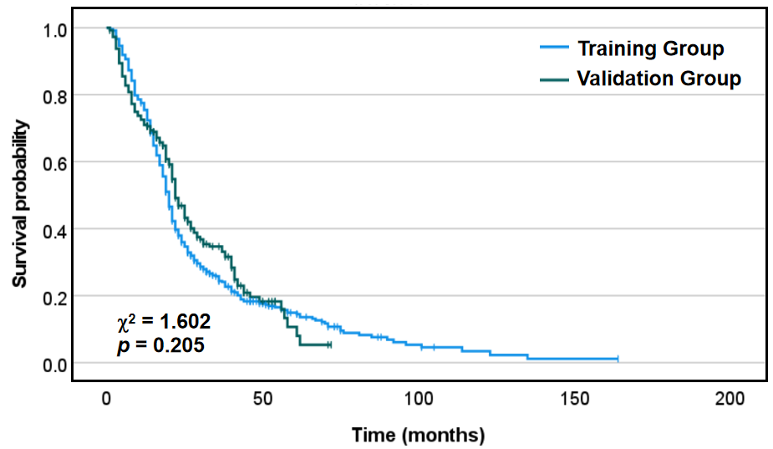
Figure S1. Kaplan-Meier curves of the two cohorts.

Table S1. Hazard ratios of PA and TBIL
 | HR | 95% CI | P Value
Prealbumin | 0.985 | 0.983 - 0.9879 | ＜0.001
Total Bilirubin | 1.056 | 1.042 - 1.0714 | ＜0.001
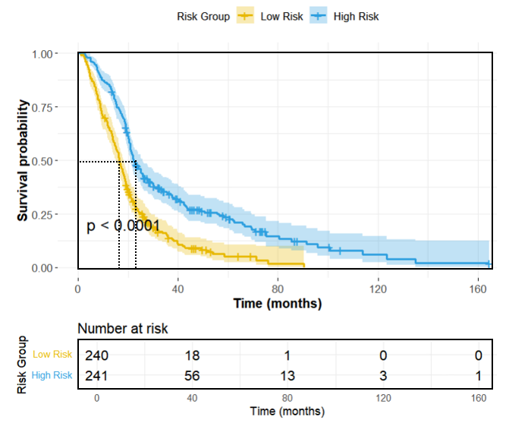
Figure S2. Kaplan-Meier curves of low-risk and high-risk groups.

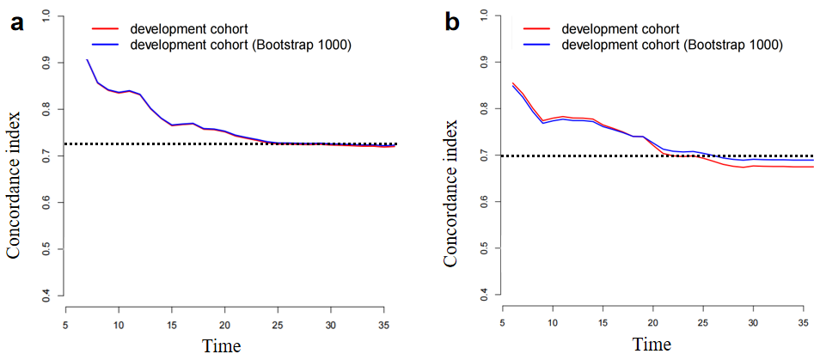
Figure S3. Bootstrap results of the two cohorts. (a) Training cohort, (b) Validation cohort.

