Accelerated discovery of stable ferroelectric perovskites via machine learning
Wenguang Hu¹, Zebin Wu¹, Menglu Li¹, Shan Feng¹, Hangbo Qi¹, Xingjian Lu¹, Xiaotao Zu¹, Liang Qiao^{1,}* and Haiyan Xiao^{1,}*

¹School of Physics, University of Electronic Science and Technology of China, Chengdu 611731, China

Supplementary Figures
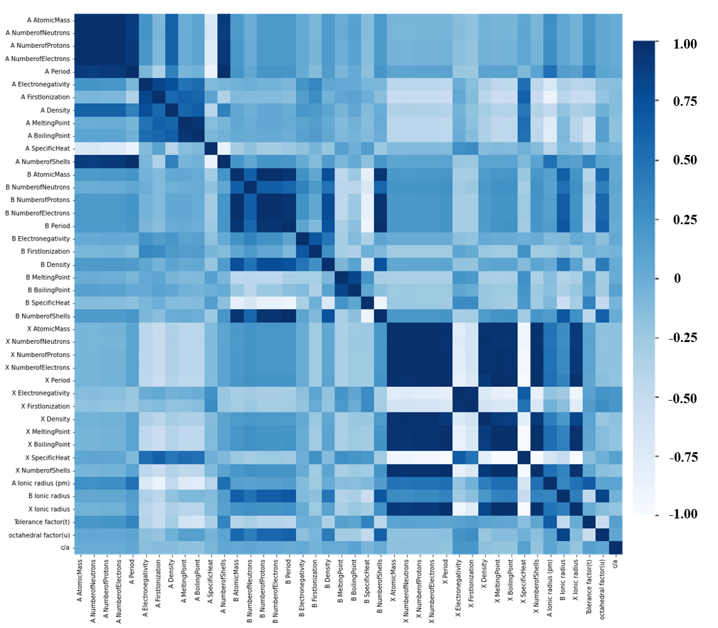
Figure S1. Correlation matrix of Pearson coefficients between 41 features and target c/a.
The Pearson coefficients between 41 original descriptors and the target value c/a are shown in Figure S1. The color indicates the strength of correlation, with darker and lighter colors representing stronger positive and negative correlation, respectively. A correlation coefficient of 0 indicates no correlation. From this, we can select the descriptors which are most correlated with c/a to complete feature engineering.
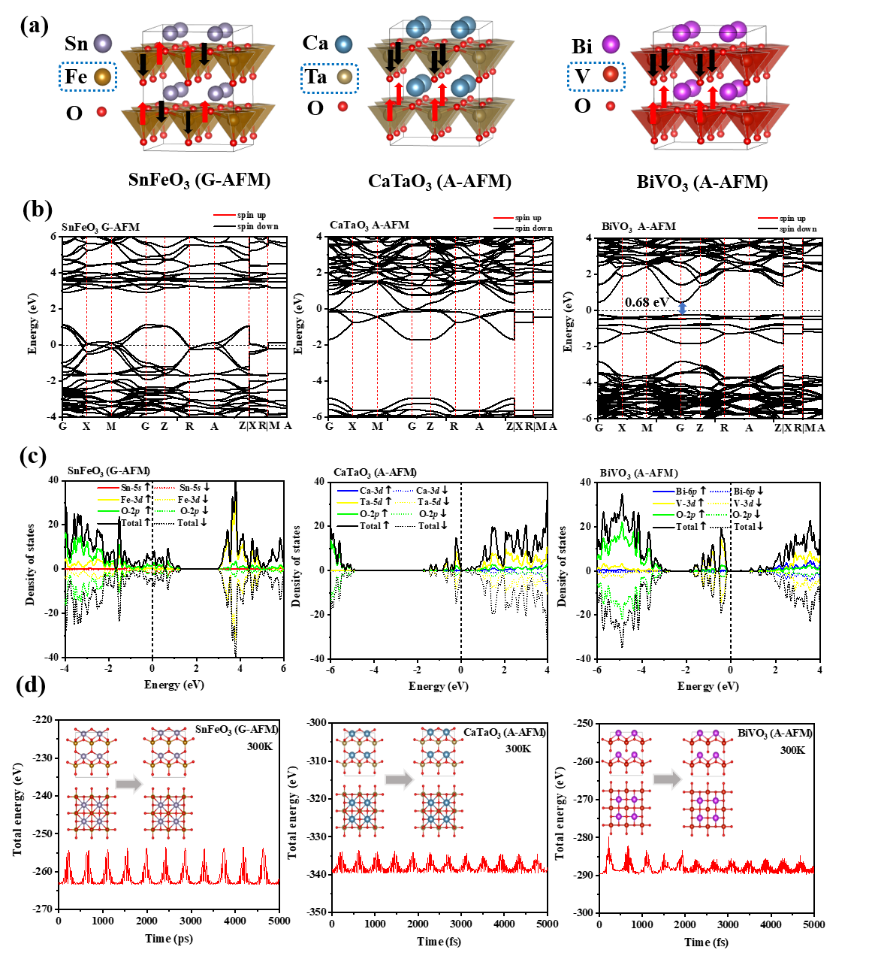
Figure S2. (a) Optimized geometrical structures, in which the magnetic atoms are enclosed in the blue frame, and red and black arrows represent spin up and spin down, respectively; (b) band structures; (c) density of states and (d) variation of total energy with time for SnFeO₃ with G-AFM magnetic ordering, CaTaO₃ with A-AFM magnetic ordering and BiVO₃ with A-AFM magnetic ordering.
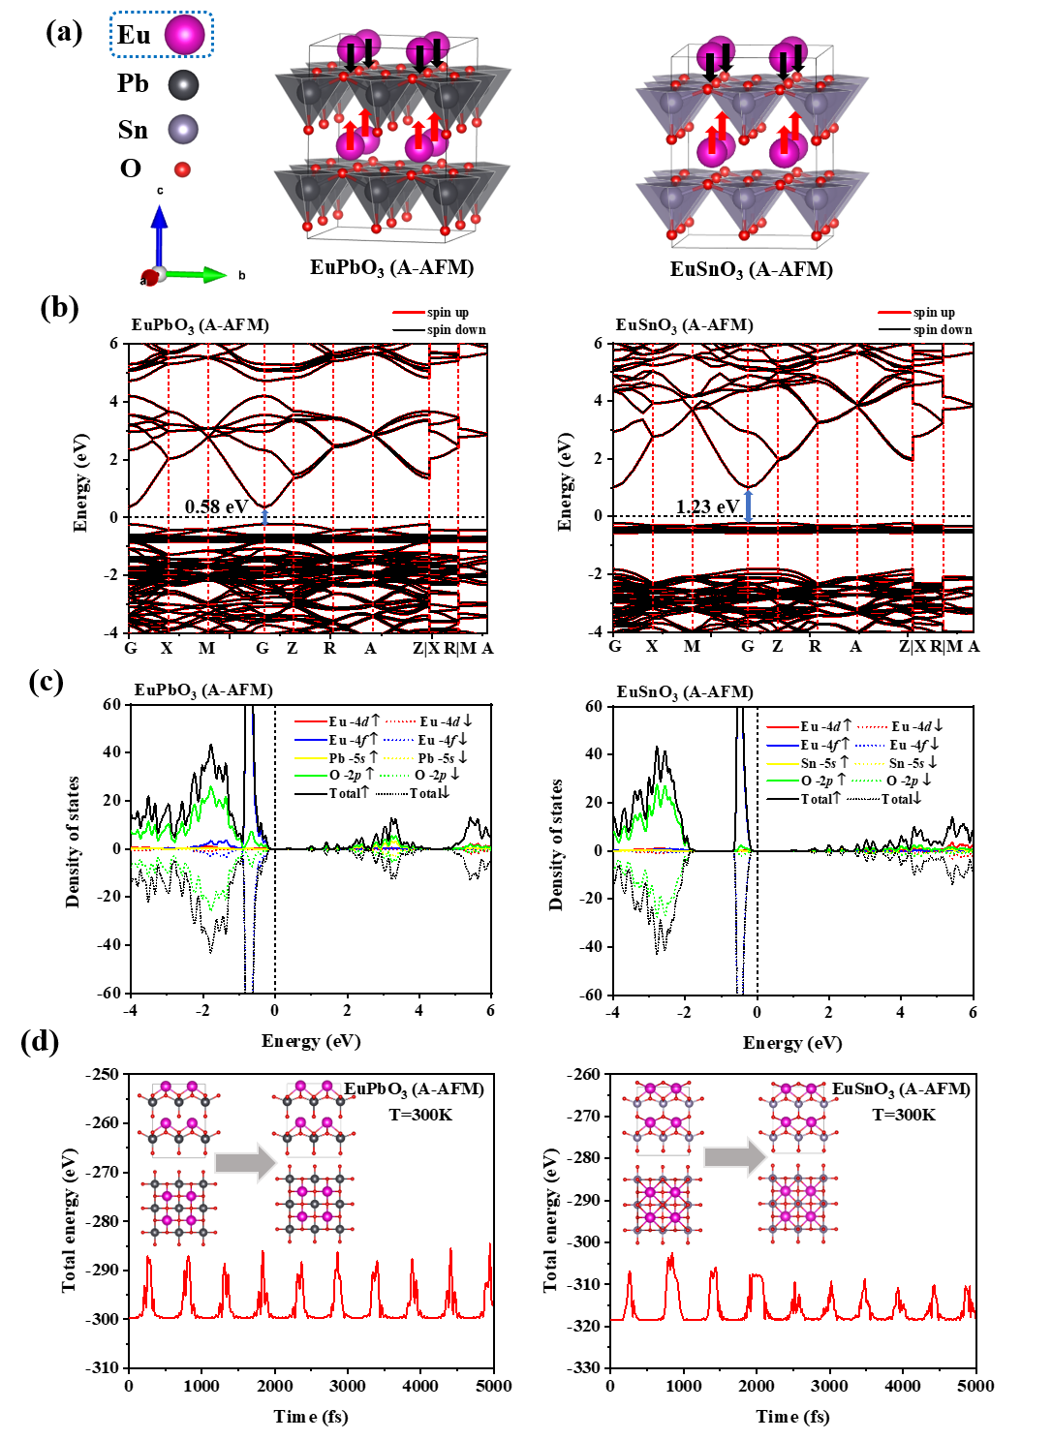
Figure S3. (a) Optimized geometrical structures, in which the magnetic atom is enclosed in the blue frame, and red and black arrows represent spin up and spin down, respectively; (b) band structures, (c) density of states and (d) variation of total energy with time for EuPbO₃ and EuSnO₃ with A-AFM magnetic orderings.
Figure S2 and Figure S3 illustrate the properties of magnetic perovskites, including SnFeO₃ with G-AFM magnetic ordering, CaTaO₃ with A-AFM magnetic ordering, BiVO₃ with A-AFM magnetic ordering, EuPbO₃ with A-AFM magnetic ordering and EuSnO₃ with A-AFM magnetic ordering. Although these perovskites may not have the lowest energy configurations, they exhibit excellent ferroelectric properties and environmental stability, making them promising candidates for ferroelectric perovskite materials.
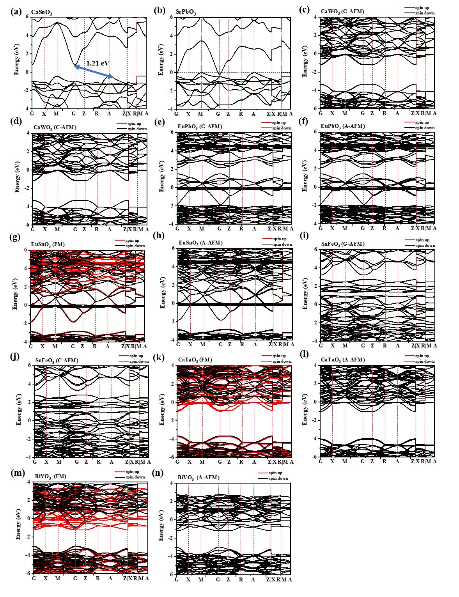
Figure S4. The band structures for selected supertetragonal perovskites obtained by the Perdew-Burke-Ernzerhof (PBE) functional.
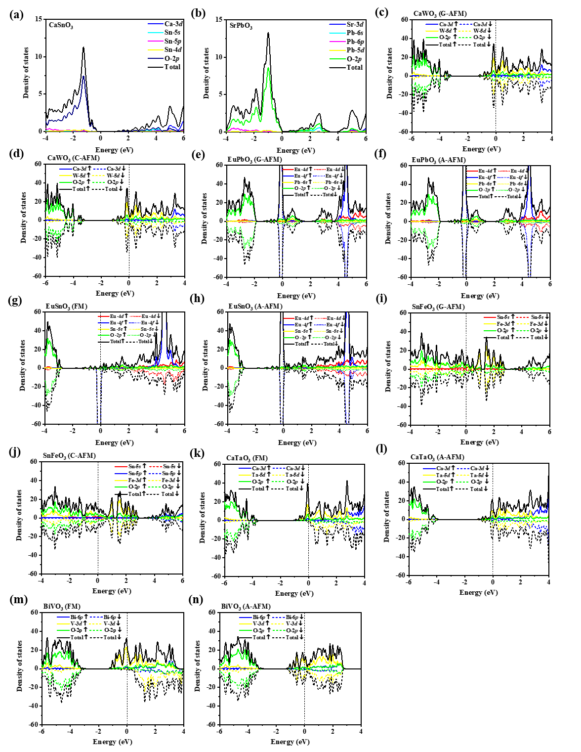
Figure S5. Density of states for selected perovskites obtained by the Perdew-Burke-Ernzerhof (PBE) functional.
Figure S4 and Figure S5 illustrate the band structures and density of states for selected supertetragonal perovskites obtained by PBE functional, respectively. In comparison with the HSE functional results, the PBE functional underestimates the band gap of materials.

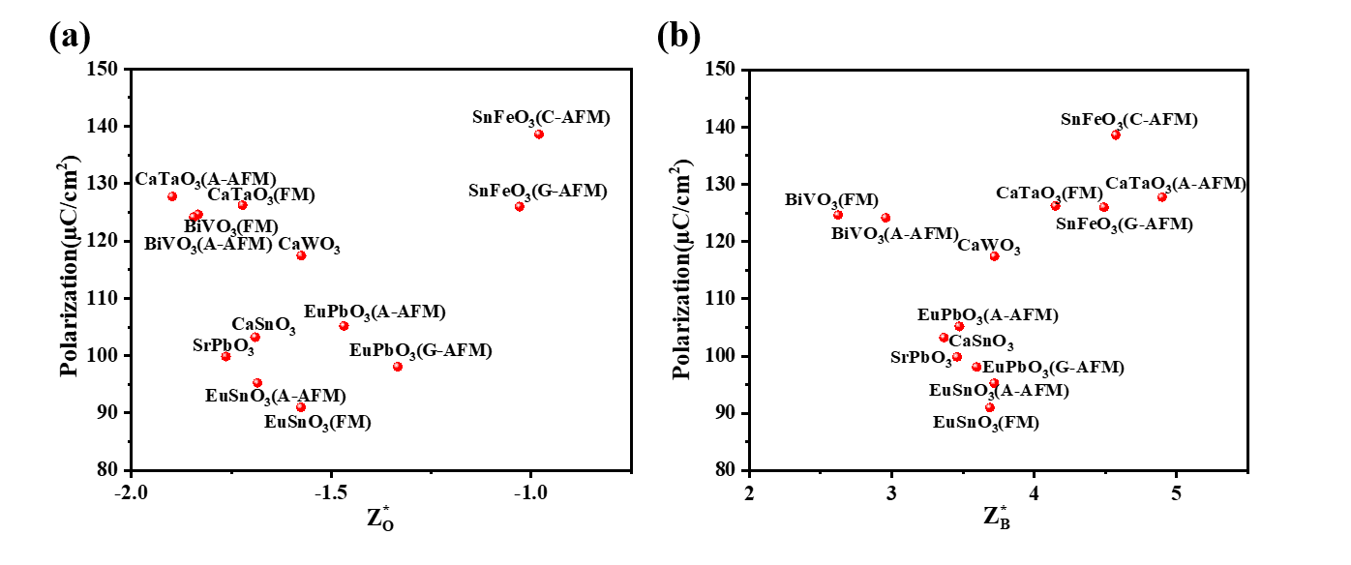
Figure S6. The relationships between polarization and born effective charge of (a) oxygen as well as (b) B-site element in supertetragonal perovskites.
Figure S6 illustrates the relationship between polarization and born effective charge of oxygen as well as B-site element. It seems that the polarization has no liner relationship with the born effective charge of B-site atom Z*_{B} and O atom Z*_{O}.

Supplementary Tables

Table S1. Introduction of the physical significance for descriptors.
Descriptor | Full name | Introduction
μ | Octahedral factor | 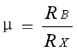  R_{B} ,ion radius of B;R_{X} ,ion radius of X
t | Tolerance factor | 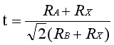  R_{A} ,ion radius of A;R_{B} ,ion radius of B;R_{X} ,ion radius of X
R_{IA} | A Ionic radius | Ion radius of A-site element
R_{IB} | B Ionic radius | Ion radius of B-site element
R_{IX} | X Ionic radius | Ion radius of X-site element
M_{A} | A AtomicMass | Atomic mass of A-site element
M_{B} | B AtomicMass | Atomic mass of B-site element
M_{X} | X AtomicMass | Atomic mass of X-site element
N_{NA} | A NumberofNeutrons | Number of neutrons of A-site element
N_{NB} | B NumberofNeutrons | Number of neutrons of B-site element
N_{NX} | X NumberofNeutrons | Number of neutrons of X-site element
N_{PA} | A NumberofProtons | Number of protons of A-site element
N_{PB} | B NumberofProtons | Number of protons of B-site element
N_{PX} | X NumberofProtons | Number of protons of X-site element
N_{EA} | A NumberofElectrons | Number of electrons of A-site element
N_{EB} | B NumberofElectrons | Number of electrons of B-site element
N_{EX} | X NumberofElectrons | Number of electrons of X-site element
P_{A} | A Period | The period in which element A is located
P_{B} | B Period | The period in which element B is located
P_{X} | X Period | The period in which element X is located
E_{A} | A Electronegativity | Electronegativity of A atom
E_{B} | B Electronegativity | Electronegativity of B atom
E_{X} | X Electronegativity | Electronegativity of X atom
F_{A} | A FirstIonization | First ionization of A atom
F_{B} | B FirstIonization | First ionization of B atom
F_{X} | X FirstIonization | First ionization of X atom
D_{A} | A Density | A density of single substance
D_{B} | B Density | B density of single substance
D_{X} | X Density | X density of single substance
MP_{A} | A MeltingPoint | A Melting point of single substance
MP_{B} | B MeltingPoint | B Melting point of single substance
MP_{X} | X MeltingPoint | X Melting point of single substance
BP_{A} | B BoilingPoint | A Boiling point of single substance
BP_{B} | B BoilingPoint | B Boiling point of single substance
BP_{X} | B BoilingPoint | X Boiling point of single substance
H_{A} | A SpecificHeat | A specific heat of single substance
H_{B} | B SpecificHeat | B specific heat of single substance
H_{X} | X SpecificHeat | X specific heat of single substance
S_{A} | A NumberofShells | Number of shells of A-site element
S_{B} | B NumberofShells | Number of shells of B-site element
S_{X} | X NumberofShells | Number of shells of X-site element

Table S2. Training scores and test scores with different classifiers.
classifier | train score |  |  | test score
classifier | accuracy | precision | recall | accuracy | precision | recall
Random Forest | 0.924 | 1 | 0.643 | 0.897 | 1 | 0.4
Extra Trees | 1 | 1 | 1 | 1 | 1 | 1

Table S3. Energy, magnetic moment, lattice constants of selected magnetic supertetragonal perovskites with different magnetic ordering. MM: magnetic moment of Eu, V, Fe, Ta, Tb, and W.
Formula | Magnetic ordering | MM (µB) | Energy (eV) | E-E_{FM} (eV) | a (Å) | c (Å) | c/a
EuPbO₃ | FM | 6.555 | -37.3363 | 0.0000 | 3.9894 | 5.4898 | 1.3761
EuPbO₃ | G-AFM | 6.557 | -37.3443 | -0.0081 | 3.9860 | 5.4842 | 1.3759
EuPbO₃ | A-AFM | 6.556 | -37.3370 | -0.0007 | 3.9876 | 5.4898 | 1.3767
EuPbO₃ | C-AFM | 6.555 | -37.3194 | 0.0169 | 3.9879 | 5.4927 | 1.3773
EuSnO₃ | FM | 6.701 | -39.6122 | 0.0000 | 3.9109 | 5.1203 | 1.3092
EuSnO₃ | G-AFM | 6.699 | -39.6034 | 0.0088 | 3.9097 | 5.1192 | 1.3094
EuSnO₃ | A-AFM | 6.702 | -39.6118 | 0.0004 | 3.9098 | 5.1207 | 1.3097
EuSnO₃ | C-AFM | 6.698 | -39.6024 | 0.0098 | 3.9102 | 5.1200 | 1.3094
BiVO₃ | FM | 1.683 | -36.0392 | 0.0000 | 3.7870 | 4.7482 | 1.2538
BiVO₃ | G-AFM | 1.414 | -35.9685 | 0.0707 | 4.0137 | 3.8890 | 0.9689
BiVO₃ | A-AFM | 1.662 | -36.0366 | 0.0026 | 3.7767 | 4.7597 | 1.2603
BiVO₃ | C-AFM | 1.459 | -35.8756 | 0.1636 | 3.8307 | 4.6171 | 1.2053
SnFeO₃ | FM | 3.277 | -32.5087 | 0.0000 | 3.6929 | 4.7804 | 1.2945
SnFeO₃ | G-AFM | 3.468 | -32.6674 | -0.1587 | 3.6563 | 4.8352 | 1.3224
SnFeO₃ | A-AFM | 3.257 | -32.5226 | -0.0138 | 3.7154 | 4.7442 | 1.2769
SnFeO₃ | C-AFM | 3.403 | -32.6760 | -0.1673 | 3.6598 | 4.8233 | 1.3179
SrFeO₃ | FM | 2.872 | -34.6519 | 0.0000 | 3.8635 | 3.8249 | 0.9900
SrFeO₃ | G-AFM | 2.695 | -34.3243 | 0.3276 | 3.7394 | 4.2942 | 1.1484
SrFeO₃ | A-AFM | 2.892 | -34.6178 | 0.0341 | 3.8687 | 3.8274 | 0.9893
SrFeO₃ | C-AFM | 2.908 | -34.5038 | 0.1481 | 3.8473 | 3.8974 | 1.0130
CaTaO₃ | FM | 0.458 | -41.7957 | 0.0000 | 3.7403 | 5.0222 | 1.3427
CaTaO₃ | G-AFM | 0 | -42.5049 | -0.7092 | 4.0297 | 4.0558 | 1.0065
CaTaO₃ | A-AFM | 0.371 | -41.7900 | 0.0057 | 3.7900 | 4.9078 | 1.2949
CaTaO₃ | C-AFM | 0 | -42.5047 | -0.7090 | 4.0302 | 4.0544 | 1.0060
SrTbO₃ | FM | 0.037 | -34.2697 | 0.0000 | 4.3609 | 4.5845 | 1.0513
SrTbO₃ | G-AFM | 0.01 | -34.2078 | 0.0619 | 4.3679 | 4.5711 | 1.0465
SrTbO₃ | A-AFM | 0.023 | -34.2046 | 0.0651 | 4.3695 | 4.5756 | 1.0472
SrTbO₃ | C-AFM | 0 | -34.2020 | 0.0677 | 4.3682 | 4.5598 | 1.0439
CaTbO₃ | FM | 0.023 | -34.3544 | 0.0000 | 4.2960 | 4.6593 | 1.0846
CaTbO₃ | G-AFM | 0.009 | -34.2862 | 0.0682 | 4.3100 | 4.6711 | 1.0838
CaTbO₃ | A-AFM | 0.008 | -34.2826 | 0.0718 | 4.3087 | 4.6609 | 1.0818
CaTbO₃ | C-AFM | 0 | -34.2645 | 0.0898 | 4.3082 | 4.6167 | 1.0716
CaWO₃ | FM | 0 | -41.1054 | 0.0000 | 4.0020 | 3.9565 | 0.9886
CaWO₃ | G-AFM | 0 | -39.8845 | 1.2209 | 3.6737 | 4.9779 | 1.3550
CaWO₃ | A-AFM | 0 | -41.1054 | 0.0000 | 4.0033 | 3.9549 | 0.9879
CaWO₃ | C-AFM | 0 | -39.8845 | 1.2209 | 3.6742 | 4.9764 | 1.3544
The ground state properties of selected magnetic perovskites with different magnetic orderings are studied, and the results are summarized in Table S2. It is shown that CaWO₃ exhibits no magnetic moment under different magnetic orderings. Therefore, we conclude that CaWO₃ is non-magnetic perovskite.

Table S4. The displacement between the center B-site atom and the surrounding O atoms (Δ_{B-O}), the born effective charge of A-site, B-site and O atoms (Z*_{A}, Z*_{B}, and Z*_{O}), and the volume of the unit cell for eight screened supertetragonal perovskites.
Formula | Magnetic ordering | 𝛥_{B-O} (Å) | Z*_{A} | Z*_{B} | Z*_{O} | Z*_{O1} | V (Å³)
CaSnO₃ | --- | 0.744 | 2.423 | 3.366 | -1.690 | -2.408 | 74.202
SrPbO₃ | --- | 0.849 | 2.671 | 3.458 | -1.763 | -2.603 | 86.589
CaWO₃ | --- | 0.757 | 2.881 | 3.721 | -1.575 | -3.452 | 67.217
EuPbO₃ | G-AFM | 0.966 | 2.142 | 3.596 | -1.333 | -3.072 | 87.131
EuPbO₃ | A-AFM | 0.971 | 2.485 | 3.474 | -1.468 | -3.022 | 87.314
EuSnO₃ | FM | 0.718 | 2.191 | 3.689 | -1.575 | -2.729 | 78.315
EuSnO₃ | A-AFM | 0.717 | 2.375 | 3.719 | -1.684 | -2.725 | 78.275
SnFeO₃ | G-AFM | 0.709 | 2.222 | 4.489 | -1.029 | -4.653 | 64.626
SnFeO₃ | C-AFM | 0.700 | 2.721 | 4.573 | -0.980 | -5.333 | 64.607
CaTaO₃ | FM | 0.767 | 2.726 | 4.149 | -1.722 | -3.432 | 70.246
CaTaO₃ | A-AFM | 0.710 | 2.601 | 4.898 | -1.897 | -3.705 | 70.499
BiVO₃ | FM | 0.674 | 3.795 | 2.624 | -1.833 | -2.754 | 68.093
BiVO₃ | A-AFM | 0.682 | 3.540 | 2.958 | -1.844 | -2.810 | 67.905

