Supplementary Information
A high-performance all-silicon photodetector enabling telecom-wavelength detection at room temperature

Mohd Saif Shaikh,^{1,2*} Mircea-Traian Catuneanu,² Ahmad Echresh,¹ Rang Li,^{1,2} Shuyu Wen,¹ Guillermo Godoy-Pérez,^{1,2} Slawomir Prucnal,¹ Manfred Helm,^{1,2} Yordan M. Georgiev,^{1,3} Kambiz Jamshidi,² Shengqiang Zhou,^{1**} & Yonder Berencén,^{1***}

¹Helmholtz-Zentrum Dresden-Rossendorf, Institute of Ion Beam Physics and Materials Research, Bautzner Landstrasse 400, 01328 Dresden, Germany
²Dresden University of Technology, 01062 Dresden, Germany
³Acad. E. Djakov Institute of Electronics, Bulgarian Academy of Sciences, 72 Tzarigradsko Chaussee blvd., 1784 Sofia, Bulgaria
m.shaikh@hzdr.de*; s.zhou@hzdr.de**; y.berencen@hzdr.de***

Device fabrication
SOI substrates with a 220 nm thick silicon layer and a 2 000 nm buried SiO₂ layer were patterned using electron beam lithography (EBL) and inductively coupled plasma reactive ion etching (ICP-RIE) to fabricate on-chip grating- and waveguide-coupled Si p-i-n photodetectors (Fig. S1). First, the SOI substrates were cleaned with acetone and isopropyl alcohol and dried with N₂. They were then baked on a hot plate at 120 °C for 2 minutes to remove residual moisture. Next, a 140 nm-thick layer of the negative tone resist hydrogen silsesquioxane (HSQ) (Dow Corning X-1541, original 6% concentration) was spin-coated onto the pre-cleaned SOI substrates at 3000 rpm for 45 seconds. The samples were then baked at 120 °C for 2 minutes and immediately loaded into the EBL system.
Electron beam exposure was performed using a Raith150TWO system (Raith GmbH) at 30 kV accelerating voltage, with a 30 µm aperture and a 4 nm beam step size. To avoid stitching errors, Fixed Beam Moving Stage (FBMS) mode was used for the formation of the grating couplers, tapers, and waveguides, with an area dose of 13490 µC/cm² and a moving stage speed of 0.13 mm/s. Standard write field exposure with an area dose of 1600 µC/cm² was used for the remaining structures. The exposed samples were developed in a high-contrast aqueous developer (5g NaOH and 20g NaCl in 475 ml deionized water) for 60 seconds, rinsed under flowing DI water, and dried with N₂.
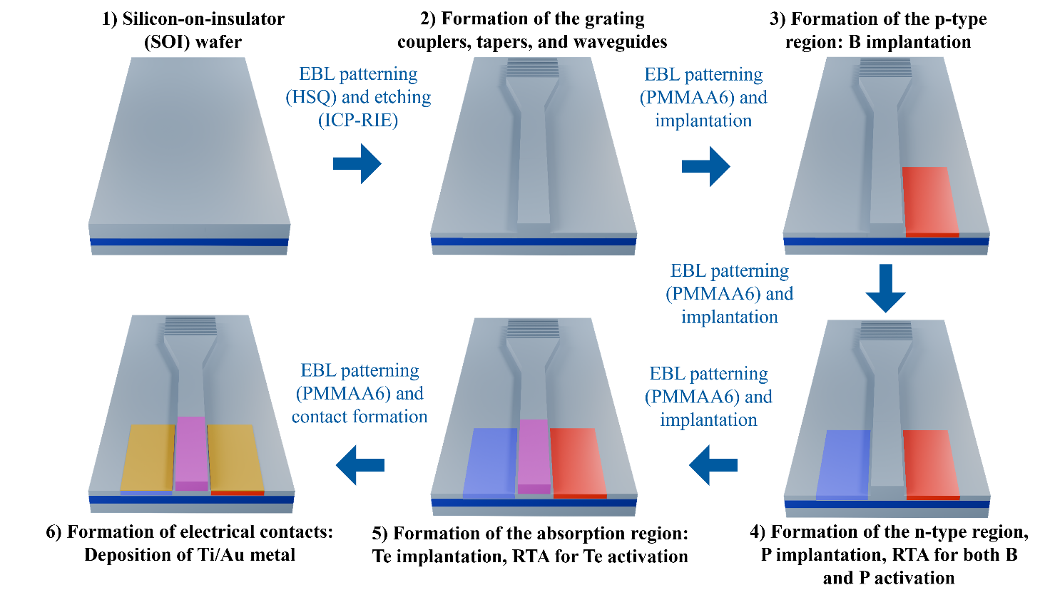
Figure S1. Process flow for the fabrication of grating- and waveguide-coupled Si:Te p-i-n photodetectors using EBL and ICP-RIE.
Finally, the HSQ patterns of the waveguides and gratings were transferred into the Si layer using a SENTECH ICP-Reactive Ion Etcher SI 500 with SF₆ (10 sccm), C₄F₈ (20 sccm), and O₂ (5 sccm) at 0.9 Pa chamber pressure, 400 W ICP power, and 12 W RF power. After etching, the remaining HSQ was removed by dipping the samples in a 1% HF solution for 3 minutes at room temperature. The fabricated devices were analyzed after each EBL cycle using SEM. All devices exhibit an overexposed grating coupler (Fig. S2) and/or a misalignment between the taper and the waveguide (Fig. S4) caused by stitching errors. The simulation of the transmission losses originating from the variation in the duty cycle and the etch depth caused during the fabrication is presented in Fig. S3.
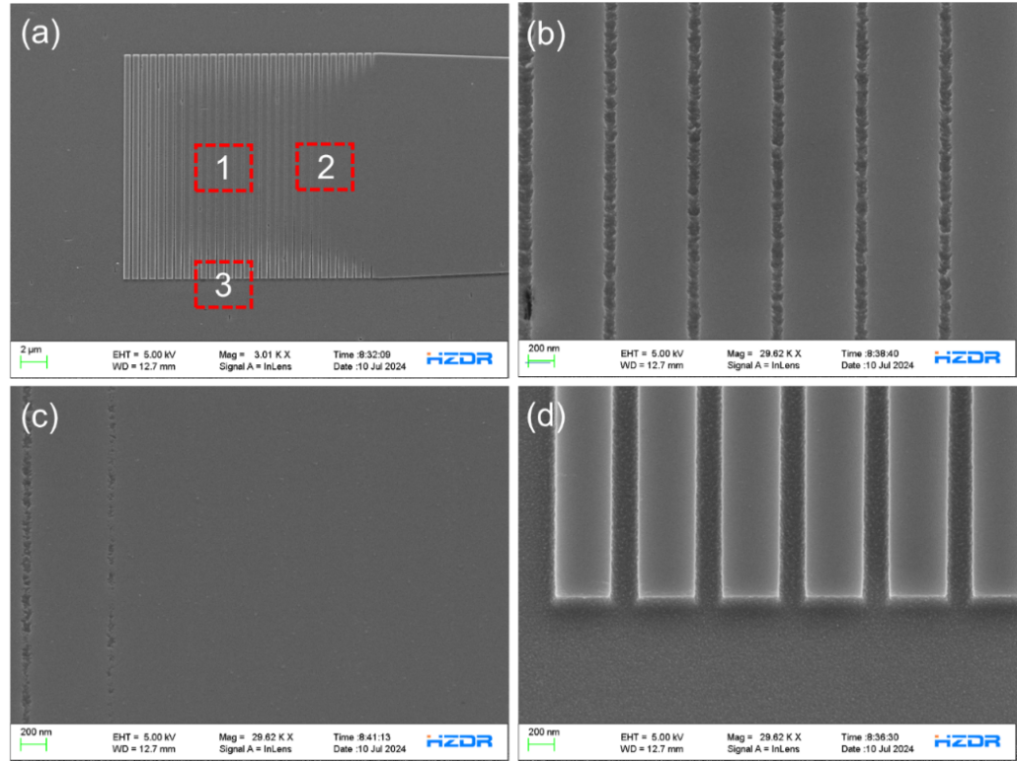
Over exposed region

Figure S2. a, SEM micrograph of the grating coupler. b, c, d, zoomed-in images for selection 1,2,3 respectively, in a.

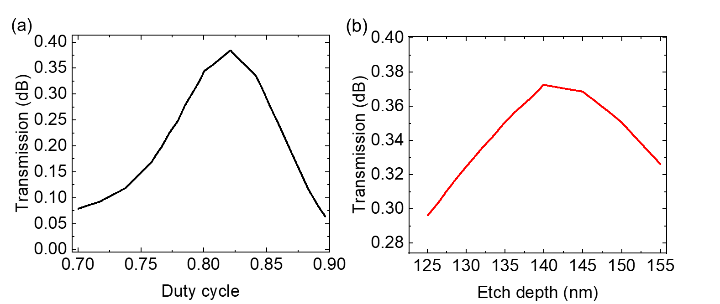

Figure S3. Simulation presenting the variation in fabrication dimensions, i.e. the duty cycle a, and etch depth b, of the grating coupler and its effects on the light transmission

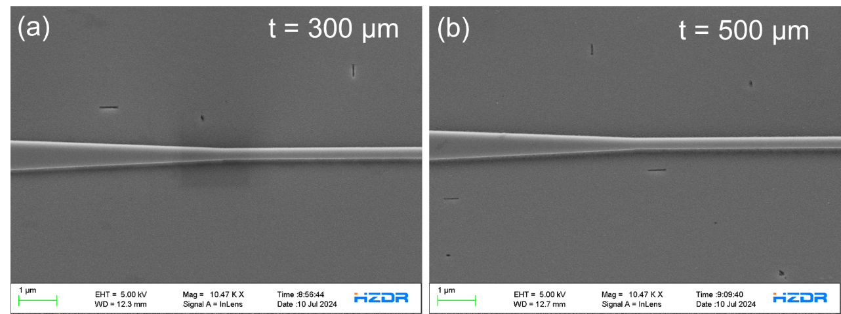

Figure S4. a, b SEM micrograph of 300 and 500 µm waveguides with their taper alignment respectively.

p-i-n junction formation
To extract the photogenerated electron-hole pairs, a p-i-n junction was fabricated along the waveguide. First, boron (B) dopant atoms were implanted 550 nm away from one edge of the waveguide, with an energy of 7 keV and a fluence of 2 × 10¹³ cm⁻², to create a p-type doped region in the intrinsic Si layer (Fig. S5(a)). Subsequently, phosphorus (P) dopant atoms were implanted on the opposite side of the waveguide, also 550 nm away from the edge, using an energy of 18 keV and a fluence of 1.7 × 10¹³ cm⁻², to form an n-type doped region (Fig. S5(b)). For both the p and n-type regions, the surface was further implanted to create p⁺ and n⁺ regions to form ohmic contacts, with fluences of 3.5 × 10¹³ cm⁻² (2 keV) and 2.7 × 10¹³ cm⁻² (5 keV), respectively.
Rapid thermal annealing (RTA) was then performed at 1100 °C for 7 seconds in an inert environment with a nitrogen flow (Fig. S6) of 10 standard liters per minute (slpm) to recover the implantation-induced damage in the Si layer and electrically activate the P and B dopants. The annealing recipe is depicted in Fig. S6 (red-1100 °C).
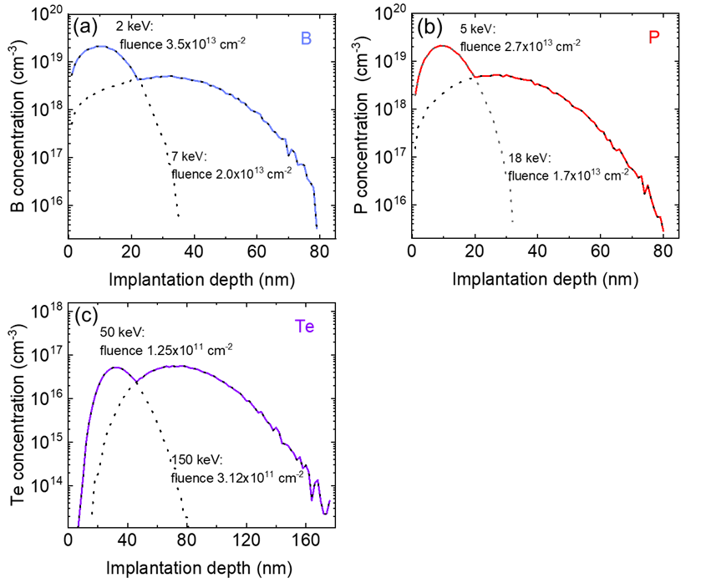
Figure S5. SRIM simulations for the implantation parameters of (a) B, (b) P, and (c) Te atoms in Si.
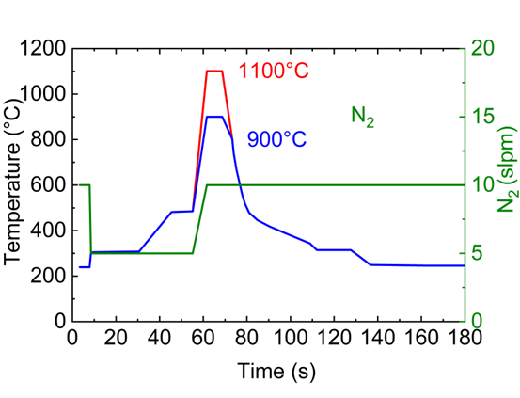
Figure S6. Temperature profile for B and P dopants (red) and Te (blue)

Tellurium atoms were locally implanted into the waveguide regions to enable sub-bandgap absorption in silicon. Before the implantation, a positive-tone resist, polymethyl methacrylate (PMMA A6), was spin-coated onto the patterned samples using a SUSS MicroTech spin coater at 3000 rpm for 50 seconds, followed by baking at 180 °C for 10 minutes. Rectangular openings aligned with the waveguide were then patterned via EBL using a 10 kV accelerating voltage, 100 μC/cm² base area dose, 30 μm aperture size, and 20 nm area step size. The exposed samples were developed in an IPA/deionized water (7:3) solution for 30 seconds, rinsed in IPA for 30 seconds, and dried with N₂.
Te ions were then implanted in two steps to achieve a uniform in-depth profile: first with a fluence of 3.12×10¹¹ cm⁻² at 150 keV, followed by a fluence of 1.25×10¹¹ cm⁻² at 50 keV (Fig. S5 (c)). Subsequently, RTA was conducted at 900 °C for 7 seconds to repair implantation-induced defects in the Si layer and activate the Te dopants. The annealing recipe is depicted in Fig. S6 (blue-900 °C).
Metal deposition
To fabricate the metal contacts, EBL, metal deposition, and a lift-off process were used. First, a positive-tone resist (PMMA A6) was spin-coated onto the patterned samples. Rectangular openings were then exposed with EBL over the B- and P-doped areas. The samples were developed in an IPA/deionized water (7:3) solution for 30 seconds, rinsed in IPA for 30 seconds, and dried with an N₂ gun. Just before metal deposition, samples were immersed in an HF (1% in H₂O) solution to remove the native oxide. A Ti/Au (10/100 nm) layer was deposited using an ultrahigh vacuum thermal evaporator. The lift-off process was completed in acetone to dissolve the resist and remove excess metal.

Loss measurement
The propagation loss was estimated from measurements of grating-waveguide-grating structures (Fig. S7) across multiple devices (Fig. S8).
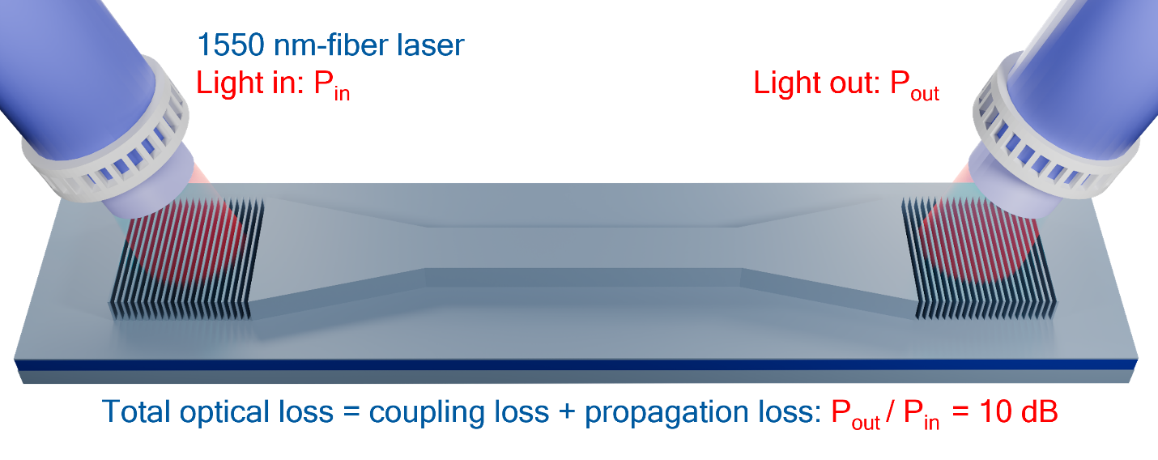
Figure S7: Schematic of the grating-waveguide-grating structure for optical loss estimation.
Figure S8. Output power measured for 20 devices (x-axis) in grating-waveguide-grating structures. The input laser power was -10 dBm, and the output power (y-axis) includes losses from both grating couplers. The total loss was estimated to be evenly distributed between the two couplers, with each contributing approximately 50%. An additional 3 dB connection loss was accounted for, resulting in a lower bound of 10 dB loss per grating coupler.
Electro-optical measurements
A 1550 nm fiber laser was coupled to an electronic variable optical attenuator (VAO, V1550A) controlled by an RF signal generator (DGS3136B). The attenuated laser output was then routed through a single-mode optical beam splitter (TD1315RA2). One output of the splitter was connected to a power meter to monitor the laser's optical power, while the other output was directed to a polarization controller (FPC651) to adjust the polarization state before reaching the grating coupler of the device under test (DUT).
The DUT was electrically contacted using RF probes, which provided both biasing and photocurrent readout. The photocurrent generated by the DUT was amplified by a transimpedance amplifier (TIA, DLCPCA-200), and the amplified signal was fed into a lock-in amplifier (SRS830) to improve the signal-to-noise ratio. The RF signal generator (DGS3136B) synchronized the modulation of the laser after the VOA with the lock-in amplifier.
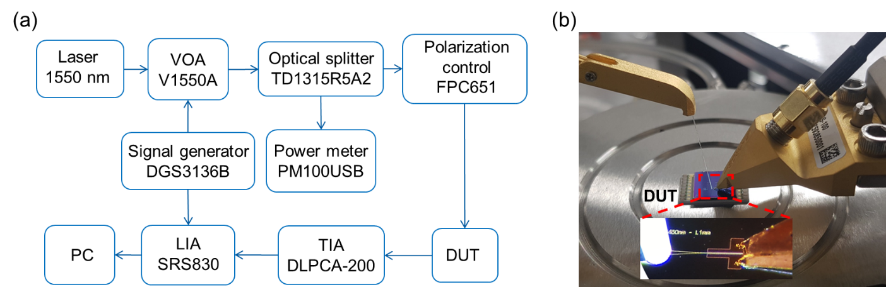
The entire setup was controlled via a computer, which was also used to acquire and process the experimental data. A schematic representation of the measurement setup is provided in Fig. S9a.

Figure S9. a, Responsivity measurement setup. b, cleaved fiber at a 10° incidence angle on the grating coupler of the GWG-PD and connected electrical probes to bias and extract the photogenerated carriers.

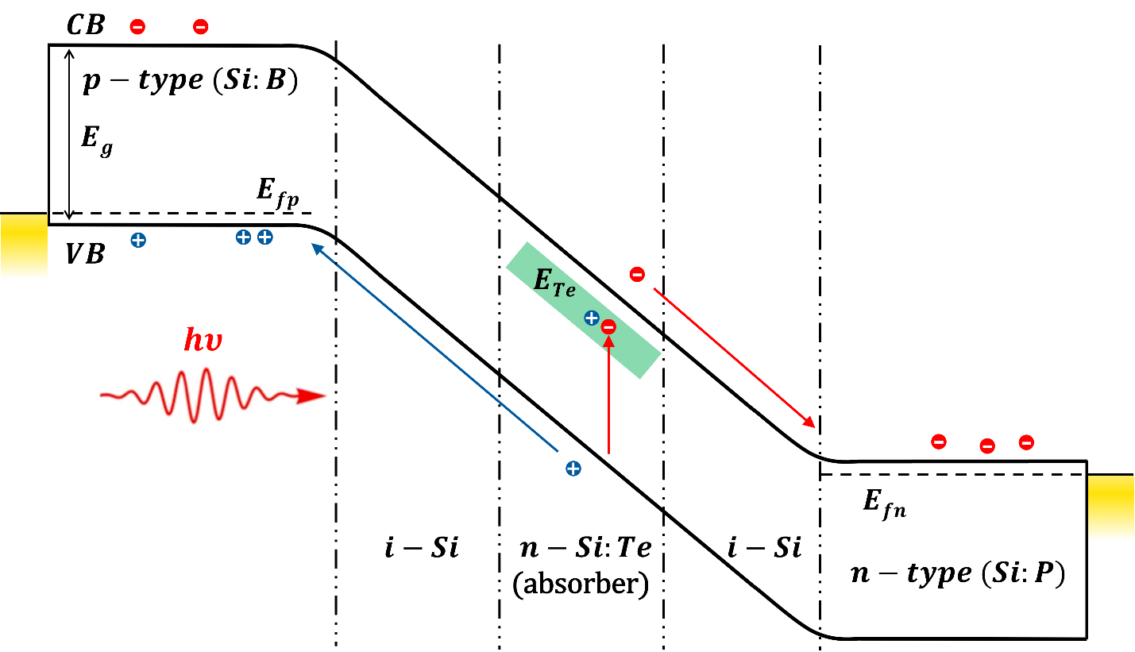
Figure S10. Energy band diagram of the GWG-PD under applied bias and 1550 nm laser illumination. Photons are absorbed in the Si active region, generating carriers that are swept through the high-electric-field drift region. The carriers transition from the intrinsic silicon (i-Si) region to the p-type (Si) and n-type (Si) regions, ultimately reaching the metal contacts.

Table S1. Comparison of responsivity and NEP for devices with different waveguide lengths, measured at 1550 nm under a reverse bias of -2 V. A 10 dB grating coupling loss is considered. D is the spacing between the n- and p-type regions and L is the length of the waveguide. Three devices of each length were measured.
Number | Devices operated at  -2 V reverse bias | 1550 nm-Responsivity (A/W) at 0.8µW | NEP_{1550nm,70Hz} W/$√(Hz))$
1 | D:1.45µm, L:300 µm | 2.1x10⁻¹ | 7.4x10⁻¹⁰
2 | D:1.45µm, L:500 µm | 3.0x10⁻¹ | 4.2x10⁻⁹
3 | D:6.45µm, L:1 mm | 9.9x10⁻² | 4.6x10⁻⁹

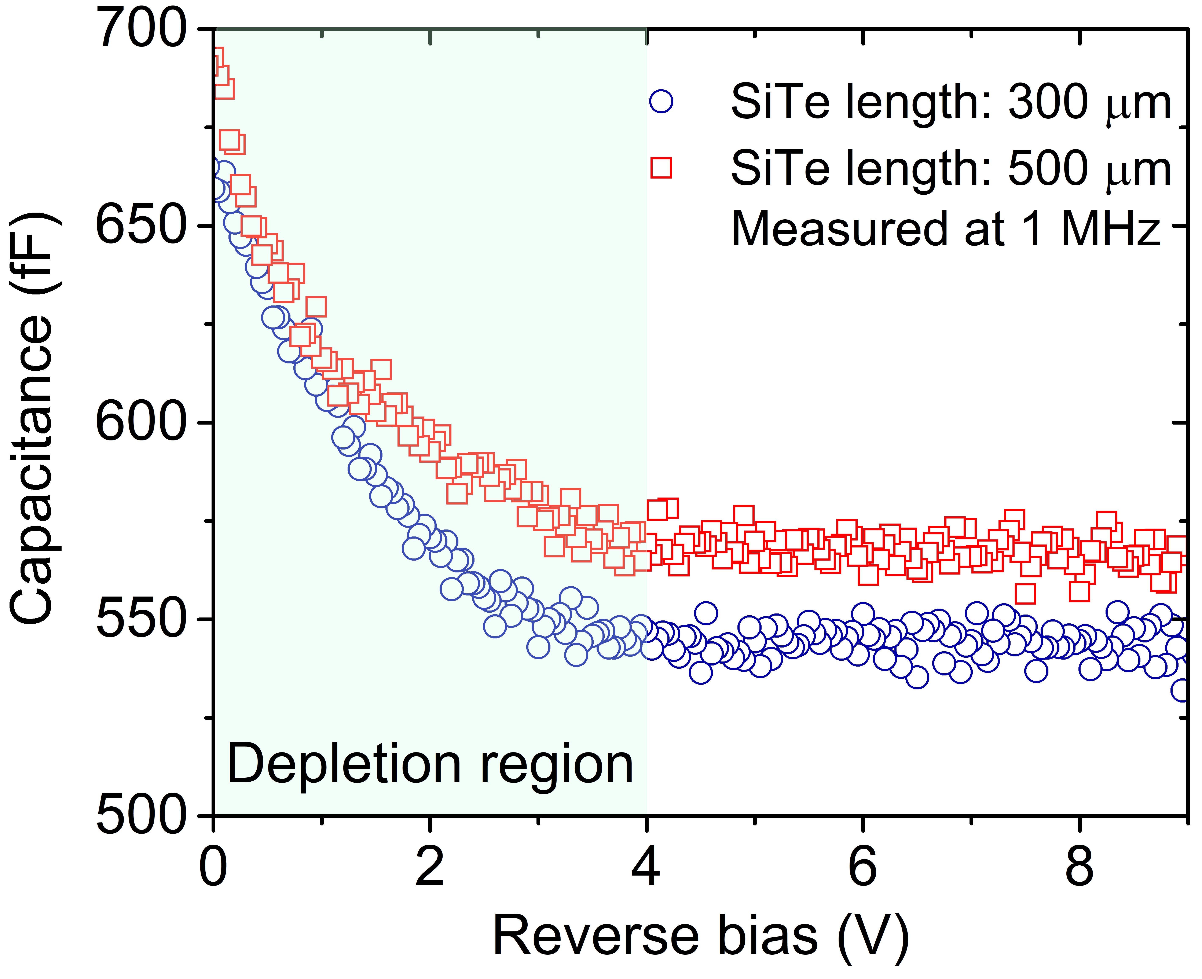
Figure S11. Capacitance as a function of applied bias for two GWG-PDs with an optical absorption length of 300 µm and 500 µm.

