Supplementary material

Supplementary material 1: Comprehensive Overview of the Sternberg Working Memory Task (STB) Protocol

The Sternberg Working Memory (STB) task, a well-established experimental paradigm in working memory research, was sourced from the Psychology Software Tools official website (PST experiment number 3012) and implemented using E-prime3.0 (PST Admin, 2022). The task is designed to assess participants' ability to store and retrieve items in short-term memory (Raghavachari et al., 2001; Brookes et al., 2011).
Task Design and Setup:
Participants were seated comfortably in front of a computer screen. They were instructed to focus on the task displayed on the monitor, which provided instructions and visual stimuli. The participants interacted with the task using a controller with two buttons (A and B) to record their responses.
Stimulus Presentation:
A series of letters were presented on the screen at a rate of one letter per second. Each series contained eight letters, and the participants' task was to memorize the black letters while ignoring the green letters, which served as distractors. The ratio of black to green letters was set to 7:1, following the default settings in the STB experimental paradigm. This setup allowed researchers to evaluate the participants' ability to distinguish relevant information amidst distractors.
Memory Retention and Retrieval:
After the series of letters was presented, the participants entered a retention phase where they had to keep the memorized black letters in their short-term memory for a duration of eight seconds. During this phase, the screen remained blank to minimize distractions and help participants focus on retaining the memorized information.
Following the retention period, a set of seven target letters was displayed one at a time on the screen. The participants were required to determine whether each target letter had been part of the memorized set. They indicated a match by pressing the 'A' button on the controller and indicated a mismatch by pressing the 'B' button.
Rest and Trial Duration:
Each response was followed by a five-second rest interval before the next trial began. This rest period was designed to provide participants with a brief pause to avoid fatigue and maintain high concentration levels throughout the task.
Experimental Cycles:
The task was divided into two experimental cycles, each lasting five minutes. During this time, participants completed several trials, each consisting of stimulus presentation, memory retention, and retrieval, as described above.
Data Collection:
Responses were recorded using E-prime3.0 software, which captured both the accuracy and reaction times of each participant. This data allowed for a detailed analysis of the participants' working memory performance.
This version of the STB task provides a comprehensive assessment of working memory, testing participants' abilities to store, retain, and retrieve information over short periods, while controlling for distractions. The results offer insights into cognitive processing and are crucial for evaluating the influence of learning behaviors on working memory functions. For more clarity, please refer to Fig. 1 for the STB experimental flowchart and Fig. 2 for on-site experimental photo.
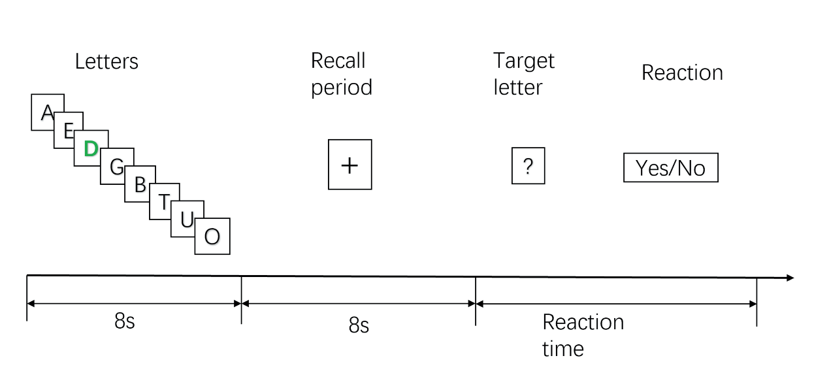
Fig.1 Sternberg working memory (STB) experimental diagram.
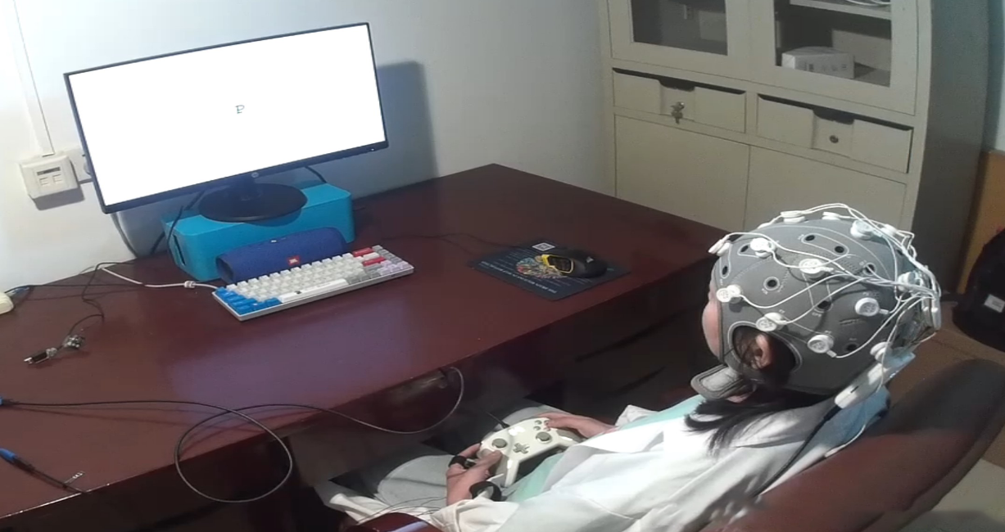
Fig.2 on-site experimental photo.

Supplementary Material 2: Detailed Overview of PAC Calculation Methodology

Methodology for Phase-Amplitude Coupling (PAC) Analysis
In this study, phase-amplitude coupling (PAC) analysis was conducted using advanced signal processing techniques to derive physiological insights from neural oscillations across various frequency bands. The analysis focuses on the interaction between low-frequency phases and high-frequency amplitudes, providing a crucial approach for understanding the dynamic coordination of brain regions.

Utilizing the Hilbert Transform
Initially, the raw EEG signals are band-pass filtered to isolate specific low- and high-frequency components. The low-frequency component often relates to the slower wave dynamics of larger neural networks, while the high-frequency component reflects more granular neural activity. Through the Hilbert transform, we extract the instantaneous phase (low frequency) and instantaneous amplitude (high frequency) from these filtered signals. This transformation enables effective extraction of complex analytic signals from real-valued data, allowing separate analyses of the signal’s phase and amplitude. In PAC analysis, grouping phases and calculating amplitude statistics accordingly are critical steps that directly influence the measurement of coupling strength. The following details the implementation of this process:

Phase Grouping and Amplitude Statistics
After extracting the low-frequency phase and high-frequency amplitude, the next step is to systematically group the continuous phase values. The groupings are based on the periodic nature of the phase to ensure even coverage across the entire phase cycle, from -π to π. This grouping involves creating a fixed number of equally spaced “bins,” each representing a phase interval for subsequent amplitude analysis.
Phase grouping is achieved by classifying calculated phase values according to their corresponding phase intervals. For instance, if 18 phase "bins" are set, each bin divides the cycle into 18 equal parts, each covering a range of 2π/18 or π/9. For example, the first bin ranges from -π to -π + π/9 = -17π/18, the second bin covers -17π/18 to -16π/18, continuing up to the final bin from 17π/18 to π. By evenly distributing these intervals, each phase bin can statistically gather enough data points to accurately represent its average amplitude.
Once phase grouping is complete, the average high-frequency amplitude is calculated for each phase bin. This calculation aggregates all amplitude values falling within a specific phase interval to derive a representative amplitude. This not only involves calculating the mean but also handling potential data issues like noise or invalid data points. When aggregating amplitude for each phase bin, invalid or abnormal data points are excluded, and a sufficient number of points per bin is ensured to maintain statistical reliability.
In this manner, amplitude distributions are generated for each phase interval. These distributions are used to calculate statistical features of amplitude changes associated with each phase, such as mean and standard deviation. These statistics provide essential inputs for subsequent KLMI calculations, enabling us to assess significant amplitude changes under given phase conditions.
The above steps describe how phase grouping and amplitude statistics are systematically implemented, ensuring analytical rigor and result interpretability. This methodology ensures that the research accurately reflects the dynamic interaction patterns between different brain frequencies during complex tasks. The data is crucial for evaluating brain region coordination in cognitive functions like attention and memory.

Kullback-Leibler Modulation Index(KLMI)
Kullback-LeiblerModulationIndex (KLMI) is an index based on statistical information theory that is used to quantify the coupling strength between neural oscillations at different frequencies, especially the coupling between low-frequency phase and high-frequency amplitude. In this study, the purpose of calculating KLMI was to analyze in detail how low-frequency phase changes affect the change patterns of high-frequency amplitudes. This analysis is crucial for revealing the neural basis of the brain's processing of complex tasks.
The calculation of KLMI relies on the comparison of two main distributions: the actual observed amplitude distribution $P$ and the expected uniform distribution $Q$. Here, $P$is the actual distribution of high−frequency amplitudes within each phase interval based on phase grouping, while $Q$ is the expected distribution of amplitudes per phase interval without the phase coupling assumption, which is usually a uniform distribution. KLMI is calculated by the following formula:
$$\text{KL}(P∥Q)=\sum_{i=1}^{k}{ }P(i)log⁡(\frac{P(i)}{Q(i)})$$
In this formula, $k$ represents the number of phase bins, $P(i)$ is the amplitude distribution within the $i$-th phase bin,$Q$ is the expected distribution of amplitudes in each phase bin without the phase coupling assumption, and $Q(i)=\frac{1}{k}$, indicating that in the absence of coupling, the distribution of amplitudes in all phase intervals is uniform.
In phase-amplitude coupling (PAC) analysis, Modulation Index (MI) is a key metric used to quantify the degree of coupling between low-frequency phase and high-frequency amplitude. MI is implemented by calculating KLMI, which measures the information gain from an ideal uniform distribution to the observed amplitude distribution, thus providing a quantitative indicator of the strength of the coupling. The normalized expression of MI is:
$$\text{MI}=\frac{\text{KL}(P∥Q)}{log⁡(k)}$$
In this formula, $log⁡(k)$ is the theoretically possible maximum divergence value in the case of a completely uniform distribution. By dividing by this value, the MI is normalized to a value between 0 and 1, where 0 means no coupling between phase and amplitude is detected and 1 means very strong coupling. Such normalization makes the value of MI unaffected by the number of phase intervals, making it easier to compare results from different studies or under different conditions.

Detailed Description of the Calculation Process
Before calculating KLMI, we first need to average the high-frequency amplitude values ​​of each phase interval to obtain 𝑃. This step is critical because it reflects the actual behavior of the high frequency amplitude at a specific low frequency phase. Once 𝑃 and 𝑄 are defined, by calculating the KL divergence between them, we can obtain a measure of how different the actual amplitude distribution is from a completely random amplitude distribution. Each element of 𝑃 is obtained by calculating the average of the amplitude values ​​that fall within the corresponding phase interval, a process that involves weighing the number of amplitude values ​​within each interval to ensure statistical validity. For each phase interval, we calculate the log-likelihood ratio of its amplitude, and then accumulate the results of all phase intervals to obtain the total KL divergence. Finally, by normalizing this total divergence value (relative to the maximum possible divergence 𝑙𝑜𝑔(𝑘)), a normalized KLMI value between 0 and 1 is obtained.
Through such calculations, KLMI provides a quantitative measure of how high-frequency amplitudes systematically deviate from a uniform distribution at a specific low-frequency phase. This not only reveals underlying neural communication mechanisms, but may also indicate how the brain adjusts its information processing strategies during specific cognitive states. Therefore, KLMI is a bridge between neural dynamics and behavioral performance, providing a powerful tool for understanding brain function.
The phase-amplitude coupling (PAC) analysis method used in this study is based on the MATLAB program developed by Benjamin Voloh based on the research of (Tort et al., 2010) and (Maris et al., 2011) and published in "PNAS" (Voloh et al., 2015). We enhanced the original code, including adding T-tests, significance analysis, and multiple comparison corrections, to suit the specific needs of our study. These improvements significantly increase the rigor of analysis, especially controlling false discovery rates when dealing with large numbers of data comparisons. All code is released under the GNU General Public License, ensuring openness and transparency of the approach. This improved analytical framework not only deepens our understanding of brain function and information processing mechanisms, but also provides a powerful tool for neuroscience research to help researchers explore the relationships between various brain regions when performing complex cognitive tasks. dynamic interaction.

