Supplementary Material for “The global significance of post fire soil erosion”

Vieira DCS^{1a}, Borrelli P^{b}, Scarpa S^{c}, Liakos L^{d}, Ballabio Cª, Panagos Pª

1 – Corresponding author (diana.simoes-vieira@ec.europa.eu)
a – European Commission, Joint Research Centre (JRC), Ispra, Italy
b – Department of Science, Roma Tre University, Rome, Italy
c – EUROPEAN DYNAMICS Luxembourg S.A.
d – UNISYSTEMS, Rue du Puits Romain 29, Bertrange, L-8070, Luxembourg

Quality assessment with previous EU-scale assessment
Given the current adaptation of the Vieira et al. (2023) methodology to allow the temporal and spatial upscaling framed in this study, we have conducted a series of assessments to determine how much the change model inputs (resolution, burned area and severity, FCOVER) would lead to error propagation until the final post-fire erosion prediction. Therefore, we have compared the results obtained under the current methodology at global scale with the previous one at EU scale for the first post-fire year of 2017 regarding:
- Burned area delineation and severity. Previous methodology included a highly detailed fire perimeter and the determination of Normalized Burn Ration (NBR) index at a resolution of 25m. The processing of this information was done for each individual wildfire, in a total of 2,679 wildfires in the EU. Under the new methodology, this information was now retrieved through the MOSEV database (Alonso-González and Fernández-García, 2021) at much coarser resolution (500m). Despite the decrease in resolution, significant benefits were brought by the increase in temporal scale offered by such database (1 vs. 18 years) and by reducing the manual technical assessment burden of individual fires at global scale (2,679 vs ~80,506,100 fires). Another benefit concerns the identification of reburns, which was not considered previously despite positive observations.
- Ground cover by FCOVER. Previous methodology used a coarse resolution (300m) FCOVER product provided by Copernicus (Fuster et al., 2020), and now it includes the determination of FCOVER at 30m resolution. Moreover, reference unburned conditions are updated in case of reburns, whereas the full history of fire occurrence and FCOVER could be assessed since the first wildfire in that given pixel. Another required adaptation was the timing of the year in which FCOVER data was retrieved. Previously a fixed date (30 October) was used to represent ground cover after fire, being revisited annually at the same time of the year to assess recovery, which was considered a good approximation given the fact that AOI was in the northern hemisphere and most of the fires generally occur before this date. Now, and because it was required to assess distinct wildfire seasons all over the globe, we follow up every single fire event in each pixel, recording the pre-fire FCOVER with the best imagery available previously to the date provided by MOSEV, recording the post-fire FCOVER based on the best imagery available for post-fire period, and then following up annually until the limit of MOSEV temporal window.

Burned area delineation and severity
Our analysis under 100m resolution shows a similar burn severity classification over the same simulated area (Table 1) as the study of Vieira et al 2023, with natural reduction of the high severity classes due to the reduction of the resolution. A fraction of the low (1%) and high (9%) burn severity classes were merged with the moderate severity (10%).

Table 1- Comparison and error determination between the manual burn severity assessment (Vieira et al., 2023) and the usage of MOSEV database for the 2017 burned areas in EU.
 | Manual NBR | MOSEV | error (total% change)
Low | 17% | 16% | -1%
Moderate | 51% | 60% | 10%
High | 32% | 23% | -9%

However, the limited availability of data for global burned areas and their severity presented itself the major limitation of this study, whereas the usage of MOSEV led to a loss of 28% in area, which correspond to fires smaller than 25ha (Fig. 1) in the EU, as also confirmed by Boschetti et al. (2019). This underestimation is also in line with the coefficient of variation of the estimated burned area found for temperate (23.3%) and Mediterranean forest (42.4%) (Boschetti et al., 2019).
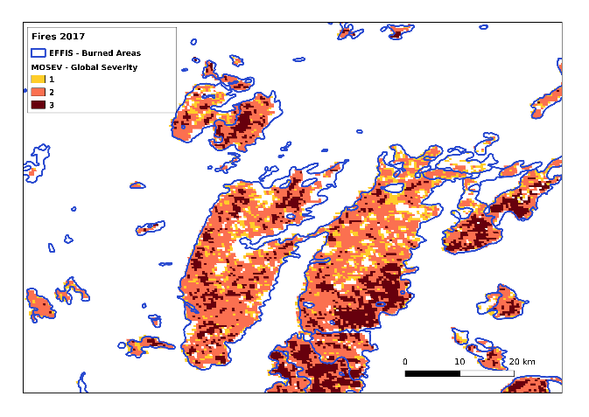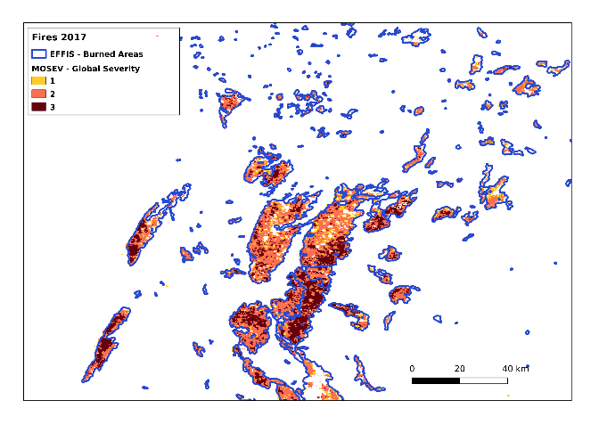
Fig. 1 – Examples of MOSEV coverage (pixel) and fire perimeter (line) for the 2017 burned areas in EU at different resolution.

Ground cover by FCOVER
Following the comparison of the FCOVER data from the available Copernicus product (300m) with the new methodology used under the Landsat Collection (30m), a double step correction was required to keep the previous model calibration (Vieira et al., 2023) based on the previous estimations performed at EU scale. We have focused on the different signals obtained by both systems (PROBA-V vs. Landsat), but also taking into consideration that FCOVER under the previous methodology concerned one moment in time (October) while the novel one is determined immediately after each fire. Therefore, the following transformation was applied which allowed us to keep the same range and interquartile as the original data collected:
$FCOVER corr_{\left(t variable, scale 30m\right)}=FCOVER_{\left(t variable, scale 30m\right)}-\left(xFCOVER_{\left(t october2017, scale 30m\right)}-x FCOVER _{\left(october2017, scale 300m\right)}\right)$ (1)
Where FCOVER corr_{(t variable, scale 30m)} corresponds to the corrected FCOVER input used in the current approach, the FCOVER_{(t variable, scale 30m)} corresponds to the data as retrieved from Google earth Engine and Landsat Collection 2, x FCOVER_{(t october, scale 30m)} corresponds to the mean FCOVER product from Landsat for single date in 30 October, and FCOVER_{(t october, scale 300m)} the mean FCOVER product from PROBA-V for single date in 30 October.
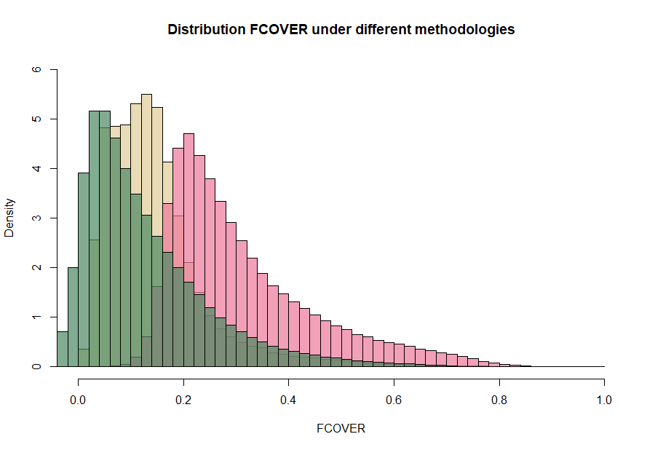
Fig. 2 - Distribution of FCOVER data under different methodologies for the 2017 burned areas in EU, FCOVER from Copernicus (PROBA-V) at 300m resolution (yellow), FCOVER obtained by Google Earth Engine following Song et al. (2022) using NDVI from Landsat Collection 2 at 30m resolution (pink), and FCOVERcorr as determined by equation 1.

Resulting post-fire soil erosion estimations
As a result from these methodological changes, soil erosion estimations resulted in a somehow more conservative methodology with reductions on the mean from 33.22 to 30.08 Mg ha⁻¹ and a shift of the median from 21.2 Mg ha⁻¹ to 16.92 Mg ha⁻¹ for the first post fire year, with a 0.504 correlation coefficient when compared to the former approach.
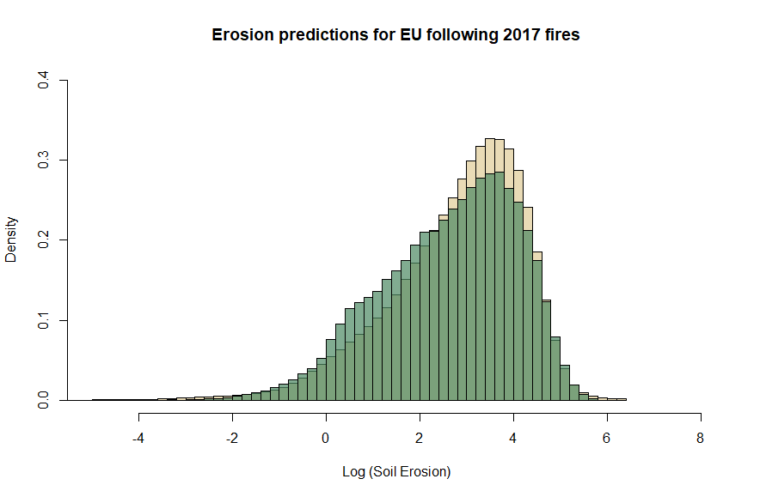
Fig. 2 - Distribution of soil erosion estimations (Log scale) under different methodologies, as a result from manual severity assessment and FCOVER from Copernicus products (yellow), and from MOSEV database and FCOVER as determined by equation 1 (green), for the 2017 burned areas in EU at 100m resolution.

Identification of uncertainties
During the development of this assessment was possible to identify several sources of uncertainties, mostly resulting from the adaptation to coarser resolution products such as the use of MOSEV (Alonso-González and Fernández-García, 2021). Notwithstanding, we also profited from the opportunity to improve the methodology used in (Vieira et al., 2023), which in overall allowed us to create the first global estimation of its kind. The quality assessment performed to EU+UK 2017 burned area (Supplementary Material) identifies several limitations when adapting this study to a global scale as follows:
- There is a substantial underestimation of burned areas when using the MOSEV database by not considering small sized burned areas (<25ha), leading to data losses of approximately 28% for EU+UK 2017 burned area. Such errors have already been quantified by Boschetti et al. (2019) across biomes types, whereas the lowest errors concerned Boreal Forest, Tropical Savanna and Temperate Savanna, while the highest were observed in the Tropical Forest, Temperate Forest and Mediterranean biomes.
- A slight reduction in the areas classified with high burn severity (9% total) to moderate severity was observed as a result of resolution changes for EU+UK 2017 burned area. Such proportion might change in other continents, depending on the contribution of high severity areas to the total burned area, but also the size of the wildfires, since high severity burns are more likely to occur in burned areas with greater dimension (Fernández-Guisuraga et al., 2023).
- Despite FCOVER determination used in this work (Song et al., 2022) was based on the same vegetation indices (NDVI) as the ones from Copernicus FCOVER product, the use of data originated from two different remote sensing systems might lead to further differences beyond the ones tackled in this study.
- The quality assessment for soil erosion after fire allowed us to evaluate the agreement between both methodologies on the EU+UK 2017 burned area, revealing that the new methodology provides more conservative soil erosion estimations after fire. However, in other continents where post-fire soil erosion is less documented and estimated (Girona-García et al., 2021; Lopes et al., 2021) these uncertainties may rise. This is particularly significant in the case of the African and South American continents, which hold a substantial contribution of burned area, and in this case soil erosion, annually.
- The main focus of this research is to estimate the soil erosion on burned areas, however this work does not address other forest disturbances such as drought, pests, or wind (Patacca et al., 2023; Seidl et al., 2017), or anthropogenic actions leading to disturbances such as logging, thinning or afforestation (Ceccherini et al., 2020).

References
Alonso-González, E., Fernández-García, V., 2021. MOSEV: a global burn severity database from MODIS (2000–2020). Earth Syst. Sci. Data 13, 1925–1938. https://doi.org/10.5194/essd-13-1925-2021
Boschetti, L., Roy, D.P., Giglio, L., Huang, H., Zubkova, M., Humber, M.L., 2019. Global validation of the collection 6 MODIS burned area product. Remote Sens. Environ. 235, 111490. https://doi.org/10.1016/j.rse.2019.111490
Ceccherini, G., Duveiller, G., Grassi, G., Lemoine, G., Avitabile, V., Pilli, R., Cescatti, A., 2020. Abrupt increase in harvested forest area over Europe after 2015. Nature 583, 72–77. https://doi.org/10.1038/s41586-020-2438-y
Fernández-Guisuraga, J.M., Martins, S., Fernandes, P.M., 2023. Characterization of biophysical contexts leading to severe wildfires in Portugal and their environmental controls. Sci. Total Environ. 875, 162575. https://doi.org/10.1016/j.scitotenv.2023.162575
Fuster, B., Sánchez-Zapero, J., Camacho, F., García-Santos, V., Verger, A., Lacaze, R., Weiss, M., Baret, F., Smets, B., 2020. Quality Assessment of PROBA-V LAI, fAPAR and fCOVER Collection 300 m Products of Copernicus Global Land Service. Remote Sens. 12, 1017. https://doi.org/10.3390/rs12061017
Girona-García, A., Vieira, D.C.S., Silva, J., Fernández, C., Robichaud, P.R., Keizer, J.J., 2021. Effectiveness of post-fire soil erosion mitigation treatments: A systematic review and meta-analysis. Earth-Sci. Rev. 217, 103611. https://doi.org/10.1016/j.earscirev.2021.103611
Lopes, A. r., Girona-García, A., Corticeiro, S., Martins, R., Keizer, J. j., Vieira, D. c. s., 2021. What is wrong with post-fire soil erosion modelling? A meta-analysis on current approaches, research gaps, and future directions. Earth Surf. Process. Landf. 46, 205–219. https://doi.org/10.1002/esp.5020
Patacca, M., Lindner, M., Lucas-Borja, M.E., Cordonnier, T., Fidej, G., Gardiner, B., Hauf, Y., Jasinevičius, G., Labonne, S., Linkevičius, E., Mahnken, M., Milanovic, S., Nabuurs, G.-J., Nagel, T.A., Nikinmaa, L., Panyatov, M., Bercak, R., Seidl, R., Ostrogović Sever, M.Z., Socha, J., Thom, D., Vuletic, D., Zudin, S., Schelhaas, M.-J., 2023. Significant increase in natural disturbance impacts on European forests since 1950. Glob. Change Biol. 29, 1359–1376. https://doi.org/10.1111/gcb.16531
Seidl, R., Thom, D., Kautz, M., Martin-Benito, D., Peltoniemi, M., Vacchiano, G., Wild, J., Ascoli, D., Petr, M., Honkaniemi, J., Lexer, M.J., Trotsiuk, V., Mairota, P., Svoboda, M., Fabrika, M., Nagel, T.A., Reyer, C.P.O., 2017. Forest disturbances under climate change. Nat. Clim. Change 7, 395–402. https://doi.org/10.1038/nclimate3303
Song, D.-X., Wang, Z., He, T., Wang, H., Liang, S., 2022. Estimation and validation of 30 m fractional vegetation cover over China through integrated use of Landsat 8 and Gaofen 2 data. Sci. Remote Sens. 6, 100058. https://doi.org/10.1016/j.srs.2022.100058
Vieira, D.C.S., Borrelli, P., Jahanianfard, D., Benali, A., Scarpa, S., Panagos, P., 2023. Wildfires in Europe: Burned soils require attention. Environ. Res. 217, 114936. https://doi.org/10.1016/j.envres.2022.114936

