Supplementary Material
Post-test
Introduction
Welcome to the final part of the research study! In the following questionnaire, we will ask you to complete, among other things, a knowledge test based on what you learned during today’s lesson in cognitive psychology. Your responses are anonymous, and you can choose to withdraw from participation at any time by informing your instructor.
- Please enter the ID number provided to you by your instructor:
Demographics
- What gender do you identify as?
  - Female
  - Male
  - Non-binary
  - Other
  - I prefer not to disclose
- How old are you?
- What is your experience with using AI software such as ChatGPT or CoPilot?
  - I have never used this tool
  - I have rarely used this tool
  - I occasionally use this tool
  - I regularly use this tool
  - I use this tool daily
Self-efficacy
- I am confident that I can understand the concepts of serial and parallel memory search.
  - Strongly disagree
  - Disagree
  - Neither agree nor disagree
  - Agree
  - Strongly agree
- I am confident that I can understand the concepts of serial exhaustive search and serial self-terminating search.
  - Strongly disagree
  - Disagree
  - Neither agree nor disagree
  - Agree
  - Strongly agree
- I’m confident I could explain the Sternberg memory search graphs to a friend
  - Strongly disagree
  - Disagree
  - Neither agree nor disagree
  - Agree
  - Strongly agree

Trust
- I feel that I need to be cautious when using ChatTutor.
  - Strongly disagree
  - Disagree
  - Neither agree nor disagree
  - Agree
  - Strongly agree
- I believe that ChatTutor is competent and effective in providing teaching assistance.
  - Strongly disagree
  - Disagree
  - Neither agree nor disagree
  - Agree
  - Strongly agree
- I can trust the information presented to me by ChatTutor.
  - Strongly disagree
  - Disagree
  - Neither agree nor disagree
  - Agree
  - Strongly agree

Knowledge test
- What type of search occurs when a probe is compared with the entire memory set simultaneously, and the reaction time remains unchanged regardless of the size of the memory set?
  - Serial search
  - Parallel search
  - Serial exhaustive search
  - Serial self-terminating search

- What type of search occurs when the probe is compared with the memory set one item at a time, and the reaction time is influenced by the size of the memory set?
  - Serial search
  - Parallel search
  - Serial exhaustive search
  - Serial self-terminating search

- What is the key difference between a serial and a parallel search?
  - In a parallel search, a probe is compared with the memory set one item at a time, while in a serial search all items are checked simultaneously.
  - In a parallel search, the probe is compared with all items simultaneously, while in a serial search, one item is compared at a time.
  - In a parallel search, the probe is compared with all items in the memory set until the last item is fully processed, while in a serial search, the search can stop once the probe is found.
  - In a parallel search, the probe is compared with all items in the memory set until the probe is found, while in a serial search, all items in the memory set are always compared.

- What type of search occurs if reaction time for both present and absent probes increase linearly with the size of the memory set?
  - Serial exhaustive search
  - Parallel terminating search
  - Serial self-terminating search
  - Parallel exhaustive search

- What type of search occurs if reaction time increases twice as much when the probe is absent compared to when it is present?
  - Serial exhaustive search
  - Parallel terminating search
  - Serial self-terminating search
  - Parallel exhaustive search

- Examine these graphs and then answer the question below: Select the graph that represents a serial self-terminating search.
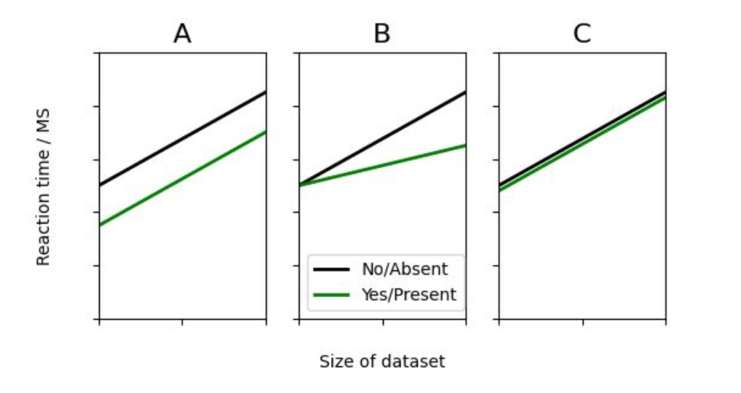
- Graph A
- Graph B
- Graph C

- Orient yourself with these graphs and then answer the following question: Select the graph that represents a serial exhaustive search.
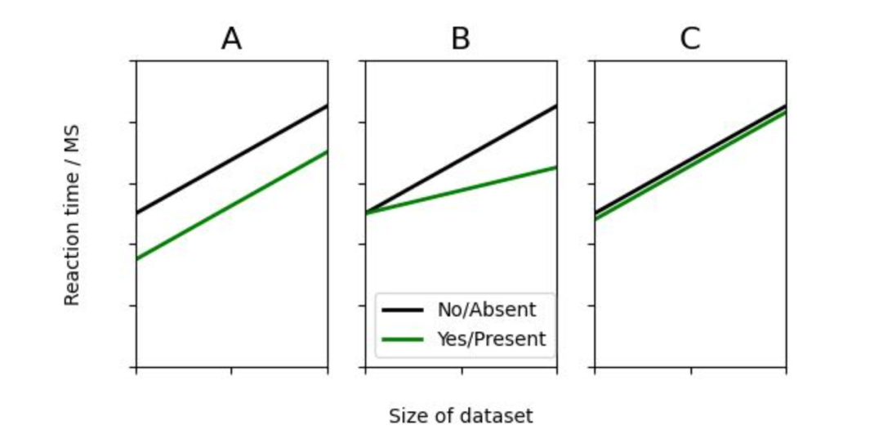
- Graph A
- Graph B
- Graph C

- Orient yourself with this graph and then answer the question below: Why are the y-axis intercepts different on this graph?
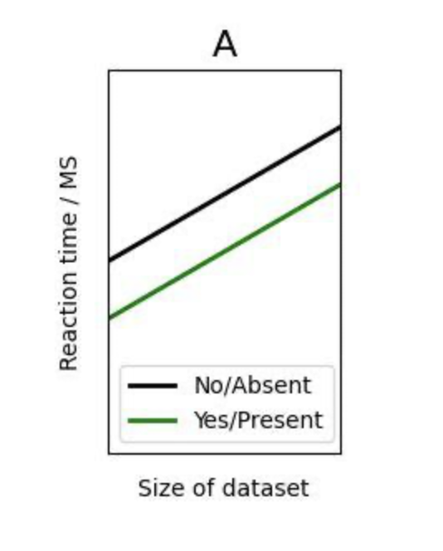
  - In direct comparison, both masked and unmasked probes are encoded simultaneously but with varying quality. During complete processing, a masked probe is unmasked first during encoding, resulting in a later start time.
  - In direct comparison, masked probes are encoded later compared to unmasked probes, while encoding during complete processing is identical for both masked and unmasked probes.
  - In direct comparison, unmasked probes are encoded earlier than masked probes, with the start time during complete processing being identical for both masked and unmasked probes.
  - In direct comparison, masked probes are always encoded earlier than unmasked probes, while there is no difference in encoding during complete processing.

- Orient yourself with this graph and then answer the question below: Why is the slope different for masked versus unmasked probes in direct comparison?
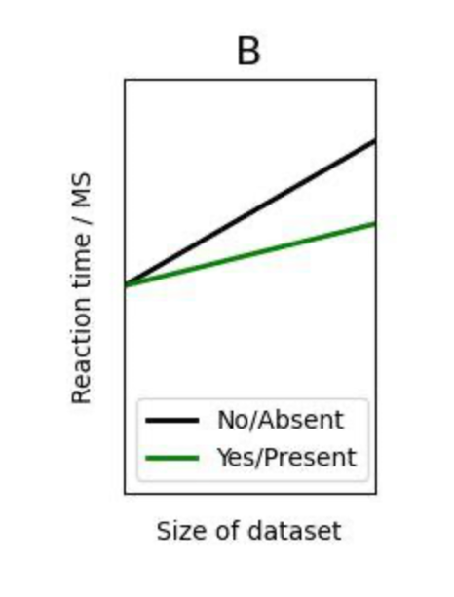
  - Masked probes resemble the memory set less closely compared to unmasked probes, making the comparison more time-consuming.
  - The slope for masked and unmasked probes differs because both types of letters have a consistent recognition speed regardless of context.
  - Masked probes are harder to recognize, making encoding more time-consuming.
  - Masked probes resemble the memory set more closely compared to unmasked probes, resulting in a steeper slope for the masked probes.

- Orient yourself with this graph and then answer the question below: What type of search does the graph represent?
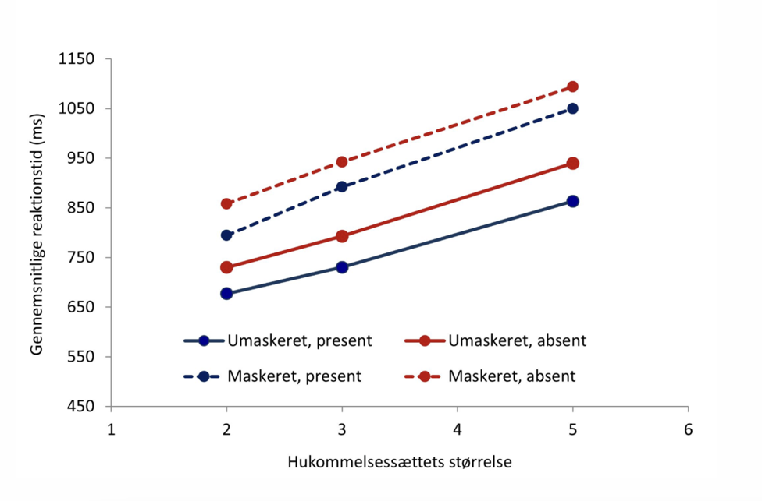
  - Serial self-terminating search with complete processing
  - Serial self-terminating search with direct comparison
  - Serial exhaustive search with complete processing
  - Serial exhaustive search with direct comparison

Follow-up

Welcome to this follow-up questionnaire! In the following questionnaire, we will ask you to complete, among other things, a knowledge test with 14 questions based on what you have learned about the Sternberg experiment in cognitive psychology. Your responses are anonymous, and you can choose to withdraw from participating at any time by informing your instructor.
- Do you remember your ID number from the last time you were taught the Sternberg experiment? Your instructor may have asked you to take a picture of the number with your phone.
  - Yes
  - No, but I completed a questionnaire last time we were taught the experiment
  - No. I was NOT present the last time we were taught the experiment
- Yes; Please enter the ID you were given by your instructor a couple of weeks ago

AI Usage
- How often have you used ChatTutor since you gained access to the website?
  - Never
  - Rarely
  - Sometimes
  - Often
  - Very often

Satisfaction
- I find it satisfying to use ChatTutor
  - Strongly disagree
  - Disagree
  - Neither agree nor disagree
  - Agree
  - Strongly agree

- I find it rewarding to use ChatTutor
  - Strongly disagree
  - Disagree
  - Neither agree nor disagree
  - Agree
  - Strongly agree
- I find it pleasant to use ChatTutor
  - Strongly disagree
  - Disagree
  - Neither agree nor disagree
  - Agree
  - Strongly agree
Behavioral Intentions
- I intend to use ChatTutor again
  - Strongly disagree
  - Disagree
  - Neither agree nor disagree
  - Agree
  - Strongly agree
- In the future, I will use ChatTutor to support my learning processes
  - Strongly disagree
  - Disagree
  - Neither agree nor disagree
  - Agree
  - Strongly agree
- I would recommend ChatTutor to others
  - Strongly disagree
  - Disagree
  - Neither agree nor disagree
  - Agree
  - Strongly agree
Knowledge Test
- What type of search occurs when a probe is compared with the entire memory set simultaneously, and reaction time remains unchanged regardless of the size of the memory set?
- Serial search
- Parallel search
- Serial exhaustive search
- Serial self-terminating search

- What is the key difference between serial and parallel search?
- In a parallel search, a probe is compared with the memory set one item at a time, while in a serial search, all items are checked simultaneously
- In a parallel search, a probe is compared with all items simultaneously, while in a serial search, one item is compared at a time
- In a parallel search, the probe is compared with all items in the memory set until the last item is fully processed, while in a serial search, the search can stop once the probe is found
- In a parallel search, a probe is compared with all items in the memory set until the probe is found, while in a serial search, all items in the memory set are always compared.

- What type of search occurs if reaction time for both present and absent probes increase linearly with the size of the memory set?
- Serial exhaustive search
- Parallel terminating search
- Serial self-terminating search
- Parallel exhaustive search

- What type of search occurs if reaction time increases twice as much when the probe is absent compared to when it is present?
- Serial exhaustive search
- Parallel terminating search
- Serial self-terminating search
- Parallel exhaustive search
- Orient yourself with these graphs and then answer the question below: Select the graph that represents a serial self-terminating search
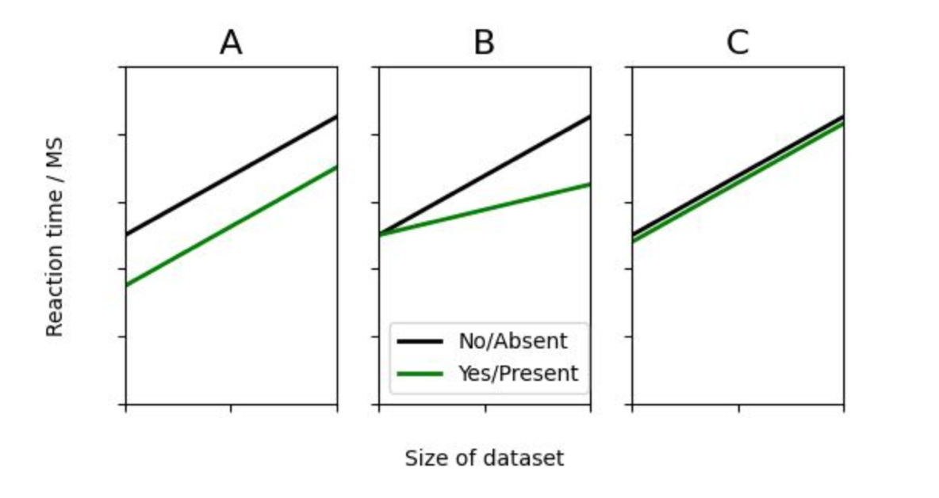
  - Graph A
  - Graph B
  - Graph C

- Orient yourself to these graphs and then answer the question below: Select the graph that represents a serial exhaustive search. 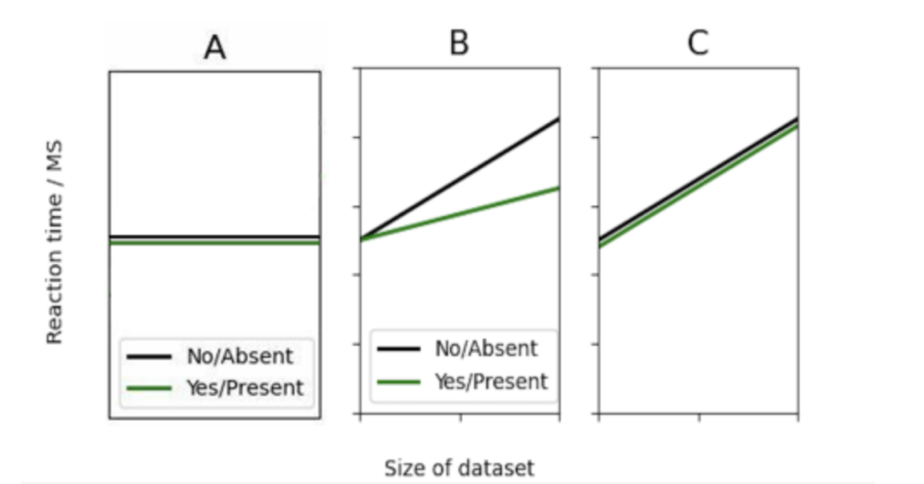
  - Graph A
  - Graph B
  - Graph C

- Orient yourself with this graph and then answer the question below: Why are the y-axis intercepts different on this graph?
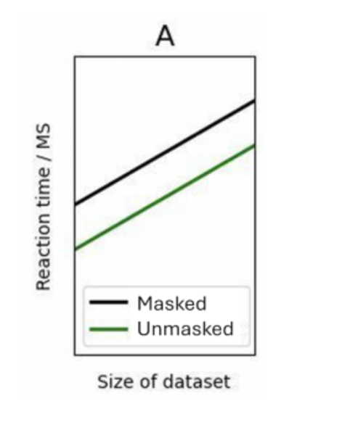

  - In direct comparison, both masked and unmasked probes are encoded simultaneously but with varying quality. During complete processing, a masked probe is unmasked first during encoding, resulting in a later start time.
  - In direct comparison, masked probes are encoded later compared to unmasked probes, while encoding during complete processing is identical for both masked and unmasked probes.
  - In direct comparison, unmasked probes are encoded earlier than masked probes, with the start time during complete processing being identical for both masked and unmasked probes.
  - In direct comparison, masked probes are always encoded earlier than unmasked probes, while there is no difference in encoding during complete processing.

- Orient yourself with this graph and then answer the question below: What type of serial search does the graph represent?
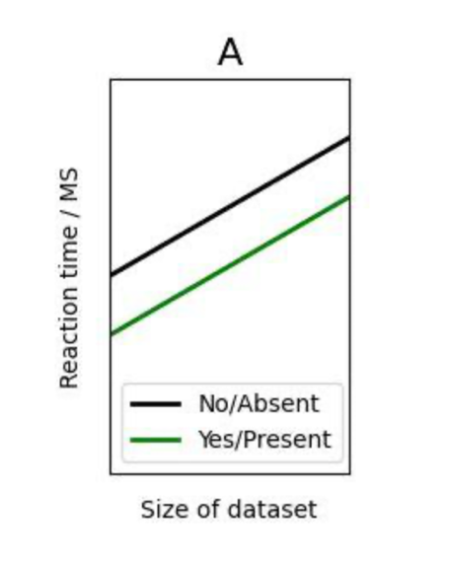

  - The graph represents a serial exhaustive search, as the increase is the same regardless of whether the test letter was included in the memory set or not.
  - The graph represents a serial self-terminating search, as the reaction times are lower when the test letter was part of the memory set compared to when it was not.
  - The graph represents a serial self-terminating search, as the increase is the same regardless of whether the test letter was included in the memory set or not.
  - The graph represents a serial exhaustive search, as the reaction times are lower when the test letter was part of the memory set compared to when it was not.

- Orient yourself to this graph and then answer the following question: Why is the slope different for masked vs. unmasked probes different in a direct comparison?
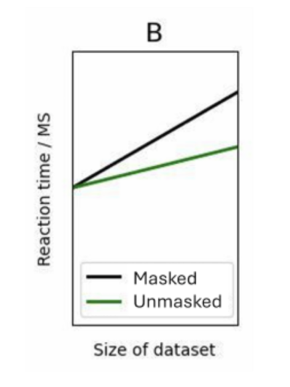
- Masked probes resemble the memory set less closely compared to unmasked probes, making the comparison more time-consuming.
- The slope for masked and unmasked probes differs because both types of letters have a consistent recognition speed regardless of context.
- Masked probes are harder to recognize, making encoding more time-consuming.
- Masked probes resemble the memory set more closely compared to unmasked probes, resulting in a steeper slope for the masked probes.

- Orient yourself to this graph and then answer the following question: How can the difference in slope between test letters that are part of the memory set and those that are not be explained in a serial self-terminating search?
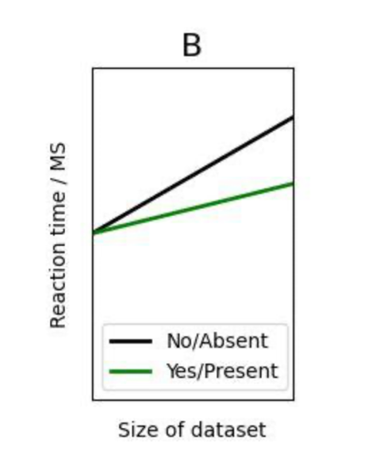
  - The comparison is more efficient when using a serial self-terminating search and the test letter is part of the memory set.
  - In a serial self-terminating search, fewer comparisons are always made when the test letter is part of the memory set.
  - In a serial self-terminating search, there is a probability of finding the correct answer before all comparisons are completed when the test letter is part of the memory set.
  - In serial self-terminating search, the participant is more likely to answer "yes," resulting in shorter response times if the answer is correct.

- Orient yourself with this graph and then answer the question below: What type of search does the graph represent?
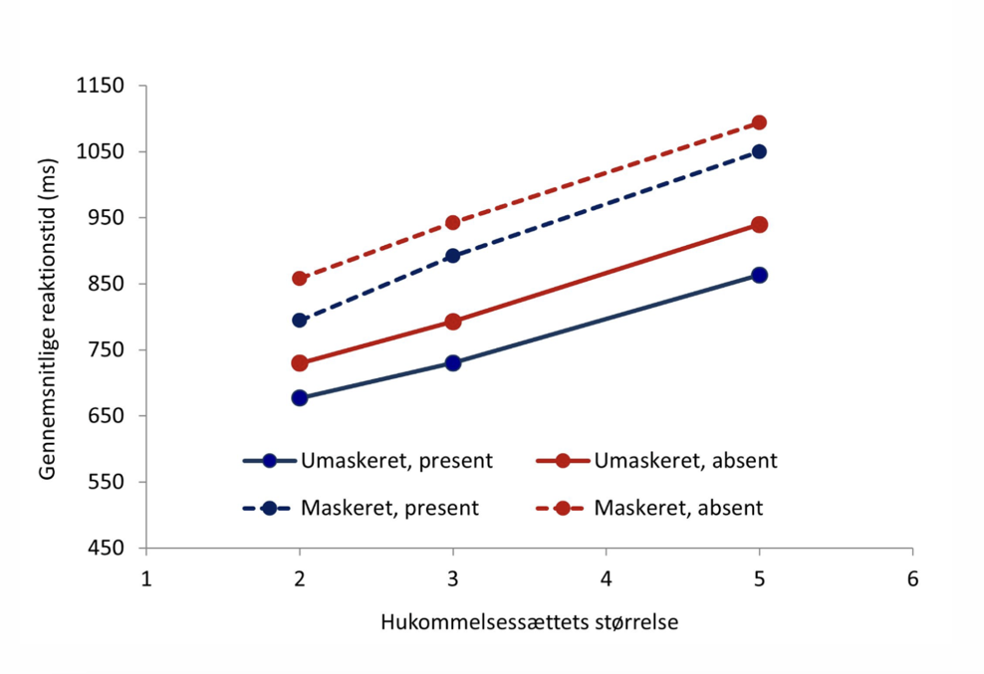
  - Serial self-terminating search with complete processing
  - Serial self-terminating search with direct comparison
  - Serial exhaustive search with complete processing
  - Serial exhaustive search with direct comparison

- Orient yourself with this graph and then answer the question below: What type of search does the graph represent?
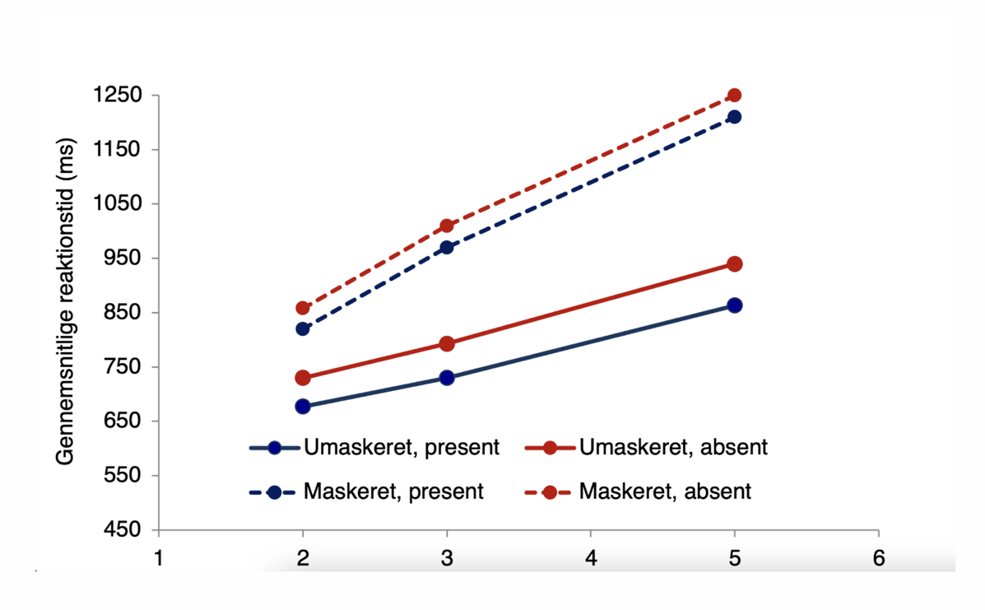
  - Serial self-terminating search with complete processing
  - Serial self-terminating search with direct comparison
  - Serial exhaustive search with complete processing
  - Serial exhaustive search with direct comparison

- Orient yourself with this graph and then answer the question below: What type of search does the graph represent?
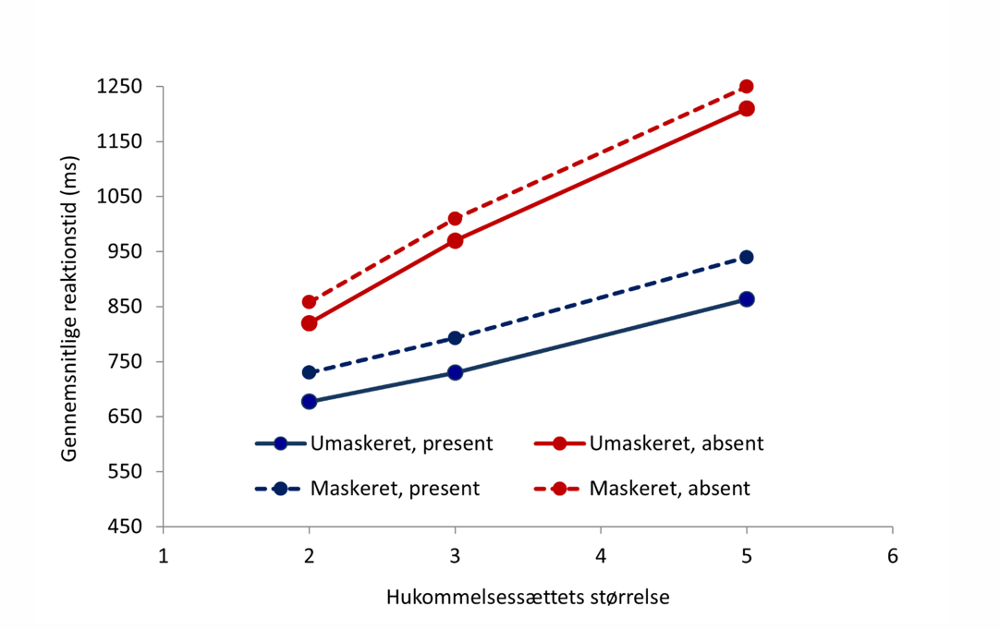
  - Serial self-terminating search with complete processing
  - Serial self-terminating search with direct comparison
  - Serial exhaustive search with complete processing
  - Serial exhaustive search with direct comparison

- Orient yourself with this graph and then answer the question below: What type of search does the graph represent?
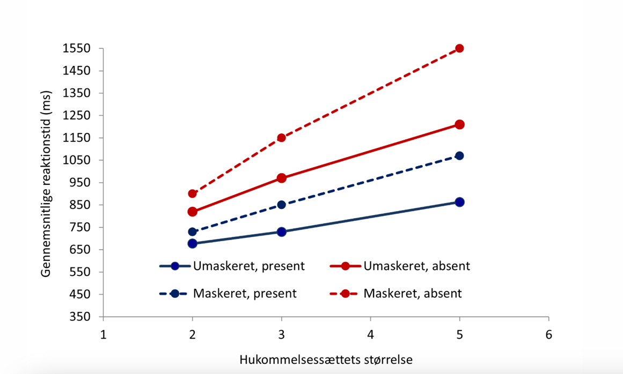
  - Serial self-terminating search with complete processing
  - Serial self-terminating search with direct comparison
  - Serial exhaustive search with complete processing
  - Serial exhaustive search with direct comparison

