Supplementary Information

Structure of the far-red light utilizing photosystem I of Acaryochloris

Tasuku Hamaguchi, Keisuke Kawakami, Kyoko Shinzawa-Itoh, Natsuko Inoue-Kashino, Shigeru Itoh, Kentaro Ifuku, Eiki Yamashita, Kou Maeda, Koji Yonekura and Yasuhiro Kashino

Correspondence to: kawakami.k@spring8.or.jp, yone@spring8.or.jp, and kashino@sci.u-hyogo.ac.jp

This file includes:

Supplementary Figures 1–22
Supplementary Tables 1–7

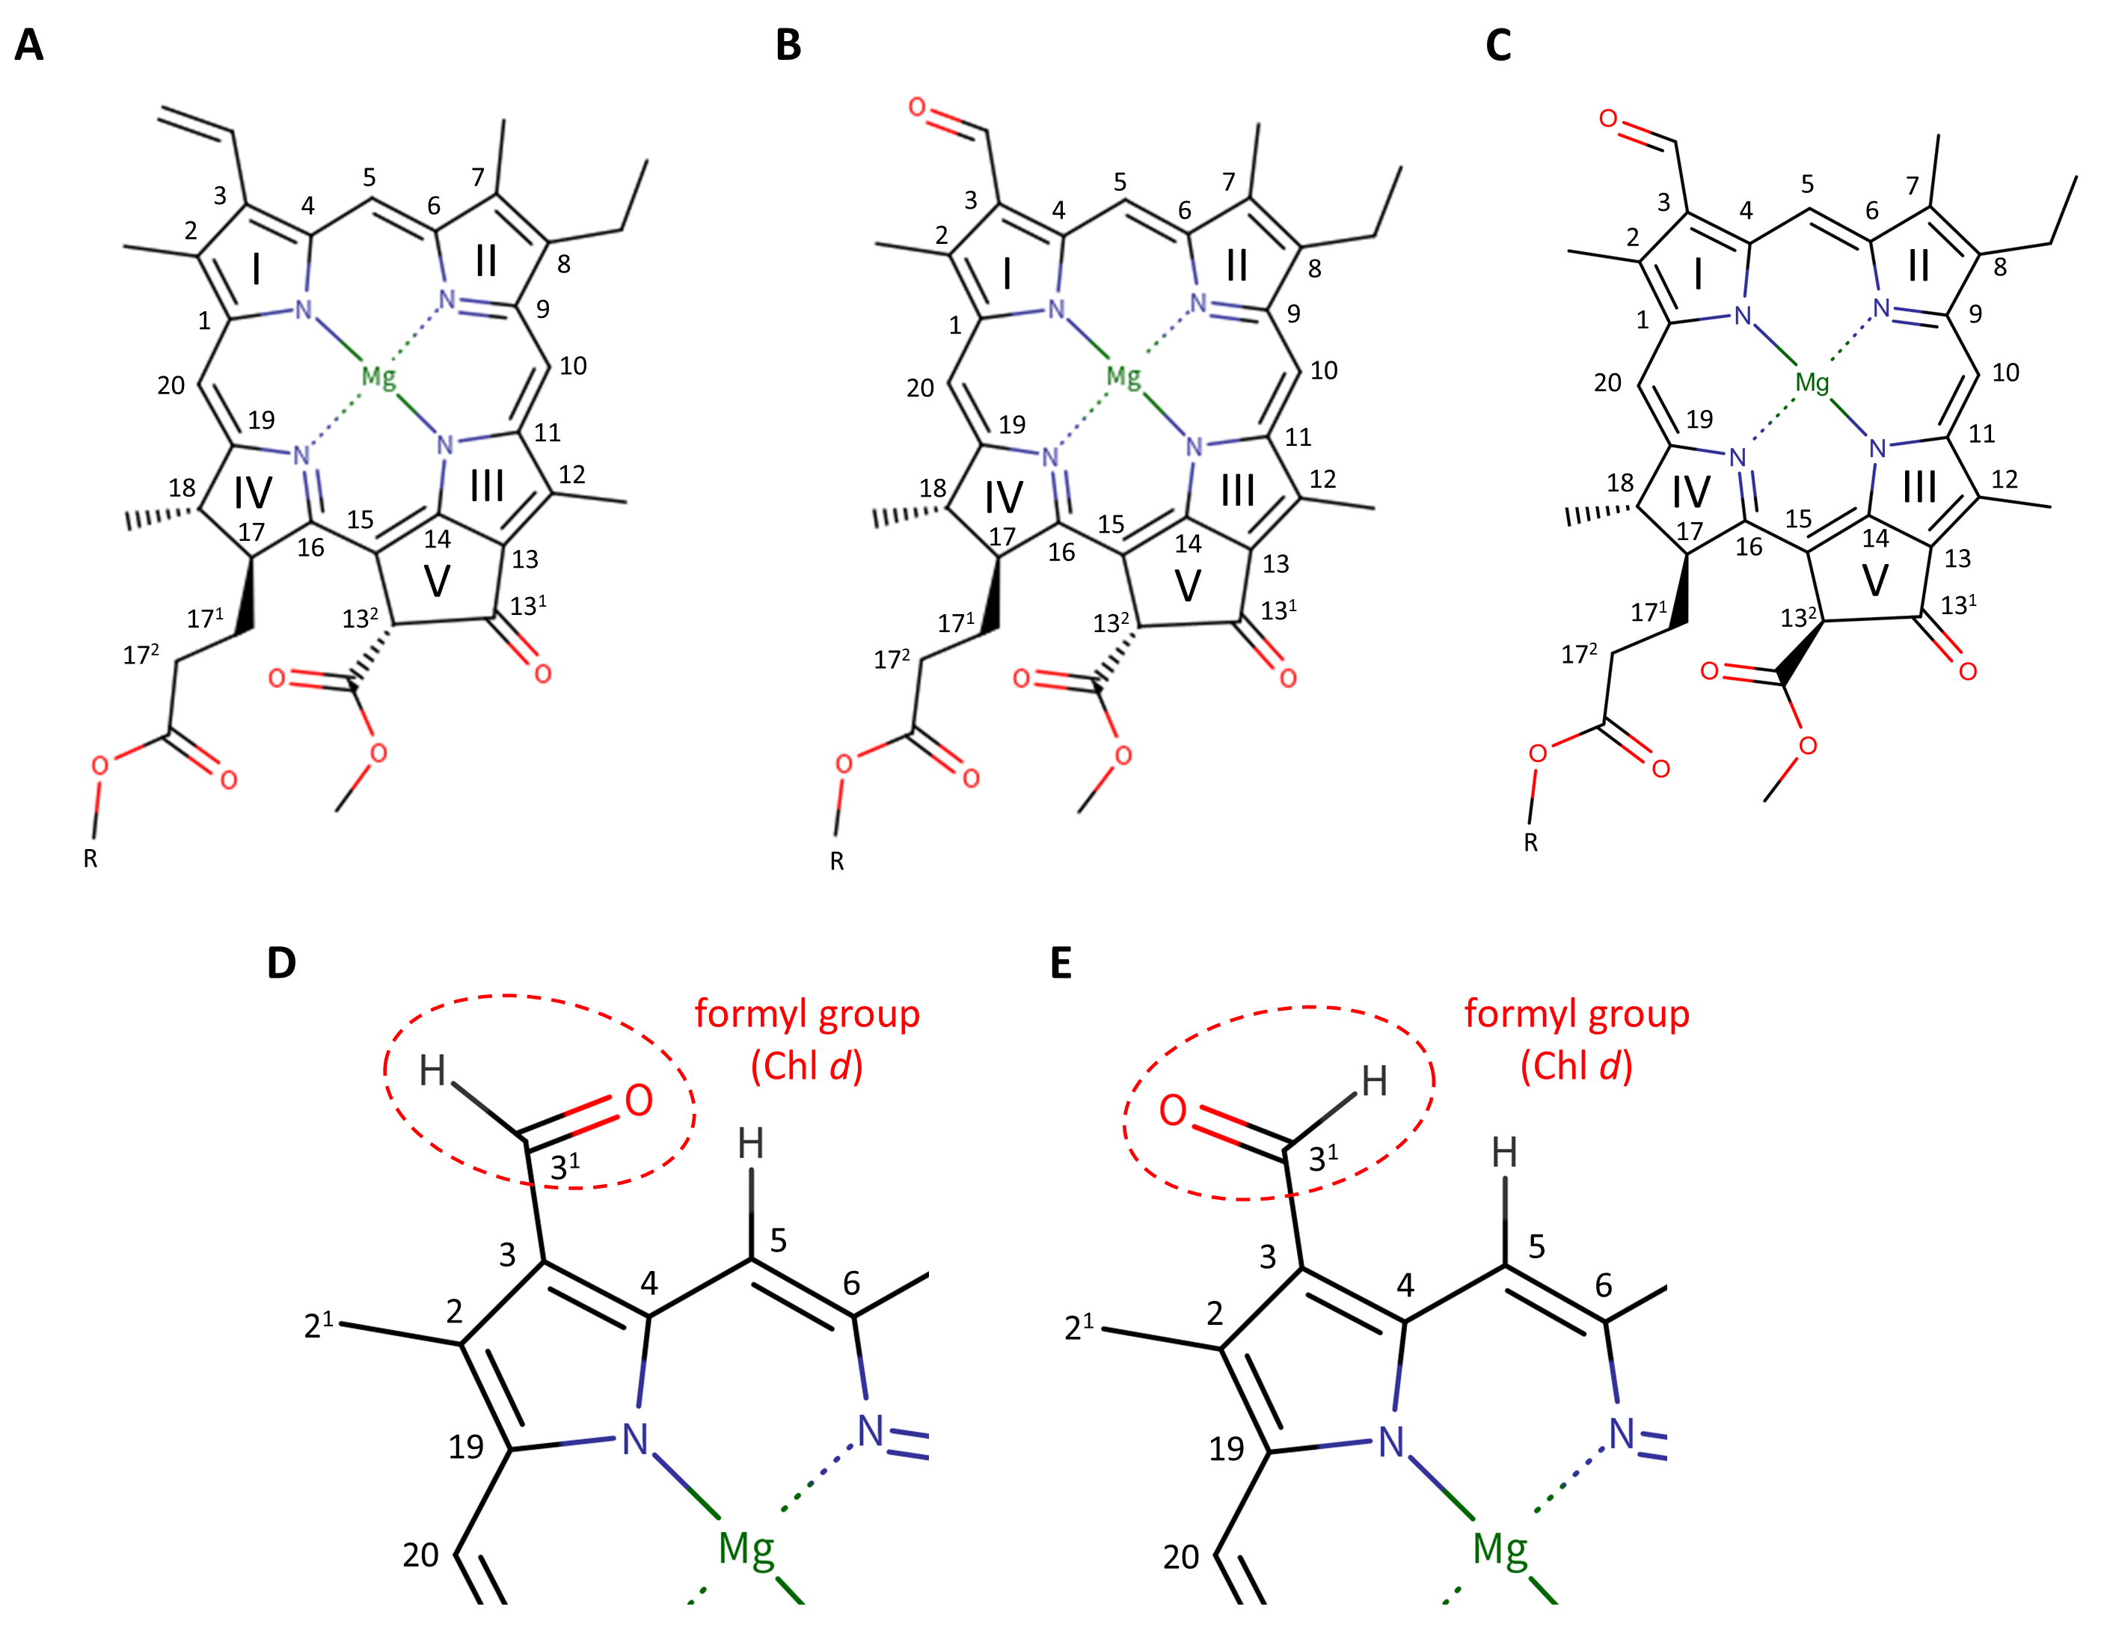
Supplementary Fig. 1: Molecular structures and carbon numbering of Chl a and Chl d according to the IUPAC numbering system (R = phytol chain).
Structure of Chl a (A), Chl d (B), and Chl d’ (C). Possible orientations of the formyl group in Chl d; (D) the carbonyl O atom is oriented toward the C5 H atom; (E) the formyl group flipped along the C3−C3¹ axis compared with (D) according to Saito et al.⁵².

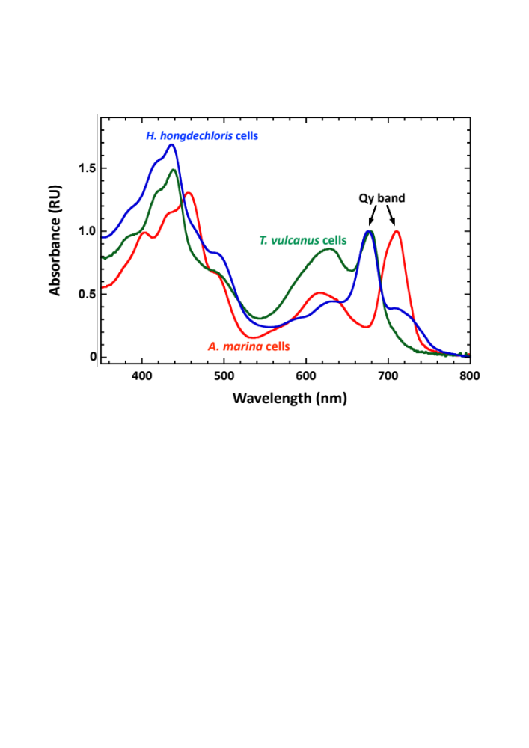

Supplementary Fig. 2: Comparison of cellular absorption spectra of three cyanobacteria.
Absorption spectra of A. marina (red line) and Thermosynechococcus vulcanus (green line) cells equivalent to 8.1 µg Chl d/mL and 5.0 µg Chl a/mL, respectively, were measured with an integrating sphere. Absorption spectrum of Chl f-carrying Halomicronema hongdechloris (blue line) cells grown in far red light, which is a courtesy of Prof. Tatsuya Tomo, is also presented. Spectra were normalized by the peak height of the Qy band with offset at 800 nm.

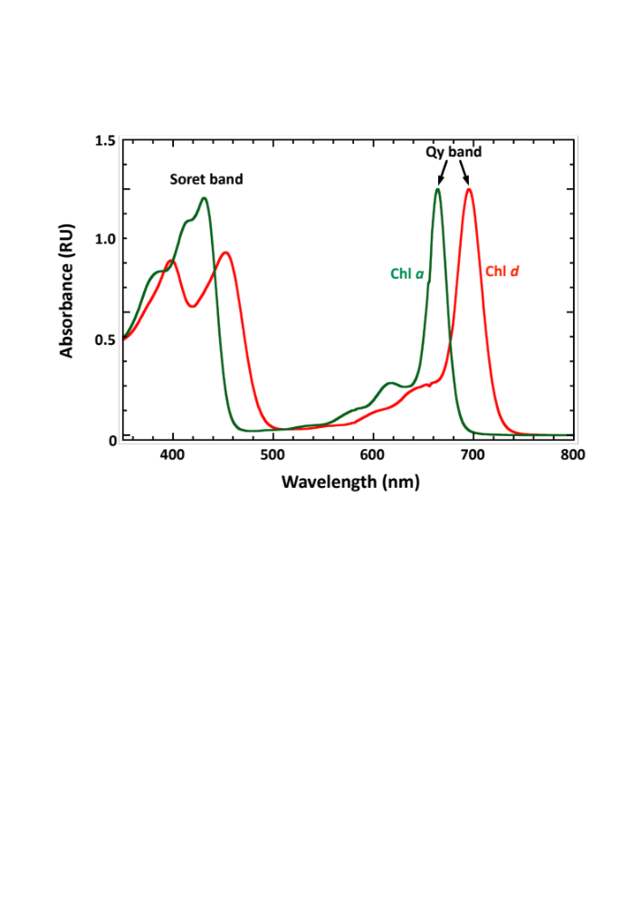

Supplementary Fig. 3: Absorption spectra of two chlorophylls.
Absorption spectrum of Chl a (green line) and d (red line) measured during HPLC analysis shown in Supplementary Fig. 16. Spectra were normalized by the peak height of the Qy band. Background noise derived from the bright line spectrum at 656.1 nm from a deuterium light source is not removed.

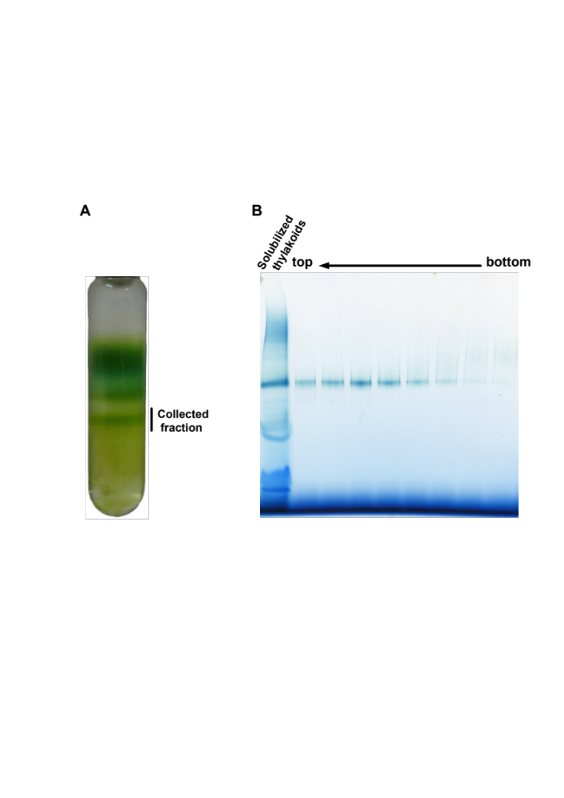

Supplementary Fig. 4: Separation of solubilized membrane protein complexes by sucrose density gradient ultracentrifugation and BN-PAGE profile of the fractions containing A. marina PSI trimer.
(A) Thylakoids solubilized by 1.0% UDM were fractionated by stepwise sucrose density gradient ultracentrifugation. (B) The bottom green band corresponding to the sucrose concentrations of 1.05–1.0 M was collected as PSI trimer fraction. Every equivalent to 100 μL in the sample volumes was collected from the bottom upward, and the fractions corresponding to the bottom green band were applied to BN-PAGE.

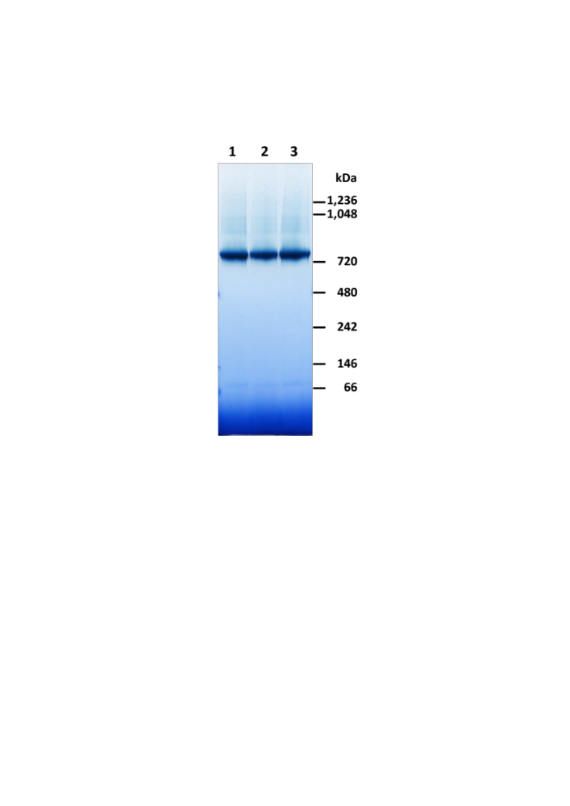

Supplementary Fig. 5. Stability of A. marina PSI.
Lane 1, PSI trimer stored at -80ºC after purification in the presence of 0.2% DM; lane 2, PSI trimer incubated at 0ºC under the dark for five days after purification in the presence of 0.2% DM; lane 3, PSI trimer incubated at 0ºC under the dark for five days after replacement of DM to 0.002% LMNG. PSI trimer equivalent to 3 µg Chl d were subjected to analysis by BN-PAGE. Positions of molecular size marker proteins are shown on the right.

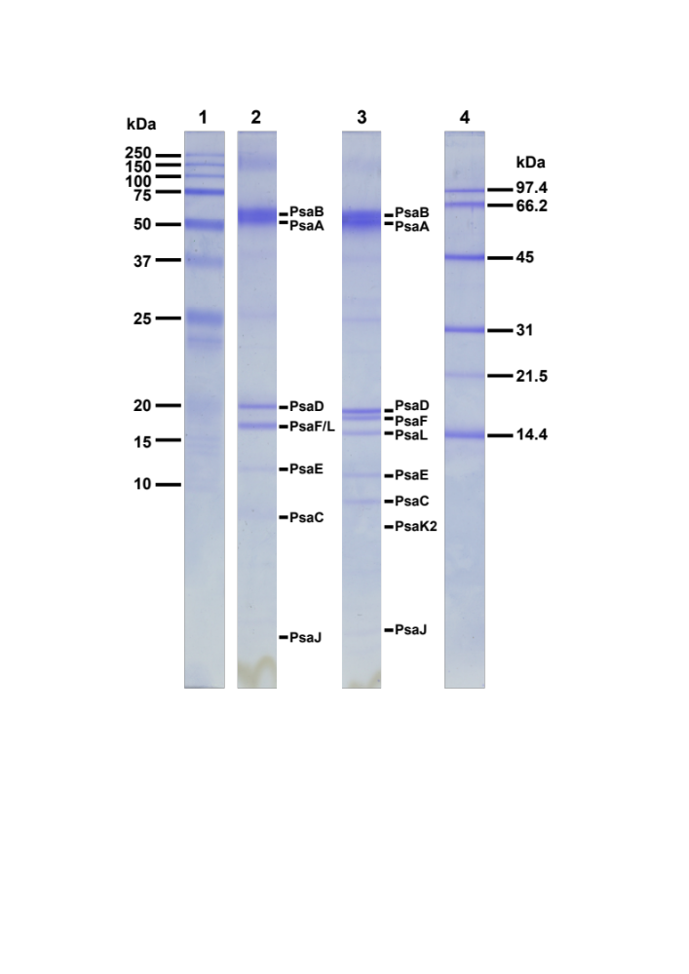

Supplementary Fig. 6: Polypeptide profile of purified PSI trimer on SDS-PAGE.
PSI trimer equivalent to 5 µg Chl d was subjected to SDS-PAGE analysis with (lane 2) or without (lane 3) dithiothreitol. Molecular size marker proteins are shown in lanes 1 and 4 [lane 1, Precision Plus Protein Standards (Bio-Rad, Hercules, CA), and lane 4, LMW Marker Kit (GE Healthcare, Chicago, IL)]. The lanes were cut-out from an identical gel with the same brightness. The polypeptide identities were determined by MS analysis after in-gel digestion by trypsin.

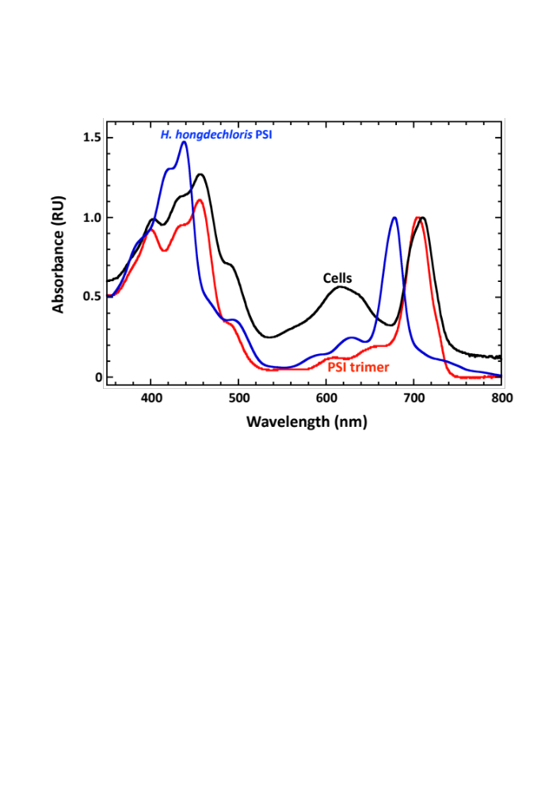

Supplementary Fig. 7: Absorption spectra of A. marina PSI trimer and cells.
Absorption spectrum of A. marina cells (black line) equivalent to 8.1 µg Chl d measured with an integrating sphere. Absorption spectrum of PSI trimer (red line) measured at 2.0 µg Chl d. Absorption spectrum of PSI isolated from cells of Chl f-carrying Halomicronema hongdechloris grown in far red light (blue line), which is a courtesy of Prof. Tatsuya Tomo, is also shown for reference. Spectra were normalized by the peak height of the Qy band.

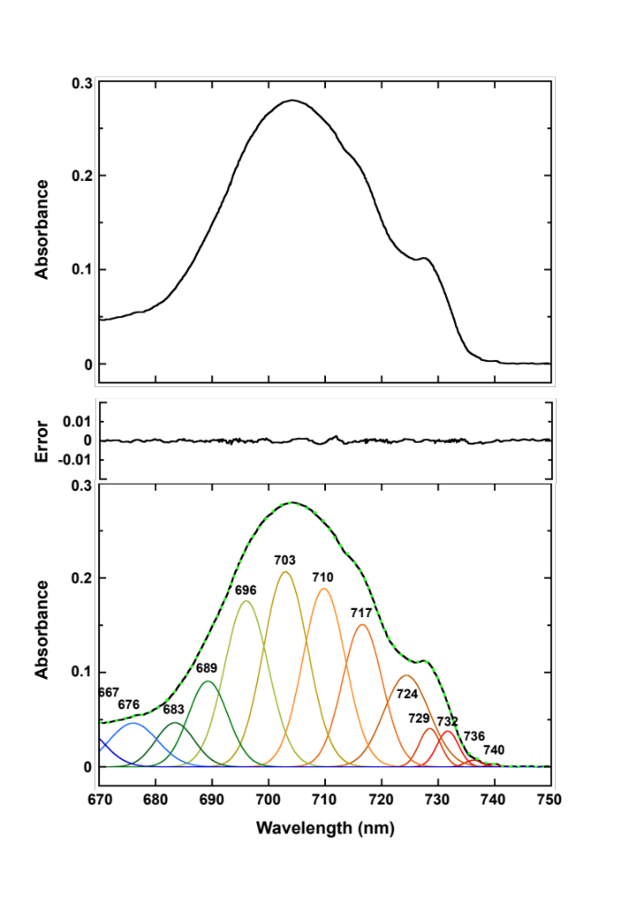

Supplementary Fig. 8: Absorption spectra of PSI trimer at 77K.
(Top) Absorption spectrum of A. marina cells equivalent to 10 µg Chl d measured using a special cuvette with a 2.0-mm light path. (Bottom) Curve fitting was performed using identical spectra converting wavelength to wavenumber using MagicPlot (ver. 2.9.3; https://magicplot.com) on MacOS.

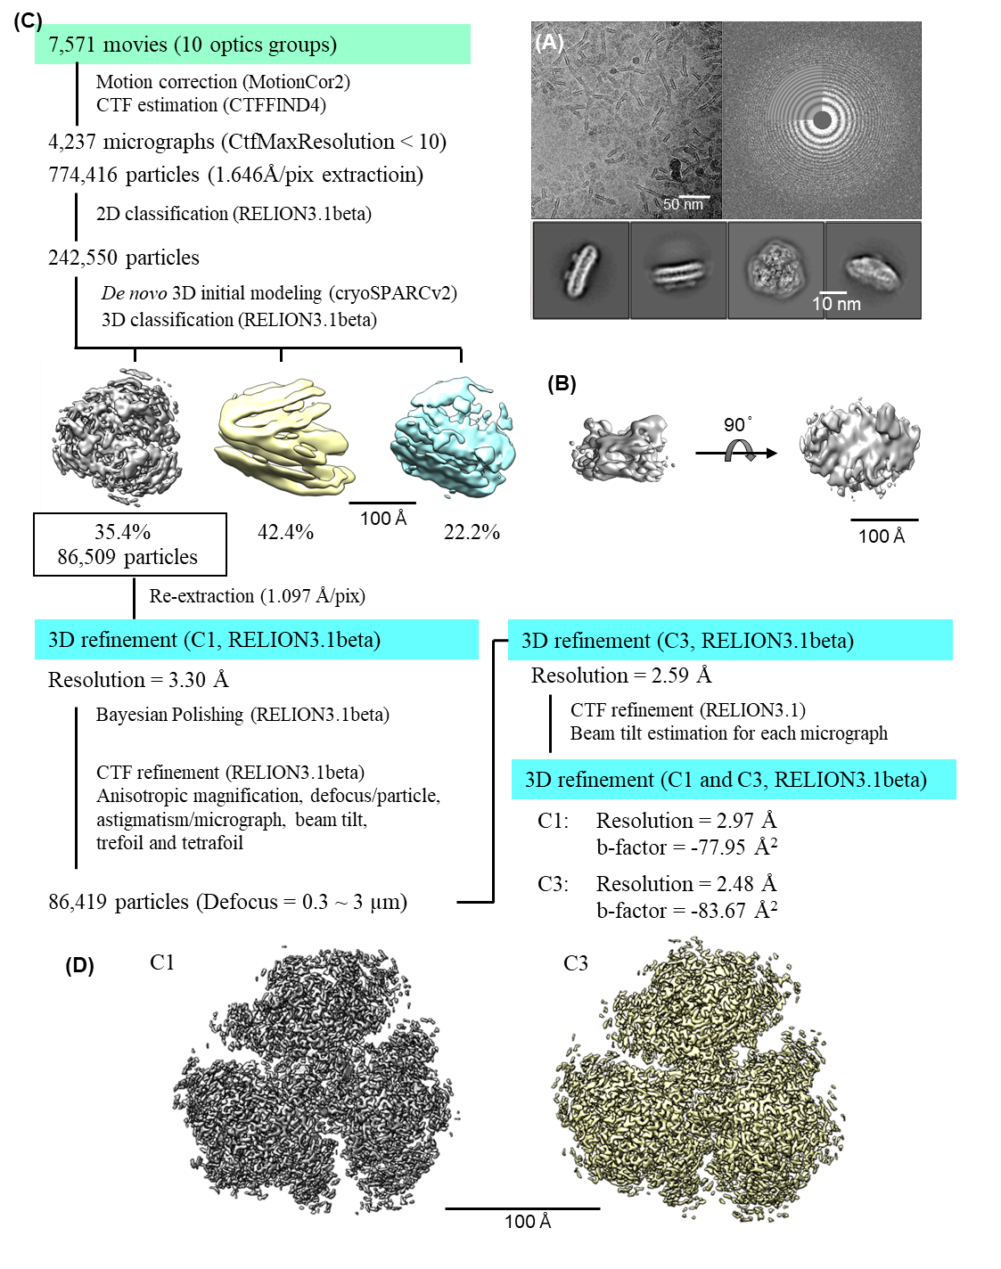

Supplementary Fig. 9: Data collection and image processing workflow of cryo-EM.
(A) Overview of the data processing workflow. (B) Representative micrograph after motion correction and class averaged images from PSI dataset. (C) Initial model of A. marina PSI produced using cryoSPARCv2. (D) Final map imposing symmetry of C1 and C3 reconstructed from 86,419 particles at 2.97 and 2.48 Å resolution, respectively. The resolutions were estimated based on the gold standard Fourier shell correlation (FSC) criteria, where the FSC between two independently reconstructed volumes drops to 0.143.

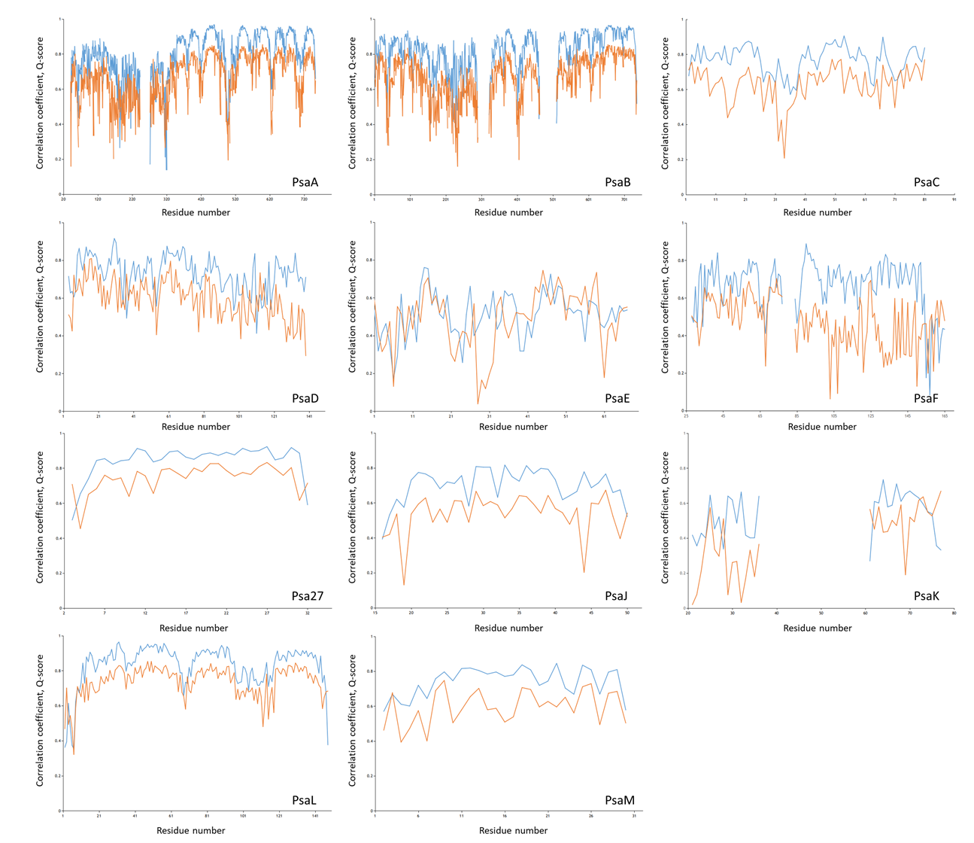

Supplementary Fig. 10: CC and Q-score values of each amino acid residue.
CC and Q-score are indicated by blue and orange lines, respectively. An area without the lines indicates that an amino acid residue was not assigned.

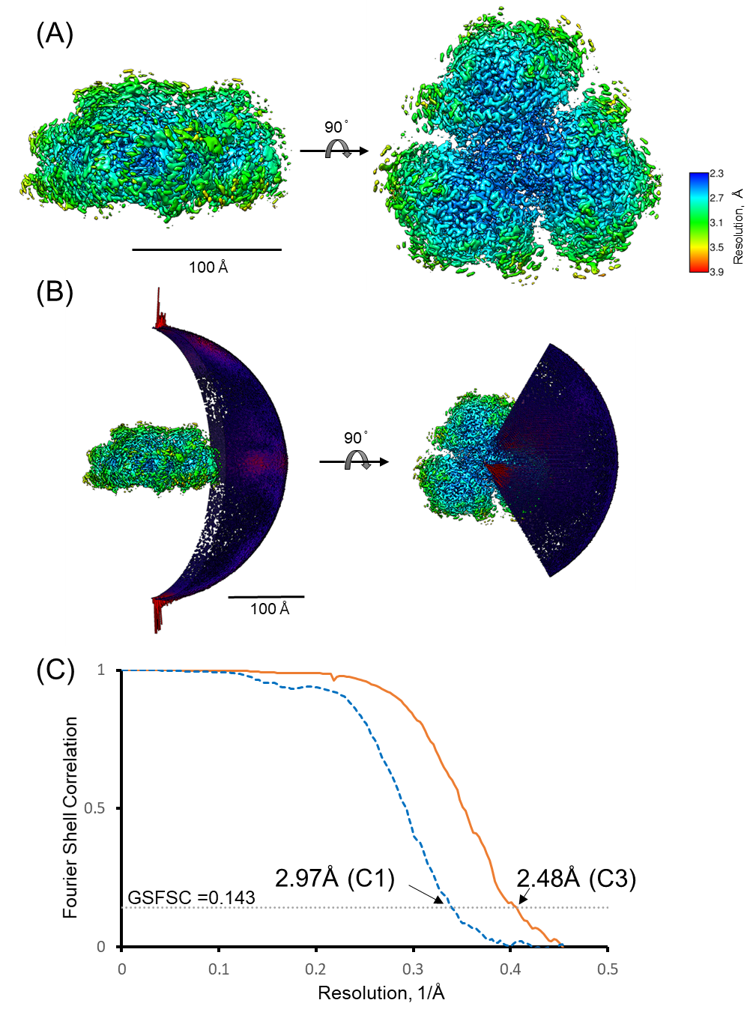

Supplementary Fig. 11: Final density map of A. marina PSI with C3 symmetry imposed.
(A) The cryo-EM density maps colored with estimated local resolution. (B) Euler angle distribution plot of all particles used for the final map. (C) Gold standard FSC curves between two half-maps independently refined in the reconstruction.

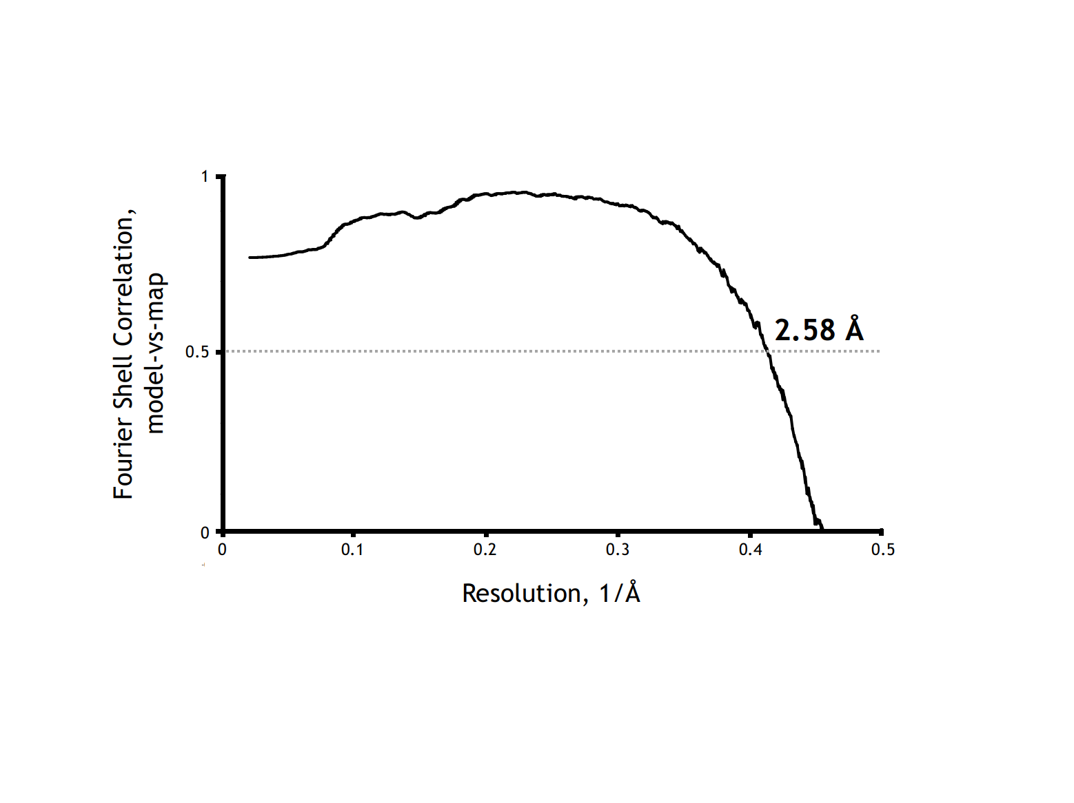

Supplementary Fig. 12: FSC curve calculated between the cryo-EM map and the refined structure model of A. marina PSI.

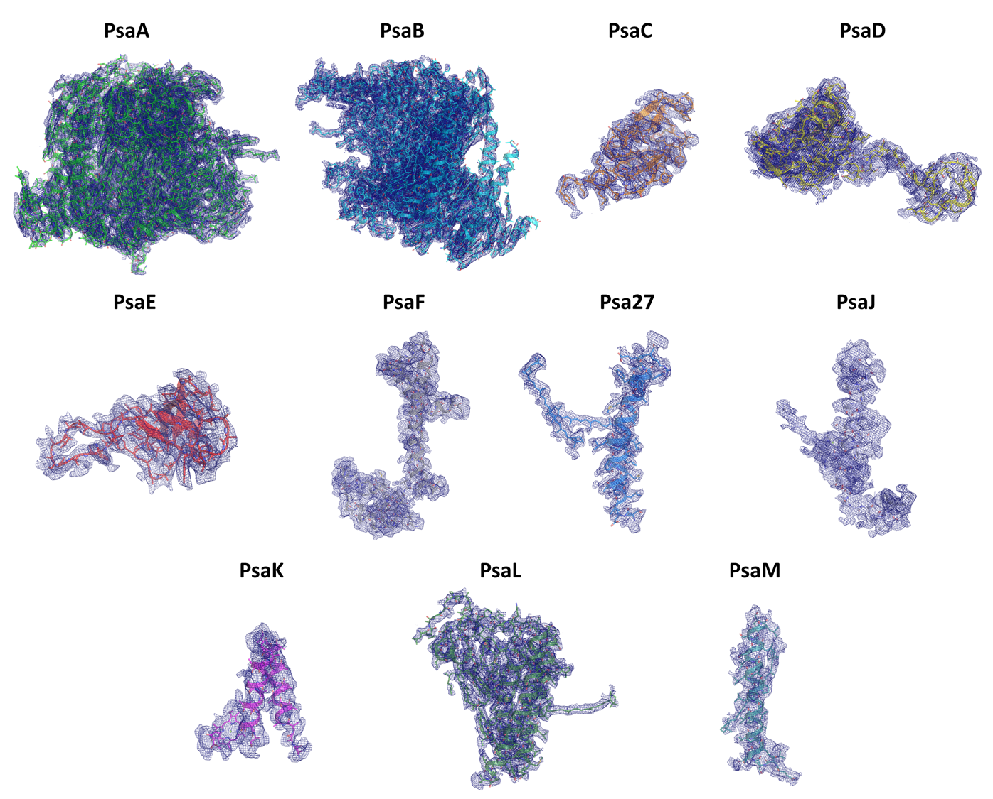

Supplementary Fig. 13: Cryo-EM density map of each protein subunit of A. marina PSI.
Each cryo-EM density map is shown in a mesh representation at 1.0 sigma contour level.

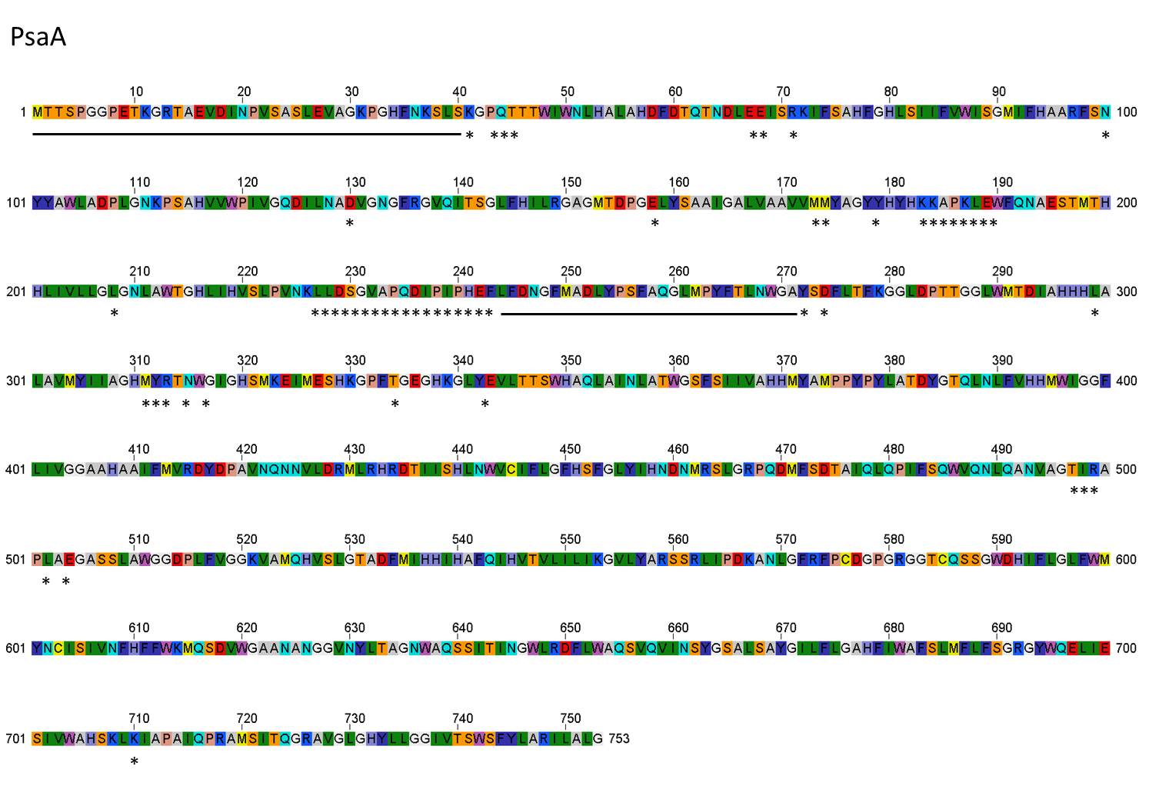
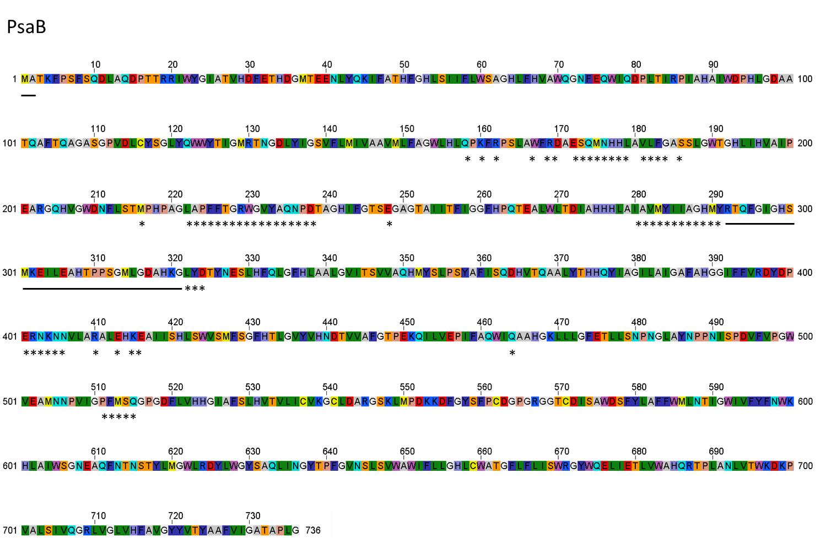
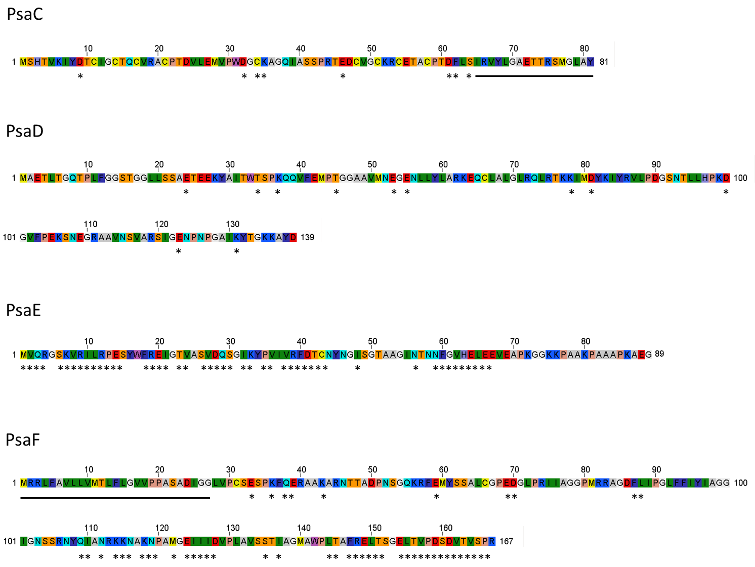
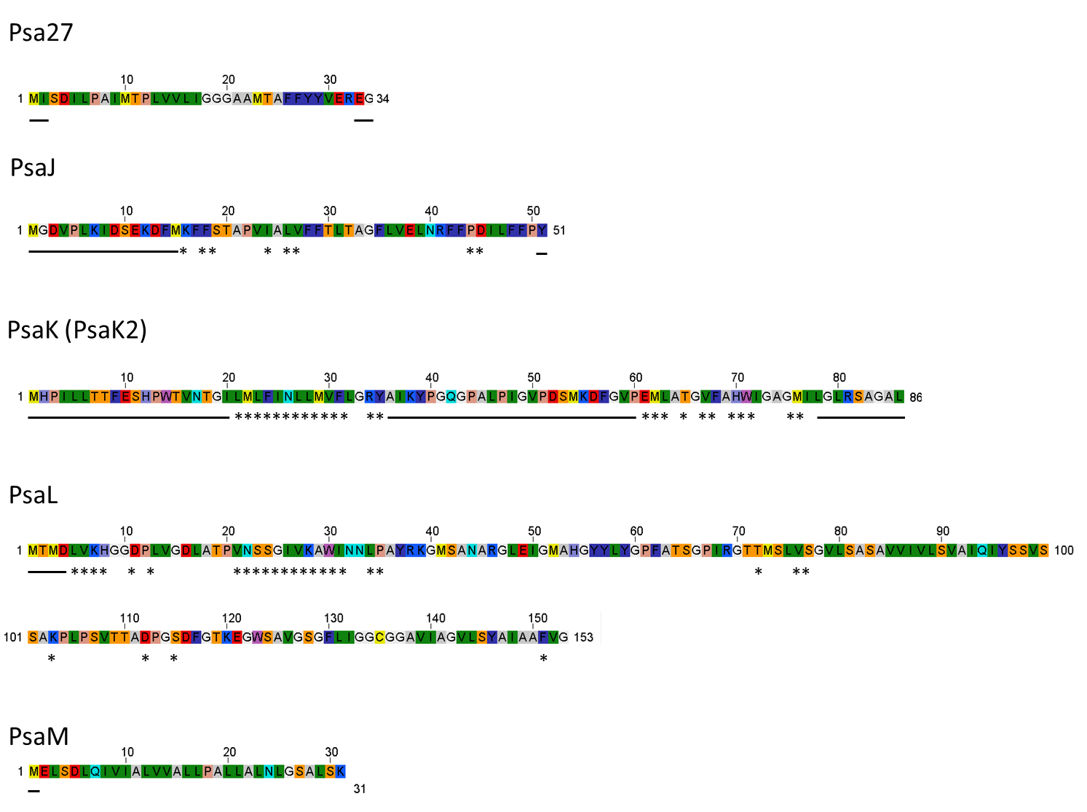

Supplementary Fig. 14: Assignment of the amino acid residues in each subunit.
“-” is a non-assigned amino acid residue and “*” is assigned as alanine because of low cryo-EM map quality.

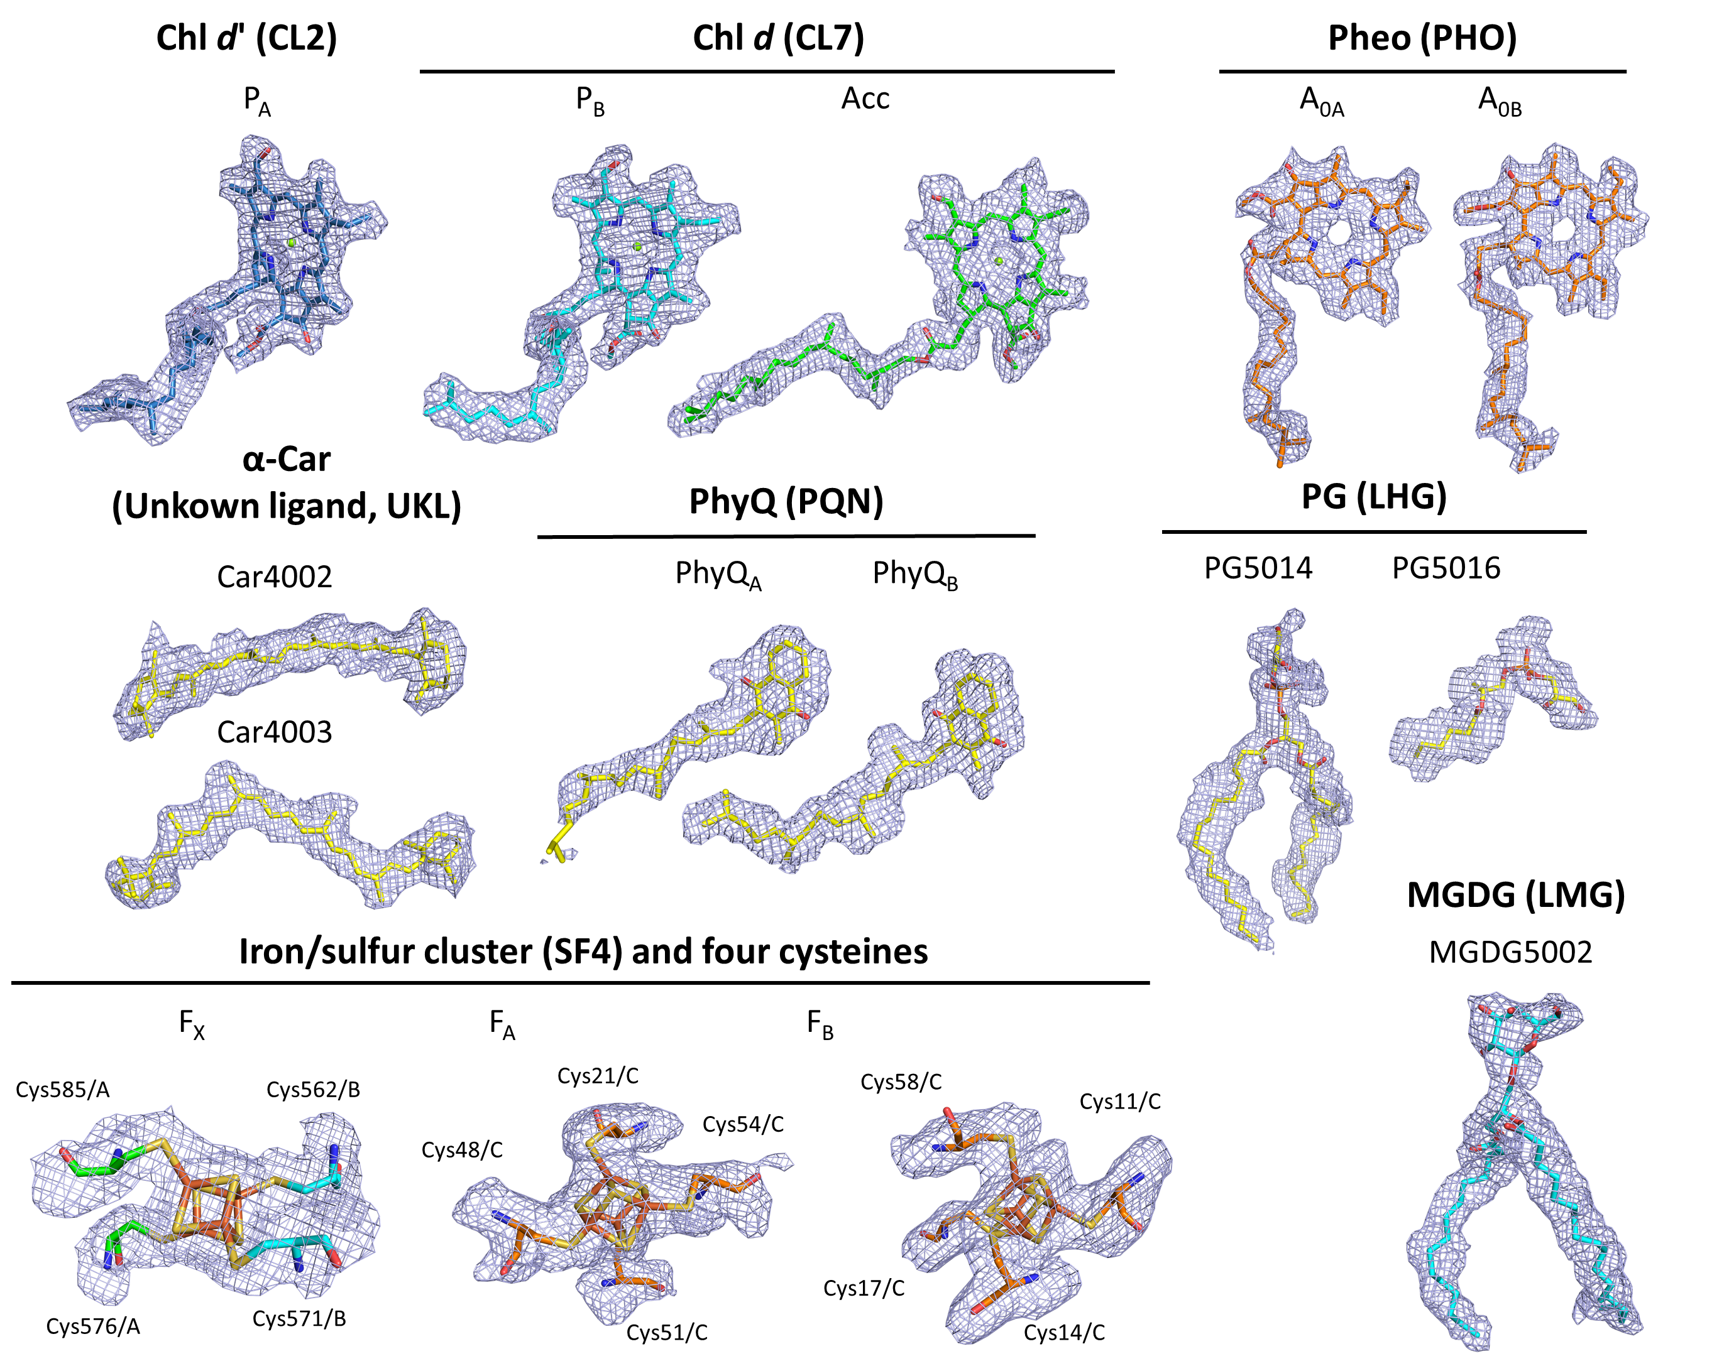

Supplementary Fig. 15: Cryo-EM density map for each cofactor.
Each cryo-EM density map is shown in a mesh representation at 1.0 sigma contour level. Each ligand ID is indicated in parentheses. The numbers for α-Car, PG, and MGDG indicate the respective residue numbers. Chlorophyll d, Chl d; chlorophyll d’, Chl d’; pheophythin, Pheo; α-carotene, α-Car; phosphatidylglycerol, PG; monogalactosyl diacylglycerol, MGDG.

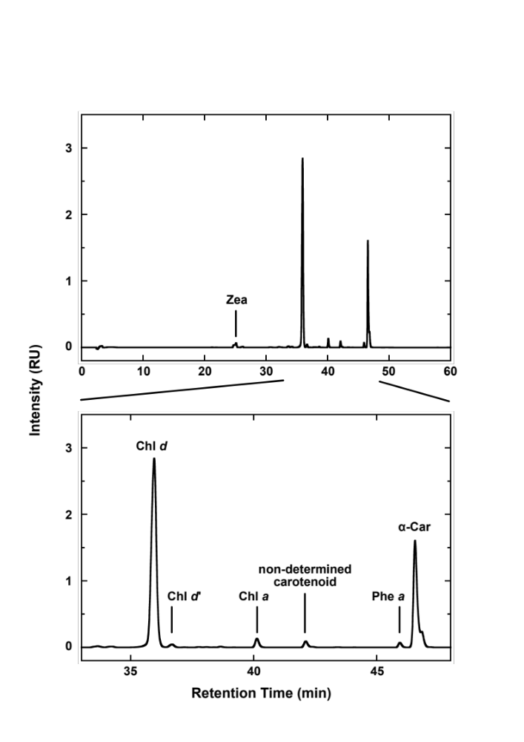

Supplementary Fig. 16: Typical HPLC chromatogram.
Pigments extracted from A. marina PSI trimer were applied to HPLC analysis to determine pigment composition. Chromatogram at 430 nm. α-Car, α-carotene; Chl, chlorophyll; Phe, pheophytin; Zea, zeaxanthin.

Supplementary Fig. 17: Arrangement of pigments in PSI.
(A) Superposition of pigments of A. marina PSI with those from T. elongatus (transparent grey). The lower figure is drawn as in Fig. 2C but rotated 90° counterclockwise. Pigments of A. marina are colored according to the amino acid residue that is their ligand: green, His; brown, probable water molecule; red, Asp; blue, Gln; magenta, Glu; cyan, phosphatidylglycerol. The black-dashed line shows a region where the arrangement of pigments differs from those in T. elongatus PSI because of different corresponding amino acids in subunits Psa27 (PsaI) and PsaL. The blue-dashed line shows a disordered region of A. marina PsaB. (B) (C) (D) Pigment–pigment interaction and the surrounding structures. Amino acid residues and pigments of T. elongatus are shown in transparent images. Solid lines show coordination bonds and dashed lines show Mg²⁺–Mg²⁺ distances between Chls.

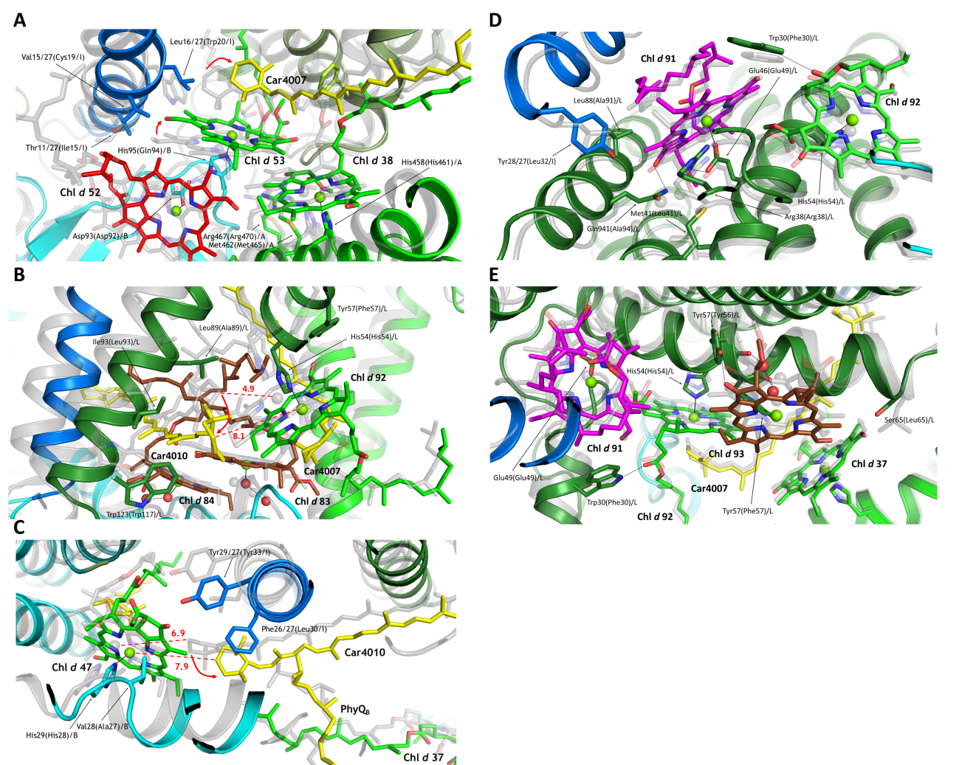

Supplementary Fig. 18: Detailed arrangement of some pigments in A. marina PSI that are different from those in T. elongatus PSI (within the black-dashed line in Fig. 17A).
Non-transparent, A. marina; transparent grey, T. elongatus. (A) Arrangement of Chl d 38, 52, and 53 and Car4007 and their surrounding environments. (B) and (C) Arrangement of Car4010. Distances between rings of Ca4010 and Mg²⁺ ions chelated in Chl d or a are shown in red. (D) and (E) Amino acid environments around Chl d 37, 91, 92 and 93 located near the center of the PSI trimer.

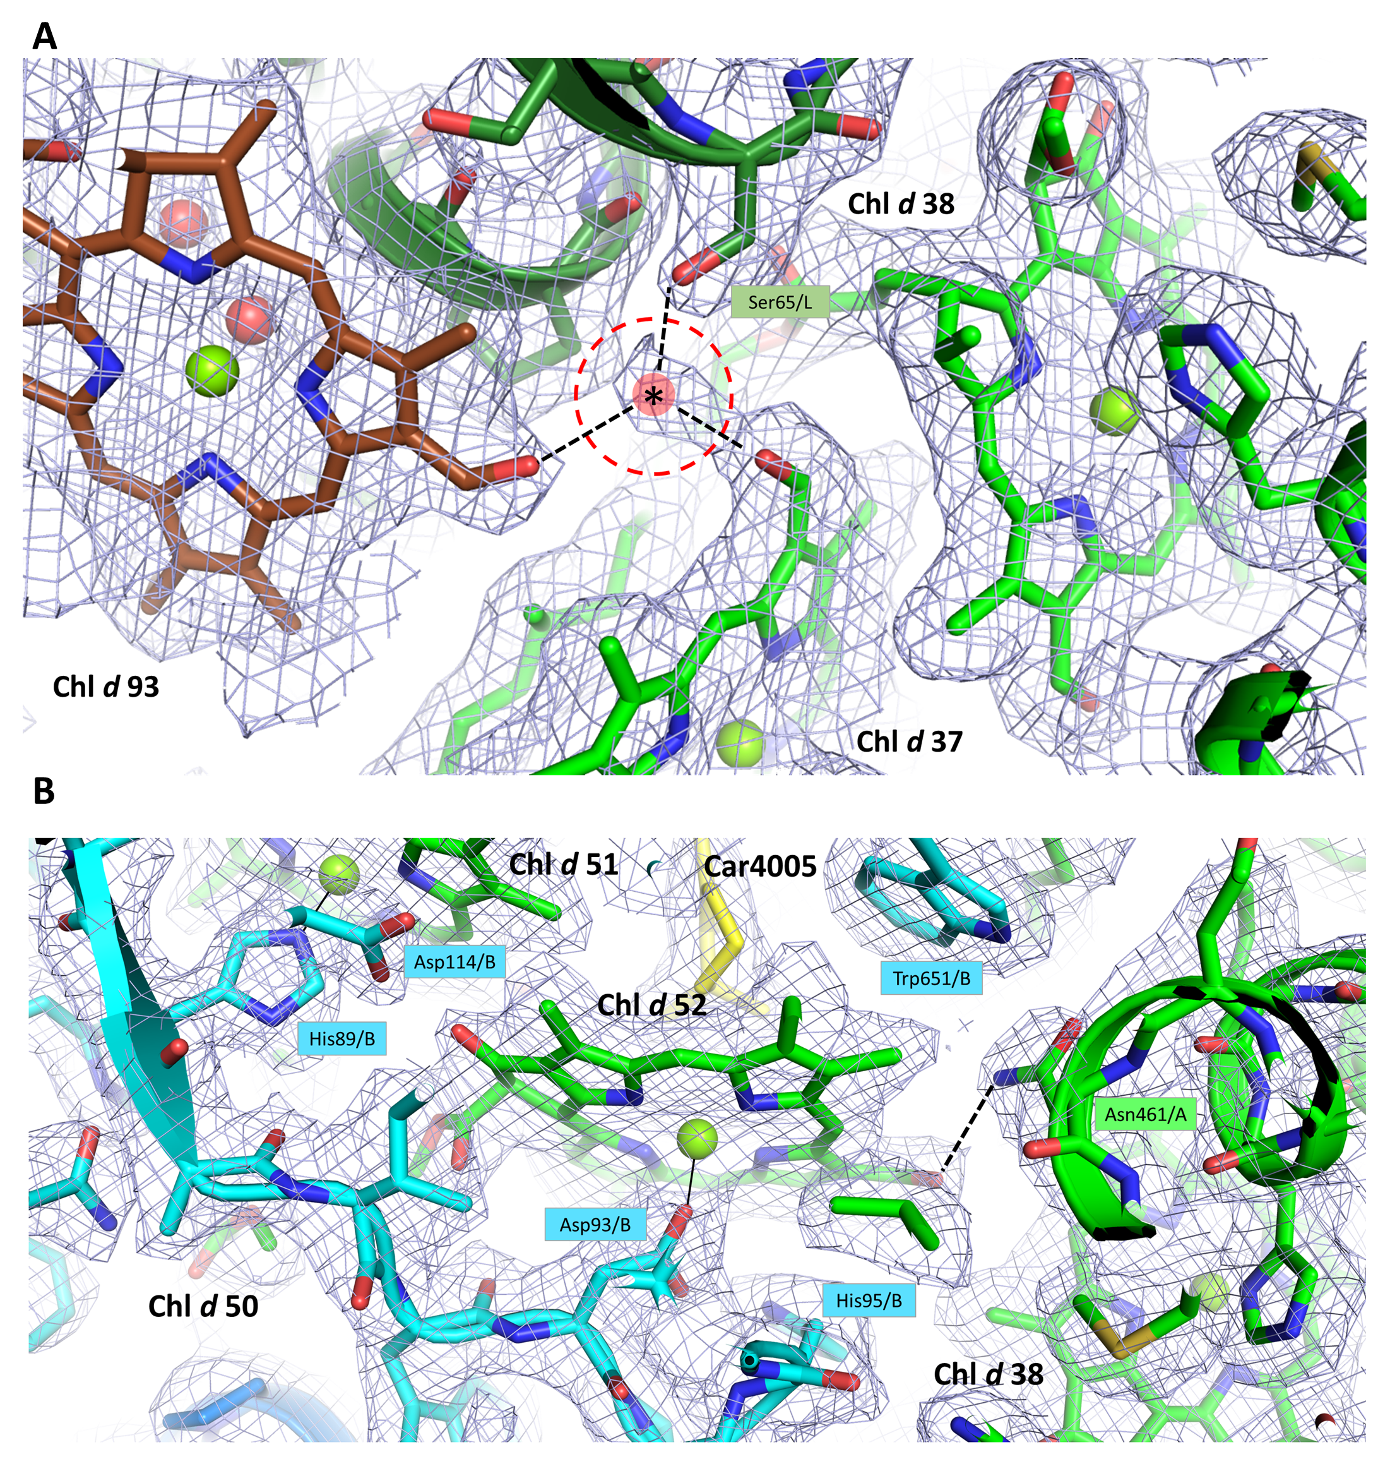
Supplementary Fig. 19: Representative examples of hydrogen bonds with the C3-formyl group of Chl d.
(A) Cryo-EM density map around Chls (Chl d 37, Chls d 38, and Chl d 93) of A. marina PSI shown in a mesh representation at 4.0 sigma contour level. One water molecule (asterisk) probably forms hydrogen bonds with neighboring Chls (Chl d 37 and Chl d 93) and Ser65/L. However, this water molecule was not assigned in the refined structure model because these were shorter than the typical hydrogen bond distance. (B) Cryo-EM density map around Chl d 52 of A. marina PSI shown in a mesh representation at 3.0 sigma contour level. The C3-formyl group of Chl d 52 forms hydrogen bond (dashed line) with Asn461/A.

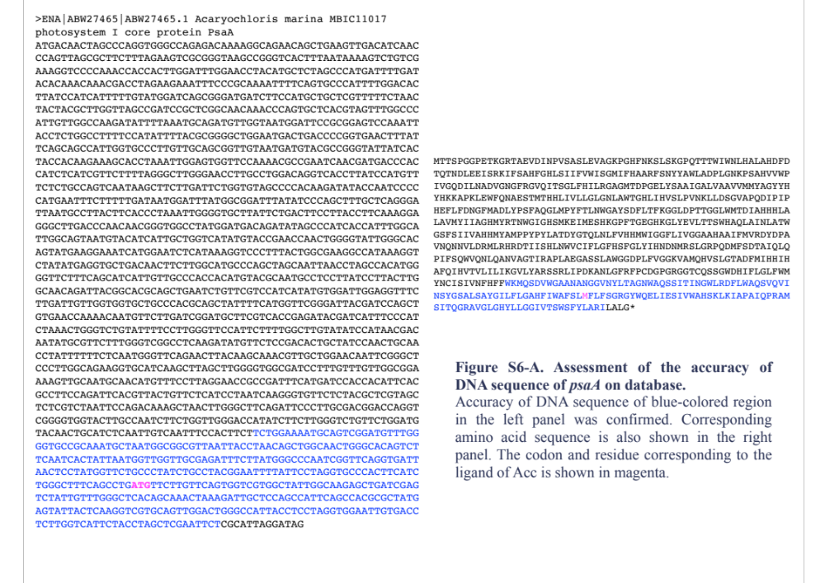
Supplementary Fig. 20-A: Assessment of the accuracy of DNA sequence of psaA in the database.
The accuracy of the DNA sequence (accession number ABW27465.1) of the blue-colored region in the upper panel was confirmed. The corresponding amino acid sequence is shown in the lower panel. The codon and residue corresponding to the ligand of Acc in A. marina PSI are shown in magenta.

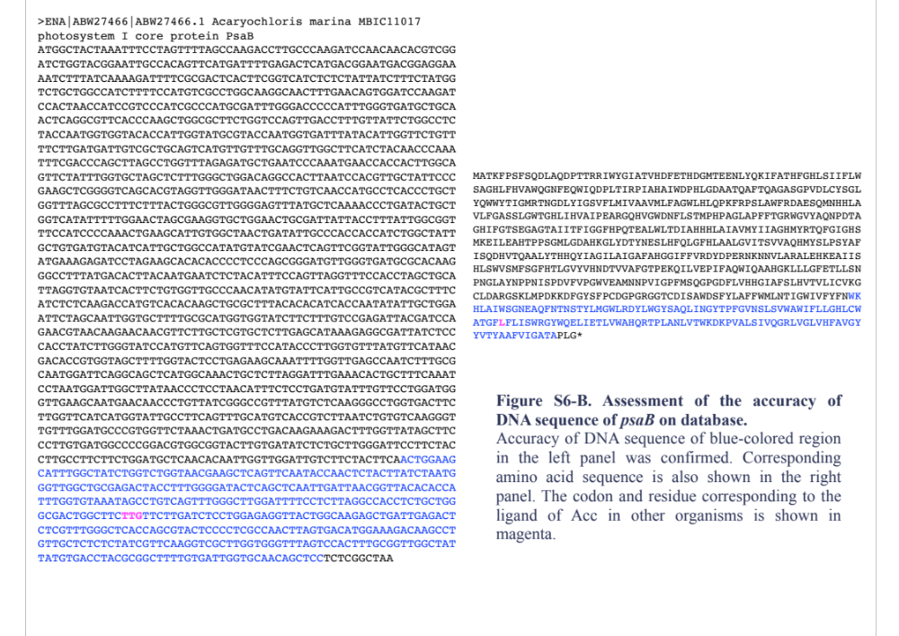
Supplementary Fig. 20-B: Assessment of the accuracy of DNA sequence of psaB in the database.
The accuracy of the DNA sequence (accession number ABW27466.1) of the blue-colored region in the upper panel was confirmed. The corresponding amino acid sequence is shown in the lower panel. The codon and residue corresponding to the ligand of Acc in other organisms are shown in magenta.

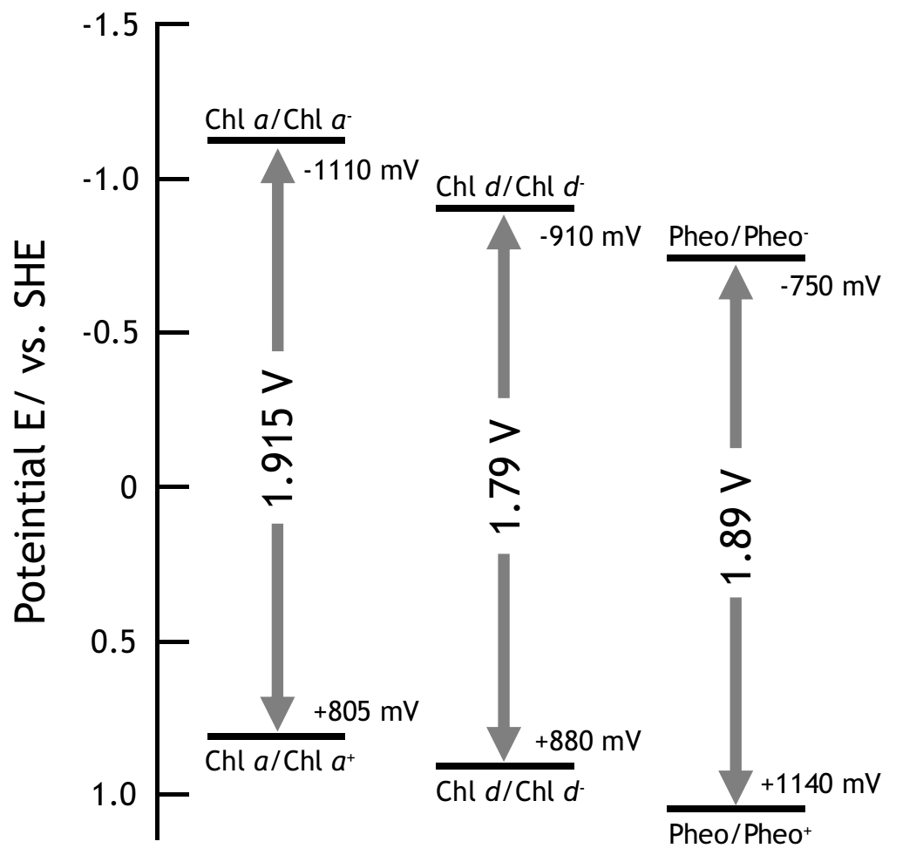

Supplementary Fig. 21: Schematic comparison of reduction potentials of Chl a, Chl d, and Pheo in acetonitrile.
The values refer to Kobayashi et al. (2013) and Komatsu et al. (2014)^{50,51}.

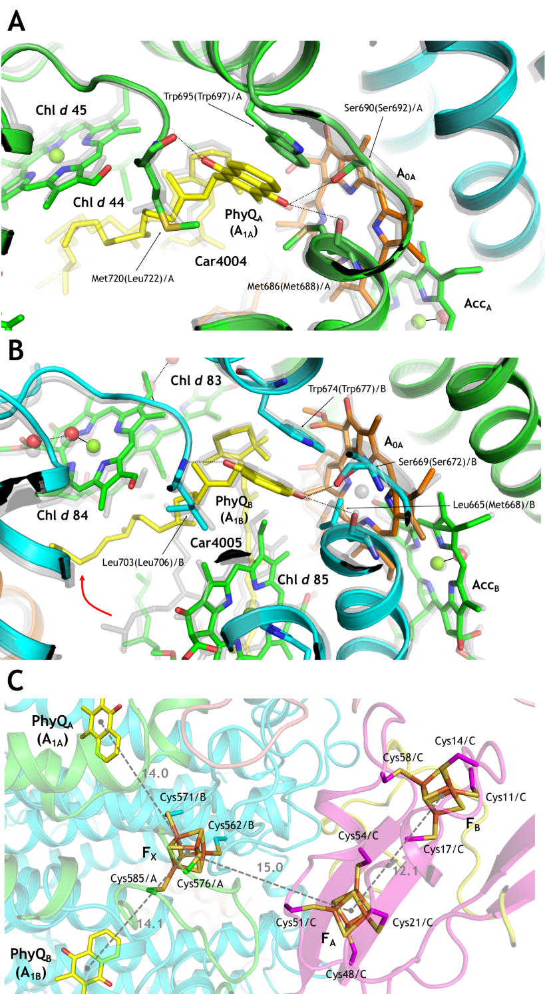

Supplementary Fig. 22: Interactions between cofactors and their surrounding amino acid residues in A. marina PSI.
(A) Interaction between PhyQ_{A} and its surrounding structures. (B) Interaction between PhyQ_{B} and its surrounding structures. (C) Distances (in Å) between cofactors and the interaction between the iron–sulfur clusters (F_{X}, F_{A}, and F_{B}) and their surrounding amino acid residues.

Supplementary Table 1: Subunit proteins in A. marina PSI.

Subunit | Chain ID | Length (residues) | Number of assigned amino acid residues | Model state | Main function in PSI
PsaA | aA, bA, cA | 765 | 41 - 243, 272 - 753 | Mainly assigned by each amino acid residue | Reaction center and electron transfer
PsaB | aB, bB, cB | 748 | 3 - 291, 322 - 464, 511 - 736 | Mainly assigned by each amino acid residue | Reaction center and electron transfer
PsaC | aC, bC, cC | 82 | 2 - 81 | Mainly assigned by each amino acid residue | Electron transfer
PsaD | aD, bD, cD | 141 | 4 - 139 | Mainly assigned by each amino acid residue | Binding site of ferredoxin
PsaE | aE, bE, cE | 90 | 1 - 67 | Mainly polyalanine model | Possibily ferredoxin docking
PsaF | aF, bF, cF | 169 | 28 - 77, 84 - 165 | Mainly polyalanine model | Binding site of plastocyanin or cytochrome c
PsaI | aI, bI, cI | 34 | 3 - 32 | Mainly assigned by each amino acid residue | Stabilization of oligomer
PsaJ | aJ, bJ, cJ | 51 | 16 - 50 | Assigned by each amino acid residue | Stabilization of PsaF
PsaK | aK, bK, cK | 60 | 21 - 36, 61 - 77 | Polyalanine model | State transition
PsaL | aL, bL, cL | 155 | 5 - 151 | Mainly assigned by each amino acid residue | Stabilization of oligomer
PsaM | aM, bM, cM | 31 | 2 - 30 | Assigned by each amino acid residue | Stabilization of oligomer
Supplementary Table 2: Subunit identification by mass spectrometry and Mascot.
Lane numbers correspond to those in Supplementary Fig. S6.

Assigned subunits | Protein Accession # | Protein Mass | Protein Score | Protein Matches
Lane 2
PsaB | gi|158305849 | 82081 | 893 | 150
PsaA | gi|158305848 | 83333 | 951 | 168
PsaD | gi|158308489 | 15087 | 1031 | 281
PsaL | gi|158304848 | 15330 | 406 | 105
PsaF | gi|158304851 | 17815 | 339 | 217
PsaE | gi|158305894 | 9542 | 385 | 139
PsaC | gi|158305064 | 8810 | 167 | 100
PsaJ | gi|158304850 | 5893 | 16 | 1
Lane 3
PsaB | gi|158305849 | 82081 | 720 | 133
PsaA | gi|158305848 | 83333 | 715 | 194
PsaD | gi|158308489 | 15087 | 746 | 220
PsaF | gi|158304851 | 17815 | 339 | 157
PsaL | gi|158304848 | 15330 | 344 | 119
PsaE | gi|158305894 | 9542 | 310 | 105
PsaC | gi|158305064 | 8810 | 210 | 98
PsaK | gi|158305041 | 9276 | 18 | 1
PsaJ | gi|158304850 | 5893 | 16 | 1

Supplementary Table 3: Statistics for data collection, processing, and refinement.
#1 PSI trimer (EMDB-xxxx)
(PDB xxxx)
Data collection
Microscope | CRYO ARM 300
Imaging device | K2 summit
Voltage (kV) | 300
Imaging mode | Counted
Software | JADAS
Grid condition | QF1.2/1.3Cu
 | Au sputtered
Magnification | x60,000
Total exposure time (sec) | 10
No. of frames | 50
Electron exposure (e–/Å²) | 85.7
Defocus range (µm) | -0.6 - -1.8
Original pixel size (Å) | 0.823
No. of total image sets | 7,571
Duration (day) | 9
Data processing
No. of used image sets | 4,237
Initial particles (no.) | 774,414
Final particles (no.) | 86,419
Pixel size for final map (Å) | 1.097
Symmetry imposed | C3 (C1)
Map resolution (Å)  FSC threshold | 2.48 (2.97)  0.143 (0.143)
B-factor for sharpening (Å²) | -83.67 (-77.95)
Map resolution range (Å) | 2.39 – 3.63 (2.63 – 4.00)
Refinement
Initial model used (PDB code) | 1JB0
Model resolution (Å)  FSC threshold | 2.57  0.50
Model resolution range (Å) | 2.57 - 204.0
Model composition  Non-hydrogen atoms  Protein residues  Ligands  Waters | 579,72  44,568  13,320  84
B factors (Å²)  Protein  Ligand  Water | 102.2  84.4  29.0
R.m.s. deviations  Bond lengths (Å)  Bond angles (°) | 0.018  2.131
Validation  MolProbity score  Clashscore  Poor rotamers (%) | 2.01  10.9  0.78
Ramachandran plot  Favored (%)  Allowed (%)  Disallowed (%) | 92.9  6.7  0.4

Supplementary Table 4: Evaluation of the agreement between EM map and final model.

 | CC* | Q-score# | Estimated resolution (Å)  by Q-score#
Overall structure  (PSI trimer) | 0.80 | 0.678 | 2.49
Protein subunit (Chain ID)
PsaA (aA, bA, cA) | 0.82 | 0.68 | 2.46
PsaB (aB, bB, cB) | 0.81 | 0.68 | 2.48
PsaC (aC, bC, cC) | 0.75 | 0.65 | 2.62
PsaD (aD, bD, cD) | 0.67 | 0.61 | 2.90
PsaE (aE, bE, cE) | 0.45 | 0.57 | 3.12
PsaF (aF, bF, cF) | 0.57 | 0.50 | 3.52
Psa27 (aI, bI, cI) | 0.80 | 0.74 | 2.12
PsaJ (aJ, bJ, cJ) | 0.63 | 0.55 | 3.18
PsaK (aK, bK, cK) | 0.39 | 0.47 | 3.63
PsaL (aL, bL, cL) | 0.83 | 0.76 | 2.04
PsaM (aM, bM, cM) | 0.66 | 0.60 | 2.89
Cofactor
Ligands | 0.79 | 0.73 | 2.20
Waters | 0.89 | 0.88 | 1.38

*CC: Correlation coefficient between the refined structure model of PSI and the cryo-EM map. #Q-score: An index showing resolvability of atoms, amino acid residues, and ligands assigned in a cryo-EM map (Local resolution map). Estimated resolution (Å) is estimated by the formula (Q-score = −0.1775 × Resolution (Å) + 1.1192) according to Pintilie et al. (2020)⁷³.

Supplementary Table 5: Sequence identity between the subunits of PSI from A. marina and those from other species.
The values of identity were calculated using MODELLER for comparative protein structure modeling.

 | T. elongatus | Synechocystis | H. hongdechloris
Oligomerization | Trimer | Trimer | Trimer
PDB code | 1JB0 | 5OY0 | 6KMW, 6KMX
PsaA | 75.6 | 75.1 | 72.6
psaB | 77.2 | 78.2 | 77.2
PsaC | 98.8 | 96.2 | 96.3
PsaD | 76.1 | 71.9 | 70.5
PsaE | 72.0 | 65.2 | 77.9
PsaF | 62.8 | 50.3 | N/A
Psa27 (vs PsaI) | 29.4 | 29.4 | 23.5
PsaJ | 53.7 | 55.0 | N/A
PsaK1 (PsaK2) | 35.0 (44.6) | 20.0 (37.5) | 33.3 (41.9)
PsaL | 40.5 | 38.6 | 40.5
PsaM | 54.8 | 64.5 | 51.6

 | Anabaena | C. reinhardtii | C. merolae
Oligomerization | Tetramer | Monomer | Monomer
PDB code | 6JEO | 6JO6 | 5ZGH
PsaA | 75.0 | 74.8 | 72.6
psaB | 76.8 | 74.2 | 72.4
PsaC | 97.5 | 87.7 | 92.6
PsaD | 40.3 | 54.0 | 7.2
PsaE | 82.9 | 53.4 | 42.7
PsaF | 54.9 | 39.4 | 38.9
Psa27 (vs PsaI) | 38.2 | 29.4 | 37.5
PsaJ | 55.1 | 58.5 | 57.9
PsaK1 (PsaK2) | 38.3 (19.8) | 3.3 (25.6) | 8.3 (40.0)
PsaL | 45.8 | 38.6 | 42.9
PsaM | 54.8 | N/A | 34.5

*N/A: Not assigned.
Supplementary Table 6: Numbering of the identified pigments in PSI.
Assigned Chl d are numbered according to the nomenclature of Adolphs et al.³⁶.

 | A. marina |  |  | T. elongatus
Pigment | ID number | Ligand | Candidate donor of hydrogen bond with the C3-formyl group of Chl d | ID number | Ligand
1 | 3101 | His678/A | N/D | 1011 | His680/A
2 | 1021 | His657/A | N/D | 1021 | His660/A
3 | 1012 | H₂O | N/D | 1012 | H₂O
4 | 1035 | H₂O | N/D | 1022 | H₂O
5 | 1026 | N/D | None | 1013 | Met688/A
6 | 1023 | N/D | None | 1023 | Met668/B
7 | 1114 | His53/A | N/D | 1101 | His52/A
8 | 1115 | His57/A | N/D | 1102 | His56/A
9 | 1116 | His77/A | His57/A | 1103 | His76/A
10 | 1117 | His80/A | Trp360/A | 1104 | His79/A
11 | N/D | N/D | N/D | 1105 | His93/A
12 | 1119 | His116/A | N/D | 1106 | Gln115/A
13 | 1120 | Gln124/A | N/D | 1107 | Gln123/A
14 | N/D | N/D | N/D | 1108 | His179/A
15 | 1122 | His182/A | N/D | 1109 | His181/A, Chl 8
16 | 1123 | His200/A | N/D | 1110 | His199/A
17 | N/D | N/D | N/D | 1111 | His200/A
18 | N/D | N/D | N/D | 1112 | His215/A
19 | 1126 | His219/A | N/D | 1113 | His218/A
20 | N/D | N/D | N/D | 1114 | H₂O
21 | 1128 | His296/A | N/D | 1115 | His299/A
22 | 1129 | His297/A | N/D | 1116 | His300/A
23 | 1130 | His298/A | N/D | 1117 | His301/A
24 | 1131 | His310/A | N/D | 1118 | His313/A
25 | 1132 | N/D | N/D | 1119 | H₂O

 | A. marina |  |  | T. elongatus
Pigment | ID number | Ligand | Candidate donor of hydrogen bond with the C3-formyl group of Chl d | ID number | Ligand
26 | N/D | His320/A | N/D | 1120 | His323/A
27 | 1134 | His329/A | N/D | 1121 | His332/A
28 | 1135 | His338/A | N/D | 1122 | His341/A
29 | 1136 | N/D | N/D | 1123 | H₂O
30 | 1137 | H₂O | N/D | 1124 | H₂O
31 | 1138 | His370/A | Ser507/A | 1125 | His373/A
32 | 1139 | His393/A | H₂O | 1126 | His396/A
33 | 1140 | His394/A | N/D | 1127 | His397/A
34 | 1141 | His408/A | N/D | 1128 | His411/A
35 | 1142 | His433/A | N/D | 1129 | His436/A
36 | 1143 | His440/A | N/D | 1130 | His443/A
37 | 1144 | His451/A | H₂O | 1131 | His454/A
38 | 1145 | His458/A | N/D | 1132 | His461/A
39 | 1146 | Gln491/A | N/D | 1133 | His494/A
40 | N/D | N/D | N/D | 1134 | Thr501/A
41 | 1148 | His537/A | N/D | 1135 | His539/A
42 | 1149 | His538/A | N/D | 1136 | His540/A
43 | 1150 | His545/A | N/D | 1137 | His547/A
44 | 1151 | His706/A | N/D | 1138 | His708/A
45 | 1152 | N/D | Trp50/A | 1139 | H₂O
46 | 1153 | His732/A | N/D | 1140 | His734/A
47 | 1201 | His29/B | N/D | 1201 | His28/B
48 | 1202 | His50/B | N/D | 1202 | His49/B
49 | 1203 | His53/B | N/D | 1203 | His52/B
50 | 1204 | His67/B | N/D | 1204 | His66/B

 | A. marina |  |  | T. elongatus
Pigment | ID number | Ligand | Candidate donor of hydrogen bond with the C3-formyl group of Chl d | ID number | Ligand
51 | 1205 | His89/B | N/D | 1205 | His88/B
52 | 1206 | Asp93/B | Asn461/A | 1206 | Asp92/B
53 | 1207 | His95/B | N/D | 1207 | Gln94/B
54 | 1208 | His156/B | N/D | 1208 | His155/B
55 | N/D | N/D | N/D | 1209 | His176/B
56 | N/D | N/D | N/D | 1210 | His177/B
57 | 1211 | His193/B | N/D | 1211 | His192/B
58 | 1212 | His196/B | N/D | 1212 | His195/B
59 | 1213 | His275/B | N/D | 1213 | His274/B
60 | 1214 | His276/B | N/D | 1214 | His275/B
61 | 1215 | His277/B | N/D | 1215 | His276/B
62 | N/D | N/D | N/D | 1216 | H₂O
63 | N/D | N/D | N/D | 1217 | His288/B
64 | N/D | N/D | N/D | 1218 | His298/B
65 | N/D | N/D | N/D | 1219 | H₂O
66 | N/D | N/D | N/D | 1220 | His332/B
67 | N/D | N/D | N/D | 1221 | Tyr329/B
68 | 1222 | N/D | N/D | 1222 | H₂O
69 | 1223 | His351/B | N/D | 1223 | His354/B
70 | 1224 | His374/B | N/D | 1224 | His377/B
71 | 1225 | His375/B | N/D | 1225 | His378/B
72 | 1226 | His389/B | N/D | 1226 | His392/B
73 | N/D | N/D | N/D | 1227 | His417/B
74 | 1228 | His421/B | N/D | 1228 | His424/B
75 | 1229 | His432/B | N/D | 1229 | His435/B

 | A. marina |  |  | T. elongatus
Pigment | ID number | Ligand | Candidate donor of hydrogen bond with the C3-formyl group of Chl d | ID number | Ligand
76 | 1230 | His439/B | N/D | 1230 | His442/B
77 | N/D | N/D | N/D | 1231 | His470/B
78 | N/D | N/D | N/D | 1232 | H₂O
79 | N/D | N/D | N/D | 1233 | H₂O
80 | 1234 | His523/B | Gln350/B | 1234 | His526/B
81 | 1235 | His524/B | N/D | 1235 | His527/B
82 | 1236 | His531/B | N/D | 1236 | His534/B
83 | 1250 | H₂O | N/D | 1237 | H₂O
84 | 1238 | H₂O | H₂O | 1238 | H₂O
85 | 1239 | His715/B | N/D | 1239 | His718/B
86 | N/D | N/D | N/D | 1301 | H₂O
87 | 1302 | Glu38/J | N/D | 1302 | Glu28/J
88 | N/D | Phe49/J | N/D | 1303 | His39/J
89 | 1401 | N/D | N/D | 1401 | N/D
90 | 1415 | N/D | N/D | 1402 | N/D
91 | 1501 | Glu46/L | N/D | 1501 | Glu49/L
92 | 1502 | His51/L | H₂O | 1502 | His54/L
93 | 1503 | H₂O | H₂O | 1503 | H₂O
94 | N/D | N/D | N/D | 1601 | H₂O
95 | N/D | N/D | N/D | 1701 | Asn23/X
96 | 1814 | PG5016 | N/D | 1801 | PG5003

*N/D: Not detected on the cryo-EM density map.

Supplementary Table 7: Pigment composition of PSI trimer relative to Chl d’ determined by HPLC analysis.
Amounts of each pigment were determined by HPLC analysis and their molar ratios to Chl d’ are presented. Standard errors are shown in parentheses.

 | Zeaxanthin | Chl d | Chl a | Phe a | α-carotene | PhyQ
Lot #1  (n=3) | 1.18  (±0.022) | 67.7  (±0.45) | 1.17  (±0.005) | 1.94  (±0.016) | 10.0  (±0.018) | 2.06  (±0.172)
Lot #2  (n=3) | 0.939  (±0.015) | 65.8  (±0.31) | 1.12  (±0.008) | 1.94  (±0.016) | 10.2  (±0.093) | 2.05  (±0.076)
Lot #3  (n=4) | 1.03  (±0.037) | 66.2  (±1.80) | 1.13  (±0.034) | 1.93  (±0.052) | 9.01  (±0.55) | 1.83  (±0.142)
Lot #4  (n=3) | 0.95  (±0.016) | 66.2  (±1.39) | 1.14  (±0.018) | 1.96  (±0.045) | 9.97  (±0.42) | 1.81  (±0.103)
Lot #5  (n=2) | 1.32  (±0.066) | 69.3  (±5.21) | 0.924  (±0.058) | 1.83  (±0.152) | 11.0  (±0.847) | 2.00  (±0.219)
mean values | 1.09  (±0.074) | 67.0  (±0.66) | 1.10  (±0.044) | 1.92  (±0.022) | 10.0  (±0.32) | 1.94  (±0.053)

