Supplementary Material*

Lu Y, Tong J, Zhang D, et al. Does SARS-CoV-2 Infection Increase Risk of Neuropsychiatric and Related Conditions? Findings from Difference-in-Differences Analyses

Table of Contents
Section 1 Data description 3
A. Description of electronic health records data 3
B. RECOVER Population and generalizability 3
Section 2 Supplemental Methods 5
A. Modeling strategy for the difference-in-difference analyses 5
B. Study variables 6
C. The definition of “increase” in the manuscript 9
Section 3 Supplemental Detailed Results 10
Section 4 Supplemental Results: patient characteristic balance between groups in primary analysis 12
A. Propensity-score (PS) models and matching 12
B. Empirical equipoise assessment 13
C. Patient characteristic balance in the primary analysis 15
Section 5 Supplemental Results: analysis for overall cohort without age stratification 17
A. Empirical equipoise assessment 17
B. Patient characteristic balance 18
C. Risk difference of COVID-19 positive group compared to COVID-19 negative group 19
Section 6 Supplemental Results: sensitivity analysis with COVID-19/respiratory negative group 21
Section 7 Supplemental Results: sensitivity analysis for sub-variants 26
A. Empirical equipoise assessment 26
B. Patient characteristic balance 33
C. Risk difference of COVID-19 positive group compared to COVID-19 negative group 39
Section 8 Supplemental Results: sensitivity analysis for sex 51
A. Empirical equipoise assessment 51
B. Patient characteristic balance 55
C. Risk difference of COVID-19 positive group compared to COVID-19 negative group 59
Section 9 Supplemental Results: sensitivity analysis for ethnicity 67
A. Empirical equipoise assessment 67
B. Patient characteristic balance 75
C. Risk difference of COVID-19 positive group compared to COVID-19 negative group 83
Section 10 Supplemental Results: sensitivity analysis for obese/non-obese subgroups 99
A. Empirical equipoise assessment 99
B. Patient characteristic balance 103
C. Risk difference of COVID-19 positive group compared to COVID-19 negative group 107
Section 11 Supplemental Results: sensitivity analysis for subgroups with different hospitalization status 115
A. Empirical equipoise assessment 115
B. Patient characteristic balance 121
C. Risk difference of COVID-19 positive group compared to COVID-19 negative group 127
Section 12 Supplemental Results: sensitivity analysis for subgroups with different levels of COVID-19 severity 139
A. Empirical equipoise assessment 139
B. Patient characteristic balance 147
C. Risk difference of COVID-19 positive group compared to COVID-19 negative group 155
Reference 170

* This supplementary material was provided by the authors to give readers further details on their article. The material was not copyedited.

Section 1 Data description

Description of electronic health records data

The real-world data utilized in our analysis is derived from electronic health records (EHRs), covering a wide range of healthcare interaction information routinely collected and stored by hospitals. This includes clinical data such as diagnoses and treatments, laboratory and test results, and administrative data including patient demographics and billing information. The hospital-based EHR data from the Researching COVID to Enhance Recovery (RECOVER) Initiative COVID-19 Database served as the basis for defining and determining exposure, outcomes, and covariates. Unlike General Practitioner (GP) data, self-reported data, or external data sources, our study used the structured, standardized EHR entries made by healthcare providers within hospital settings. EHR data provides a more detailed and integrated view of a patient's health status, medical history, and healthcare interactions across various providers and settings.

RECOVER Population and generalizability

The National Institutions of Health (NIH) launched the new RECOVER initiative in 2021 to leverage EHR data to better identify and characterize patients with pos-acute sequelae of SARS-CoV-2 infection (PASC). RECOVER obtains EHRs from three large national healthcare networks within the United States, covering regional catchment areas across 41 states. These networks collectively hold the EHRs of over 60 million patients, including records from more than 7 million individuals who have been affected by COVID-19. RECOVER collaborates with the National Institutes of Health's (NIH) All of Us Research Program, which contributes additional health records to this vast database. Together, these sources comprise one of the world's largest collections of EHRs.

In our study, participating institutions in this study included: Ann & Robert H. Lurie Children’s Hospital of Chicago, Children’s Hospital Colorado, Children’s Hospital of Philadelphia, Children’s National Medical Center, Cincinnati Children’s Hospital Medical Center, Duke University, Medical College of Wisconsin, Medical University of South Carolina (MUSC), Montefiore, Nationwide Children’s Hospital, Nemours Children’s Health System (inclusive of the Delaware and Florida health system), New York University School of Medicine, Northwestern University, OCHIN, Seattle Children’s Hospital, Stanford Children’s Health, University of California, San Francisco, University of Iowa Healthcare, University of Michigan, University of Missouri, University of Nebraska Medical Center, University of Pittsburgh, Vanderbilt University Medical Center, Wake Forest Baptist Health, and Weill Cornell Medical College. For this study, we used the s9 version of the data, collected till June 2023, which comprises 6,868,813 patients.

Our study represents the most comprehensive research conducted in the U.S. on PASC in children and youths, analyzing a total of 1,211,388 samples. It features a longer follow-up period than most existing studies targeting this age group in the U.S., specifically covering the timeframes of both the Delta and Omicron variant outbreaks. We recognize the potential limitations of EHR studies, particularly concerning the completeness of longitudinal follow-up for individuals. To mitigate this, our study only included patients who had an encounter within the 24 months prior to the cohort entry. This criterion ensured that the patients included had ongoing interactions with the healthcare system, enhancing the reliability of follow-up data.

Section 2 Supplemental Methods

Modeling strategy for the difference-in-difference analyses

For each outcome (i.e., mental health disorder), we use a binary indicator $R$ as the SARS-CoV-2 infection status groups ($R=1$ for SARS-CoV-2 infected/COVID-19 positive cohort, $R=0$ for SARS-CoV-2 uninfected/COVID-19 negative cohort, $M$ as the indicator of before or after index date ($M=0$ for prior to the index date vs. $M=1$ for after the index date), and $Y$ to denote the occurrence of the specific potential mental health PASC symptoms and conditions.

A Poisson regression model was fitted by regressing the mental health symptoms and conditions on COVID-19 positive/negative groups, before/after index date status, and the interaction between COVID-19 positive/negative groups and before/after index date status:

$$h\left(Y\right)=β_{0}+β_{1}*R+β_{2}*M+β_{3}*R*M,$$

where $h\left(Y\right)$ is the log link function. The coefficient of the interaction term, $β_{3}$, represents the differential increase of differences of outcomes between COVID-19 positive/negative cohorts over time.

Study variables

Supp Table 1. Variables used in the difference-in-difference study of two cohorts evaluating the effect of the SARS-CoV-2 infection on mental health disorders in children aged 5 to 11 years and youths aged 12 to 20 years during the study period.

Variable | Functional form | Values | Detail | Codes/references
Treatment
(i.e., Exposure)
Documented infection | Indicator | Yes/No | Based on the observation and visit occurrence domains. Defined as a polymerase-chain-reaction (PCR), serology, or antigen tests positive for COVID-19, or diagnoses of COVID-19, post-acute sequelae of SARS-CoV-2 (PASC), or multisystem inflammatory syndrome in children (MIS-C) regardless of the presence of symptoms. | See https://github.com/PEDSnet/PASC/tree/main/observation_derivation_recover_ml_phenotype/specs for detailed codes.
Outcomes
Mental health disorders | Indicator | Yes/No | We developed Systematized Nomenclature of Medicine (SNOMED) cluster of codes, which served as outcomes. We coded 4,047 SNOMED codes into 49 clusters and 15 categories. These long-COVID-compatible diagnoses were categorized based on previously identified clusters of codes associated with post-acute manifestations of COVID-19 in earlier research. | See https://github.com/yiwenluiris/PASC_Mental_Health_Public/blob/main/mhcc_codes_0627v4_v4.csv for detailed codes.
Confounding variables
Age (years) | Linear | NA | Based on records in the person domain. | Age is defined as the integer of (date – birth date)/365.25
Sex | Indicator | Male/Female | Based on records in the person domain. | NA
Race/Ethnicity | 4 categories | Non-Hispanic White  Non-Hispanic Black  Hispanic  Other/unknown | Based on records in the person domain. | NA
Site | 25 categories | 25 different sites (hospitals) | Based on records in the person domain | NA
Obesity | Indicator | Yes/No | Based on records in the measurement domain.  If measured at age < 24*30.5 days, NHANES weight z score > 1.64  If measured at 24*30.5 < age <240*30.5, NHANES BMI z score > 1.64  If measured at age >= 240*30.5, BMI kg/m2 > 30 | NA
PMCA (Pediatric Medical Complexity Algorithm) | 3 categories | No chronic condition (PMCA = 0)  Non-complex chronic condition (PMCA = 1)  Complex chronic condition comorbidities (PMCA = 2) | Based on the condition occurrence and visit occurrence domains. | Simon, T. D., Haaland, W., Hawley, K., Lambka, K., & Mangione-Smith, R. (2018). Development and validation of the Pediatric Medical Complexity Algorithm (PMCA) version 3.0. Academic pediatrics, 18(5), 577-580.
Number of visits to emergency department in 18 months to 7 days prior to the entry | 3 categories | 0  1  >=2 | Based on the condition occurrence and visit occurrence domains. | NA
Number of inpatient visits in 18 months to 7 days prior to the entry | 3 categories | 0  1  >=2 | Based on the condition occurrence and visit occurrence domains, including Inpatient Hospital Stay, Emergency Department Admit to Inpatient Hospital Stay, and Observation Stay | NA
Number of outpatient visits in 18 months to 7 days prior to the entry | 3 categories | 0  1  >=2 | Based on the condition occurrence and visit occurrence domains including Ambulatory/Outpatient Visit (With a Physician) and Interactive Telemedicine Service | NA
Number of COVID-19 negative tests prior to the entry | 3 categories | 0  1  >=2 | Based on the condition occurrence and visit occurrence domains. | NA
Variables for sensitivity analysis
Mild COVID-19 | Indicator | Yes/No | Based on the condition occurrence domain. | Forrest, C. B., Burrows, E. K., Mejias, A., Razzaghi, H., Christakis, D., Jhaveri, R., Lee, G. M., Pajor, N. M., Rao, S., Thacker, D., & Bailey, L. C. (2022). Severity of Acute COVID-19 in Children &amp;lt;18 Years Old March 2020 to December 2021. Pediatrics, 149(4). https://doi.org/10.1542/peds.2021-055765  Code sets are available through https://github.com/PEDSnet/COVID19_Severity/tree/main.
Moderate or severe COVID-19 | Indicator | Yes/No | Based on the condition occurrence, procedure occurrence, drug, device and death domains. | Forrest, C. B., Burrows, E. K., Mejias, A., Razzaghi, H., Christakis, D., Jhaveri, R., Lee, G. M., Pajor, N. M., Rao, S., Thacker, D., & Bailey, L. C. (2022). Severity of Acute COVID-19 in Children &amp;lt;18 Years Old March 2020 to December 2021. Pediatrics, 149(4). https://doi.org/10.1542/peds.2021-055765  Code sets are available through https://github.com/PEDSnet/COVID19_Severity/tree/main.
ICU admission with COVID-19 | Indicator | Yes/No | Based on the adt_occurrence domain | NICU, CICU, PICU

Note: All of the domains in the table above are based on the PEDSnet common data model (CDM). More details are available through this link: https://data-models-service.research.chop.edu.

The definition of “increase” in the manuscript

Supp Figure 1. Illustration of the distinction between "new-onset" and "increase" as used in the manuscript. Supp Figure 1(A) provides an example scenario where, prior to the index date, four individuals have a specific neuropsychiatric or related condition (Group P1), while six individuals do not have the condition (Group N1). After the index date, four of the six individuals in Group N1 develop the condition and are moved to Group P2 (those with the condition after the index date), while three of the four individuals in Group P1 no longer have the condition and are moved to Group N2 (those without the condition after the index date). Supp Figure 1(B) illustrates that the four individuals moving from Group N1 to Group P2 are classified as "new-onset" cases. Supp Figure 1(C) demonstrates how the "increase" is calculated in the paper. Since there were four individuals in Group P1 before the index date and five individuals in Group P2 after the index date, the difference (one individual) is counted as the "increase."

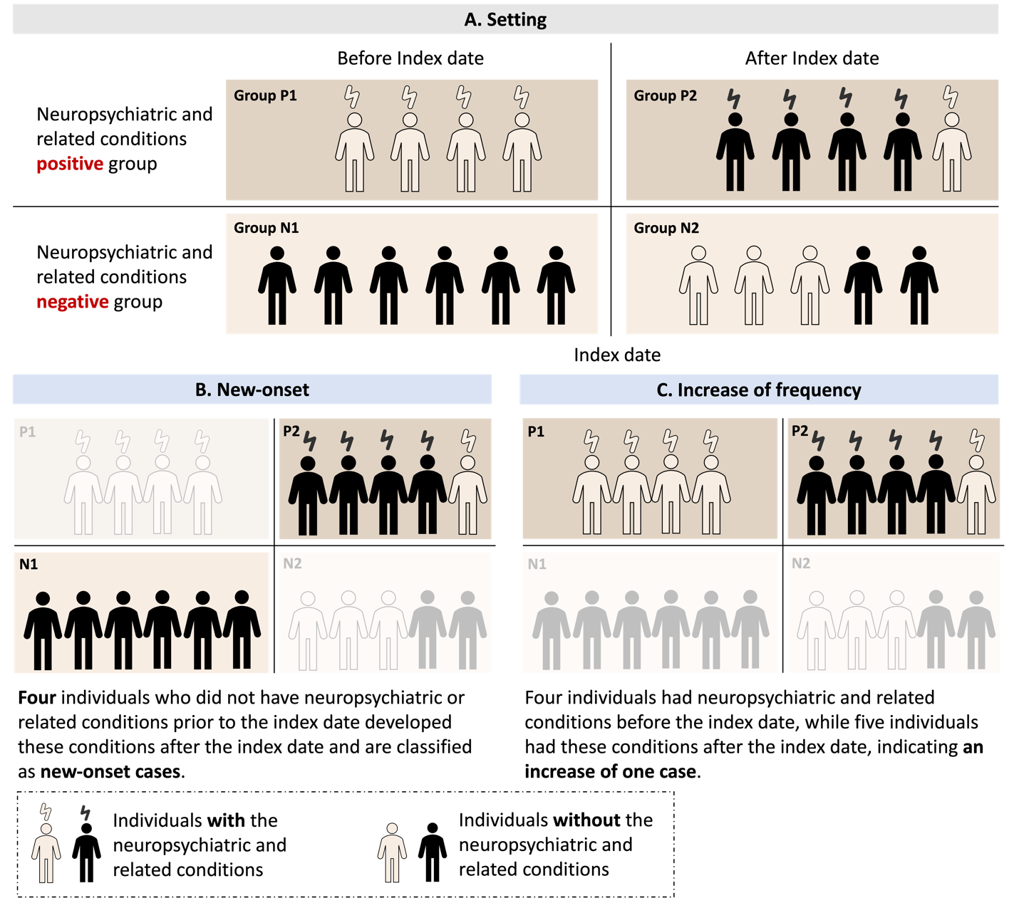

Statistical analysis plan
Aims
Estimate the effects of COVID-19 illness on risk of neuropsychiatric and related outcomes in children and youths.
- Examine the outcome in multiple ways:
  - Any neuropsychiatric and related outcomes.
  - By categories, which are aggregations of clusters.
  - By clusters, which are aggregations of diagnosis codes.

Design for primary analysis
Retrospective Cohort Study Design:
Age [5, 20.99] during 2020-03-01 ~ latest data (latest date: 2023-03-16 - 6 months)
Stratified analysis:
- Children: Age [5,11.99]
- Youths: Age [12,20.99]

Follow-up time: maximum of 6-month follow-up
- 28 - 179 days follow-up post-acute phase

Inclusion criteria:
- For COVID-19 group:
  - First covid-19 positive test during study period
  - Had at least one visit 28 - 179 days after the index date
  - Had at least one visit 24 months - 7 days prior to the index date
  - Satisfy the age constraint
- For contemporary control group:
  - Not part of COVID-19 group
  - At least a negative test of COVID-19 during 2020-03-01~2023-03-16 – 6 months: PCR/antigen/serology
    - Index date: a randomly selected negative test date based on the empirical distribution of index dates in the COVID-19 cohort
  - Had at least one visit 28 - 179 days after the index date
  - Had at least one visit 24 months - 7 days prior to the index date
  - Satisfy the age constraint
- For all groups, remove:
  - Participants with prior history of neuropsychiatric and related conditions (the outcome symptoms) 24 months to 7 days prior to the index date
  - Participants with sex unknown.

Section 3 Supplemental Detailed Results

Supp Table 2. Estimated risk difference in mental health conditions between the COVID-19 positive cohort and the COVID-19 negative cohort for children and youths.

Symptoms | Children [95%CI] | Youths [95%CI]
Any Neuropsychiatric and related conditions | 0.96% [0.75%, 1.16%] | 0.84% [0.53%, 1.15%]
Adverse Childhood Experiences | 0.01% [-0.02%, 0.03%] | 0.06% [0.02%, 0.11%]
Emotional Abuse | -0.01% [-0.01%, 0.00%] | 0.01% [0.00%, 0.03%]
Neglect | 0.01% [0.00%, 0.02%] | 0.00% [-0.01%, 0.01%]
Physical Abuse | -0.01% [-0.03%, 0.02%] | 0.03% [0.00%, 0.06%]
Sexual Abuse | 0.01% [-0.01%, 0.02%] | 0.03% [0.00%, 0.05%]
Anxiety Disorders | 0.33% [0.24%, 0.43%] | 0.27% [0.03%, 0.51%]
Anxiety Disorder | 0.26% [0.19%, 0.33%] | 0.26% [0.05%, 0.48%]
OCD | 0.02% [0.00%, 0.04%] | 0.02% [-0.03%, 0.08%]
Somatoform Disorder | 0.03% [0.00%, 0.05%] | -0.04% [-0.10%, 0.02%]
Stress Disorder | 0.08% [0.02%, 0.14%] | 0.08% [-0.06%, 0.22%]
Disruptive Behavior Disorders | 0.04% [-0.01%, 0.09%] | 0.01% [-0.07%, 0.08%]
Conduct Disorder | 0.02% [-0.02%, 0.06%] | -0.02% [-0.06%, 0.02%]
Impulse Control Disorder | 0.00% [-0.03%, 0.03%] | -0.01% [-0.06%, 0.05%]
Oppositional Defiant Disorder | 0.02% [0.00%, 0.05%] | 0.03% [-0.02%, 0.08%]
Eating and Feeding Disorders | 0.08% [0.04%, 0.13%] | -0.06% [-0.14%, 0.03%]
Avoidant/Restrictive Food Intake | 0.07% [0.03%, 0.11%] | -0.07% [-0.15%, 0.02%]
Other Eating and Feeding Disorder | 0.01% [-0.01%, 0.04%] | 0.01% [-0.01%, 0.03%]
Elimination Disorders | 0.02% [-0.03%, 0.06%] | 0.03% [-0.01%, 0.07%]
Encopresis | 0.00% [-0.02%, 0.02%] | 0.01% [0.00%, 0.03%]
Enuresis | 0.02% [-0.02%, 0.06%] | 0.02% [-0.02%, 0.06%]
Gender Dysphoria/Sexual Dysfunction | 0.00% [-0.01%, 0.01%] | -0.03% [-0.08%, 0.02%]
Gender Dysphoria | 0.00% [-0.01%, 0.01%] | -0.03% [-0.08%, 0.02%]
Paraphilia | 0.00% [0.00%, 0.00%] | 0.00% [-0.01%, 0.00%]
Sexual Dysfunction | 0.00% [0.00%, 0.00%] | 0.00% [-0.01%, 0.01%]
Intentional Self-Harm/Suicidality | 0.02% [0.00%, 0.05%] | 0.11% [0.02%, 0.20%]
Parasuicidality | 0.01% [-0.01%, 0.02%] | 0.02% [-0.02%, 0.07%]
Suicidality | 0.02% [0.00%, 0.03%] | 0.11% [0.02%, 0.19%]
Mood Disorders | 0.02% [-0.02%, 0.05%] | 0.05% [-0.15%, 0.25%]
Bipolar Disorder | 0.01% [0.00%, 0.02%] | -0.02% [-0.05%, 0.02%]
Major Depression | 0.00% [-0.02%, 0.02%] | -0.14% [-0.29%, 0.02%]
Minor Depression | 0.01% [-0.02%, 0.04%] | 0.21% [0.05%, 0.37%]
Neurocognitive Disorders | 0.05% [0.02%, 0.07%] | 0.10% [0.04%, 0.15%]
Catatonia | 0.00% [0.00%, 0.00%] | 0.00% [-0.01%, 0.02%]
Delirium | 0.04% [0.02%, 0.06%] | 0.08% [0.03%, 0.14%]
Encephalopathy | 0.00% [-0.01%, 0.02%] | 0.02% [0.00%, 0.04%]
Neurodevelopmental Disorders | 0.59% [0.41%, 0.76%] | 0.47% [0.27%, 0.67%]
Academic Developmental Disorder | 0.02% [-0.02%, 0.06%] | 0.05% [0.00%, 0.11%]
ADHD | 0.11% [0.02%, 0.21%] | 0.33% [0.16%, 0.50%]
Autism Spectrum Disorder | 0.10% [0.02%, 0.18%] | 0.06% [-0.03%, 0.15%]
Communication/Motor Disorder | 0.38% [0.25%, 0.52%] | 0.06% [0.00%, 0.12%]
Intellectual Disability | 0.12% [0.05%, 0.20%] | 0.09% [0.01%, 0.17%]
Personality Disorders | 0.00% [-0.01%, 0.01%] | -0.02% [-0.06%, 0.01%]
Personality Disorder | 0.00% [-0.01%, 0.01%] | -0.02% [-0.06%, 0.01%]
Psychotic Disorders | 0.01% [0.00%, 0.02%] | -0.03% [-0.07%, 0.01%]
Psychotic Disorder | 0.01% [0.00%, 0.01%] | -0.01% [-0.04%, 0.02%]
Schizoaffective Disorder | 0.00% [0.00%, 0.00%] | 0.00% [-0.02%, 0.01%]
Schizophrenia | 0.00% [0.00%, 0.00%] | -0.02% [-0.04%, 0.01%]
Sleep-Wake Disorders | 0.05% [0.00%, 0.09%] | 0.16% [0.07%, 0.24%]
Hypersomnia | 0.00% [-0.01%, 0.01%] | 0.01% [-0.02%, 0.04%]
Insomnia | 0.02% [-0.01%, 0.06%] | 0.13% [0.06%, 0.21%]
Parasomnias | 0.03% [0.00%, 0.06%] | 0.03% [0.00%, 0.06%]
Standalone Symptoms | 0.07% [0.01%, 0.13%] | 0.17% [0.08%, 0.26%]
Anger/Aggression | 0.03% [0.00%, 0.06%] | 0.01% [-0.03%, 0.06%]
Anxiety Symptoms | 0.03% [-0.02%, 0.07%] | 0.05% [0.00%, 0.10%]
Attention Symptoms | 0.01% [-0.02%, 0.04%] | 0.08% [0.03%, 0.14%]
Depressive Symptoms | 0.00% [-0.01%, 0.02%] | 0.02% [0.00%, 0.04%]
Hallucinations | 0.00% [-0.01%, 0.01%] | 0.01% [-0.02%, 0.04%]
Substance Use and Dependence | 0.01% [0.00%, 0.03%] | 0.00% [-0.07%, 0.08%]
Alcohol | 0.00% [0.00%, 0.00%] | -0.01% [-0.03%, 0.02%]
Opioid Related | 0.01% [0.00%, 0.02%] | 0.00% [-0.02%, 0.02%]
Other Substances | 0.01% [0.00%, 0.02%] | -0.01% [-0.04%, 0.02%]
THC | 0.00% [0.00%, 0.00%] | -0.01% [-0.06%, 0.03%]
Tobacco | 0.00% [0.00%, 0.00%] | 0.00% [-0.05%, 0.06%]
Tic Disorders | 0.05% [0.02%, 0.08%] | 0.02% [-0.03%, 0.06%]
Tic Disorder | 0.05% [0.02%, 0.08%] | 0.02% [-0.03%, 0.06%]

Section 4 Supplemental Results: patient characteristic balance between groups in primary analysis

A. Propensity-score (PS) models and matching

We built large-scale PS model for both children and youths cohorts with baseline patient characteristics including
- Demographics (age at index date; race/ethnicity; gender)
- Obesity
- Chronic condition indicator as defined by the Pediatric Medical Complexity Algorithm (PMCA)
  - No chronic condition (PMCA = 0)
  - Non-complex chronic condition (PMCA = 1)
  - Complex chronic condition comorbidities (PMCA = 2)
- Healthcare utilization 24 months ~ 7 days prior to index date categorized to 0,1,2,>=3
  - Number of outpatient visits
  - Number of inpatient visits
  - Number of ED visits
  - Number of unique medications/prescriptions
  - Number of COVID tests
- Cohort entry date (index date) categorized to 1 month
- Hospital index
- Existence of a list of 205 chronic conditions 24 months ~ 7 days prior to index

We exclude all covariates that occur in fewer than 0.1% of participants in the cohort for computational efficiency.

B. Empirical equipoise assessment

To evaluate the comparability between the study groups, we present the preference score, which offers an intuitive interpretation by transforming the propensity score to incorporate the prevalence of treatment. Specifically, the preference score (F) is linked to the propensity score (S) and the prevalence of treatment (P) through the equation: ln(F/(1-F)) = ln(S/(1-S)) - ln(P/(1-P))^{1,2}. Supp Figure 2, 3 below shows the distribution of preference scores across two treatment groups in each study cohort, which indicates high comparability of these studies.

Supp Figure 2. Preference score distributions for COVID-19 positive and negative groups in children. A greater convergence of these distributions indicates a higher similarity in the predicted likelihood of being infected between the COVID-19 positive (red) and negative (blue) participants.

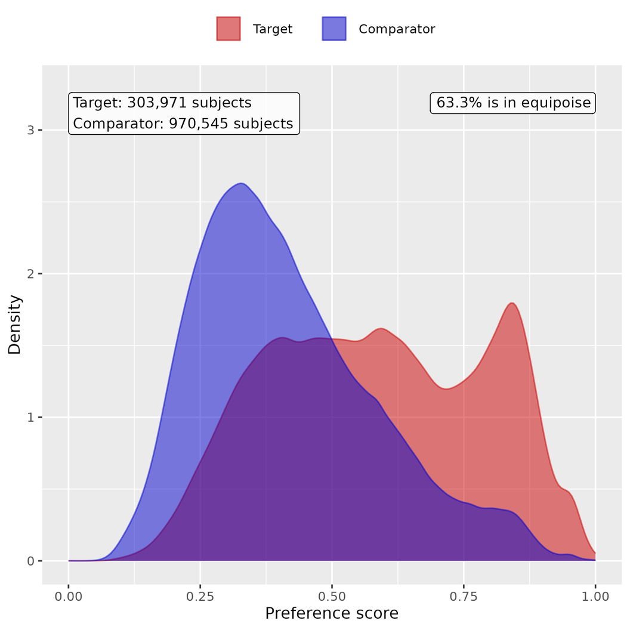
Supp Figure 3. Preference score distributions for COVID-19 positive and negative groups in youths. A greater convergence of these distributions indicates a higher similarity in the predicted likelihood of being infected between the COVID-19 positive (red) and negative (blue) participants.
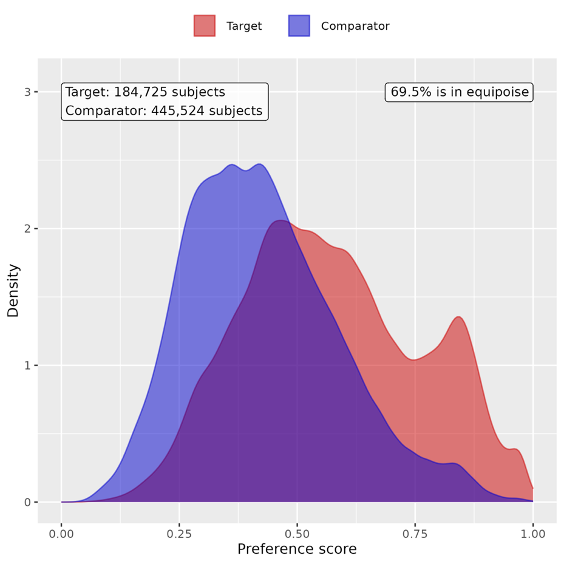

C. Patient characteristic balance in the primary analysis
We evaluate the balance of patient characteristics using the standardized difference of means (SMD). Supp Figure 4, 5 presents the SMD of three cohorts before and after PS score matching.

Supp Figure 4. Patient characteristic balance before and after large-scale PS matching with ratio 1:2 in children. The upper panel displays the top 20 covariates with the largest standardized difference of means before matching, while the lower panel displays the top 20 covariates with the largest standardized difference of means after matching.
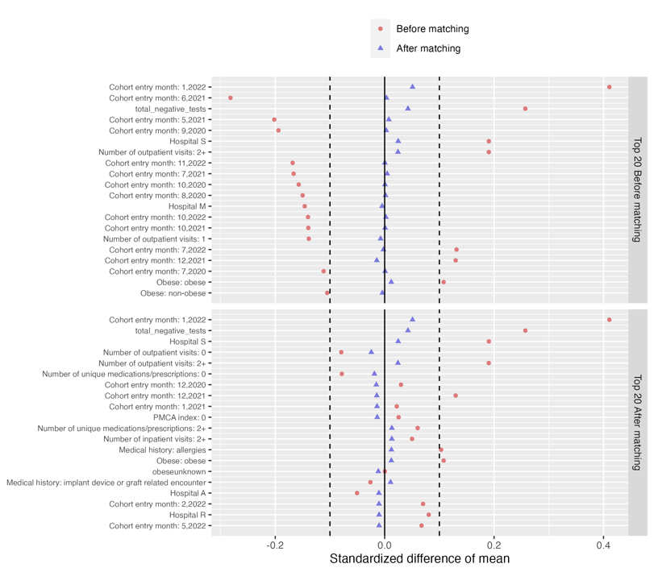

Supp Figure 5. Patient characteristic balance before and after large-scale PS matching with ratio 1:2 in youths. The upper panel displays the top 20 covariates with the largest standardized difference of means before matching, while the lower panel displays the top 20 covariates with the largest standardized difference of means after matching.

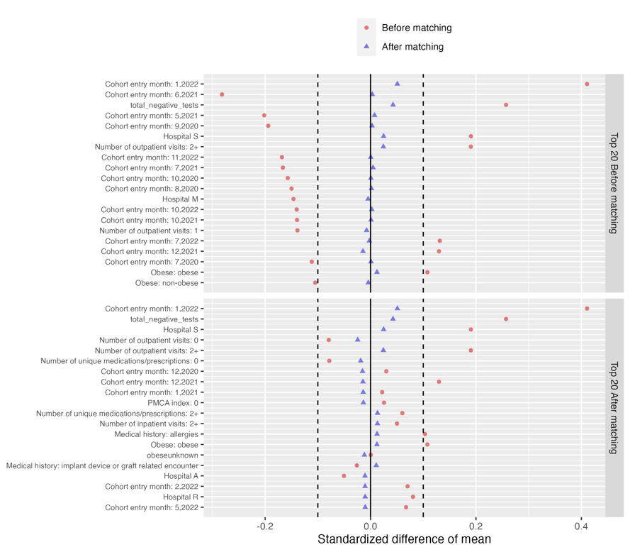

Section 5 Supplemental Results: analysis for overall cohort without age stratification

We conducted sensitivity analyses to investigate risk of mental health conditions for overall cohort without age stratification. We performed the same PS matching procedure and difference-in-difference method to estimate the risk difference.

Empirical equipoise assessment

Supp Figure 6. Preference score distributions of COVID-19 positive and negative groups in the overall cohort without age stratification. A greater convergence of these distributions indicates a higher similarity in the predicted likelihood of being infected between the COVID-19 positive (red) and negative (blue) participants.
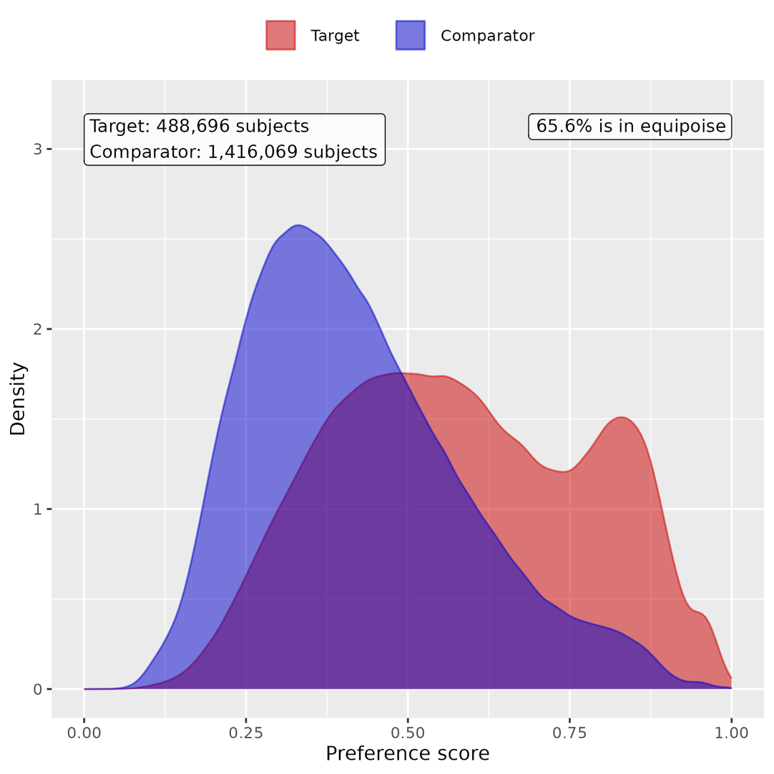

B. Patient characteristic balance

Supp Figure 7. Patient characteristic balance before and after large-scale PS matching with ratio 1:2 in the overall cohort without age stratification. The upper panel displays the top 20 covariates with the largest standardized difference of means before matching, while the lower panel displays the top 20 covariates with the largest standardized difference of means after matching.

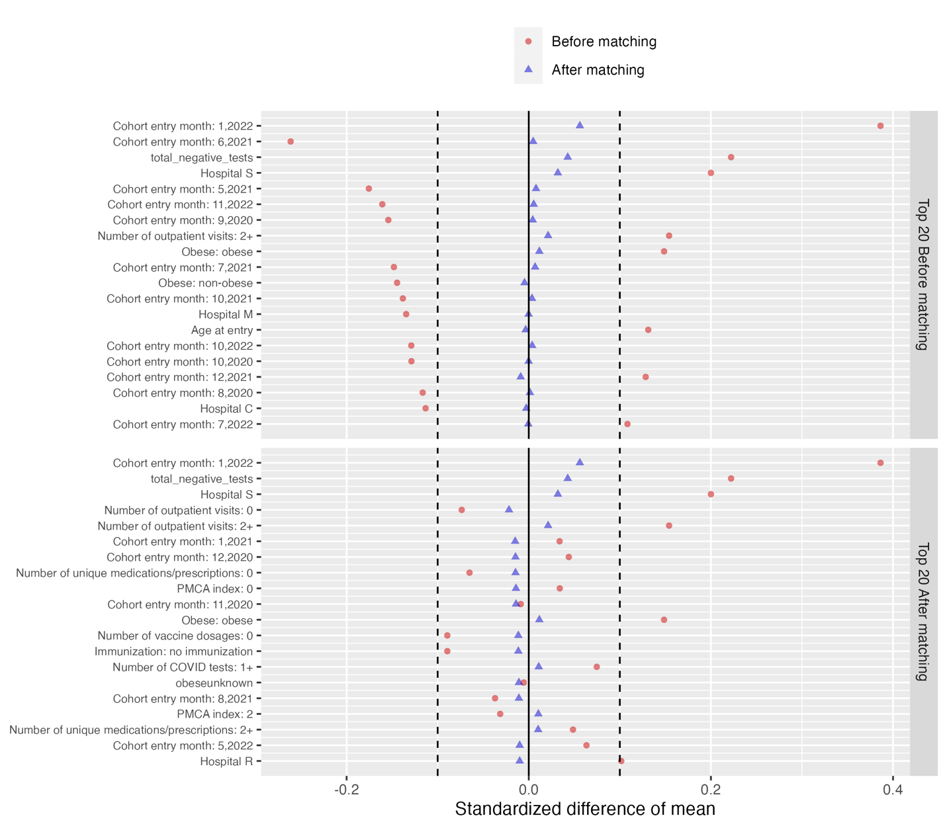

C. Risk difference of COVID-19 positive group compared to COVID-19 negative group

Supp Figure 8. Estimated risk difference of having at least one condition, at category level, and at cluster level between the COVID-19 positive cohort and the COVID-19 negative group for the overall cohort without age stratification.
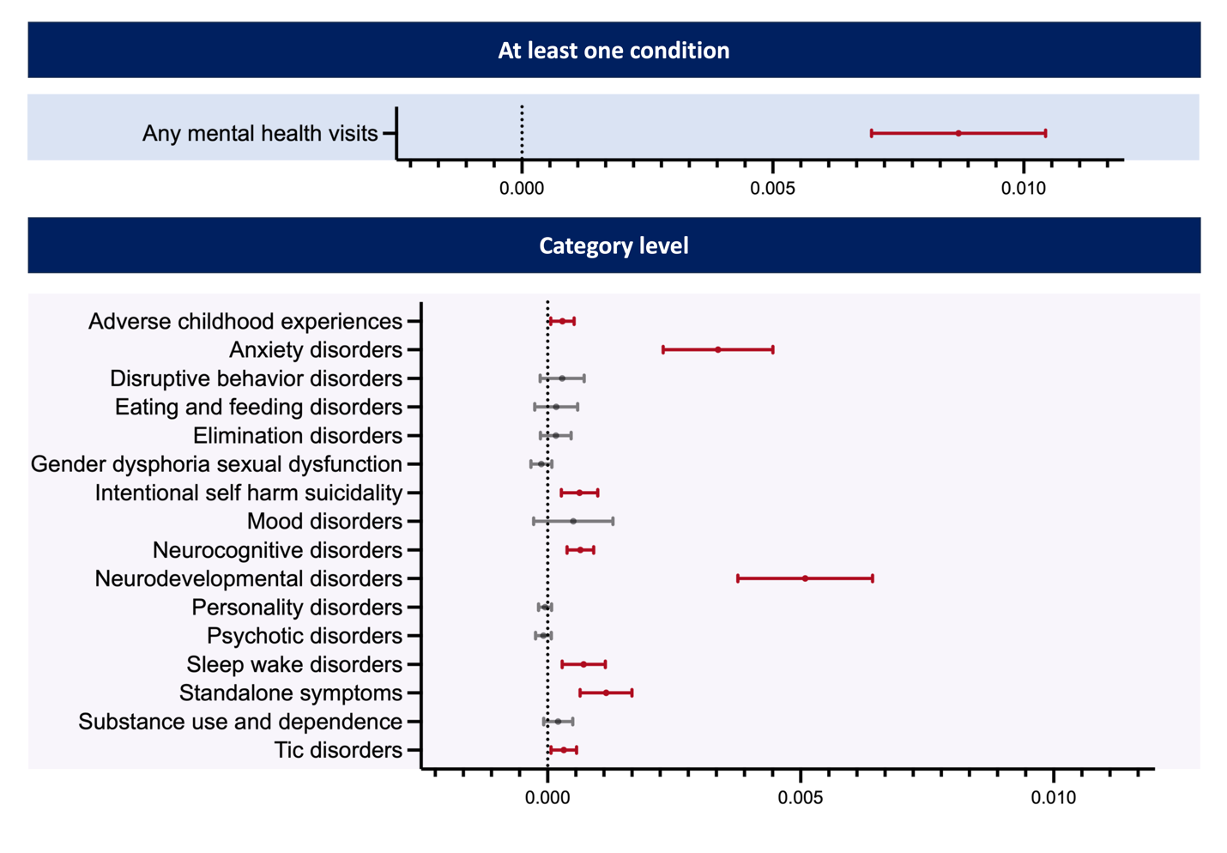
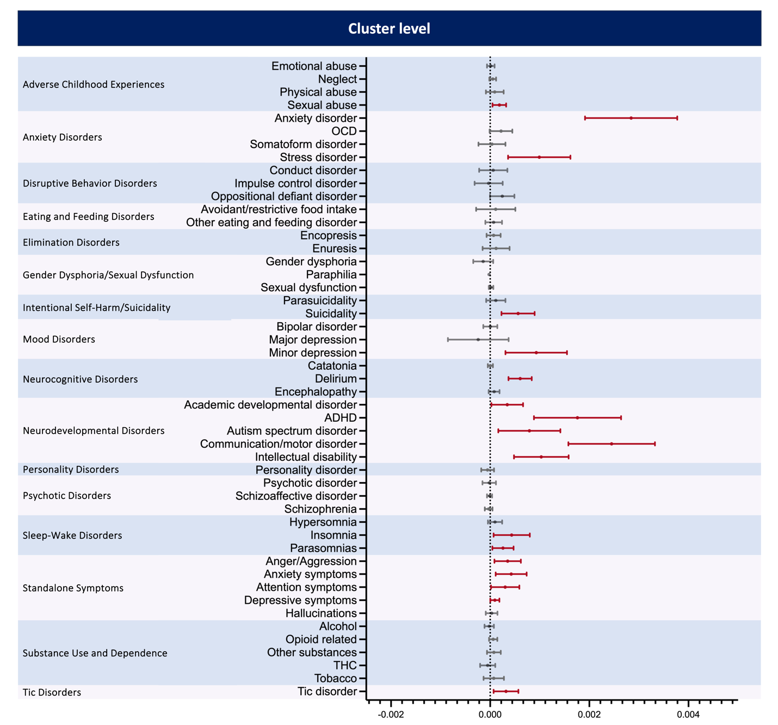

Section 6 Supplemental Results: sensitivity analysis with COVID-19/respiratory negative group

We conducted sensitivity analyses to examine whether the risk of mental health conditions is elevated in the COVID-19 positive group compared to a control group that is both COVID-19 negative and has never been infected with any non-COVID respiratory conditions, including influenza, parainfluenza, rhinovirus, and respiratory syncytial virus (RSV) infection. Below, we present the attrition table for the COVID-19 positive group, COVID-19 negative group, and the combined COVID-19/respiratory negative group.

Supp Figure 9. Attrition table of the COVID-19 positive group, COVID-19 negative group, and COVID-19/respiratory negative group
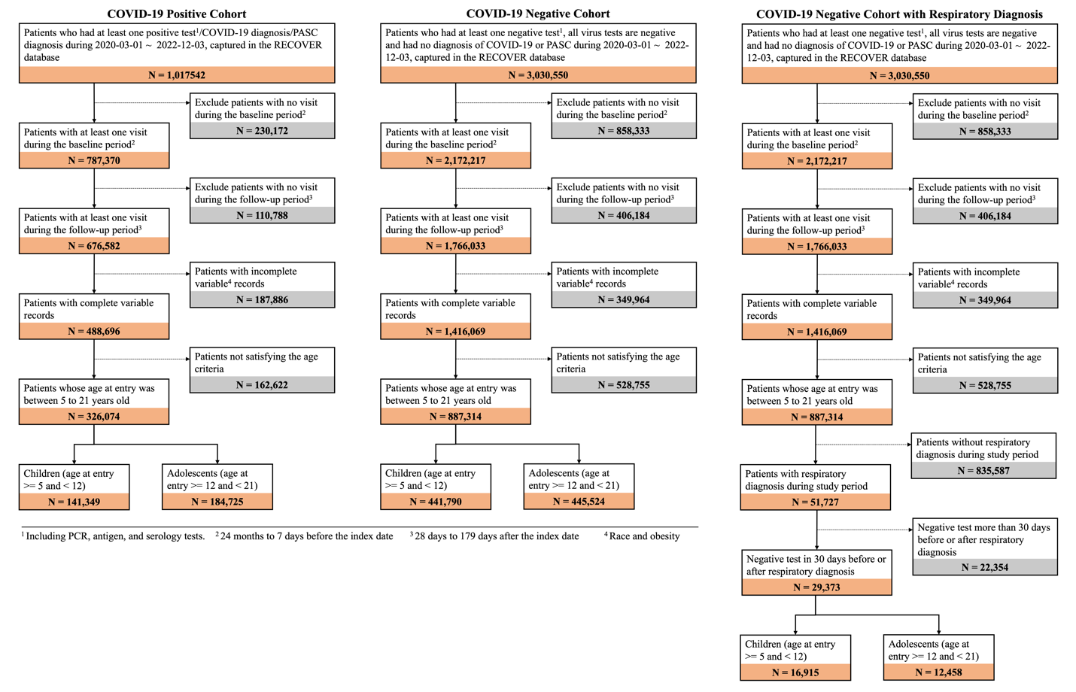

Here we also report the equipoise plots and standard mean difference plots between COVID-19 positive group and COVID-19/respiratory negative group for both children and youths.

Supp Figure 10. Preference score distributions of COVID-19 positive group and COVID-19/respiratory negative group in children. A greater convergence of these distributions indicates a higher similarity in the predicted likelihood of being infected between the COVID-19 positive (red) and negative (blue) participants.
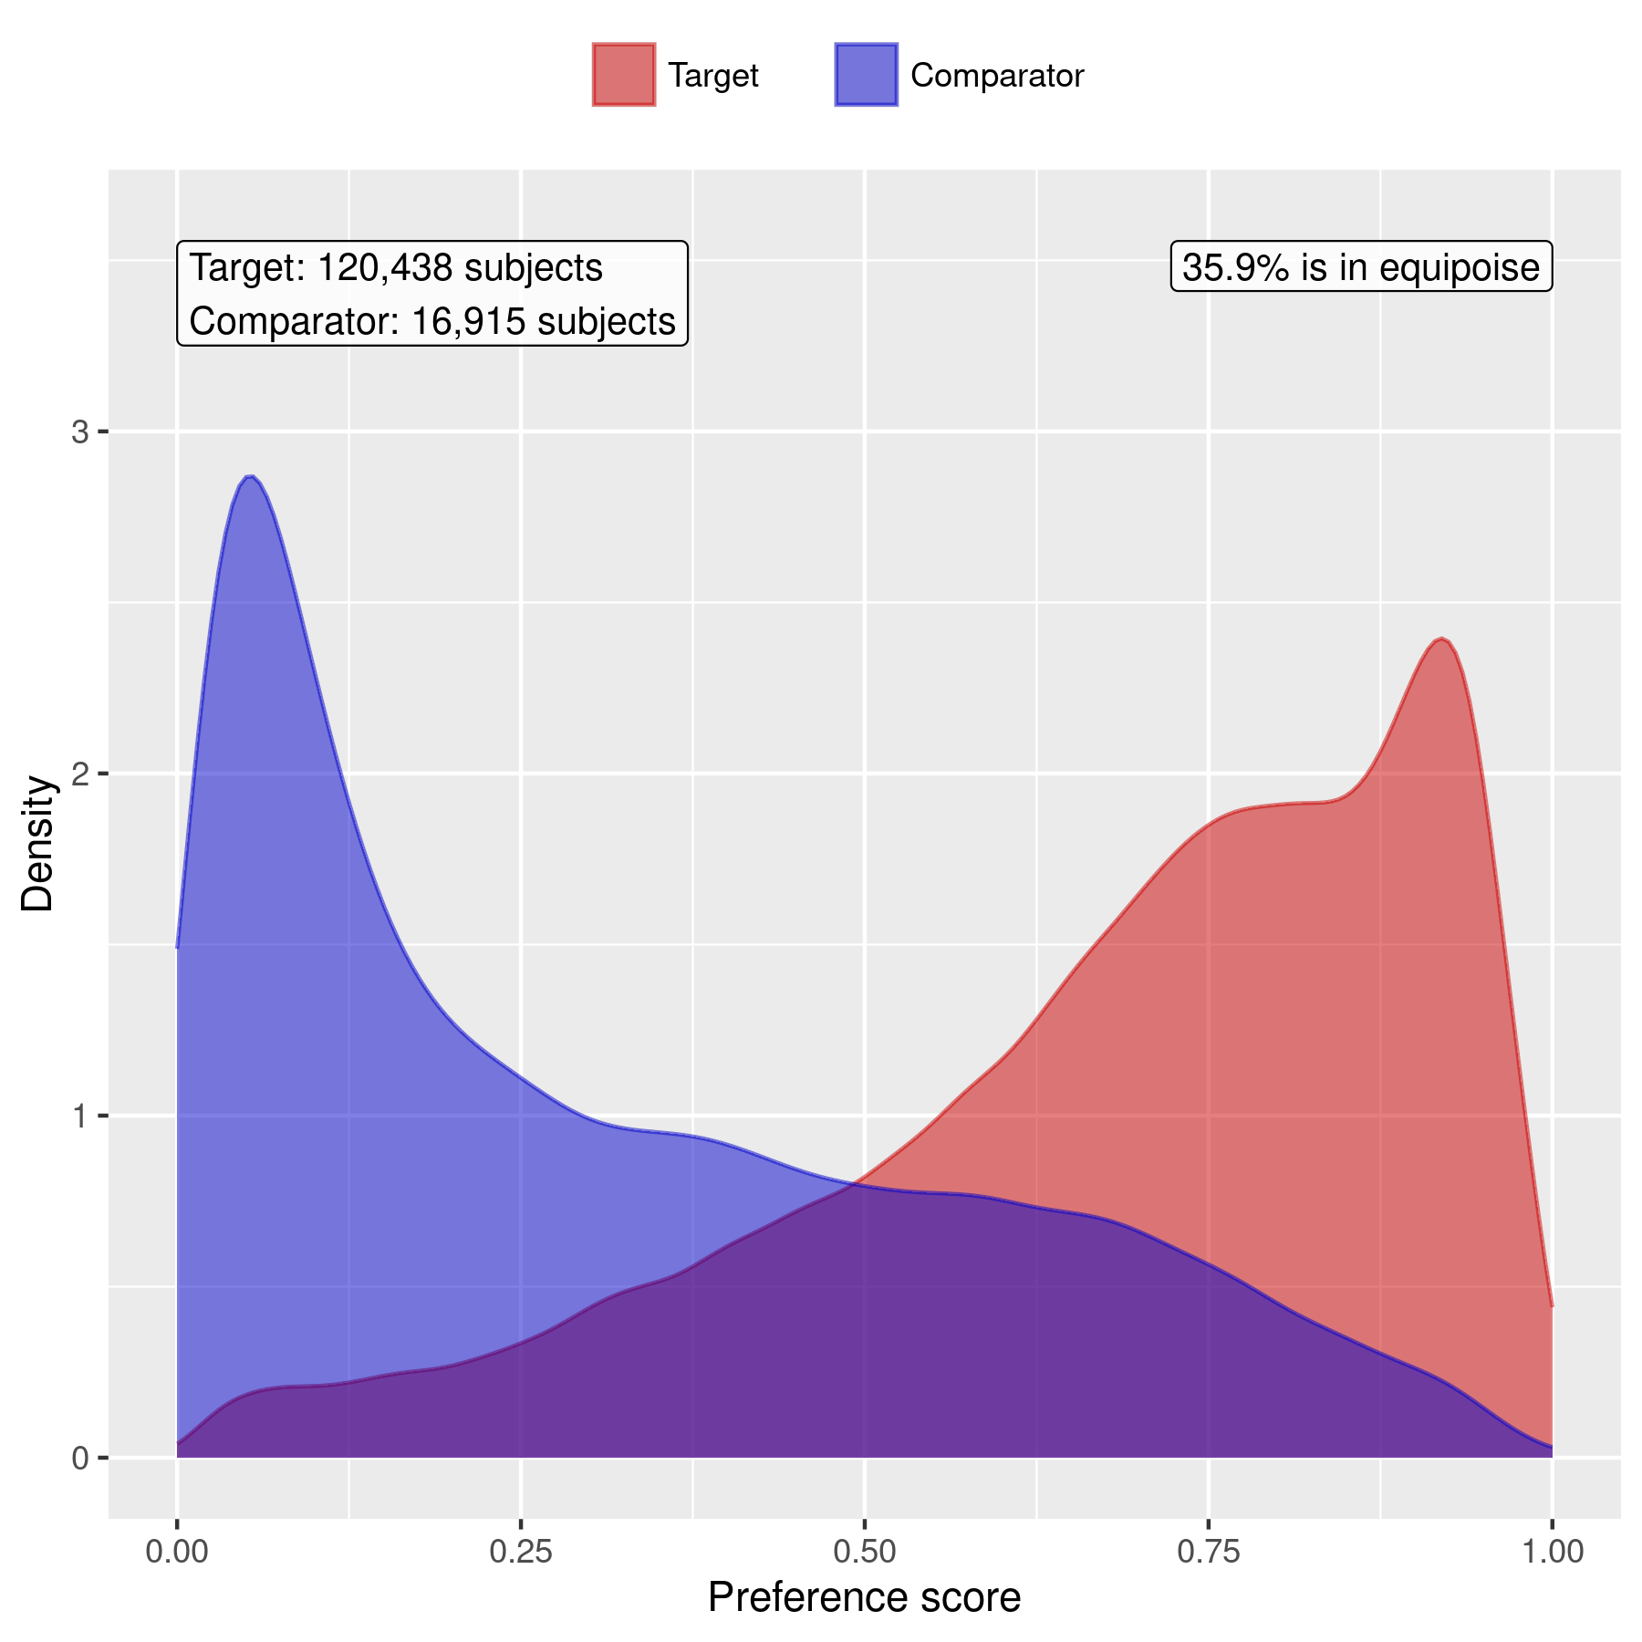

Supp Figure 11. Preference score distributions of COVID-19 positive group and COVID-19/respiratory negative group in youths. A greater convergence of these distributions indicates a higher similarity in the predicted likelihood of being infected between the COVID-19 positive (red) and negative (blue) participants.
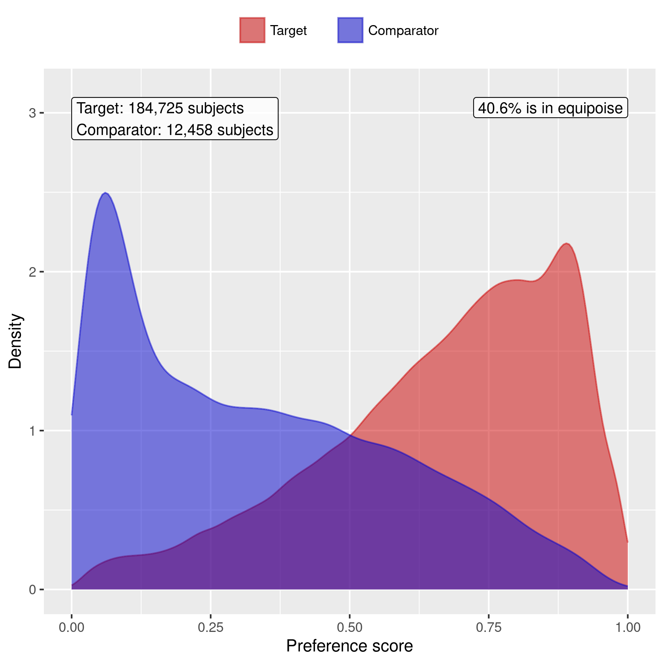

Supp Figure 12. Patient characteristic balance before and after large-scale PS matching with ratio 1:1 for children. The upper panel displays the top 20 covariates with the largest standardized difference of means before matching, while the lower panel displays the top 20 covariates with the largest standardized difference of means after matching.
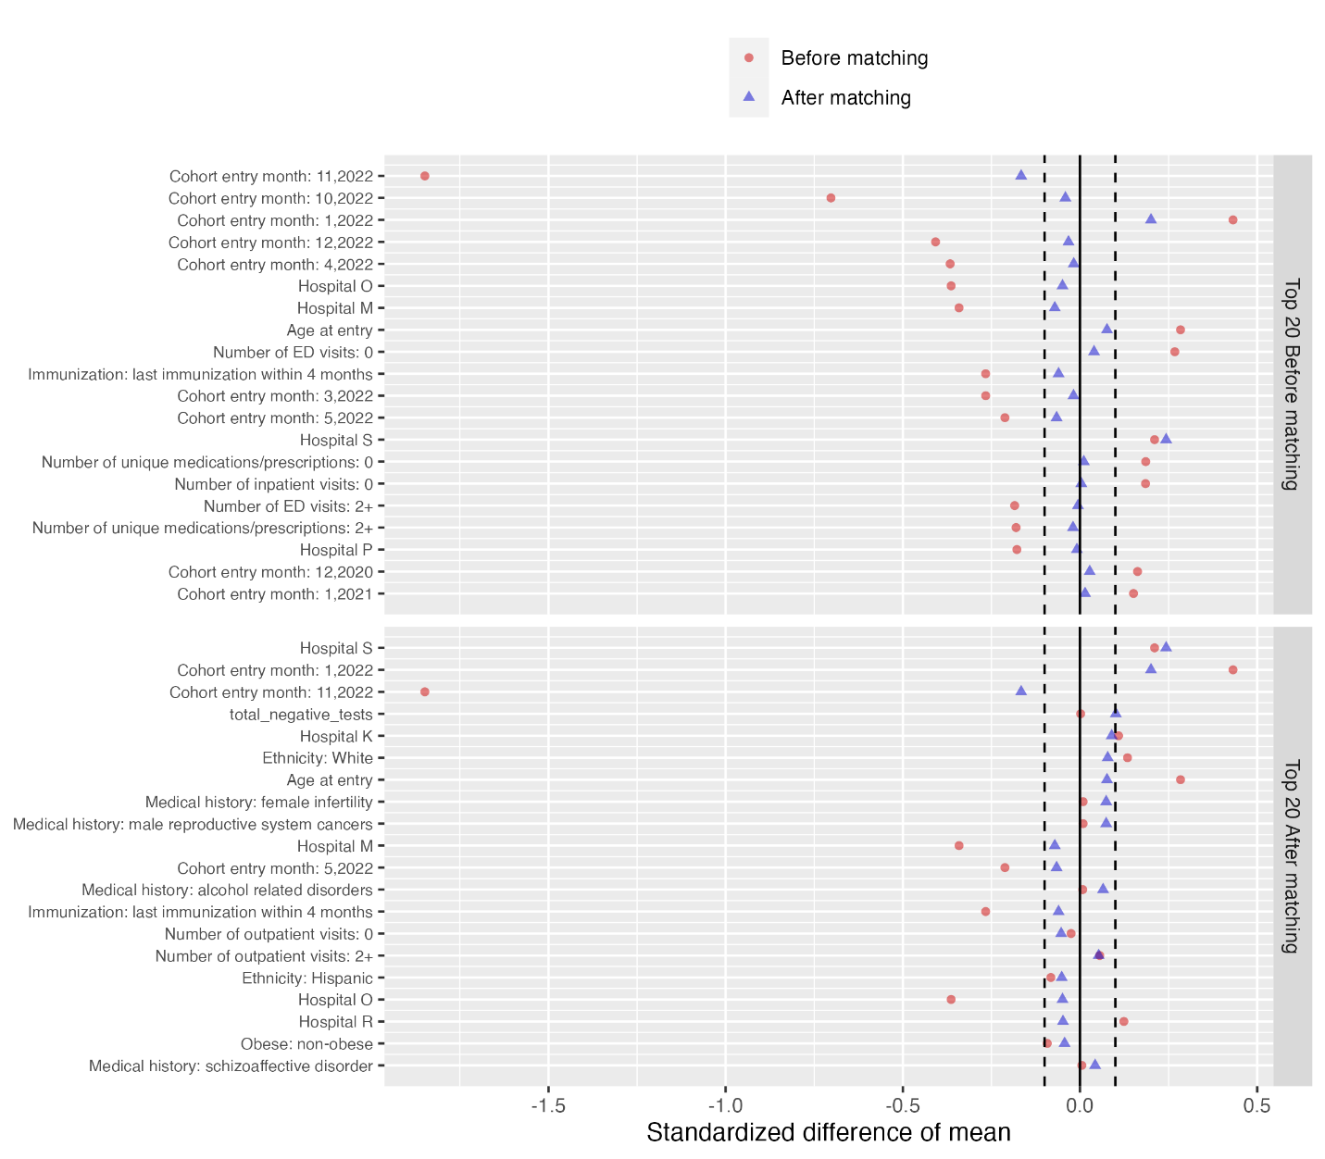

Supp Figure 13. Patient characteristic balance before and after large-scale PS matching with ratio 1:1 for youths. The upper panel displays the top 20 covariates with the largest standardized difference of means before matching, while the lower panel displays the top 20 covariates with the largest standardized difference of means after matching.
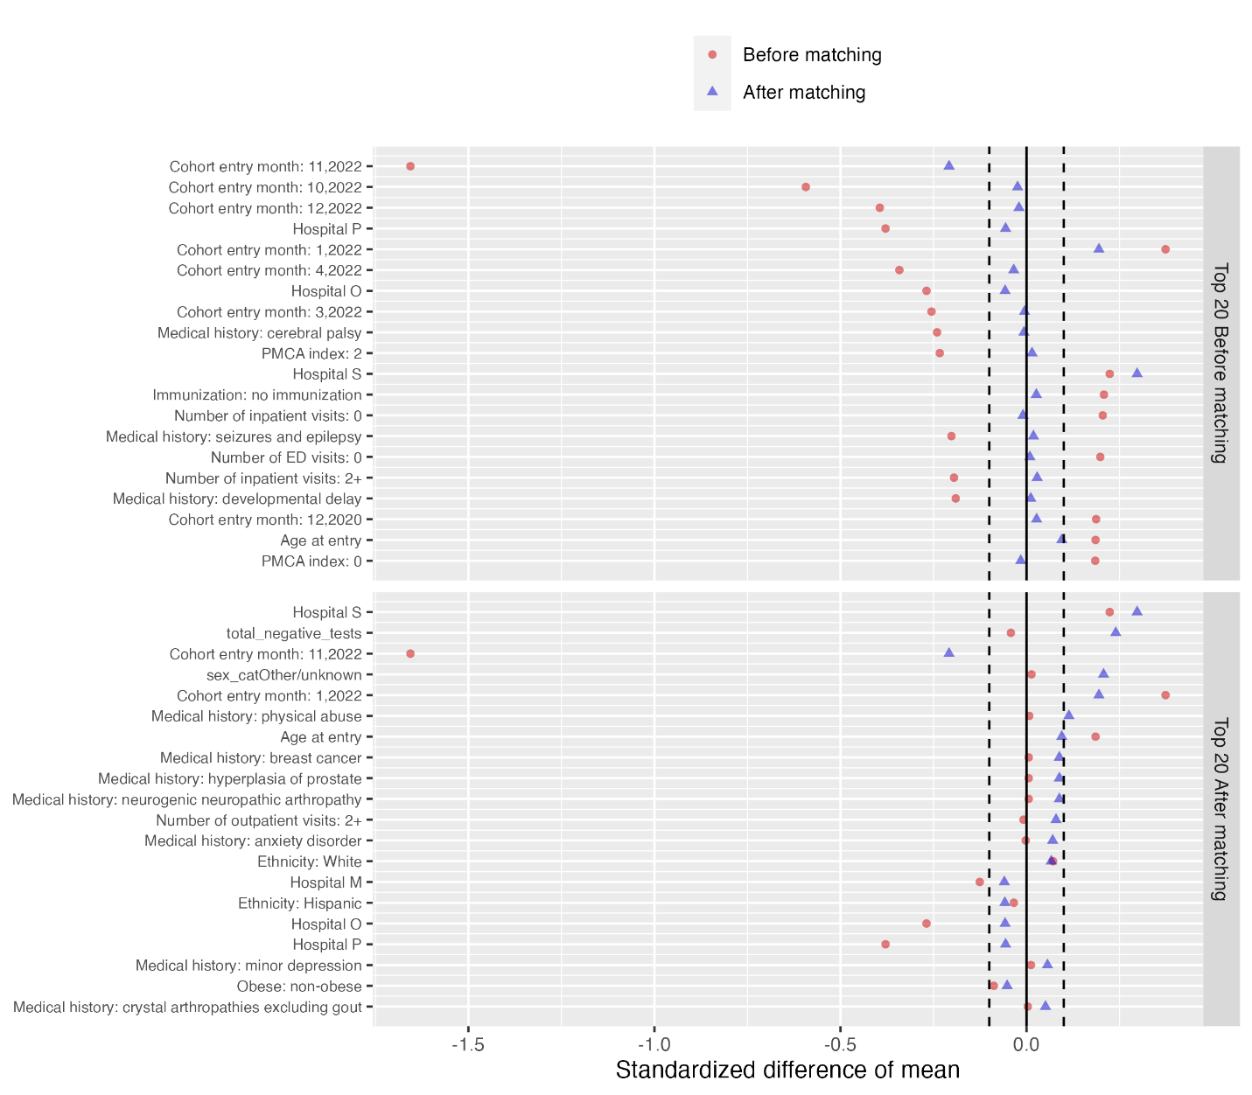

We present the results of the interrupted time series analysis in Supp Figure 14. The analysis focuses on symptoms with a baseline prevalence of at least 1% in either the COVID-19 positive or negative cohorts among children or youths. As shown in the results, the risk of most outcomes, including the composite outcome 'At least one incident,' is not significantly higher in the COVID-19 positive group compared to the COVID-19/respiratory negative group. A key factor contributing to this finding may be the small sample size of the COVID-19/respiratory negative group, which is substantially smaller than the COVID-19 positive group, leading to imbalanced cohorts for analysis. This imbalance also highlights a limitation of the difference-in-difference analysis, which typically requires the COVID-19/respiratory negative group to have at least four times the sample size of the COVID-19 positive group to effectively detect interactions.

Supp Figure 14. Estimated risk difference of having high-prevalence outcomes between the COVID-19 positive group and the COVID-19/respiratory negative group
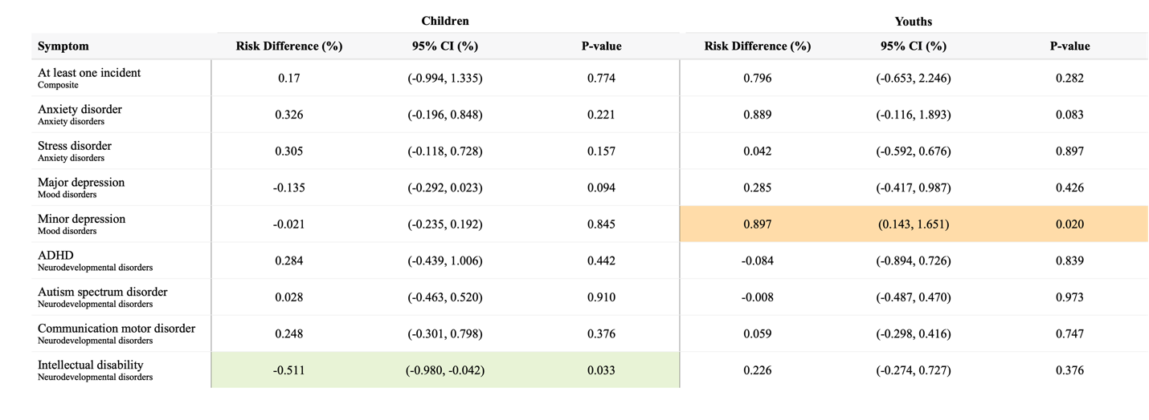

Section 7 Supplemental Results: sensitivity analysis for sub-variants

We conducted sensitivity analyses to investigate if the risk of mental health conditions would be affected by the sub-variants. Therefore, we conducted the subgroup analysis based on three time periods: pre-Delta (March 1, 2021 to June 1, 2021), Delta (July 1, 2021 to November 30, 2021), and Omicron (January 1, 2022 to December 3, 2022). The subgroups for the time periods were defined based on the index date of the patients. We performed the same PS matching procedure and difference-in-difference method to estimate the risk difference.

A. Empirical equipoise assessment

Supp Figure 15. Preference score distributions of COVID-19 positive and negative groups in children during pre-Delta period. A greater convergence of these distributions indicates a higher similarity in the predicted likelihood of being infected between the COVID-19 positive (red) and negative (blue) participants.
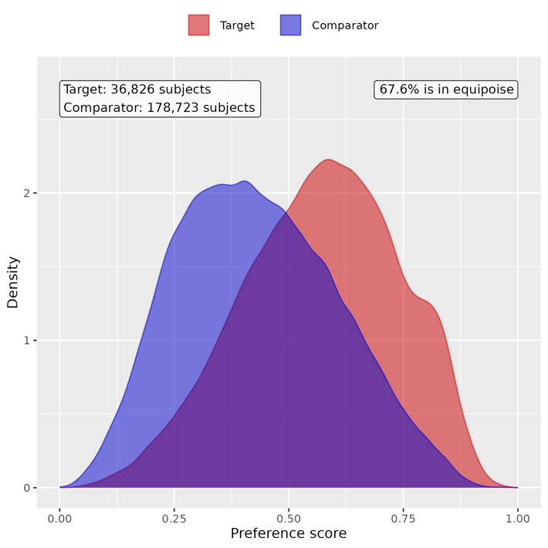

Supp Figure 16. Preference score distributions of COVID-19 positive and negative groups in children during Delta period. A greater convergence of these distributions indicates a higher similarity in the predicted likelihood of being infected between the COVID-19 positive (red) and negative (blue) participants.
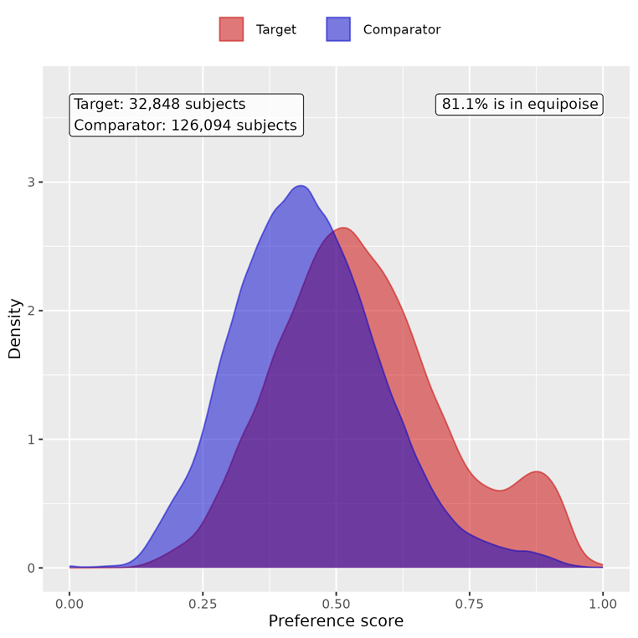

Supp Figure 17. Preference score distributions of COVID-19 positive and negative groups in children during Omicron period. A greater convergence of these distributions indicates a higher similarity in the predicted likelihood of being infected between the COVID-19 positive (red) and negative (blue) participants.
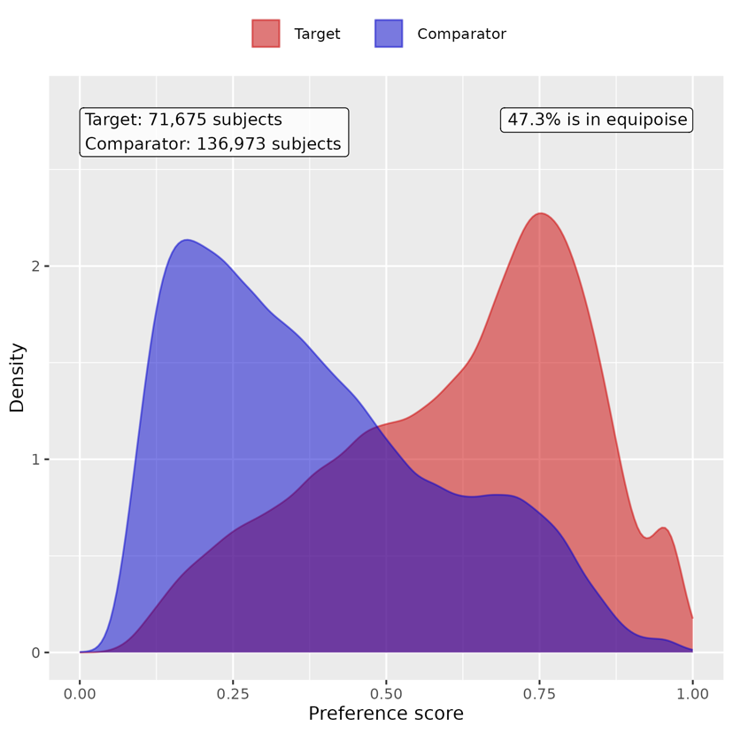

Supp Figure 18. Preference score distributions of COVID-19 positive and negative groups for youths in pre-Delta period. A greater convergence of these distributions indicates a higher similarity in the predicted likelihood of being infected between the COVID-19 positive (red) and negative (blue) participants.
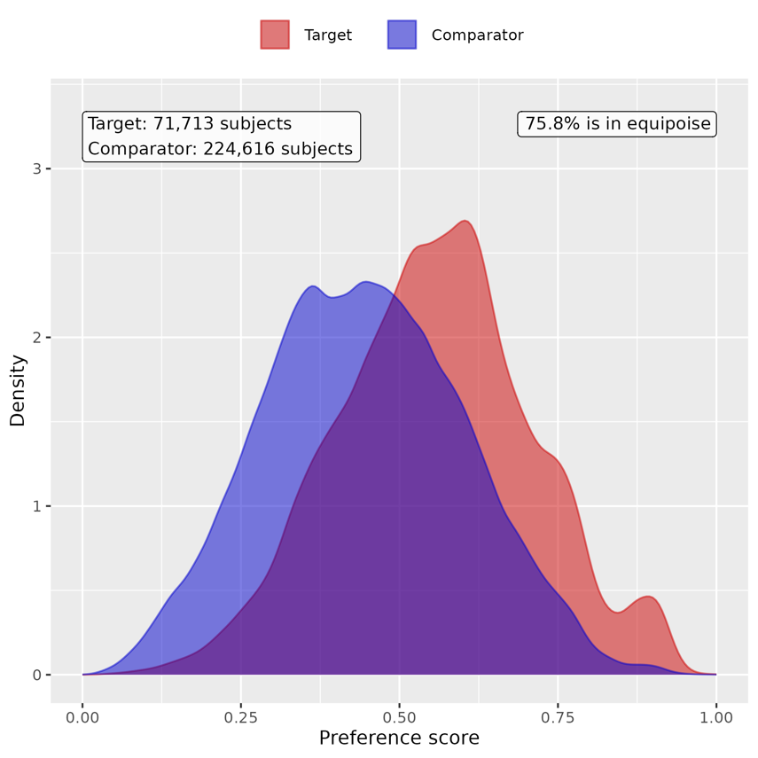

Supp Figure 19. Preference score distributions of COVID-19 positive and negative groups for youths in Delta period. A greater convergence of these distributions indicates a higher similarity in the predicted likelihood of being infected between the COVID-19 positive (red) and negative (blue) participants.
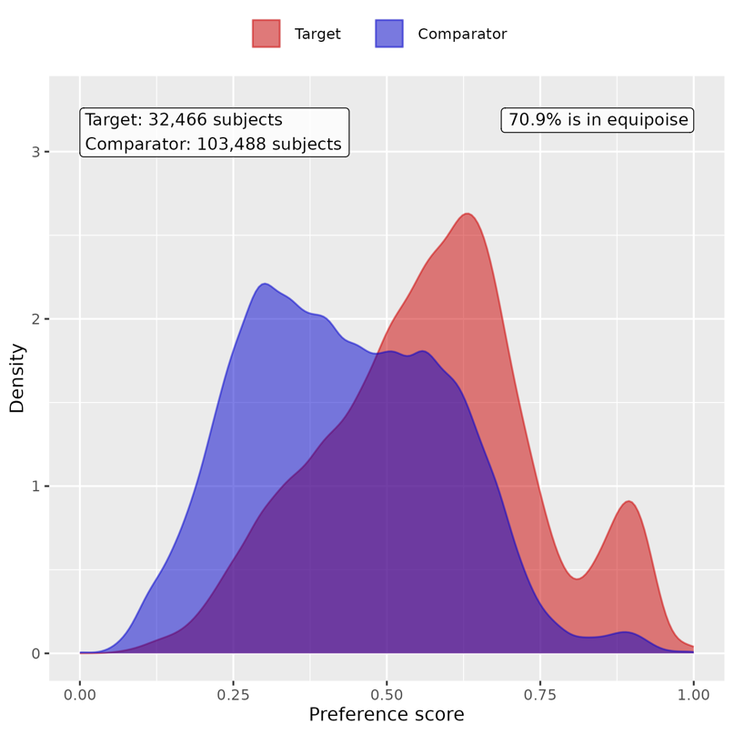

Supp Figure 20. Preference score distributions of COVID-19 positive and negative groups for youths in Omicron period. A greater convergence of these distributions indicates a higher similarity in the predicted likelihood of being infected between the COVID-19 positive (red) and negative (blue) participants.
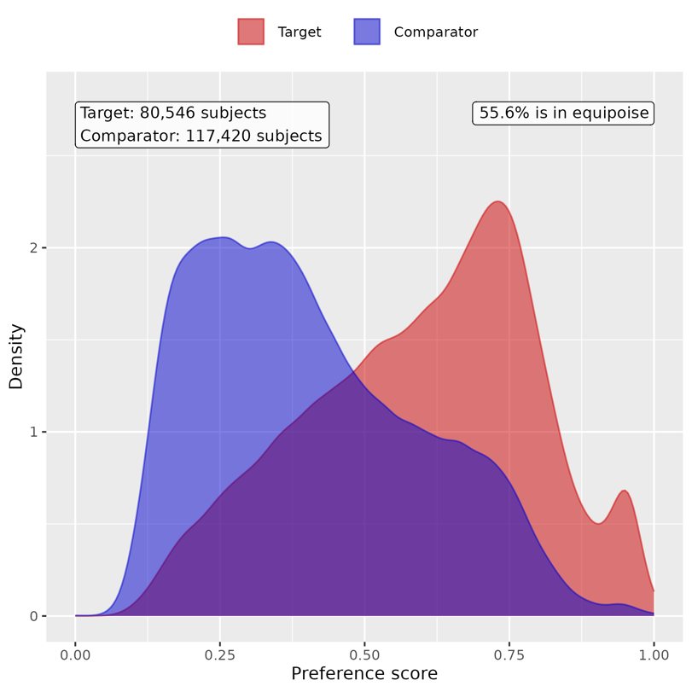

B. Patient characteristic balance

Supp Figure 21. Patient characteristic balance before and after large-scale PS matching with ratio 1:2 for children in pre-Delta period. The upper panel displays the top 20 covariates with the largest standardized difference of means before matching, while the lower panel displays the top 20 covariates with the largest standardized difference of means after matching.
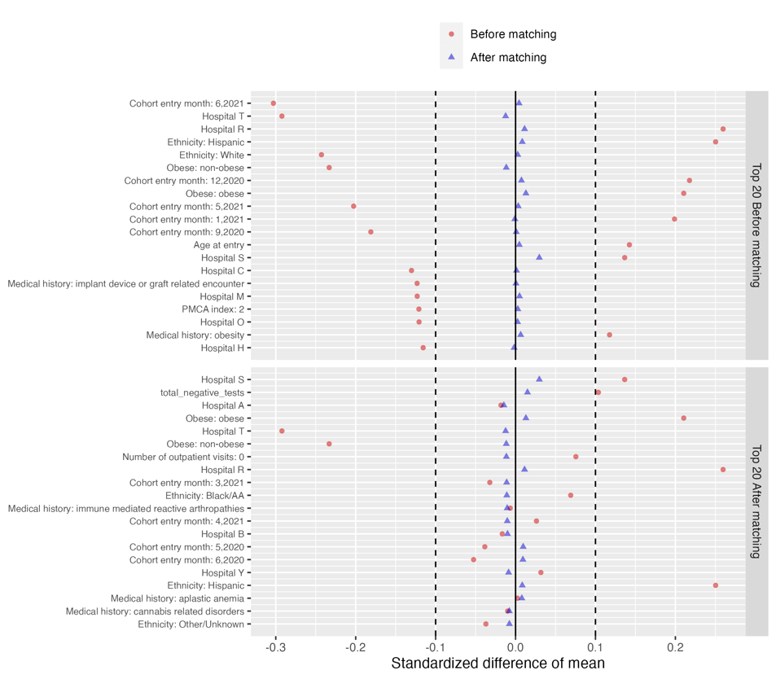

Supp Figure 22. Patient characteristic balance before and after large-scale PS matching with ratio 1:2 for children in Delta period. The upper panel displays the top 20 covariates with the largest standardized difference of means before matching, while the lower panel displays the top 20 covariates with the largest standardized difference of means after matching.
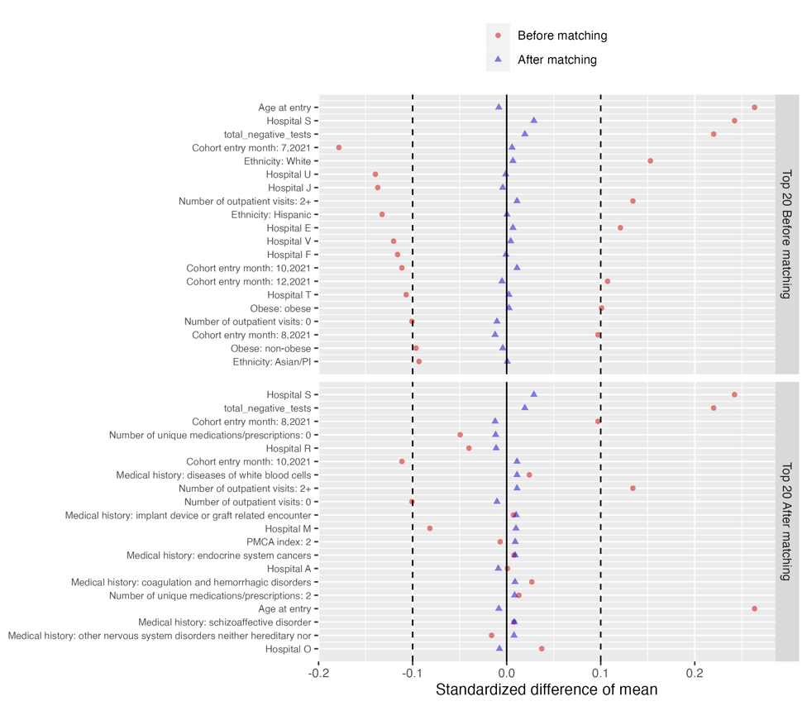
Supp Figure 23. Patient characteristic balance before and after large-scale PS matching with ratio 1:2 for children in Omicron period. The upper panel displays the top 20 covariates with the largest standardized difference of means before matching, while the lower panel displays the top 20 covariates with the largest standardized difference of means after matching.
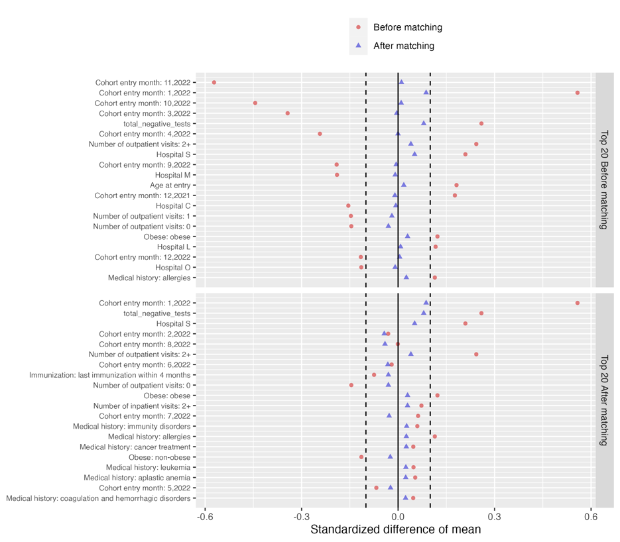

Supp Figure 24. Patient characteristic balance before and after large-scale PS matching with ratio 1:2 for youths in pre-Delta period. The upper panel displays the top 20 covariates with the largest standardized difference of means before matching, while the lower panel displays the top 20 covariates with the largest standardized difference of means after matching.
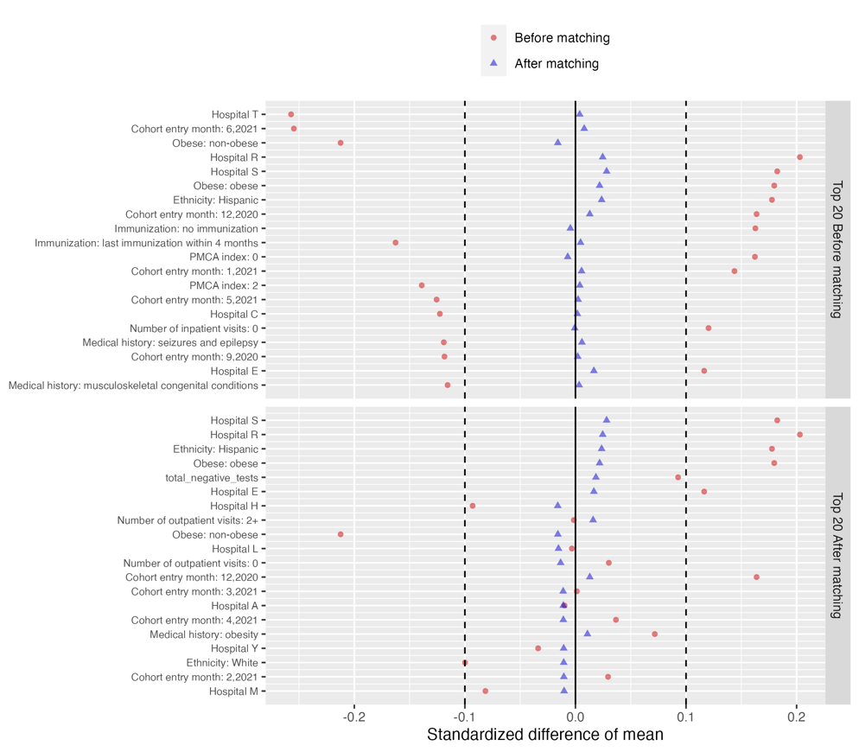

Supp Figure 25. Patient characteristic balance before and after large-scale PS matching with ratio 1:2 for youths in Delta period. The upper panel displays the top 20 covariates with the largest standardized difference of means before matching, while the lower panel displays the top 20 covariates with the largest standardized difference of means after matching.
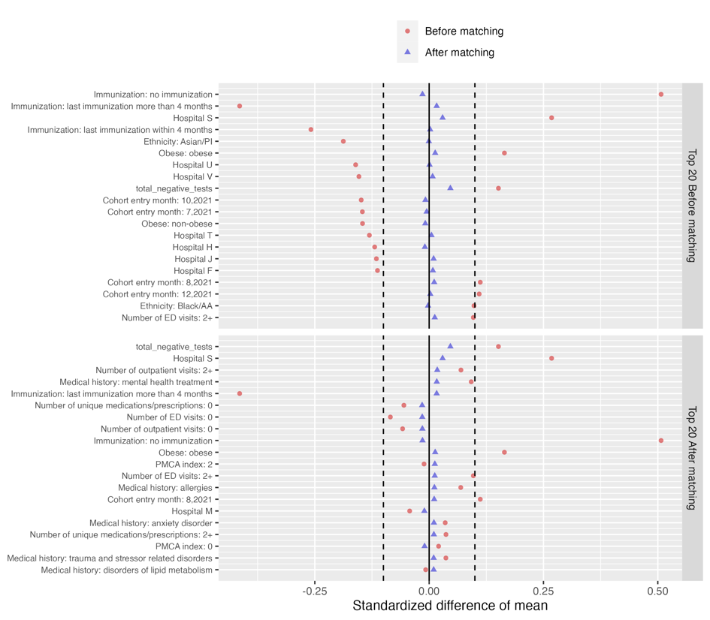

Supp Figure 26. Patient characteristic balance before and after large-scale PS matching with ratio 1:2 for youths in Omicron period. The upper panel displays the top 20 covariates with the largest standardized difference of means before matching, while the lower panel displays the top 20 covariates with the largest standardized difference of means after matching.
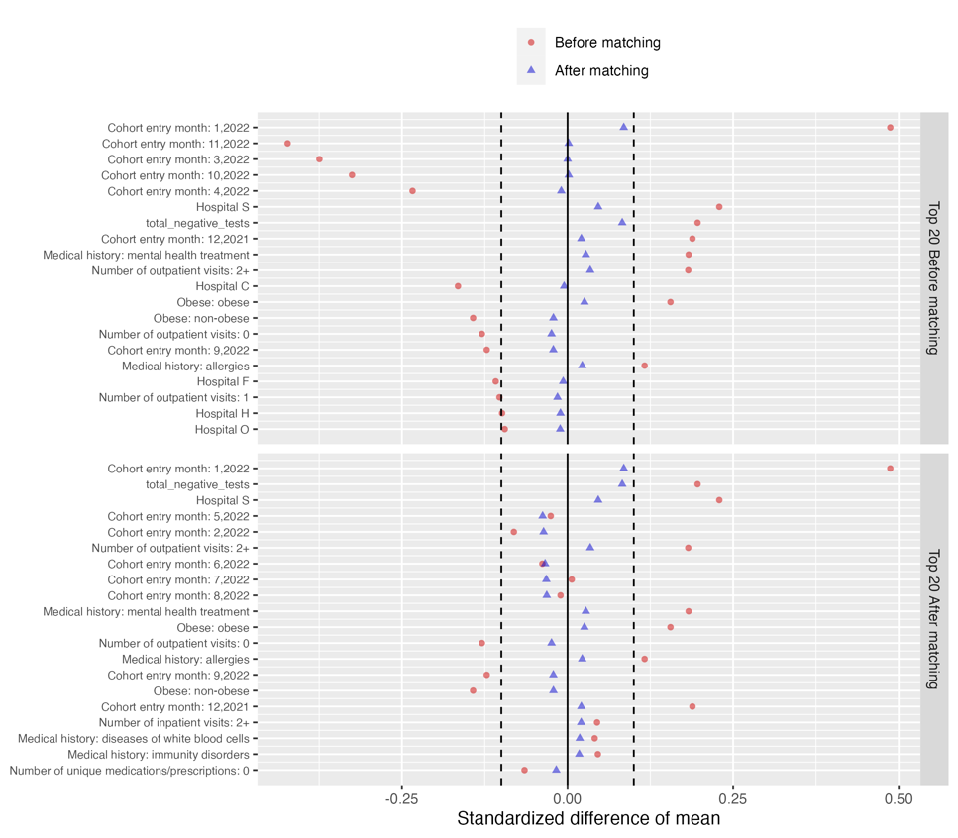

C. Risk difference of COVID-19 positive group compared to COVID-19 negative group

Supp Table 3. Estimated risk difference in mental health conditions between the COVID-19 positive group and COVID-19 negative group for children in pre-Delta period

Category | Cluster | Risk difference (%) | 95% CI (%) | P value
Composite | At least one incident | 0.999 | (0.429, 1.568) | <0.001
Adverse childhood experiences | Emotional abuse | 0.01 | (-0.018, 0.037) | 0.5
 | Neglect | 0.005 | (-0.018, 0.027) | 0.686
 | Physical abuse | 0 | (-0.054, 0.055) | 0.992
 | Sexual abuse | 0 | (-0.046, 0.046) | 0.99
Anxiety disorders | Anxiety disorder | 0.124 | (-0.135, 0.384) | 0.348
 | OCD | 0.105 | (0.039, 0.171) | 0.002
 | Somatoform disorder | 0.025 | (-0.056, 0.107) | 0.547
 | Stress disorder | 0.111 | (-0.108, 0.329) | 0.322
Disruptive behavior disorders | Conduct disorder | -0.001 | (-0.126, 0.124) | 0.984
 | Impulse control disorder | -0.07 | (-0.189, 0.050) | 0.253
 | Oppositional defiant disorder | 0.003 | (-0.105, 0.111) | 0.961
Eating and feeding disorders | Avoidant restrictive food intake | -0.018 | (-0.114, 0.078) | 0.717
 | Other eating and feeding disorder | -0.023 | (-0.071, 0.024) | 0.336
Elimination disorders | Encopresis | 0.024 | (-0.046, 0.095) | 0.499
 | Enuresis | -0.048 | (-0.190, 0.095) | 0.513
Gender dysphoria sexual dysfunction | Gender dysphoria | 0.005 | (-0.030, 0.040) | 0.778
 | Paraphilia | -0.001 | (-0.005, 0.002) | 0.468
 | Sexual dysfunction | 0.003 | (-0.005, 0.011) | 0.468
Intentional self-harm/suicidality | Parasuicidality | -0.02 | (-0.069, 0.029) | 0.427
 | Suicidality | -0.006 | (-0.075, 0.064) | 0.872
Mood disorders | Bipolar disorder | 0.035 | (-0.005, 0.075) | 0.086
 | Major depression | -0.027 | (-0.129, 0.075) | 0.6
 | Minor depression | -0.067 | (-0.176, 0.042) | 0.231
Neurocognitive disorders | Catatonia | -0.003 | (-0.016, 0.010) | 0.646
 | Delirium | 0.066 | (0.011, 0.121) | 0.018
 | Encephalopathy | 0.011 | (-0.031, 0.053) | 0.605
Neurodevelopmental disorders | Academic developmental disorder | 0.017 | (-0.131, 0.165) | 0.82
 | ADHD | 0.122 | (-0.228, 0.473) | 0.493
 | Autism spectrum disorder | 0.153 | (-0.073, 0.380) | 0.185
 | Communication motor disorder | 0.252 | (-0.008, 0.512) | 0.057
 | Intellectual disability | 0.165 | (-0.024, 0.353) | 0.087
Personality disorders | Personality disorder | -0.007 | (-0.034, 0.019) | 0.597
Psychotic disorders | Psychotic disorder | -0.004 | (-0.037, 0.029) | 0.832
 | Schizoaffective disorder | NA | NA | NA
 | Schizophrenia | -0.001 | (-0.012, 0.010) | 0.817
Sleep wake disorders | Hypersomnia | 0.031 | (-0.018, 0.079) | 0.217
 | Insomnia | -0.005 | (-0.127, 0.118) | 0.942
 | Parasomnias | 0.03 | (-0.053, 0.113) | 0.477
Standalone symptoms | Anger aggression | 0.064 | (-0.033, 0.161) | 0.199
 | Anxiety symptoms | 0.034 | (-0.050, 0.118) | 0.429
 | Attention symptoms | -0.074 | (-0.188, 0.041) | 0.207
 | Depressive symptoms | -0.019 | (-0.043, 0.005) | 0.117
 | Hallucinations | 0.003 | (-0.036, 0.042) | 0.879
Substance use and dependence | Alcohol | 0.001 | (-0.006, 0.009) | 0.744
 | Opioid related | -0.004 | (-0.016, 0.008) | 0.536
 | Other substances | 0.006 | (-0.012, 0.024) | 0.536
 | THC | NA | NA | NA
 | Tobacco | 0.003 | (-0.001, 0.007) | 0.168
Tic disorders | Tic disorder | 0.073 | (-0.022, 0.167) | 0.133

Supp Table 4. Estimated risk difference in mental health conditions between the COVID-19 positive cohort and COVID-19 negative cohort for children in Delta period

Category | Cluster | Risk difference (%) | 95% CI (%) | P value
Composite | At least one incident | 0.716 | (0.089, 1.344) | 0.025
Adverse childhood experiences | Emotional abuse | -0.013 | (-0.047, 0.022) | 0.470
 | Neglect | -0.004 | (-0.024, 0.017) | 0.737
 | Physical abuse | 0.036 | (-0.025, 0.097) | 0.244
 | Sexual abuse | 0.044 | (-0.003, 0.092) | 0.069
Anxiety disorders | Anxiety disorder | 0.397 | (0.107, 0.687) | 0.007
 | OCD | -0.028 | (-0.095, 0.038) | 0.403
 | Somatoform disorder | 0.08 | (-0.005, 0.166) | 0.065
 | Stress disorder | 0.084 | (-0.151, 0.318) | 0.484
Disruptive behavior disorders | Conduct disorder | -0.026 | (-0.155, 0.103) | 0.692
 | Impulse control disorder | -0.025 | (-0.147, 0.098) | 0.694
 | Oppositional defiant disorder | 0.046 | (-0.067, 0.158) | 0.426
Eating and feeding disorders | Avoidant restrictive food intake | 0.038 | (-0.060, 0.137) | 0.447
 | Other eating and feeding disorder | 0.023 | (-0.024, 0.069) | 0.337
Elimination disorders | Encopresis | 0.039 | (-0.037, 0.115) | 0.310
 | Enuresis | -0.083 | (-0.236, 0.069) | 0.284
Gender dysphoria sexual dysfunction | Gender dysphoria | -0.009 | (-0.049, 0.032) | 0.672
 | Paraphilia | 0.002 | (-0.003, 0.006) | 0.467
 | Sexual dysfunction | NA | NA | NA
Intentional self-harm/suicidality | Parasuicidality | 0.014 | (-0.041, 0.068) | 0.620
 | Suicidality | 0.023 | (-0.055, 0.100) | 0.566
Mood disorders | Bipolar disorder | 0.02 | (-0.025, 0.065) | 0.372
 | Major depression | -0.004 | (-0.095, 0.088) | 0.940
 | Minor depression | 0.08 | (-0.040, 0.201) | 0.192
Neurocognitive disorders | Catatonia | 0.006 | (-0.005, 0.017) | 0.262
 | Delirium | 0.063 | (0.011, 0.115) | 0.018
 | Encephalopathy | 0.001 | (-0.040, 0.041) | 0.972
Neurodevelopmental disorders | Academic developmental disorder | 0.01 | (-0.146, 0.166) | 0.901
 | ADHD | 0.185 | (-0.223, 0.593) | 0.374
 | Autism spectrum disorder | 0.07 | (-0.197, 0.337) | 0.606
 | Communication motor disorder | 0.07 | (-0.208, 0.348) | 0.622
 | Intellectual disability | 0.012 | (-0.183, 0.208) | 0.900
Personality disorders | Personality disorder | 0.02 | (-0.008, 0.049) | 0.160
Psychotic disorders | Psychotic disorder | -0.008 | (-0.039, 0.022) | 0.595
 | Schizoaffective disorder | 0.003 | (-0.001, 0.008) | 0.170
 | Schizophrenia | -0.003 | (-0.011, 0.005) | 0.428
Sleep wake disorders | Hypersomnia | -0.065 | (-0.114, -0.016) | 0.010
 | Insomnia | -0.024 | (-0.158, 0.111) | 0.733
 | Parasomnias | 0.027 | (-0.058, 0.112) | 0.535
Standalone symptoms | Anger aggression | 0.039 | (-0.067, 0.145) | 0.470
 | Anxiety symptoms | 0.106 | (0.014, 0.197) | 0.023
 | Attention symptoms | 0.035 | (-0.098, 0.168) | 0.605
 | Depressive symptoms | 0.008 | (-0.018, 0.035) | 0.538
 | Hallucinations | 0.007 | (-0.031, 0.044) | 0.728
Substance use and dependence | Alcohol | 0 | (-0.006, 0.006) | 1.000
 | Opioid related | 0 | (-0.010, 0.010) | 0.971
 | Other substances | 0.018 | (-0.006, 0.041) | 0.139
 | THC | NA | NA | NA
 | Tobacco | 0.003 | (-0.009, 0.015) | 0.604
Tic disorders | Tic disorder | 0.071 | (-0.039, 0.181) | 0.204

Supp Table 5. Estimated risk difference in mental health conditions between the COVID-19 positive cohort and COVID-19 negative cohort for children in Omicron period

Category | Cluster | Risk difference (%) | 95% CI (%) | P value
Composite | At least one incident | 0.618 | (0.112, 1.124) | 0.017
Adverse childhood experiences | Emotional abuse | -0.024 | (-0.058, 0.010) | 0.160
 | Neglect | 0.014 | (-0.007, 0.034) | 0.185
 | Physical abuse | -0.004 | (-0.054, 0.047) | 0.887
 | Sexual abuse | -0.007 | (-0.043, 0.029) | 0.698
Anxiety disorders | Anxiety disorder | 0.304 | (0.079, 0.529) | 0.008
 | OCD | 0.024 | (-0.031, 0.080) | 0.393
 | Somatoform disorder | 0.014 | (-0.066, 0.095) | 0.729
 | Stress disorder | 0.042 | (-0.138, 0.223) | 0.646
Disruptive behavior disorders | Conduct disorder | -0.046 | (-0.149, 0.056) | 0.378
 | Impulse control disorder | -0.013 | (-0.108, 0.081) | 0.783
 | Oppositional defiant disorder | 0.037 | (-0.042, 0.117) | 0.357
Eating and feeding disorders | Avoidant restrictive food intake | 0.07 | (-0.020, 0.161) | 0.126
 | Other eating and feeding disorder | -0.009 | (-0.057, 0.038) | 0.704
Elimination disorders | Encopresis | 0.058 | (-0.005, 0.122) | 0.071
 | Enuresis | 0.09 | (-0.029, 0.209) | 0.137
Gender dysphoria sexual dysfunction | Gender dysphoria | -0.004 | (-0.036, 0.028) | 0.790
 | Paraphilia | -0.001 | (-0.004, 0.002) | 0.400
 | Sexual dysfunction | -0.002 | (-0.010, 0.005) | 0.551
Intentional self-harm/suicidality | Parasuicidality | -0.007 | (-0.051, 0.037) | 0.753
 | Suicidality | 0.034 | (-0.026, 0.093) | 0.265
Mood disorders | Bipolar disorder | 0.001 | (-0.034, 0.035) | 0.970
 | Major depression | -0.033 | (-0.095, 0.030) | 0.307
 | Minor depression | 0.015 | (-0.076, 0.106) | 0.746
Neurocognitive disorders | Catatonia | 0 | (-0.009, 0.009) | 0.963
 | Delirium | 0.022 | (-0.027, 0.071) | 0.379
 | Encephalopathy | -0.006 | (-0.038, 0.026) | 0.718
Neurodevelopmental disorders | Academic developmental disorder | 0.035 | (-0.093, 0.162) | 0.596
 | ADHD | 0.136 | (-0.169, 0.440) | 0.382
 | Autism spectrum disorder | 0.133 | (-0.101, 0.366) | 0.266
 | Communication motor disorder | 0.095 | (-0.153, 0.343) | 0.452
 | Intellectual disability | 0.061 | (-0.109, 0.232) | 0.482
Personality disorders | Personality disorder | -0.005 | (-0.027, 0.017) | 0.639
Psychotic disorders | Psychotic disorder | 0.004 | (-0.024, 0.031) | 0.793
 | Schizoaffective disorder | 0.001 | (-0.004, 0.006) | 0.627
 | Schizophrenia | 0.002 | (-0.003, 0.007) | 0.376
Sleep wake disorders | Hypersomnia | -0.008 | (-0.040, 0.024) | 0.615
 | Insomnia | 0.018 | (-0.081, 0.118) | 0.716
 | Parasomnias | 0.076 | (0.002, 0.150) | 0.044
Standalone symptoms | Anger aggression | 0.002 | (-0.080, 0.083) | 0.971
 | Anxiety symptoms | 0.051 | (-0.034, 0.135) | 0.238
 | Attention symptoms | 0.046 | (-0.063, 0.154) | 0.409
 | Depressive symptoms | 0.008 | (-0.013, 0.030) | 0.450
 | Hallucinations | -0.004 | (-0.034, 0.026) | 0.793
Substance use and dependence | Alcohol | -0.003 | (-0.008, 0.003) | 0.310
 | Opioid related | 0.006 | (-0.006, 0.018) | 0.299
 | Other substances | 0.009 | (-0.007, 0.024) | 0.266
 | THC | 0 | (-0.004, 0.004) | 1.000
 | Tobacco | -0.004 | (-0.010, 0.002) | 0.199
Tic disorders | Tic disorder | 0.029 | (-0.059, 0.117) | 0.516

Supp Table 6. Estimated risk difference in mental health conditions between the COVID-19 positive cohort and COVID-19 negative cohort for youths in pre-Delta period

Category | Cluster | Risk difference (%) | 95% CI (%) | P value
Composite | At least one incident | 0.782 | (0.337, 1.227) | <0.001
Adverse childhood experiences | Emotional abuse | 0.01 | (-0.007, 0.026) | 0.272
 | Neglect | 0.002 | (-0.013, 0.016) | 0.804
 | Physical abuse | 0.019 | (-0.023, 0.061) | 0.38
 | Sexual abuse | 0.006 | (-0.031, 0.044) | 0.743
Anxiety disorders | Anxiety disorder | 0.357 | (0.057, 0.657) | 0.02
 | OCD | 0.016 | (-0.059, 0.090) | 0.681
 | Somatoform disorder | 0.003 | (-0.078, 0.084) | 0.941
 | Stress disorder | 0.253 | (0.060, 0.446) | 0.01
Disruptive behavior disorders | Conduct disorder | -0.014 | (-0.072, 0.044) | 0.634
 | Impulse control disorder | -0.024 | (-0.100, 0.053) | 0.547
 | Oppositional defiant disorder | 0.044 | (-0.029, 0.117) | 0.233
Eating and feeding disorders | Avoidant restrictive food intake | -0.089 | (-0.205, 0.028) | 0.137
 | Other eating and feeding disorder | 0.02 | (-0.007, 0.046) | 0.142
Elimination disorders | Encopresis | 0.005 | (-0.015, 0.025) | 0.608
 | Enuresis | 0.027 | (-0.024, 0.077) | 0.3
Gender dysphoria sexual dysfunction | Gender dysphoria | -0.057 | (-0.118, 0.005) | 0.07
 | Paraphilia | 0.003 | (-0.005, 0.011) | 0.495
 | Sexual dysfunction | 0.008 | (-0.009, 0.025) | 0.35
Intentional self-harm/suicidality | Parasuicidality | 0.014 | (-0.047, 0.075) | 0.656
 | Suicidality | 0.146 | (0.027, 0.264) | 0.016
Mood disorders | Bipolar disorder | 0.02 | (-0.029, 0.068) | 0.429
 | Major depression | -0.088 | (-0.328, 0.152) | 0.471
 | Minor depression | 0.11 | (-0.108, 0.327) | 0.323
Neurocognitive disorders | Catatonia | -0.008 | (-0.025, 0.009) | 0.361
 | Delirium | 0.071 | (-0.005, 0.147) | 0.067
 | Encephalopathy | 0.006 | (-0.025, 0.036) | 0.718
Neurodevelopmental disorders | Academic developmental disorder | 0.071 | (-0.006, 0.148) | 0.071
 | ADHD | 0.307 | (0.064, 0.551) | 0.013
 | Autism spectrum disorder | 0.031 | (-0.084, 0.146) | 0.598
 | Communication motor disorder | 0.082 | (-0.003, 0.166) | 0.06
 | Intellectual disability | 0.041 | (-0.064, 0.146) | 0.448
Personality disorders | Personality disorder | -0.027 | (-0.071, 0.018) | 0.24
Psychotic disorders | Psychotic disorder | -0.016 | (-0.063, 0.031) | 0.496
 | Schizoaffective disorder | -0.002 | (-0.023, 0.019) | 0.879
 | Schizophrenia | 0.004 | (-0.026, 0.033) | 0.804
Sleep wake disorders | Hypersomnia | 0.017 | (-0.028, 0.063) | 0.453
 | Insomnia | 0.094 | (-0.015, 0.203) | 0.09
 | Parasomnias | 0.012 | (-0.031, 0.056) | 0.577
Standalone symptoms | Anger aggression | 0.062 | (-0.003, 0.126) | 0.06
 | Anxiety symptoms | 0.017 | (-0.045, 0.078) | 0.592
 | Attention symptoms | 0.052 | (-0.018, 0.121) | 0.148
 | Depressive symptoms | 0.023 | (-0.002, 0.049) | 0.075
 | Hallucinations | 0.007 | (-0.032, 0.046) | 0.715
Substance use and dependence | Alcohol | 0.018 | (-0.021, 0.057) | 0.376
 | Opioid related | 0.014 | (-0.010, 0.037) | 0.25
 | Other substances | -0.023 | (-0.072, 0.026) | 0.36
 | THC | -0.059 | (-0.119, 0.001) | 0.054
 | Tobacco | -0.002 | (-0.079, 0.076) | 0.967
Tic disorders | Tic disorder | 0.008 | (-0.054, 0.069) | 0.808

Supp Table 7. Estimated risk difference in mental health conditions between the COVID-19 positive cohort and COVID-19 negative cohort for youths in Delta period

Category | Cluster | Risk difference (%) | 95% CI (%) | P value
Composite | At least one incident | 0.903 | (0.188, 1.618) | 0.013
Adverse childhood experiences | Emotional abuse | 0.016 | (-0.017, 0.050) | 0.329
 | Neglect | 0.001 | (-0.025, 0.027) | 0.929
 | Physical abuse | 0.026 | (-0.052, 0.103) | 0.519
 | Sexual abuse | 0.086 | (0.016, 0.155) | 0.016
Anxiety disorders | Anxiety disorder | -0.057 | (-0.538, 0.424) | 0.817
 | OCD | 0.043 | (-0.072, 0.158) | 0.466
 | Somatoform disorder | 0.016 | (-0.112, 0.144) | 0.809
 | Stress disorder | -0.149 | (-0.464, 0.167) | 0.356
Disruptive behavior disorders | Conduct disorder | -0.003 | (-0.099, 0.094) | 0.952
 | Impulse control disorder | 0.001 | (-0.130, 0.131) | 0.993
 | Oppositional defiant disorder | 0.014 | (-0.109, 0.137) | 0.822
Eating and feeding disorders | Avoidant restrictive food intake | -0.077 | (-0.260, 0.106) | 0.410
 | Other eating and feeding disorder | -0.002 | (-0.051, 0.047) | 0.925
Elimination disorders | Encopresis | 0.022 | (-0.012, 0.056) | 0.209
 | Enuresis | 0.022 | (-0.069, 0.113) | 0.634
Gender dysphoria sexual dysfunction | Gender dysphoria | -0.025 | (-0.125, 0.075) | 0.623
 | Paraphilia | -0.005 | (-0.019, 0.009) | 0.461
 | Sexual dysfunction | -0.002 | (-0.029, 0.025) | 0.883
Intentional self-harm/suicidality | Parasuicidality | 0.052 | (-0.049, 0.154) | 0.312
 | Suicidality | 0.134 | (-0.064, 0.332) | 0.184
Mood disorders | Bipolar disorder | -0.021 | (-0.096, 0.055) | 0.593
 | Major depression | -0.2 | (-0.554, 0.154) | 0.268
 | Minor depression | 0.131 | (-0.227, 0.490) | 0.472
Neurocognitive disorders | Catatonia | 0.005 | (-0.023, 0.033) | 0.710
 | Delirium | 0.06 | (-0.064, 0.184) | 0.340
 | Encephalopathy | 0.02 | (-0.024, 0.064) | 0.364
Neurodevelopmental disorders | Academic developmental disorder | 0.082 | (-0.042, 0.205) | 0.195
 | ADHD | 0.414 | (0.007, 0.821) | 0.046
 | Autism spectrum disorder | 0.113 | (-0.099, 0.326) | 0.297
 | Communication motor disorder | 0.057 | (-0.083, 0.197) | 0.428
 | Intellectual disability | 0.175 | (0.004, 0.346) | 0.044
Personality disorders | Personality disorder | -0.01 | (-0.080, 0.060) | 0.775
Psychotic disorders | Psychotic disorder | 0.016 | (-0.057, 0.089) | 0.669
 | Schizoaffective disorder | -0.016 | (-0.038, 0.007) | 0.183
 | Schizophrenia | -0.009 | (-0.052, 0.034) | 0.689
Sleep wake disorders | Hypersomnia | -0.003 | (-0.074, 0.068) | 0.930
 | Insomnia | 0.213 | (0.041, 0.385) | 0.015
 | Parasomnias | 0.062 | (-0.007, 0.130) | 0.076
Standalone symptoms | Anger aggression | -0.04 | (-0.151, 0.070) | 0.475
 | Anxiety symptoms | 0.105 | (0.003, 0.207) | 0.044
 | Attention symptoms | 0.152 | (0.035, 0.269) | 0.011
 | Depressive symptoms | 0.038 | (0.001, 0.075) | 0.047
 | Hallucinations | 0.03 | (-0.031, 0.091) | 0.338
Substance use and dependence | Alcohol | -0.021 | (-0.076, 0.035) | 0.467
 | Opioid related | 0.004 | (-0.032, 0.039) | 0.832
 | Other substances | -0.013 | (-0.090, 0.065) | 0.744
 | THC | 0.049 | (-0.045, 0.142) | 0.308
 | Tobacco | 0.025 | (-0.108, 0.158) | 0.716
Tic disorders | Tic disorder | 0.048 | (-0.057, 0.152) | 0.370

Supp Table 8. Estimated risk difference in mental health conditions between the COVID-19 positive cohort and COVID-19 negative cohort for youths in Omicron period

Category | Cluster | Risk difference (%) | 95% CI (%) | P value
Composite | At least one incident | 0.648 | (0.081, 1.215) | 0.025
Adverse childhood experiences | Emotional abuse | 0.014 | (-0.017, 0.044) | 0.380
 | Neglect | 0.007 | (-0.013, 0.027) | 0.498
 | Physical abuse | -0.003 | (-0.061, 0.055) | 0.916
 | Sexual abuse | 0.013 | (-0.036, 0.062) | 0.608
Anxiety disorders | Anxiety disorder | 0.359 | (-0.039, 0.757) | 0.077
 | OCD | 0.037 | (-0.067, 0.140) | 0.488
 | Somatoform disorder | -0.079 | (-0.193, 0.035) | 0.174
 | Stress disorder | -0.005 | (-0.252, 0.242) | 0.968
Disruptive behavior disorders | Conduct disorder | -0.038 | (-0.111, 0.035) | 0.310
 | Impulse control disorder | 0.003 | (-0.094, 0.099) | 0.959
 | Oppositional defiant disorder | 0.013 | (-0.073, 0.099) | 0.768
Eating and feeding disorders | Avoidant restrictive food intake | -0.123 | (-0.280, 0.035) | 0.126
 | Other eating and feeding disorder | -0.02 | (-0.057, 0.017) | 0.283
Elimination disorders | Encopresis | 0.006 | (-0.024, 0.036) | 0.687
 | Enuresis | 0.014 | (-0.051, 0.080) | 0.670
Gender dysphoria sexual dysfunction | Gender dysphoria | 0.023 | (-0.088, 0.135) | 0.681
 | Paraphilia | -0.018 | (-0.034, -0.002) | 0.024
 | Sexual dysfunction | -0.003 | (-0.025, 0.019) | 0.814
Intentional self-harm/suicidality | Parasuicidality | 0.006 | (-0.082, 0.095) | 0.891
 | Suicidality | 0.028 | (-0.128, 0.184) | 0.723
Mood disorders | Bipolar disorder | -0.053 | (-0.113, 0.007) | 0.082
 | Major depression | -0.162 | (-0.439, 0.114) | 0.250
 | Minor depression | 0.228 | (-0.077, 0.533) | 0.142
Neurocognitive disorders | Catatonia | 0.009 | (-0.017, 0.035) | 0.490
 | Delirium | 0.077 | (-0.023, 0.176) | 0.130
 | Encephalopathy | 0.027 | (-0.014, 0.068) | 0.202
Neurodevelopmental disorders | Academic developmental disorder | 0.029 | (-0.072, 0.129) | 0.578
 | ADHD | 0.266 | (-0.051, 0.583) | 0.100
 | Autism spectrum disorder | 0.018 | (-0.170, 0.206) | 0.850
 | Communication motor disorder | 0.021 | (-0.098, 0.139) | 0.734
 | Intellectual disability | 0.078 | (-0.074, 0.230) | 0.314
Personality disorders | Personality disorder | -0.031 | (-0.093, 0.031) | 0.327
Psychotic disorders | Psychotic disorder | -0.017 | (-0.081, 0.048) | 0.615
 | Schizoaffective disorder | -0.01 | (-0.038, 0.018) | 0.476
 | Schizophrenia | -0.037 | (-0.078, 0.005) | 0.081
Sleep wake disorders | Hypersomnia | 0.023 | (-0.036, 0.081) | 0.450
 | Insomnia | 0.101 | (-0.036, 0.237) | 0.149
 | Parasomnias | 0.044 | (-0.014, 0.103) | 0.138
Standalone symptoms | Anger aggression | -0.006 | (-0.093, 0.082) | 0.900
 | Anxiety symptoms | 0.065 | (-0.027, 0.156) | 0.164
 | Attention symptoms | 0.131 | (0.037, 0.225) | 0.006
 | Depressive symptoms | 0.015 | (-0.015, 0.045) | 0.336
 | Hallucinations | 0.02 | (-0.032, 0.072) | 0.455
Substance use and dependence | Alcohol | -0.025 | (-0.069, 0.019) | 0.267
 | Opioid related | -0.013 | (-0.044, 0.018) | 0.415
 | Other substances | -0.01 | (-0.070, 0.051) | 0.753
 | THC | -0.02 | (-0.093, 0.054) | 0.596
 | Tobacco | 0.016 | (-0.082, 0.114) | 0.743
Tic disorders | Tic disorder | 0.079 | (-0.005, 0.164) | 0.067

Section 8 Supplemental Results: sensitivity analysis for sex

We conducted sensitivity analyses on both cohorts stratified by sex to investigate the potential effect of sex on the risk of mental health conditions. We performed the same PS matching procedure and difference-in-difference method to estimate the risk difference.

A. Empirical equipoise assessment

Supp Figure 27. Preference score distributions of COVID-19 positive and negative groups for female children. A greater convergence of these distributions indicates a higher similarity in the predicted likelihood of being infected between the COVID-19 positive (red) and negative (blue) participants.
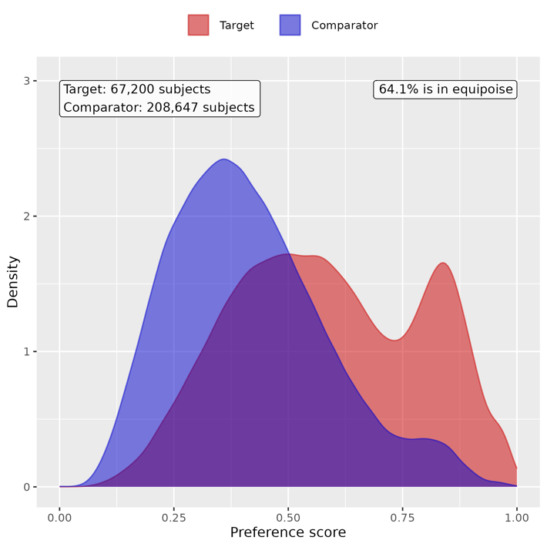

Supp Figure 28. Preference score distributions of COVID-19 positive and negative groups for male children. A greater convergence of these distributions indicates a higher similarity in the predicted likelihood of being infected between the COVID-19 positive (red) and negative (blue) participants.
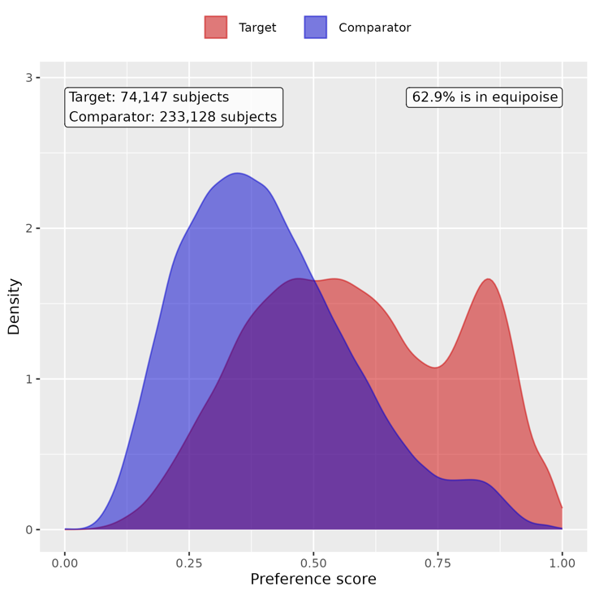

Supp Figure 29. Preference score distributions of COVID-19 positive and negative groups for female youths. A greater convergence of these distributions indicates a higher similarity in the predicted likelihood of being infected between the COVID-19 positive (red) and negative (blue) participants.
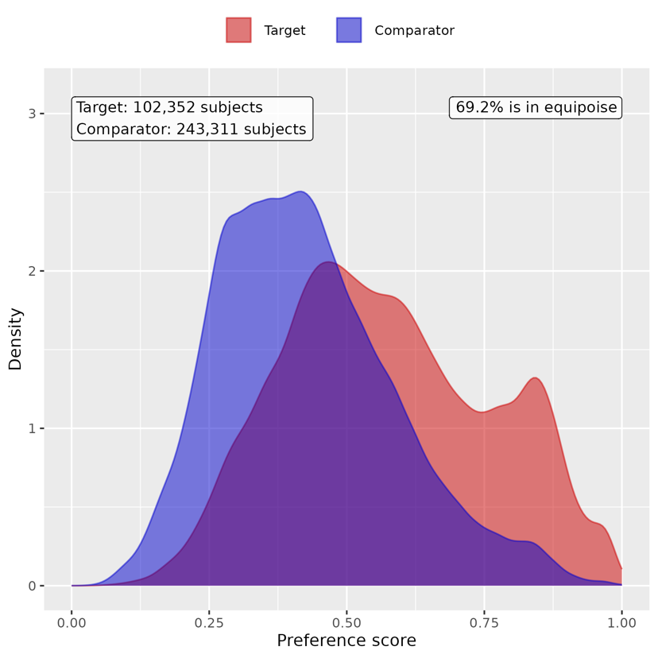

Supp Figure 30. Preference score distributions of COVID-19 positive and negative groups for male youths. A greater convergence of these distributions indicates a higher similarity in the predicted likelihood of being infected between the COVID-19 positive (red) and negative (blue) participants.
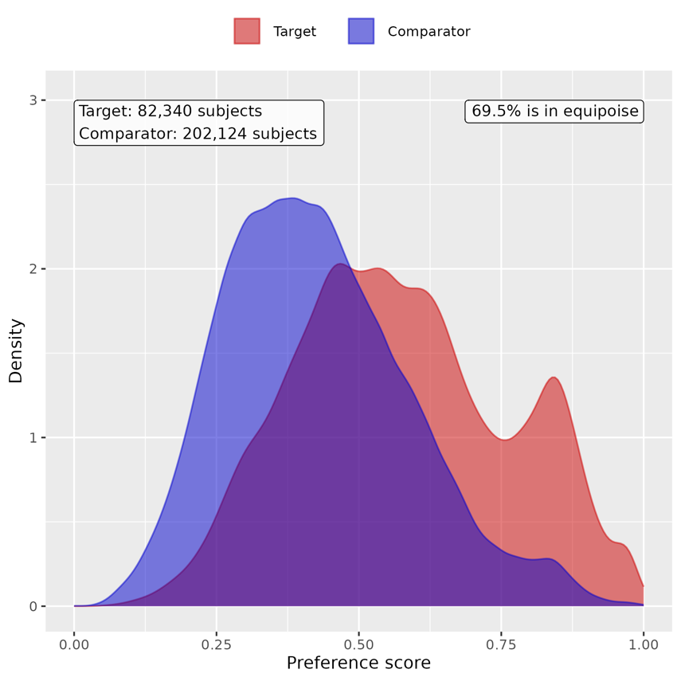

B. Patient characteristic balance

Supp Figure 31. Patient characteristic balance before and after large-scale PS matching with ratio 1:2 for female children. The upper panel displays the top 20 covariates with the largest standardized difference of means before matching, while the lower panel displays the top 20 covariates with the largest standardized difference of means after matching.
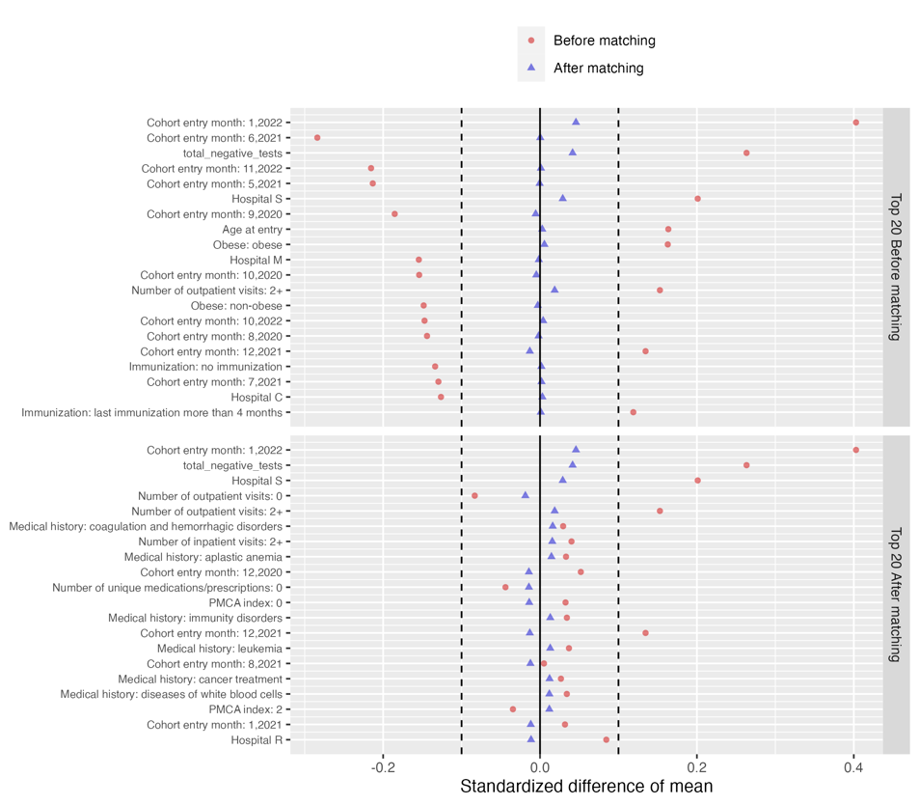

Supp Figure 32. Patient characteristic balance before and after large-scale PS matching with ratio 1:2 for male children. The upper panel displays the top 20 covariates with the largest standardized difference of means before matching, while the lower panel displays the top 20 covariates with the largest standardized difference of means after matching.
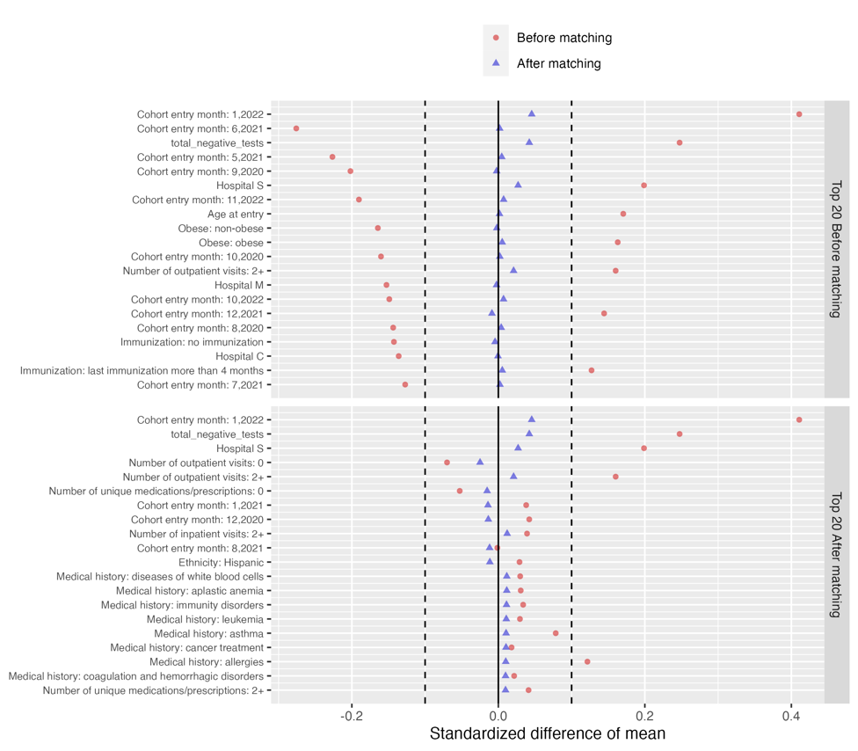
Supp Figure 33. Patient characteristic balance before and after large-scale PS matching with ratio 1:2 for female youths. The upper panel displays the top 20 covariates with the largest standardized difference of means before matching, while the lower panel displays the top 20 covariates with the largest standardized difference of means after matching.
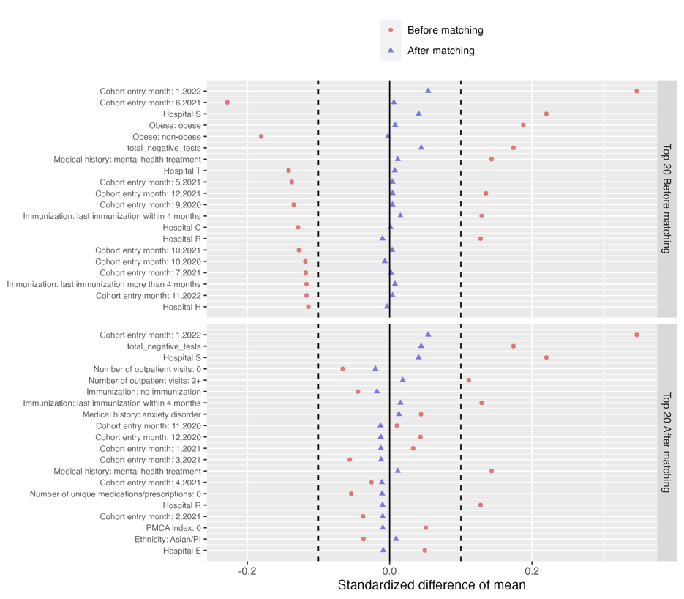

Supp Figure 34. Patient characteristic balance before and after large-scale PS matching with ratio 1:2 for male youths. The upper panel displays the top 20 covariates with the largest standardized difference of means before matching, while the lower panel displays the top 20 covariates with the largest standardized difference of means after matching.
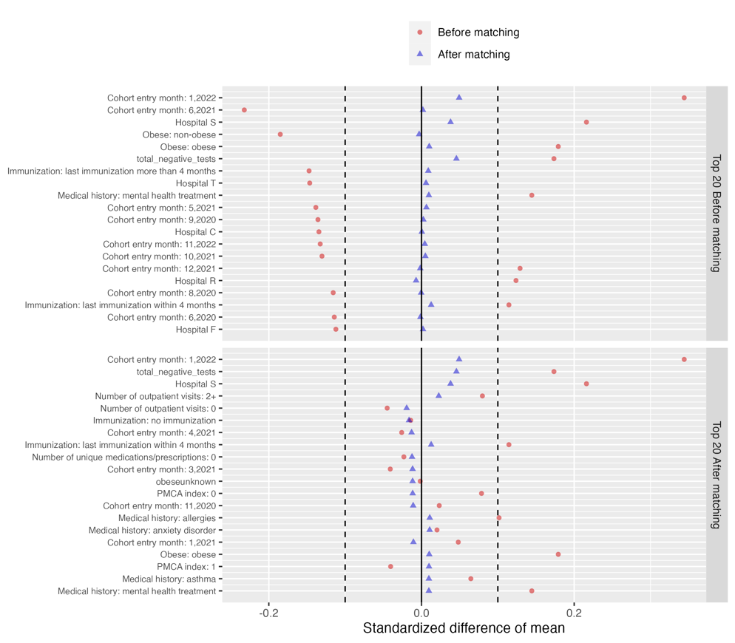

C. Risk difference of COVID-19 positive group compared to COVID-19 negative group

Supp Table 9. Estimated risk difference in mental health conditions between the COVID-19 positive cohort and COVID-19 negative cohort for female children

Category | Cluster | Risk difference (%) | 95% CI (%) | P value
Composite | At least one incident | 0.773 | (0.352, 1.194) | <0.001
Adverse childhood experiences | Emotional abuse | -0.008 | (-0.035, 0.020) | 0.583
 | Neglect | 0.007 | (-0.011, 0.026) | 0.444
 | Physical abuse | 0.018 | (-0.026, 0.063) | 0.427
 | Sexual abuse | -0.019 | (-0.061, 0.023) | 0.379
Anxiety disorders | Anxiety disorder | 0.323 | (0.114, 0.531) | 0.002
 | OCD | 0.045 | (-0.006, 0.096) | 0.087
 | Somatoform disorder | 0.048 | (-0.022, 0.117) | 0.180
 | Stress disorder | 0.036 | (-0.133, 0.206) | 0.674
Disruptive behavior disorders | Conduct disorder | -0.015 | (-0.093, 0.062) | 0.699
 | Impulse control disorder | 0.004 | (-0.066, 0.075) | 0.907
 | Oppositional defiant disorder | -0.015 | (-0.077, 0.047) | 0.638
Eating and feeding disorders | Avoidant restrictive food intake | 0.036 | (-0.041, 0.113) | 0.357
 | Other eating and feeding disorder | 0 | (-0.036, 0.037) | 0.986
Elimination disorders | Encopresis | 0.019 | (-0.032, 0.069) | 0.473
 | Enuresis | 0.047 | (-0.057, 0.151) | 0.374
Gender dysphoria sexual dysfunction | Gender dysphoria | 0 | (-0.031, 0.031) | 0.989
 | Paraphilia | -0.002 | (-0.005, 0.002) | 0.281
 | Sexual dysfunction | 0.003 | (-0.002, 0.007) | 0.300
Intentional self-harm/suicidality | Parasuicidality | 0.01 | (-0.029, 0.049) | 0.620
 | Suicidality | 0.022 | (-0.038, 0.082) | 0.476
Mood disorders | Bipolar disorder | 0.014 | (-0.018, 0.047) | 0.394
 | Major depression | -0.041 | (-0.116, 0.035) | 0.292
 | Minor depression | -0.008 | (-0.098, 0.081) | 0.854
Neurocognitive disorders | Catatonia | 0.001 | (-0.008, 0.011) | 0.818
 | Delirium | 0.027 | (-0.012, 0.066) | 0.178
 | Encephalopathy | -0.003 | (-0.033, 0.027) | 0.841
Neurodevelopmental disorders | Academic developmental disorder | 0.085 | (-0.027, 0.197) | 0.136
 | ADHD | 0.039 | (-0.188, 0.265) | 0.737
 | Autism spectrum disorder | 0.046 | (-0.098, 0.189) | 0.533
 | Communication motor disorder | 0.108 | (-0.072, 0.287) | 0.240
 | Intellectual disability | 0.173 | (0.036, 0.309) | 0.013
Personality disorders | Personality disorder | 0.008 | (-0.010, 0.027) | 0.395
Psychotic disorders | Psychotic disorder | -0.003 | (-0.026, 0.021) | 0.833
 | Schizoaffective disorder | NA | NA | NA
 | Schizophrenia | -0.004 | (-0.011, 0.004) | 0.344
Sleep wake disorders | Hypersomnia | -0.004 | (-0.036, 0.028) | 0.813
 | Insomnia | 0.103 | (0.014, 0.192) | 0.023
 | Parasomnias | 0.045 | (-0.015, 0.104) | 0.141
Standalone symptoms | Anger aggression | 0.022 | (-0.040, 0.084) | 0.483
 | Anxiety symptoms | 0.058 | (-0.014, 0.130) | 0.116
 | Attention symptoms | 0.016 | (-0.071, 0.102) | 0.726
 | Depressive symptoms | 0.017 | (-0.003, 0.038) | 0.098
 | Hallucinations | 0.003 | (-0.029, 0.034) | 0.864
Substance use and dependence | Alcohol | -0.004 | (-0.011, 0.002) | 0.203
 | Opioid related | 0.006 | (-0.007, 0.018) | 0.370
 | Other substances | 0.015 | (0.001, 0.030) | 0.038
 | THC | 0.001 | (-0.001, 0.003) | 0.446
 | Tobacco | -0.001 | (-0.009, 0.008) | 0.903
Tic disorders | Tic disorder | 0.049 | (-0.012, 0.110) | 0.119

Supp Table 10. Estimated risk difference in mental health conditions between the COVID-19 positive cohort and COVID-19 negative cohort for male children

Category | Cluster | Risk difference (%) | 95% CI (%) | P value
Composite | At least one incident | 0.983 | (0.509, 1.458) | <0.001
Adverse childhood experiences | Emotional abuse | -0.012 | (-0.037, 0.013) | 0.360
 | Neglect | 0.007 | (-0.008, 0.023) | 0.358
 | Physical abuse | -0.003 | (-0.048, 0.042) | 0.897
 | Sexual abuse | 0.02 | (-0.006, 0.046) | 0.123
Anxiety disorders | Anxiety disorder | 0.293 | (0.091, 0.494) | 0.004
 | OCD | 0.043 | (-0.006, 0.093) | 0.087
 | Somatoform disorder | 0.033 | (-0.031, 0.098) | 0.308
 | Stress disorder | 0.197 | (0.034, 0.360) | 0.018
Disruptive behavior disorders | Conduct disorder | 0 | (-0.105, 0.105) | 0.999
 | Impulse control disorder | -0.079 | (-0.180, 0.021) | 0.122
 | Oppositional defiant disorder | 0.075 | (-0.014, 0.163) | 0.097
Eating and feeding disorders | Avoidant restrictive food intake | 0.012 | (-0.065, 0.090) | 0.760
 | Other eating and feeding disorder | 0 | (-0.042, 0.043) | 0.986
Elimination disorders | Encopresis | 0.016 | (-0.046, 0.077) | 0.617
 | Enuresis | 0.021 | (-0.091, 0.134) | 0.708
Gender dysphoria sexual dysfunction | Gender dysphoria | -0.009 | (-0.032, 0.015) | 0.486
 | Paraphilia | 0.001 | (-0.001, 0.003) | 0.447
 | Sexual dysfunction | -0.003 | (-0.008, 0.002) | 0.307
Intentional self-harm/suicidality | Parasuicidality | -0.005 | (-0.044, 0.034) | 0.820
 | Suicidality | 0.014 | (-0.034, 0.063) | 0.555
Mood disorders | Bipolar disorder | 0.042 | (0.012, 0.071) | 0.006
 | Major depression | -0.011 | (-0.069, 0.047) | 0.706
 | Minor depression | 0.034 | (-0.044, 0.111) | 0.393
Neurocognitive disorders | Catatonia | 0 | (-0.008, 0.007) | 0.905
 | Delirium | 0.072 | (0.029, 0.116) | 0.001
 | Encephalopathy | 0.009 | (-0.021, 0.040) | 0.551
Neurodevelopmental disorders | Academic developmental disorder | -0.016 | (-0.134, 0.103) | 0.795
 | ADHD | 0.351 | (0.036, 0.667) | 0.029
 | Autism spectrum disorder | 0.218 | (-0.015, 0.451) | 0.067
 | Communication motor disorder | 0.255 | (0.021, 0.490) | 0.033
 | Intellectual disability | 0.077 | (-0.080, 0.234) | 0.335
Personality disorders | Personality disorder | -0.003 | (-0.024, 0.019) | 0.786
Psychotic disorders | Psychotic disorder | 0.006 | (-0.019, 0.032) | 0.616
 | Schizoaffective disorder | 0.003 | (-0.001, 0.007) | 0.102
 | Schizophrenia | 0.003 | (-0.004, 0.010) | 0.431
Sleep wake disorders | Hypersomnia | 0.001 | (-0.033, 0.034) | 0.974
 | Insomnia | -0.045 | (-0.141, 0.051) | 0.356
 | Parasomnias | 0.035 | (-0.032, 0.103) | 0.307
Standalone symptoms | Anger aggression | 0.046 | (-0.038, 0.130) | 0.285
 | Anxiety symptoms | 0.058 | (-0.010, 0.126) | 0.096
 | Attention symptoms | 0.002 | (-0.099, 0.102) | 0.975
 | Depressive symptoms | -0.005 | (-0.022, 0.013) | 0.586
 | Hallucinations | 0.006 | (-0.019, 0.032) | 0.630
Substance use and dependence | Alcohol | 0 | (-0.005, 0.006) | 0.896
 | Opioid related | -0.001 | (-0.011, 0.009) | 0.902
 | Other substances | -0.003 | (-0.021, 0.016) | 0.780
 | THC | 0.001 | (-0.001, 0.003) | 0.447
 | Tobacco | -0.002 | (-0.008, 0.003) | 0.397
Tic disorders | Tic disorder | 0.053 | (-0.037, 0.143) | 0.250

Supp Table 11. Estimated risk difference in mental health conditions between the COVID-19 positive cohort and COVID-19 negative cohort for female youths

Category | Cluster | Risk difference (%) | 95% CI (%) | P value
Composite | At least one incident | 0.716 | (0.280, 1.152) | 0.001
Adverse childhood experiences | Emotional abuse | 0.002 | (-0.019, 0.022) | 0.878
 | Neglect | -0.002 | (-0.017, 0.013) | 0.802
 | Physical abuse | 0.018 | (-0.032, 0.068) | 0.489
 | Sexual abuse | 0.037 | (-0.010, 0.085) | 0.123
Anxiety disorders | Anxiety disorder | 0.27 | (-0.053, 0.593) | 0.102
 | OCD | 0.008 | (-0.070, 0.086) | 0.836
 | Somatoform disorder | -0.025 | (-0.116, 0.065) | 0.585
 | Stress disorder | 0.038 | (-0.163, 0.239) | 0.709
Disruptive behavior disorders | Conduct disorder | -0.017 | (-0.063, 0.029) | 0.457
 | Impulse control disorder | -0.024 | (-0.088, 0.040) | 0.456
 | Oppositional defiant disorder | -0.017 | (-0.075, 0.040) | 0.555
Eating and feeding disorders | Avoidant restrictive food intake | -0.108 | (-0.244, 0.029) | 0.122
 | Other eating and feeding disorder | 0.004 | (-0.025, 0.033) | 0.782
Elimination disorders | Encopresis | -0.004 | (-0.020, 0.012) | 0.607
 | Enuresis | 0.024 | (-0.019, 0.067) | 0.269
Gender dysphoria sexual dysfunction | Gender dysphoria | -0.05 | (-0.129, 0.029) | 0.213
 | Paraphilia | -0.006 | (-0.016, 0.004) | 0.221
 | Sexual dysfunction | 0 | (-0.016, 0.016) | 0.976
Intentional self-harm/suicidality | Parasuicidality | 0.042 | (-0.031, 0.115) | 0.265
 | Suicidality | 0.11 | (-0.022, 0.242) | 0.101
Mood disorders | Bipolar disorder | -0.02 | (-0.070, 0.030) | 0.433
 | Major depression | -0.216 | (-0.466, 0.034) | 0.090
 | Minor depression | 0.309 | (0.062, 0.556) | 0.014
Neurocognitive disorders | Catatonia | -0.005 | (-0.020, 0.010) | 0.505
 | Delirium | 0.128 | (0.054, 0.202) | <0.001
 | Encephalopathy | 0.009 | (-0.018, 0.037) | 0.499
Neurodevelopmental disorders | Academic developmental disorder | 0.025 | (-0.042, 0.091) | 0.467
 | ADHD | 0.191 | (-0.010, 0.392) | 0.063
 | Autism spectrum disorder | 0.038 | (-0.051, 0.127) | 0.399
 | Communication motor disorder | 0.058 | (-0.013, 0.130) | 0.111
 | Intellectual disability | -0.003 | (-0.095, 0.090) | 0.957
Personality disorders | Personality disorder | -0.043 | (-0.095, 0.009) | 0.107
Psychotic disorders | Psychotic disorder | -0.013 | (-0.059, 0.033) | 0.584
 | Schizoaffective disorder | 0.002 | (-0.017, 0.021) | 0.823
 | Schizophrenia | -0.002 | (-0.026, 0.021) | 0.838
Sleep wake disorders | Hypersomnia | 0.002 | (-0.044, 0.048) | 0.933
 | Insomnia | 0.041 | (-0.066, 0.147) | 0.452
 | Parasomnias | 0.043 | (0.001, 0.085) | 0.042
Standalone symptoms | Anger aggression | 0.011 | (-0.044, 0.067) | 0.694
 | Anxiety symptoms | 0.073 | (0.007, 0.139) | 0.031
 | Attention symptoms | 0.075 | (0.006, 0.145) | 0.033
 | Depressive symptoms | 0.02 | (-0.008, 0.047) | 0.157
 | Hallucinations | 0.014 | (-0.027, 0.055) | 0.500
Substance use and dependence | Alcohol | -0.005 | (-0.040, 0.030) | 0.786
 | Opioid related | -0.002 | (-0.023, 0.020) | 0.886
 | Other substances | -0.016 | (-0.062, 0.029) | 0.480
 | THC | -0.006 | (-0.061, 0.049) | 0.829
 | Tobacco | 0.014 | (-0.064, 0.091) | 0.733
Tic disorders | Tic disorder | 0 | (-0.056, 0.056) | 0.997

Supp Table 12. Estimated risk difference in mental health conditions between the COVID-19 positive cohort and COVID-19 negative cohort for male youths

Category | Cluster | Risk difference (%) | 95% CI (%) | P value
Composite | At least one incident | 0.899 | (0.453, 1.346) | <0.001
Adverse childhood experiences | Emotional abuse | 0.027 | (0.007, 0.047) | 0.008
 | Neglect | 0.009 | (-0.006, 0.024) | 0.265
 | Physical abuse | 0.033 | (0.001, 0.066) | 0.044
 | Sexual abuse | 0.013 | (-0.005, 0.031) | 0.152
Anxiety disorders | Anxiety disorder | 0.351 | (0.087, 0.614) | 0.009
 | OCD | 0.037 | (-0.038, 0.111) | 0.337
 | Somatoform disorder | -0.038 | (-0.109, 0.032) | 0.287
 | Stress disorder | 0.185 | (0.010, 0.360) | 0.038
Disruptive behavior disorders | Conduct disorder | -0.003 | (-0.074, 0.068) | 0.935
 | Impulse control disorder | 0.057 | (-0.036, 0.149) | 0.229
 | Oppositional defiant disorder | 0.057 | (-0.028, 0.142) | 0.186
Eating and feeding disorders | Avoidant restrictive food intake | -0.029 | (-0.113, 0.054) | 0.488
 | Other eating and feeding disorder | 0.001 | (-0.025, 0.027) | 0.950
Elimination disorders | Encopresis | 0.034 | (0.005, 0.063) | 0.023
 | Enuresis | 0.013 | (-0.049, 0.074) | 0.687
Gender dysphoria sexual dysfunction | Gender dysphoria | 0.003 | (-0.058, 0.063) | 0.934
 | Paraphilia | -0.001 | (-0.010, 0.007) | 0.764
 | Sexual dysfunction | 0.006 | (-0.012, 0.024) | 0.524
Intentional self-harm/suicidality | Parasuicidality | -0.017 | (-0.066, 0.031) | 0.481
 | Suicidality | 0.118 | (0.023, 0.214) | 0.015
Mood disorders | Bipolar disorder | 0.018 | (-0.025, 0.061) | 0.419
 | Major depression | 0.02 | (-0.157, 0.197) | 0.823
 | Minor depression | 0.106 | (-0.075, 0.288) | 0.251
Neurocognitive disorders | Catatonia | 0.013 | (-0.008, 0.035) | 0.214
 | Delirium | 0.032 | (-0.046, 0.109) | 0.423
 | Encephalopathy | 0.023 | (-0.010, 0.057) | 0.170
Neurodevelopmental disorders | Academic developmental disorder | 0.073 | (-0.018, 0.163) | 0.116
 | ADHD | 0.513 | (0.215, 0.812) | <0.001
 | Autism spectrum disorder | 0.09 | (-0.088, 0.269) | 0.322
 | Communication motor disorder | 0.048 | (-0.060, 0.155) | 0.384
 | Intellectual disability | 0.128 | (-0.005, 0.261) | 0.058
Personality disorders | Personality disorder | -0.016 | (-0.049, 0.018) | 0.364
Psychotic disorders | Psychotic disorder | 0.007 | (-0.044, 0.058) | 0.793
 | Schizoaffective disorder | -0.01 | (-0.031, 0.011) | 0.363
 | Schizophrenia | -0.013 | (-0.049, 0.024) | 0.501
Sleep wake disorders | Hypersomnia | 0.021 | (-0.025, 0.068) | 0.369
 | Insomnia | 0.241 | (0.133, 0.349) | <0.001
 | Parasomnias | 0.004 | (-0.044, 0.052) | 0.871
Standalone symptoms | Anger aggression | 0.032 | (-0.048, 0.112) | 0.434
 | Anxiety symptoms | 0.066 | (0.002, 0.130) | 0.042
 | Attention symptoms | 0.056 | (-0.020, 0.131) | 0.149
 | Depressive symptoms | 0.025 | (0.005, 0.044) | 0.013
 | Hallucinations | 0.019 | (-0.017, 0.055) | 0.303
Substance use and dependence | Alcohol | -0.009 | (-0.047, 0.028) | 0.623
 | Opioid related | -0.001 | (-0.027, 0.024) | 0.914
 | Other substances | -0.013 | (-0.065, 0.039) | 0.623
 | THC | -0.044 | (-0.106, 0.018) | 0.164
 | Tobacco | 0.026 | (-0.049, 0.101) | 0.500
Tic disorders | Tic disorder | 0.06 | (-0.014, 0.134) | 0.109

Section 9 Supplemental Results: sensitivity analysis for ethnicity

We conducted sensitivity analyses on both cohorts stratified by ethnicity (i.e., Asian/PI, Black/AA, Hispanic, and White) to investigate the potential effect of race on the risk of mental health conditions. We performed the same PS matching procedure and difference-in-difference method to estimate the risk difference.

A. Empirical equipoise assessment

Supp Figure 35. Preference score distributions of COVID-19 positive and negative groups for children in Asian/PI group. A greater convergence of these distributions indicates a higher similarity in the predicted likelihood of being infected between the COVID-19 positive (red) and negative (blue) participants.
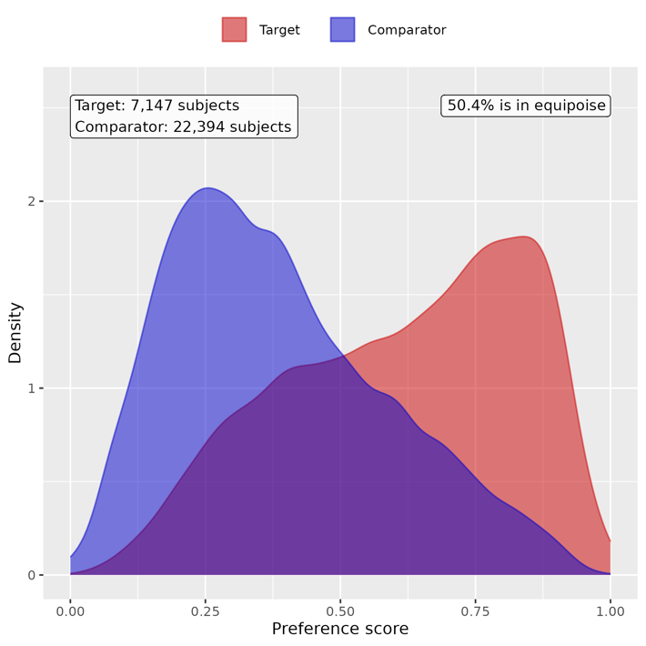

Supp Figure 36. Preference score distributions of COVID-19 positive and negative groups for children in Black/AA group. A greater convergence of these distributions indicates a higher similarity in the predicted likelihood of being infected between the COVID-19 positive (red) and negative (blue) participants.
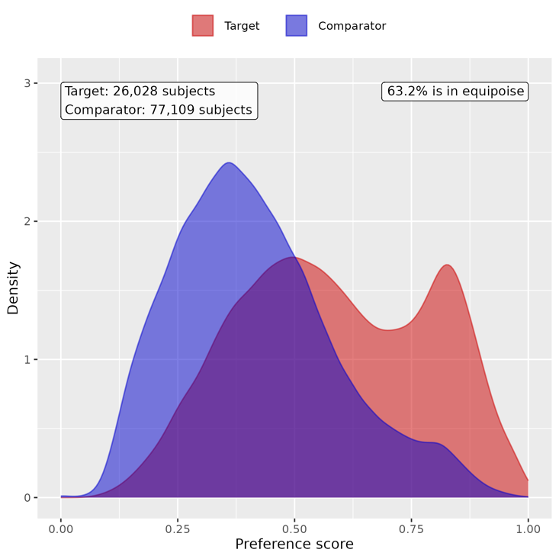

Supp Figure 37. Preference score distributions of COVID-19 positive and negative groups for children in Hispanic group. A greater convergence of these distributions indicates a higher similarity in the predicted likelihood of being infected between the COVID-19 positive (red) and negative (blue) participants.
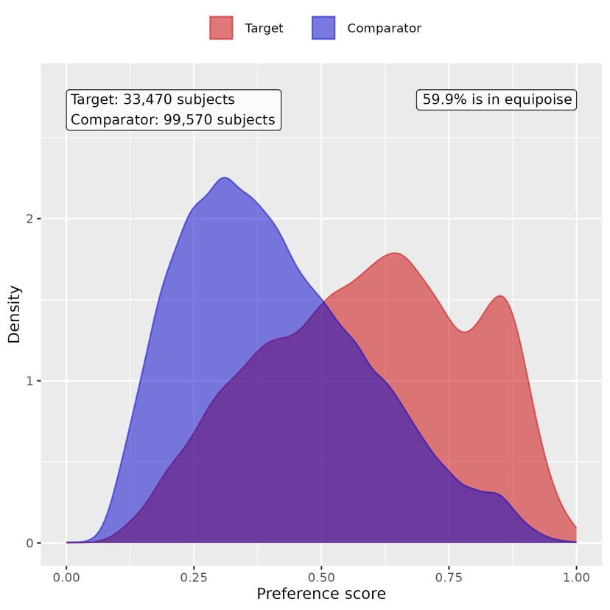

Supp Figure 38. Preference score distributions of COVID-19 positive and negative groups for children in White group. A greater convergence of these distributions indicates a higher similarity in the predicted likelihood of being infected between the COVID-19 positive (red) and negative (blue) participants.
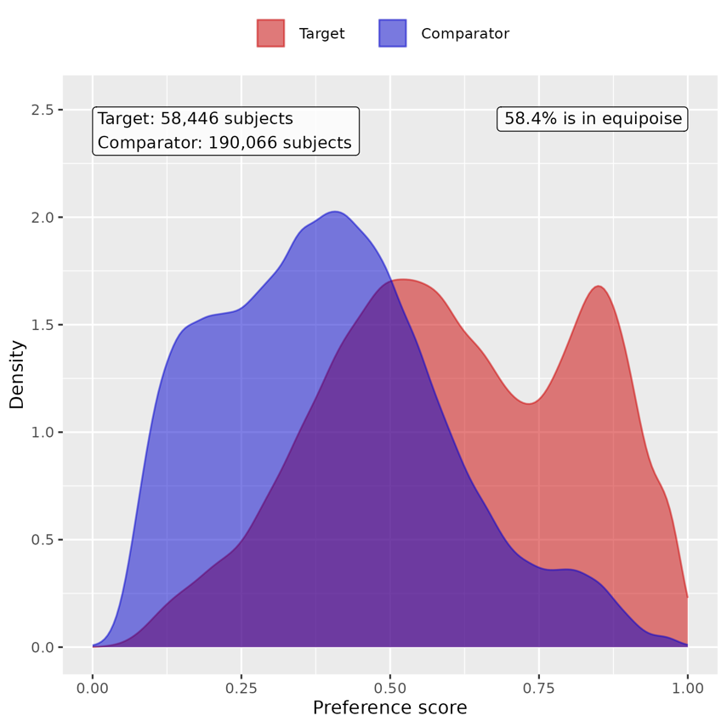

Supp Figure 39. Preference score distributions of COVID-19 positive and negative groups for youths in Asian/PI group. A greater convergence of these distributions indicates a higher similarity in the predicted likelihood of being infected between the COVID-19 positive (red) and negative (blue) participants.
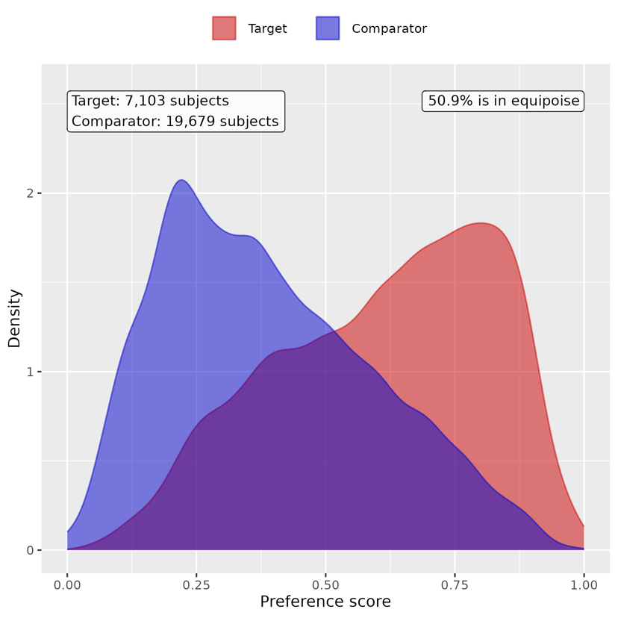

Supp Figure 40. Preference score distributions of COVID-19 positive and negative groups for youths in Black/AA group. A greater convergence of these distributions indicates a higher similarity in the predicted likelihood of being infected between the COVID-19 positive (red) and negative (blue) participants.
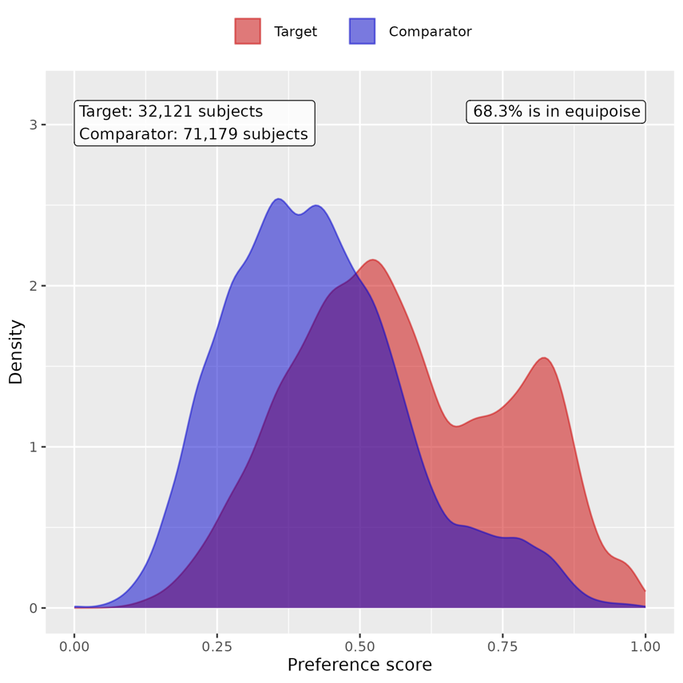

Supp Figure 41. Preference score distributions of COVID-19 positive and negative groups for youths in Hispanic group. A greater convergence of these distributions indicates a higher similarity in the predicted likelihood of being infected between the COVID-19 positive (red) and negative (blue) participants.
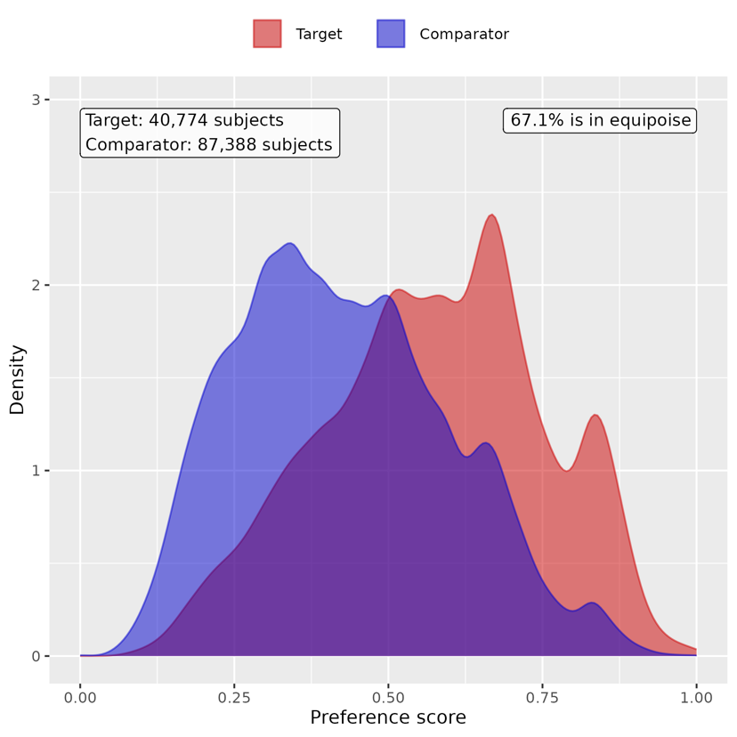

Supp Figure 42. Preference score distributions of COVID-19 positive and negative groups for youths in White group. A greater convergence of these distributions indicates a higher similarity in the predicted likelihood of being infected between the COVID-19 positive (red) and negative (blue) participants.
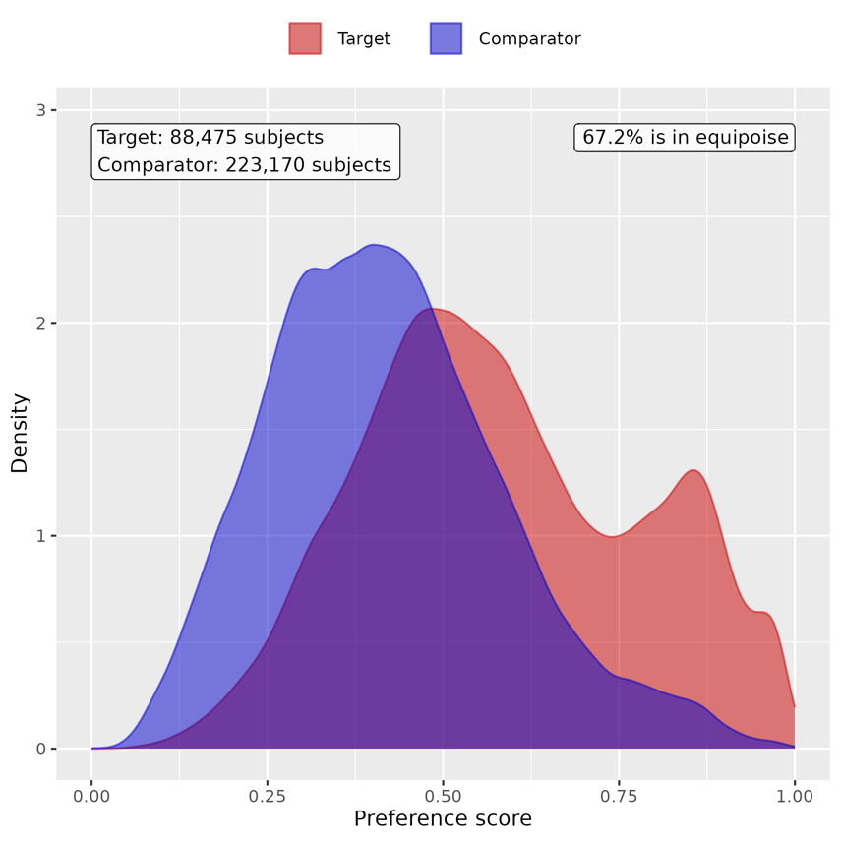

B. Patient characteristic balance

Supp Figure 43. Patient characteristic balance before and after large-scale PS matching with ratio 1:2 for children in Asian/PI group. The upper panel displays the top 20 covariates with the largest standardized difference of means before matching, while the lower panel displays the top 20 covariates with the largest standardized difference of means after matching.
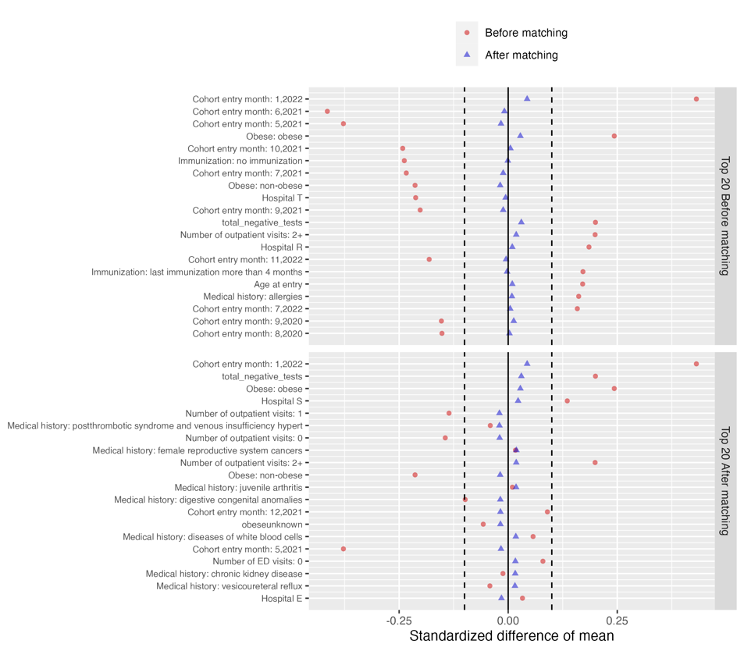

Supp Figure 44. Patient characteristic balance before and after large-scale PS matching with ratio 1:2 for children in Black/AA group. The upper panel displays the top 20 covariates with the largest standardized difference of means before matching, while the lower panel displays the top 20 covariates with the largest standardized difference of means after matching.
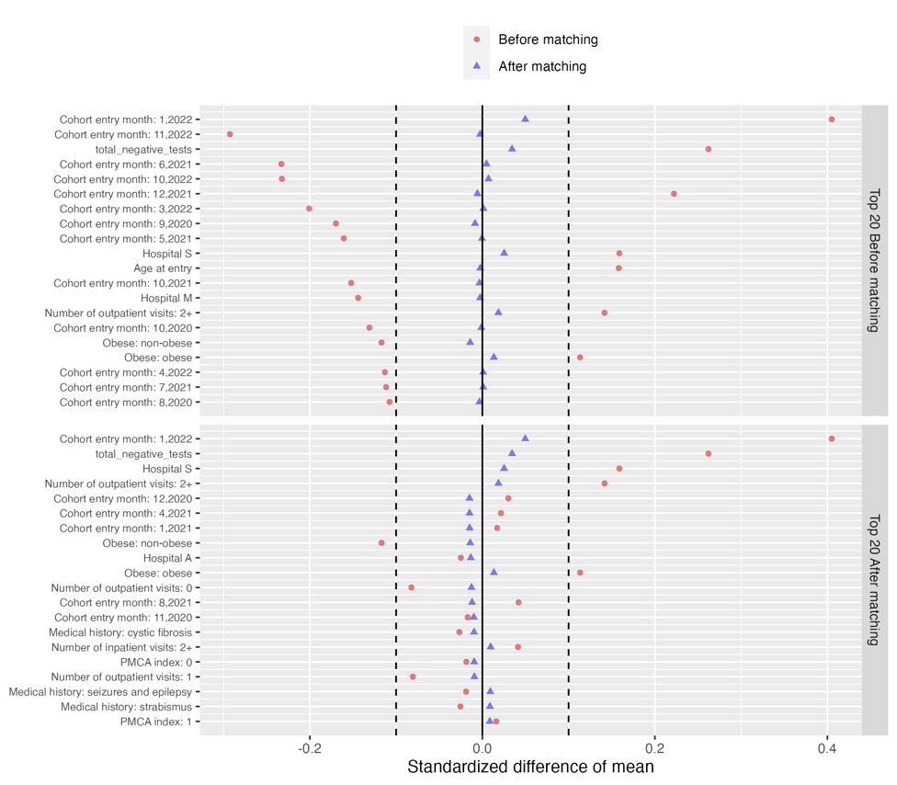
Supp Figure 45, Patient characteristic balance before and after large-scale PS matching with ratio 1:2 for children in Hispanic group. The upper panel displays the top 20 covariates with the largest standardized difference of means before matching, while the lower panel displays the top 20 covariates with the largest standardized difference of means after matching.
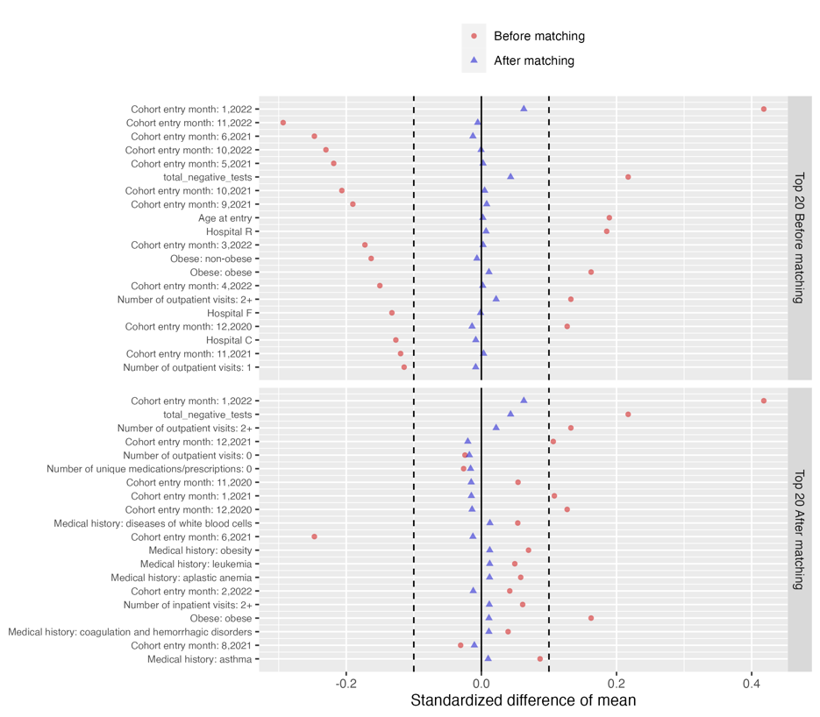

Supp Figure 46. Patient characteristic balance before and after large-scale PS matching with ratio 1:2 for children in White group. The upper panel displays the top 20 covariates with the largest standardized difference of means before matching, while the lower panel displays the top 20 covariates with the largest standardized difference of means after matching.
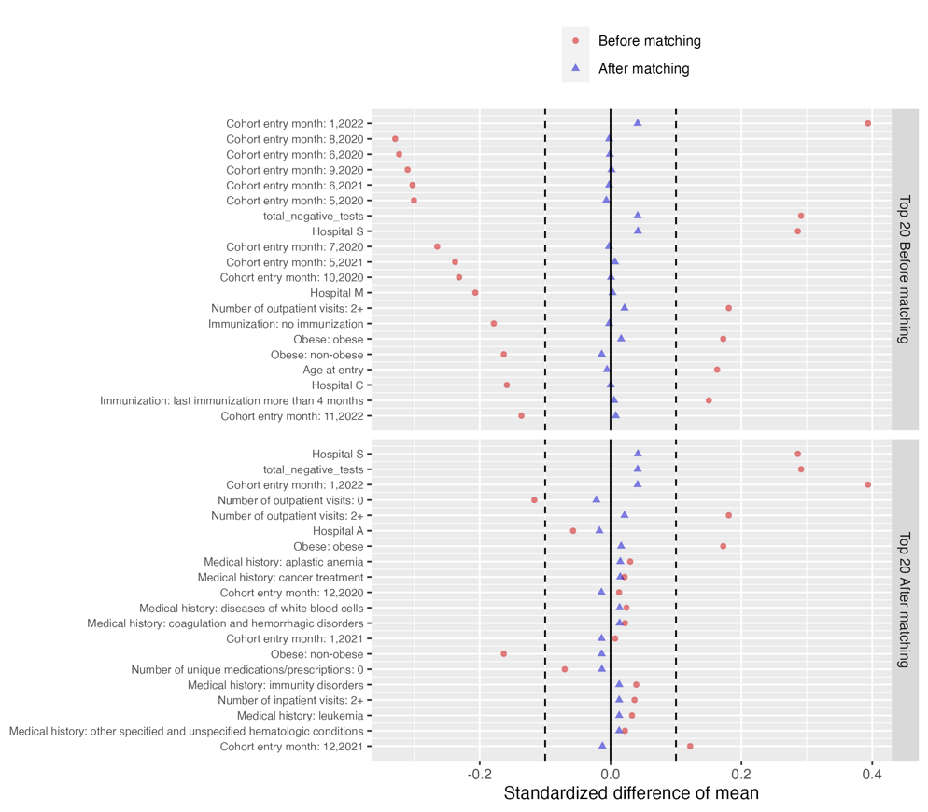

Supp Figure 47. Patient characteristic balance before and after large-scale PS matching with ratio 1:2 for youths in Asian/PI group. The upper panel displays the top 20 covariates with the largest standardized difference of means before matching, while the lower panel displays the top 20 covariates with the largest standardized difference of means after matching.
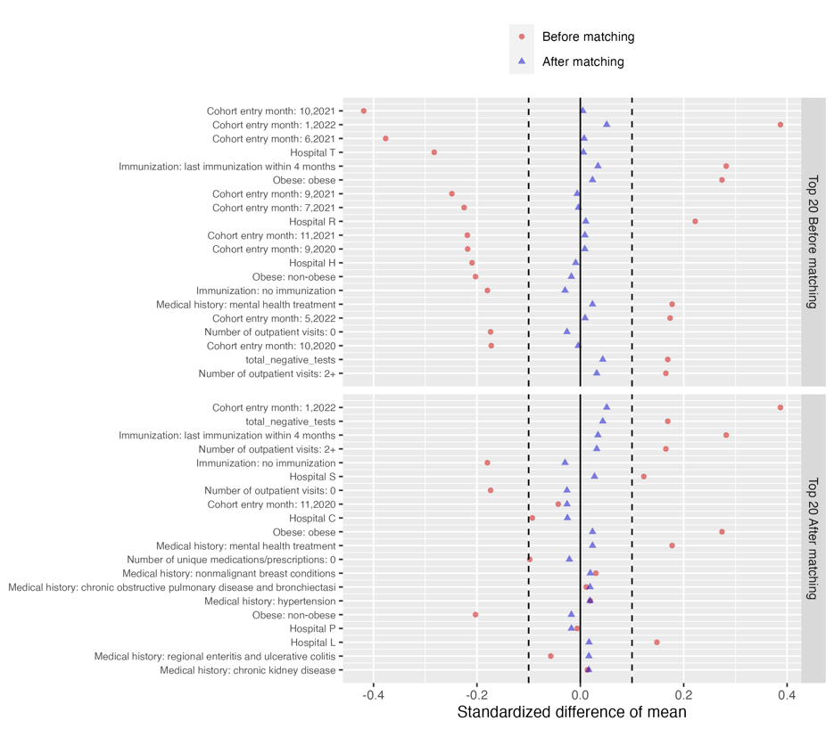

Supp Figure 48. Patient characteristic balance before and after large-scale PS matching with ratio 1:2 for youths in Black/AA group. The upper panel displays the top 20 covariates with the largest standardized difference of means before matching, while the lower panel displays the top 20 covariates with the largest standardized difference of means after matching.
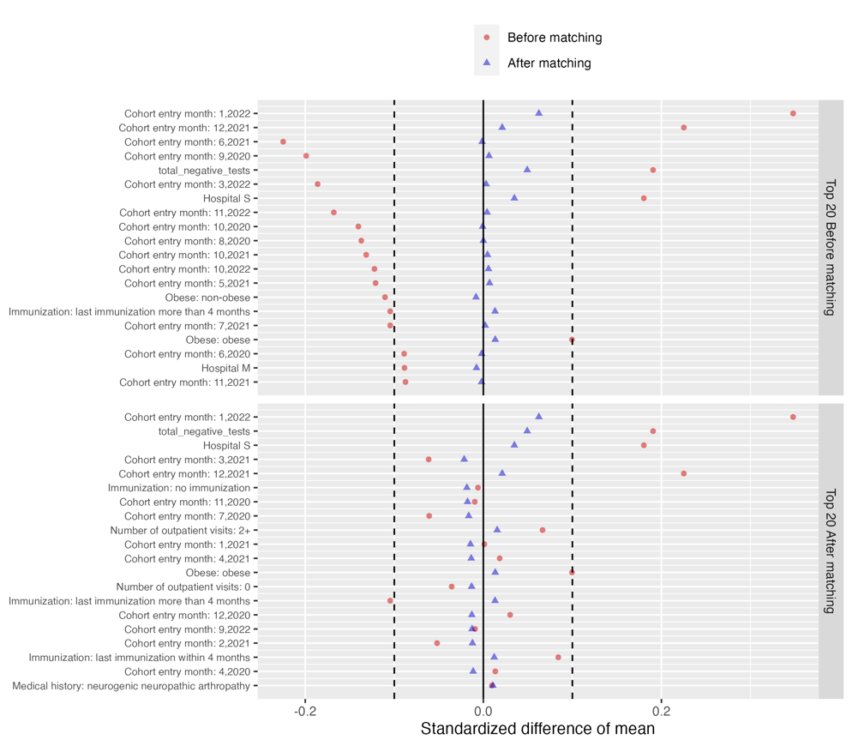

Supp Figure 49. Patient characteristic balance before and after large-scale PS matching with ratio 1:2 for youths in Hispanic group. The upper panel displays the top 20 covariates with the largest standardized difference of means before matching, while the lower panel displays the top 20 covariates with the largest standardized difference of means after matching.
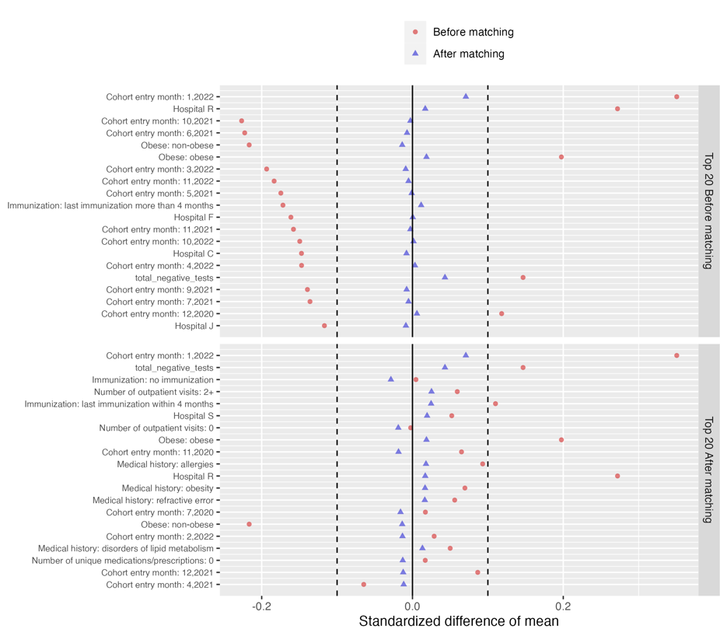

Supp Figure 50. Patient characteristic balance before and after large-scale PS matching with ratio 1:2 for youths in White group. The upper panel displays the top 20 covariates with the largest standardized difference of means before matching, while the lower panel displays the top 20 covariates with the largest standardized difference of means after matching.
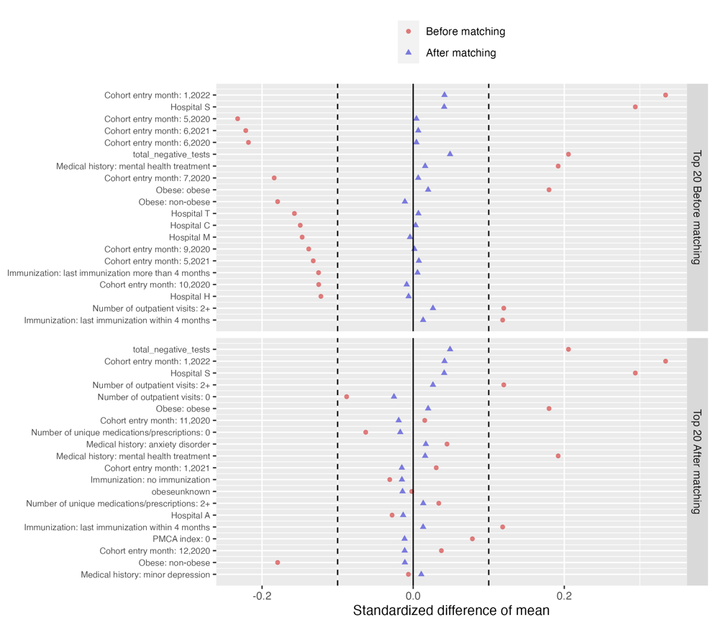

C. Risk difference of COVID-19 positive group compared to COVID-19 negative group

Supp Table 13. Estimated risk difference in mental health conditions between the COVID-19 positive cohort and COVID-19 negative cohort for children in Asian/PI group

Category | Cluster | Risk difference (%) | 95% CI (%) | P value
Composite | At least one incident | 0.54 | (-0.680, 1.759) | 0.386
Adverse childhood experiences | Emotional abuse | -0.029 | (-0.083, 0.025) | 0.292
 | Neglect | 0.025 | (-0.023, 0.074) | 0.303
 | Physical abuse | 0.034 | (-0.039, 0.107) | 0.360
 | Sexual abuse | 0.002 | (-0.052, 0.057) | 0.931
Anxiety disorders | Anxiety disorder | 0.172 | (-0.287, 0.631) | 0.462
 | OCD | 0.118 | (-0.008, 0.244) | 0.067
 | Somatoform disorder | 0.08 | (-0.115, 0.276) | 0.422
 | Stress disorder | 0.102 | (-0.253, 0.456) | 0.573
Disruptive behavior disorders | Conduct disorder | -0.029 | (-0.209, 0.151) | 0.751
 | Impulse control disorder | 0 | (-0.145, 0.145) | 1.000
 | Oppositional defiant disorder | 0.045 | (-0.064, 0.153) | 0.417
Eating and feeding disorders | Avoidant restrictive food intake | 0.032 | (-0.220, 0.283) | 0.806
 | Other eating and feeding disorder | -0.098 | (-0.220, 0.023) | 0.112
Elimination disorders | Encopresis | 0.041 | (-0.070, 0.152) | 0.467
 | Enuresis | 0.017 | (-0.218, 0.252) | 0.888
Gender dysphoria sexual dysfunction | Gender dysphoria | -0.029 | (-0.093, 0.035) | 0.373
 | Paraphilia | NA | NA | NA
 | Sexual dysfunction | -0.01 | (-0.034, 0.015) | 0.433
Intentional self-harm/suicidality | Parasuicidality | -0.096 | (-0.204, 0.013) | 0.083
 | Suicidality | 0.034 | (-0.046, 0.114) | 0.408
Mood disorders | Bipolar disorder | -0.01 | (-0.082, 0.063) | 0.794
 | Major depression | -0.1 | (-0.200, 0.000) | 0.051
 | Minor depression | 0.021 | (-0.123, 0.164) | 0.779
Neurocognitive disorders | Catatonia | NA | NA | NA
 | Delirium | 0.01 | (-0.107, 0.126) | 0.870
 | Encephalopathy | 0.041 | (-0.053, 0.135) | 0.389
Neurodevelopmental disorders | Academic developmental disorder | 0.073 | (-0.182, 0.328) | 0.576
 | ADHD | 0.24 | (-0.301, 0.782) | 0.385
 | Autism spectrum disorder | 0.112 | (-0.586, 0.809) | 0.754
 | Communication motor disorder | -0.353 | (-1.023, 0.317) | 0.302
 | Intellectual disability | 0.058 | (-0.396, 0.513) | 0.802
Personality disorders | Personality disorder | 0.028 | (-0.026, 0.082) | 0.314
Psychotic disorders | Psychotic disorder | 0.035 | (-0.038, 0.108) | 0.343
 | Schizoaffective disorder | NA | NA | NA
 | Schizophrenia | NA | NA | NA
Sleep wake disorders | Hypersomnia | -0.028 | (-0.108, 0.053) | 0.497
 | Insomnia | 0.046 | (-0.140, 0.232) | 0.628
 | Parasomnias | 0.006 | (-0.182, 0.194) | 0.950
Standalone symptoms | Anger aggression | -0.102 | (-0.259, 0.055) | 0.204
 | Anxiety symptoms | 0.059 | (-0.164, 0.283) | 0.602
 | Attention symptoms | 0.138 | (-0.104, 0.381) | 0.263
 | Depressive symptoms | 0 | (-0.034, 0.034) | 1.000
 | Hallucinations | -0.01 | (-0.034, 0.015) | 0.433
Substance use and dependence | Alcohol | NA | NA | NA
 | Opioid related | NA | NA | NA
 | Other substances | 0 | (-0.034, 0.034) | 1.000
 | THC | NA | NA | NA
 | Tobacco | NA | NA | NA
Tic disorders | Tic disorder | 0.063 | (-0.154, 0.280) | 0.568

Supp Table 14, Estimated risk difference in mental health conditions between the COVID-19 positive cohort and COVID-19 negative cohort for children in Black/AA group

Category | Cluster | Risk difference (%) | 95% CI (%) | P value
Composite | At least one incident | 0.586 | (-0.155, 1.327) | 0.121
Adverse childhood experiences | Emotional abuse | -0.03 | (-0.076, 0.015) | 0.194
 | Neglect | 0.01 | (-0.023, 0.044) | 0.552
 | Physical abuse | -0.021 | (-0.113, 0.072) | 0.662
 | Sexual abuse | -0.013 | (-0.091, 0.065) | 0.747
Anxiety disorders | Anxiety disorder | 0.376 | (0.110, 0.642) | 0.006
 | OCD | 0.003 | (-0.050, 0.057) | 0.899
 | Somatoform disorder | -0.046 | (-0.158, 0.066) | 0.423
 | Stress disorder | 0.124 | (-0.162, 0.410) | 0.397
Disruptive behavior disorders | Conduct disorder | -0.164 | (-0.334, 0.006) | 0.059
 | Impulse control disorder | -0.063 | (-0.212, 0.085) | 0.404
 | Oppositional defiant disorder | -0.046 | (-0.177, 0.086) | 0.496
Eating and feeding disorders | Avoidant restrictive food intake | 0.036 | (-0.079, 0.152) | 0.538
 | Other eating and feeding disorder | 0.007 | (-0.064, 0.077) | 0.852
Elimination disorders | Encopresis | 0.008 | (-0.071, 0.088) | 0.841
 | Enuresis | 0.129 | (-0.067, 0.325) | 0.198
Gender dysphoria sexual dysfunction | Gender dysphoria | -0.008 | (-0.038, 0.023) | 0.619
 | Paraphilia | NA | NA | NA
 | Sexual dysfunction | 0.004 | (-0.002, 0.011) | 0.192
Intentional self-harm/suicidality | Parasuicidality | 0.016 | (-0.044, 0.075) | 0.603
 | Suicidality | 0.069 | (-0.039, 0.177) | 0.211
Mood disorders | Bipolar disorder | 0.047 | (-0.006, 0.100) | 0.081
 | Major depression | -0.022 | (-0.125, 0.081) | 0.670
 | Minor depression | -0.034 | (-0.169, 0.100) | 0.615
Neurocognitive disorders | Catatonia | 0.008 | (-0.004, 0.021) | 0.192
 | Delirium | 0.074 | (-0.004, 0.152) | 0.062
 | Encephalopathy | -0.004 | (-0.040, 0.032) | 0.832
Neurodevelopmental disorders | Academic developmental disorder | 0.007 | (-0.197, 0.210) | 0.949
 | ADHD | 0.251 | (-0.214, 0.715) | 0.291
 | Autism spectrum disorder | -0.076 | (-0.397, 0.244) | 0.640
 | Communication motor disorder | 0.022 | (-0.332, 0.375) | 0.904
 | Intellectual disability | 0.044 | (-0.193, 0.282) | 0.713
Personality disorders | Personality disorder | -0.017 | (-0.046, 0.013) | 0.274
Psychotic disorders | Psychotic disorder | 0.002 | (-0.051, 0.054) | 0.953
 | Schizoaffective disorder | NA | NA | NA
 | Schizophrenia | -0.017 | (-0.039, 0.005) | 0.132
Sleep wake disorders | Hypersomnia | -0.002 | (-0.062, 0.057) | 0.943
 | Insomnia | -0.003 | (-0.161, 0.155) | 0.972
 | Parasomnias | 0.002 | (-0.079, 0.082) | 0.966
Standalone symptoms | Anger aggression | 0.036 | (-0.086, 0.158) | 0.559
 | Anxiety symptoms | 0.033 | (-0.073, 0.139) | 0.541
 | Attention symptoms | -0.061 | (-0.216, 0.094) | 0.442
 | Depressive symptoms | -0.018 | (-0.049, 0.014) | 0.276
 | Hallucinations | 0.002 | (-0.054, 0.058) | 0.943
Substance use and dependence | Alcohol | -0.002 | (-0.009, 0.004) | 0.444
 | Opioid related | 0.016 | (-0.009, 0.040) | 0.205
 | Other substances | 0.009 | (-0.015, 0.034) | 0.464
 | THC | -0.002 | (-0.009, 0.004) | 0.444
 | Tobacco | 0.001 | (-0.010, 0.012) | 0.896
Tic disorders | Tic disorder | 0.085 | (-0.009, 0.180) | 0.075

Supp Table 15. Estimated risk difference in mental health conditions between the COVID-19 positive cohort and COVID-19 negative cohort for children in Hispanic group

Category | Cluster | Risk difference (%) | 95% CI (%) | P value
Composite | At least one incident | 1.133 | (0.499, 1.766) | <0.001
Adverse childhood experiences | Emotional abuse | 0.01 | (-0.042, 0.062) | 0.697
 | Neglect | 0.008 | (-0.012, 0.027) | 0.438
 | Physical abuse | -0.041 | (-0.103, 0.022) | 0.200
 | Sexual abuse | 0.01 | (-0.033, 0.053) | 0.659
Anxiety disorders | Anxiety disorder | 0.346 | (0.078, 0.615) | 0.011
 | OCD | 0.02 | (-0.029, 0.070) | 0.426
 | Somatoform disorder | 0.047 | (-0.058, 0.151) | 0.382
 | Stress disorder | 0.119 | (-0.130, 0.368) | 0.348
Disruptive behavior disorders | Conduct disorder | 0.051 | (-0.071, 0.174) | 0.413
 | Impulse control disorder | -0.007 | (-0.096, 0.083) | 0.886
 | Oppositional defiant disorder | 0.051 | (-0.037, 0.139) | 0.255
Eating and feeding disorders | Avoidant restrictive food intake | 0.08 | (-0.041, 0.202) | 0.194
 | Other eating and feeding disorder | 0.017 | (-0.035, 0.069) | 0.526
Elimination disorders | Encopresis | -0.023 | (-0.094, 0.049) | 0.534
 | Enuresis | -0.053 | (-0.179, 0.074) | 0.416
Gender dysphoria sexual dysfunction | Gender dysphoria | 0 | (-0.033, 0.033) | 1.000
 | Paraphilia | NA | NA | NA
 | Sexual dysfunction | -0.003 | (-0.012, 0.005) | 0.456
Intentional self-harm/suicidality | Parasuicidality | -0.008 | (-0.053, 0.038) | 0.738
 | Suicidality | 0.028 | (-0.035, 0.090) | 0.382
Mood disorders | Bipolar disorder | 0.04 | (-0.004, 0.083) | 0.073
 | Major depression | -0.054 | (-0.147, 0.040) | 0.258
 | Minor depression | 0.019 | (-0.094, 0.131) | 0.746
Neurocognitive disorders | Catatonia | -0.007 | (-0.020, 0.006) | 0.283
 | Delirium | 0.063 | (0.009, 0.117) | 0.022
 | Encephalopathy | -0.025 | (-0.064, 0.013) | 0.197
Neurodevelopmental disorders | Academic developmental disorder | -0.058 | (-0.235, 0.119) | 0.521
 | ADHD | 0.19 | (-0.141, 0.520) | 0.261
 | Autism spectrum disorder | 0.289 | (0.001, 0.577) | 0.049
 | Communication motor disorder | 0.301 | (-0.013, 0.615) | 0.060
 | Intellectual disability | -0.014 | (-0.230, 0.203) | 0.902
Personality disorders | Personality disorder | 0.015 | (-0.011, 0.040) | 0.253
Psychotic disorders | Psychotic disorder | -0.008 | (-0.036, 0.020) | 0.584
 | Schizoaffective disorder | NA | NA | NA
 | Schizophrenia | -0.001 | (-0.012, 0.010) | 0.908
Sleep wake disorders | Hypersomnia | 0.006 | (-0.034, 0.046) | 0.773
 | Insomnia | -0.024 | (-0.139, 0.091) | 0.683
 | Parasomnias | 0.034 | (-0.051, 0.120) | 0.430
Standalone symptoms | Anger aggression | 0.012 | (-0.076, 0.101) | 0.786
 | Anxiety symptoms | 0.1 | (-0.019, 0.219) | 0.098
 | Attention symptoms | 0.097 | (-0.032, 0.226) | 0.140
 | Depressive symptoms | 0.005 | (-0.024, 0.035) | 0.731
 | Hallucinations | 0.002 | (-0.036, 0.040) | 0.920
Substance use and dependence | Alcohol | NA | NA | NA
 | Opioid related | -0.006 | (-0.016, 0.003) | 0.197
 | Other substances | 0.006 | (-0.017, 0.028) | 0.612
 | THC | -0.002 | (-0.007, 0.003) | 0.438
 | Tobacco | 0.009 | (-0.003, 0.021) | 0.140
Tic disorders | Tic disorder | -0.014 | (-0.110, 0.082) | 0.770

Supp Table 16. Estimated risk difference in mental health conditions between the COVID-19 positive cohort and COVID-19 negative cohort for children in White group

Category | Cluster | Risk difference (%) | 95% CI (%) | P value
Composite | At least one incident | 0.718 | (0.187, 1.249) | 0.008
Adverse childhood experiences | Emotional abuse | 0.001 | (-0.022, 0.024) | 0.939
 | Neglect | 0.014 | (-0.006, 0.033) | 0.171
 | Physical abuse | 0.046 | (0.000, 0.092) | 0.048
 | Sexual abuse | 0.022 | (-0.013, 0.057) | 0.211
Anxiety disorders | Anxiety disorder | 0.253 | (-0.017, 0.524) | 0.066
 | OCD | 0.047 | (-0.027, 0.120) | 0.215
 | Somatoform disorder | 0.08 | (0.008, 0.152) | 0.029
 | Stress disorder | 0.106 | (-0.085, 0.296) | 0.278
Disruptive behavior disorders | Conduct disorder | -0.018 | (-0.128, 0.091) | 0.743
 | Impulse control disorder | -0.078 | (-0.195, 0.038) | 0.187
 | Oppositional defiant disorder | 0.054 | (-0.046, 0.154) | 0.289
Eating and feeding disorders | Avoidant restrictive food intake | 0.006 | (-0.084, 0.096) | 0.897
 | Other eating and feeding disorder | -0.03 | (-0.077, 0.018) | 0.218
Elimination disorders | Encopresis | 0.048 | (-0.026, 0.122) | 0.202
 | Enuresis | 0.013 | (-0.120, 0.147) | 0.845
Gender dysphoria sexual dysfunction | Gender dysphoria | 0.002 | (-0.037, 0.042) | 0.903
 | Paraphilia | 0 | (-0.004, 0.004) | 1.000
 | Sexual dysfunction | -0.003 | (-0.009, 0.003) | 0.300
Intentional self-harm/suicidality | Parasuicidality | 0.013 | (-0.038, 0.063) | 0.628
 | Suicidality | 0.026 | (-0.037, 0.090) | 0.414
Mood disorders | Bipolar disorder | -0.002 | (-0.042, 0.037) | 0.916
 | Major depression | 0.008 | (-0.074, 0.090) | 0.850
 | Minor depression | -0.012 | (-0.116, 0.092) | 0.819
Neurocognitive disorders | Catatonia | 0.006 | (-0.003, 0.016) | 0.180
 | Delirium | 0.032 | (-0.015, 0.079) | 0.178
 | Encephalopathy | 0.024 | (-0.012, 0.060) | 0.183
Neurodevelopmental disorders | Academic developmental disorder | 0.04 | (-0.086, 0.165) | 0.537
 | ADHD | 0.064 | (-0.291, 0.419) | 0.723
 | Autism spectrum disorder | 0.125 | (-0.098, 0.348) | 0.273
 | Communication motor disorder | 0.266 | (0.029, 0.502) | 0.028
 | Intellectual disability | 0.209 | (0.039, 0.379) | 0.016
Personality disorders | Personality disorder | 0.01 | (-0.017, 0.036) | 0.479
Psychotic disorders | Psychotic disorder | 0.009 | (-0.018, 0.036) | 0.507
 | Schizoaffective disorder | 0.001 | (-0.004, 0.006) | 0.658
 | Schizophrenia | 0.004 | (-0.002, 0.011) | 0.204
Sleep wake disorders | Hypersomnia | -0.003 | (-0.043, 0.038) | 0.901
 | Insomnia | 0.022 | (-0.093, 0.136) | 0.710
 | Parasomnias | 0.043 | (-0.043, 0.129) | 0.325
Standalone symptoms | Anger aggression | 0.02 | (-0.074, 0.113) | 0.683
 | Anxiety symptoms | 0.021 | (-0.050, 0.092) | 0.565
 | Attention symptoms | 0.027 | (-0.084, 0.139) | 0.629
 | Depressive symptoms | 0.015 | (-0.007, 0.038) | 0.186
 | Hallucinations | 0.014 | (-0.016, 0.045) | 0.359
Substance use and dependence | Alcohol | -0.003 | (-0.012, 0.007) | 0.595
 | Opioid related | 0 | (-0.014, 0.013) | 0.946
 | Other substances | 0.002 | (-0.019, 0.023) | 0.858
 | THC | 0.001 | (-0.002, 0.004) | 0.443
 | Tobacco | -0.004 | (-0.012, 0.003) | 0.283
Tic disorders | Tic disorder | 0.068 | (-0.036, 0.172) | 0.202

Supp Table 17. Estimated risk difference in mental health conditions between the COVID-19 positive cohort and COVID-19 negative cohort for youths in Asian/PI group

Category | Cluster | Risk difference (%) | 95% CI (%) | P value
Composite | At least one incident | 0.465 | (-0.957, 1.886) | 0.522
Adverse childhood experiences | Emotional abuse | 0 | (-0.069, 0.069) | 1.000
 | Neglect | -0.016 | (-0.040, 0.009) | 0.209
 | Physical abuse | 0.06 | (-0.060, 0.179) | 0.330
 | Sexual abuse | 0.002 | (-0.093, 0.096) | 0.974
Anxiety disorders | Anxiety disorder | -0.216 | (-1.109, 0.677) | 0.636
 | OCD | 0.06 | (-0.201, 0.321) | 0.651
 | Somatoform disorder | -0.107 | (-0.377, 0.164) | 0.440
 | Stress disorder | 0.225 | (-0.359, 0.809) | 0.449
Disruptive behavior disorders | Conduct disorder | -0.071 | (-0.226, 0.084) | 0.367
 | Impulse control disorder | -0.055 | (-0.252, 0.142) | 0.582
 | Oppositional defiant disorder | 0.002 | (-0.125, 0.129) | 0.981
Eating and feeding disorders | Avoidant restrictive food intake | 0.04 | (-0.401, 0.482) | 0.858
 | Other eating and feeding disorder | 0.026 | (-0.052, 0.103) | 0.516
Elimination disorders | Encopresis | 0.012 | (-0.037, 0.060) | 0.645
 | Enuresis | 0.018 | (-0.113, 0.150) | 0.785
Gender dysphoria sexual dysfunction | Gender dysphoria | 0.003 | (-0.258, 0.264) | 0.981
 | Paraphilia | 0.047 | (-0.008, 0.102) | 0.092
 | Sexual dysfunction | 0 | (-0.049, 0.049) | 1.000
Intentional self-harm/suicidality | Parasuicidality | 0.05 | (-0.117, 0.218) | 0.557
 | Suicidality | 0.195 | (-0.152, 0.542) | 0.271
Mood disorders | Bipolar disorder | -0.02 | (-0.182, 0.142) | 0.810
 | Major depression | -0.142 | (-0.845, 0.561) | 0.692
 | Minor depression | 0.222 | (-0.453, 0.898) | 0.519
Neurocognitive disorders | Catatonia | 0.031 | (-0.046, 0.109) | 0.427
 | Delirium | 0.121 | (-0.082, 0.324) | 0.242
 | Encephalopathy | 0.063 | (-0.071, 0.197) | 0.359
Neurodevelopmental disorders | Academic developmental disorder | 0.077 | (-0.154, 0.309) | 0.513
 | ADHD | -0.087 | (-0.645, 0.470) | 0.759
 | Autism spectrum disorder | 0.159 | (-0.316, 0.634) | 0.512
 | Communication motor disorder | -0.054 | (-0.417, 0.309) | 0.771
 | Intellectual disability | 0.26 | (-0.123, 0.643) | 0.183
Personality disorders | Personality disorder | -0.083 | (-0.225, 0.060) | 0.256
Psychotic disorders | Psychotic disorder | 0.053 | (-0.118, 0.224) | 0.545
 | Schizoaffective disorder | 0 | (-0.049, 0.049) | 1.000
 | Schizophrenia | -0.02 | (-0.097, 0.057) | 0.615
Sleep wake disorders | Hypersomnia | -0.095 | (-0.236, 0.045) | 0.184
 | Insomnia | 0.081 | (-0.254, 0.415) | 0.637
 | Parasomnias | -0.028 | (-0.171, 0.114) | 0.698
Standalone symptoms | Anger aggression | 0.013 | (-0.165, 0.190) | 0.890
 | Anxiety symptoms | 0.283 | (0.038, 0.529) | 0.024
 | Attention symptoms | 0.055 | (-0.203, 0.313) | 0.677
 | Depressive symptoms | 0.093 | (-0.008, 0.193) | 0.072
 | Hallucinations | -0.024 | (-0.146, 0.098) | 0.700
Substance use and dependence | Alcohol | -0.071 | (-0.180, 0.038) | 0.203
 | Opioid related | -0.004 | (-0.059, 0.051) | 0.881
 | Other substances | 0.027 | (-0.113, 0.168) | 0.704
 | THC | -0.095 | (-0.227, 0.037) | 0.157
 | Tobacco | 0.003 | (-0.193, 0.198) | 0.979
Tic disorders | Tic disorder | 0.097 | (-0.132, 0.326) | 0.408

Supp Table 18. Estimated risk difference in mental health conditions between the COVID-19 positive cohort and COVID-19 negative cohort for youths in Black/AA group

Category | Cluster | Risk difference (%) | 95% CI (%) | P value
Composite | At least one incident | 0.124 | (-0.608, 0.856) | 0.740
Adverse childhood experiences | Emotional abuse | 0.03 | (-0.003, 0.064) | 0.072
 | Neglect | -0.008 | (-0.038, 0.022) | 0.619
 | Physical abuse | 0.114 | (0.019, 0.210) | 0.019
 | Sexual abuse | 0.048 | (-0.034, 0.129) | 0.255
Anxiety disorders | Anxiety disorder | -0.223 | (-0.638, 0.191) | 0.291
 | OCD | 0.015 | (-0.067, 0.096) | 0.727
 | Somatoform disorder | -0.098 | (-0.244, 0.049) | 0.190
 | Stress disorder | -0.306 | (-0.645, 0.033) | 0.077
Disruptive behavior disorders | Conduct disorder | 0.023 | (-0.094, 0.139) | 0.701
 | Impulse control disorder | 0.034 | (-0.125, 0.193) | 0.677
 | Oppositional defiant disorder | 0.104 | (-0.039, 0.247) | 0.155
Eating and feeding disorders | Avoidant restrictive food intake | -0.02 | (-0.171, 0.130) | 0.790
 | Other eating and feeding disorder | -0.008 | (-0.059, 0.042) | 0.746
Elimination disorders | Encopresis | 0.01 | (-0.019, 0.038) | 0.509
 | Enuresis | 0.099 | (-0.011, 0.209) | 0.079
Gender dysphoria sexual dysfunction | Gender dysphoria | -0.05 | (-0.123, 0.023) | 0.181
 | Paraphilia | NA | NA | NA
 | Sexual dysfunction | 0.003 | (-0.026, 0.033) | 0.815
Intentional self-harm/suicidality | Parasuicidality | 0.006 | (-0.092, 0.104) | 0.906
 | Suicidality | 0.184 | (-0.040, 0.407) | 0.108
Mood disorders | Bipolar disorder | -0.073 | (-0.159, 0.012) | 0.093
 | Major depression | -0.259 | (-0.617, 0.099) | 0.157
 | Minor depression | 0.138 | (-0.228, 0.503) | 0.461
Neurocognitive disorders | Catatonia | 0.024 | (-0.012, 0.060) | 0.189
 | Delirium | 0.176 | (0.028, 0.325) | 0.020
 | Encephalopathy | -0.013 | (-0.062, 0.036) | 0.596
Neurodevelopmental disorders | Academic developmental disorder | 0.007 | (-0.140, 0.154) | 0.926
 | ADHD | 0.264 | (-0.146, 0.673) | 0.207
 | Autism spectrum disorder | 0.098 | (-0.110, 0.307) | 0.355
 | Communication motor disorder | 0.064 | (-0.092, 0.220) | 0.420
 | Intellectual disability | -0.066 | (-0.260, 0.128) | 0.506
Personality disorders | Personality disorder | -0.008 | (-0.066, 0.051) | 0.796
Psychotic disorders | Psychotic disorder | -0.015 | (-0.126, 0.096) | 0.792
 | Schizoaffective disorder | -0.01 | (-0.047, 0.026) | 0.576
 | Schizophrenia | 0.008 | (-0.063, 0.079) | 0.824
Sleep wake disorders | Hypersomnia | 0.005 | (-0.071, 0.082) | 0.889
 | Insomnia | 0.074 | (-0.098, 0.245) | 0.400
 | Parasomnias | 0.046 | (-0.016, 0.108) | 0.150
Standalone symptoms | Anger aggression | 0.072 | (-0.064, 0.209) | 0.298
 | Anxiety symptoms | 0.113 | (-0.002, 0.227) | 0.054
 | Attention symptoms | 0.003 | (-0.105, 0.111) | 0.960
 | Depressive symptoms | 0.02 | (-0.026, 0.066) | 0.393
 | Hallucinations | 0.035 | (-0.043, 0.113) | 0.386
Substance use and dependence | Alcohol | -0.019 | (-0.065, 0.028) | 0.431
 | Opioid related | -0.004 | (-0.050, 0.041) | 0.857
 | Other substances | -0.047 | (-0.114, 0.020) | 0.166
 | THC | -0.112 | (-0.222, -0.001) | 0.047
 | Tobacco | -0.062 | (-0.197, 0.072) | 0.361
Tic disorders | Tic disorder | 0.001 | (-0.075, 0.078) | 0.972

Supp Table 19. Estimated risk difference in mental health conditions between the COVID-19 positive cohort and COVID-19 negative cohort for youths in Hispanic group

Category | Cluster | Risk difference (%) | 95% CI (%) | P value
Composite | At least one incident | 1.101 | (0.457, 1.745) | <0.001
Adverse childhood experiences | Emotional abuse | 0.003 | (-0.036, 0.043) | 0.875
 | Neglect | -0.003 | (-0.021, 0.015) | 0.774
 | Physical abuse | 0.005 | (-0.053, 0.064) | 0.855
 | Sexual abuse | 0.061 | (0.003, 0.120) | 0.040
Anxiety disorders | Anxiety disorder | 0.398 | (-0.026, 0.822) | 0.066
 | OCD | 0.008 | (-0.070, 0.087) | 0.832
 | Somatoform disorder | 0.012 | (-0.115, 0.139) | 0.857
 | Stress disorder | 0.21 | (-0.093, 0.512) | 0.174
Disruptive behavior disorders | Conduct disorder | -0.064 | (-0.144, 0.016) | 0.119
 | Impulse control disorder | -0.027 | (-0.104, 0.050) | 0.494
 | Oppositional defiant disorder | 0.028 | (-0.049, 0.105) | 0.479
Eating and feeding disorders | Avoidant restrictive food intake | -0.049 | (-0.224, 0.126) | 0.586
 | Other eating and feeding disorder | -0.035 | (-0.069, -0.002) | 0.038
Elimination disorders | Encopresis | 0.001 | (-0.026, 0.029) | 0.917
 | Enuresis | -0.009 | (-0.069, 0.050) | 0.761
Gender dysphoria sexual dysfunction | Gender dysphoria | -0.033 | (-0.127, 0.061) | 0.486
 | Paraphilia | -0.007 | (-0.016, 0.002) | 0.140
 | Sexual dysfunction | 0.002 | (-0.022, 0.025) | 0.898
Intentional self-harm/suicidality | Parasuicidality | 0.017 | (-0.066, 0.101) | 0.684
 | Suicidality | 0.081 | (-0.072, 0.235) | 0.298
Mood disorders | Bipolar disorder | -0.032 | (-0.098, 0.033) | 0.337
 | Major depression | 0.314 | (-0.006, 0.634) | 0.055
 | Minor depression | 0.223 | (-0.103, 0.550) | 0.180
Neurocognitive disorders | Catatonia | -0.013 | (-0.036, 0.011) | 0.292
 | Delirium | 0.065 | (-0.047, 0.178) | 0.255
 | Encephalopathy | -0.001 | (-0.046, 0.044) | 0.962
Neurodevelopmental disorders | Academic developmental disorder | 0.123 | (-0.003, 0.249) | 0.055
 | ADHD | 0.204 | (-0.079, 0.487) | 0.158
 | Autism spectrum disorder | 0.017 | (-0.170, 0.203) | 0.862
 | Communication motor disorder | -0.015 | (-0.148, 0.118) | 0.828
 | Intellectual disability | 0.117 | (-0.052, 0.286) | 0.176
Personality disorders | Personality disorder | 0.016 | (-0.037, 0.069) | 0.548
Psychotic disorders | Psychotic disorder | -0.033 | (-0.098, 0.032) | 0.323
 | Schizoaffective disorder | -0.01 | (-0.038, 0.018) | 0.479
 | Schizophrenia | -0.041 | (-0.085, 0.004) | 0.073
Sleep wake disorders | Hypersomnia | -0.008 | (-0.062, 0.045) | 0.763
 | Insomnia | 0.024 | (-0.129, 0.178) | 0.755
 | Parasomnias | 0.024 | (-0.037, 0.084) | 0.445
Standalone symptoms | Anger aggression | 0.065 | (-0.021, 0.151) | 0.140
 | Anxiety symptoms | 0.094 | (-0.022, 0.210) | 0.112
 | Attention symptoms | 0.1 | (0.001, 0.199) | 0.047
 | Depressive symptoms | -0.008 | (-0.050, 0.033) | 0.695
 | Hallucinations | -0.031 | (-0.085, 0.023) | 0.258
Substance use and dependence | Alcohol | 0.024 | (-0.027, 0.076) | 0.356
 | Opioid related | -0.001 | (-0.031, 0.030) | 0.972
 | Other substances | 0.006 | (-0.065, 0.076) | 0.877
 | THC | 0.031 | (-0.054, 0.115) | 0.475
 | Tobacco | 0.022 | (-0.061, 0.105) | 0.604
Tic disorders | Tic disorder | 0.025 | (-0.045, 0.096) | 0.483

Supp Table 20. Estimated risk difference in mental health conditions between the COVID-19 positive cohort and COVID-19 negative cohort for youths in White group

Category | Cluster | Risk difference (%) | 95% CI (%) | P value
Composite | At least one incident | 1.123 | (0.647, 1.599) | <0.001
Adverse childhood experiences | Emotional abuse | 0.007 | (-0.010, 0.025) | 0.423
 | Neglect | 0.009 | (-0.007, 0.025) | 0.276
 | Physical abuse | 0.017 | (-0.027, 0.061) | 0.453
 | Sexual abuse | 0.012 | (-0.025, 0.049) | 0.534
Anxiety disorders | Anxiety disorder | 0.461 | (0.111, 0.810) | 0.010
 | OCD | 0.034 | (-0.063, 0.131) | 0.493
 | Somatoform disorder | -0.012 | (-0.099, 0.075) | 0.787
 | Stress disorder | 0.145 | (-0.052, 0.341) | 0.149
Disruptive behavior disorders | Conduct disorder | -0.048 | (-0.105, 0.009) | 0.101
 | Impulse control disorder | 0.003 | (-0.084, 0.090) | 0.947
 | Oppositional defiant disorder | -0.022 | (-0.101, 0.057) | 0.585
Eating and feeding disorders | Avoidant restrictive food intake | -0.133 | (-0.266, 0.001) | 0.051
 | Other eating and feeding disorder | 0.013 | (-0.019, 0.044) | 0.437
Elimination disorders | Encopresis | 0.018 | (-0.007, 0.043) | 0.162
 | Enuresis | -0.004 | (-0.058, 0.049) | 0.872
Gender dysphoria sexual dysfunction | Gender dysphoria | -0.006 | (-0.093, 0.081) | 0.892
 | Paraphilia | -0.007 | (-0.018, 0.004) | 0.204
 | Sexual dysfunction | 0.002 | (-0.016, 0.021) | 0.805
Intentional self-harm/suicidality | Parasuicidality | 0.05 | (-0.025, 0.124) | 0.190
 | Suicidality | 0.115 | (-0.014, 0.245) | 0.081
Mood disorders | Bipolar disorder | 0.013 | (-0.036, 0.063) | 0.597
 | Major depression | -0.274 | (-0.524, -0.024) | 0.032
 | Minor depression | 0.312 | (0.065, 0.558) | 0.013
Neurocognitive disorders | Catatonia | 0 | (-0.017, 0.018) | 0.957
 | Delirium | 0.061 | (-0.017, 0.138) | 0.126
 | Encephalopathy | 0.015 | (-0.016, 0.047) | 0.342
Neurodevelopmental disorders | Academic developmental disorder | 0.028 | (-0.048, 0.104) | 0.467
 | ADHD | 0.468 | (0.183, 0.753) | 0.001
 | Autism spectrum disorder | 0.068 | (-0.080, 0.215) | 0.369
 | Communication motor disorder | 0.092 | (-0.000, 0.184) | 0.051
 | Intellectual disability | 0.114 | (-0.001, 0.229) | 0.051
Personality disorders | Personality disorder | -0.034 | (-0.090, 0.023) | 0.243
Psychotic disorders | Psychotic disorder | -0.016 | (-0.060, 0.028) | 0.483
 | Schizoaffective disorder | -0.001 | (-0.021, 0.019) | 0.918
 | Schizophrenia | -0.006 | (-0.031, 0.020) | 0.667
Sleep wake disorders | Hypersomnia | 0.023 | (-0.031, 0.076) | 0.404
 | Insomnia | 0.131 | (0.011, 0.250) | 0.032
 | Parasomnias | 0.028 | (-0.023, 0.079) | 0.280
Standalone symptoms | Anger aggression | 0.004 | (-0.064, 0.072) | 0.908
 | Anxiety symptoms | 0.019 | (-0.040, 0.078) | 0.526
 | Attention symptoms | 0.092 | (0.010, 0.174) | 0.027
 | Depressive symptoms | 0.029 | (0.006, 0.052) | 0.014
 | Hallucinations | 0.023 | (-0.017, 0.064) | 0.253
Substance use and dependence | Alcohol | -0.002 | (-0.044, 0.039) | 0.906
 | Opioid related | 0.01 | (-0.015, 0.034) | 0.453
 | Other substances | -0.008 | (-0.061, 0.045) | 0.767
 | THC | 0.004 | (-0.056, 0.063) | 0.905
 | Tobacco | 0.044 | (-0.047, 0.135) | 0.343
Tic disorders | Tic disorder | 0.043 | (-0.037, 0.123) | 0.288

Section 10 Supplemental Results: sensitivity analysis for obese/non-obese subgroups

We conducted sensitivity analyses on both cohorts stratified by the obesity status (i.e., obsess or non-obese). We performed the same PS matching procedure and difference-in-difference method to estimate the risk difference.

A. Empirical equipoise assessment

Supp Figure 51. Preference score distributions of COVID-19 positive and negative groups for non-obese children. A greater convergence of these distributions indicates a higher similarity in the predicted likelihood of being infected between the COVID-19 positive (red) and negative (blue) participants.
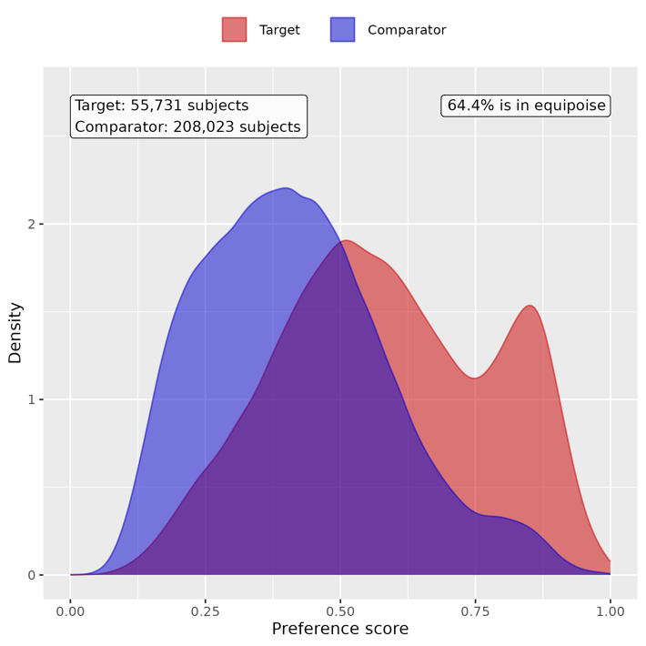

Supp Figure 52. Preference score distributions of COVID-19 positive and negative groups for obese children. A greater convergence of these distributions indicates a higher similarity in the predicted likelihood of being infected between the COVID-19 positive (red) and negative (blue) participants.
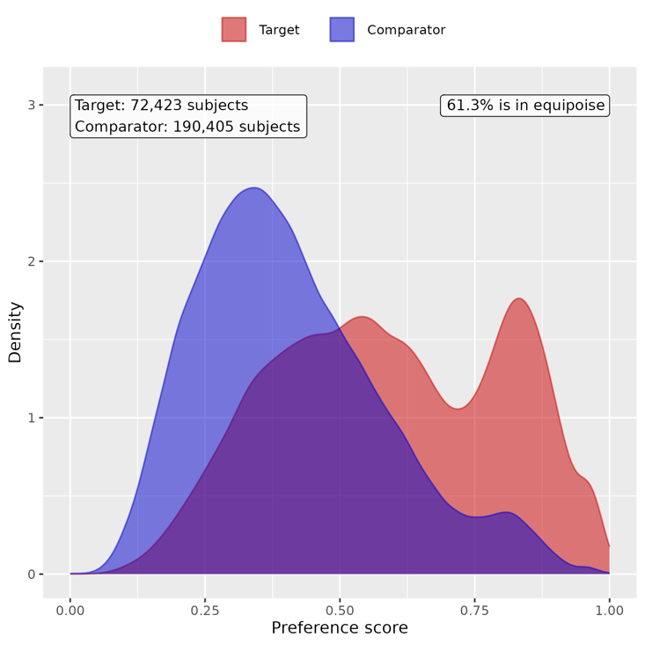

Supp Figure 53. Preference score distributions of COVID-19 positive and negative groups for non-obese youths. A greater convergence of these distributions indicates a higher similarity in the predicted likelihood of being infected between the COVID-19 positive (red) and negative (blue) participants.
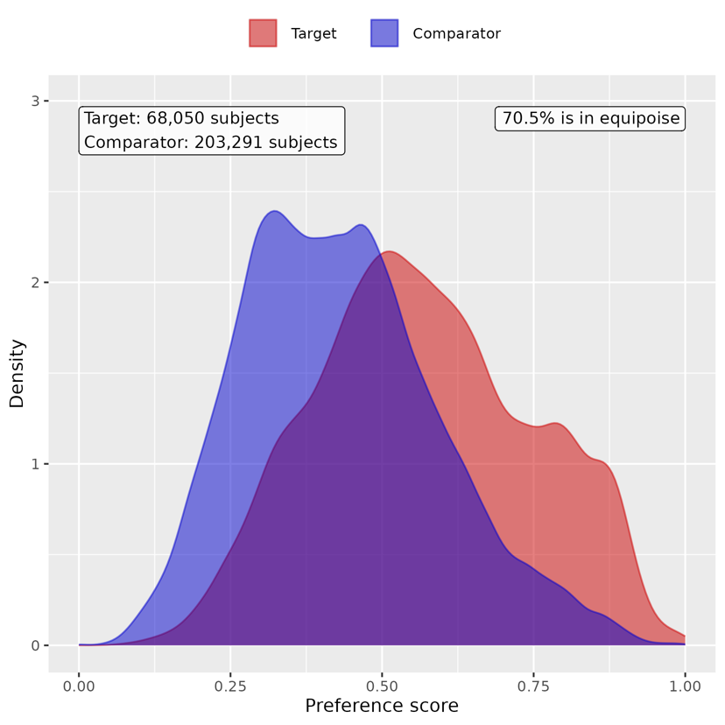

Supp Figure 54. Preference score distributions of COVID-19 positive and negative groups for obese youths. A greater convergence of these distributions indicates a higher similarity in the predicted likelihood of being infected between the COVID-19 positive (red) and negative (blue) participants.
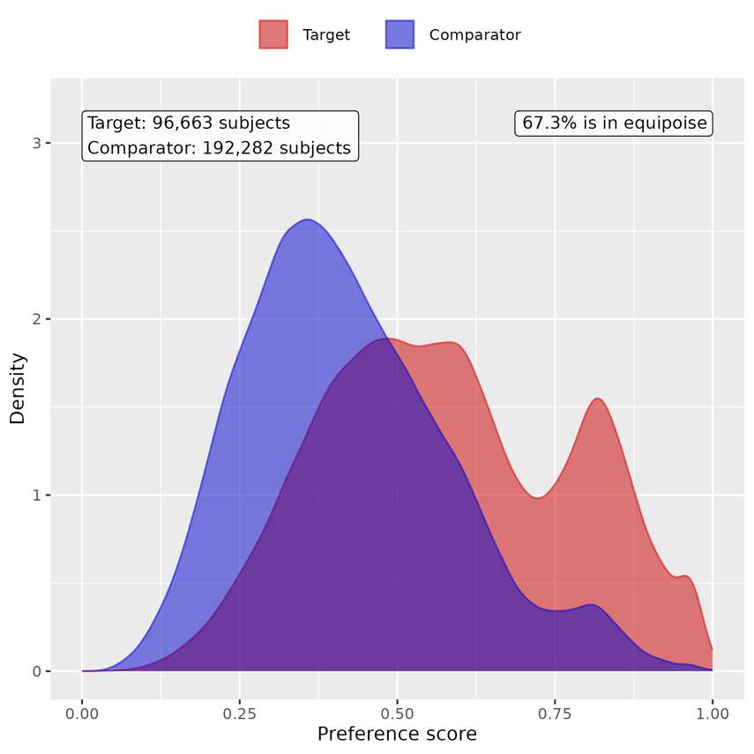

B. Patient characteristic balance

Supp Figure 55. Patient characteristic balance before and after large-scale PS matching with ratio 1:2 for non-obese children. The upper panel displays the top 20 covariates with the largest standardized difference of means before matching, while the lower panel displays the top 20 covariates with the largest standardized difference of means after matching.
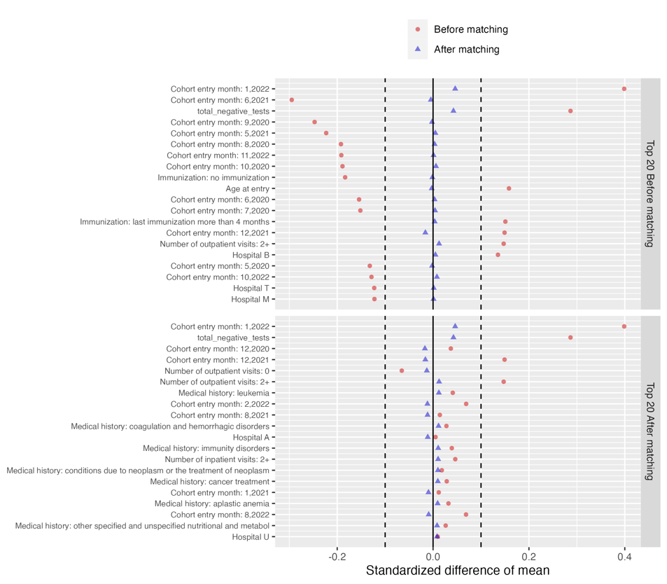

Supp Figure 56. Patient characteristic balance before and after large-scale PS matching with ratio 1:2 for obese children. The upper panel displays the top 20 covariates with the largest standardized difference of means before matching, while the lower panel displays the top 20 covariates with the largest standardized difference of means after matching.
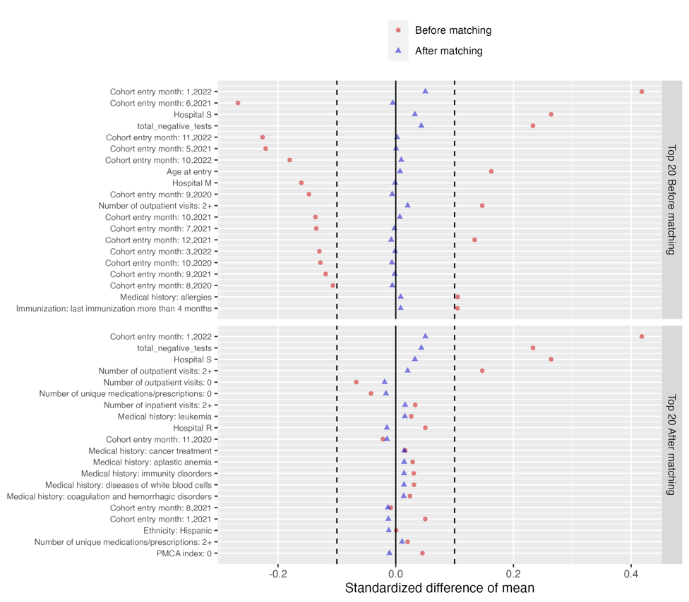
Supp Figure 57. Patient characteristic balance before and after large-scale PS matching with ratio 1:2 for non-obese youths. The upper panel displays the top 20 covariates with the largest standardized difference of means before matching, while the lower panel displays the top 20 covariates with the largest standardized difference of means after matching.
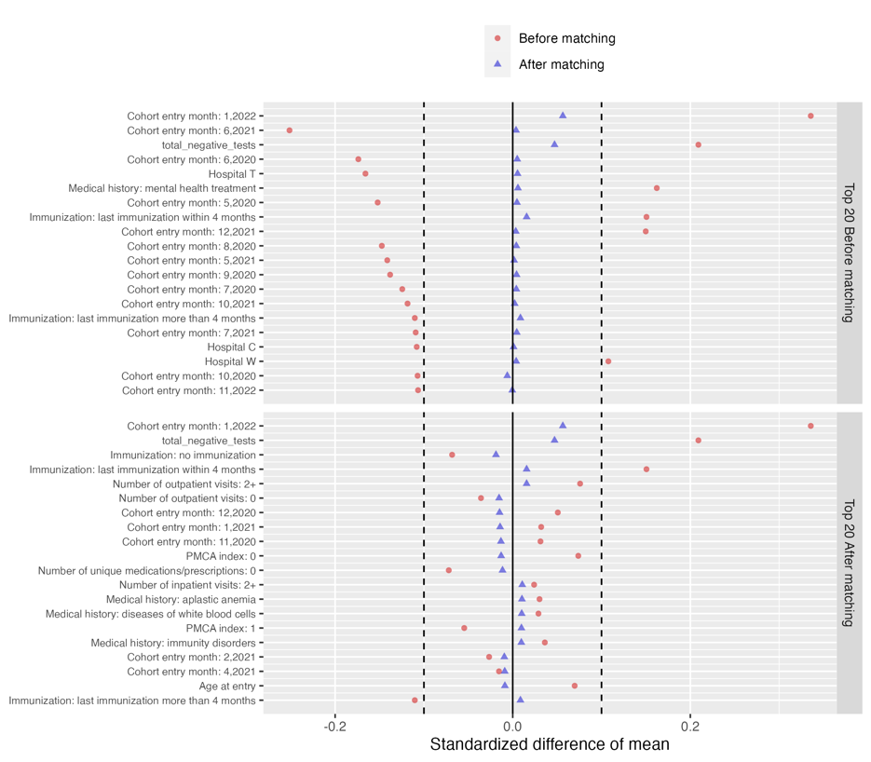

Supp Figure 58. Patient characteristic balance before and after large-scale PS matching with ratio 1:2 for obese youths. The upper panel displays the top 20 covariates with the largest standardized difference of means before matching, while the lower panel displays the top 20 covariates with the largest standardized difference of means after matching.
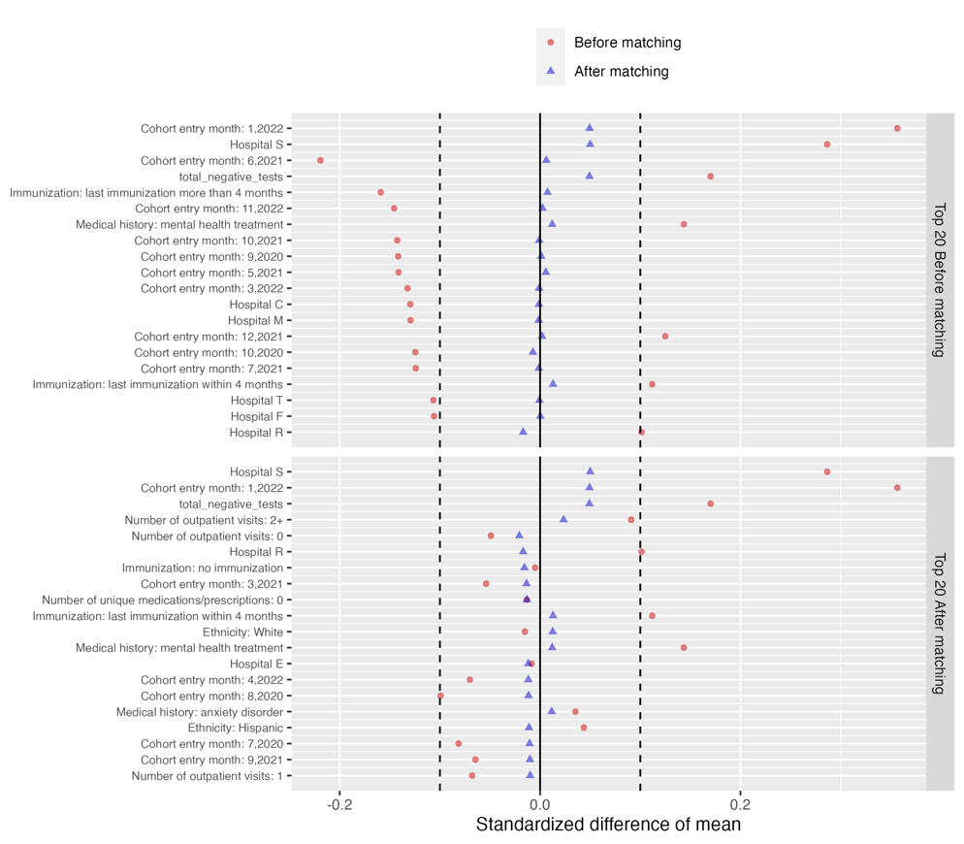

C. Risk difference of COVID-19 positive group compared to COVID-19 negative group

Supp Table 21. Estimated risk difference in mental health conditions between the COVID-19 positive cohort and COVID-19 negative cohort for non-obese children

Category | Cluster | Risk difference (%) | 95% CI (%) | P value
Composite | At least one incident | 1.001 | (0.508, 1.494) | <0.001
Adverse childhood experiences | Emotional abuse | -0.001 | (-0.022, 0.020) | 0.923
 | Neglect | 0 | (-0.020, 0.020) | 0.998
 | Physical abuse | 0.029 | (-0.017, 0.076) | 0.215
 | Sexual abuse | 0.008 | (-0.028, 0.043) | 0.673
Anxiety disorders | Anxiety disorder | 0.296 | (0.076, 0.517) | 0.008
 | OCD | 0.03 | (-0.030, 0.091) | 0.326
 | Somatoform disorder | 0.07 | (-0.002, 0.142) | 0.058
 | Stress disorder | 0.04 | (-0.122, 0.201) | 0.630
Disruptive behavior disorders | Conduct disorder | -0.032 | (-0.133, 0.068) | 0.528
 | Impulse control disorder | -0.03 | (-0.132, 0.073) | 0.572
 | Oppositional defiant disorder | 0.036 | (-0.046, 0.117) | 0.394
Eating and feeding disorders | Avoidant restrictive food intake | 0.058 | (-0.031, 0.146) | 0.201
 | Other eating and feeding disorder | 0.007 | (-0.041, 0.056) | 0.766
Elimination disorders | Encopresis | 0.025 | (-0.049, 0.100) | 0.502
 | Enuresis | 0.037 | (-0.086, 0.161) | 0.554
Gender dysphoria sexual dysfunction | Gender dysphoria | 0.007 | (-0.027, 0.041) | 0.687
 | Paraphilia | 0 | (-0.004, 0.004) | 1.000
 | Sexual dysfunction | -0.004 | (-0.009, 0.001) | 0.102
Intentional self-harm/suicidality | Parasuicidality | 0.015 | (-0.028, 0.059) | 0.496
 | Suicidality | 0.041 | (-0.019, 0.101) | 0.183
Mood disorders | Bipolar disorder | 0.004 | (-0.029, 0.038) | 0.798
 | Major depression | 0.024 | (-0.045, 0.093) | 0.497
 | Minor depression | 0.068 | (-0.020, 0.156) | 0.129
Neurocognitive disorders | Catatonia | 0.006 | (-0.004, 0.016) | 0.270
 | Delirium | 0.048 | (0.004, 0.091) | 0.031
 | Encephalopathy | 0.004 | (-0.027, 0.035) | 0.798
Neurodevelopmental disorders | Academic developmental disorder | -0.001 | (-0.129, 0.127) | 0.986
 | ADHD | 0.106 | (-0.200, 0.411) | 0.498
 | Autism spectrum disorder | 0.137 | (-0.082, 0.356) | 0.219
 | Communication motor disorder | 0.213 | (-0.022, 0.449) | 0.076
 | Intellectual disability | 0.139 | (-0.031, 0.310) | 0.109
Personality disorders | Personality disorder | -0.008 | (-0.028, 0.012) | 0.412
Psychotic disorders | Psychotic disorder | -0.005 | (-0.025, 0.015) | 0.638
 | Schizoaffective disorder | -0.001 | (-0.004, 0.002) | 0.450
 | Schizophrenia | 0.004 | (-0.003, 0.011) | 0.284
Sleep wake disorders | Hypersomnia | -0.008 | (-0.037, 0.021) | 0.595
 | Insomnia | 0.029 | (-0.070, 0.128) | 0.565
 | Parasomnias | 0.036 | (-0.037, 0.109) | 0.334
Standalone symptoms | Anger aggression | 0.008 | (-0.073, 0.089) | 0.848
 | Anxiety symptoms | 0.046 | (-0.029, 0.121) | 0.226
 | Attention symptoms | 0.041 | (-0.062, 0.145) | 0.434
 | Depressive symptoms | 0 | (-0.022, 0.022) | 1.000
 | Hallucinations | -0.004 | (-0.032, 0.025) | 0.795
Substance use and dependence | Alcohol | 0.001 | (-0.007, 0.009) | 0.840
 | Opioid related | 0.002 | (-0.008, 0.012) | 0.663
 | Other substances | 0.014 | (-0.002, 0.029) | 0.090
 | THC | 0.001 | (-0.002, 0.004) | 0.450
 | Tobacco | 0.002 | (-0.005, 0.009) | 0.538
Tic disorders | Tic disorder | 0.106 | (0.013, 0.198) | 0.025

Supp Table 22. Estimated risk difference in mental health conditions between the COVID-19 positive cohort and COVID-19 negative cohort for obese children

Category | Cluster | Risk difference (%) | 95% CI (%) | P value
Composite | At least one incident | 0.917 | (0.431, 1.404) | <0.001
Adverse childhood experiences | Emotional abuse | -0.02 | (-0.053, 0.013) | 0.244
 | Neglect | 0.016 | (-0.002, 0.034) | 0.073
 | Physical abuse | 0.014 | (-0.034, 0.063) | 0.563
 | Sexual abuse | 0.007 | (-0.031, 0.044) | 0.724
Anxiety disorders | Anxiety disorder | 0.335 | (0.112, 0.558) | 0.003
 | OCD | 0.039 | (-0.012, 0.090) | 0.137
 | Somatoform disorder | -0.002 | (-0.075, 0.071) | 0.966
 | Stress disorder | 0.136 | (-0.053, 0.326) | 0.158
Disruptive behavior disorders | Conduct disorder | -0.005 | (-0.106, 0.097) | 0.925
 | Impulse control disorder | -0.001 | (-0.094, 0.091) | 0.978
 | Oppositional defiant disorder | 0.066 | (-0.020, 0.151) | 0.131
Eating and feeding disorders | Avoidant restrictive food intake | -0.029 | (-0.111, 0.054) | 0.496
 | Other eating and feeding disorder | -0.023 | (-0.063, 0.017) | 0.254
Elimination disorders | Encopresis | 0.045 | (-0.007, 0.096) | 0.091
 | Enuresis | 0.015 | (-0.099, 0.130) | 0.793
Gender dysphoria sexual dysfunction | Gender dysphoria | -0.011 | (-0.038, 0.017) | 0.448
 | Paraphilia | -0.001 | (-0.003, 0.001) | 0.441
 | Sexual dysfunction | 0.002 | (-0.005, 0.008) | 0.624
Intentional self-harm/suicidality | Parasuicidality | -0.003 | (-0.047, 0.041) | 0.893
 | Suicidality | 0.016 | (-0.038, 0.071) | 0.558
Mood disorders | Bipolar disorder | 0.033 | (-0.001, 0.068) | 0.057
 | Major depression | -0.047 | (-0.121, 0.026) | 0.206
 | Minor depression | -0.027 | (-0.119, 0.065) | 0.566
Neurocognitive disorders | Catatonia | 0 | (-0.007, 0.006) | 0.926
 | Delirium | 0.065 | (0.018, 0.113) | 0.007
 | Encephalopathy | 0 | (-0.033, 0.034) | 0.978
Neurodevelopmental disorders | Academic developmental disorder | 0.083 | (-0.043, 0.209) | 0.196
 | ADHD | 0.364 | (0.058, 0.670) | 0.020
 | Autism spectrum disorder | 0.178 | (-0.037, 0.392) | 0.104
 | Communication motor disorder | 0.22 | (-0.007, 0.447) | 0.058
 | Intellectual disability | 0.103 | (-0.054, 0.260) | 0.199
Personality disorders | Personality disorder | 0.008 | (-0.015, 0.032) | 0.479
Psychotic disorders | Psychotic disorder | 0.001 | (-0.028, 0.031) | 0.943
 | Schizoaffective disorder | 0.003 | (-0.002, 0.007) | 0.301
 | Schizophrenia | -0.002 | (-0.009, 0.006) | 0.617
Sleep wake disorders | Hypersomnia | 0.011 | (-0.028, 0.049) | 0.588
 | Insomnia | 0.023 | (-0.080, 0.127) | 0.658
 | Parasomnias | 0.04 | (-0.029, 0.108) | 0.257
Standalone symptoms | Anger aggression | 0.055 | (-0.026, 0.135) | 0.181
 | Anxiety symptoms | 0.031 | (-0.047, 0.109) | 0.434
 | Attention symptoms | -0.008 | (-0.111, 0.095) | 0.876
 | Depressive symptoms | 0.01 | (-0.009, 0.029) | 0.285
 | Hallucinations | 0.026 | (-0.005, 0.057) | 0.100
Substance use and dependence | Alcohol | -0.007 | (-0.014, -0.000) | 0.045
 | Opioid related | 0.001 | (-0.011, 0.013) | 0.882
 | Other substances | 0.004 | (-0.015, 0.023) | 0.676
 | THC | NA | NA | NA
 | Tobacco | -0.003 | (-0.011, 0.004) | 0.419
Tic disorders | Tic disorder | -0.001 | (-0.081, 0.078) | 0.975

Supp Table 23. Estimated risk difference in mental health conditions between the COVID-19 positive cohort and COVID-19 negative cohort for non-obese youths

Category | Cluster | Risk difference (%) | 95% CI (%) | P value
Composite | At least one incident | 0.683 | (0.187, 1.178) | 0.007
Adverse childhood experiences | Emotional abuse | 0.004 | (-0.013, 0.021) | 0.656
 | Neglect | 0.005 | (-0.013, 0.023) | 0.590
 | Physical abuse | 0.028 | (-0.025, 0.081) | 0.301
 | Sexual abuse | 0.007 | (-0.038, 0.053) | 0.747
Anxiety disorders | Anxiety disorder | 0.328 | (-0.011, 0.667) | 0.058
 | OCD | 0.031 | (-0.064, 0.126) | 0.518
 | Somatoform disorder | 0.042 | (-0.054, 0.138) | 0.392
 | Stress disorder | 0.018 | (-0.180, 0.216) | 0.860
Disruptive behavior disorders | Conduct disorder | -0.027 | (-0.091, 0.037) | 0.415
 | Impulse control disorder | -0.027 | (-0.113, 0.060) | 0.544
 | Oppositional defiant disorder | 0.039 | (-0.036, 0.115) | 0.303
Eating and feeding disorders | Avoidant restrictive food intake | -0.175 | (-0.329, -0.021) | 0.026
 | Other eating and feeding disorder | -0.014 | (-0.051, 0.023) | 0.462
Elimination disorders | Encopresis | 0.012 | (-0.016, 0.040) | 0.415
 | Enuresis | -0.009 | (-0.063, 0.045) | 0.742
Gender dysphoria sexual dysfunction | Gender dysphoria | -0.039 | (-0.122, 0.043) | 0.350
 | Paraphilia | -0.003 | (-0.016, 0.010) | 0.693
 | Sexual dysfunction | 0.008 | (-0.012, 0.029) | 0.437
Intentional self-harm/suicidality | Parasuicidality | 0.036 | (-0.042, 0.115) | 0.367
 | Suicidality | 0.095 | (-0.047, 0.237) | 0.189
Mood disorders | Bipolar disorder | 0.01 | (-0.042, 0.061) | 0.711
 | Major depression | -0.137 | (-0.389, 0.114) | 0.285
 | Minor depression | 0.052 | (-0.204, 0.308) | 0.691
Neurocognitive disorders | Catatonia | 0.002 | (-0.020, 0.024) | 0.874
 | Delirium | 0.043 | (-0.042, 0.127) | 0.324
 | Encephalopathy | 0.012 | (-0.024, 0.048) | 0.501
Neurodevelopmental disorders | Academic developmental disorder | 0.037 | (-0.049, 0.123) | 0.400
 | ADHD | 0.364 | (0.082, 0.646) | 0.011
 | Autism spectrum disorder | 0.046 | (-0.099, 0.190) | 0.536
 | Communication motor disorder | 0.075 | (-0.029, 0.179) | 0.156
 | Intellectual disability | 0.061 | (-0.067, 0.189) | 0.352
Personality disorders | Personality disorder | -0.002 | (-0.053, 0.048) | 0.927
Psychotic disorders | Psychotic disorder | 0.004 | (-0.047, 0.055) | 0.875
 | Schizoaffective disorder | -0.002 | (-0.024, 0.019) | 0.827
 | Schizophrenia | -0.012 | (-0.047, 0.022) | 0.477
Sleep wake disorders | Hypersomnia | -0.025 | (-0.072, 0.022) | 0.295
 | Insomnia | 0.076 | (-0.038, 0.190) | 0.189
 | Parasomnias | 0.02 | (-0.032, 0.072) | 0.458
Standalone symptoms | Anger aggression | 0.011 | (-0.062, 0.084) | 0.769
 | Anxiety symptoms | 0.103 | (0.024, 0.182) | 0.010
 | Attention symptoms | 0.109 | (0.025, 0.192) | 0.011
 | Depressive symptoms | 0.014 | (-0.015, 0.044) | 0.341
 | Hallucinations | 0.006 | (-0.038, 0.049) | 0.797
Substance use and dependence | Alcohol | -0.04 | (-0.081, 0.002) | 0.063
 | Opioid related | 0 | (-0.025, 0.026) | 0.986
 | Other substances | -0.026 | (-0.080, 0.028) | 0.347
 | THC | -0.042 | (-0.112, 0.027) | 0.234
 | Tobacco | -0.001 | (-0.087, 0.086) | 0.989
Tic disorders | Tic disorder | 0.082 | (0.004, 0.159) | 0.039

Supp Table 24. Estimated risk difference in mental health conditions between the COVID-19 positive cohort and COVID-19 negative cohort for obese youths

Category | Cluster | Risk difference (%) | 95% CI (%) | P value
Composite | At least one incident | 1.167 | (0.691, 1.642) | <0.001
Adverse childhood experiences | Emotional abuse | 0.025 | (-0.000, 0.051) | 0.053
 | Neglect | 0.001 | (-0.015, 0.017) | 0.919
 | Physical abuse | 0.042 | (-0.004, 0.088) | 0.074
 | Sexual abuse | 0.041 | (0.001, 0.081) | 0.045
Anxiety disorders | Anxiety disorder | 0.364 | (0.035, 0.692) | 0.030
 | OCD | 0.049 | (-0.027, 0.124) | 0.210
 | Somatoform disorder | -0.049 | (-0.140, 0.041) | 0.287
 | Stress disorder | 0.183 | (-0.035, 0.401) | 0.100
Disruptive behavior disorders | Conduct disorder | -0.039 | (-0.103, 0.024) | 0.226
 | Impulse control disorder | 0.034 | (-0.052, 0.120) | 0.439
 | Oppositional defiant disorder | 0.033 | (-0.047, 0.113) | 0.421
Eating and feeding disorders | Avoidant restrictive food intake | 0.037 | (-0.077, 0.151) | 0.524
 | Other eating and feeding disorder | 0.02 | (-0.006, 0.047) | 0.128
Elimination disorders | Encopresis | 0.015 | (-0.006, 0.035) | 0.162
 | Enuresis | 0.02 | (-0.040, 0.079) | 0.514
Gender dysphoria sexual dysfunction | Gender dysphoria | -0.035 | (-0.112, 0.043) | 0.381
 | Paraphilia | -0.001 | (-0.009, 0.006) | 0.757
 | Sexual dysfunction | 0.002 | (-0.017, 0.020) | 0.869
Intentional self-harm/suicidality | Parasuicidality | 0.033 | (-0.032, 0.098) | 0.319
 | Suicidality | 0.187 | (0.066, 0.307) | 0.002
Mood disorders | Bipolar disorder | -0.042 | (-0.094, 0.011) | 0.120
 | Major depression | -0.042 | (-0.286, 0.203) | 0.739
 | Minor depression | 0.39 | (0.149, 0.632) | 0.002
Neurocognitive disorders | Catatonia | 0.004 | (-0.012, 0.021) | 0.609
 | Delirium | 0.137 | (0.054, 0.219) | 0.001
 | Encephalopathy | 0.023 | (-0.009, 0.054) | 0.158
Neurodevelopmental disorders | Academic developmental disorder | 0.064 | (-0.024, 0.151) | 0.153
 | ADHD | 0.458 | (0.192, 0.724) | <0.001
 | Autism spectrum disorder | 0.093 | (-0.056, 0.242) | 0.223
 | Communication motor disorder | 0.071 | (-0.024, 0.166) | 0.142
 | Intellectual disability | 0.159 | (0.037, 0.280) | 0.011
Personality disorders | Personality disorder | -0.044 | (-0.094, 0.005) | 0.081
Psychotic disorders | Psychotic disorder | 0 | (-0.052, 0.051) | 0.986
 | Schizoaffective disorder | -0.004 | (-0.024, 0.017) | 0.731
 | Schizophrenia | -0.01 | (-0.041, 0.021) | 0.530
Sleep wake disorders | Hypersomnia | 0.017 | (-0.034, 0.068) | 0.513
 | Insomnia | 0.153 | (0.032, 0.274) | 0.013
 | Parasomnias | 0.049 | (0.001, 0.097) | 0.048
Standalone symptoms | Anger aggression | 0.07 | (-0.004, 0.143) | 0.063
 | Anxiety symptoms | 0.03 | (-0.038, 0.098) | 0.390
 | Attention symptoms | 0.061 | (-0.016, 0.139) | 0.122
 | Depressive symptoms | 0.029 | (0.003, 0.055) | 0.029
 | Hallucinations | 0.012 | (-0.031, 0.054) | 0.596
Substance use and dependence | Alcohol | 0.016 | (-0.020, 0.052) | 0.375
 | Opioid related | -0.002 | (-0.027, 0.024) | 0.904
 | Other substances | 0.01 | (-0.041, 0.061) | 0.707
 | THC | -0.012 | (-0.071, 0.047) | 0.690
 | Tobacco | 0.051 | (-0.031, 0.134) | 0.221
Tic disorders | Tic disorder | 0.018 | (-0.048, 0.085) | 0.593

Section 11 Supplemental Results: sensitivity analysis for subgroups with different hospitalization status

We conducted sensitivity analyses on both cohorts stratified by the hospitalization status (i.e, non-hospitalized, hospitalized, admitted to ICU). We performed the same PS matching procedure and difference-in-difference method to estimate the risk difference.

A. Empirical equipoise assessment

Supp Figure 59. Preference score distributions of COVID-19 positive and negative groups for non-hospitalized children. A greater convergence of these distributions indicates a higher similarity in the predicted likelihood of being infected between the COVID-19 positive (red) and negative (blue) participants.
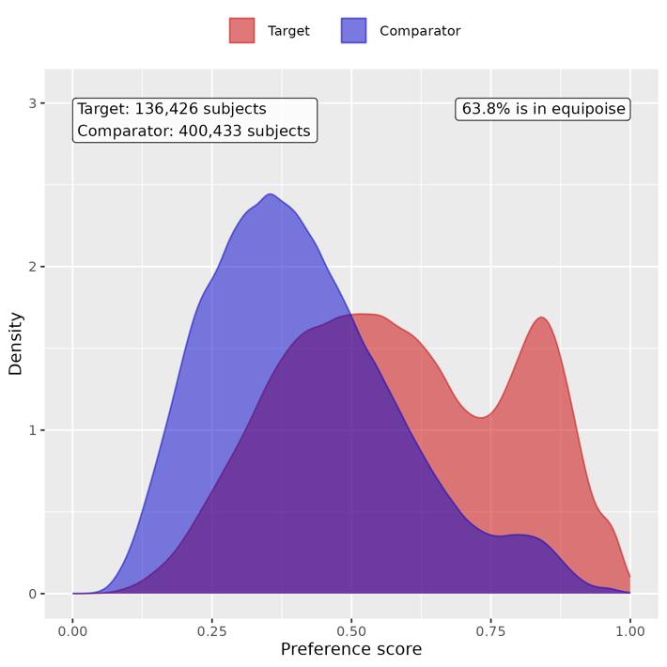

Supp Figure 60. Preference score distributions of COVID-19 positive and negative groups for hospitalized children. A greater convergence of these distributions indicates a higher similarity in the predicted likelihood of being infected between the COVID-19 positive (red) and negative (blue) participants.
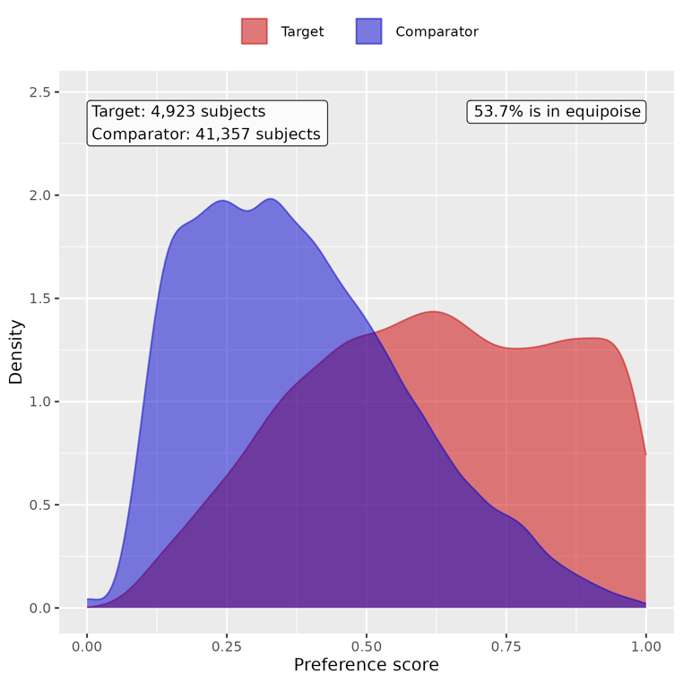

Supp Figure 61. Preference score distributions of COVID-19 positive and negative groups for children admitted to ICU. A greater convergence of these distributions indicates a higher similarity in the predicted likelihood of being infected between the COVID-19 positive (red) and negative (blue) participants.
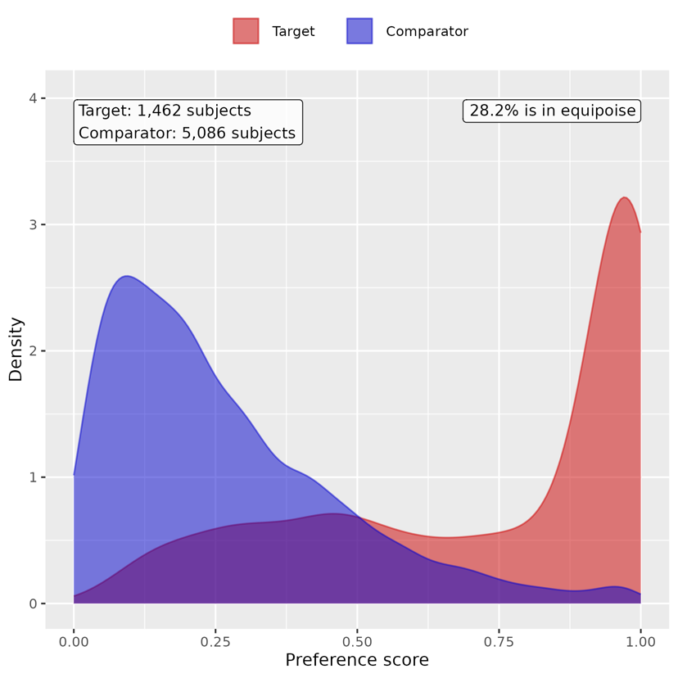

Supp Figure 62. Preference score distributions of COVID-19 positive and negative groups for non-hospitalized youths. A greater convergence of these distributions indicates a higher similarity in the predicted likelihood of being infected between the COVID-19 positive (red) and negative (blue) participants.
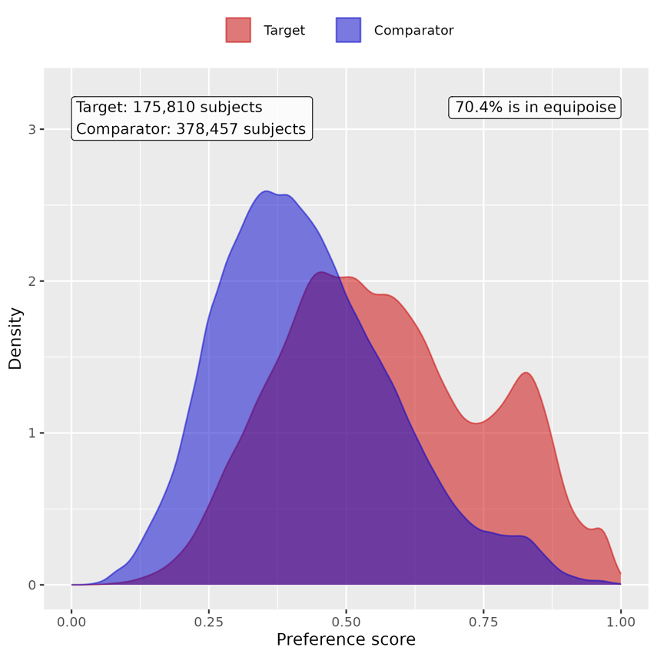

Supp Figure 63. Preference score distributions of COVID-19 positive and negative groups for hospitalized youths. A greater convergence of these distributions indicates a higher similarity in the predicted likelihood of being infected between the COVID-19 positive (red) and negative (blue) participants.
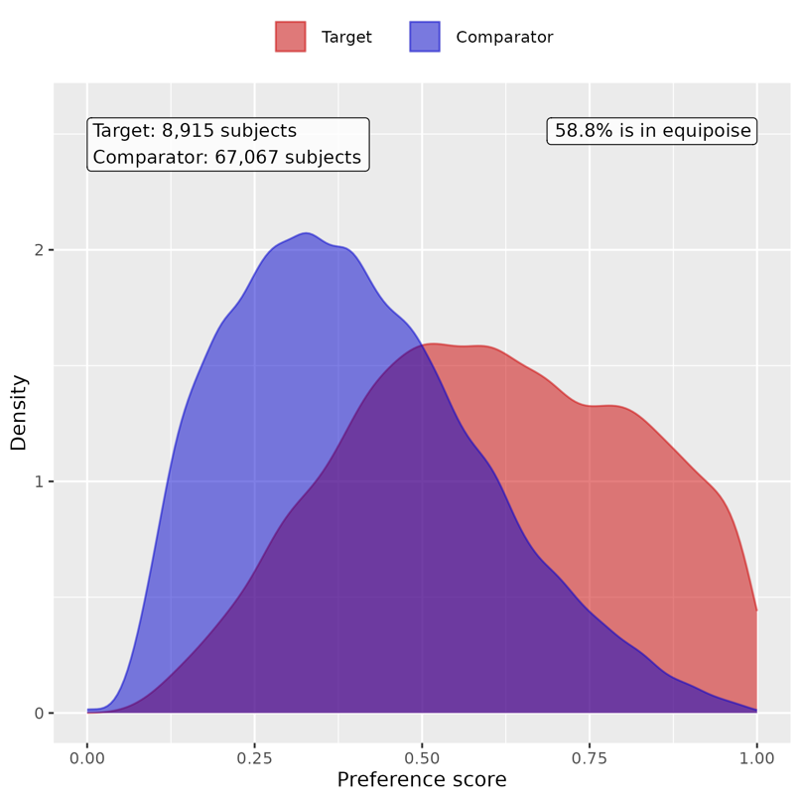

Supp Figure 64. Preference score distributions of COVID-19 positive and COVID-19 negative groups for youths admitted to ICU. A greater convergence of these distributions indicates a higher similarity in the predicted likelihood of being infected between the COVID-19 positive (red) and negative (blue) participants.
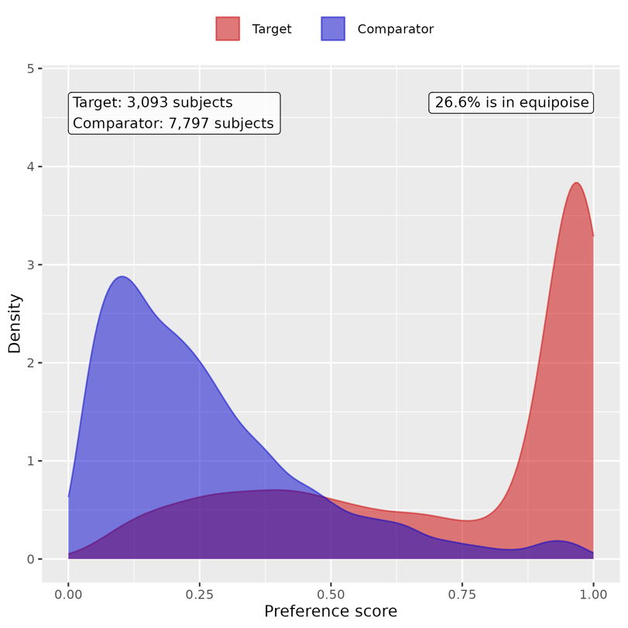

B. Patient characteristic balance

Supp Figure 65. Patient characteristic balance before and after large-scale PS matching with ratio 1:2 for non-hospitalized children. The upper panel displays the top 20 covariates with the largest standardized difference of means before matching, while the lower panel displays the top 20 covariates with the largest standardized difference of means after matching.
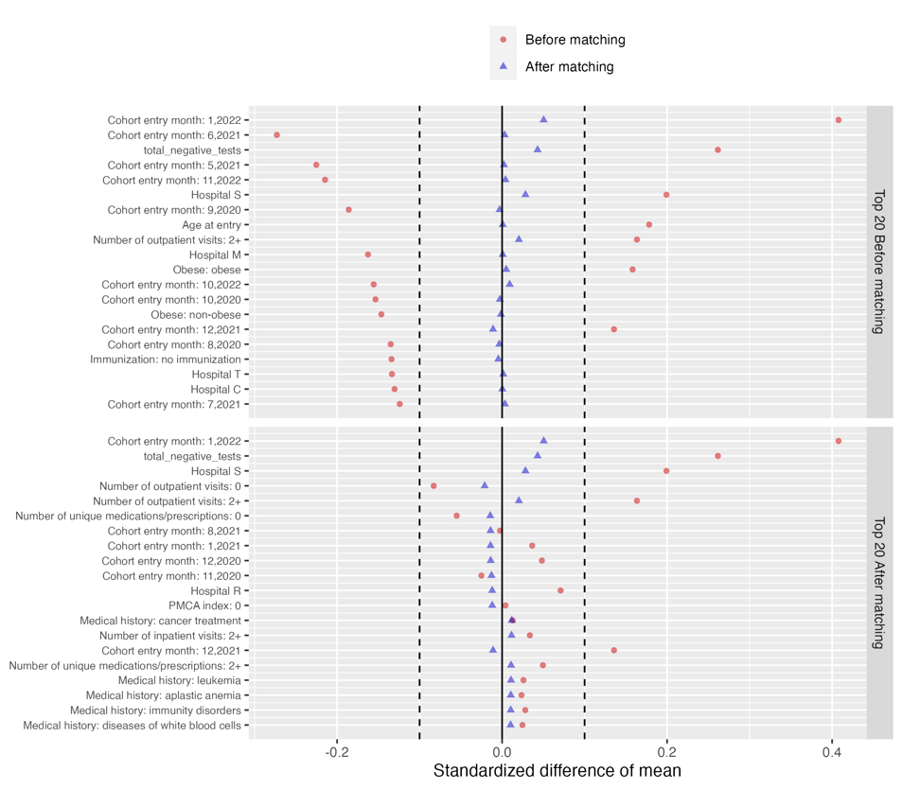

Supp Figure 66. Patient characteristic balance before and after large-scale PS matching with ratio 1:2 for hospitalized children. The upper panel displays the top 20 covariates with the largest standardized difference of means before matching, while the lower panel displays the top 20 covariates with the largest standardized difference of means after matching.
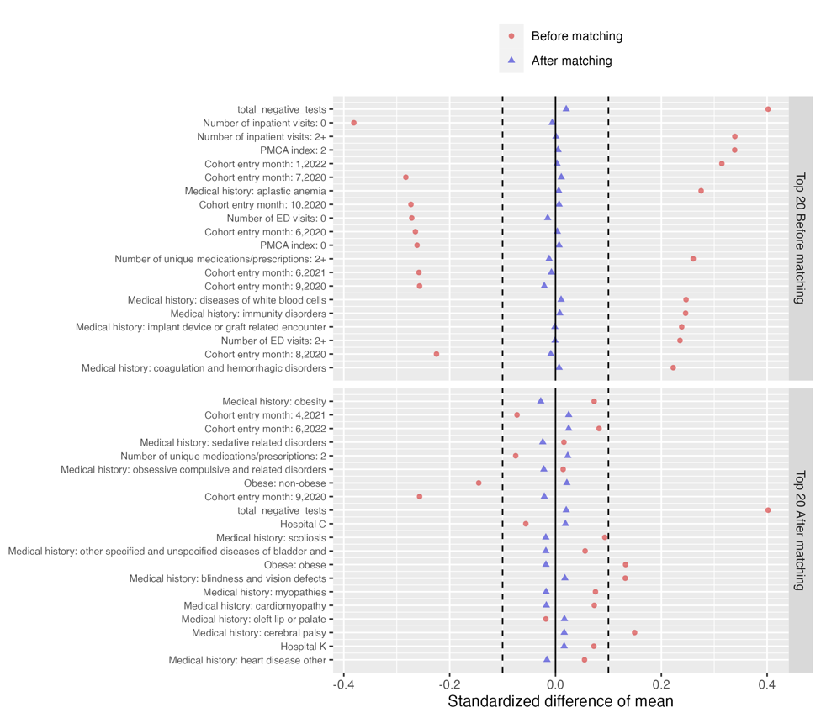
Supp Figure 67. Patient characteristic balance before and after large-scale PS matching with ratio 1:2 for children admitted to ICU. The upper panel displays the top 20 covariates with the largest standardized difference of means before matching, while the lower panel displays the top 20 covariates with the largest standardized difference of means after matching.
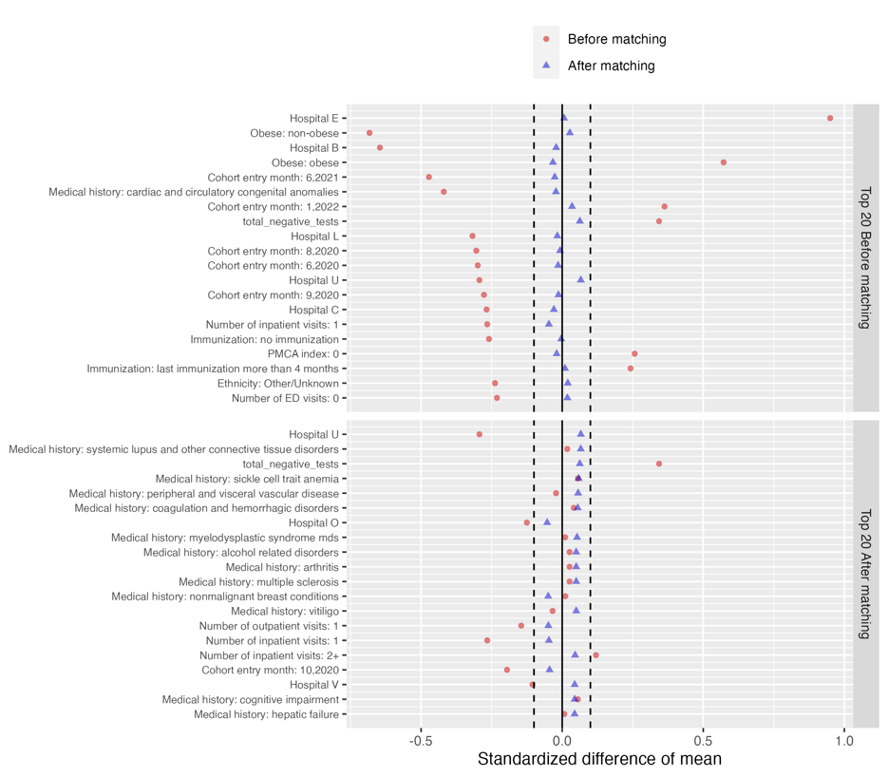

Supp Figure 68. Patient characteristic balance before and after large-scale PS matching with ratio 1:2 for non-hospitalized youths. The upper panel displays the top 20 covariates with the largest standardized difference of means before matching, while the lower panel displays the top 20 covariates with the largest standardized difference of means after matching.
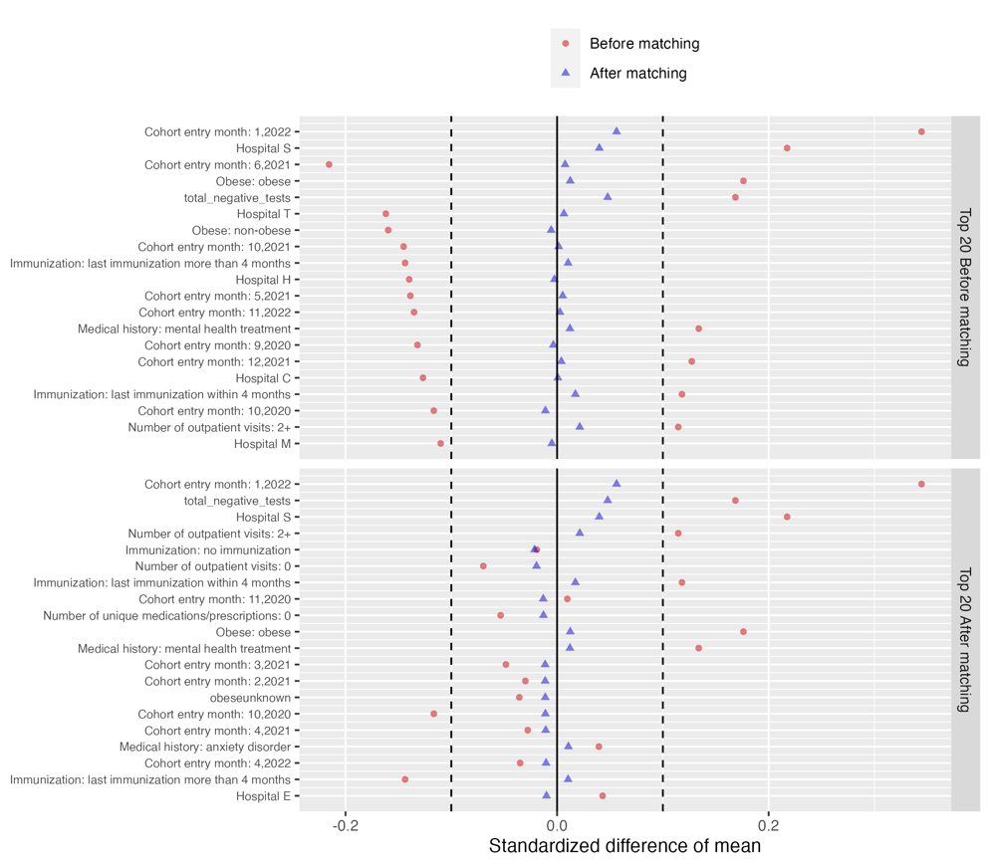

Supp Figure 69. Patient characteristic balance before and after large-scale PS matching with ratio 1:2 for hospitalized youths. The upper panel displays the top 20 covariates with the largest standardized difference of means before matching, while the lower panel displays the top 20 covariates with the largest standardized difference of means after matching.
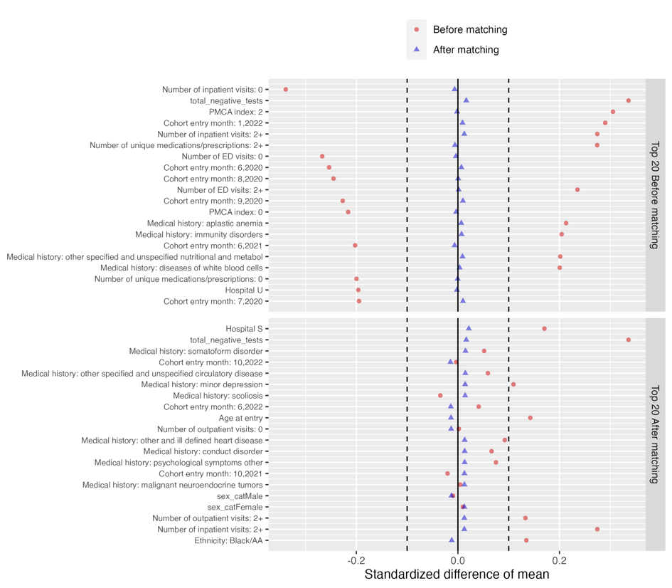

Supp Figure 70. Patient characteristic balance before and after large-scale PS matching with ratio 1:2 for youths admitted to ICU. The upper panel displays the top 20 covariates with the largest standardized difference of means before matching, while the lower panel displays the top 20 covariates with the largest standardized difference of means after matching.
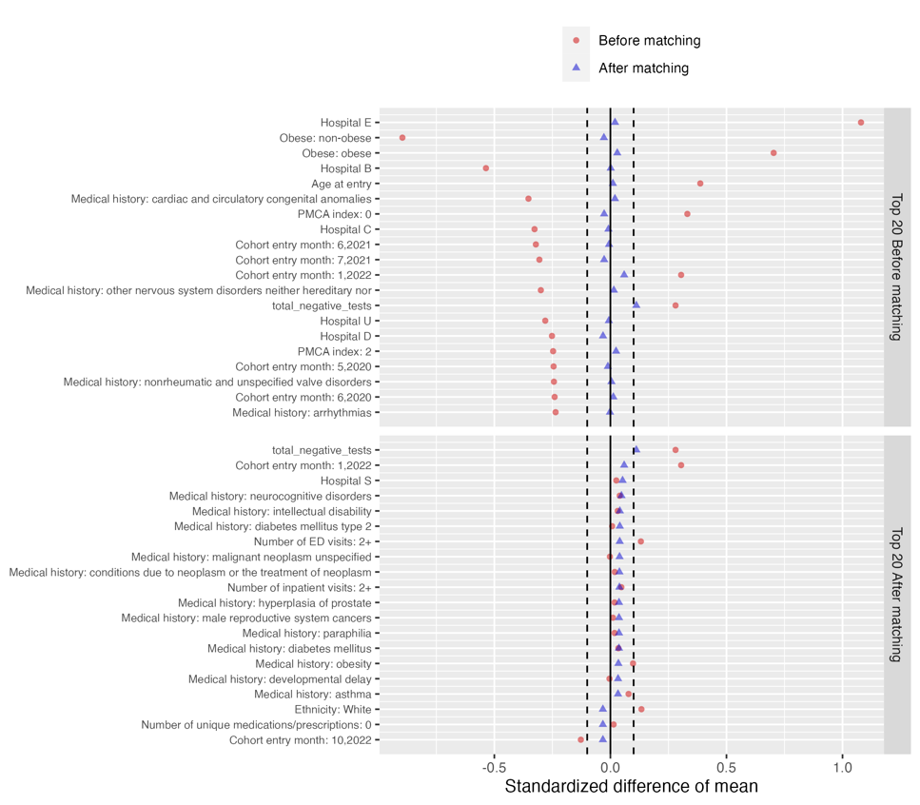

C. Risk difference of COVID-19 positive group compared to COVID-19 negative group

Supp Table 25. Estimated risk difference in mental health conditions between the COVID-19 positive cohort and COVID-19 negative cohort for non-hospitalized children

Category | Cluster | Risk difference (%) | 95% CI (%) | P value
Composite | At least one incident | 0.774 | (0.453, 1.096) | <0.001
Adverse childhood experiences | Emotional abuse | -0.006 | (-0.025, 0.013) | 0.515
 | Neglect | 0.002 | (-0.010, 0.014) | 0.721
 | Physical abuse | 0.02 | (-0.010, 0.051) | 0.194
 | Sexual abuse | 0.01 | (-0.014, 0.034) | 0.430
Anxiety disorders | Anxiety disorder | 0.295 | (0.151, 0.439) | <0.001
 | OCD | 0.035 | (-0.001, 0.071) | 0.055
 | Somatoform disorder | 0.025 | (-0.022, 0.072) | 0.299
 | Stress disorder | 0.123 | (0.005, 0.242) | 0.042
Disruptive behavior disorders | Conduct disorder | -0.009 | (-0.075, 0.057) | 0.787
 | Impulse control disorder | -0.021 | (-0.083, 0.041) | 0.503
 | Oppositional defiant disorder | 0.042 | (-0.013, 0.097) | 0.137
Eating and feeding disorders | Avoidant restrictive food intake | 0.027 | (-0.027, 0.081) | 0.328
 | Other eating and feeding disorder | -0.009 | (-0.036, 0.018) | 0.510
Elimination disorders | Encopresis | 0.033 | (-0.006, 0.071) | 0.096
 | Enuresis | 0.014 | (-0.065, 0.092) | 0.734
Gender dysphoria sexual dysfunction | Gender dysphoria | -0.008 | (-0.028, 0.011) | 0.409
 | Paraphilia | -0.001 | (-0.003, 0.001) | 0.280
 | Sexual dysfunction | 0.001 | (-0.003, 0.004) | 0.663
Intentional self-harm/suicidality | Parasuicidality | 0 | (-0.027, 0.026) | 0.976
 | Suicidality | 0.01 | (-0.026, 0.046) | 0.576
Mood disorders | Bipolar disorder | 0.023 | (0.001, 0.046) | 0.042
 | Major depression | -0.009 | (-0.054, 0.036) | 0.685
 | Minor depression | 0.001 | (-0.057, 0.059) | 0.976
Neurocognitive disorders | Catatonia | 0 | (-0.004, 0.003) | 0.799
 | Delirium | 0.038 | (0.012, 0.064) | 0.004
 | Encephalopathy | 0.002 | (-0.016, 0.019) | 0.844
Neurodevelopmental disorders | Academic developmental disorder | 0.033 | (-0.050, 0.115) | 0.436
 | ADHD | 0.152 | (-0.050, 0.353) | 0.141
 | Autism spectrum disorder | 0.158 | (0.020, 0.297) | 0.025
 | Communication motor disorder | 0.157 | (0.009, 0.305) | 0.038
 | Intellectual disability | 0.095 | (-0.002, 0.193) | 0.056
Personality disorders | Personality disorder | 0.003 | (-0.011, 0.017) | 0.681
Psychotic disorders | Psychotic disorder | 0.001 | (-0.015, 0.017) | 0.914
 | Schizoaffective disorder | 0.002 | (-0.000, 0.005) | 0.072
 | Schizophrenia | -0.001 | (-0.005, 0.003) | 0.470
Sleep wake disorders | Hypersomnia | 0.003 | (-0.019, 0.025) | 0.784
 | Insomnia | -0.001 | (-0.065, 0.063) | 0.980
 | Parasomnias | 0.021 | (-0.024, 0.066) | 0.360
Standalone symptoms | Anger aggression | 0.035 | (-0.016, 0.087) | 0.178
 | Anxiety symptoms | 0.047 | (-0.001, 0.096) | 0.055
 | Attention symptoms | -0.005 | (-0.073, 0.062) | 0.875
 | Depressive symptoms | 0.007 | (-0.007, 0.021) | 0.324
 | Hallucinations | 0.009 | (-0.010, 0.028) | 0.351
Substance use and dependence | Alcohol | -0.002 | (-0.006, 0.001) | 0.203
 | Opioid related | 0.003 | (-0.003, 0.008) | 0.317
 | Other substances | 0.004 | (-0.006, 0.013) | 0.438
 | THC | 0 | (-0.001, 0.002) | 0.445
 | Tobacco | 0 | (-0.004, 0.005) | 0.844
Tic disorders | Tic disorder | 0.048 | (-0.008, 0.104) | 0.092

Supp Table 26. Estimated risk difference in mental health conditions between the COVID-19 positive cohort and COVID-19 negative cohort for hospitalized children

Category | Cluster | Risk difference (%) | 95% CI (%) | P value
Composite | At least one incident | 4.222 | (2.051, 6.393) | <0.001
Adverse childhood experiences | Emotional abuse | -0.058 | (-0.135, 0.020) | 0.145
 | Neglect | 0.076 | (-0.029, 0.181) | 0.157
 | Physical abuse | 0.023 | (-0.263, 0.308) | 0.877
 | Sexual abuse | 0.058 | (-0.104, 0.219) | 0.484
Anxiety disorders | Anxiety disorder | 1.762 | (0.694, 2.830) | 0.001
 | OCD | 0.151 | (-0.097, 0.400) | 0.233
 | Somatoform disorder | 0.254 | (-0.121, 0.628) | 0.184
 | Stress disorder | 0.532 | (-0.253, 1.316) | 0.184
Disruptive behavior disorders | Conduct disorder | -0.362 | (-0.857, 0.134) | 0.153
 | Impulse control disorder | 0.165 | (-0.375, 0.705) | 0.550
 | Oppositional defiant disorder | 0.038 | (-0.320, 0.397) | 0.834
Eating and feeding disorders | Avoidant restrictive food intake | 0.43 | (-0.078, 0.938) | 0.097
 | Other eating and feeding disorder | 0.091 | (-0.195, 0.377) | 0.531
Elimination disorders | Encopresis | -0.127 | (-0.480, 0.226) | 0.480
 | Enuresis | 0.211 | (-0.251, 0.673) | 0.371
Gender dysphoria sexual dysfunction | Gender dysphoria | 0.03 | (-0.131, 0.191) | 0.715
 | Paraphilia | NA | NA | NA
 | Sexual dysfunction | NA | NA | NA
Intentional self-harm/suicidality | Parasuicidality | 0.199 | (-0.080, 0.478) | 0.162
 | Suicidality | 0.146 | (-0.247, 0.538) | 0.466
Mood disorders | Bipolar disorder | 0.133 | (-0.069, 0.336) | 0.197
 | Major depression | -0.086 | (-0.485, 0.313) | 0.672
 | Minor depression | 0.41 | (-0.029, 0.850) | 0.067
Neurocognitive disorders | Catatonia | 0.076 | (-0.019, 0.171) | 0.118
 | Delirium | 0.079 | (-0.330, 0.489) | 0.704
 | Encephalopathy | 0.202 | (-0.104, 0.508) | 0.197
Neurodevelopmental disorders | Academic developmental disorder | 0.32 | (-0.155, 0.794) | 0.187
 | ADHD | 0.684 | (-0.469, 1.838) | 0.245
 | Autism spectrum disorder | 0.925 | (-0.215, 2.065) | 0.112
 | Communication motor disorder | 0.899 | (-0.308, 2.106) | 0.144
 | Intellectual disability | 1.021 | (-0.198, 2.239) | 0.101
Personality disorders | Personality disorder | 0.068 | (-0.081, 0.216) | 0.372
Psychotic disorders | Psychotic disorder | 0.11 | (-0.061, 0.280) | 0.207
 | Schizoaffective disorder | NA | NA | NA
 | Schizophrenia | 0.034 | (-0.044, 0.111) | 0.393
Sleep wake disorders | Hypersomnia | 0.141 | (-0.041, 0.322) | 0.129
 | Insomnia | 0.235 | (-0.355, 0.825) | 0.436
 | Parasomnias | 0.174 | (-0.233, 0.582) | 0.401
Standalone symptoms | Anger aggression | 0.39 | (-0.109, 0.888) | 0.125
 | Anxiety symptoms | 0.614 | (0.085, 1.143) | 0.023
 | Attention symptoms | 0.529 | (0.073, 0.984) | 0.023
 | Depressive symptoms | 0.036 | (-0.069, 0.140) | 0.505
 | Hallucinations | -0.036 | (-0.248, 0.176) | 0.742
Substance use and dependence | Alcohol | -0.022 | (-0.054, 0.010) | 0.175
 | Opioid related | 0.049 | (-0.102, 0.201) | 0.523
 | Other substances | 0.111 | (-0.073, 0.296) | 0.236
 | THC | 0.012 | (-0.020, 0.044) | 0.461
 | Tobacco | -0.012 | (-0.044, 0.020) | 0.461
Tic disorders | Tic disorder | 0.157 | (-0.217, 0.532) | 0.411

Supp Table 27. Estimated risk difference in mental health conditions between the COVID-19 positive cohort and COVID-19 negative cohort for children admitted to ICU

Category | Cluster | Risk difference (%) | 95% CI (%) | P value
Composite | At least one incident | 5.338 | (-0.107, 10.782) | 0.055
Adverse childhood experiences | Emotional abuse | -0.13 | (-0.323, 0.063) | 0.187
 | Neglect | 0.354 | (-0.032, 0.740) | 0.072
 | Physical abuse | 0.334 | (-0.305, 0.974) | 0.305
 | Sexual abuse | 0.185 | (-0.246, 0.617) | 0.401
Anxiety disorders | Anxiety disorder | 2.873 | (0.511, 5.236) | 0.017
 | OCD | 0.055 | (-0.331, 0.441) | 0.779
 | Somatoform disorder | 0.744 | (-0.219, 1.706) | 0.130
 | Stress disorder | 0.552 | (-1.298, 2.402) | 0.559
Disruptive behavior disorders | Conduct disorder | 0.334 | (-0.835, 1.504) | 0.575
 | Impulse control disorder | 0.26 | (-0.511, 1.031) | 0.509
 | Oppositional defiant disorder | 0.799 | (0.005, 1.592) | 0.049
Eating and feeding disorders | Avoidant restrictive food intake | 0.614 | (-0.290, 1.517) | 0.183
 | Other eating and feeding disorder | 0.185 | (-0.455, 0.825) | 0.571
Elimination disorders | Encopresis | -0.13 | (-0.640, 0.381) | 0.618
 | Enuresis | 0.818 | (-0.125, 1.761) | 0.089
Gender dysphoria sexual dysfunction | Gender dysphoria | 0.055 | (-0.417, 0.528) | 0.819
 | Paraphilia | NA | NA | NA
 | Sexual dysfunction | NA | NA | NA
Intentional self-harm/suicidality | Parasuicidality | 0.26 | (-0.286, 0.805) | 0.351
 | Suicidality | 0.13 | (-0.381, 0.640) | 0.618
Mood disorders | Bipolar disorder | 0.11 | (-0.362, 0.583) | 0.647
 | Major depression | -0.13 | (-0.769, 0.509) | 0.690
 | Minor depression | 0.834 | (-0.025, 1.694) | 0.057
Neurocognitive disorders | Catatonia | 0.334 | (0.000, 0.669) | 0.050
 | Delirium | 0.39 | (-1.106, 1.885) | 0.610
 | Encephalopathy | 0.276 | (-0.541, 1.093) | 0.508
Neurodevelopmental disorders | Academic developmental disorder | -0.094 | (-1.279, 1.090) | 0.876
 | ADHD | 1.591 | (-0.995, 4.177) | 0.228
 | Autism spectrum disorder | -0.338 | (-2.846, 2.170) | 0.792
 | Communication motor disorder | 1.094 | (-2.089, 4.277) | 0.501
 | Intellectual disability | 0.468 | (-3.005, 3.940) | 0.792
Personality disorders | Personality disorder | 0.185 | (-0.246, 0.617) | 0.401
Psychotic disorders | Psychotic disorder | 0.055 | (-0.417, 0.528) | 0.819
 | Schizoaffective disorder | NA | NA | NA
 | Schizophrenia | 0.13 | (-0.063, 0.323) | 0.187
Sleep wake disorders | Hypersomnia | -0.221 | (-0.888, 0.446) | 0.517
 | Insomnia | -0.094 | (-1.529, 1.341) | 0.898
 | Parasomnias | -0.445 | (-1.445, 0.555) | 0.383
Standalone symptoms | Anger aggression | 0.688 | (-0.106, 1.482) | 0.089
 | Anxiety symptoms | 0.669 | (-0.791, 2.129) | 0.369
 | Attention symptoms | 0.614 | (-0.661, 1.888) | 0.345
 | Depressive symptoms | 0.055 | (-0.218, 0.328) | 0.692
 | Hallucinations | -0.224 | (-0.734, 0.286) | 0.390
Substance use and dependence | Alcohol | NA | NA | NA
 | Opioid related | -0.019 | (-0.598, 0.559) | 0.947
 | Other substances | 0.5 | (-0.010, 1.010) | 0.055
 | THC | NA | NA | NA
 | Tobacco | NA | NA | NA
Tic disorders | Tic disorder | 0.205 | (-0.341, 0.750) | 0.462

Supp Table 28. Estimated risk difference in mental health conditions between the COVID-19 positive cohort and COVID-19 negative cohort for non-hospitalized youths

Category | Cluster | Risk difference (%) | 95% CI (%) | P value
Composite | At least one incident | 1.006 | (0.689, 1.322) | <0.001
Adverse childhood experiences | Emotional abuse | 0.016 | (0.001, 0.030) | 0.037
 | Neglect | 0.005 | (-0.004, 0.014) | 0.310
 | Physical abuse | 0.03 | (0.001, 0.059) | 0.043
 | Sexual abuse | 0.028 | (0.002, 0.055) | 0.037
Anxiety disorders | Anxiety disorder | 0.41 | (0.194, 0.626) | <0.001
 | OCD | 0.047 | (-0.008, 0.101) | 0.091
 | Somatoform disorder | -0.009 | (-0.067, 0.048) | 0.749
 | Stress disorder | 0.107 | (-0.028, 0.243) | 0.122
Disruptive behavior disorders | Conduct disorder | -0.028 | (-0.067, 0.011) | 0.158
 | Impulse control disorder | 0.021 | (-0.030, 0.073) | 0.419
 | Oppositional defiant disorder | 0.033 | (-0.016, 0.082) | 0.183
Eating and feeding disorders | Avoidant restrictive food intake | 0.052 | (-0.028, 0.131) | 0.206
 | Other eating and feeding disorder | 0.005 | (-0.013, 0.023) | 0.606
Elimination disorders | Encopresis | 0.008 | (-0.006, 0.022) | 0.269
 | Enuresis | 0.006 | (-0.030, 0.043) | 0.738
Gender dysphoria sexual dysfunction | Gender dysphoria | -0.005 | (-0.057, 0.047) | 0.845
 | Paraphilia | -0.004 | (-0.010, 0.003) | 0.286
 | Sexual dysfunction | -0.001 | (-0.013, 0.011) | 0.871
Intentional self-harm/suicidality | Parasuicidality | 0.031 | (-0.012, 0.073) | 0.161
 | Suicidality | 0.148 | (0.069, 0.226) | <0.001
Mood disorders | Bipolar disorder | -0.003 | (-0.035, 0.030) | 0.875
 | Major depression | 0.008 | (-0.150, 0.167) | 0.920
 | Minor depression | 0.22 | (0.061, 0.379) | 0.007
Neurocognitive disorders | Catatonia | -0.004 | (-0.014, 0.005) | 0.377
 | Delirium | 0.052 | (0.002, 0.102) | 0.042
 | Encephalopathy | 0.013 | (-0.006, 0.033) | 0.167
Neurodevelopmental disorders | Academic developmental disorder | 0.049 | (-0.007, 0.104) | 0.084
 | ADHD | 0.371 | (0.194, 0.549) | <0.001
 | Autism spectrum disorder | 0.091 | (-0.001, 0.183) | 0.052
 | Communication motor disorder | 0.039 | (-0.021, 0.099) | 0.203
 | Intellectual disability | 0.058 | (-0.013, 0.130) | 0.108
Personality disorders | Personality disorder | -0.025 | (-0.054, 0.005) | 0.109
Psychotic disorders | Psychotic disorder | 0 | (-0.029, 0.030) | 0.982
 | Schizoaffective disorder | -0.004 | (-0.017, 0.008) | 0.497
 | Schizophrenia | -0.003 | (-0.021, 0.016) | 0.766
Sleep wake disorders | Hypersomnia | 0.008 | (-0.024, 0.040) | 0.624
 | Insomnia | 0.102 | (0.027, 0.176) | 0.008
 | Parasomnias | 0.028 | (-0.003, 0.059) | 0.077
Standalone symptoms | Anger aggression | 0.027 | (-0.017, 0.071) | 0.229
 | Anxiety symptoms | 0.061 | (0.016, 0.105) | 0.008
 | Attention symptoms | 0.061 | (0.010, 0.113) | 0.020
 | Depressive symptoms | 0.013 | (-0.004, 0.030) | 0.138
 | Hallucinations | 0.011 | (-0.014, 0.036) | 0.368
Substance use and dependence | Alcohol | -0.002 | (-0.028, 0.023) | 0.851
 | Opioid related | 0.002 | (-0.012, 0.015) | 0.814
 | Other substances | -0.005 | (-0.037, 0.027) | 0.762
 | THC | 0.003 | (-0.036, 0.042) | 0.887
 | Tobacco | 0.027 | (-0.027, 0.081) | 0.324
Tic disorders | Tic disorder | 0.035 | (-0.011, 0.080) | 0.132

Supp Table 29. Estimated risk difference in mental health conditions between the COVID-19 positive cohort and COVID-19 negative cohort for hospitalized youths

Category | Cluster | Risk difference (%) | 95% CI (%) | P value
Composite | At least one incident | 3.535 | (1.862, 5.207) | <0.001
Adverse childhood experiences | Emotional abuse | 0.003 | (-0.078, 0.083) | 0.949
 | Neglect | 0.055 | (-0.063, 0.172) | 0.361
 | Physical abuse | 0.035 | (-0.252, 0.323) | 0.811
 | Sexual abuse | 0.069 | (-0.117, 0.255) | 0.465
Anxiety disorders | Anxiety disorder | 1.153 | (-0.054, 2.360) | 0.061
 | OCD | 0.134 | (-0.192, 0.460) | 0.421
 | Somatoform disorder | 0.499 | (0.085, 0.912) | 0.018
 | Stress disorder | 0.61 | (-0.215, 1.435) | 0.147
Disruptive behavior disorders | Conduct disorder | -0.015 | (-0.336, 0.306) | 0.926
 | Impulse control disorder | 0.186 | (-0.261, 0.633) | 0.414
 | Oppositional defiant disorder | 0.098 | (-0.248, 0.444) | 0.580
Eating and feeding disorders | Avoidant restrictive food intake | -0.162 | (-0.755, 0.431) | 0.592
 | Other eating and feeding disorder | 0.134 | (-0.036, 0.304) | 0.123
Elimination disorders | Encopresis | 0.03 | (-0.072, 0.132) | 0.569
 | Enuresis | 0.205 | (-0.020, 0.430) | 0.074
Gender dysphoria sexual dysfunction | Gender dysphoria | -0.213 | (-0.532, 0.105) | 0.189
 | Paraphilia | -0.013 | (-0.054, 0.029) | 0.550
 | Sexual dysfunction | -0.013 | (-0.071, 0.046) | 0.672
Intentional self-harm/suicidality | Parasuicidality | 0.058 | (-0.311, 0.427) | 0.760
 | Suicidality | 0.221 | (-0.450, 0.893) | 0.518
Mood disorders | Bipolar disorder | 0.022 | (-0.198, 0.242) | 0.846
 | Major depression | 0.197 | (-0.748, 1.142) | 0.684
 | Minor depression | 0.67 | (-0.256, 1.596) | 0.156
Neurocognitive disorders | Catatonia | 0.149 | (0.007, 0.292) | 0.040
 | Delirium | 0.759 | (0.304, 1.214) | 0.001
 | Encephalopathy | 0.242 | (0.037, 0.446) | 0.021
Neurodevelopmental disorders | Academic developmental disorder | 0.084 | (-0.246, 0.414) | 0.617
 | ADHD | 0.967 | (0.097, 1.836) | 0.029
 | Autism spectrum disorder | 0.254 | (-0.410, 0.918) | 0.454
 | Communication motor disorder | 0.485 | (-0.002, 0.972) | 0.051
 | Intellectual disability | 0.723 | (-0.036, 1.482) | 0.062
Personality disorders | Personality disorder | 0.174 | (-0.103, 0.451) | 0.218
Psychotic disorders | Psychotic disorder | 0.063 | (-0.241, 0.367) | 0.684
 | Schizoaffective disorder | 0.058 | (-0.061, 0.176) | 0.342
 | Schizophrenia | 0.005 | (-0.197, 0.207) | 0.963
Sleep wake disorders | Hypersomnia | 0.048 | (-0.160, 0.257) | 0.648
 | Insomnia | 0.765 | (0.245, 1.285) | 0.004
 | Parasomnias | 0.031 | (-0.181, 0.243) | 0.776
Standalone symptoms | Anger aggression | 0.195 | (-0.189, 0.579) | 0.319
 | Anxiety symptoms | 0.315 | (-0.065, 0.696) | 0.104
 | Attention symptoms | 0.251 | (-0.029, 0.530) | 0.079
 | Depressive symptoms | 0.029 | (-0.077, 0.135) | 0.595
 | Hallucinations | 0.027 | (-0.227, 0.281) | 0.835
Substance use and dependence | Alcohol | 0.087 | (-0.080, 0.254) | 0.306
 | Opioid related | 0.077 | (-0.106, 0.261) | 0.409
 | Other substances | 0.055 | (-0.203, 0.313) | 0.676
 | THC | -0.08 | (-0.393, 0.233) | 0.615
 | Tobacco | 0.006 | (-0.349, 0.360) | 0.975
Tic disorders | Tic disorder | 0.185 | (-0.063, 0.434) | 0.144

Supp Table 30. Estimated risk difference in mental health conditions between the COVID-19 positive cohort and COVID-19 negative cohort for youths admitted to ICU

Category | Cluster | Risk difference (%) | 95% CI (%) | P value
Composite | At least one incident | 3.418 | (-0.139, 6.974) | 0.060
Adverse childhood experiences | Emotional abuse | 0 | (-0.104, 0.104) | 1.000
 | Neglect | -0.13 | (-0.362, 0.102) | 0.273
 | Physical abuse | -0.155 | (-0.536, 0.227) | 0.427
 | Sexual abuse | -0.084 | (-0.339, 0.170) | 0.516
Anxiety disorders | Anxiety disorder | 0.985 | (-1.284, 3.254) | 0.395
 | OCD | 0.309 | (-0.199, 0.817) | 0.233
 | Somatoform disorder | -0.102 | (-0.852, 0.648) | 0.790
 | Stress disorder | -0.865 | (-2.382, 0.652) | 0.264
Disruptive behavior disorders | Conduct disorder | 0.288 | (-0.256, 0.832) | 0.300
 | Impulse control disorder | 0 | (-0.631, 0.631) | 1.000
 | Oppositional defiant disorder | -0.151 | (-0.742, 0.440) | 0.616
Eating and feeding disorders | Avoidant restrictive food intake | 0.407 | (-0.499, 1.314) | 0.379
 | Other eating and feeding disorder | 0.197 | (-0.088, 0.481) | 0.176
Elimination disorders | Encopresis | -0.042 | (-0.189, 0.105) | 0.574
 | Enuresis | 0.221 | (-0.207, 0.649) | 0.311
Gender dysphoria sexual dysfunction | Gender dysphoria | 0.165 | (-0.408, 0.738) | 0.573
 | Paraphilia | NA | NA | NA
 | Sexual dysfunction | -0.042 | (-0.146, 0.062) | 0.427
Intentional self-harm/suicidality | Parasuicidality | 0.559 | (-0.055, 1.172) | 0.074
 | Suicidality | -0.067 | (-1.105, 0.972) | 0.900
Mood disorders | Bipolar disorder | 0.046 | (-0.314, 0.405) | 0.804
 | Major depression | -0.285 | (-2.016, 1.446) | 0.747
 | Minor depression | 1.214 | (-0.319, 2.747) | 0.121
Neurocognitive disorders | Catatonia | 0.112 | (-0.172, 0.397) | 0.439
 | Delirium | 1.38 | (0.177, 2.583) | 0.025
 | Encephalopathy | 0.277 | (-0.300, 0.855) | 0.347
Neurodevelopmental disorders | Academic developmental disorder | -0.327 | (-0.986, 0.333) | 0.332
 | ADHD | 1.138 | (-0.429, 2.704) | 0.155
 | Autism spectrum disorder | 0.109 | (-1.266, 1.483) | 0.877
 | Communication motor disorder | 0.404 | (-0.667, 1.475) | 0.460
 | Intellectual disability | -0.829 | (-2.754, 1.097) | 0.399
Personality disorders | Personality disorder | 0.017 | (-0.501, 0.536) | 0.948
Psychotic disorders | Psychotic disorder | -0.197 | (-0.655, 0.262) | 0.400
 | Schizoaffective disorder | 0.112 | (-0.015, 0.240) | 0.084
 | Schizophrenia | -0.042 | (-0.275, 0.190) | 0.722
Sleep wake disorders | Hypersomnia | 0 | (-0.415, 0.415) | 1.000
 | Insomnia | 0.323 | (-0.748, 1.394) | 0.555
 | Parasomnias | -0.049 | (-0.477, 0.379) | 0.822
Standalone symptoms | Anger aggression | -0.06 | (-0.584, 0.464) | 0.823
 | Anxiety symptoms | 0.548 | (-0.283, 1.378) | 0.196
 | Attention symptoms | 0.126 | (-0.588, 0.840) | 0.729
 | Depressive symptoms | 0.088 | (-0.016, 0.192) | 0.098
 | Hallucinations | -0.2 | (-0.622, 0.222) | 0.352
Substance use and dependence | Alcohol | 0.116 | (-0.266, 0.497) | 0.552
 | Opioid related | -0.162 | (-0.637, 0.314) | 0.505
 | Other substances | 0.277 | (-0.318, 0.873) | 0.362
 | THC | -0.004 | (-0.576, 0.569) | 0.990
 | Tobacco | -0.46 | (-1.235, 0.314) | 0.244
Tic disorders | Tic disorder | 0.067 | (-0.315, 0.448) | 0.732

Section 12 Supplemental Results: sensitivity analysis for subgroups with different levels of COVID-19 severity

We conducted sensitivity analyses on both cohorts stratified by the COVID-19 severity (i.e., asymptomatic, mild, moderate, and severe). We performed the same PS matching procedure and difference-in-difference method to estimate the risk difference.

A. Empirical equipoise assessment

Supp Figure 71. Preference score distributions of COVID-19 positive and negative groups for children in asymptomatic group. A greater convergence of these distributions indicates a higher similarity in the predicted likelihood of being infected between the COVID-19 positive (red) and negative (blue) participants.
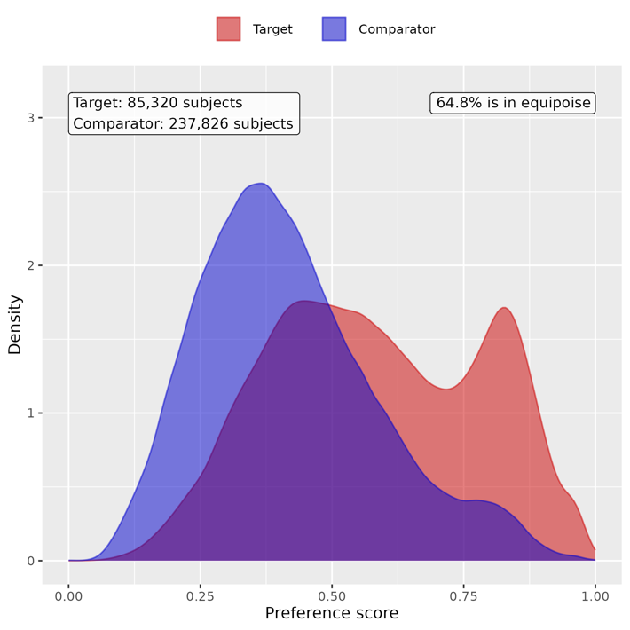

Supp Figure 72. Preference score distributions of COVID-19 positive and negative groups for children in mild group. A greater convergence of these distributions indicates a higher similarity in the predicted likelihood of being infected between the COVID-19 positive (red) and negative (blue) participants.
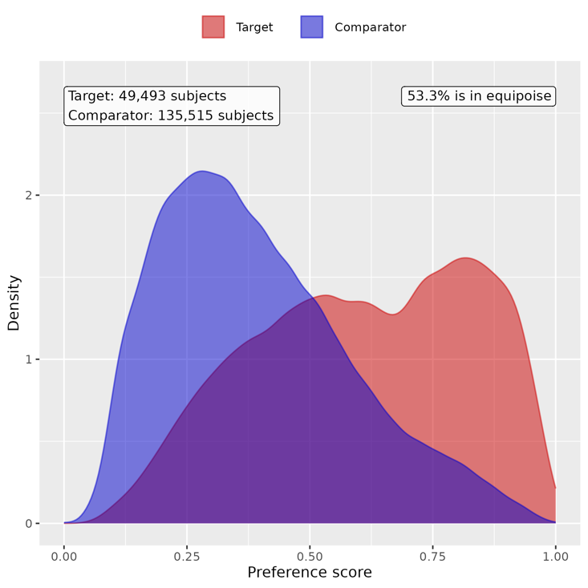

Supp Figure 73. Preference score distributions of COVID-19 positive and negative groups for children in moderate group. A greater convergence of these distributions indicates a higher similarity in the predicted likelihood of being infected between the COVID-19 positive (red) and negative (blue) participants.
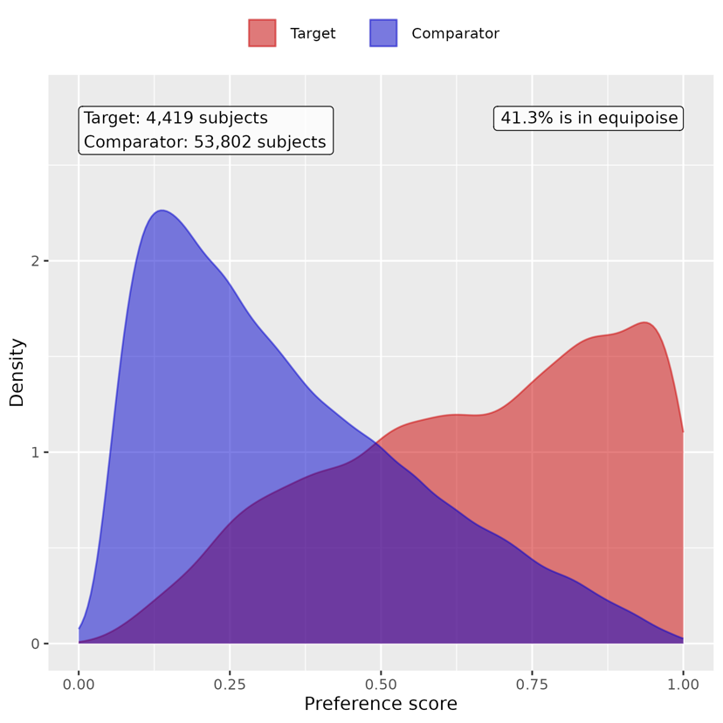

Supp Figure 74. Preference score distributions of COVID-19 positive and negative groups for children in severe group. A greater convergence of these distributions indicates a higher similarity in the predicted likelihood of being infected between the COVID-19 positive (red) and negative (blue) participants.
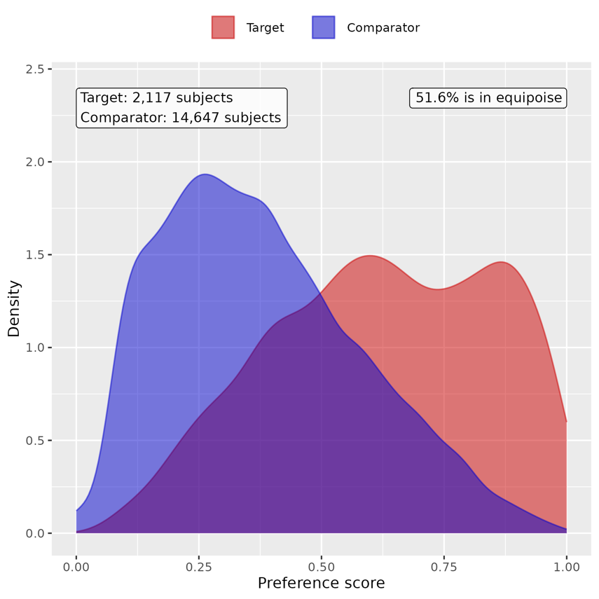

Supp Figure 75. Preference score distributions of COVID-19 positive and COVID-19 negative groups for youths in asymptomatic group. A greater convergence of these distributions indicates a higher similarity in the predicted likelihood of being infected between the COVID-19 positive (red) and negative (blue) participants.
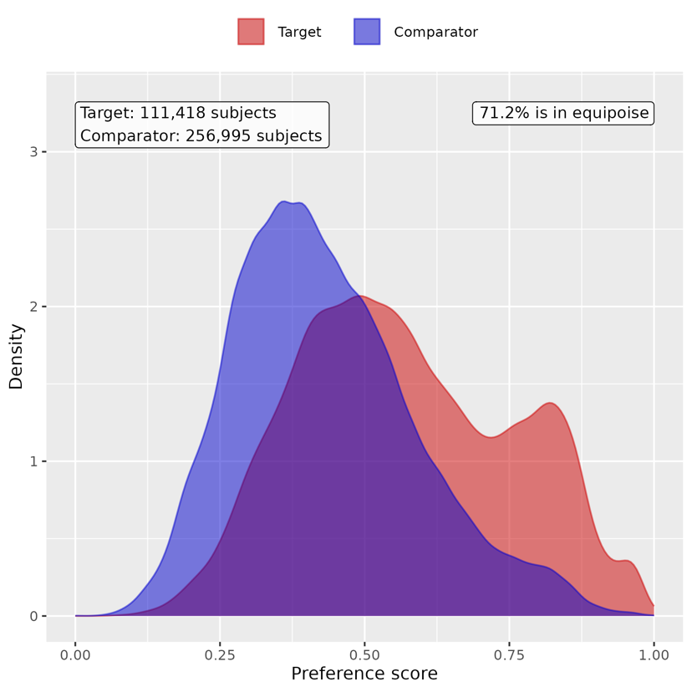

Supp Figure 76. Preference score distributions of COVID-19 positive and negative groups for youths in mild group. A greater convergence of these distributions indicates a higher similarity in the predicted likelihood of being infected between the COVID-19 positive (red) and negative (blue) participants.
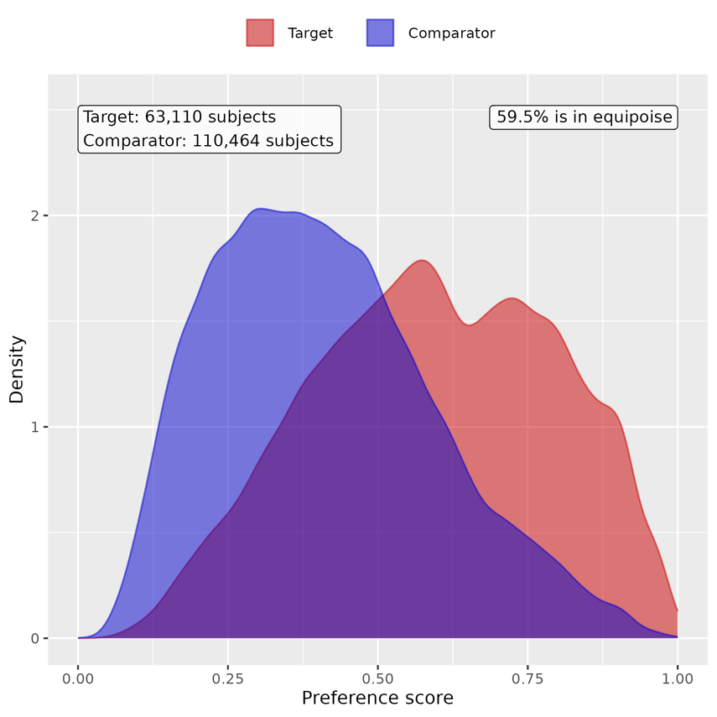

Supp Figure 77. Preference score distributions of COVID-19 positive and negative groups for youths in moderate group. A greater convergence of these distributions indicates a higher similarity in the predicted likelihood of being infected between the COVID-19 positive (red) and negative (blue) participants.
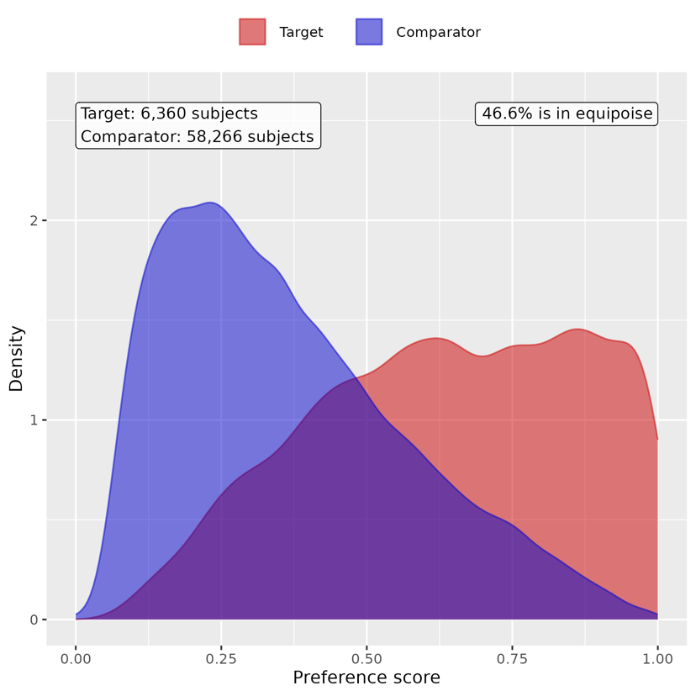

Supp Figure 78. Preference score distributions of COVID-19 positive and negative groups for youths in severe group. A greater convergence of these distributions indicates a higher similarity in the predicted likelihood of being infected between the COVID-19 positive (red) and negative (blue) participants.
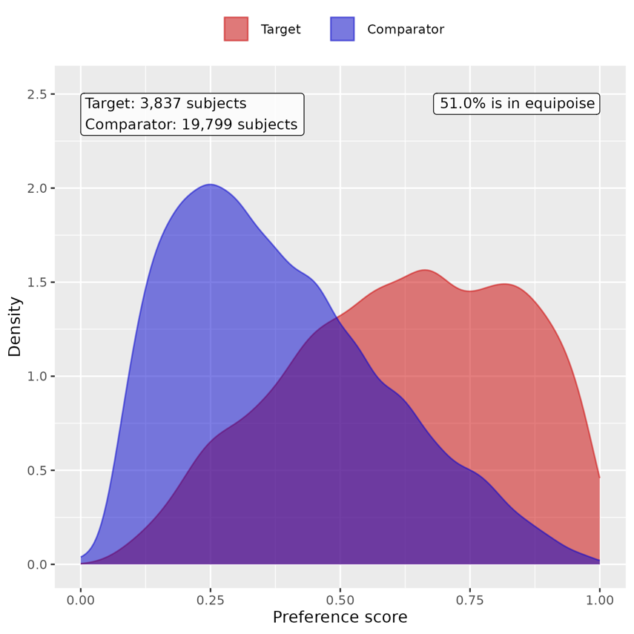

B. Patient characteristic balance

Supp Figure 79. Patient characteristic balance before and after large-scale PS matching with ratio 1:2 for children in asymptomatic group. The upper panel displays the top 20 covariates with the largest standardized difference of means before matching, while the lower panel displays the top 20 covariates with the largest standardized difference of means after matching.
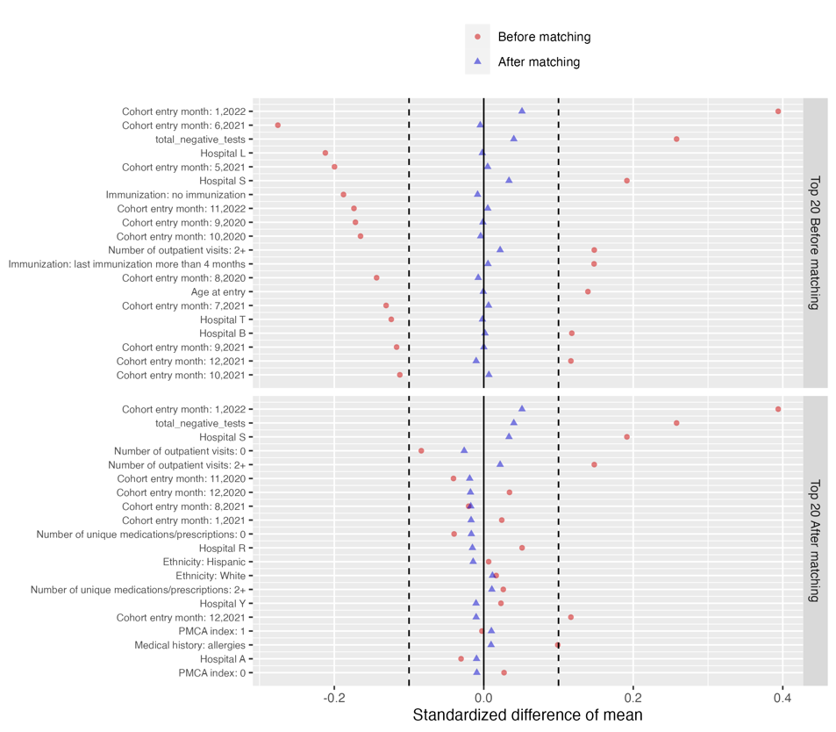

Supp Figure 80. Patient characteristic balance before and after large-scale PS matching with ratio 1:2 for children in mild group. The upper panel displays the top 20 covariates with the largest standardized difference of means before matching, while the lower panel displays the top 20 covariates with the largest standardized difference of means after matching.
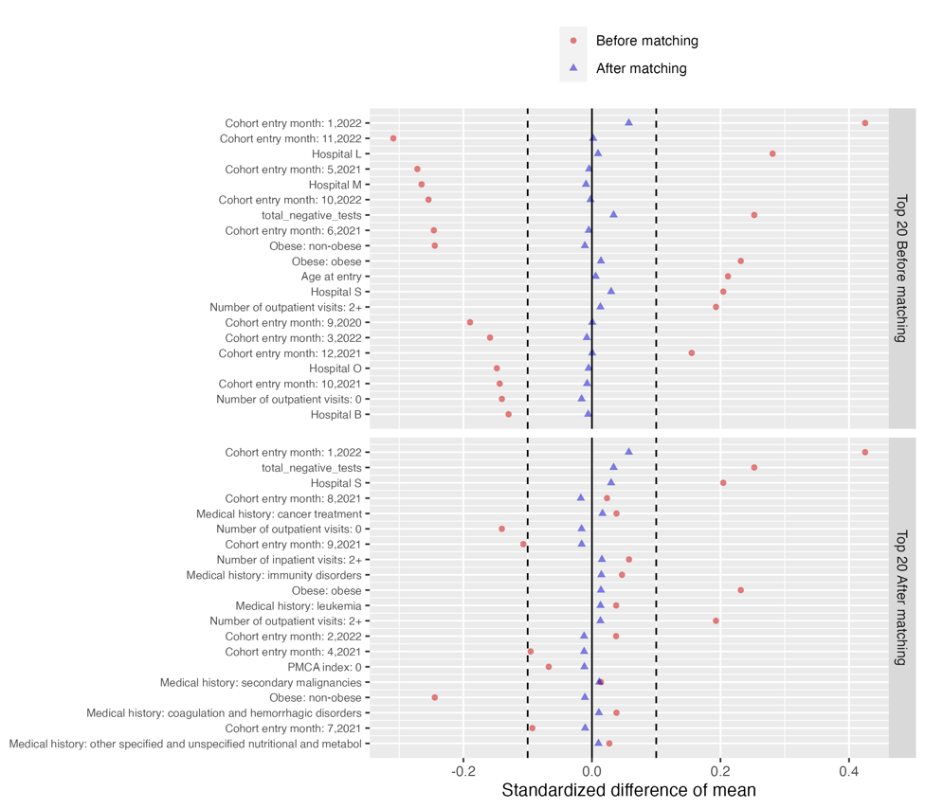
Supp Figure 81. Patient characteristic balance before and after large-scale PS matching with ratio 1:2 for children in moderate group. The upper panel displays the top 20 covariates with the largest standardized difference of means before matching, while the lower panel displays the top 20 covariates with the largest standardized difference of means after matching.
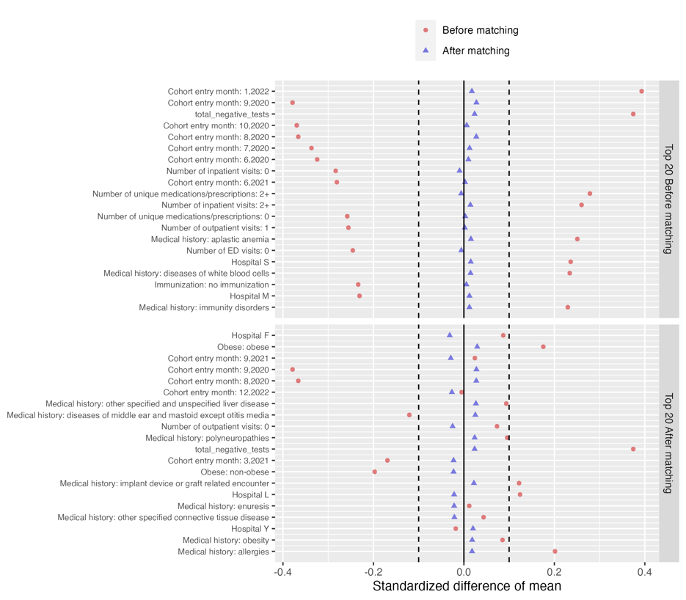

Supp Figure 82. Patient characteristic balance before and after large-scale PS matching with ratio 1:2 for children in severe group. The upper panel displays the top 20 covariates with the largest standardized difference of means before matching, while the lower panel displays the top 20 covariates with the largest standardized difference of means after matching.
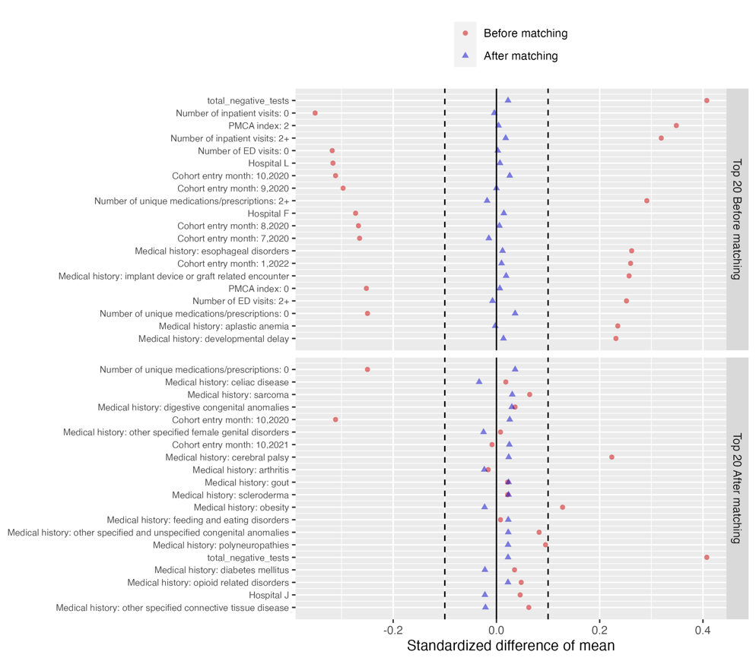

Supp Figure 83. Patient characteristic balance before and after large-scale PS matching with ratio 1:2 for youths in asymptomatic group. The upper panel displays the top 20 covariates with the largest standardized difference of means before matching, while the lower panel displays the top 20 covariates with the largest standardized difference of means after matching.
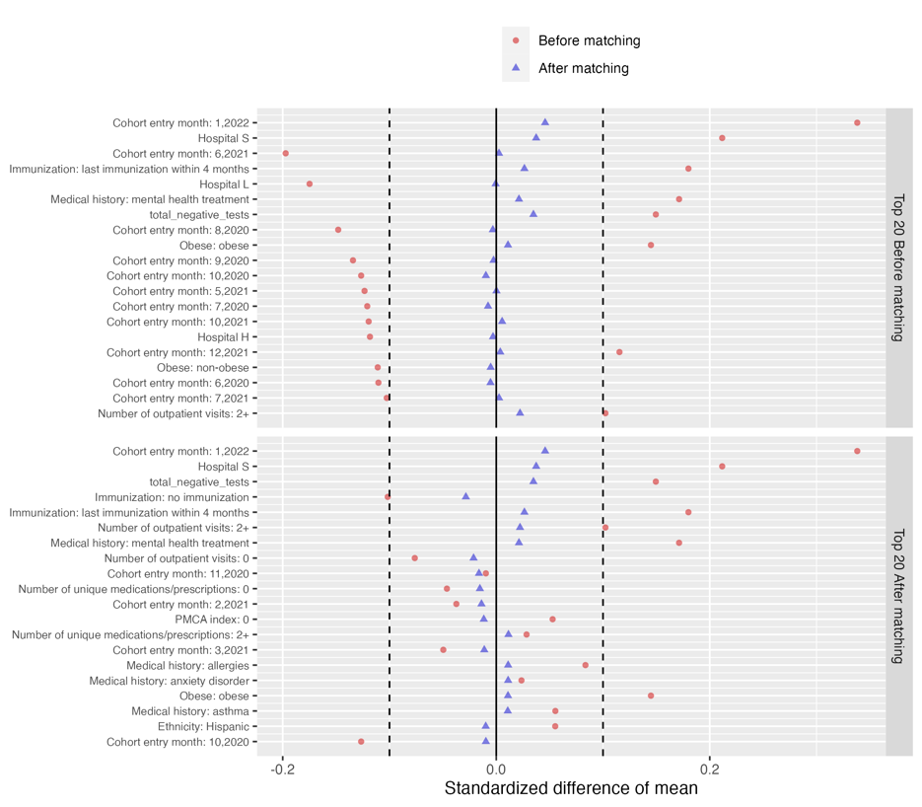

Supp Figure 84. Patient characteristic balance before and after large-scale PS matching with ratio 1:2 for youths in mild group. The upper panel displays the top 20 covariates with the largest standardized difference of means before matching, while the lower panel displays the top 20 covariates with the largest standardized difference of means after matching.
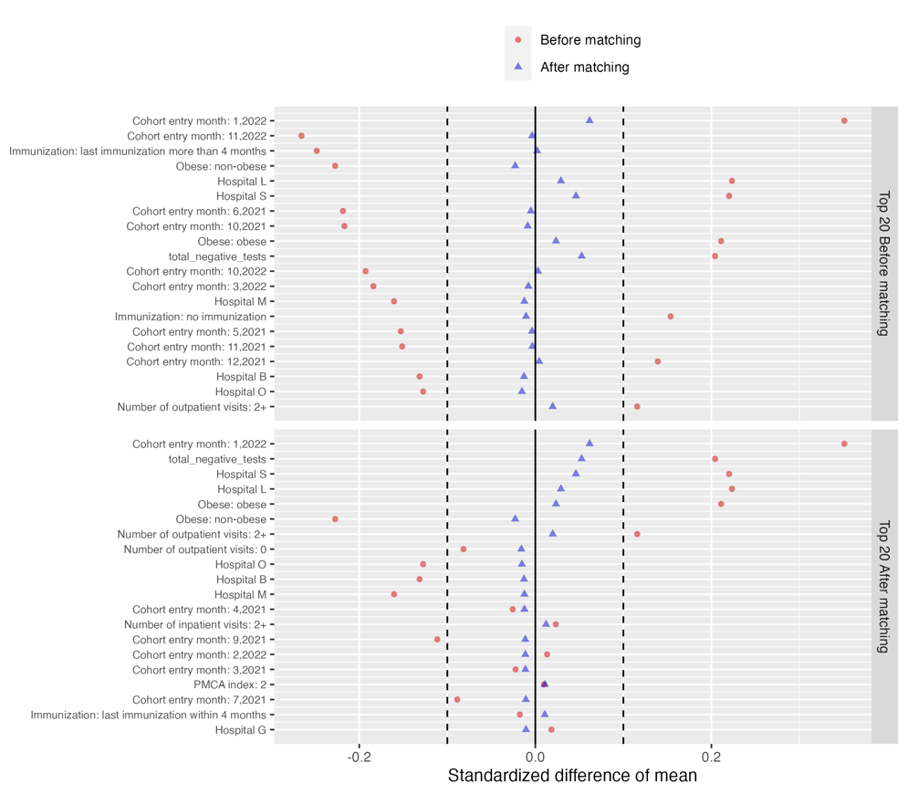

Supp Figure 85. Patient characteristic balance before and after large-scale PS matching with ratio 1:2 for youths in moderate group. The upper panel displays the top 20 covariates with the largest standardized difference of means before matching, while the lower panel displays the top 20 covariates with the largest standardized difference of means after matching.
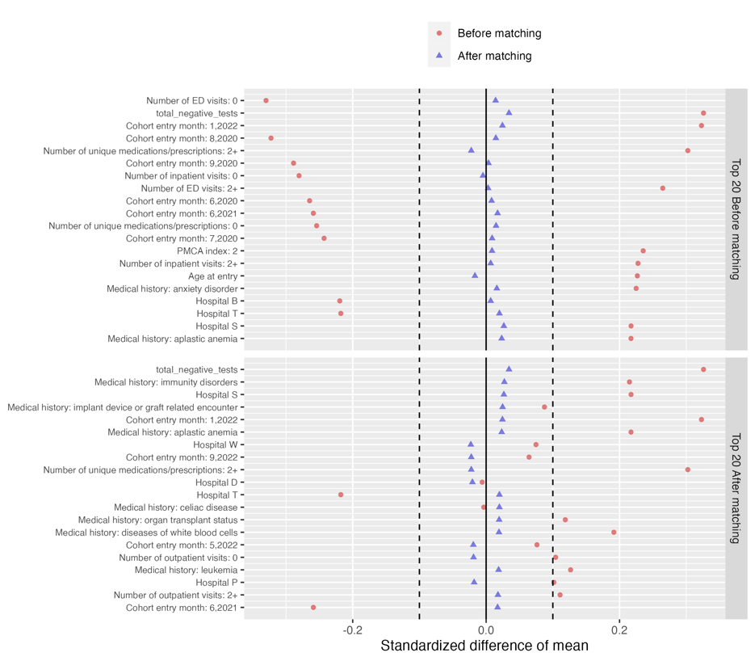

Supp Figure 86. Patient characteristic balance before and after large-scale PS matching with ratio 1:2 for youths in severe group. The upper panel displays the top 20 covariates with the largest standardized difference of means before matching, while the lower panel displays the top 20 covariates with the largest standardized difference of means after matching.
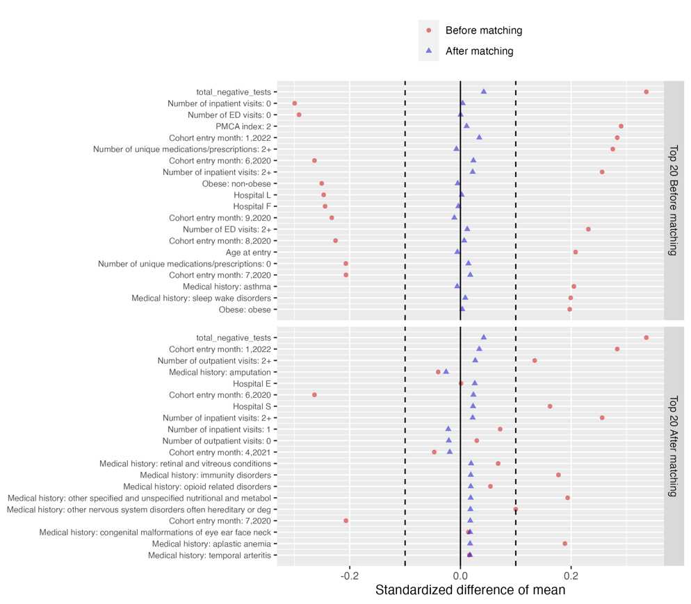

C. Risk difference of COVID-19 positive group compared to COVID-19 negative group

Supp Table 31. Estimated risk difference in mental health conditions between the COVID-19 positive cohort and COVID-19 negative cohort for children in asymptomatic group

Category | Cluster | Risk difference (%) | 95% CI (%) | P value
Composite | At least one incident | 1.029 | (0.624, 1.433) | <0.001
Adverse childhood experiences | Emotional abuse | -0.002 | (-0.024, 0.020) | 0.893
 | Neglect | 0.012 | (-0.002, 0.025) | 0.088
 | Physical abuse | 0.002 | (-0.038, 0.042) | 0.929
 | Sexual abuse | 0.007 | (-0.025, 0.039) | 0.650
Anxiety disorders | Anxiety disorder | 0.436 | (0.257, 0.615) | <0.001
 | OCD | 0.038 | (-0.009, 0.085) | 0.109
 | Somatoform disorder | 0.035 | (-0.021, 0.092) | 0.220
 | Stress disorder | 0.11 | (-0.039, 0.259) | 0.148
Disruptive behavior disorders | Conduct disorder | -0.042 | (-0.127, 0.043) | 0.329
 | Impulse control disorder | -0.095 | (-0.177, -0.013) | 0.023
 | Oppositional defiant disorder | 0.036 | (-0.036, 0.108) | 0.332
Eating and feeding disorders | Avoidant restrictive food intake | 0.06 | (-0.001, 0.121) | 0.054
 | Other eating and feeding disorder | -0.006 | (-0.040, 0.027) | 0.716
Elimination disorders | Encopresis | 0.016 | (-0.038, 0.070) | 0.562
 | Enuresis | -0.018 | (-0.117, 0.080) | 0.716
Gender dysphoria sexual dysfunction | Gender dysphoria | -0.008 | (-0.034, 0.017) | 0.510
 | Paraphilia | NA | NA | NA
 | Sexual dysfunction | -0.001 | (-0.006, 0.003) | 0.560
Intentional self-harm/suicidality | Parasuicidality | -0.016 | (-0.053, 0.020) | 0.378
 | Suicidality | 0.007 | (-0.044, 0.058) | 0.786
Mood disorders | Bipolar disorder | 0.015 | (-0.011, 0.042) | 0.257
 | Major depression | -0.045 | (-0.104, 0.014) | 0.132
 | Minor depression | 0 | (-0.076, 0.075) | 0.998
Neurocognitive disorders | Catatonia | -0.002 | (-0.008, 0.004) | 0.557
 | Delirium | 0.043 | (0.012, 0.074) | 0.006
 | Encephalopathy | 0.016 | (-0.008, 0.040) | 0.185
Neurodevelopmental disorders | Academic developmental disorder | 0.015 | (-0.090, 0.120) | 0.778
 | ADHD | 0.245 | (-0.007, 0.497) | 0.056
 | Autism spectrum disorder | 0.161 | (-0.015, 0.338) | 0.074
 | Communication motor disorder | 0.225 | (0.035, 0.414) | 0.020
 | Intellectual disability | 0.148 | (0.016, 0.280) | 0.028
Personality disorders | Personality disorder | 0.008 | (-0.010, 0.026) | 0.366
Psychotic disorders | Psychotic disorder | -0.002 | (-0.021, 0.017) | 0.845
 | Schizoaffective disorder | 0.001 | (-0.003, 0.006) | 0.560
 | Schizophrenia | -0.001 | (-0.007, 0.006) | 0.865
Sleep wake disorders | Hypersomnia | -0.004 | (-0.032, 0.025) | 0.804
 | Insomnia | 0.038 | (-0.043, 0.120) | 0.358
 | Parasomnias | 0.014 | (-0.043, 0.071) | 0.627
Standalone symptoms | Anger aggression | 0.047 | (-0.022, 0.116) | 0.184
 | Anxiety symptoms | 0.073 | (0.015, 0.130) | 0.013
 | Attention symptoms | -0.015 | (-0.101, 0.071) | 0.736
 | Depressive symptoms | 0.01 | (-0.007, 0.027) | 0.250
 | Hallucinations | 0.007 | (-0.018, 0.033) | 0.562
Substance use and dependence | Alcohol | -0.001 | (-0.007, 0.005) | 0.753
 | Opioid related | 0.005 | (-0.003, 0.013) | 0.193
 | Other substances | -0.002 | (-0.015, 0.011) | 0.770
 | THC | NA | NA | NA
 | Tobacco | -0.002 | (-0.007, 0.004) | 0.588
Tic disorders | Tic disorder | 0.053 | (-0.019, 0.124) | 0.151

Supp Table 32. Estimated risk difference in mental health conditions between the COVID-19 positive cohort and COVID-19 negative cohort for children in mild group

Category | Cluster | Risk difference (%) | 95% CI (%) | P value
Composite | At least one incident | 0.086 | (-0.476, 0.648) | 0.764
Adverse childhood experiences | Emotional abuse | -0.019 | (-0.057, 0.020) | 0.337
 | Neglect | -0.006 | (-0.028, 0.017) | 0.622
 | Physical abuse | 0.004 | (-0.049, 0.057) | 0.884
 | Sexual abuse | -0.016 | (-0.059, 0.027) | 0.467
Anxiety disorders | Anxiety disorder | 0.076 | (-0.185, 0.337) | 0.568
 | OCD | 0.029 | (-0.032, 0.090) | 0.352
 | Somatoform disorder | 0.081 | (-0.011, 0.172) | 0.084
 | Stress disorder | 0 | (-0.212, 0.212) | 0.998
Disruptive behavior disorders | Conduct disorder | 0.051 | (-0.059, 0.161) | 0.359
 | Impulse control disorder | 0.074 | (-0.031, 0.178) | 0.167
 | Oppositional defiant disorder | 0.003 | (-0.090, 0.096) | 0.955
Eating and feeding disorders | Avoidant restrictive food intake | -0.084 | (-0.187, 0.020) | 0.112
 | Other eating and feeding disorder | -0.005 | (-0.053, 0.044) | 0.844
Elimination disorders | Encopresis | 0.025 | (-0.037, 0.086) | 0.429
 | Enuresis | 0.058 | (-0.078, 0.195) | 0.402
Gender dysphoria sexual dysfunction | Gender dysphoria | 0.005 | (-0.027, 0.036) | 0.770
 | Paraphilia | -0.001 | (-0.005, 0.002) | 0.433
 | Sexual dysfunction | 0.001 | (-0.006, 0.008) | 0.807
Intentional self-harm/suicidality | Parasuicidality | 0.029 | (-0.015, 0.073) | 0.197
 | Suicidality | 0.038 | (-0.025, 0.101) | 0.237
Mood disorders | Bipolar disorder | 0.016 | (-0.025, 0.057) | 0.434
 | Major depression | 0.004 | (-0.081, 0.089) | 0.928
 | Minor depression | 0.045 | (-0.060, 0.151) | 0.399
Neurocognitive disorders | Catatonia | 0.002 | (-0.006, 0.010) | 0.569
 | Delirium | 0.007 | (-0.037, 0.051) | 0.762
 | Encephalopathy | -0.011 | (-0.035, 0.013) | 0.380
Neurodevelopmental disorders | Academic developmental disorder | -0.023 | (-0.166, 0.119) | 0.751
 | ADHD | -0.101 | (-0.457, 0.254) | 0.577
 | Autism spectrum disorder | 0.074 | (-0.159, 0.308) | 0.533
 | Communication motor disorder | -0.039 | (-0.288, 0.209) | 0.756
 | Intellectual disability | -0.016 | (-0.169, 0.136) | 0.835
Personality disorders | Personality disorder | -0.006 | (-0.032, 0.020) | 0.641
Psychotic disorders | Psychotic disorder | 0.004 | (-0.024, 0.032) | 0.783
 | Schizoaffective disorder | 0.003 | (-0.002, 0.008) | 0.267
 | Schizophrenia | 0.001 | (-0.007, 0.009) | 0.726
Sleep wake disorders | Hypersomnia | -0.004 | (-0.043, 0.034) | 0.825
 | Insomnia | 0.035 | (-0.073, 0.142) | 0.529
 | Parasomnias | 0.033 | (-0.046, 0.113) | 0.412
Standalone symptoms | Anger aggression | 0.058 | (-0.029, 0.146) | 0.189
 | Anxiety symptoms | -0.017 | (-0.114, 0.080) | 0.730
 | Attention symptoms | 0.006 | (-0.112, 0.125) | 0.918
 | Depressive symptoms | 0.004 | (-0.019, 0.027) | 0.733
 | Hallucinations | 0.021 | (-0.013, 0.055) | 0.225
Substance use and dependence | Alcohol | -0.008 | (-0.015, -0.000) | 0.039
 | Opioid related | 0.003 | (-0.006, 0.012) | 0.522
 | Other substances | 0.008 | (-0.013, 0.029) | 0.429
 | THC | NA | NA | NA
 | Tobacco | 0.005 | (-0.003, 0.012) | 0.202
Tic disorders | Tic disorder | 0.015 | (-0.081, 0.112) | 0.753

Supp Table 33. Estimated risk difference in mental health conditions between the COVID-19 positive cohort and COVID-19 negative cohort for children in moderate group

Category | Cluster | Risk difference (%) | 95% CI (%) | P value
Composite | At least one incident | 3.523 | (1.450, 5.596) | <0.001
Adverse childhood experiences | Emotional abuse | -0.013 | (-0.048, 0.022) | 0.465
 | Neglect | 0.062 | (-0.016, 0.140) | 0.121
 | Physical abuse | 0.111 | (-0.108, 0.330) | 0.320
 | Sexual abuse | 0.086 | (-0.024, 0.197) | 0.126
Anxiety disorders | Anxiety disorder | 0.807 | (-0.178, 1.792) | 0.108
 | OCD | 0.036 | (-0.146, 0.218) | 0.700
 | Somatoform disorder | -0.129 | (-0.459, 0.201) | 0.443
 | Stress disorder | 0.729 | (0.029, 1.428) | 0.041
Disruptive behavior disorders | Conduct disorder | -0.181 | (-0.649, 0.286) | 0.447
 | Impulse control disorder | 0.157 | (-0.268, 0.582) | 0.469
 | Oppositional defiant disorder | 0.188 | (-0.148, 0.523) | 0.273
Eating and feeding disorders | Avoidant restrictive food intake | 0.638 | (0.138, 1.137) | 0.012
 | Other eating and feeding disorder | -0.077 | (-0.301, 0.148) | 0.502
Elimination disorders | Encopresis | 0.272 | (-0.014, 0.559) | 0.062
 | Enuresis | 0.146 | (-0.315, 0.606) | 0.536
Gender dysphoria sexual dysfunction | Gender dysphoria | 0.052 | (-0.096, 0.201) | 0.490
 | Paraphilia | NA | NA | NA
 | Sexual dysfunction | NA | NA | NA
Intentional self-harm/suicidality | Parasuicidality | 0.064 | (-0.115, 0.242) | 0.485
 | Suicidality | 0.163 | (-0.025, 0.352) | 0.090
Mood disorders | Bipolar disorder | 0.143 | (-0.055, 0.342) | 0.156
 | Major depression | 0.09 | (-0.168, 0.347) | 0.494
 | Minor depression | 0.06 | (-0.295, 0.415) | 0.742
Neurocognitive disorders | Catatonia | NA | NA | NA
 | Delirium | 0.15 | (-0.082, 0.383) | 0.205
 | Encephalopathy | 0.075 | (-0.082, 0.232) | 0.348
Neurodevelopmental disorders | Academic developmental disorder | 0.316 | (-0.204, 0.836) | 0.233
 | ADHD | 0.317 | (-0.815, 1.449) | 0.583
 | Autism spectrum disorder | 0.751 | (-0.308, 1.810) | 0.164
 | Communication motor disorder | 0.514 | (-0.608, 1.636) | 0.370
 | Intellectual disability | 0.321 | (-0.657, 1.299) | 0.520
Personality disorders | Personality disorder | 0 | (-0.086, 0.086) | 1.000
Psychotic disorders | Psychotic disorder | 0.064 | (-0.035, 0.163) | 0.208
 | Schizoaffective disorder | NA | NA | NA
 | Schizophrenia | -0.011 | (-0.061, 0.038) | 0.653
Sleep wake disorders | Hypersomnia | 0.036 | (-0.139, 0.211) | 0.689
 | Insomnia | -0.086 | (-0.578, 0.405) | 0.730
 | Parasomnias | 0.311 | (-0.073, 0.694) | 0.112
Standalone symptoms | Anger aggression | -0.093 | (-0.474, 0.289) | 0.634
 | Anxiety symptoms | 0.188 | (-0.243, 0.619) | 0.393
 | Attention symptoms | 0.385 | (-0.023, 0.792) | 0.064
 | Depressive symptoms | -0.088 | (-0.193, 0.017) | 0.100
 | Hallucinations | -0.01 | (-0.115, 0.096) | 0.857
Substance use and dependence | Alcohol | NA | NA | NA
 | Opioid related | 0.002 | (-0.091, 0.094) | 0.971
 | Other substances | 0.101 | (-0.039, 0.241) | 0.157
 | THC | 0.013 | (-0.022, 0.048) | 0.465
 | Tobacco | NA | NA | NA
Tic disorders | Tic disorder | -0.052 | (-0.388, 0.283) | 0.760

Supp Table 34. Estimated risk difference in mental health conditions between the COVID-19 positive cohort and COVID-19 negative cohort for children in severe group

Category | Cluster | Risk difference (%) | 95% CI (%) | P value
Composite | At least one incident | 4.481 | (1.189, 7.773) | 0.008
Adverse childhood experiences | Emotional abuse | -0.028 | (-0.157, 0.100) | 0.668
 | Neglect | 0.204 | (-0.006, 0.414) | 0.057
 | Physical abuse | 0.414 | (0.043, 0.784) | 0.029
 | Sexual abuse | 0.102 | (-0.080, 0.284) | 0.271
Anxiety disorders | Anxiety disorder | 1.506 | (0.065, 2.947) | 0.041
 | OCD | -0.061 | (-0.307, 0.185) | 0.625
 | Somatoform disorder | 0.357 | (-0.192, 0.906) | 0.202
 | Stress disorder | 0.684 | (-0.386, 1.754) | 0.210
Disruptive behavior disorders | Conduct disorder | 0.041 | (-0.600, 0.681) | 0.901
 | Impulse control disorder | 0.296 | (-0.258, 0.850) | 0.295
 | Oppositional defiant disorder | 0.199 | (-0.227, 0.625) | 0.359
Eating and feeding disorders | Avoidant restrictive food intake | 0.544 | (-0.126, 1.213) | 0.111
 | Other eating and feeding disorder | 0.092 | (-0.327, 0.511) | 0.668
Elimination disorders | Encopresis | -0.074 | (-0.445, 0.297) | 0.696
 | Enuresis | 0.414 | (-0.192, 1.019) | 0.181
Gender dysphoria sexual dysfunction | Gender dysphoria | 0.074 | (-0.149, 0.297) | 0.515
 | Paraphilia | NA | NA | NA
 | Sexual dysfunction | NA | NA | NA
Intentional self-harm/suicidality | Parasuicidality | -0.061 | (-0.385, 0.262) | 0.710
 | Suicidality | 0.181 | (-0.115, 0.478) | 0.231
Mood disorders | Bipolar disorder | 0.102 | (-0.195, 0.399) | 0.500
 | Major depression | -0.107 | (-0.447, 0.233) | 0.536
 | Minor depression | 0.319 | (-0.235, 0.873) | 0.259
Neurocognitive disorders | Catatonia | 0.181 | (0.033, 0.330) | 0.017
 | Delirium | 0.355 | (-0.502, 1.212) | 0.417
 | Encephalopathy | 0.094 | (-0.599, 0.788) | 0.790
Neurodevelopmental disorders | Academic developmental disorder | -0.049 | (-0.738, 0.641) | 0.890
 | ADHD | 0.788 | (-0.686, 2.262) | 0.295
 | Autism spectrum disorder | -0.077 | (-1.624, 1.470) | 0.922
 | Communication motor disorder | 1.366 | (-0.586, 3.318) | 0.170
 | Intellectual disability | 0.212 | (-1.764, 2.187) | 0.834
Personality disorders | Personality disorder | 0.209 | (0.013, 0.406) | 0.037
Psychotic disorders | Psychotic disorder | 0.097 | (-0.226, 0.420) | 0.557
 | Schizoaffective disorder | NA | NA | NA
 | Schizophrenia | 0.051 | (-0.023, 0.125) | 0.178
Sleep wake disorders | Hypersomnia | 0.089 | (-0.303, 0.482) | 0.655
 | Insomnia | 0.212 | (-0.645, 1.069) | 0.628
 | Parasomnias | 0.033 | (-0.531, 0.597) | 0.908
Standalone symptoms | Anger aggression | -0.112 | (-0.656, 0.432) | 0.686
 | Anxiety symptoms | 0.457 | (-0.307, 1.221) | 0.241
 | Attention symptoms | 0.059 | (-0.650, 0.768) | 0.871
 | Depressive symptoms | -0.028 | (-0.194, 0.138) | 0.740
 | Hallucinations | -0.102 | (-0.312, 0.108) | 0.340
Substance use and dependence | Alcohol | NA | NA | NA
 | Opioid related | -0.061 | (-0.349, 0.226) | 0.676
 | Other substances | 0.255 | (-0.012, 0.523) | 0.061
 | THC | NA | NA | NA
 | Tobacco | NA | NA | NA
Tic disorders | Tic disorder | 0.102 | (-0.276, 0.480) | 0.597

Supp Table 35. Estimated risk difference in mental health conditions between the COVID-19 positive cohort and COVID-19 negative cohort for youths in asymptomatic group

Category | Cluster | Risk difference (%) | 95% CI (%) | P value
Composite | At least one incident | 0.865 | (0.474, 1.255) | <0.001
Adverse childhood experiences | Emotional abuse | 0.006 | (-0.012, 0.023) | 0.545
 | Neglect | 0.004 | (-0.010, 0.017) | 0.575
 | Physical abuse | 0.037 | (-0.003, 0.077) | 0.068
 | Sexual abuse | 0.017 | (-0.018, 0.051) | 0.339
Anxiety disorders | Anxiety disorder | 0.267 | (0.004, 0.530) | 0.047
 | OCD | 0.012 | (-0.057, 0.081) | 0.732
 | Somatoform disorder | 0.044 | (-0.024, 0.112) | 0.205
 | Stress disorder | 0.023 | (-0.146, 0.193) | 0.787
Disruptive behavior disorders | Conduct disorder | -0.048 | (-0.102, 0.007) | 0.085
 | Impulse control disorder | -0.039 | (-0.111, 0.032) | 0.283
 | Oppositional defiant disorder | -0.003 | (-0.068, 0.062) | 0.927
Eating and feeding disorders | Avoidant restrictive food intake | -0.139 | (-0.241, -0.036) | 0.008
 | Other eating and feeding disorder | 0.004 | (-0.017, 0.025) | 0.703
Elimination disorders | Encopresis | 0.011 | (-0.009, 0.031) | 0.286
 | Enuresis | 0.033 | (-0.013, 0.079) | 0.163
Gender dysphoria sexual dysfunction | Gender dysphoria | -0.03 | (-0.098, 0.039) | 0.397
 | Paraphilia | -0.002 | (-0.010, 0.005) | 0.511
 | Sexual dysfunction | -0.002 | (-0.017, 0.013) | 0.764
Intentional self-harm/suicidality | Parasuicidality | -0.016 | (-0.075, 0.043) | 0.598
 | Suicidality | 0.055 | (-0.056, 0.166) | 0.332
Mood disorders | Bipolar disorder | -0.011 | (-0.052, 0.030) | 0.605
 | Major depression | -0.241 | (-0.440, -0.042) | 0.018
 | Minor depression | 0.104 | (-0.097, 0.304) | 0.312
Neurocognitive disorders | Catatonia | 0.004 | (-0.008, 0.016) | 0.485
 | Delirium | 0.078 | (0.016, 0.140) | 0.014
 | Encephalopathy | 0.016 | (-0.007, 0.039) | 0.163
Neurodevelopmental disorders | Academic developmental disorder | 0.051 | (-0.018, 0.120) | 0.151
 | ADHD | 0.374 | (0.154, 0.594) | <0.001
 | Autism spectrum disorder | 0.064 | (-0.056, 0.184) | 0.297
 | Communication motor disorder | 0.028 | (-0.049, 0.105) | 0.483
 | Intellectual disability | 0.031 | (-0.064, 0.125) | 0.526
Personality disorders | Personality disorder | -0.055 | (-0.095, -0.014) | 0.008
Psychotic disorders | Psychotic disorder | -0.004 | (-0.043, 0.034) | 0.831
 | Schizoaffective disorder | -0.007 | (-0.025, 0.010) | 0.416
 | Schizophrenia | -0.012 | (-0.038, 0.013) | 0.351
Sleep wake disorders | Hypersomnia | 0.027 | (-0.012, 0.067) | 0.178
 | Insomnia | 0.08 | (-0.011, 0.171) | 0.085
 | Parasomnias | 0.027 | (-0.012, 0.066) | 0.168
Standalone symptoms | Anger aggression | 0.021 | (-0.042, 0.085) | 0.509
 | Anxiety symptoms | 0.057 | (0.002, 0.111) | 0.041
 | Attention symptoms | 0.052 | (-0.011, 0.116) | 0.108
 | Depressive symptoms | 0.021 | (-0.001, 0.042) | 0.059
 | Hallucinations | 0.013 | (-0.022, 0.048) | 0.473
Substance use and dependence | Alcohol | -0.003 | (-0.034, 0.028) | 0.846
 | Opioid related | -0.001 | (-0.019, 0.018) | 0.958
 | Other substances | -0.012 | (-0.054, 0.030) | 0.575
 | THC | -0.028 | (-0.078, 0.022) | 0.269
 | Tobacco | 0.038 | (-0.027, 0.103) | 0.247
Tic disorders | Tic disorder | 0.051 | (-0.007, 0.109) | 0.087

Supp Table 36. Estimated risk difference in mental health conditions between the COVID-19 positive cohort and COVID-19 negative cohort for youths in mild group

Category | Cluster | Risk difference (%) | 95% CI (%) | P value
Composite | At least one incident | 0.025 | (-0.566, 0.617) | 0.933
Adverse childhood experiences | Emotional abuse | 0.032 | (0.002, 0.061) | 0.036
 | Neglect | 0.003 | (-0.016, 0.021) | 0.790
 | Physical abuse | 0.011 | (-0.045, 0.066) | 0.704
 | Sexual abuse | 0.023 | (-0.026, 0.073) | 0.356
Anxiety disorders | Anxiety disorder | -0.127 | (-0.544, 0.289) | 0.550
 | OCD | 0.06 | (-0.041, 0.160) | 0.246
 | Somatoform disorder | -0.125 | (-0.249, -0.001) | 0.049
 | Stress disorder | 0.025 | (-0.235, 0.284) | 0.853
Disruptive behavior disorders | Conduct disorder | 0.005 | (-0.063, 0.073) | 0.883
 | Impulse control disorder | 0.049 | (-0.049, 0.146) | 0.329
 | Oppositional defiant disorder | 0.044 | (-0.043, 0.131) | 0.327
Eating and feeding disorders | Avoidant restrictive food intake | -0.011 | (-0.167, 0.146) | 0.894
 | Other eating and feeding disorder | 0.004 | (-0.037, 0.046) | 0.833
Elimination disorders | Encopresis | 0.016 | (-0.008, 0.041) | 0.184
 | Enuresis | -0.059 | (-0.126, 0.008) | 0.084
Gender dysphoria sexual dysfunction | Gender dysphoria | -0.019 | (-0.109, 0.072) | 0.687
 | Paraphilia | -0.01 | (-0.022, 0.002) | 0.092
 | Sexual dysfunction | 0.017 | (-0.007, 0.041) | 0.157
Intentional self-harm/suicidality | Parasuicidality | 0.089 | (0.009, 0.169) | 0.030
 | Suicidality | 0.172 | (0.026, 0.319) | 0.021
Mood disorders | Bipolar disorder | 0.003 | (-0.063, 0.070) | 0.926
 | Major depression | -0.131 | (-0.435, 0.173) | 0.399
 | Minor depression | 0.078 | (-0.223, 0.380) | 0.610
Neurocognitive disorders | Catatonia | 0.004 | (-0.013, 0.020) | 0.654
 | Delirium | 0.044 | (-0.054, 0.142) | 0.378
 | Encephalopathy | 0 | (-0.029, 0.029) | 0.998
Neurodevelopmental disorders | Academic developmental disorder | 0.02 | (-0.079, 0.118) | 0.696
 | ADHD | 0.049 | (-0.284, 0.381) | 0.774
 | Autism spectrum disorder | -0.011 | (-0.171, 0.150) | 0.897
 | Communication motor disorder | 0.044 | (-0.065, 0.152) | 0.431
 | Intellectual disability | 0.075 | (-0.046, 0.195) | 0.225
Personality disorders | Personality disorder | -0.001 | (-0.060, 0.058) | 0.972
Psychotic disorders | Psychotic disorder | -0.002 | (-0.060, 0.055) | 0.934
 | Schizoaffective disorder | -0.002 | (-0.025, 0.021) | 0.873
 | Schizophrenia | 0.002 | (-0.031, 0.035) | 0.910
Sleep wake disorders | Hypersomnia | -0.014 | (-0.073, 0.045) | 0.633
 | Insomnia | 0.094 | (-0.049, 0.236) | 0.200
 | Parasomnias | 0.031 | (-0.026, 0.088) | 0.286
Standalone symptoms | Anger aggression | -0.015 | (-0.095, 0.065) | 0.719
 | Anxiety symptoms | 0.048 | (-0.042, 0.137) | 0.297
 | Attention symptoms | 0.114 | (0.015, 0.213) | 0.024
 | Depressive symptoms | 0.04 | (0.007, 0.073) | 0.017
 | Hallucinations | -0.009 | (-0.057, 0.040) | 0.723
Substance use and dependence | Alcohol | -0.016 | (-0.064, 0.033) | 0.524
 | Opioid related | 0.02 | (-0.006, 0.045) | 0.132
 | Other substances | -0.014 | (-0.074, 0.047) | 0.654
 | THC | 0.009 | (-0.065, 0.083) | 0.812
 | Tobacco | -0.032 | (-0.141, 0.076) | 0.558
Tic disorders | Tic disorder | -0.015 | (-0.098, 0.068) | 0.720

Supp Table 37. Estimated risk difference in mental health conditions between the COVID-19 positive cohort and COVID-19 negative cohort for youths in moderate group

Category | Cluster | Risk difference (%) | 95% CI (%) | P value
Composite | At least one incident | 3.007 | (1.125, 4.889) | 0.002
Adverse childhood experiences | Emotional abuse | 0.01 | (-0.058, 0.079) | 0.765
 | Neglect | 0.01 | (-0.058, 0.079) | 0.765
 | Physical abuse | 0.135 | (-0.121, 0.392) | 0.302
 | Sexual abuse | 0 | (-0.168, 0.168) | 1.000
Anxiety disorders | Anxiety disorder | 1.418 | (0.031, 2.804) | 0.045
 | OCD | -0.004 | (-0.367, 0.359) | 0.983
 | Somatoform disorder | 0.108 | (-0.313, 0.530) | 0.615
 | Stress disorder | 1.388 | (0.518, 2.258) | 0.002
Disruptive behavior disorders | Conduct disorder | -0.003 | (-0.270, 0.265) | 0.984
 | Impulse control disorder | 0.032 | (-0.293, 0.358) | 0.846
 | Oppositional defiant disorder | 0.116 | (-0.203, 0.434) | 0.477
Eating and feeding disorders | Avoidant restrictive food intake | 0.272 | (-0.367, 0.911) | 0.404
 | Other eating and feeding disorder | 0.056 | (-0.131, 0.242) | 0.559
Elimination disorders | Encopresis | -0.009 | (-0.109, 0.091) | 0.859
 | Enuresis | -0.105 | (-0.341, 0.131) | 0.385
Gender dysphoria sexual dysfunction | Gender dysphoria | -0.161 | (-0.468, 0.145) | 0.303
 | Paraphilia | NA | NA | NA
 | Sexual dysfunction | -0.017 | (-0.059, 0.025) | 0.432
Intentional self-harm/suicidality | Parasuicidality | 0.043 | (-0.272, 0.358) | 0.790
 | Suicidality | 0.445 | (-0.105, 0.995) | 0.112
Mood disorders | Bipolar disorder | -0.055 | (-0.266, 0.157) | 0.613
 | Major depression | 0.508 | (-0.508, 1.525) | 0.327
 | Minor depression | 1.235 | (0.212, 2.259) | 0.018
Neurocognitive disorders | Catatonia | 0.041 | (-0.091, 0.174) | 0.541
 | Delirium | 0.135 | (-0.297, 0.567) | 0.541
 | Encephalopathy | 0.04 | (-0.126, 0.206) | 0.636
Neurodevelopmental disorders | Academic developmental disorder | -0.053 | (-0.426, 0.319) | 0.779
 | ADHD | 1.036 | (0.071, 2.001) | 0.035
 | Autism spectrum disorder | 0.143 | (-0.492, 0.779) | 0.659
 | Communication motor disorder | 0.422 | (-0.020, 0.864) | 0.062
 | Intellectual disability | 0.705 | (0.038, 1.371) | 0.038
Personality disorders | Personality disorder | 0.119 | (-0.128, 0.367) | 0.344
Psychotic disorders | Psychotic disorder | 0.047 | (-0.181, 0.274) | 0.689
 | Schizoaffective disorder | 0.06 | (-0.073, 0.193) | 0.379
 | Schizophrenia | 0.11 | (-0.056, 0.277) | 0.194
Sleep wake disorders | Hypersomnia | -0.078 | (-0.318, 0.162) | 0.525
 | Insomnia | 0.267 | (-0.278, 0.813) | 0.337
 | Parasomnias | 0.016 | (-0.204, 0.235) | 0.890
Standalone symptoms | Anger aggression | 0.344 | (0.049, 0.640) | 0.023
 | Anxiety symptoms | 0.446 | (0.051, 0.842) | 0.027
 | Attention symptoms | 0.055 | (-0.224, 0.333) | 0.701
 | Depressive symptoms | -0.044 | (-0.141, 0.053) | 0.373
 | Hallucinations | 0.006 | (-0.177, 0.190) | 0.945
Substance use and dependence | Alcohol | -0.105 | (-0.278, 0.068) | 0.234
 | Opioid related | 0.046 | (-0.117, 0.208) | 0.584
 | Other substances | 0.131 | (-0.108, 0.370) | 0.282
 | THC | -0.089 | (-0.414, 0.236) | 0.593
 | Tobacco | -0.074 | (-0.472, 0.324) | 0.716
Tic disorders | Tic disorder | 0.075 | (-0.181, 0.332) | 0.566

Supp Table 38. Estimated risk difference in mental health conditions between the COVID-19 positive cohort and COVID-19 negative cohort for youths in severe group

Category | Cluster | Risk difference (%) | 95% CI (%) | P value
Composite | At least one incident | 4.077 | (1.539, 6.615) | 0.002
Adverse childhood experiences | Emotional abuse | 0.016 | (-0.025, 0.057) | 0.454
 | Neglect | 0 | (-0.129, 0.129) | 1.000
 | Physical abuse | -0.006 | (-0.251, 0.240) | 0.964
 | Sexual abuse | -0.062 | (-0.236, 0.111) | 0.480
Anxiety disorders | Anxiety disorder | 1.989 | (0.281, 3.696) | 0.022
 | OCD | -0.081 | (-0.521, 0.358) | 0.716
 | Somatoform disorder | -0.189 | (-0.798, 0.419) | 0.542
 | Stress disorder | -0.063 | (-1.144, 1.018) | 0.909
Disruptive behavior disorders | Conduct disorder | -0.212 | (-0.586, 0.162) | 0.267
 | Impulse control disorder | 0.168 | (-0.296, 0.633) | 0.478
 | Oppositional defiant disorder | -0.084 | (-0.460, 0.293) | 0.663
Eating and feeding disorders | Avoidant restrictive food intake | -0.101 | (-0.853, 0.651) | 0.792
 | Other eating and feeding disorder | 0.031 | (-0.214, 0.276) | 0.803
Elimination disorders | Encopresis | 0.134 | (0.011, 0.257) | 0.032
 | Enuresis | 0.336 | (0.036, 0.636) | 0.028
Gender dysphoria sexual dysfunction | Gender dysphoria | 0.09 | (-0.263, 0.444) | 0.616
 | Paraphilia | 0.028 | (-0.013, 0.069) | 0.181
 | Sexual dysfunction | 0.012 | (-0.046, 0.070) | 0.677
Intentional self-harm/suicidality | Parasuicidality | 0.075 | (-0.357, 0.506) | 0.734
 | Suicidality | -0.19 | (-0.894, 0.515) | 0.598
Mood disorders | Bipolar disorder | 0.049 | (-0.267, 0.366) | 0.761
 | Major depression | 0.055 | (-1.173, 1.283) | 0.930
 | Minor depression | 0.48 | (-0.671, 1.631) | 0.414
Neurocognitive disorders | Catatonia | -0.066 | (-0.286, 0.154) | 0.558
 | Delirium | 0.932 | (0.126, 1.737) | 0.023
 | Encephalopathy | 0.132 | (-0.362, 0.626) | 0.601
Neurodevelopmental disorders | Academic developmental disorder | 0.273 | (-0.212, 0.759) | 0.270
 | ADHD | 0.29 | (-0.858, 1.438) | 0.620
 | Autism spectrum disorder | 0.119 | (-0.893, 1.132) | 0.817
 | Communication motor disorder | 0.73 | (-0.028, 1.487) | 0.059
 | Intellectual disability | 0.605 | (-0.714, 1.923) | 0.369
Personality disorders | Personality disorder | 0.029 | (-0.336, 0.394) | 0.876
Psychotic disorders | Psychotic disorder | 0.146 | (-0.321, 0.613) | 0.539
 | Schizoaffective disorder | 0.096 | (-0.051, 0.243) | 0.202
 | Schizophrenia | -0.007 | (-0.259, 0.245) | 0.959
Sleep wake disorders | Hypersomnia | 0.006 | (-0.326, 0.337) | 0.974
 | Insomnia | 0.114 | (-0.709, 0.937) | 0.786
 | Parasomnias | -0.044 | (-0.360, 0.273) | 0.788
Standalone symptoms | Anger aggression | 0.094 | (-0.342, 0.529) | 0.673
 | Anxiety symptoms | 0.407 | (-0.150, 0.964) | 0.152
 | Attention symptoms | 0.387 | (-0.079, 0.854) | 0.104
 | Depressive symptoms | -0.09 | (-0.226, 0.045) | 0.192
 | Hallucinations | 0.081 | (-0.240, 0.403) | 0.620
Substance use and dependence | Alcohol | 0.235 | (-0.016, 0.487) | 0.067
 | Opioid related | -0.297 | (-0.588, -0.005) | 0.046
 | Other substances | 0.142 | (-0.237, 0.520) | 0.463
 | THC | -0.041 | (-0.443, 0.361) | 0.841
 | Tobacco | 0.068 | (-0.445, 0.582) | 0.794
Tic disorders | Tic disorder | -0.057 | (-0.403, 0.290) | 0.748

Reference
1. Chapter 12 Population-Level Estimation | The Book of OHDSI. https://ohdsi.github.io/TheBookOfOhdsi/PopulationLevelEstimation.html.
2. Walker, A. M. et al. A tool for assessing the feasibility of comparative effectiveness research. Comparative Effectiveness Research 3, 11–20 (2013).

