SUPPLEMENTAL APPENDIX

Association Between Antecedent Statin Use and Decreased Mortality in
Hospitalized Patients with COVID-19

TABLE OF CONTENTS
Page 2 Supplemental Table 1. ICD-10-CM codes used to classify baseline conditions
Page 3 Supplemental Table 2. Missing rate of laboratory markers
Page 4 Supplemental Figure 1. Distribution of the estimated propensity score for antecedent statin use, among patients who did and did not actually receive the treatment

Page 5 Supplemental Figure 2. Standardized mean differences in the unmatched and matched sample

Page 6 Supplemental Figure 3. Multivariable regression to examine association of antecedent statin use with primary endpoint (in-hospital mortality within 30 days) in study sample restricted to patients with history of hypertension, coronary artery disease and stroke or transient ischemic attack.

Page 7 Supplemental Figure 4. Multivariable regression to examine association of antecedent statin use (modified definition)* with primary endpoint (in-hospital mortality within 30 days)

Supplemental Table 1. ICD-10-CM codes used to classify baseline conditions

Comorbidity | ICD-10-CM codes
Hypertension | I10-13, I15-16, O10.1-10.4, O10.9
Diabetes | E08 -11, E13, O24.4
Coronary Artery Disease | I21-25, Z98.61, Z95.1
Heart Failure | I09.81, I11.0, I13.0, I50, I42
Chronic Lung Disease | J40-47, J60, J66, J67.2, J67.8-67.9, J68.4, J84, G47.3
Stroke/transient ischemic attack | I60-64, I69, H34.1, G45
Atrial arrhythmias | I47.1, I47.9, I48.0-48.4, I48.91, i48.92, I49.9
Chronic Kidney Disease | N03, N07-08, N11, N14, N18-19, N29, I12, I13, Z99.2, E10.22, E11.22, E13.22, E08.22, O10.3, D63.1
Chronic Liver Disease | K70 – K77

Supplemental Table 2. Missing laboratory markers in the propensity-matched cohort
Laboratory marker | Statin Users (648) | Non-statin Users (648)
White blood cell count | 1 (0.1%) | 4 (0.6%)
Platelet count | 6 (0.9%) | 8 (1.2%)
Creatinine | 0 | 0
AST | 7 (1.0%) | 10 (1.5%)
ALT | 11 (1.7%) | 12 (1.9%)
Hs-Troponin | 34 (5.2%) | 47 (7.3%)
Albumin | 5 (0.8%) | 11 (1.7%)
D-dimer | 92 (14.2%) | 111 (17.1%)
Ferritin | 38 (5.9%) | 59 (9.1%)
ESR | 80 (12.3%) | 74 (11.4%)
CRP | 38 (5.9%) | 43 (6.6%)

ALT = alanine aminotransferase; AST = aspartate aminotransferase; CRP = C-reactive protein; ESR = erythrocyte sedimentation rate; hs-Troponin = high sensitivity Troponin T; IQR = interquartile range

Supplemental Figure 1. Distribution of the estimated propensity score for antecedent statin use, among patients who did and did not actually receive the treatment

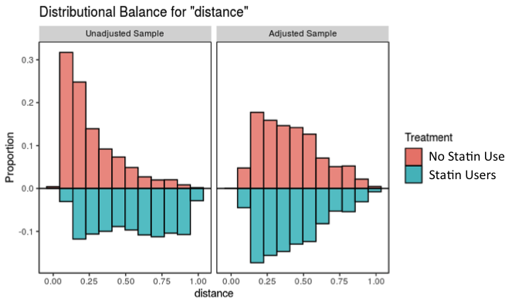
Supplemental Figure 2. Standardized mean differences in the unmatched and matched sample

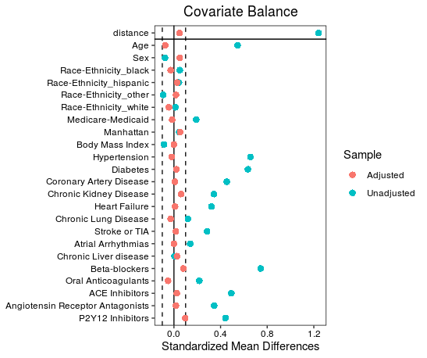

Supplemental Figure 3. Multivariable regression to examine association of antecedent statin use with primary endpoint (in-hospital mortality within 30 days) in study sample restricted to patients with history of hypertension, coronary artery disease and stroke or transient ischemic attack.

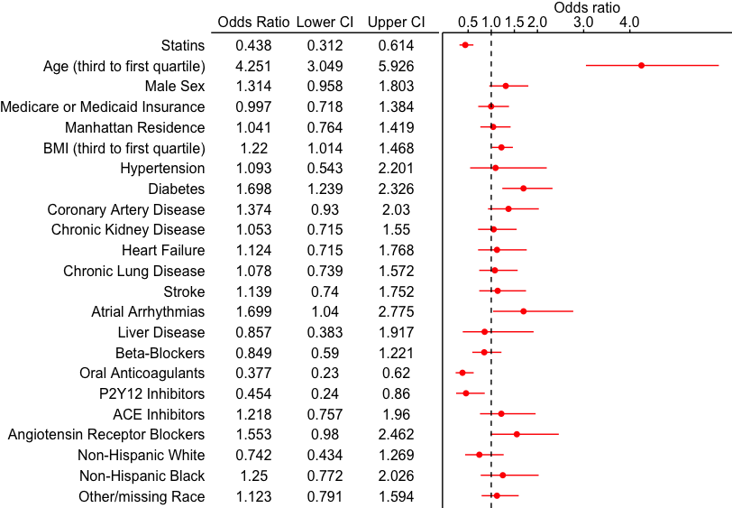

Supplemental Figure 4. Multivariable regression to examine association of statin use (modified definition)* with primary endpoint (in-hospital mortality within 30 days)

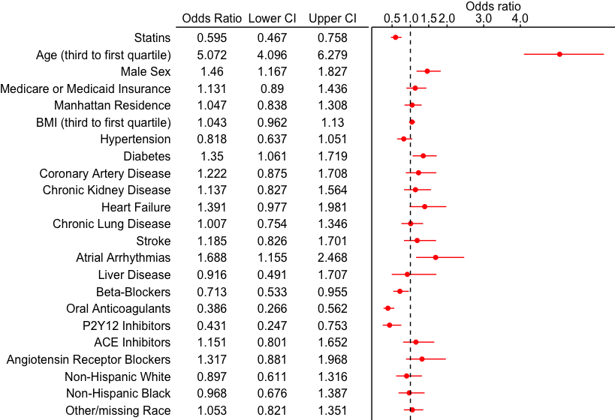

*In this analysis, patients were classified as statin users if they were either prescribed outpatient statin use per the electronic medical record or received statins during hospitalization

