Supplementary Material

1 Supplementary Methods
  - Electroconvulsive therapy
Electrode placement was either bitemporal (N = 8), bifrontal (N = 16), right unilateral (N = 6), or frontotemporal (N = 2). During the treatment course, one patient each switched from right unilateral to bitemporal, from right unilateral to bifrontal, and from bifrontal to right unilateral placement. Anesthesia was induced using either propofol (1–2 mg/kg body weight), thiopental sodium (2–4 mg/kg body weight), ketamine (60 mg), or sevoflurane (7.2–8%). To determine stimulus intensity, the half-age stimulation strategy was used for patients receiving bilateral stimulation and the titration stimulation strategy was used for those receiving right unilateral stimulation.
  - MRI parameters
T1w images were obtained using 3D MPRAGE with the following parameters: repetition time (TR)=2500 ms, echo time (TE)=2.18 ms, flip angle=8°, number of slices=224, field of view (FOV)=240×256, matrix size=300×320, and spatial resolution=0.8×0.8×0.8 mm. T2w images were acquired using 3D SPACE with the following parameters: TR=3200 ms, TE=565 ms for Verio and 564 ms for Skyra, number of slices=224, FOV=240×256, matrix size=300×320, and spatial resolution=0.8×0.8×0.8 mm. Eyes-open rs-fMRI images were acquired using a multiband gradient echo planar imaging with the following parameters: TR=800 ms, TE=34.4 ms, flip angle=52°, number of slices=60, FOV= 206×206, matrix size=86×86, spatial resolution=2.4×2.4×2.4 mm, multiband acceleration factor=6, and volumes=750. The phase encoding direction was swapped alternatively between AP and PA for all the rs-fMRI scans.
  - Region of interest
We selected regions of interest (ROIs) that either have known anatomical connections with the amygdala or have been reported to show abnormal rs-FC with the amygdala in depression. For cortical regions, we used the multi-modal parcellation atlas by Glasser et al.¹ to define cortical ROIs. Specifically, we selected the orbitofrontal cortex (OFC), ventromedial prefrontal cortex (vmPFC), dorsomedial PFC (dmPFC), dorsolateral PFC (dlPFC), subgenual anterior cingulate cortex (sgACC), perigenual ACC (pgACC), dorsal ACC (dACC), insula, and precuneus. The dlPFC and precuneus do not have direct anatomical connections with the amygdala, but these regions have been reported to demonstrate abnormal rs-FC in depression and were included for the current analysis². These ROIs were concatenated bilaterally except for the dlPFC and insula. For some ROIs, multiple parcellations were combined to increase interpretability and reduce the number of statistical tests. The correspondence between the ROIs in this study and Glasser parcellations is detailed in Supplementary Table. 4.
The same selection criteria were applied to subcortical ROIs, resulting in the inclusion of the CA1, CA2-3, CA4-DG³, bed nucleus of the stria terminalis (BNST), lateral hypothalamus (laHTH)⁴, mediodorsal thalamus (MDTH)⁵, caudate (Ca), putamen (Pu), nucleus accumbens (NAC)⁶, periaqueductal gray (PAG), dorsal raphe nucleus (dRN), and median raphe nucleus (mRN)⁷. All subcortical ROIs were concatenated bilaterally. ROIs that met the criteria but were too small for the spatial resolution of rs-fMRI (e.g., the locus coeruleus) were not included in the current analysis.

2 Supplementary Tables
Supplementary Table 1. Electroconvulsive therapy (ECT) parameters
Variable | Mean (SD) | Range
Number of ECT sessions | 10.8 (2.9) | 4–18
Number of days between the first and last ECT sessions | 37.8 (13.1) | 10–72
Stimulus power (mC) | 239.9 (145.7) | -
EEG seizure length (sec) | 46.8 (23.8) | -
Postictal suppression index (%) | 72.8 (23.2) | -

Supplementary Table 2. Transcranial magnetic stimulation (TMS) parameters
Variable
Number of TMS sessions, range | 15–30
Number of days between the first and last TMS sessions, range | 20–50
Number of pulses per session | 3000
Duty cycle on (sec) | 4
Duty cycle off (sec) | 26
Pulse frequency (Hz) | 10
Power (% resting motor threshold), range | 80–120

 | Number of participants
 | Site 1 |  | Site 2 | Site 3
 | MAGNETOM Verio | MAGNETOM Skyra | MAGNETOM Skyra fit | MAGNETOM Skyra
Depression (N = 187) | 76 | 14 | 85 | 12
HC (N = 113) | 52 | 6 | 55 | 0
CBT (N = 63) | 45 | 0 | 18 | 0
Medication (N = 43) | 21 | 0 | 22 | 0
ECT (N = 32) | 0 | 12 | 20 | 0
TMS (N = 26) | 0 | 0 | 14 | 12
Supplementary Table 3. Number of participants by site and scanner type. HC: healthy controls; CBT: cognitive behavioral therapy; ECT: electroconvulsive therapy; TMS: transcranial magnetic stimulation

Supplementary Table 4. Correspondence between ROIs in the current study and Glasser parcellations
ROI | Glasser parcellation
OFC | OFC, pOFC
vmPFC | s32, p32, 10r, 10v
dmPFC | 9m
dlPFC | p9-46v, 46, 9-46d, a9-46v
sgACC | 25
pgACC | a24
dACC | p24, a24pr, a32pr, p32pr, d32
Precuneus | 5mv, PCV, 7m, 7pm, 7Am, 31pd
Insula | AVI, MI, PoI1, PoI2

Supplementary Table 5. Effect sizes of pre-treatment connectivity differences between healthy controls and patients stratified by medication status and healthy controls. A positive Cohen’s d value indicates greater rs-FC in patients with depression than in healthy controls. MDTH: Mediodorsal thalamus; PAG: periaqueductal gray; dRN: dorsal raphe nucleus; pgACC: perigenual anterior cingulate cortex; dmPFC: dorsomedial prefrontal cortex; CBT: cognitive behavioral therapy; ECT: Electroconvulsive therapy; TMS: Transcranial magnetic stimulation.
 |  | Cohen’s d for patients with depression and healthy controls
 |  | All patients  (N = 187) | Medicated  (N = 171) | Unmedicated  (N = 16) | Medicated with antidepressants  (N = 150) | Antidepressant-free  (N = 37)
Basolateral | MDTH | .531 | .544 | .430 | .596 | .287
 | PAG | .419 | .435 | .218 | .409 | .447
 | dRN | .333 | .327 | .393 | .361 | .205
 | pgACC | .363 | .356 | .409 | .395 | .202
Basomedial | MDTH | .578 | .590 | .401 | .612 | .420
 | PAG | .406 | .390 | .509 | .381 | .468
 | dmPFC | .531 | .560 | .242 | .581 | .357

Supplementary Table 6. Characteristics of treatment groups stratified by treatment outcome. CBT: cognitive behavioral therapy; ECT: electroconvulsive therapy; TMS: transcranial magnetic stimulation.
 | CBT | Medication | ECT | TMS | statistics | p-value
Remitters
(Post HAMD-17 score <= 8)
N | 29 | 17 | 18 | 10
Age (yrs), mean (SD) | 42.9 (15.0) | 47.4 (14.3) | 55.9 (11.5) | 46.3 (12.9) | F=3.18 | 0.03
Sex (M/F) | 12/17 | 13/4 | 9/9 | 6/4 | χ²=5.58 | 0.13
Pre HAMD-17 score, mean (SD) | 12.1 (4.0) | 11.0 (4.8) | 22.5 (8.6) | 14.7 (4.1) | F=15.03 | < 0.001
Post HAMD-17 score, mean (SD) | 4.3 (1.9) | 3.7 (2.0) | 3.4 (2.1) | 5.1 (1.6) | F=1.91 | 0.14
Responders
(>= 50% HAMD-17 score decrease)
N | 27 | 14 | 27 | 12
Age (yrs), mean (SD) | 43.9 (14.6) | 47.0 (12.4) | 55.8 (13.6) | 42.0 (14.2) | F=4.20 | 0.01
Sex (M/F) | 11/16 | 11/3 | 11/16 | 7/5 | χ²=6.76 | 0.08
Pre HAMD-17 score, mean (SD) | 13.8 (5.3) | 13.2 (5.7) | 23.6 (8.3) | 16.2 (3.5) | F=12.90 | < 0.001
Post HAMD-17 score, mean (SD) | 4.5 (2.5) | 3.7 (2.8) | 5.3 (3.3) | 5.8 (2.2) | F=1.57 | 0.20

Supplementary Table 7. Characteristics of patients in different treatment groups stratified by baseline depression severity. CBT: cognitive behavioral therapy; ECT: electroconvulsive therapy; TMS: transcranial magnetic stimulation.
Depression severity | CBT | Medication | ECT | TMS | statistics | p-value
Moderate to severe
(HAMD-17 score>= 17)
N | 18 | 12 | 26 | 17
Age (yrs), mean (SD) | 43.3 (11.1) | 48.1 (15.1) | 56.5 (14.6) | 41.2 (13.8) | F=3.18 | 0.03
Sex (M/F) | 8/10 | 7/5 | 10/16 | 7/10 | χ²=1.38 | 0.71
Pre HAMD-17 score, mean (SD) | 20.7 (3.1) | 24.2 (6.3) | 26.1 (6.5) | 20.5 (3.2) | F=5.57 | 0.002
Post HAMD-17 score, mean (SD) | 13.2 (7.1) | 15.4 (10.1) | 7.4 (5.3) | 12.9 (5.8) | F=4.71 | 0.005
Remission (Yes/No) | 5/13 | 3/9 | 13/13 | 3/14 | χ²=5.79 | 0.12
Response (Yes/No) | 8/10 | 5/7 | 21/5 | 6/11 | χ²=11.31 | 0.01
Mild
(HAMD-17 score< 17)
N | 45 | 31 | 6 | 9
Age (yrs), mean (SD) | 41.9 (13.7) | 45.9 (14.9) | 46.2 (9.9) | 45.1 (14.2) | F=0.57 | 0.64
Sex (M/F) | 17/28 | 19/12 | 3/3 | 5/4 | χ²=4.29 | 0.23
Pre HAMD-17 score, mean (SD) | 11.4 (2.4) | 10.8 (2.5) | 13.5 (2.9) | 13.2 (3.0) | F=3.30 | 0.02
Post HAMD-17 score, mean (SD) | 8.4 (5.9) | 8.5 (5.6) | 4.8 (2.7) | 6.6 (3.7) | F=1.02 | 0.39
Remission (Yes/No) | 24/21 | 14/17 | 5/1 | 7/2 | χ²=5.09 | 0.17
Response (Yes/No) | 19/26 | 9/22 | 6/0 | 6/3 | χ²=12.39 | 0.006

Supplementary Table 8. Characteristics of treatment groups stratified by age. CBT: cognitive behavioral therapy; ECT: electroconvulsive therapy; TMS: transcranial magnetic stimulation.
Age group | CBT | Medication | ECT | TMS | statistics | p-value
Older
(age >= 60 years)
N | 6 | 6 | 13 | 3
Age (yrs), mean (SD) | 66.7 (8.4) | 73.8 (3.8) | 68.7 (5.0) | 72.0 (2.2) | F=1.78 | 0.18
Sex (M/F) | 4/2 | 2/4 | 4/9 | 0/3 | χ²=4.32 | 0.23
Pre HAMD-17 score, mean (SD) | 15.5 (4.6) | 14.5 (6.0) | 27.4 (7.7) | 20.7 (3.4) | F=6.70 | 0.002
Post HAMD-17 score, mean (SD) | 9.8 (9.3) | 6.3 (3.5) | 5.5 (4.1) | 13.3 (5.8) | F=1.68 | 0.20
Remission (Yes/No) | 4/2 | 3/3 | 8/5 | 1/2 | χ²=1.14 | 0.77
Response (Yes/No) | 4/2 | 2/4 | 12/1 | 1/2 | χ²=8.49 | 0.04
Young to middle-aged
(age < 60 years)
N | 57 | 37 | 19 | 23
Age (yrs), mean (SD) | 39.7 (10.6) | 42.1 (10.9) | 44.8 (10.1) | 38.7 (9.8) | F=1.59 | 0.20
Sex (M/F) | 21/36 | 24/13 | 9/10 | 12/11 | χ²=7.20 | 0.07
Pre HAMD-17 score, mean (SD) | 13.9 (5.0) | 14.5 (7.4) | 21.2 (6.7) | 17.7 (4.7) | F=8.33 | < 0.001
Post HAMD-17 score, mean (SD) | 9.8 (6.3) | 11.1 (8.1) | 7.9 (5.3) | 10.3 (5.9) | F=0.99 | 0.40
Remission (Yes/No) | 25/32 | 14/23 | 10/9 | 9/14 | χ²=1.27 | 0.74
Response (Yes/No) | 23/34 | 12/25 | 15/4 | 11/12 | χ²=11.79 | 0.008

3 Supplementary Figures
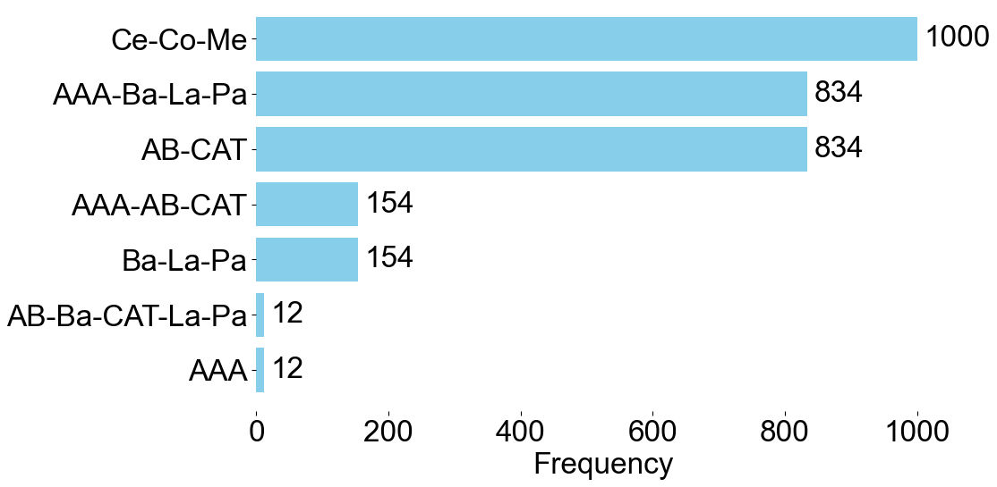
Supplementary Figure 1. Clustering reliability of the amygdala nuclei generated using the FreeSurfer module. K-means++ clustering was performed against average similarity matrix of BOLD time courses 1,000 times with random seed values varying from 0 to 999. The centromedial subdivision (Ce-Co-Me) appeared in every run. The basolateral (AAA-Ba-La-Pa) and basomedial (AB-CAT) subdivisions appeared in 83.4% of runs. AAA: anterior amygdaloid area; Ba: basal nucleus; La: lateral nucleus; Pa: paralaminar nucleus; AB: accessory basal nucleus; CAT: cortico-amygdaloid transition area; Co: cortical nucleus; Ce: central nucleus; Me: medial nucleus.

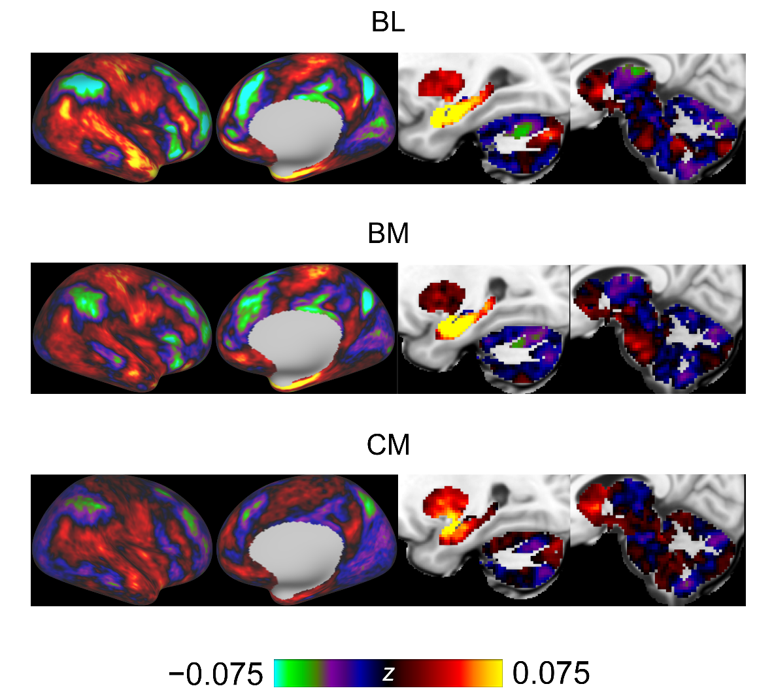
Supplementary Figure 2. Whole-brain rs-FC of each amygdala subdivision. We plotted group-average z-transformed rs-FC values. BL: basolateral; BM: basomedial; CM: centromedial.
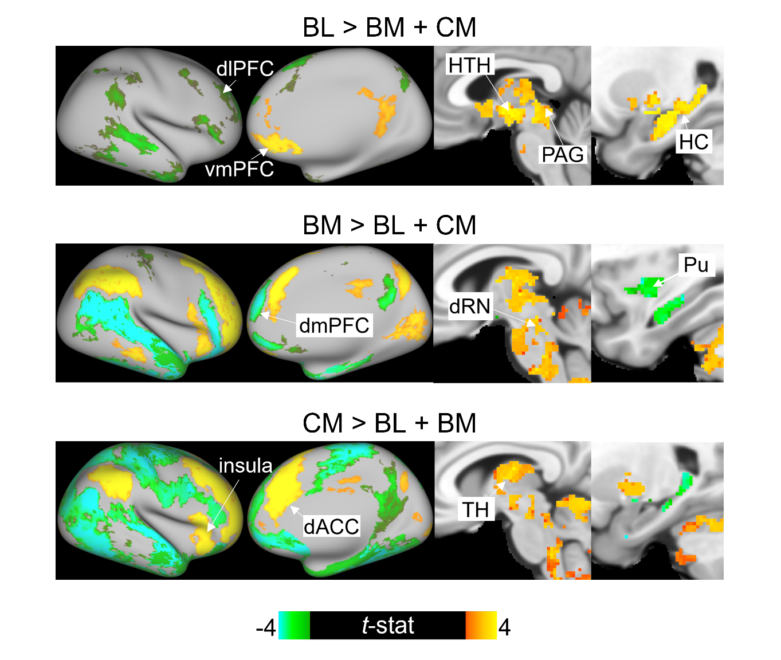
Supplementary Figure 3. Comparisons of the whole-brain rs-FC of each amygdala subdivision with those of other subdivisions. Yellow indicates significantly greater connectivity with one subdivision compared with others. Green indicates significantly lower connectivity with one subdivision compared with others. BL: basolateral; BM: basomedial; CM: centromedial. For visualization purposes, these maps show regions with uncorrected $p_{TFCE}$ < 0.005.

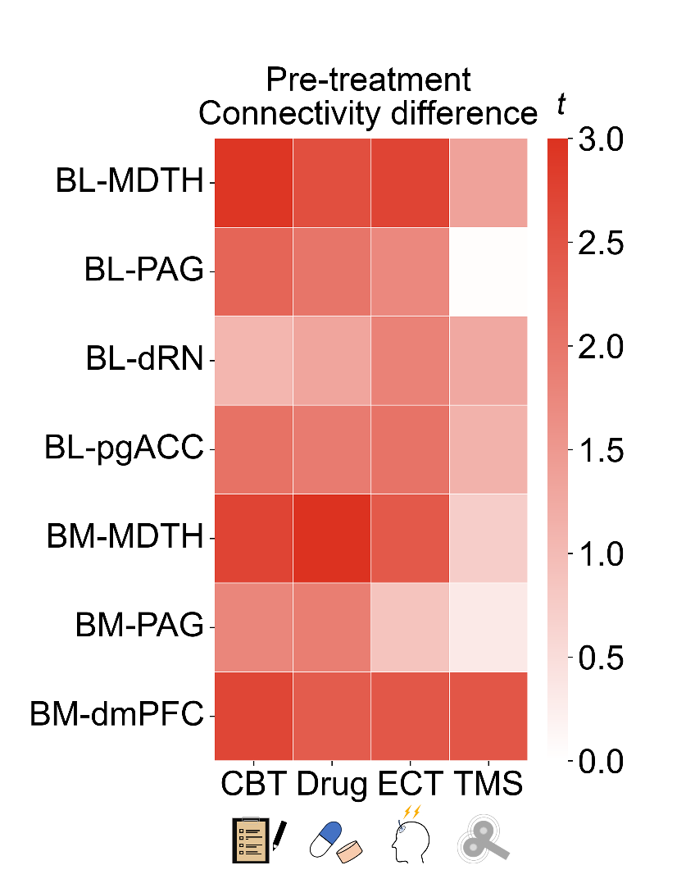
Supplementary Figure 4. Pre-treatment connectivity differences between treatment and healthy control groups. A positive t-value indicates a greater rs-FC in patients with depression than in healthy controls. MDTH: mediodorsal thalamus; PAG: periaqueductal gray; dRN: dorsal raphe nucleus; pgACC: perigenual anterior cingulate cortex; dmPFC: dorsomedial prefrontal cortex; CBT: cognitive behavioral therapy; ECT: electroconvulsive therapy; TMS: transcranial magnetic stimulation.

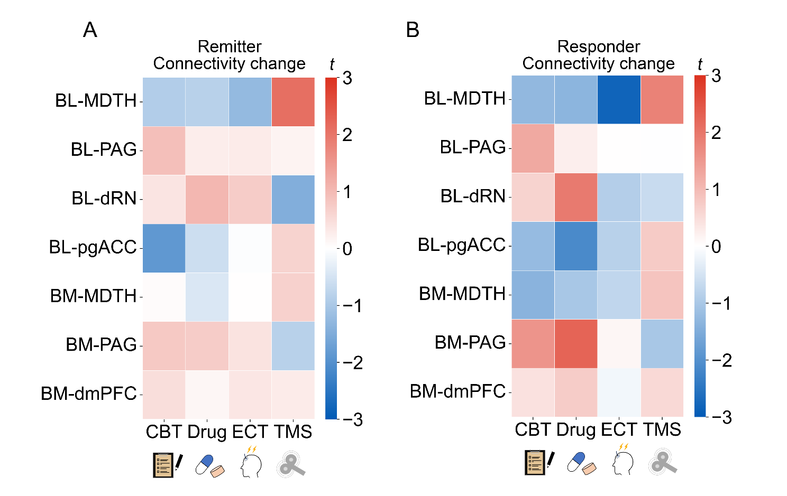
Supplementary Figure 5. Connectivity changes in different treatment groups stratified by treatment outcome. Changes in rs-FC in (A) remitters and (B) responders. A negative t-value indicates a group-level decrease in rs-FC following treatment. Characteristics of these groups are provided in Supplementary Table. 6. MDTH: mediodorsal thalamus; PAG: periaqueductal gray; dRN: dorsal raphe nucleus; pgACC: perigenual anterior cingulate cortex; dmPFC: dorsomedial prefrontal cortex; CBT: cognitive behavioral therapy; ECT: electroconvulsive therapy; TMS: transcranial magnetic stimulation.

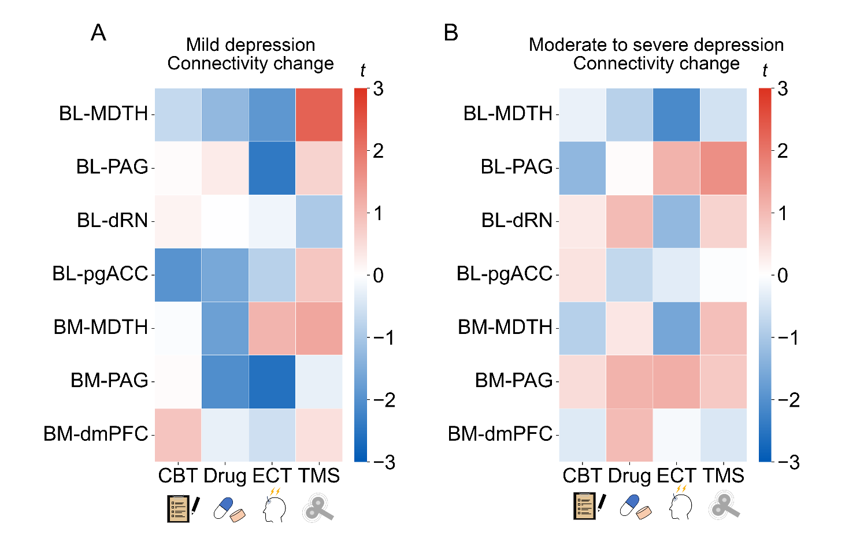
Supplementary Figure 6. Connectivity changes in different treatment groups stratified by baseline depression severity. Changes in rs-FC in patients with (A) mild depression and (B) moderate to severe depression. A negative t-value indicates a group-level decrease in rs-FC following treatment. Characteristics of these groups are provided in Supplementary Table. 7. MDTH: mediodorsal thalamus; PAG: periaqueductal gray; dRN: dorsal raphe nucleus; pgACC: perigenual anterior cingulate cortex; dmPFC: dorsomedial prefrontal cortex; CBT: cognitive behavioral therapy; ECT: electroconvulsive therapy; TMS: transcranial magnetic stimulation.

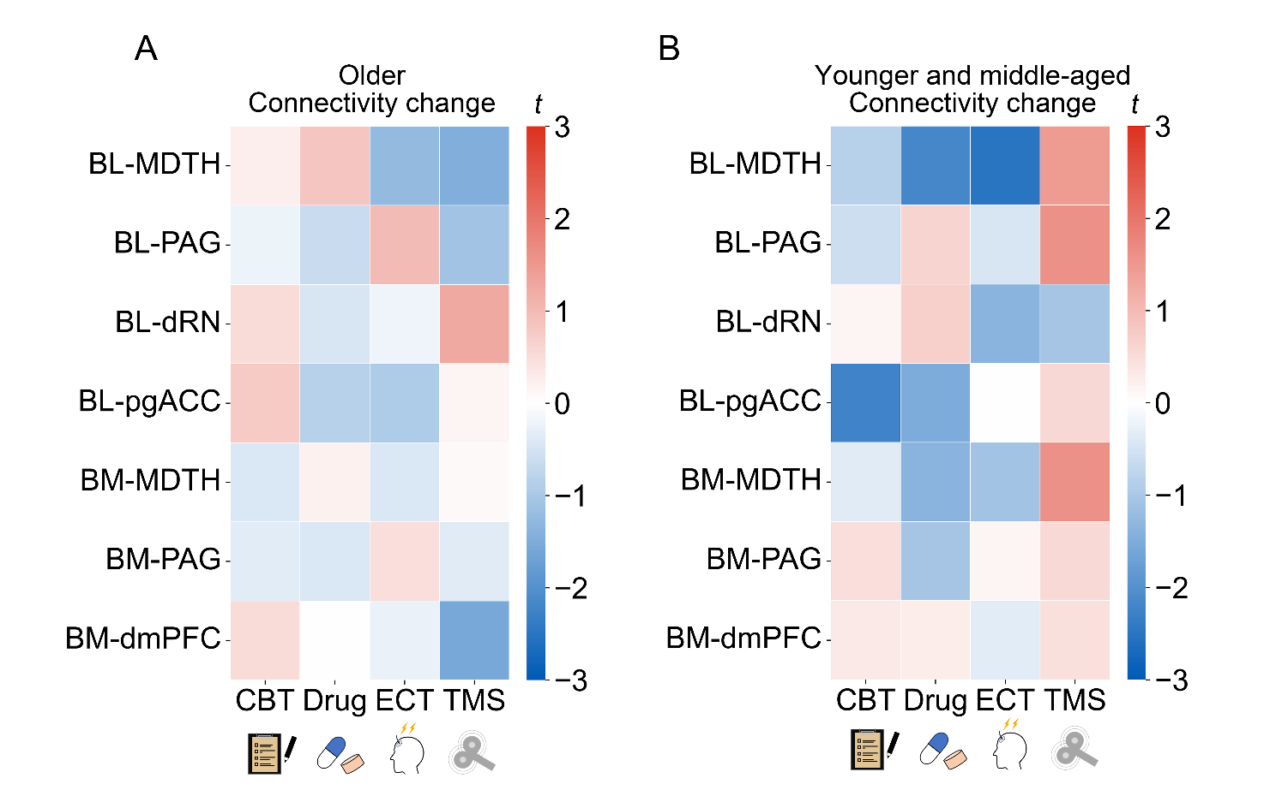
Supplementary Figure 7. Connectivity changes in different treatment groups stratified by age. Changes in rs-FC in (A) older patients and (B) younger and middle-aged patients. A negative t-value indicates a group-level decrease in rs-FC following treatment. Characteristics of the groups are provided in Supplementary Table. 8. MDTH: mediodorsal thalamus; PAG: periaqueductal gray; dRN: dorsal raphe nucleus; pgACC: perigenual anterior cingulate cortex; dmPFC: dorsomedial prefrontal cortex; CBT: cognitive behavioral therapy; ECT: electroconvulsive therapy; TMS: transcranial magnetic stimulation.

References
1. Glasser MF, Coalson TS, Robinson EC, Hacker CD, Harwell J, Yacoub E et al. A multi-modal parcellation of human cerebral cortex. Nature 2016; 536: 171–178.
2. Tang S, Lu L, Zhang L, Hu X, Bu X, Li H et al. Abnormal amygdala resting-state functional connectivity in adults and adolescents with major depressive disorder: A comparative meta-analysis. EBiomedicine 2018; 36: 436–445.
3. Winterburn JL, Pruessner JC, Chavez S, Schira MM, Lobaugh NJ, Voineskos AN et al. A novel in vivo atlas of human hippocampal subfields using high-resolution 3T magnetic resonance imaging. Neuroimage 2013; 74: 254–265.
4. Neudorfer C, Germann J, Elias GJB, Gramer R, Boutet A, Lozano AM. A high-resolution in vivo magnetic resonance imaging atlas of the human hypothalamic region. Sci Data 2020; 7: 305.
5. Najdenovska E, Alemán-Gómez Y, Battistella G, Descoteaux M, Hagmann P, Jacquemont S et al. In-vivo probabilistic atlas of human thalamic nuclei based on diffusion- weighted magnetic resonance imaging. Sci Data 2018; 5: 180270.
6. Pauli WM, Nili AN, Tyszka JM. A high-resolution probabilistic in vivo atlas of human subcortical brain nuclei. Sci Data 2018; 5: 180063.
7. Edlow BL, Takahashi E, Wu O, Benner T, Dai G, Bu L et al. Neuroanatomic connectivity of the human ascending arousal system critical to consciousness and its disorders. J Neuropathol Exp Neurol 2012; 71: 531–546.

