SUPPLEMENTARY INFORMATION (SI)

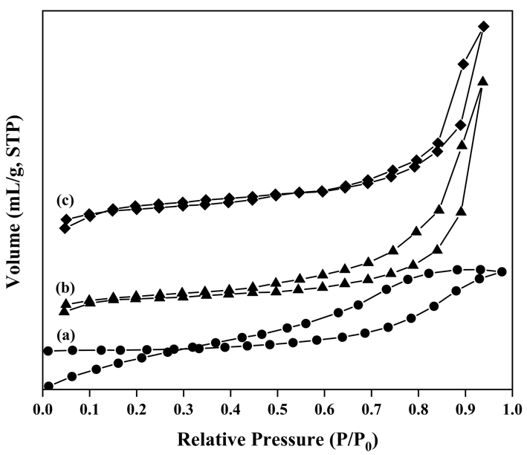
ESM_1. N₂ Adsorption-desorption of Mg/Al LDH (a), Mg/Al-TiO₂ (b), and Mg/Al-ZnO (c)

ESM_2. BET analysis of catalysts
Adsorbent | Surface Area (m²/g) | Pore Size (nm), BJH | Pore Volume (cm³/g), BJH
Mg/Al-LDH | 8.963 | 6.225 | 0.028
Mg/Al-TiO₂ | 17.199 | 7.010 | 0.060
Mg/Al-ZnO | 14.830 | 4.489 | 0.033

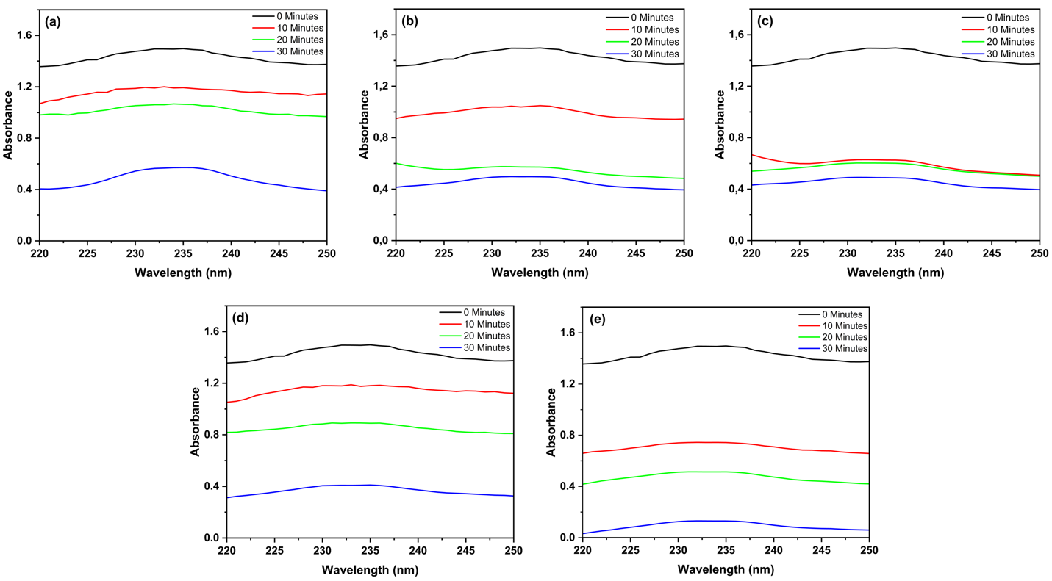
ESM_3. UV-Vis spectrum of oxidative desulfurization dibenzothiophene by Mg/Al and composites (50$℃$, 300 rpm, 0.25 g catalysts, n-hexane solvent)

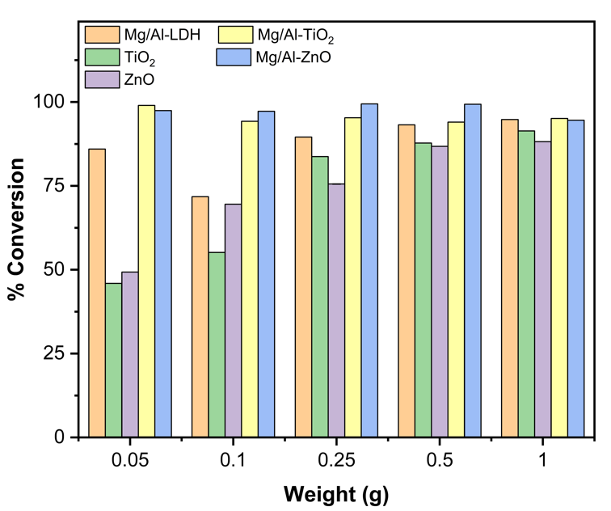
ESM_4. Effect of catalyst dosage to oxidative desulfurization of dibenzothiophene by Mg/Al and composites (50$℃$, 300 rpm, 30 min, n-hexane solvent)

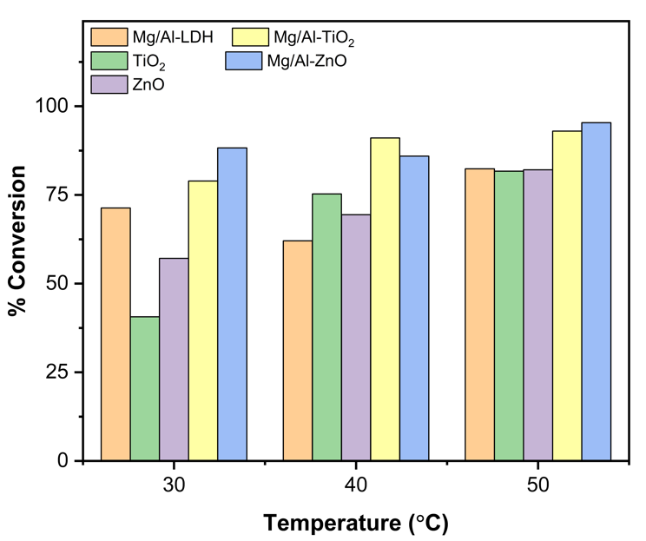
ESM_5. Effect of various temperatures on oxidative desulfurization of dibenzotiophene using Mg/Al and composite catalysts (30 min, 300 rpm, n-hexane solvent)

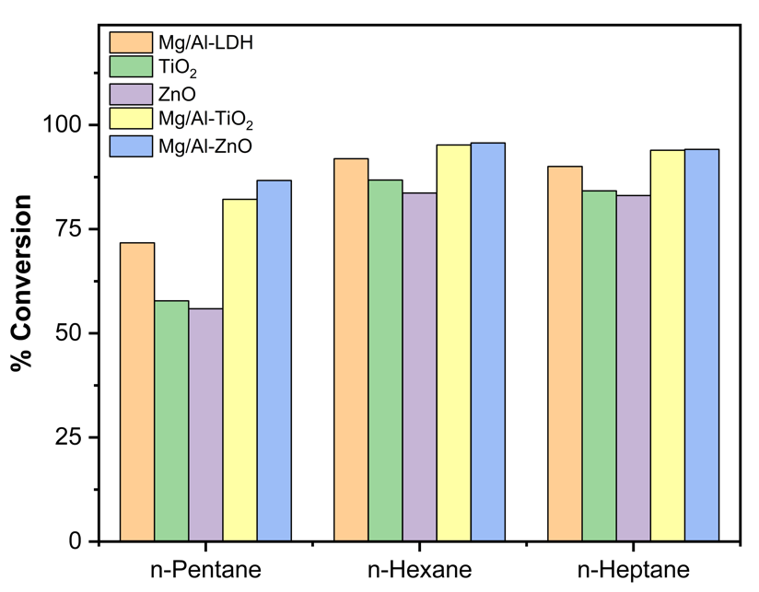
ESM_6. Effect of solvent on oxidative desulfurization of dibenzothiophene by Mg/Al and composite catalysts (50$℃$, 300 rpm, 30 min)

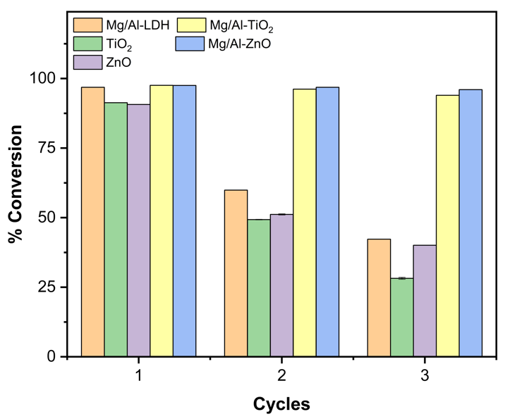
ESM_7. Reusability of Mg/Al and composites catalysts son oxidative desulfurization of dibenzothiophene (50$℃$, 300 rpm, 30 min, n-hexane solvent)

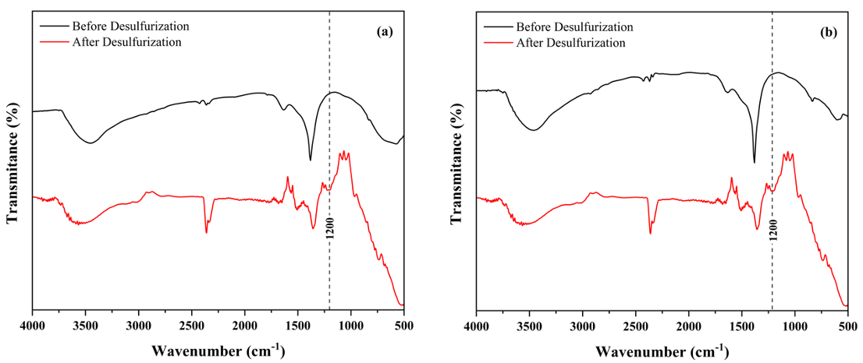
ESM_8. FTIR spectrum of Mg/Al-TiO₂ (a) and Mg/Al-ZnO (b) before and after oxidative desulfurization of third cycle processes.

