Supplement
Supplementary table 1: Sensitivity analysis adjusting on incident fractures, heart attack, cancer and stroke. Hazard ratio and 95 % confidence intervals for cardiovascular risk-factors and the risk of VTE, and VTE subtypes.
 | All VTE |  |  | Pulmonary embolism |  |  | DVT |  |  | Primary |  |  | Secondary
 | Cases | adjusted HR* |  | Cases | adjusted HR* |  | Cases | adjusted HR* |  | Cases | adjusted HR* |  | Cases | adjusted HR*
physical act T1 | 545 | ref |  | 166 | ref |  | 379 | ref |  | 163 | Ref |  | 382 | Ref
PA T2 | 545 | 1.02 (0.90: 1.15) |  | 160 | 1.04 (0.84: 1.30) |  | 387 | 1.03 (0.89: 1.19) |  | 156 | 0.98 (0.78: 1.22) |  | 389 | 1.06 (0.92: 1.22)
PA T3 | 559 | 1.02 (0.91: 1.16) |  | 179 | 1.01 (0.81: 1.25) |  | 381 | 1.01 (0.88: 1.17) |  | 113 | 0.71 (0.56: 0.91) |  | 446 | 1.14 (1.00: 1.31)
Never smoker | 946 | ref |  | 295 | ref |  | 662 | ref |  | 253 | ref |  | 693 | ref
X smoker | 557 | 0.95 (0.86: 1.06) |  | 166 | 0.94 (0.78: 1.14) |  | 392 | 0.94 (0.83: 1.07) |  | 131 | 0.84 (0.68: 1.04) |  | 426 | 0.81 (0.66: 1.01)
smoker | 146 | 0.87 (0.73: 1.03) |  | 44 | 0.96 (0.70: 1.33) |  | 103 | 0.84 (0.68: 1.03) |  | 48 | 0.99 (0.73: 1.36) |  | 98 | 0.96 (0.88: 1.12)
hypertension | 827 | 1.05 (0.95: 1.16) |  | 296 | 1.20 (1.00: 1.45) |  | 532 | 0.99 (0.88: 1.12) |  | 204 | 1.02 (0.84: 1.26) |  | 623 | 1.07 (0.95: 1.21)
dyslipidaemia | 354 | 0.90 (0.79: 1.01) |  | 142 | 1.03 (0.84: 1.26) |  | 212 | 0.83 (0.71: 0.97) |  | 69 | 0.68 (0.52: 0.89) |  | 285 | 0.97 (0.85: 1.12)
diabetes | 36 | 0.73 (0.52: 1.02) |  | 17 | 0.88 (0.54: 1.44) |  | 19 | 0.62 (0.40: 0.99) |  | 11 | 0.95 (0.52: 1.75) |  | 25 | 0.66 (0.44: 0.99)
*adjusted on education level, statin use, menopause, MHT use, parity, type of menopause, family history of CVD, BMI, incident fractures, stroke, cancer and myocardial infarction

Supplementary table 2: Sensitivity analysis excluding cases occurring after 2005 which were not strictly validated via mailing. Hazard ratio and 95 % confidence intervals for cardiovascular risk-factors and the risk of VTE, and VTE subtypes.
 | All VTE |  |  | Pulmonary embolism |  |  | DVT |  |  | Primary |  |  | Secondary
 | Cases | adjusted HR* |  | Cases | adjusted HR* |  | Cases | adjusted HR* |  | Cases | adjusted HR* |  | Cases | adjusted HR*
physical act T1 | 413 | ref |  | 97 | ref |  | 316 | ref |  | 154 | ref |  | 259 | ref
PA T2 | 422 | 1.04 (0.90: 1.19) |  | 97 | 1.05 (0.79: 1.39) |  | 325 | 1.03 (0.88: 1.21) |  | 148 | 0.97 (0.77: 1.22) |  | 274 | 1.08 (0.91: 1.28)
PA T3 | 394 | 0.98 (0.85: 1.12) |  | 96 | 1.00 (0.75: 1.33) |  | 298 | 0.97 (0.83: 1.14) |  | 107 | 0.70 (0.54: 0.90) |  | 287 | 1.14 (0.96: 1.34)
Never smoker | 721 | Ref |  | 172 | ref |  | 549 | ref |  | 241 | ref |  | 480 | ref
X smoker | 383 | 0.92 (0.82: 1.05) |  | 88 | 0.93 (0.72: 1.20) |  | 295 | 0.92 (0.80; 1.07) |  | 120 | 0.87 (0.71: 1.09) |  | 263 | 0.95 (0.82: 1.10)
smoker | 125 | 0.89 (0.74: 1.08) |  | 30 | 0.99 (0.67: 1.47) |  | 95 | 0.86 (0.69: 1.07) |  | 48 | 1.05 (0.77: 1.44) |  | 77 | 0.81 (0.64: 1.04)
hypertension | 583 | 1.02 (0.91: 1.15) |  | 162 | 1.22 (0.95: 1.56) |  | 421 | 0.97 (0.84: 1.11) |  | 191 | 0.96 (0.78: 1.18) |  | 392 | 1.05 (0.91: 1.22)
dyslipidaemia | 189 | 0.86 (0.73: 1.01) |  | 52 | 0.87 (0.64: 1.19) |  | 137 | 0.86 (0.71: 1.04) |  | 58 | 0.74 (0.56: 0.99) |  | 131 | 0.93 (0.76: 1.13)
diabetes | 21 | 0.71 (0.46: 1.11) |  | 6 | 0.68 (0.30: 1.54) |  | 15 | 0.73 (0.44: 1.22) |  | 10 | 1.01 (0.54: 1.92) |  | 11 | 0.56 (0.31: 1.03)
*adjusted on education level, statin use, menopause, MHT use, parity, type of menopause, family history of CVD and BMI
All cases validated by imaging procedures
Supplementary figures
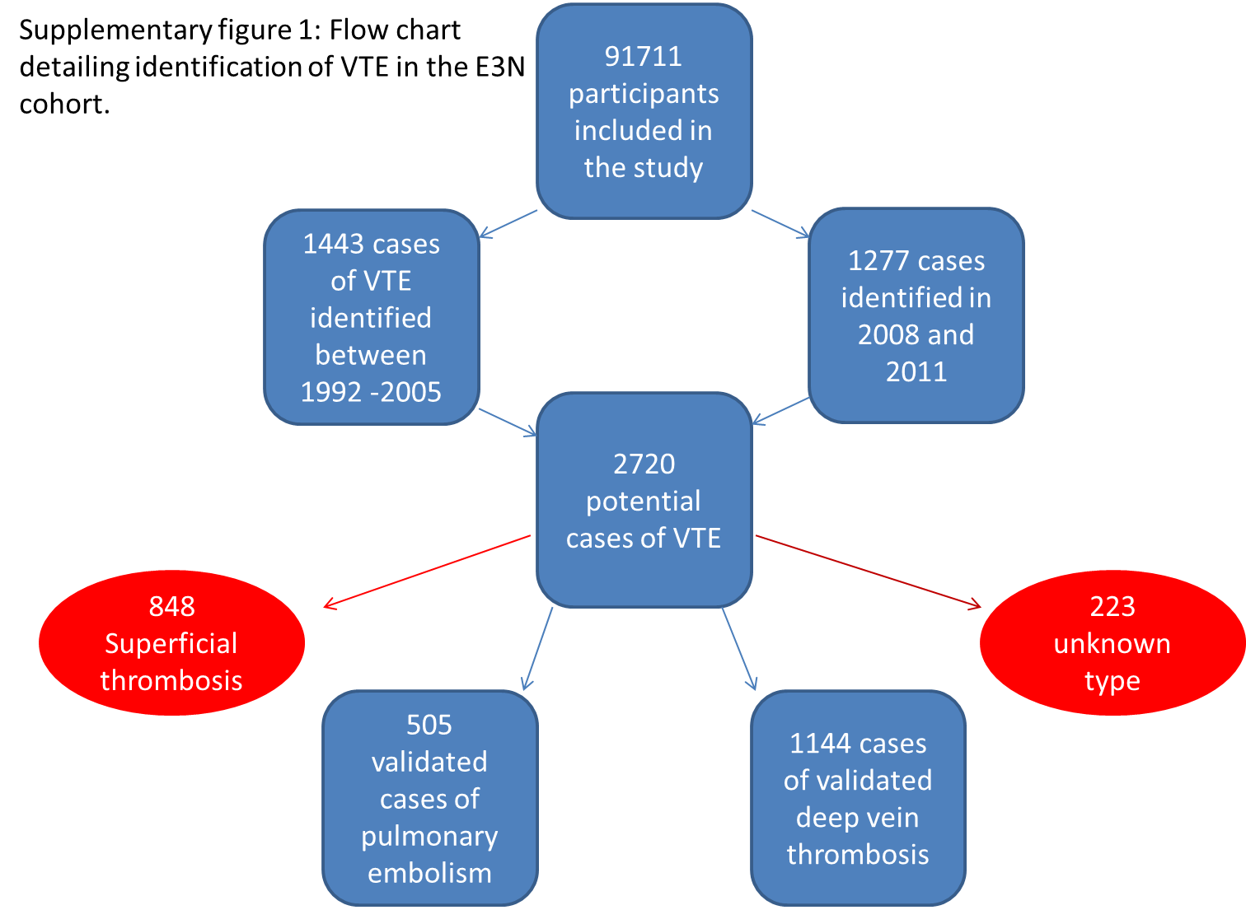

Supplementary Figures
S Figure 2: Causal diagrams showing assumed relations between cardiovascular risk-factors and VTE
- Cardiometabolic factors including diabetes, hypertension and dyslipidaemia
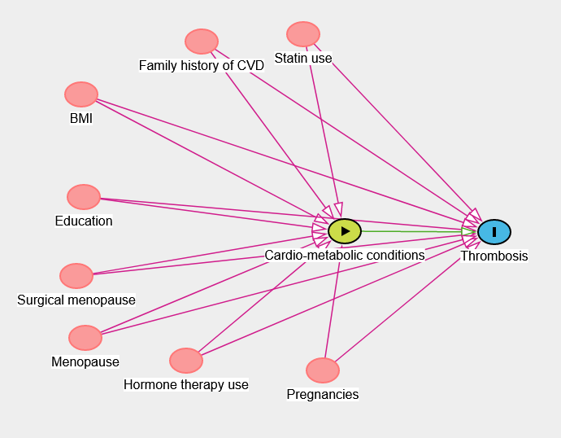
- Physical activity

- smoking


