Supplementary Information
Table 1. Logistic Regression Model for Predicting Retention of Junior Researchers (Career Age <=5 Years)
 | Model 1:  Paper publishing | Model 2:  Academic independence | Model 3:  Career progression
Team Hierarchy | -3.73 (0.003) *** | -3.24 (0.003) *** | -3.21 (0.004) ***
Institution [High-tier] | 0.31 (0.001) *** | 0.25 (0.001) *** | 0.50 (0.001) ***
Authorship [First] | 0.30 (0.001) *** | 0.25 (0.001) *** | 0.34 (0.001) ***
Gender [Male] | 0.09 (0.001) *** | 0.24 (0.001) *** | 0.25 (0.001) ***
Mean Senior Career Age | 0.03 (0.000) *** | 0.02 (0.000) *** | 0.03 (0.000) ***
Year | 0.01 (0.000) *** | 0.01 (0.000) *** | 0.02 (0.000) ***
Team Size | -0.00 (0.000) *** | -0.001 (0.000) *** | 0.002 (0.000) ***
Intercept | -12.81 (0.057) *** | -9.35 (0.059) *** | -45.13 (0.107) ***
Observations | 69,794,286 | 69,794,286 | 39,317,411

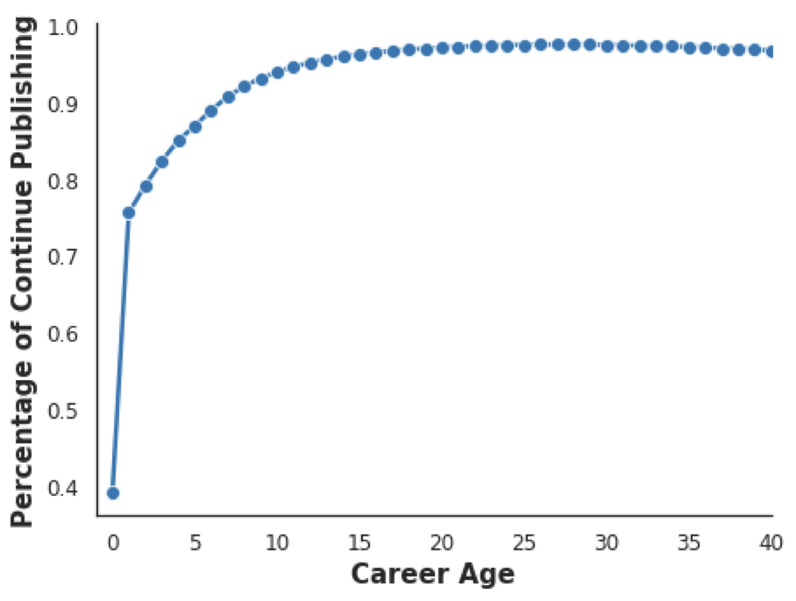
Fig S1. The percentage of researchers who continue publishing is analyzed for career ages ranging from 1 to 40 years. Career age is defined as the time from a researcher’s first publication to the publication of the focal paper. Continuing to publish refers to researchers who publish at least one paper within five years after the focal paper. Junior researchers face more significant dropout challenges and exhibit lower retention rates compared to their senior counterparts.
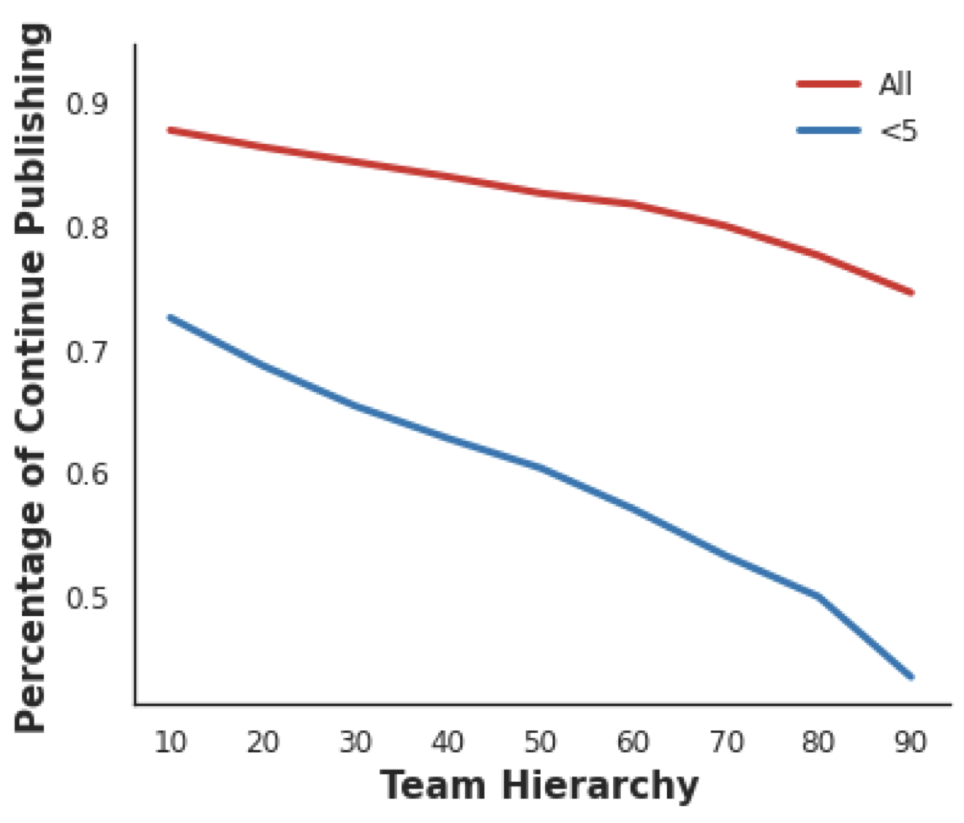
Fig S2. Flat team hierarchies benefit both junior and senior researchers, helping them stay in academia and continue publishing.

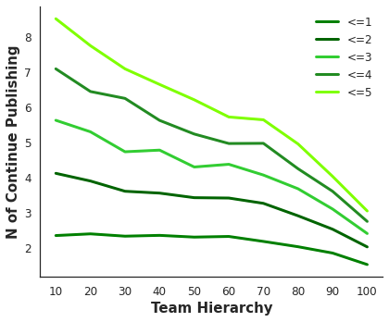
Fig S3. The number of papers published within five years after the focal paper decreases for junior researchers aged 1 to 5 as team hierarchy increases. Career age is defined as the time from the publication of the first paper to the focal paper. Team hierarchy is measured by the Gini index of career age among coauthors, reflecting the disparity of power within the team. Team hierarchy is plotted in 10 bins, each representing a 10% increment, ranging from the 10th to the 100th percentile.
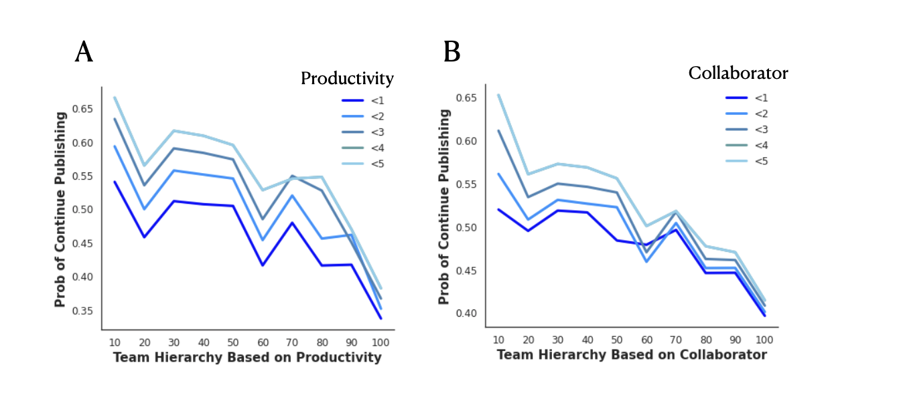Fig S4. Validation of team hierarchy based on productivity and collaborator a. Team hierarchy is measured using the Gini index of productivity, which reflects the disparity in the number of publications before the focal paper among coauthors. b. Team hierarchy is measured using the Gini index of collaborators, which reflects the disparity in the number of collaborators before the focal paper among coauthors. In both cases, the trend is consistent: as team hierarchy increases, the probability of continuing to publish decreases.
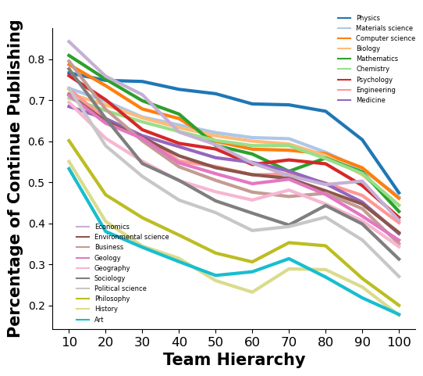
Fig S5. Flat structure enhances retention for junior researchers (career age ≤ 5) across 19 disciplines.
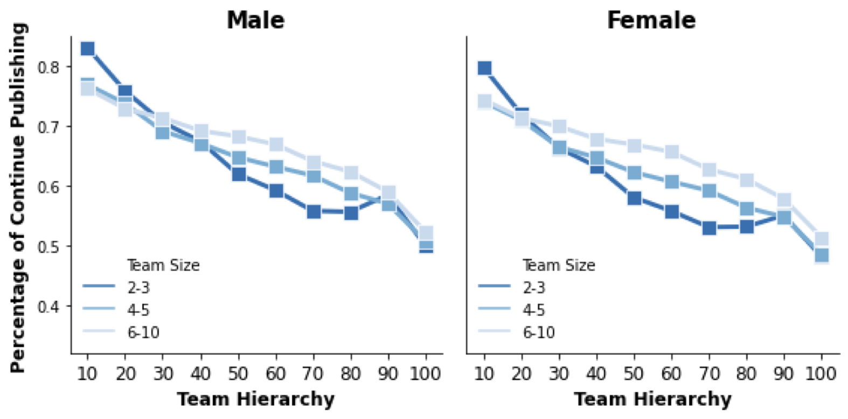
Fig S6. Flat structure increases the likelihood of continuing publishing in small teams compared to large teams, regardless of the junior researchers' gender. Male junior researchers have higher retention rates than female junior researchers across different team sizes.
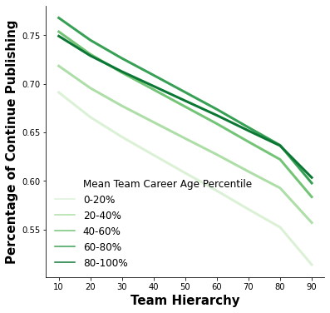
Fig S7. Flat structure enhances the probability of continue publishing across different mean team career age percentiles, especially in teams with 60-80% mean team career age. The mean team career age is the average values of career age for all team members.

