Supplementary Materials

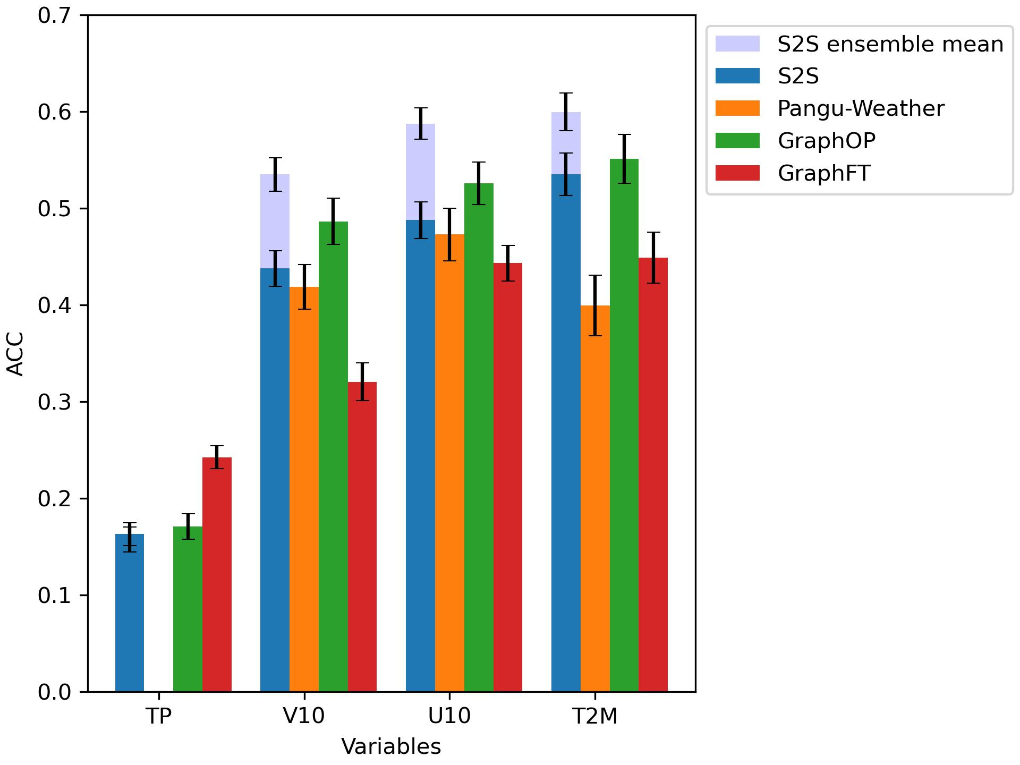
Supplementary Figure 1 Bar plot of ACC for a lead-time of week 2 for Pangu-Weather, Graphcast Operational, GraphFT and S2S accompanied by their error bars representing 95% confidence intervals. GraphOP achieves ACC values comparable to the deterministic S2S model, but still lower than the probabilistic S2S model, which is the most precise model for week 2 for U10, V10 and T2M

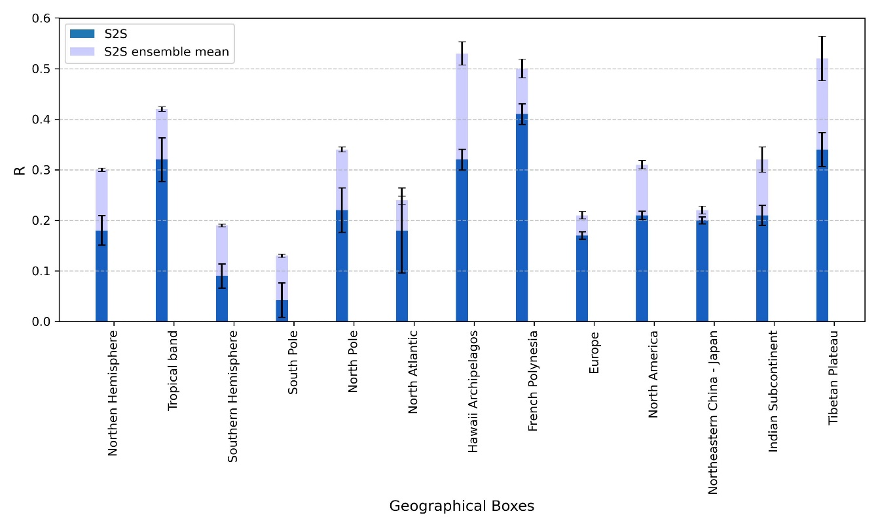
Supplementary Figure 2. Bar plot of ACC for T2M for a lead-time of week 4 for S2S control and S2S ensemble in several geographical boxes accompanied by their error bars representing 95% confidence intervals. Forecasts from GraphOP or Pangu for week 4 were not included.
The Supplementary Figure 2 shows the R_{t} correlation coefficient for S2S control and ensemble systems, for T2M and for week 4. It is evident that S2S ensemble outperforms S2S control in all considered geographical boxes except in the North-Atlantic Ocean, where the difference in ACC is not significant. This result demonstrates that S2S ensemble forecasts are, with a very few exceptions, better in terms of accuracy than S2S deterministic forecasts. As we have seen in Figure 5, GraphFT significantly outperforms S2S control in almost all regions of the word. It can be further extrapolated that an ensemble version of GraphFT should yield even more better results, and could significantly outperform S2S ensemble in all considered geographical boxes and control variables.

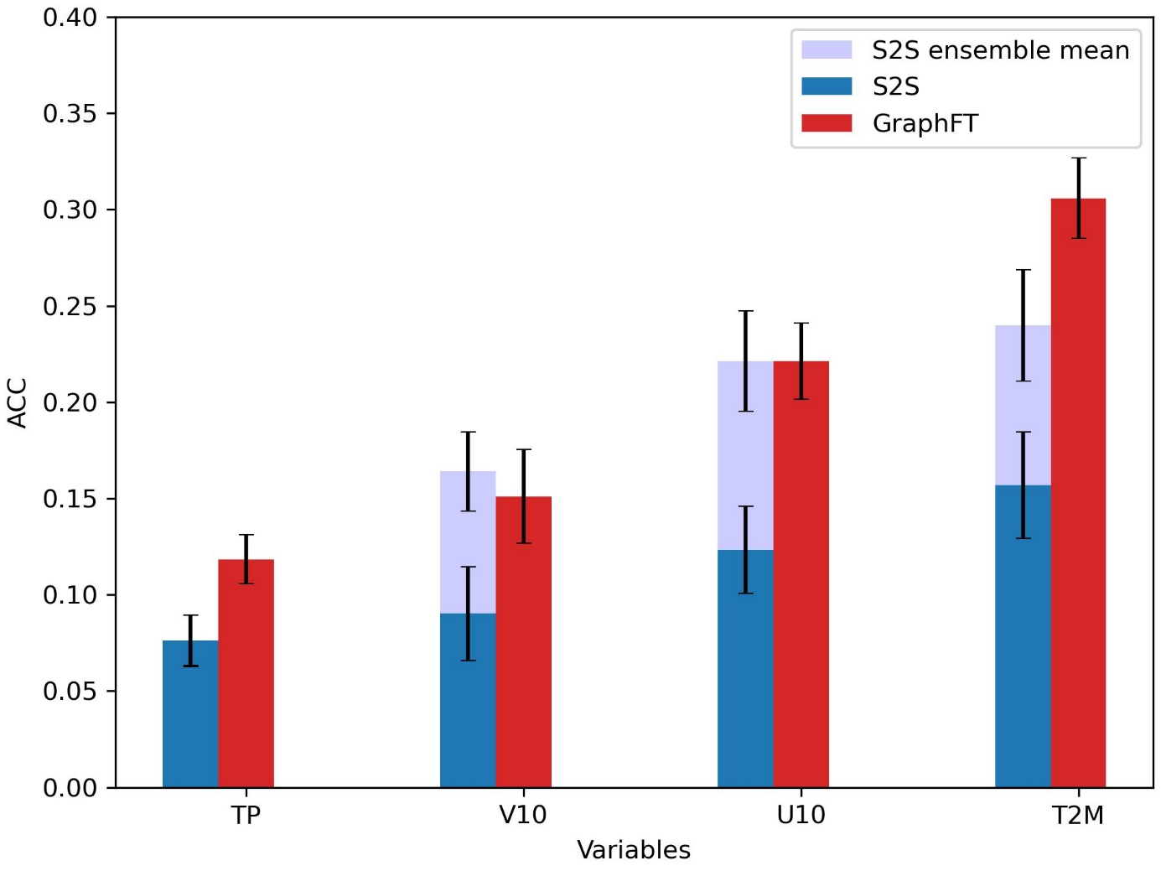
Supplementary Figure 3. Bar plot of ACC for a lead-time of week 4 GraphFT and S2S accompanied by their error bars representing 95% confidence intervals. Forecasts from GraphOP or Pangu for week 4 were not included, their accumulated errors becoming too large at such long lead, so that the best model would either be the ensemble mean of S2S or GraphFT.

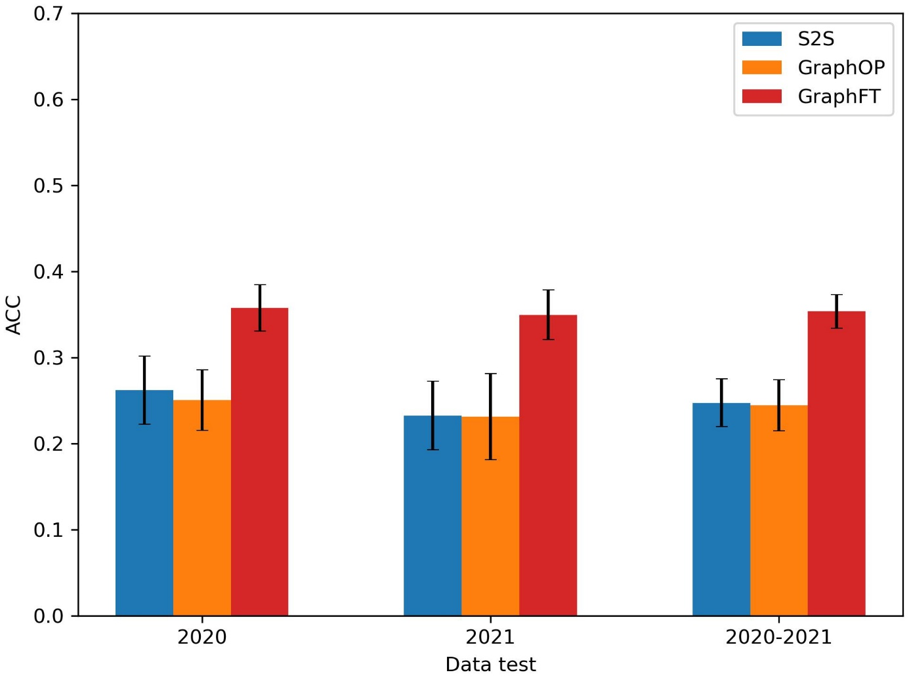
Supplementary Figure 4. Bar plot of ACC for a lead-time of week 3 for T2M computed with only one year, 2020 or 2021, then with both 2020 and 2021 years, for S2S GraphOP and GraphFT

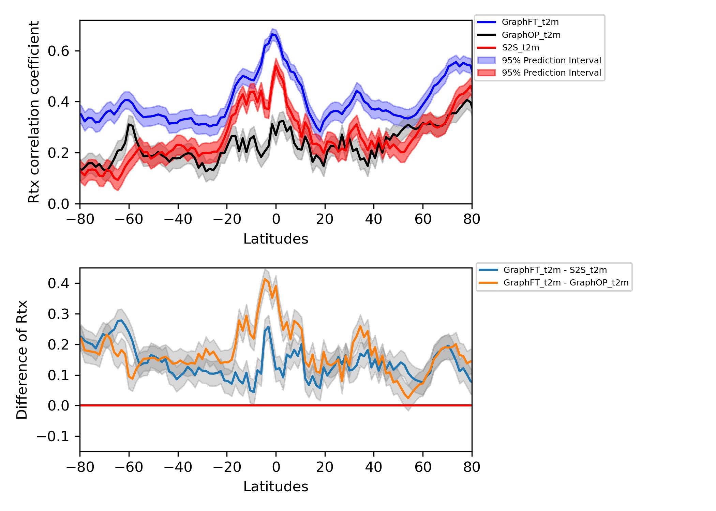
Supplementary Figure 5. Zonal mean of R correlation coefficient for variable T2M for week 3 for GraphFT, GraphOP and S2S along the latitudes (upper panel). Difference of zonal mean of R between GraphFT – GraphOP and GraphFT – S2S (lower panel) accompanied by their 95% confidence intervals.

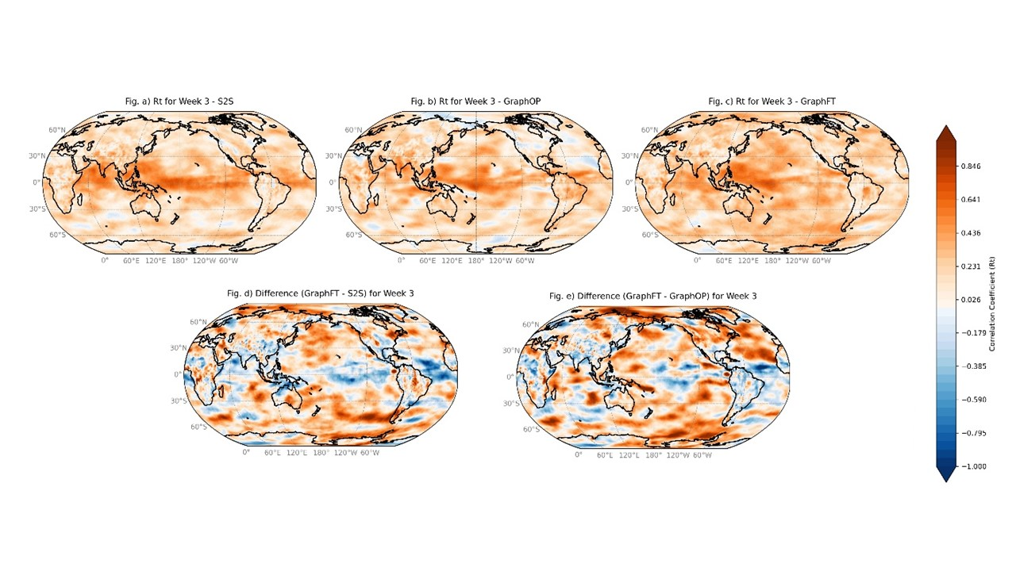
Supplementary Figure 6. Spatial map of R correlation coefficient of S2S (upper left), GraphOP (upper middle) and GraphFT (upper right), along with R differences between GraphFT-S2S (lower left) and GraphFT-GraphOP (lower right) for U10 at forecast lead-time of week 3

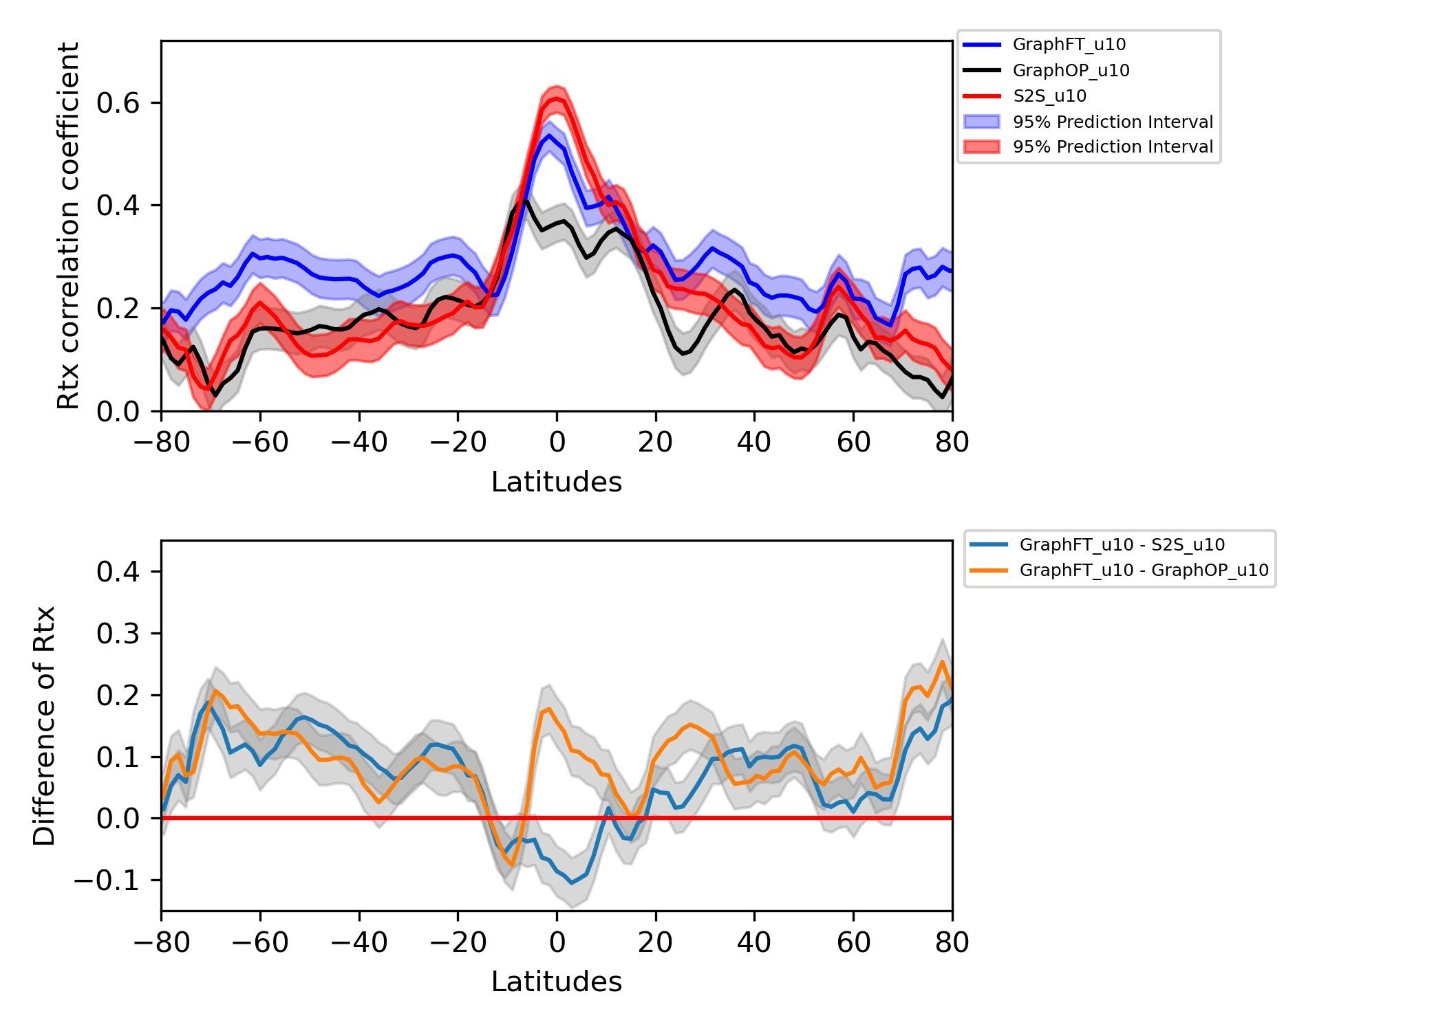
Supplementary Figure 7. Zonal mean of R correlation coefficient for variable U10 for week 3 for GraphFT, GraphOP and S2S along the latitudes (upper panel). Difference of zonal mean of R between GraphFT – GraphOP and GraphFT – S2S (lower panel) accompanied by their 95% confidence intervals.

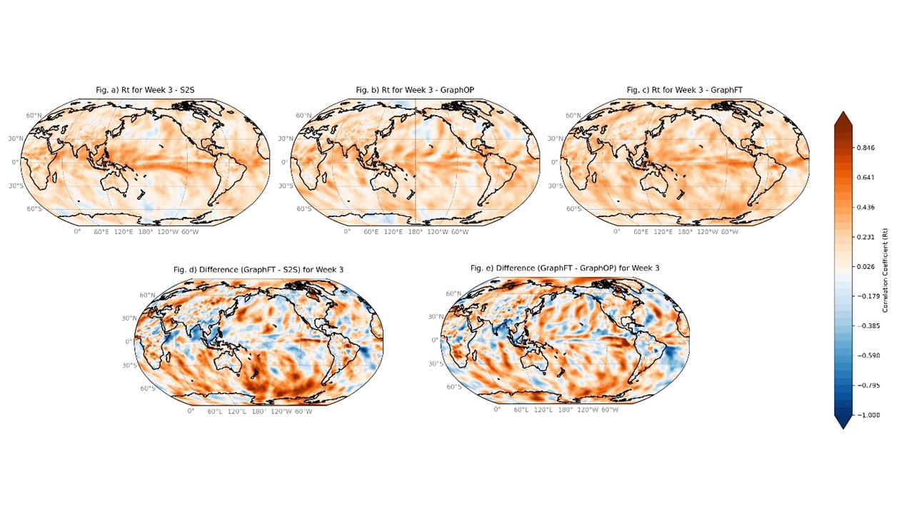
Supplementary Figure 8. Spatial map of R correlation coefficient of S2S (upper left), GraphOP (upper middle) and GraphFT (upper right), along with R differences between GraphFT-S2S (lower left) and GraphFT-GraphOP (lower right) for V10 at forecast lead-time of week 3

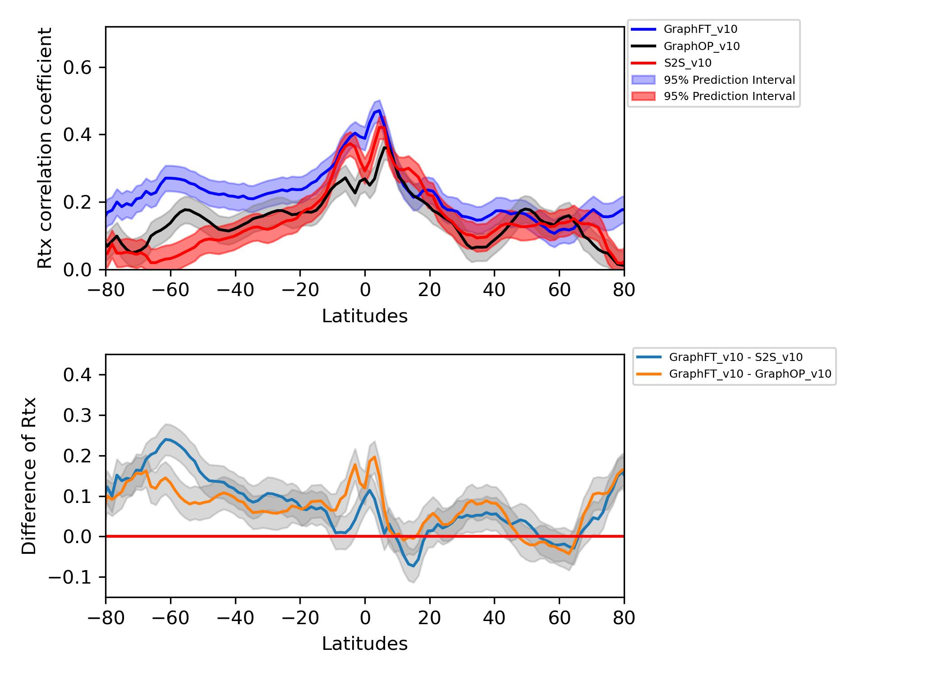
Supplementary Figure 9. Zonal mean of R correlation coefficient for variable V10 for week 3 for GraphFT, GraphOP and S2S along the latitudes (upper panel). Difference of zonal mean of R between GraphFT – GraphOP and GraphFT – S2S (lower panel) accompanied by their 95% confidence intervals.

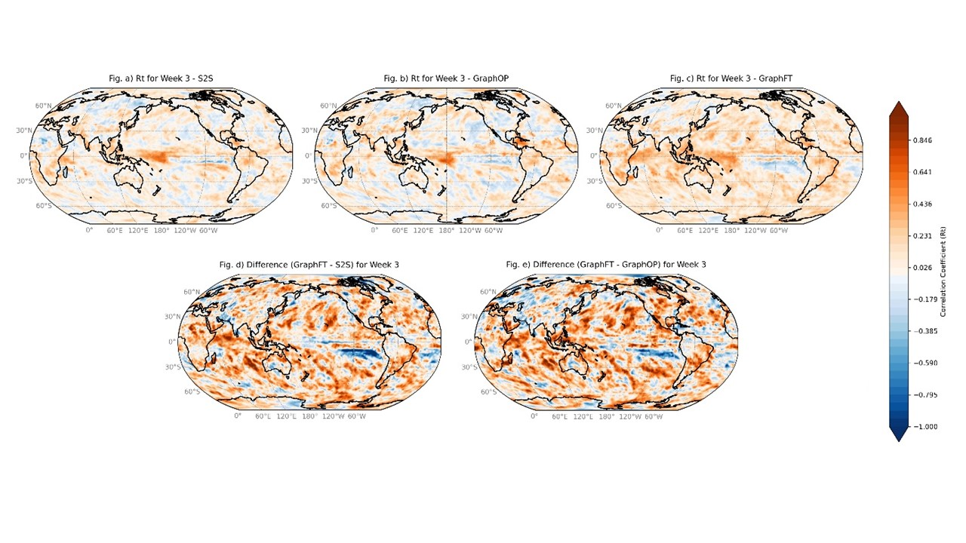
Supplementary Figure 10. Spatial map of R correlation coefficient of S2S (upper left), GraphOP (upper middle) and GraphFT (upper right), along with R differences between GraphFT-S2S (lower left) and GraphFT-GraphOP (lower right) for TP at forecast lead-time of week 3

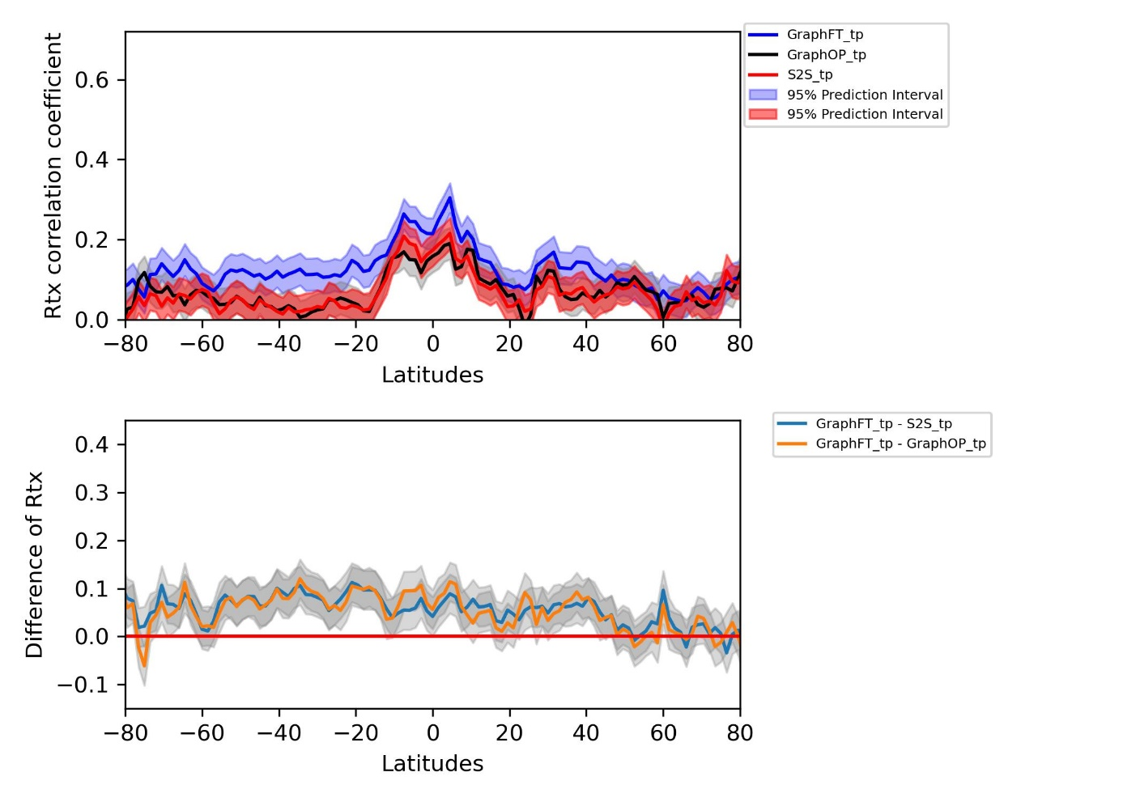
Supplementary Figure 11. Zonal mean of R correlation coefficient for variable TP for week 3 for GraphFT, GraphOP and S2S along the latitudes (upper panel). Difference of zonal mean of R between GraphFT – GraphOP and GraphFT – S2S (lower panel) accompanied by their 95% confidence intervals.

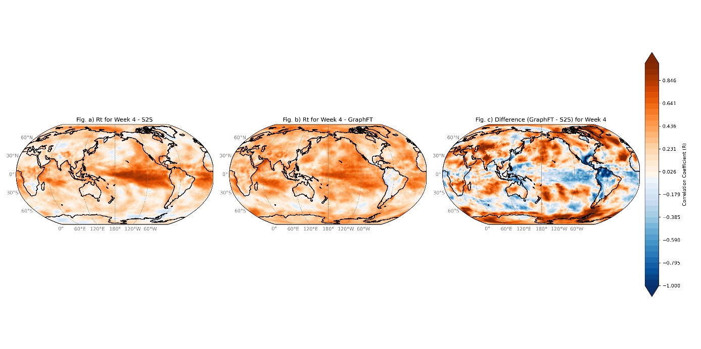
Supplementary Figure 12. Spatial map of R correlation coefficient of S2S (left), GraphFT (middle) and GraphFT – S2S (right), for T2M at forecast lead-time of week 4.

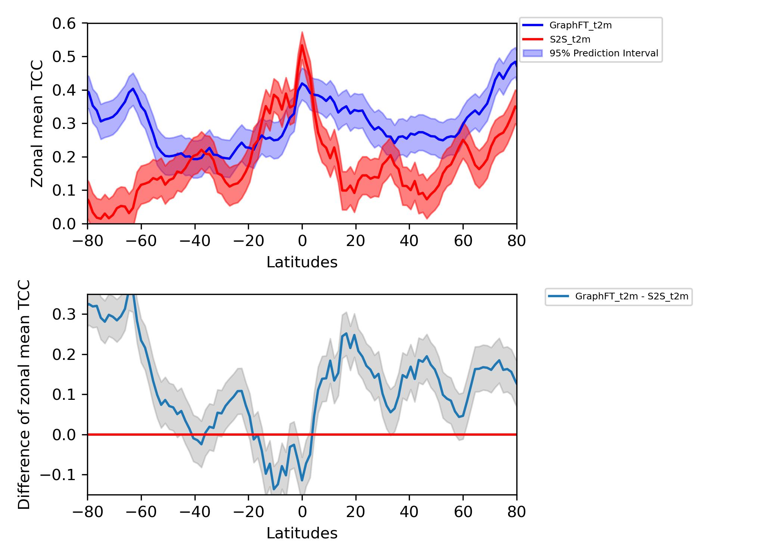
Supplementary Figure 13. Zonal mean of R correlation coefficient for variable T2M for week 4 for GraphFT and S2S along the latitudes (upper panel). Difference of zonal mean of R between GraphFT – S2S (lower panel), accompanied by their 95% confidence intervals.

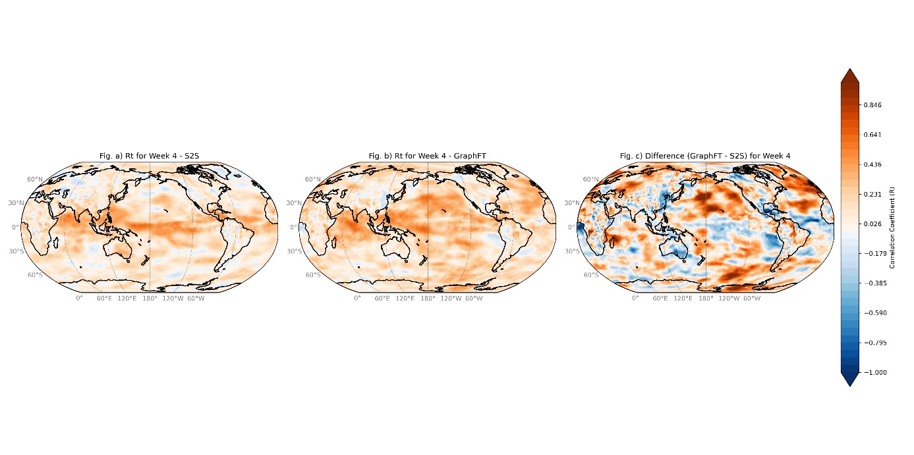
Supplementary Figure 14. Spatial map of R correlation coefficient of S2S (left), GraphFT (middle) and GraphFT – S2S (right), for U10 at forecast lead-time of week 4.

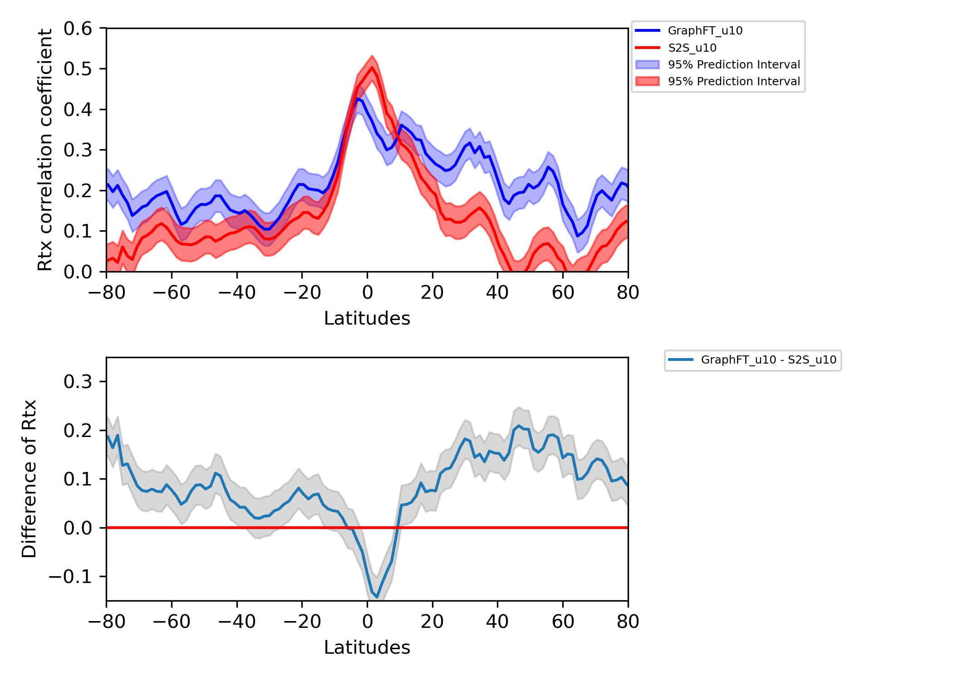
Supplementary Figure 15. Zonal mean of R correlation coefficient for variable U10 for week 4 for GraphFT and S2S along the latitudes (upper panel). Difference of zonal mean of R between GraphFT – S2S (lower panel), accompanied by their 95% confidence intervals.

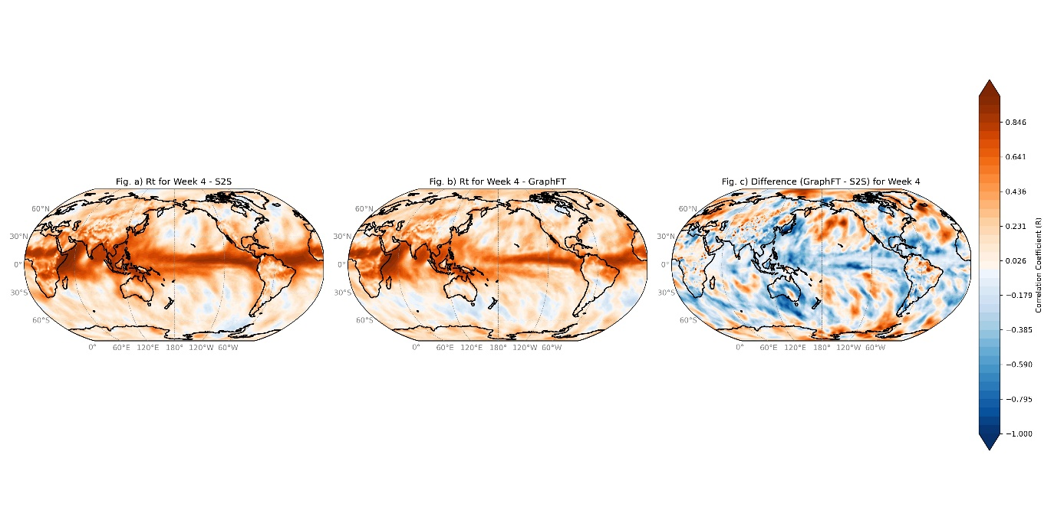
Supplementary Figure 16. Spatial map of R correlation coefficient of S2S (left), GraphFT (middle) and GraphFT – S2S (right), for V10 at forecast lead-time of week 4.

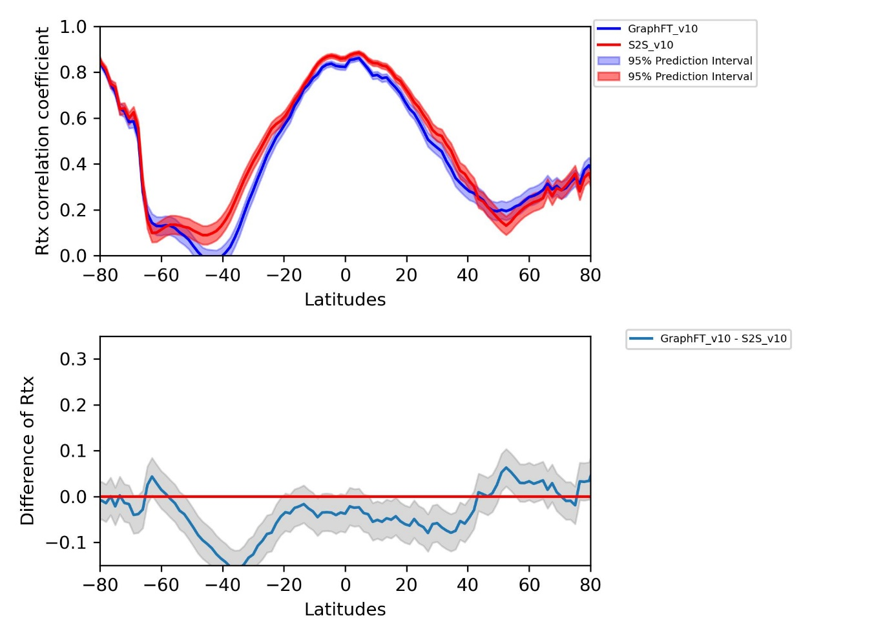
Supplementary Figure 17. Zonal mean of R correlation coefficient for variable V10 for week 4 for GraphFT and S2S along the latitudes (upper panel). Difference of zonal mean of R between GraphFT – S2S (lower panel), accompanied by their 95% confidence intervals.

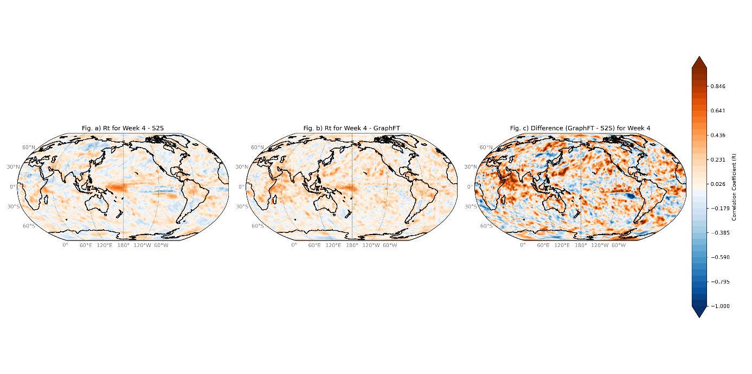
Supplementary Figure 18. Spatial map of R correlation coefficient of S2S (left), GraphFT (middle) and GraphFT – S2S (right), for TP at forecast lead-time of week 4.

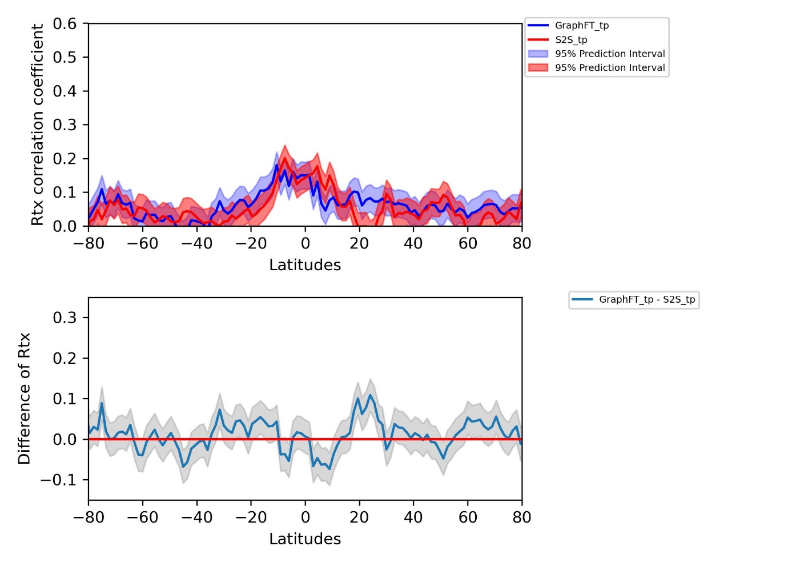
Supplementary Figure 19. Zonal mean of R correlation coefficient for variable TP for week 4 for GraphFT and S2S along the latitudes (upper panel). Difference of zonal mean of R between GraphFT – S2S (lower panel), accompanied by their 95% confidence intervals.

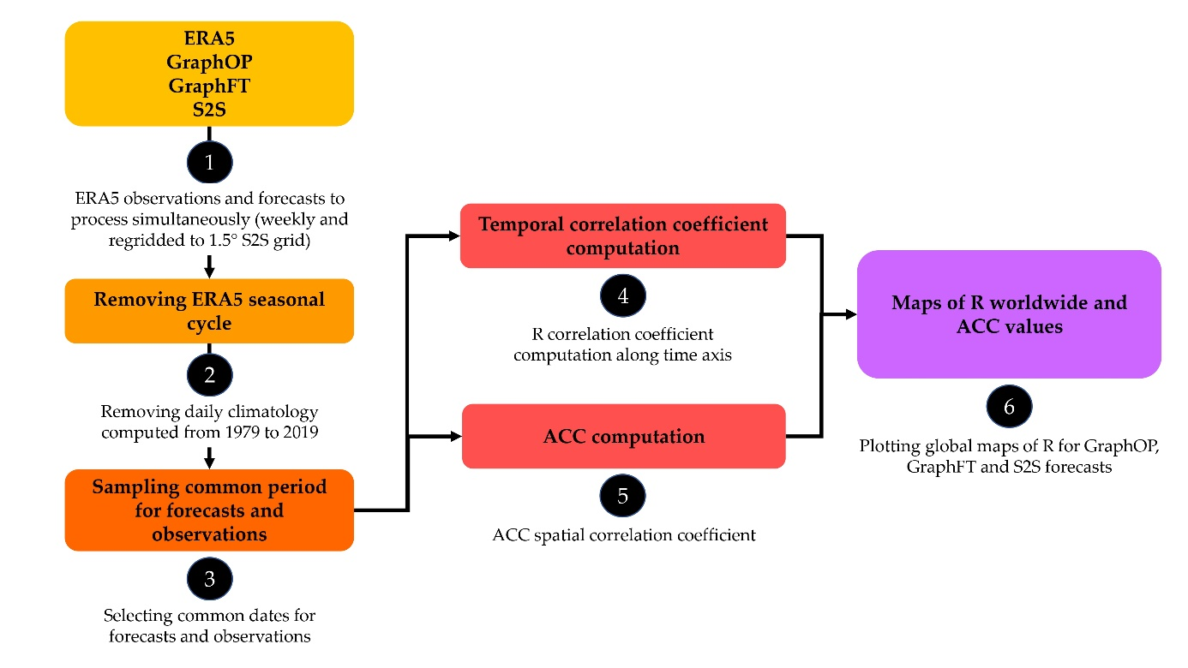
Supplementary Figure 20. Post-processing process for ACC and Rt computation for all variables for week 3 and 4 for forecasting skill evaluation

