Identification of industrial sewage sludge based on heavy metal profiles: A case study of printing and dyeing industry

Xufeng Zhang^{a,b}, Shuyu Chenª, Fangting Ai^{b}, Limin Jin^{b}, Ningzheng Zhu^{a,b}, Xiang-Zhou Meng^{a,b,c,*}

ª State Key Laboratory of Pollution Control and Resources Reuse, College of Environmental Science and Engineering, Tongji University, Shanghai 200092, China
^{b} Jiaxing-Tongji Environmental Research Institute, 1994 Linggongtang Road, Jiaxing 314051, Zhejiang Province, China
^{c} Shanghai Institute of Pollution Control and Ecological Security, Shanghai 200092, China
* Corresponding author email: xzmeng@tongji.edu.cn (X.-Z. Meng).

Table S1. Sampling information of industrial and municipal sewage sludge.
Table S2. Content of heavy metals in industrial and municipal sewage sludge (mg kg⁻¹).
Table S3. Correlation analysis of heavy metals in sewage sludge of PD.
Table S4. Correlation analysis of heavy metals in sewage sludge of PD (Chemical fiber).
Table S5. Correlation analysis of heavy metals in sewage sludge of PD (Cotton).
Table S6. Correlation analysis of heavy metals in sewage sludge of PD (Wool, silk and others).
Table S7. Percentage of heavy metal contents in industrial and municipal sewage sludge (%).
Table S8. Content of acid soluble heavy metals in industrial and municipal sewage sludge (mg kg⁻¹).
Table S9. Content of reducible heavy metals in industrial and municipal sewage sludge (mg kg⁻¹).
Table S10. Content of oxidizable heavy metals in industrial and municipal sewage sludge (mg kg⁻¹).
Table S11. Content of residual heavy metals in industrial and municipal sewage sludge (mg kg⁻¹).
Table S12. Factor loadings of explorative PCA for heavy metals standard data set.
Table S13. Factor loadings of explorative PCA for heavy metal forms standard data set.
Table S14. The classification results obtained by self-verification according to LDA.
Fig. S1. Percentage of heavy metal contents in industrial and municipal sewage sludge. PD and MS represent printing and dyeing industry and municipal sewage treatment plant, respectively.
Fig. S2. Content of different forms of heavy metals in industrial and municipal sewage sludge. PD, MW, CH, PM, RP, EL and MS represent printing and dyeing industry, metalworking industry, chemical industry, papermaking industry, rubber and plastic industry, electron industry and municipal sewage treatment plant, respectively.
Fig. S3. Canonical discriminant functions of sewage sludge from PD, other industries and MS according to the data sets of percentages of heavy metal contents. PD and MS represent printing and dyeing industry and municipal sewage treatment plant, respectively.
Fig. S4. Canonical discriminant functions of sewage sludge from PD, other industries and MS according to the data sets of percentages of heavy metal forms. PD and MS represent printing and dyeing industry and municipal sewage treatment plant, respectively.

Table S1. Sampling information of industrial and municipal sewage sludge.
Industrial category |  | Sampling site | Enterprise | Sample no.
Printing and dyeing industry (PD) | Chemical fiber | Jiaxing, Zhejiang | Bolindun (BLD) | PD–1
Printing and dyeing industry (PD) | Chemical fiber | Suzhou, Jiangsu | Hongda (HD) | PD–2
Printing and dyeing industry (PD) | Chemical fiber | Jiaxing, Zhejiang | Jiucailong (JCL) | PD–3
Printing and dyeing industry (PD) | Chemical fiber | Jiaxing, Zhejiang | Jinfeng (JF) | PD–4
Printing and dyeing industry (PD) | Chemical fiber | Jiaxing, Zhejiang | Jinxiang (JX) | PD–5
Printing and dyeing industry (PD) | Chemical fiber | Jiaxing, Zhejiang | Lantian (LT) | PD–6
Printing and dyeing industry (PD) | Chemical fiber | Jiaxing, Zhejiang | Nanyang (NY) | PD–7
Printing and dyeing industry (PD) | Chemical fiber | Jiaxing, Zhejiang | Sanyang (SY) | PD–8
Printing and dyeing industry (PD) | Chemical fiber | Jiaxing, Zhejiang | Tianlun (TL) | PD–9
Printing and dyeing industry (PD) | Chemical fiber | Jiaxing, Zhejiang | Xingmengyuan (XMY) | PD–10
Printing and dyeing industry (PD) | Chemical fiber | Jiaxing, Zhejiang | Yuhua (YH) | PD–11
Printing and dyeing industry (PD) | Chemical fiber | Jiaxing, Zhejiang | Zhongwei (ZW) | PD–12
Printing and dyeing industry (PD) | Cotton | Jiaxing, Zhejiang | Danfeng (DF) | PD–13
Printing and dyeing industry (PD) | Cotton | Jiaxing, Zhejiang | Fulijia (FLJ) | PD–14
Printing and dyeing industry (PD) | Cotton | Jiaxing, Zhejiang | Haiyan (HY) | PD–15
Printing and dyeing industry (PD) | Cotton | Jiaxing, Zhejiang | Jinlun (JL) | PD–16
Printing and dyeing industry (PD) | Cotton | Jiaxing, Zhejiang | Kanglong (KL) | PD–17
Printing and dyeing industry (PD) | Cotton | Jiaxing, Zhejiang | Mengdi (MD) | PD–18
Printing and dyeing industry (PD) | Cotton | Jiaxing, Zhejiang | Qixiu (QX) | PD–19
Printing and dyeing industry (PD) | Cotton | Jiaxing, Zhejiang | Yongxin (YX) | PD–20
Printing and dyeing industry (PD) | Wool, silk and others | Jiaxing, Zhejiang | Jinda (JD) | PD–21
Printing and dyeing industry (PD) | Wool, silk and others | Jiaxing, Zhejiang | Zhongtai (ZT) | PD–22
Printing and dyeing industry (PD) | Wool, silk and others | Suzhou, Jiangsu | Jiangsu (JS) | PD–23
Other industries | Metalworking industry (MW) | Jiaxing, Zhejiang | Dongming (DM) | MW–1
Other industries | Metalworking industry (MW) | Jiaxing, Zhejiang | Huading (HD') | MW–2
Other industries | Metalworking industry (MW) | Jiaxing, Zhejiang | Heiwei (HW) | MW–3
Other industries | Metalworking industry (MW) | Jiaxing, Zhejiang | Hengyu (HY') | MW–4
Other industries | Metalworking industry (MW) | Jiaxing, Zhejiang | Jiefuyi (JFY) | MW–5
Other industries | Metalworking industry (MW) | Jiaxing, Zhejiang | Shangyang (SHY) | MW–6
Other industries | Metalworking industry (MW) | Jiaxing, Zhejiang | Tianyun (TY) | MW–7
Other industries | Metalworking industry (MW) | Jiaxing, Zhejiang | Weifeng (WF) | MW–8
Other industries | Metalworking industry (MW) | Jiaxing, Zhejiang | Xingping (XP) | MW–9
Other industries | Chemical industry (CH) | Jiaxing, Zhejiang | Fucheng (FC) | CH–1
Other industries | Chemical industry (CH) | Jiaxing, Zhejiang | Weibo (WB) | CH–2
Other industries | Papermaking industry (PM) | Jiaxing, Zhejiang | Rongsheng (RS) | PM–1
Other industries | Rubber and plastic industry (RP) | Jiaxing, Zhejiang | Donghai (DH) | RP–1
Other industries | Electron industry (EL) | Jiaxing, Zhejiang | Chengyi (CY) | EL–1
Municipal sewage treatment plant (MS) |  | Jiaxing, Zhejiang | Lianhe (LH) | MS–1
 |  | Suzhou, Jiangsu | Loujiang (LJ) | MS–2
 |  | Baoshan, Shanghai | Shidongkou (SDK) | MS–3
 |  | Wuxi, Jiangsu | Xincheng (XC) | MS–4

Table S2. Content of heavy metals in industrial and municipal sewage sludge (mg kg⁻¹).
Sample | Ba | Co | Cr | Cu | Mn | Ni | Pb | Sb | V | Zn
PD–1 | 78.1 | 27.3 | 81.5 | 142 | 754 | 54.5 | 10.8 | 670 | 32.3 | 815
PD–2 | 133 | 12.4 | 75.7 | 231 | 685 | 25.0 | 50.7 | 97.6 | 176 | 2860
PD–3 | 87.2 | 46.5 | 157 | 30.7 | 1110 | 33.4 | 12.9 | 359 | 31.3 | 394
PD–4 | 57.8 | 4.90 | 408 | 71.2 | 125 | 87.1 | 31.0 | 171 | 28.6 | 380
PD–5 | 305 | 24.4 | 858 | 92.8 | 588 | 59.8 | 36.3 | 252 | 91.4 | 993
PD–6 | 120 | 4.75 | 45.8 | 33.7 | 198 | 24.4 | 21.3 | 410 | 85.8 | 177
PD–7 | 33.8 | 25.2 | 702 | 5.38 | 676 | 70.7 | 12.4 | 927 | 8.21 | 2290
PD–8 | 119 | 136 | 1310 | 40.6 | 2200 | 42.4 | 16.2 | 162 | 10.0 | 564
PD–9 | 94.2 | 9.15 | 159 | 36.4 | 99.5 | 203 | 32.2 | 1386 | 146 | 347
PD–10 | 180 | 9.77 | 57.6 | 36.5 | 294 | 39.0 | 32.9 | 481 | 166 | 309
PD–11 | 44.1 | 3.85 | 25.0 | 9.57 | 72.2 | 8.32 | 5.23 | 360 | 6.88 | 537
PD–12 | 186 | 86.5 | 84.7 | 29.8 | 1730 | 56.7 | 21.9 | 1140 | 65.6 | 813
PD–13 | 435 | 38.1 | 1290 | 153 | 955 | 68.5 | 58.7 | 29.4 | 15.0 | 1430
PD–14 | 63.7 | 27.3 | 624 | 74.8 | 180 | 22.0 | 200 | 3.65 | 79.3 | 847
PD–15 | 120 | 33.1 | 119 | 34.5 | 1000 | 36.0 | 7.77 | 29.3 | 33.1 | 543
PD–16 | 64.4 | 4.11 | 226 | 26.9 | 145 | 47.5 | 13.0 | 2560 | 241 | 133
PD–17 | 504 | 5.41 | 263 | 2310 | 1110 | 26.1 | 91.5 | 12.2 | 196 | 443
PD–18 | 28.3 | 8.44 | 155 | 57.2 | 180 | 12.2 | 8.73 | 281 | 40.1 | 393
PD–19 | 41.2 | 7.15 | 168 | 11.6 | 191 | 62.3 | 7.91 | 154 | 190 | 50.8
PD–20 | 110 | 12.6 | 127 | 410 | 1950 | 35.0 | 164 | 16.0 | 59.0 | 1500
PD–21 | 96.5 | 25.0 | 370 | 64.9 | 955 | 39.1 | 28.4 | 69.0 | 14.0 | 2880
PD–22 | 87.0 | 6.29 | 44.2 | 8.24 | 203 | 10.8 | 6.37 | 296 | 148 | 83.5
PD–23 | 121 | 14.2 | 816 | 92.2 | 940 | 66.5 | 13.9 | 444 | 109 | 5160
MW–1 | 76.7 | 123 | 7610 | 492 | 820 | 4520 | 26.4 | 5.47 | 0.06 | 368
MW–2 | 48.9 | 263 | 9220 | 18,300 | 850 | 9050 | 20.4 | 2.74 | 2.57 | 379
MW–3 | 189 | 299 | 80.6 | 68.2 | 3290 | 60.3 | 15.2 | 2.92 | 16.3 | 1600
MW–4 | 1640 | 4.74 | 838 | 51.9 | 68.7 | 16.1 | 127 | 0.58 | 201 | 269
MW–5 | 250 | 18.6 | 392 | 707 | 554 | 226 | 5.94 | 2.79 | 0.98 | 117
MW–6 | 1750 | 11.4 | 168 | 178 | 720 | 89.3 | 31.5 | 0.65 | 5.19 | 3840
MW–7 | 33.7 | 2.43 | 122 | 89.4 | 44.6 | 733 | 7.11 | 0.07 | 6.80 | 224
MW–8 | 70.5 | 39.9 | 14.7 | 188 | 75.4 | 1460 | 59.2 | 0.57 | 195 | 3770
MW–9 | 4.59 | 19.6 | 173 | 31.4 | 676 | 52.3 | 5.99 | 4.11 | 9.20 | 189
CH–1 | 62.4 | 1.77 | 36.5 | 23.0 | 74.8 | 2.08 | 23.5 | 0.10 | 10.5 | 302
CH–2 | 44.8 | 8.65 | 78.6 | 22.2 | 231 | 25.3 | 21.9 | 3.97 | 98.0 | 135
PM–1 | 636 | 33.6 | 40.5 | 88.3 | 609 | 44.0 | 106 | 33.7 | 62.9 | 345
RP–1 | 96.8 | 7.76 | 61.9 | 153 | 1340 | 9410 | 16.7 | 0.56 | 19.5 | 4930
EL–1 | 942 | 59.5 | 59.8 | 59,300 | 8990 | 142 | 127 | 8.04 | 30.4 | 593
MS–1 | 477 | 92.7 | 1118 | 932 | 437 | 214 | 37.2 | 152 | 47.2 | 2480
MS–2 | 979 | 14.6 | 57.8 | 139 | 468 | 27.9 | 107 | 0.81 | 62.5 | 587
MS–3 | 481 | 10.7 | 96.0 | 212 | 317 | 34. 8 | 43.4 | 11.6 | 71.0 | 796
MS–4 | 694 | 24.5 | 816 | 192 | 526 | 156 | 81.0 | 5.14 | 59.4 | 738
PD (Chemical fiber) | 120 | 32.6 | 331 | 63.3 | 711 | 58.7 | 23.7 | 534* | 70.6 | 873
PD (Cotton) | 171 | 17.0 | 371 | 385 | 714 | 38.7 | 68.9 | 386* | 107 | 667
PD (Wool, silk and others) | 102 | 15.2 | 410 | 55.1 | 699 | 38.8 | 16.2 | 269* | 90.5 | 2710
PD (Total) | 135 | 24.9 | 355 | 174 | 711 | 49.2 | 38.4 | 448* | 85.8 | 1040
MW | 451 | 86.8 | 2069 | 2230 | 789 | 1800 | 33.2 | 2.21 | 48.5 | 1190
CH | 53.6 | 5.21 | 57.5 | 22.6 | 153 | 13.7 | 22.7 | 2.04 | 54.2 | 218
PM | 636 | 33.6 | 40.5 | 88.3 | 609 | 44.0 | 106 | 33.7 | 62.9 | 345
RP | 96.8 | 7.76 | 61.9 | 153 | 1340 | 9410 | 16.7 | 0.56 | 19.5 | 4930
EL | 942 | 59.5 | 59.8 | 59,300 | 8990 | 142 | 127 | 8.04 | 30.4 | 593
MS | 658 | 35.6 | 522 | 369 | 437 | 108 | 67.2 | 42.5 | 60.0 | 1150
PD, MW, CH, PM, RP, EL and MS represent printing and dyeing industry, metalworking industry, chemical industry, papermaking industry, rubber and plastic industry, electron industry and municipal sewage treatment plant, respectively. * represents a significant difference (p < 0.05).

Table S3. Correlation analysis of heavy metals in sewage sludge of PD.
 | Ba | Co | Cr | Cu | Mn | Ni | Pb | Sb | V | Zn
Ba | 1 | 0.079 | 0.348 | 0.683** | 0.295 | –0.004 | 0.224 | –0.238 | 0.167 | 0.017
Co |  | 1 | 0.507* | –0.154 | 0.737** | –0.013 | –0.079 | –0.057 | –0.421* | –0.016
Cr |  |  | 1 | –0.045 | 0.344 | 0.155 | 0.118 | –0.182 | –0.330 | 0.333
Cu |  |  |  | 1 | 0.219 | –0.139 | 0.340 | –0.215 | 0.320 | –0.042
Mn |  |  |  |  | 1 | –0.112 | 0.180 | –0.219 | –0.333 | 0.255
Ni |  |  |  |  |  | 1 | –0.114 | 0.387 | 0.088 | 0.037
Pb |  |  |  |  |  |  | 1 | –0.312 | 0.054 | 0.055
Sb |  |  |  |  |  |  |  | 1 | 0.380 | –0.149
V |  |  |  |  |  |  |  |  | 1 | –0.133
Zn |  |  |  |  |  |  |  |  |  | 1
*p < 0.05.
**p < 0.01.

Table S4. Correlation analysis of heavy metals in sewage sludge of PD (Chemical fiber).
 | Ba | Co | Cr | Cu | Mn | Ni | Pb | Sb | V | Zn
Ba | 1 | 0.157 | 0.197 | 0.200 | 0.191 | –0.077 | 0.519 | –0.118 | 0.470 | –0.035
Co |  | 1 | 0.602* | –0.167 | 0.969** | –0.129 | –0.263 | –0.007 | –0.365 | –0.068
Cr |  |  | 1 | –0.133 | 0.514 | 0.050 | –0.056 | –0.255 | –0.380 | 0.104
Cu |  |  |  | 1 | –0.023 | –0.133 | 0.610* | –0.375 | 0.440 | 0.565
Mn |  |  |  |  | 1 | –0.223 | –0.205 | –0.027 | –0.311 | 0.094
Ni |  |  |  |  |  | 1 | 0.231 | 0.674* | 0.240 | –0.151
Pb |  |  |  |  |  |  | 1 | –0.172 | 0.831** | 0.347
Sb |  |  |  |  |  |  |  | 1 | 0.099 | –0.075
V |  |  |  |  |  |  |  |  | 1 | 0.176
Zn |  |  |  |  |  |  |  |  |  | 1
*p < 0.05.
**p < 0.01.

Table S5. Correlation analysis of heavy metals in sewage sludge of PD (Cotton).
 | Ba | Co | Cr | Cu | Mn | Ni | Pb | Sb | V | Zn
Ba | 1 | 0.218 | 0.524 | 0.736* | 0.427 | 0.217 | 0.106 | –0.278 | –0.004 | 0.331
Co |  | 1 | 0.671 | –0.333 | 0.180 | 0.244 | 0.179 | –0.428 | –0.739* | 0.575
Cr |  |  | 1 | –0.097 | –0.015 | 0.463 | 0.216 | –0.179 | –0.370 | 0.552
Cu |  |  |  | 1 | 0.381 | –0.263 | 0.217 | –0.217 | 0.348 | –0.029
Mn |  |  |  |  | 1 | 0.028 | 0.378 | –0.408 | –0.340 | 0.701
Ni |  |  |  |  |  | 1 | –0.315 | 0.159 | 0.156 | 0.104
Pb |  |  |  |  |  |  | 1 | –0.358 | –0.196 | 0.616
Sb |  |  |  |  |  |  |  | 1 | 0.612 | –0.444
V |  |  |  |  |  |  |  |  | 1 | –0.680
Zn |  |  |  |  |  |  |  |  |  | 1
*p < 0.05.
**p < 0.01.

Table S6. Correlation analysis of heavy metals in sewage sludge of PD (Wool, silk and others).
 | Ba | Co | Cr | Cu | Mn | Ni | Pb | Sb | V | Zn
Ba | 1 | 0.182 | 0.987 | 0.900 | 0.701 | 0.966 | 0.092 | 0.610 | –0.031 | 0.952
Co |  | 1 | 0.340 | 0.593 | 0.829 | 0.430 | 0.996 | –0.668 | –0.988 | 0.474
Cr |  |  | 1 | 0.959 | 0.808 | 0.995 | 0.252 | 0.473 | –0.193 | 0.989
Cu |  |  |  | 1 | 0.942 | 0.982 | 0.517 | 0.203 | –0.464 | 0.990
Mn |  |  |  |  | 1 | 0.862 | 0.774 | –0.137 | –0.734 | 0.885
Ni |  |  |  |  |  | 1 | 0.346 | 0.385 | –0.289 | 0.999*
Pb |  |  |  |  |  |  | 1 | –0.733 | –0.998* | 0.391
Sb |  |  |  |  |  |  |  | 1 | 0.773 | 0.339
V |  |  |  |  |  |  |  |  | 1 | –0.335
Zn |  |  |  |  |  |  |  |  |  | 1
*p < 0.05.
**p < 0.01.
Table S7. Percentage of heavy metal contents in industrial and municipal sewage sludge (%).
Sample | Ba | Co | Cr | Cu | Mn | Ni | Pb | Sb | V | Zn
PD–1 | 2.93 | 1.03 | 3.06 | 5.34 | 28.3 | 2.04 | 0.41 | 25.1 | 1.21 | 30.6
PD–2 | 3.05 | 0.29 | 1.74 | 5.30 | 15.8 | 0.58 | 1.17 | 2.25 | 4.04 | 65.8
PD–3 | 3.86 | 2.06 | 6.93 | 1.36 | 49.0 | 1.48 | 0.57 | 15.9 | 1.39 | 17.4
PD–4 | 4.23 | 0.36 | 29.9 | 5.22 | 9.13 | 6.39 | 2.27 | 12.5 | 2.10 | 27.9
PD–5 | 9.24 | 0.74 | 26.0 | 2.81 | 17.8 | 1.81 | 1.10 | 7.64 | 2.77 | 30.1
PD–6 | 10.8 | 0.42 | 4.08 | 3.00 | 17.7 | 2.18 | 1.90 | 36.6 | 7.65 | 15.8
PD–7 | 0.71 | 0.53 | 14.8 | 0.11 | 14.2 | 1.49 | 0.26 | 19.5 | 0.17 | 48.2
PD–8 | 2.59 | 2.96 | 28.5 | 0.88 | 47.8 | 0.92 | 0.35 | 3.52 | 0.22 | 12.2
PD–9 | 3.75 | 0.36 | 6.32 | 1.45 | 3.96 | 8.08 | 1.28 | 55.2 | 5.79 | 13.8
PD–10 | 11.2 | 0.61 | 3.59 | 2.27 | 18.3 | 2.43 | 2.05 | 29.9 | 10.4 | 19.2
PD–11 | 4.12 | 0.36 | 2.33 | 0.89 | 6.73 | 0.78 | 0.49 | 33.6 | 0.64 | 50.1
PD–12 | 4.42 | 2.05 | 2.01 | 0.71 | 41.1 | 1.35 | 0.52 | 27.0 | 1.56 | 19.3
PD–13 | 9.73 | 0.85 | 28.8 | 3.43 | 21.4 | 1.53 | 1.31 | 0.66 | 0.33 | 32.0
PD–14 | 3.00 | 1.29 | 29.4 | 3.53 | 8.51 | 1.04 | 9.41 | 0.17 | 3.74 | 39.9
PD–15 | 6.10 | 1.69 | 6.06 | 1.76 | 51.3 | 1.84 | 0.40 | 1.49 | 1.69 | 27.7
PD–16 | 1.86 | 0.12 | 6.53 | 0.78 | 4.18 | 1.37 | 0.37 | 74.0 | 6.96 | 3.84
PD–17 | 10.2 | 0.11 | 5.31 | 46.6 | 22.4 | 0.53 | 1.84 | 0.24 | 3.95 | 8.92
PD–18 | 2.43 | 0.73 | 13.3 | 4.91 | 15.4 | 1.05 | 0.75 | 24.2 | 3.45 | 33.8
PD–19 | 4.66 | 0.81 | 19.1 | 1.31 | 21.6 | 7.05 | 0.90 | 17.4 | 21.5 | 5.75
PD–20 | 2.51 | 0.29 | 2.91 | 9.35 | 44.5 | 0.80 | 3.74 | 0.36 | 1.35 | 34.2
PD–21 | 2.13 | 0.55 | 8.16 | 1.43 | 21.0 | 0.86 | 0.63 | 1.52 | 0.31 | 63.4
PD–22 | 9.74 | 0.70 | 4.95 | 0.92 | 22.8 | 1.21 | 0.71 | 33.1 | 16.57 | 9.35
PD–23 | 1.56 | 0.18 | 10.5 | 1.19 | 12.1 | 0.86 | 0.18 | 5.71 | 1.41 | 66.4
MW–1 | 0.55 | 0.88 | 54.2 | 3.51 | 5.84 | 32.2 | 0.19 | 0.04 | 0.00 | 2.62
MW–2 | 0.13 | 0.69 | 24.2 | 47.9 | 2.23 | 23.8 | 0.05 | 0.01 | 0.01 | 0.99
MW–3 | 3.37 | 5.32 | 1.43 | 1.21 | 58.6 | 1.07 | 0.27 | 0.05 | 0.29 | 28.4
MW–4 | 51.0 | 0.15 | 26.0 | 1.61 | 2.13 | 0.50 | 3.94 | 0.02 | 6.23 | 8.35
MW–5 | 11.0 | 0.82 | 17.2 | 31.1 | 24.4 | 9.95 | 0.26 | 0.12 | 0.04 | 5.14
MW–6 | 25.7 | 0.17 | 2.47 | 2.62 | 10.6 | 1.31 | 0.46 | 0.01 | 0.08 | 56.6
MW–7 | 2.67 | 0.19 | 9.64 | 7.08 | 3.53 | 58.0 | 0.56 | 0.01 | 0.54 | 17.7
MW–8 | 1.20 | 0.68 | 0.25 | 3.21 | 1.29 | 24.8 | 1.01 | 0.01 | 3.33 | 64.2
MW–9 | 0.39 | 1.68 | 14.9 | 2.69 | 58.0 | 4.49 | 0.51 | 0.35 | 0.79 | 16.2
CH–1 | 11.6 | 0.33 | 6.79 | 4.28 | 13.9 | 0.39 | 4.38 | 0.02 | 1.96 | 56.3
CH–2 | 6.70 | 1.29 | 11.8 | 3.32 | 34.5 | 3.78 | 3.28 | 0.59 | 14.7 | 20.1
PM–1 | 31.8 | 1.68 | 2.02 | 4.42 | 30.5 | 2.20 | 5.30 | 1.68 | 3.14 | 17.2
RP–1 | 0.60 | 0.05 | 0.39 | 0.96 | 8.33 | 58.7 | 0.10 | 0.00 | 0.12 | 30.8
EL–1 | 1.34 | 0.08 | 0.09 | 84.4 | 12.8 | 0.20 | 0.18 | 0.01 | 0.04 | 0.84
MS–1 | 7.97 | 1.55 | 18.7 | 15.6 | 7.31 | 3.57 | 0.62 | 2.54 | 0.79 | 41.4
MS–2 | 40.1 | 0.60 | 2.36 | 5.70 | 19.1 | 1.14 | 4.38 | 0.03 | 2.56 | 24.0
MS–3 | 23.2 | 0.51 | 4.63 | 10.2 | 15.3 | 1.68 | 2.09 | 0.56 | 3.43 | 38.4
MS–4 | 21.1 | 0.74 | 24.8 | 5.83 | 16.0 | 4.72 | 2.46 | 0.16 | 1.81 | 22.4
PD (Chemical fiber) | 5.07 | 0.98 | 10.8 | 2.45 | 22.5 | 2.46 | 1.03 | 22.4* | 3.16 | 29.2
PD (Cotton) | 5.06 | 0.73 | 13.9 | 8.95 | 23.7 | 1.90 | 2.34 | 14.8* | 5.37 | 23.3
PD (Wool, silk and others) | 4.48 | 0.48 | 7.87 | 1.18 | 18.6 | 0.98 | 0.51 | 13.4* | 6.09 | 46.4
PD (Total) | 4.99 | 0.83 | 11.5 | 4.54 | 22.4 | 2.07 | 1.42 | 18.6* | 4.31 | 29.4
MW | 10.7 | 1.17 | 16.7 | 11.2 | 18.5 | 17.4 | 0.81 | 0.07 | 1.26 | 22.3
CH | 9.16 | 0.81 | 9.28 | 3.80 | 24.2 | 2.08 | 3.83 | 0.31 | 8.31 | 38.2
PM | 31.8 | 1.68 | 2.02 | 4.42 | 30.5 | 2.20 | 5.30 | 1.68 | 3.14 | 17.2
RP | 0.60 | 0.05 | 0.39 | 0.96 | 8.33 | 58.7 | 0.10 | 0.00 | 0.12 | 30.8
EL | 1.34 | 0.08 | 0.09 | 84.4 | 12.8 | 0.20 | 0.18 | 0.01 | 0.04 | 0.84
MS | 23.1 | 0.85 | 12.6 | 9.33 | 14.4 | 2.78 | 2.39 | 0.82 | 2.14 | 31.6
PD, MW, CH, PM, RP, EL and MS represent printing and dyeing industry, metalworking industry, chemical industry, papermaking industry, rubber and plastic industry, electron industry and municipal sewage treatment plant, respectively. *represents a significant difference (p < 0.05).
Table S8. Content of acid soluble heavy metals in industrial and municipal sewage sludge (mg kg⁻¹).
Sample | Ba | Co | Cr | Cu | Mn | Ni | Pb | Sb | V | Zn
PD–1 | 16.9 | 8.76 | 0.69 | 9.26 | 210 | 26.8 | 0.06 | 19.1 | 0.17 | 443
PD–2 | 46.0 | 3.20 | 0.05 | 0.01 | 133 | 5.30 | 0.02 | 5.79 | 0.02 | 1148
PD–3 | 15.1 | 21.4 | 0.02 | 0.01 | 627 | 11.0 | 4.05 | 8.29 | 0.14 | 126
PD–4 | 18.2 | 3.33 | 51.5 | 2.19 | 20.5 | 65.5 | 0.20 | 4.09 | 0.00 | 285
PD–5 | 30.3 | 9.37 | 27.0 | 0.14 | 35.2 | 5.25 | 0.29 | 0.32 | 0.00 | 334
PD–6 | 11.7 | 0.26 | 3.61 | 0.39 | 21.5 | 3.18 | 0.55 | 12.1 | 0.09 | 83.7
PD–7 | 2.60 | 8.64 | 6.96 | 0.05 | 155 | 21.4 | 0.00 | 0.58 | 0.00 | 1016
PD–8 | 20.3 | 73.7 | 53.7 | 0.28 | 258 | 9.42 | 0.02 | 0.00 | 0.00 | 356
PD–9 | 3.44 | 3.26 | 22.5 | 0.50 | 18.5 | 59.8 | 0.05 | 3.03 | 0.00 | 171
PD–10 | 3.71 | 2.65 | 8.81 | 0.84 | 61.8 | 13.7 | 0.06 | 2.70 | 0.00 | 172
PD–11 | 1.64 | 1.27 | 0.72 | 0.79 | 34.7 | 1.63 | 0.02 | 2.68 | 0.04 | 422
PD–12 | 12.3 | 11.2 | 0.00 | 0.02 | 592 | 7.78 | 0.00 | 3.90 | 0.09 | 6.01
PD–13 | 39.8 | 16.0 | 9.72 | 0.03 | 158 | 7.69 | 0.22 | 1.80 | 0.35 | 427
PD–14 | 30.4 | 14.4 | 42.0 | 0.07 | 64.8 | 10.1 | 4.50 | 0.12 | 0.00 | 344
PD–15 | 22.5 | 8.05 | 0.23 | 0.06 | 260 | 6.27 | 0.00 | 0.43 | 0.07 | 14.5
PD–16 | 6.60 | 1.30 | 4.90 | 0.42 | 31.0 | 14.1 | 0.00 | 17.0 | 0.04 | 40.2
PD–17 | 11.5 | 0.51 | 0.54 | 56.3 | 308 | 6.35 | 0.04 | 0.30 | 0.48 | 220
PD–18 | 5.97 | 4.64 | 0.66 | 0.29 | 62.9 | 5.14 | 0.00 | 0.00 | 0.05 | 231
PD–19 | 10.1 | 1.80 | 2.29 | 3.88 | 44.4 | 3.92 | 0.00 | 7.09 | 0.28 | 16.6
PD–20 | 0.00 | 0.00 | 3.60 | 6.19 | 437 | 0.00 | 0.01 | 0.00 | 0.05 | 753
PD–21 | 14.6 | 12.4 | 3.47 | 0.03 | 440 | 19.4 | 0.00 | 1.12 | 0.03 | 1238
PD–22 | 1.71 | 1.33 | 1.74 | 0.87 | 45.6 | 1.49 | 0.04 | 0.51 | 0.18 | 25.2
PD–23 | 3.89 | 1.37 | 0.26 | 0.00 | 261 | 3.09 | 0.10 | 1.40 | 0.00 | 365
MW–1 | 3.36 | 74.4 | 136 | 19.7 | 598 | 1875 | 0.00 | 0.00 | 0.00 | 73.8
MW–2 | 0.00 | 137 | 0.47 | 1007 | 339 | 5357 | 0.00 | 0.00 | 0.11 | 40.2
MW–3 | 0.00 | 176 | 0.00 | 0.00 | 2450 | 54.5 | 0.00 | 0.00 | 0.00 | 230
MW–4 | 130 | 0.64 | 2.52 | 4.53 | 25.6 | 1.51 | 0.01 | 0.00 | 0.00 | 14.4
MW–5 | 0.00 | 0.73 | 0.02 | 0.23 | 34.4 | 10.6 | 0.00 | 0.00 | 0.00 | 0.00
MW–6 | 614 | 5.54 | 4.38 | 1.13 | 554 | 34.1 | 0.02 | 0.00 | 0.00 | 1172
MW–7 | 0.00 | 0.38 | 0.01 | 5.81 | 10.2 | 133 | 0.00 | 0.00 | 0.06 | 35.8
MW–8 | 1.87 | 1.74 | 0.00 | 0.66 | 17.5 | 39.0 | 0.00 | 0.00 | 0.10 | 475
MW–9 | 0.00 | 3.43 | 4.28 | 1.67 | 66.9 | 11.2 | 0.00 | 0.00 | 0.00 | 10.9
CH–1 | 0.00 | 0.18 | 0.02 | 3.22 | 0.00 | 0.00 | 0.00 | 0.00 | 0.01 | 0.00
CH–2 | 20.0 | 1.82 | 0.88 | 0.83 | 193 | 5.75 | 0.00 | 0.00 | 0.00 | 64.7
PM–1 | 0.83 | 1.70 | 0.00 | 0.00 | 134 | 5.04 | 0.00 | 0.17 | 0.00 | 0.00
RP–1 | 0.00 | 4.47 | 0.14 | 50.8 | 1424 | 4467 | 0.00 | 0.00 | 0.01 | 2488
EL–1 | 45.2 | 12.8 | 0.00 | 22,539 | 3455 | 46.1 | 0.00 | 0.00 | 0.00 | 114
MS–1 | 25.2 | 57.0 | 9.26 | 49.1 | 488 | 80.0 | 0.00 | 1.42 | 0.00 | 1701
MS–2 | 0.88 | 1.37 | 0.01 | 0.89 | 204 | 7.65 | 0.00 | 0.00 | 0.53 | 246
MS–3 | 0.64 | 1.11 | 0.10 | 0.64 | 107 | 6.72 | 0.00 | 0.00 | 0.11 | 223
MS–4 | 0.00 | 6.62 | 0.03 | 0.86 | 353 | 41.3 | 0.00 | 0.00 | 0.25 | 298
PD, MW, CH, PM, RP, EL and MS represent printing and dyeing industry, metalworking industry, chemical industry, papermaking industry, rubber and plastic industry, electron industry and municipal sewage treatment plant, respectively.

Table S9. Content of reducible heavy metals in industrial and municipal sewage sludge (mg kg⁻¹).
Sample | Ba | Co | Cr | Cu | Mn | Ni | Pb | Sb | V | Zn
PD–1 | 15.7 | 5.98 | 4.57 | 19.6 | 69.6 | 12.7 | 0.05 | 0.42 | 5.14 | 236
PD–2 | 27.1 | 1.31 | 6.16 | 0.28 | 60.5 | 3.50 | 0.89 | 2.73 | 5.74 | 1977
PD–3 | 18.6 | 9.86 | 4.62 | 1.13 | 112 | 8.96 | 0.00 | 0.00 | 5.14 | 160
PD–4 | 7.07 | 0.36 | 52.2 | 0.73 | 5.97 | 8.19 | 1.48 | 15.1 | 7.67 | 68.0
PD–5 | 19.8 | 2.21 | 49.9 | 0.11 | 71.3 | 1.61 | 2.83 | 2.10 | 16.1 | 371
PD–6 | 2.12 | 0.05 | 11.0 | 0.31 | 4.07 | 0.75 | 2.01 | 35.4 | 20.6 | 27.2
PD–7 | 1.93 | 6.71 | 68.4 | 0.59 | 43.6 | 20.2 | 0.56 | 17.4 | 2.64 | 1330
PD–8 | 12.5 | 17.7 | 67.4 | 1.41 | 78.8 | 3.57 | 0.62 | 7.25 | 2.13 | 102
PD–9 | 9.70 | 1.53 | 8.63 | 0.55 | 6.44 | 53.1 | 1.26 | 4.88 | 13.5 | 94.6
PD–10 | 25.5 | 0.65 | 6.21 | 0.23 | 15.9 | 4.97 | 2.06 | 4.88 | 4.70 | 61.5
PD–11 | 2.45 | 0.73 | 15.8 | 0.70 | 14.4 | 1.75 | 1.47 | 79.9 | 2.16 | 95.1
PD–12 | 95.7 | 33.1 | 1.38 | 0.11 | 727 | 22.3 | 0.01 | 9.20 | 7.87 | 532
PD–13 | 66.0 | 5.37 | 221 | 5.52 | 49.2 | 9.87 | 26.7 | 1.80 | 1.23 | 902
PD–14 | 9.39 | 1.77 | 46.1 | 0.32 | 8.79 | 1.54 | 16.7 | 0.00 | 9.77 | 262
PD–15 | 81.3 | 11.2 | 3.25 | 0.17 | 536 | 13.7 | 0.00 | 0.75 | 5.99 | 440
PD–16 | 6.19 | 0.72 | 14.9 | 1.88 | 9.68 | 11.9 | 0.42 | 5.07 | 37.0 | 34.0
PD–17 | 23.8 | 0.25 | 28.0 | 20.4 | 48.6 | 3.85 | 1.07 | 0.08 | 18.1 | 71.6
PD–18 | 8.19 | 1.08 | 5.71 | 1.03 | 37.8 | 1.31 | 0.01 | 0.00 | 8.09 | 101
PD–19 | 1.30 | 0.89 | 29.0 | 0.25 | 12.7 | 2.21 | 0.11 | 2.13 | 99.6 | 13.3
PD–20 | 8.25 | 1.02 | 13.1 | 13.9 | 93.8 | 8.27 | 1.75 | 0.00 | 3.23 | 357
PD–21 | 16.0 | 4.19 | 23.9 | 0.63 | 204 | 6.43 | 0.22 | 0.00 | 2.64 | 1831
PD–22 | 2.97 | 1.18 | 13.5 | 0.20 | 10.9 | 0.51 | 1.77 | 56.2 | 77.9 | 16.3
PD–23 | 47.1 | 1.61 | 11.6 | 0.00 | 209 | 11.1 | 0.50 | 0.74 | 4.95 | 1930
MW–1 | 0.77 | 58.6 | 2577 | 139 | 180 | 1424 | 0.00 | 0.00 | 0.00 | 202
MW–2 | 0.00 | 198 | 205 | 17,517 | 798 | 5402 | 0.00 | 0.00 | 0.00 | 363
MW–3 | 36.5 | 112 | 1.08 | 1.09 | 1125 | 16.6 | 0.00 | 0.00 | 0.97 | 543
MW–4 | 497 | 1.26 | 187 | 10.9 | 8.19 | 1.70 | 1.15 | 0.00 | 0.00 | 190
MW–5 | 98.2 | 8.51 | 2.04 | 245 | 467 | 88.6 | 0.00 | 0.00 | 0.71 | 71.1
MW–6 | 608 | 3.25 | 5.30 | 1.21 | 114 | 18.9 | 0.05 | 0.00 | 0.21 | 1827
MW–7 | 0.13 | 0.52 | 13.0 | 25.2 | 11.9 | 167 | 0.05 | 0.00 | 0.36 | 73.2
MW–8 | 20.8 | 2.85 | 0.00 | 1.61 | 16.1 | 91.6 | 0.00 | 0.00 | 1.59 | 1223
MW–9 | 0.00 | 3.14 | 69.9 | 3.74 | 72.3 | 13.2 | 0.11 | 0.00 | 0.02 | 18.2
CH–1 | 0.00 | 0.09 | 0.00 | 6.03 | 0.00 | 0.00 | 0.00 | 0.00 | 0.10 | 0.00
CH–2 | 14.4 | 1.01 | 2.46 | 1.21 | 33.7 | 2.68 | 0.00 | 0.00 | 0.85 | 61.5
PM–1 | 34.6 | 0.31 | 0.00 | 1.26 | 196 | 1.01 | 0.00 | 0.26 | 0.61 | 15.6
RP–1 | 40.6 | 2.01 | 0.00 | 54.6 | 384 | 2760 | 0.01 | 0.00 | 1.75 | 2485
EL–1 | 56.5 | 17.2 | 1.19 | 23,178 | 3051 | 55.1 | 0.00 | 0.00 | 1.23 | 242
MS–1 | 169 | 21.3 | 51.7 | 127 | 135 | 52.0 | 0.01 | 4.78 | 1.71 | 1058
MS–2 | 275 | 2.09 | 0.13 | 22.7 | 397 | 5.96 | 0.36 | 0.00 | 1.03 | 414
MS–3 | 179 | 1.35 | 14.3 | 31.9 | 91.2 | 7.16 | 1.60 | 0.00 | 0.61 | 391
MS–4 | 235 | 4.34 | 40.5 | 36.3 | 316 | 22.8 | 0.50 | 0.00 | 1.81 | 342
PD, MW, CH, PM, RP, EL and MS represent printing and dyeing industry, metalworking industry, chemical industry, papermaking industry, rubber and plastic industry, electron industry and municipal sewage treatment plant, respectively.
Table S10. Content of oxidizable heavy metals in industrial and municipal sewage sludge (mg kg⁻¹).
Sample | Ba | Co | Cr | Cu | Mn | Ni | Pb | Sb | V | Zn
PD–1 | 2.98 | 4.01 | 23.4 | 81.5 | 22.3 | 4.03 | 1.79 | 7.31 | 1.76 | 49.0
PD–2 | 6.14 | 1.31 | 32.5 | 176.7 | 8.64 | 6.31 | 3.67 | 14.3 | 5.28 | 698
PD–3 | 14.6 | 7.03 | 82.4 | 23.2 | 53.7 | 4.70 | 2.04 | 4.18 | 0.00 | 29.8
PD–4 | 2.70 | 1.16 | 187 | 78.0 | 7.79 | 16.5 | 4.00 | 40.3 | 2.05 | 39.7
PD–5 | 5.95 | 7.45 | 511 | 73.9 | 44.4 | 4.64 | 10.0 | 20.2 | 0.00 | 229
PD–6 | 0.44 | 0.32 | 22.6 | 15.2 | 2.42 | 2.59 | 6.17 | 81.3 | 13.2 | 20.3
PD–7 | 1.36 | 2.93 | 139 | 5.40 | 22.2 | 9.03 | 2.11 | 65.5 | 0.00 | 63.8
PD–8 | 3.46 | 20.7 | 476 | 23.6 | 84.3 | 2.32 | 3.78 | 6.78 | 0.00 | 24.2
PD–9 | 5.94 | 2.58 | 65.8 | 27.5 | 6.64 | 68.6 | 3.67 | 44.8 | 17.4 | 50.7
PD–10 | 9.16 | 2.73 | 40.2 | 25.1 | 14.8 | 9.51 | 4.81 | 24.8 | 9.53 | 26.3
PD–11 | 0.00 | 0.24 | 16.5 | 3.98 | 2.42 | 0.00 | 0.48 | 186 | 0.41 | 12.6
PD–12 | 17.3 | 31.0 | 9.69 | 24.8 | 33.0 | 15.5 | 3.13 | 15.8 | 2.70 | 51.3
PD–13 | 6.95 | 11.6 | 584 | 116 | 25.9 | 4.87 | 11.4 | 1.07 | 0.00 | 209
PD–14 | 3.95 | 8.07 | 312 | 58.1 | 5.07 | 4.53 | 49.7 | 1.21 | 1.01 | 137
PD–15 | 10.6 | 9.46 | 65.7 | 25.3 | 39.1 | 8.04 | 0.77 | 5.85 | 2.99 | 56.5
PD–16 | 1.04 | 0.41 | 70.6 | 8.40 | 4.90 | 6.32 | 1.61 | 45.9 | 18.9 | 10.2
PD–17 | 14.6 | 1.39 | 55.6 | 1766 | 20.0 | 6.75 | 21.1 | 5.28 | 45.8 | 22.3
PD–18 | 1.10 | 1.37 | 47.3 | 37.2 | 41.8 | 1.55 | 0.20 | 0.00 | 0.86 | 30.2
PD–19 | 0.14 | 1.30 | 23.8 | 3.15 | 5.58 | 0.57 | 0.18 | 6.02 | 19.5 | 4.08
PD–20 | 1.00 | 0.91 | 66.8 | 153 | 34.9 | 5.33 | 6.13 | 0.33 | 0.15 | 65.4
PD–21 | 1.59 | 3.78 | 134 | 35.7 | 31.3 | 3.56 | 4.71 | 0.51 | 0.00 | 262
PD–22 | 0.08 | 1.26 | 9.58 | 0.89 | 6.48 | 0.14 | 0.15 | 149 | 16.3 | 9.30
PD–23 | 9.42 | 8.43 | 347 | 55.4 | 86.5 | 16.7 | 2.27 | 0.59 | 0.00 | 1984
MW–1 | 4.75 | 11.2 | 3196 | 328 | 39.1 | 286 | 3.10 | 0.00 | 0.00 | 35.5
MW–2 | 2.84 | 12.9 | 689 | 4158 | 72.3 | 744 | 1.04 | 0.00 | 2.43 | 90.6
MW–3 | 27.5 | 101 | 20.3 | 53.1 | 270 | 9.58 | 0.25 | 0.00 | 1.17 | 959
MW–4 | 281 | 0.52 | 593 | 15.9 | 0.00 | 1.66 | 53.0 | 0.51 | 0.00 | 68.8
MW–5 | 50.4 | 3.49 | 98.9 | 490 | 83.3 | 46.5 | 1.83 | 0.00 | 0.00 | 41.7
MW–6 | 52.8 | 1.95 | 54.7 | 140 | 52.1 | 10.8 | 31.7 | 0.00 | 0.00 | 569
MW–7 | 3.53 | 0.98 | 25.8 | 44.8 | 18.7 | 237 | 9.60 | 0.00 | 7.17 | 84.0
MW–8 | 33.2 | 5.31 | 5.23 | 88.8 | 8.21 | 412 | 65.8 | 0.00 | 8.73 | 1245
MW–9 | 1.52 | 1.75 | 8.24 | 8.77 | 48.1 | 3.00 | 2.83 | 0.00 | 0.00 | 11.2
CH–1 | 3.80 | 0.32 | 0.02 | 2.61 | 16.6 | 1.46 | 0.10 | 0.00 | 8.06 | 20.0
CH–2 | 0.23 | 1.19 | 28.5 | 8.15 | 5.99 | 0.32 | 1.21 | 0.00 | 0.00 | 11.5
PM–1 | 45.5 | 4.53 | 8.58 | 16.4 | 65.5 | 6.41 | 1.03 | 1.65 | 5.56 | 118
RP–1 | 16.7 | 0.85 | 1.88 | 28.3 | 56.8 | 2225 | 1.02 | 0.00 | 5.33 | 1011
EL–1 | 96.8 | 1.20 | 6.68 | 17,434 | 230 | 2.56 | 12.8 | 0.00 | 0.00 | 46.0
MS–1 | 21.4 | 15.8 | 895 | 750 | 25.1 | 73.5 | 2.56 | 4.25 | 0.00 | 213
MS–2 | 47.9 | 2.80 | 22.5 | 88.9 | 63.3 | 3.13 | 1.80 | 0.62 | 11.3 | 45.2
MS–3 | 10.1 | 2.39 | 26.9 | 98.5 | 19.9 | 4.24 | 3.13 | 0.13 | 5.93 | 46.2
MS–4 | 33.7 | 3.65 | 508 | 116 | 39.5 | 28.4 | 3.66 | 0.47 | 0.00 | 47.9
PD, MW, CH, PM, RP, EL and MS represent printing and dyeing industry, metalworking industry, chemical industry, papermaking industry, rubber and plastic industry, electron industry and municipal sewage treatment plant, respectively.

Table S11. Content of residual heavy metals in industrial and municipal sewage sludge (mg kg⁻¹).
Sample | Ba | Co | Cr | Cu | Mn | Ni | Pb | Sb | V | Zn
PD–1 | 49.3 | 14.2 | 75.8 | 14.1 | 515 | 13.9 | 11.7 | 706 | 23.2 | 219
PD–2 | 81.3 | 7.10 | 16.3 | 95.3 | 515 | 28.6 | 52.4 | 93.2 | 180 | 463
PD–3 | 56.1 | 13.0 | 52.0 | 3.82 | 461 | 9.44 | 7.05 | 350 | 29.0 | 114
PD–4 | 36.1 | 1.49 | 60.2 | 17.7 | 97.2 | 12.9 | 28.2 | 126 | 19.5 | 41.5
PD–5 | 270 | 10.1 | 77.3 | 28.6 | 469 | 40.6 | 33.1 | 274 | 108 | 110
PD–6 | 115 | 5.32 | 17.3 | 8.16 | 192 | 17.3 | 18.8 | 289 | 65.9 | 57.8
PD–7 | 29.6 | 7.62 | 155 | 0.23 | 597 | 17.1 | 12.5 | 918 | 5.50 | 464
PD–8 | 123 | 56.2 | 200 | 11.0 | 3128 | 28.8 | 12.4 | 206 | 8.46 | 171
PD–9 | 99.9 | 3.83 | 25.6 | 9.74 | 114 | 20.9 | 29.1 | 1704 | 128 | 54.8
PD–10 | 158 | 4.59 | 29.2 | 38.2 | 304 | 30.2 | 39.8 | 407 | 228 | 84.7
PD–11 | 30.9 | 0.33 | 5.45 | 0.00 | 30.8 | 2.28 | 1.53 | 84.8 | 5.25 | 15.5
PD–12 | 193 | 26.8 | 61.1 | 7.81 | 685 | 24.9 | 25.4 | 1249 | 66.1 | 171
PD–13 | 395 | 2.35 | 82.1 | 27.1 | 832 | 32.8 | 21.0 | 37.0 | 15.4 | 58.0
PD–14 | 48.3 | 2.92 | 205 | 17.1 | 108 | 11.3 | 160 | 1.64 | 87.4 | 67.6
PD–15 | 20.1 | 10.6 | 17.9 | 6.54 | 173 | 15.6 | 7.47 | 22.0 | 31.0 | 72.8
PD–16 | 62.8 | 2.60 | 27.5 | 4.01 | 95.9 | 10.8 | 11.1 | 2526 | 201 | 85.8
PD–17 | 471 | 4.31 | 106 | 1083 | 1026 | 22.1 | 87.5 | 9.03 | 88.1 | 385
PD–18 | 19.5 | 2.57 | 46.2 | 15.2 | 59.6 | 2.92 | 8.28 | 237 | 30.7 | 92.5
PD–19 | 32.0 | 4.42 | 55.0 | 0.95 | 153 | 62.0 | 7.47 | 122 | 58.4 | 22.0
PD–20 | 144 | 5.84 | 45.3 | 296 | 1075 | 26.5 | 167 | 17.9 | 51.4 | 373
PD–21 | 70.9 | 5.72 | 237 | 8.90 | 454 | 13.8 | 25.5 | 83.9 | 12.3 | 1199
PD–22 | 87.9 | 1.61 | 20.1 | 4.19 | 182 | 9.66 | 5.32 | 106 | 29.9 | 35.2
PD–23 | 82.0 | 11.2 | 206 | 47.7 | 329 | 26.1 | 10.5 | 478 | 76.7 | 1757
MW–1 | 60.9 | 40.0 | 2048 | 103 | 202 | 717 | 31.6 | 5.83 | 0.00 | 108
MW–2 | 51.2 | 3.13 | 11,906 | 719 | 8.80 | 218 | 20.1 | 2.52 | 0.00 | 23.1
MW–3 | 130 | 28.3 | 67.8 | 38.8 | 179 | 9.47 | 14.0 | 0.00 | 20.2 | 206
MW–4 | 1034 | 3.17 | 267 | 25.8 | 48.8 | 13.7 | 75.0 | 0.00 | 211 | 72.6
MW–5 | 68.7 | 7.48 | 438 | 219 | 175 | 82.4 | 6.70 | 3.11 | 0.00 | 75.2
MW–6 | 727 | 0.00 | 103 | 111 | 305 | 28.9 | 0.00 | 0.55 | 4.68 | 797
MW–7 | 0.00 | 0.00 | 3.44 | 0.00 | 3.61 | 0.00 | 0.00 | 0.07 | 0.00 | 63.4
MW–8 | 31.5 | 28.2 | 15.4 | 109 | 27.4 | 921 | 0.00 | 0.68 | 173 | 733
MW–9 | 2.75 | 21.4 | 121 | 25.0 | 546 | 26.2 | 4.15 | 5.60 | 11.2 | 159
CH–1 | 65.5 | 1.16 | 31.6 | 9.65 | 70.4 | 0.00 | 20.7 | 0.12 | 4.76 | 291
CH–2 | 20.5 | 4.83 | 56.8 | 12.5 | 59.1 | 16.5 | 24.8 | 3.84 | 132 | 59.0
PM–1 | 609 | 31.7 | 37.3 | 84.1 | 246 | 38.9 | 120 | 40.4 | 68.1 | 260
RP–1 | 55.3 | 2.35 | 74.8 | 51.2 | 85.3 | 2200 | 23.0 | 0.50 | 17.9 | 923
EL–1 | 822 | 29.5 | 47.0 | 5463 | 2765 | 27.6 | 133 | 8.29 | 40.6 | 232
MS–1 | 255 | 13.6 | 318 | 171 | 62.1 | 20.6 | 42.5 | 160 | 55.9 | 233
MS–2 | 661 | 6.69 | 35.6 | 44.8 | 115 | 12.5 | 99.7 | 0.00 | 55.7 | 92.0
MS–3 | 417 | 9.03 | 53.2 | 58.3 | 143 | 22.2 | 35.0 | 10.3 | 81.2 | 79.0
MS–4 | 400 | 10.8 | 239 | 56.7 | 125 | 98.8 | 76.4 | 8.03 | 56.4 | 102
PD, MW, CH, PM, RP, EL and MS represent printing and dyeing industry, metalworking industry, chemical industry, papermaking industry, rubber and plastic industry, electron industry and municipal sewage treatment plant, respectively.
Table S12. Factor loadings of explorative PCA for heavy metals standard data set.
Variable | Factor 1 | Factor 2 | Factor 3 | Factor 4 | Factor 5
Ba | –0.09 | 0.82 | 0.01 | –0.07 | –0.02
Co | 0.90 | –0.09 | –0.09 | 0.09 | 0.12
Cr | –0.01 | 0.09 | –0.07 | 0.01 | 0.87
Cu | –0.17 | –0.06 | –0.26 | –0.90 | –0.14
Mn | 0.93 | –0.04 | –0.04 | –0.02 | –0.15
Ni | –0.39 | –0.45 | –0.22 | –0.01 | 0.48
Pb | –0.05 | 0.82 | –0.02 | 0.15 | 0.09
Sb | –0.13 | –0.29 | 0.81 | 0.12 | –0.23
V | –0.03 | 0.22 | 0.80 | 0.01 | 0.03
Zn | –0.20 | 0.01 | –0.46 | 0.70 | –0.44
% Variation | 19.51 | 17.63 | 16.37 | 14.32 | 11.41
% Cumulative variation | 19.51 | 37.14 | 53.51 | 67.83 | 79.24
All of the variables were reported; factor weights > 0.70 and < −0.70 were shown in bold type.

Table S13. Factor loadings of explorative PCA for heavy metal forms standard data set.
Variable | Factor 1 | Factor 2 | Factor 3 | Factor 4 | Factor 5
Ba (acid soluble) | −0.24 | 0.32 | 0.16 | 0.00 | 0.09
Co (acid soluble) | 0.04 | 0.87 | 0.18 | 0.00 | −0.04
Cr (acid soluble) | −0.24 | 0.28 | 0.36 | −0.62 | −0.07
Cu (acid soluble) | 0.03 | 0.02 | −0.57 | 0.09 | −0.06
Mn (acid soluble) | −0.10 | 0.55 | −0.19 | 0.60 | 0.00
Ni (acid soluble) | 0.11 | 0.92 | −0.01 | −0.06 | −0.05
Pb (acid soluble) | −0.03 | 0.10 | 0.10 | 0.02 | 0.04
Sb (acid soluble) | 0.00 | −0.04 | 0.17 | −0.13 | −0.10
V (acid soluble) | 0.88 | 0.09 | −0.06 | −0.09 | −0.05
Zn (acid soluble) | −0.29 | 0.47 | 0.34 | −0.27 | −0.18
Ba (reducible) | −0.12 | −0.03 | 0.26 | 0.83 | −0.06
Co (reducible) | 0.70 | 0.28 | −0.11 | 0.36 | 0.11
Cr (reducible) | 0.06 | −0.05 | 0.07 | −0.31 | 0.32
Cu (reducible) | 0.77 | 0.11 | −0.37 | 0.05 | 0.01
Mn (reducible) | 0.56 | −0.07 | −0.07 | 0.57 | −0.05
Ni (reducible) | 0.61 | 0.24 | 0.06 | 0.29 | 0.08
Pb (reducible) | 0.08 | 0.02 | 0.19 | −0.12 | −0.02
Sb (reducible) | −0.09 | 0.12 | 0.04 | −0.15 | −0.05
V (reducible) | −0.04 | −0.07 | −0.06 | 0.01 | −0.06
Zn (reducible) | 0.60 | −0.02 | 0.32 | 0.56 | −0.01
Ba (oxidizable) | 0.14 | −0.05 | −0.05 | 0.11 | 0.76
Co (oxidizable) | −0.05 | −0.05 | 0.39 | 0.16 | 0.24
Cr (oxidizable) | −0.14 | 0.02 | 0.87 | 0.06 | 0.06
Cu (oxidizable) | −0.05 | 0.30 | 0.80 | 0.05 | 0.01
Mn (oxidizable) | 0.08 | 0.01 | −0.03 | 0.04 | 0.46
Ni (oxidizable) | −0.08 | −0.12 | −0.03 | −0.07 | −0.05
Pb (oxidizable) | −0.01 | −0.03 | 0.06 | 0.00 | 0.94
Sb (oxidizable) | 0.02 | −0.14 | 0.11 | 0.01 | −0.03
V (oxidizable) | 0.61 | 0.03 | −0.26 | −0.18 | 0.17
Zn (oxidizable) | 0.00 | 0.00 | −0.14 | 0.19 | 0.37
Ba (residual) | 0.09 | −0.10 | −0.20 | −0.60 | −0.56
Co (residual) | −0.35 | −0.73 | −0.23 | −0.24 | −0.13
Cr (residual) | 0.13 | −0.04 | −0.79 | 0.18 | −0.17
Cu (residual) | −0.53 | −0.43 | −0.32 | −0.14 | 0.01
Mn (residual) | −0.30 | −0.33 | 0.18 | −0.76 | −0.09
Ni (residual) | −0.31 | −0.63 | −0.01 | −0.05 | 0.02
Pb (residual) | −0.02 | 0.00 | −0.14 | 0.05 | −0.88
Sb (residual) | 0.06 | −0.08 | −0.01 | −0.04 | 0.07
V (residual) | −0.51 | −0.06 | 0.24 | 0.14 | −0.09
Zn (residual) | −0.26 | −0.43 | −0.54 | −0.33 | −0.01
% Variation | 17.89 | 14.40 | 10.64 | 10.02 | 7.28
% Cumulative variation | 17.89 | 32.29 | 42.93 | 52.94 | 60.22
All of the variables were reported; factor weights > 0.70 and < −0.70 were shown in bold type.
Table S14. The classification results obtained by self-verification according to LDA.
Method | Count/Percentage | Groups | Prediction group member |  |  | Total
Method | Count/Percentage | Groups | 1 | 2 | 3 | Total
Heavy metal contents | Count | 1 | 22 | 1 | 0 | 23
Heavy metal contents | Count | 2 | 3 | 8 | 3 | 14
Heavy metal contents | Count | 3 | 0 | 0 | 4 | 4
Heavy metal contents | % | 1 | 95.7 | 4.3 | 0 | 100
Heavy metal contents | % | 2 | 21.4 | 57.1 | 21.4 | 100
Heavy metal contents | % | 3 | 0 | 0 | 100 | 100
Heavy metal forms | Count | 1 | 23 | 0 | 0 | 23
Heavy metal forms | Count | 2 | 0 | 14 | 0 | 14
Heavy metal forms | Count | 3 | 0 | 0 | 4 | 4
Heavy metal forms | % | 1 | 100 | 0 | 0 | 100
Heavy metal forms | % | 2 | 0 | 100 | 0 | 100
Heavy metal forms | % | 3 | 0 | 0 | 100 | 100

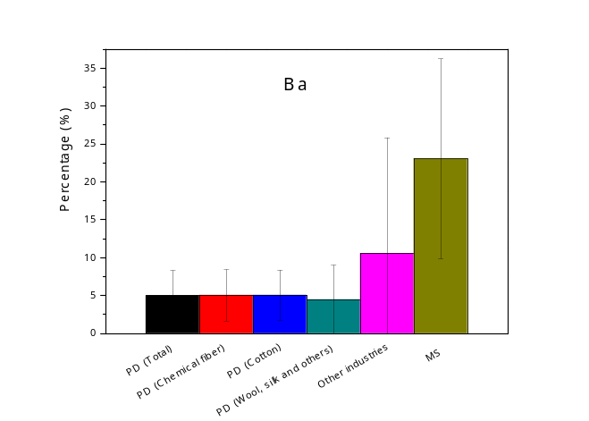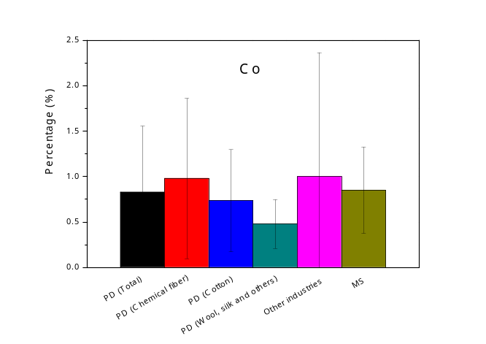
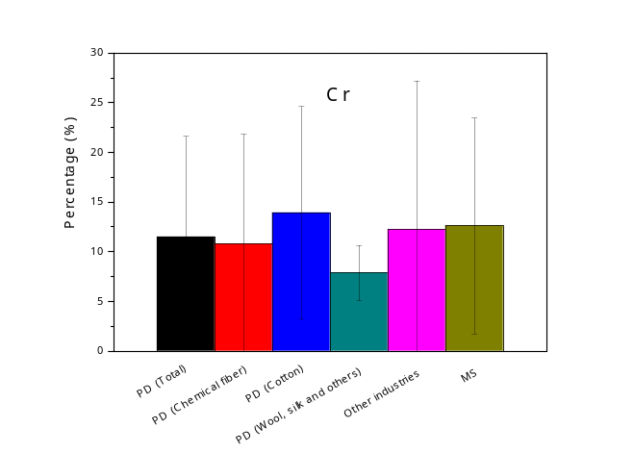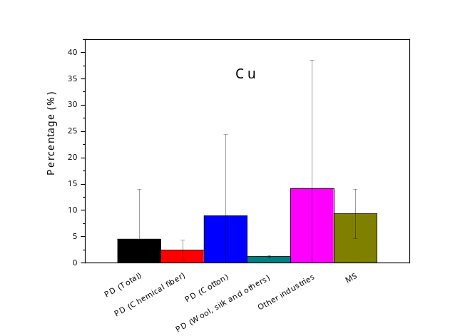
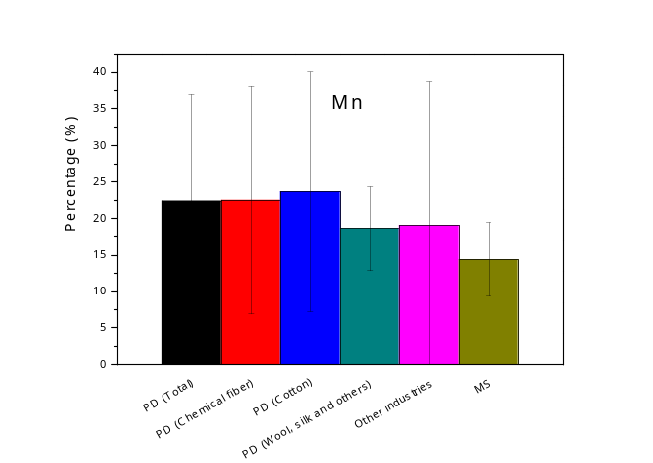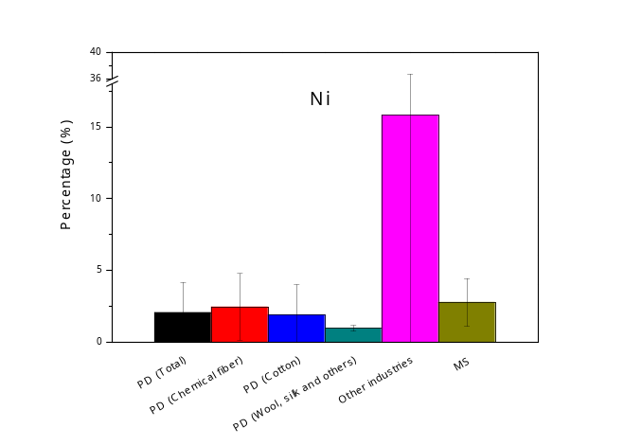
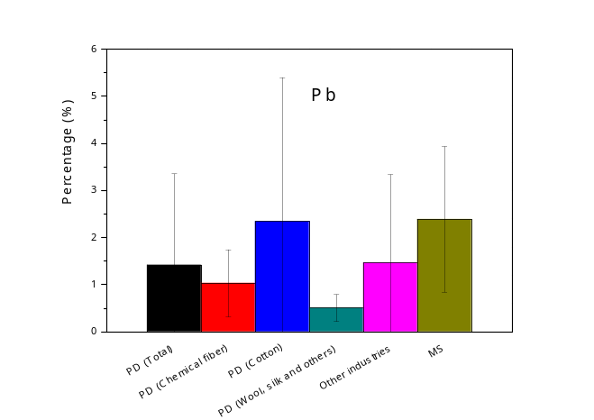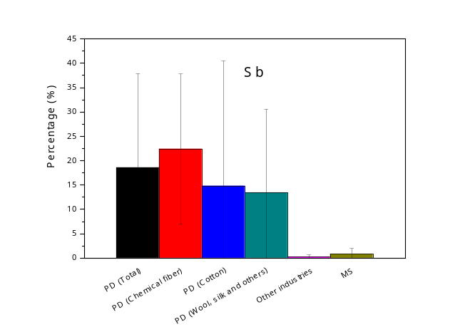
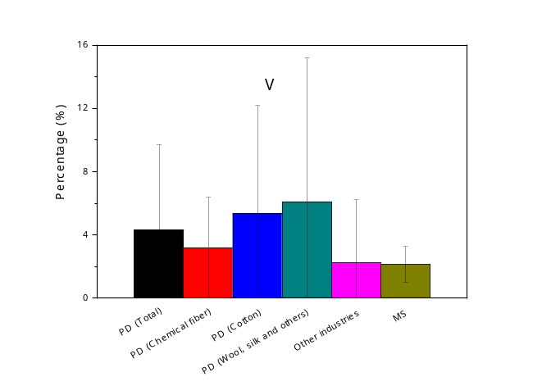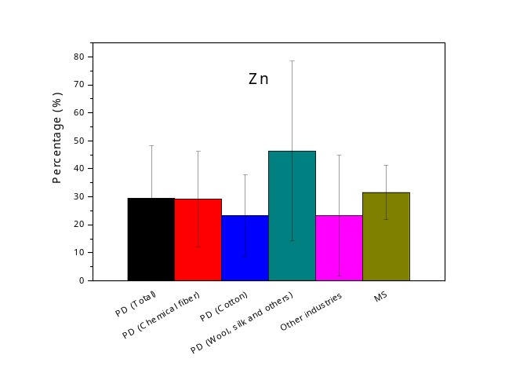
Fig. S1. Percentage of heavy metal contents in industrial and municipal sewage sludge. PD and MS represent printing and dyeing industry and municipal sewage treatment plant, respectively.
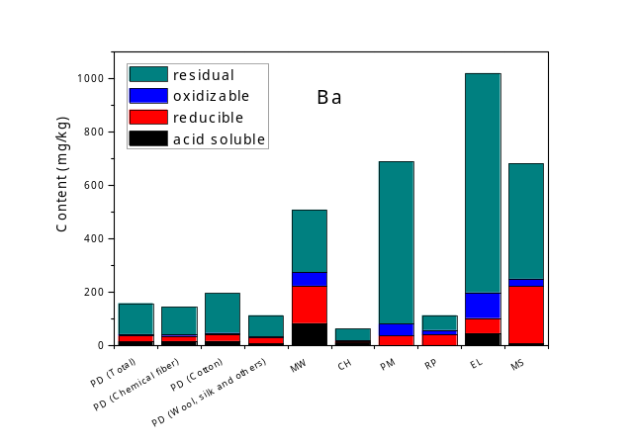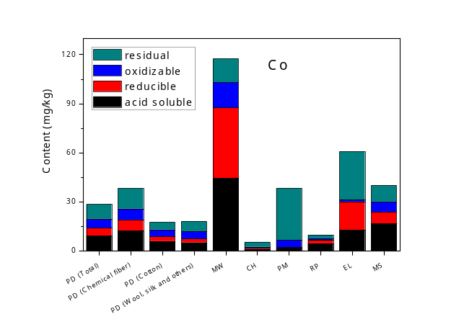
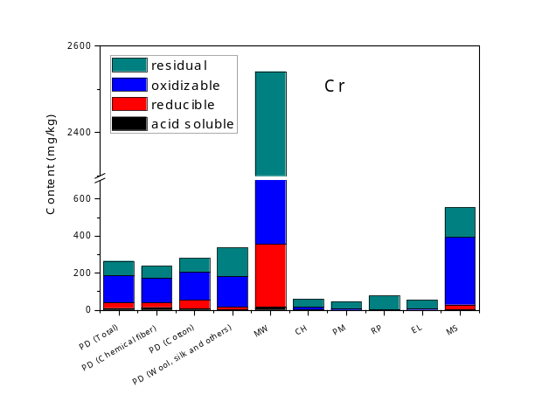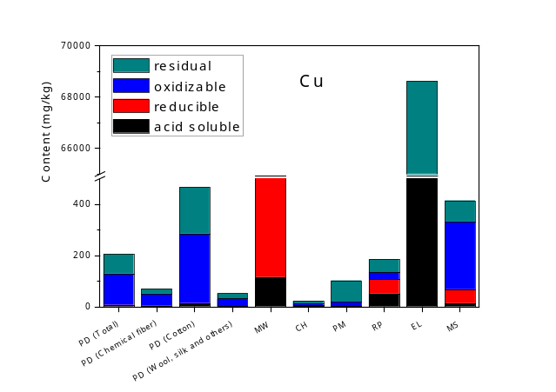
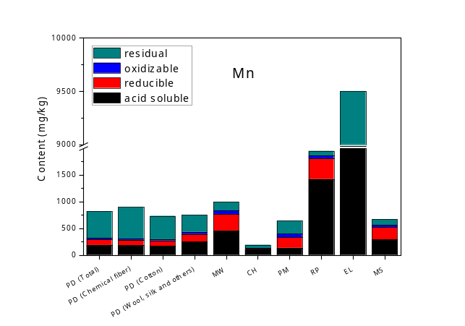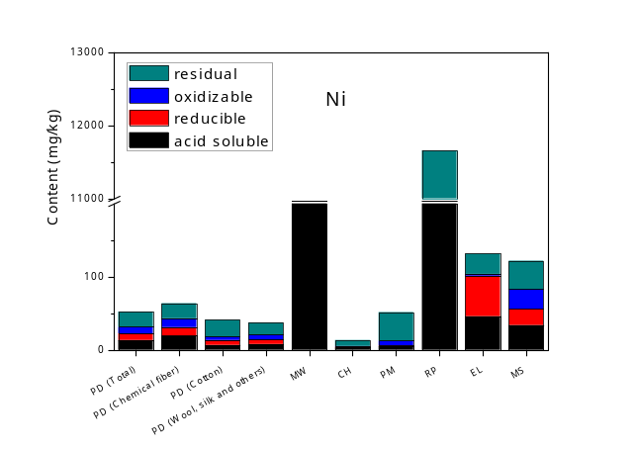
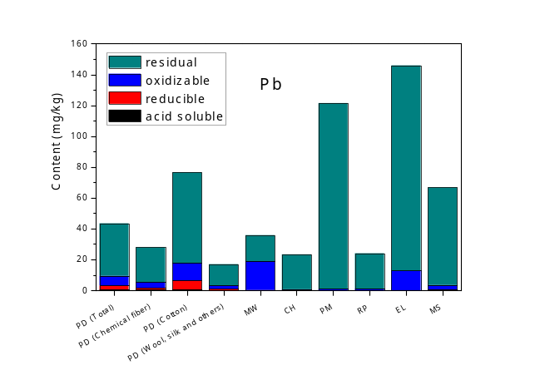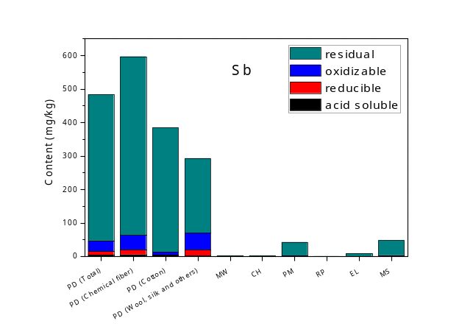
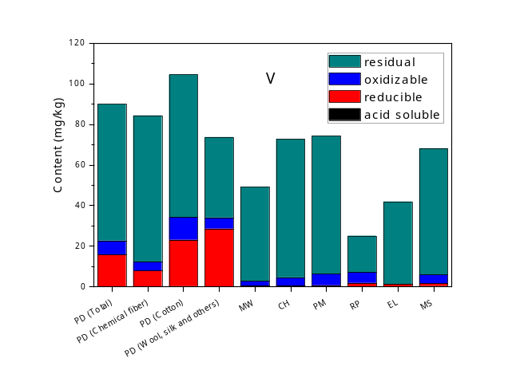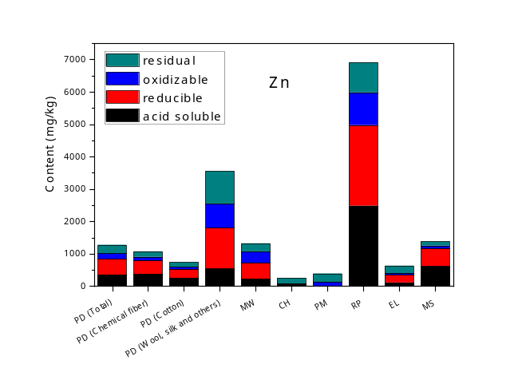
Fig. S2. Content of different forms of heavy metals in industrial and municipal sewage sludge. PD, MW, CH, PM, RP, EL and MS represent printing and dyeing industry, metalworking industry, chemical industry, papermaking industry, rubber and plastic industry, electron industry and municipal sewage treatment plant, respectively.

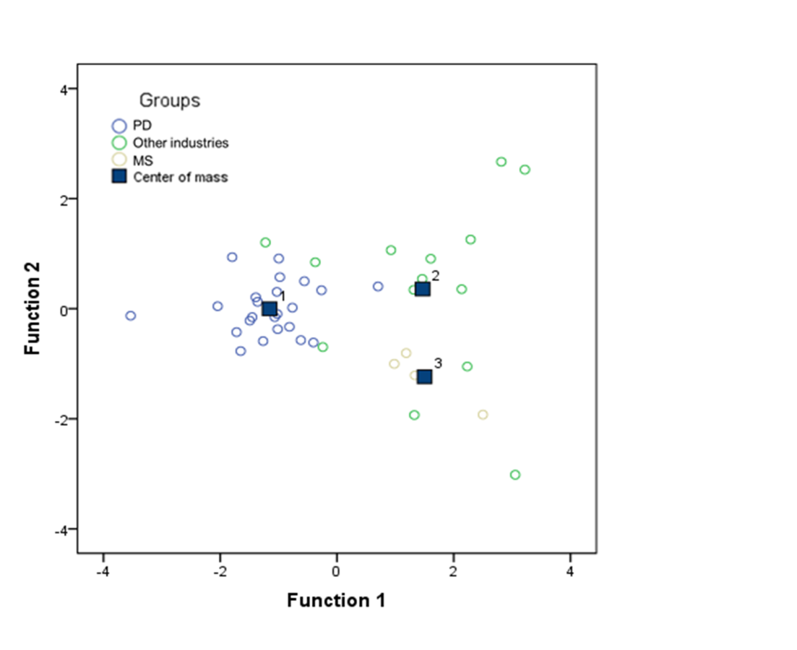
Fig. S3. Canonical discriminant functions of sewage sludge from PD, other industries and MS according to the data sets of percentages of heavy metal contents. PD and MS represent printing and dyeing industry and municipal sewage treatment plant, respectively.

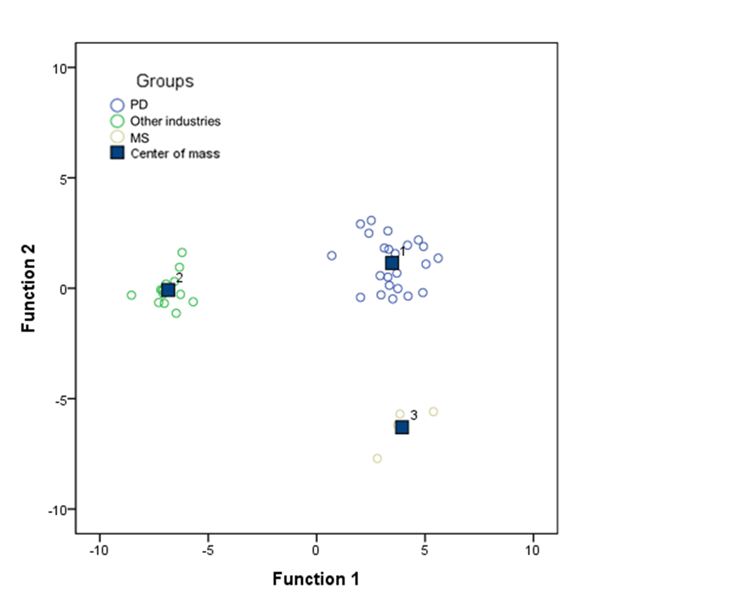
Fig. S4. Canonical discriminant functions of sewage sludge from PD, other industries and MS according to the data sets of percentages of heavy metal forms. PD and MS represent printing and dyeing industry and municipal sewage treatment plant, respectively.

