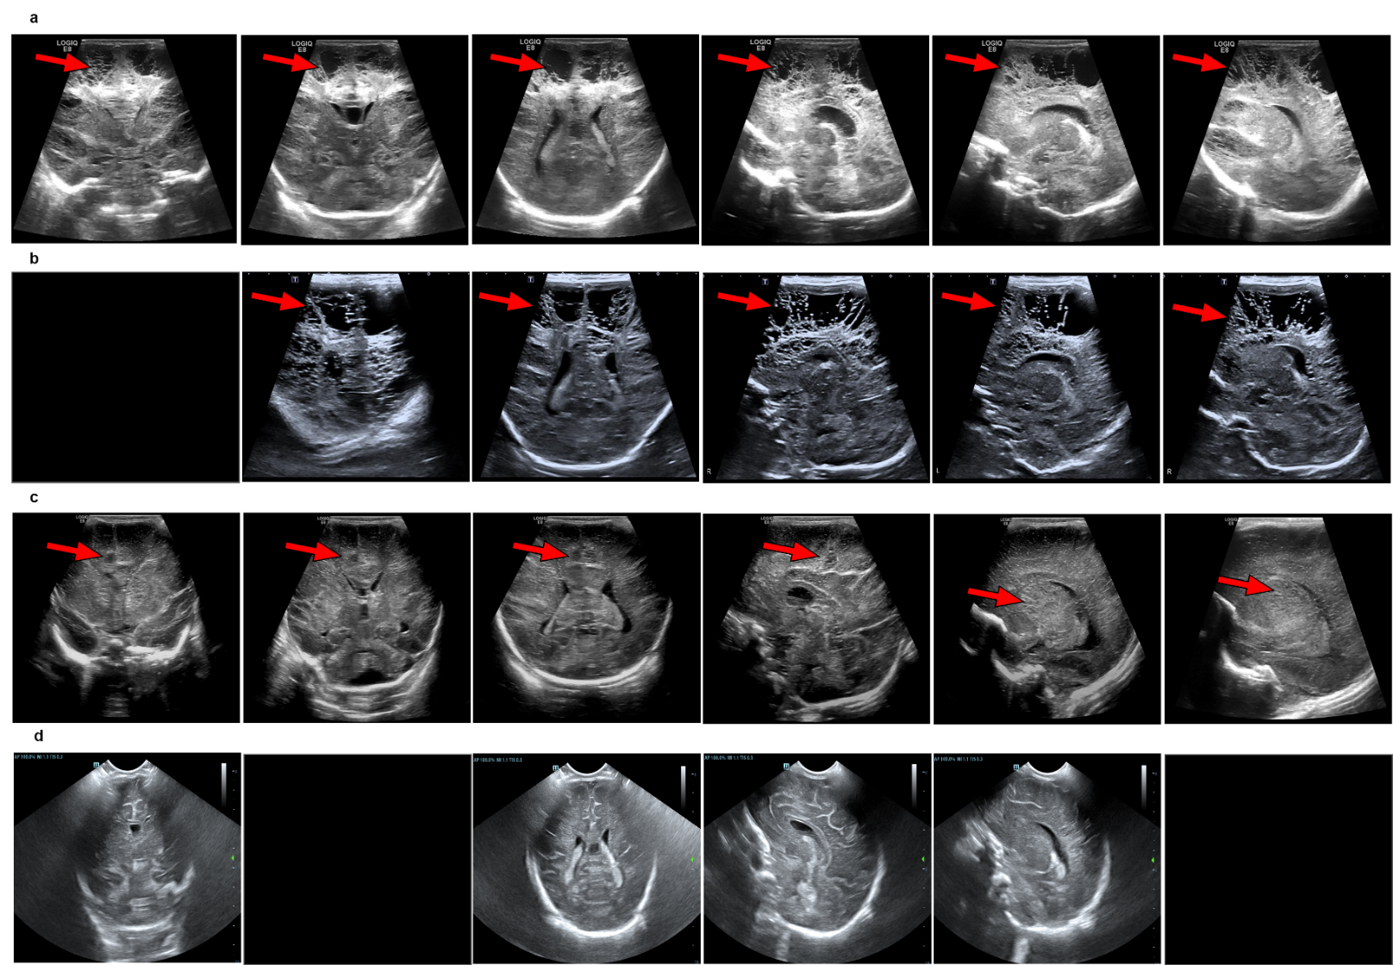
Extended Figure 1 | Extracted standard views of misdiagnosed cases in the internal and external test sets. All four cases were PVL, with red arrows highlighting the presence of cystic periventricular white matter. The images that appeared entirely black indicate the absence of standard views. In panel d, the cystic periventricular white matter was not discernible due to the lesion being located between frames of varying standard views, compounded by its small size.
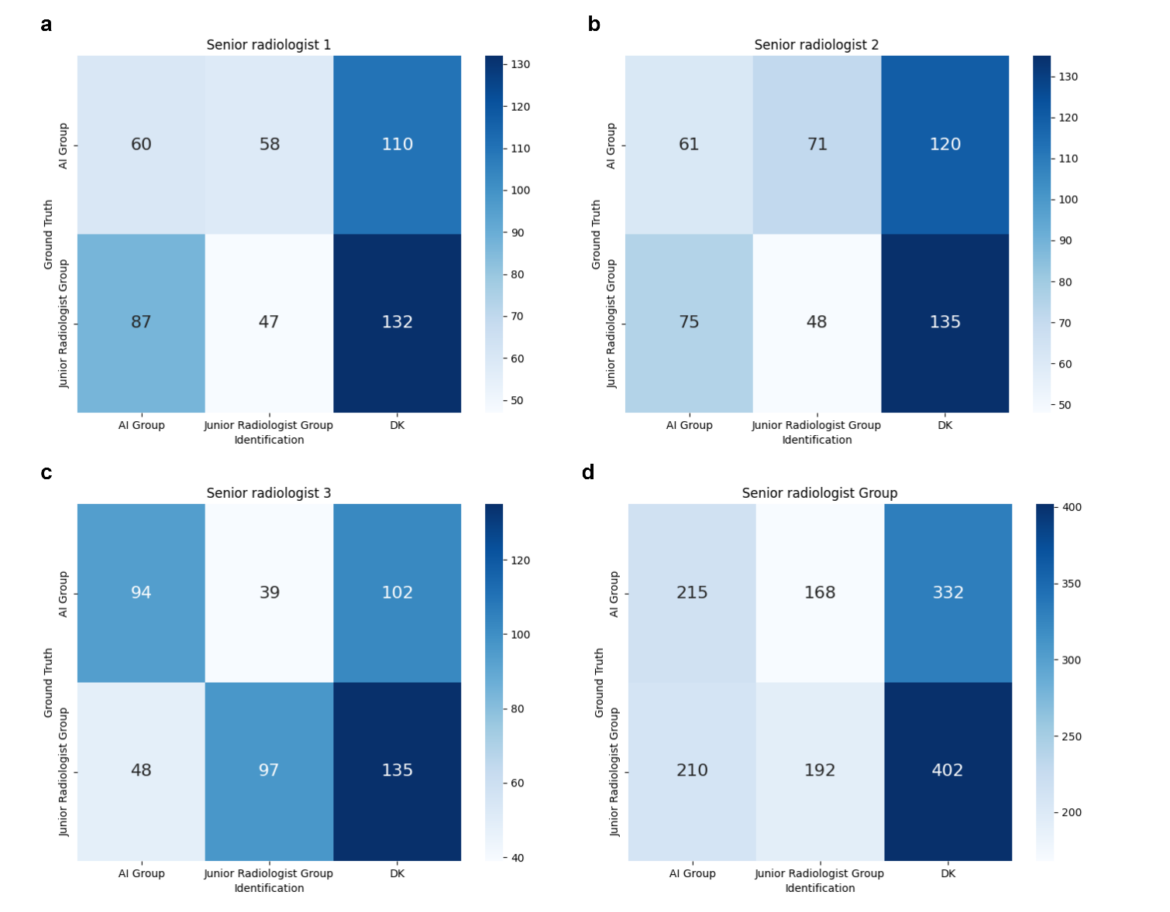
Extended Figure 2 | The metric of source identification. Figures a to d represent the source identification of three senior radiologists and the group of senior radiologists. 'Identification' refers to the senior radiologists' determination of whether the source originates from AI or junior doctors, while 'Ground truth' indicates the actual source of the data. DK, don’t know.
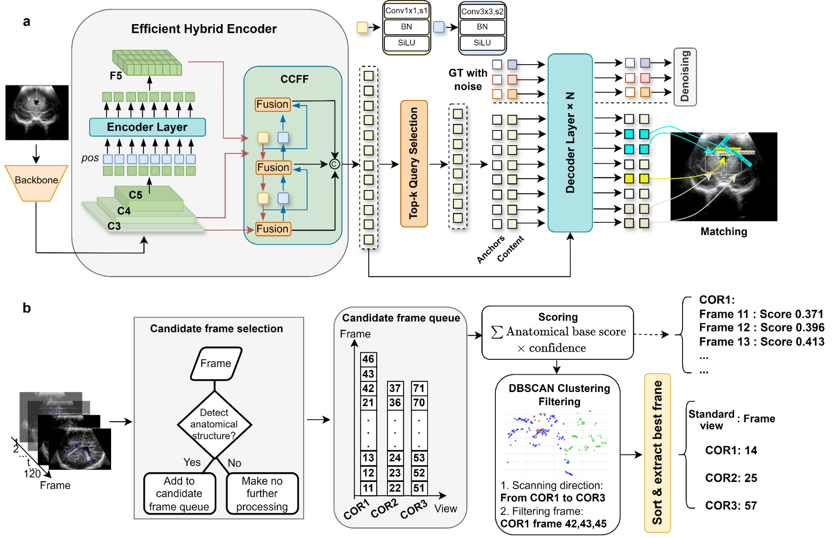
Extended Figure 3 | The workflow of the view extraction module. a, The architecture of the object detection model. b, The workflow of the candidate frame scoring algorithm. COR1, Coronal plane anterior horn of the lateral ventricle view; COR2, Coronal plane third ventricle view; COR3, Coronal plane body of the lateral ventricle view.
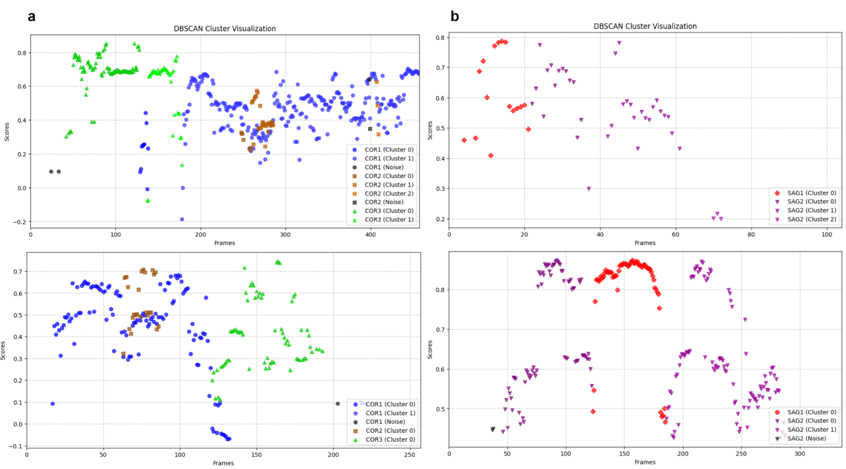
Extended Figure 4 | DBSCAN clusters in CUS videos. a. DBSCAN clusters in the coronal plane video. The brown cluster represents the cluster in the coronal plane slice of the lateral ventricle and third ventricle, while the green cluster represents the cluster in the body of the lateral ventricle. The direction of these two clusters helps determine the scanning direction of the ultrasound video, thereby eliminating the unnecessary clusters of the anterior horn of the lateral ventricle (blue). The images above and below show different scanning directions. b. DBSCAN clusters in the sagittal plane video. The red cluster represents the mid-sagittal plane, and the purple cluster represents the para-sagittal plane. If two purple clusters are located on either side of the red cluster, we can distinguish these two clusters as frames from the left or right parasagittal plane.
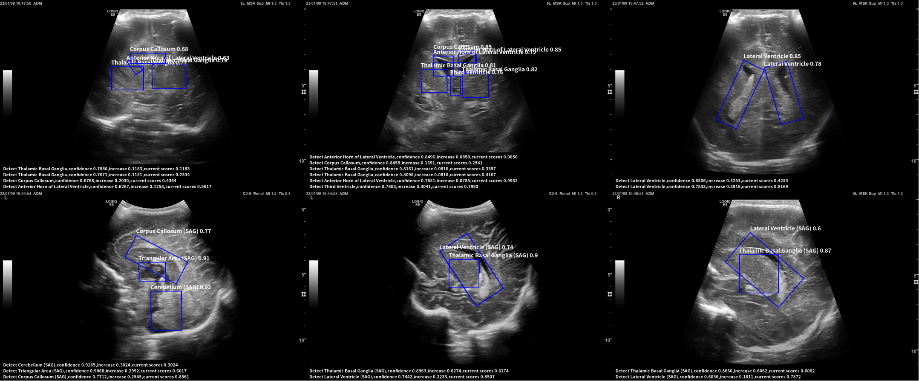
Extended Figure 5 | Anatomical structures detection and candidate frame scoring. The bounding box was predicted by the model, and the label and value corresponded to the anatomical structure predicted by the model and the confidence score. The text below described the process of candidate frame scoring.

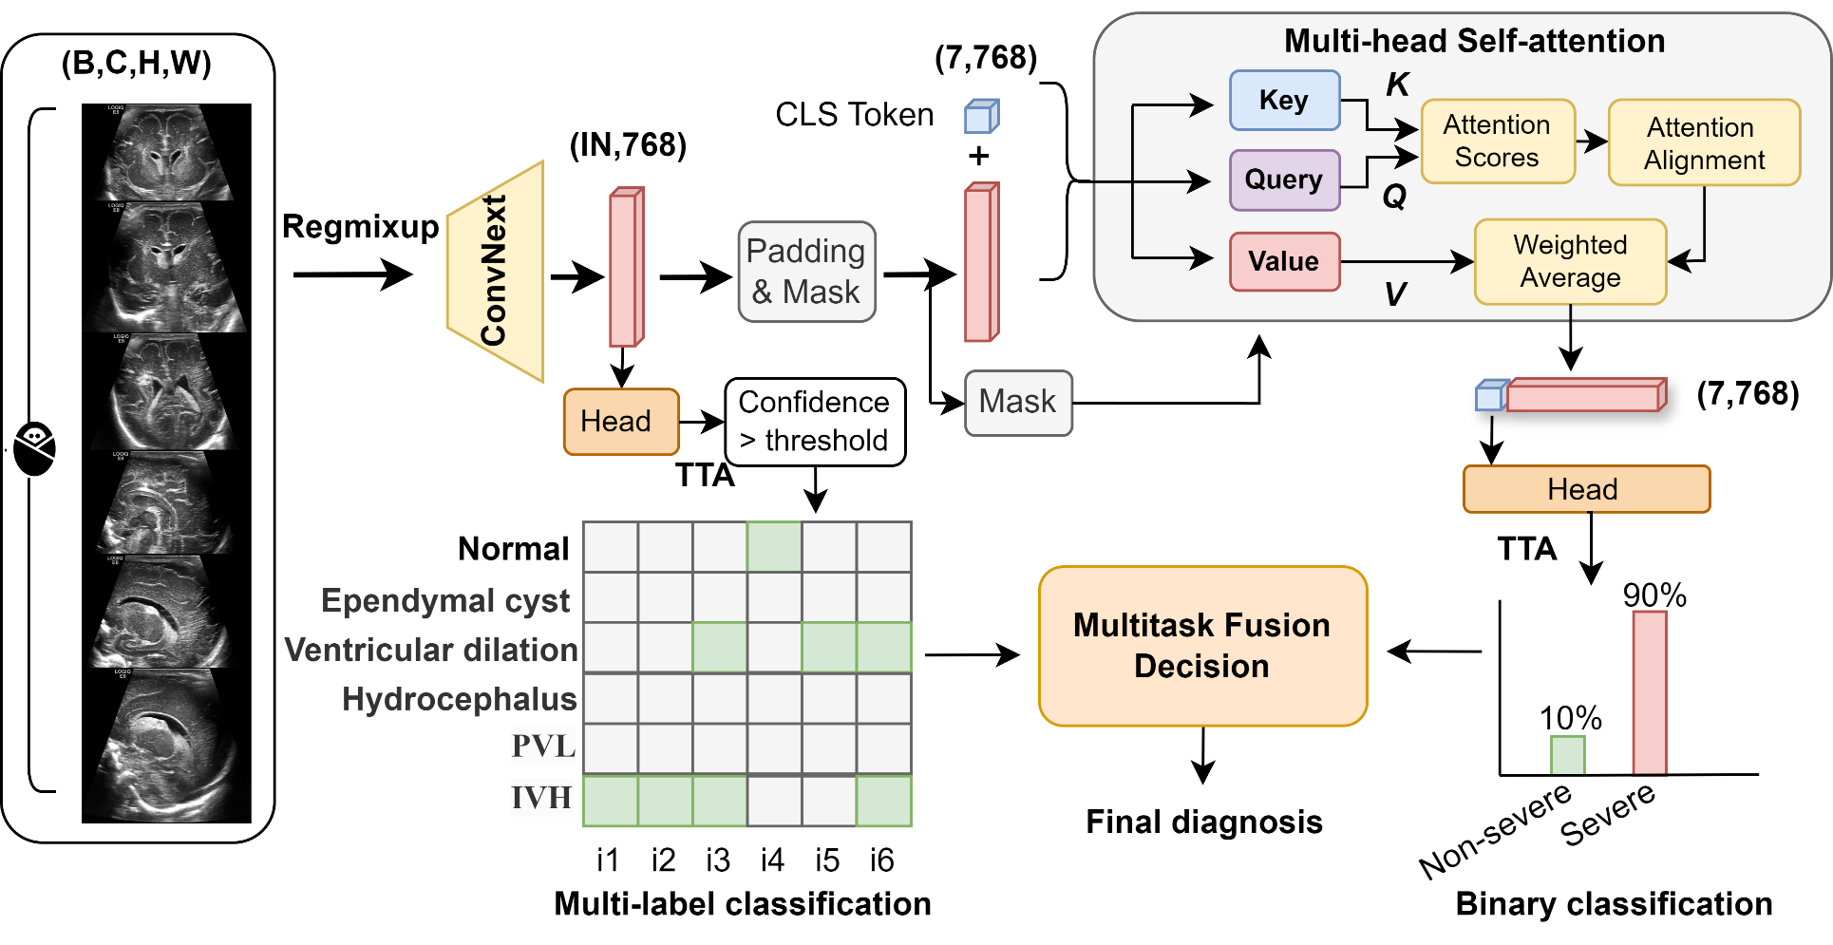
Extended Figure 6 | The architecture of the diagnostic model. IN, number of images; TTA, test time augmentation; i1 to i6, CUS image1 to CUS image6.

Extended Table 1 | Candidate frame scoring algorithm
Standard view | Candidate frame selection | Base score | Maximum appearance numbers
COR anterior horn view | Anterior horn of lateral ventricle | - Anterior horn of lateral ventricle: 0.2  - Corpus callosum: 0.3  - Thalamic basal ganglia: 0.15 | - Anterior horn of lateral ventricle:2  - Corpus callosum: 2  - Thalamus/vasal Ganglia: 1
COR third ventricle view | The third ventricle | - Third ventricle: 0.4  - Anterior horn of lateral ventricle: 0.1  - Corpus callosum: 0.3  - Thalamic basal ganglia: 0.1 | - Anterior horn of lateral ventricle: 2  - Corpus callosum: 2  - Thalamus/basal Ganglia: 1  - Third ventricle: 1
COR body view | Lateral ventricle | - Lateral ventricle: 0.5 | - Lateral ventricle: 2
SAG midsagittal view | Two from the corpus callosum, third ventricle, and cerebellum. | - Corpus callosum: 0.33  - Trigone of lateral ventricles: 0.33  - Cerebellum: 0.33 | - Corpus callosum: 1  - Trigone of lateral ventricles: 1  - Cerebellum: 1
SAG left parasagittal view | Lateral ventricle or thalamic basal ganglia | - Lateral ventricle: 0.3  - Thalamic basal ganglia: 0.7 | - Lateral ventricle: 1  - Thalamic basal ganglia: 1
SAG right parasagittal view |  | - Lateral ventricle: 0.3  - Thalamic basal ganglia: 0.7 | - Lateral ventricle: 1  - Thalamic basal ganglia:1
Each frame of a CUS video was processed by the object detection model and returned anatomical detection results. Candidate frame selection: If any of the anatomical structures were detected, the frame would be added to the candidate frame queue of the corresponding standard view. Base score: The total score of a frame was the sum of the base scores of all detected structures, multiplied by the corresponding prediction confidence. Maximum appearance number: To limit the situation that the same structure was detected multiple times and prevent inaccuracy scoring.

