Supplementary Information
Supplementary Tabel 1. Performance of mid-levle radiologists in internal test set. The metrics include sensitivity, specificity, Positive Predictive Value (PPV), and Negative Predictive Value (NPV), each represented as median (95% confidence interval), with the 95% CI calculated using the Clopper-Pearson method.

Supplementary Table 2. Performance of mid-level radiologist in external test set.

Supplementary Table 3. Comparison of junior radiologist group without and with AI assistance. The metrics include sensitivity, specificity and F1-score. The P-value between performance of junior radiologist without AI assistance and with AI assistance was calculated by paired chi-square test.

Supplementary Table 4. Performance of NCLS in Normal vs. Abnormal classification. Abnormal cases include ependymal cysts, ventricular dilatation, intraventricular hemorrhage of varying degrees, periventricular leukomalacia, and hydrocephalus. We classify normal and abnormal cases using multi-label classification in the diagnostic model.

Supplementary Table 5. Subgroup analysis of different probe type. The P-value between two probe type group was calculated by Mann-Whitney U test.

Supplementary Table 6. Subgroup analysis of different GA group. The P-value between three GA groups was calculated by Kruskal-Wallis H test followed by Dunn's Multiple Comparison Test.

Supplementary Table 7. The qualitative scoring of the extracted views by senior radiologists. The qualitative scoring includes four criteria: View correctness, Detection correctness, Anatomical structure recognition, and Clinical value. Each criterion is scored on a scale from 0 to 5. View correctness evaluates how well the AI-extracted view matches the optimal standard view. Detection correctness assesses the accuracy and completeness of the detected structures. Anatomical structure recognition evaluates whether the anatomical structures are clear and complete. Clinical value determines how well the extracted view supports clinical diagnosis.

Supplementary Figure 1. Distribution of Specific Conditions in the Dataset.

Supplementary Figure 2. Heatmap for certain cases.
Supplementary Table 1 | Performance of mid-levle radiologists in internal test set.
 | R1 |  | R2 |  | R3 |  | R4 |  | R5 |  | R6
 | Percentage  (95% CI) | n/N | Percentage  (95% CI) | n/N | Percentage  (95% CI) | n/N | Percentage  (95% CI) | n/N | Percentage  (95% CI) | n/N | Percentage  (95% CI) | n/N
SEN | 93.75  (69.77-99.84) | 15/16 | 75.00 (47.62-92.73) | 12/16 | 68.75 (41.34-88.98) | 11/16 | 100.00  (78.20-100.00) | 16/16 | 87.50 (61.65-98.45) | 14/16 | 100.00  (78.20-100.00) | 16/16
SPE | 98.91  (96.11-99.87) | 181/183 | 100.00% (98.00%-100.00%) | 183/183 | 100.00 (98.00-100.00) | 183/183 | 95.63 (91.57-98.09) | 175/183 | 98.36 (95.28-99.66) | 180/183 | 96.17 (92.28-98.45) | 176/184
PPV | 88.24  (63.56-98.54) | 15/17 | 100.00  (73.54-100.00) | 12/12 | 100.00  (71.51-100.00) | 11/11 | 66.67 (44.68-84.37) | 16/24 | 82.35  (56.57-96.20) | 14/17 | 69.57 (47.08-86.79) | 16/23
NPV | 99.45  (96.98-99.99) | 181/182 | 97.86 (94.61-99.41) | 183/187 | 97.34 (93.90-99.13) | 183/188 | 100.00  (97.91-100.00) | 175/175 | 98.90 (96.09-99.87) | 180/182 | 100.00  (97.93-100.00) | 176/176
 | R7 |  | R8 |  | R9 |  | R10 |  | R11
 | Percentage  (95% CI) | n/N | Percentage  (95% CI) | n/N | Percentage  (95% CI) | n/N | Percentage  (95% CI) | n/N | Percentage  (95% CI) | n/N
SEN | 68.75 (41.34-88.98) | 11/16 | 81.25 (54.35-95.95) | 13/16 | 75.00 (47.62-92.73) | 12/16 | 75.00 (47.62-92.73) | 12/16 | 68.75 (41.34-88.98) | 11/16
SPE | 100.00% (98.00%-100.00%) | 183/183 | 98.91 (96.11-99.87) | 181/183 | 98.91 (96.11-99.87) | 181/183 | 98.91 (96.11-99.87) | 181/183 | 99.45 (96.99-99.99) | 182/183
PPV | 100.00  (71.51-100.00) | 11/11 | 86.67  (59.54-98.34) | 13/15 | 85.71 (57.19-98.22) | 12/14 | 85.71  (57.19-98.22) | 12/14 | 91.67  (61.52-99.79) | 11/12
NPV | 97.34 (93.90-99.13) | 183/188 | 98.37 (95.31-99.66) | 181/184 | 97.84 (94.56-99.41) | 181/185 | 97.84 (94.56-99.41) | 181/185 | 97.33 (93.87-99.13) | 182/187
R, radiologist; SEN, sensitivity; SPE, specificity; PPV, positive predicted value; NPV, negative predicted value.

Supplementary Table 2 | Performance of mid-level radiologist in external test set.
 | R1 |  | R2 |  | R3 |  | R4 |  | R5 |  | R6
 | Percentage  (95% CI) | n/N | Percentage  (95% CI) | n/N | Percentage  (95% CI) | n/N | Percentage  (95% CI) | n/N | Percentage  (95% CI) | n/N | Percentage  (95% CI) | n/N
SEN | 88.46  (69.85-97.55) | 23/26 | 61.54  (40.57-79.77) | 16/26 | 38.46  (20.23-59.43) | 10/26 | 73.08  (52.21-88.43) | 19/26 | 57.69  (36.92-76.65) | 15/26 | 100.00  (86.77-100.00) | 26/26
SPE | 96.06 (93.36-97.89) | 317/330 | 100.00% (98.89%-100.00%) | 330/330 | 98.79 (96.93-99.67) | 326/330 | 93.64 (90.44-96.02) | 309/330 | 99.39 (97.83-99.93) | 328/330 | 93.94 (90.79-96.26) | 310/330
PPV | 63.89  (46.22-79.18) | 23/36 | 100.00  (79.41-100.00) | 16/16 | 71.43  (41.90-91.61) | 10/14 | 47.50  (31.51-63.87) | 19/40 | 88.24  (63.56-98.54) | 15/17 | 56.52  (41.11-71.07) | 26/46
NPV | 99.06  (97.28-99.81) | 317/320 | 97.06  (94.66-98.58) | 330/340 | 95.32  (92.51-97.30) | 326/342 | 97.78  (95.49-99.10) | 309/316 | 96.76  (94.27-98.37) | 328/339 | 100.00  (98.82-100.00) | 310/310
 | R7 |  | R8 |  | R9 |  | R10 |  | R11
 | Percentage  (95% CI) | n/N | Percentage  (95% CI) | n/N | Percentage  (95% CI) | n/N | Percentage  (95% CI) | n/N | Percentage  (95% CI) | n/N
SEN | 50.00  (29.93-70.07) | 13/26 | 61.54  (40.57-79.77) | 16/26 | 84.62  (65.13-95.64) | 22/26 | 80.77  (60.65-93.45) | 21/26 | 92.31  (74.87-99.05) | 24/26
SPE | 98.79 (96.93-99.67) | 326/330 | 99.70 (98.32-99.99) | 329/330 | 96.36 (93.73-98.11) | 318/330 | 98.48 (96.50-99.51) | 325/330 | 97.88 (95.68-99.14) | 323/330
PPV | 76.47  (50.10-93.19) | 13/17 | 94.12  (71.31-99.85) | 16/17 | 64.71  (46.49-80.25) | 22/34 | 80.77  (60.65-93.45) | 21/26 | 77.42  (58.90-90.41) | 24/31
NPV | 96.17  (93.53-97.94) | 326/339 | 97.05  (94.64-98.58) | 329/339 | 98.76  (96.85-99.66) | 318/322 | 98.48  (96.50-99.51) | 325/330 | 99.38  (97.79-99.93) | 323/325
R, radiologist; SEN, sensitivity; SPE, specificity; PPV, positive predicted value; NPV, negative predicted value.

Supplementary Table 3 | Comparison of junior radiologist group without and with AI assistance.
Datasets | Radiologist | SEN (%) |  | P-value | SPE (%) |  | P-value | F1-score (%)
Datasets | Radiologist | wo. AI | w. AI | P-value | wo. AI | w. AI | P-value | wo. AI | w. AI
Internal  test set | R1 | 100.00 | 100.00 | 1.000 | 84.15 | 87.43 | <0.001 | 52.46 | 58.18
Internal  test set | R2 | 75.00 | 93.75 | 0.250 | 84.15 | 89.62 | <0.001 | 42.11 | 60.00
Internal  test set | R3 | 100.00 | 100.00 | 1.000 | 85.79 | 91.26 | <0.001 | 55.17 | 66.67
Internal  test set | R4 | 93.75 | 100.00 | 1.000 | 75.41 | 74.32 | <0.001 | 39.47 | 40.51
Internal  test set | R5 | 93.75 | 100.00 | 1.000 | 93.99 | 89.62 | <0.001 | 71.43 | 62.75
Internal  test set | R6 | 93.75 | 87.50 | 1.000 | 48.63 | 92.35 | <0.001 | 24.00 | 63.64
Internal  test set | R7 | 81.25 | 100.00 | 1.000 | 96.72 | 92.35 | <0.001 | 74.29 | 69.57
Internal  test set | R8 | 62.50 | 93.75 | 0.375 | 98.91 | 91.80 | <0.001 | 71.43 | 65.22
Internal  test set | R9 | 87.50 | 100.00 | 1.000 | 98.36 | 95.63 | <0.001 | 84.85 | 80.00
Internal  test set | Avg. | 87.50 | 97.22 | - | 85.12 | 89.37 | - | 57.24 | 62.95
External test set | R1 | 84.62 | 92.31 | 0.019 | 94.24 | 93.03 | <0.001 | 65.67 | 65.75
External test set | R2 | 15.38 | 80.77 | 0.555 | 98.18 | 95.45 | <0.001 | 22.22 | 67.74
External test set | R3 | 76.92 | 84.62 | 0.001 | 96.67 | 93.64 | <0.001 | 70.18 | 63.77
External test set | R4 | 76.92 | 96.15 | 0.231 | 80.61 | 78.18 | <0.001 | 36.36 | 40.65
External test set | R5 | 88.46 | 92.31 | 0.009 | 95.15 | 92.12 | <0.001 | 70.77 | 63.16
External test set | R6 | 92.31 | 84.62 | 0.289 | 82.12 | 92.73 | <0.001 | 41.12 | 64.86
External test set | R7 | 88.46 | 96.15 | 0.115 | 92.42 | 92.12 | <0.001 | 62.16 | 64.94
External test set | R8 | 42.31 | 92.31 | 0.492 | 94.55 | 88.18 | <0.001 | 40.00 | 53.93
External test set | R9 | 88.46 | 92.31 | 0.009 | 97.27 | 95.76 | <0.001 | 79.31 | 75.00
External test set | Avg. | 71.79 | 91.03 | - | 92.36 | 91.25 | - | 54.20 | 62.20
R, radiologist; SEN, sensitivity; SPE, specificity;

Supplementary Table 4 | Performance of NCLS in Normal vs. Abnormal classification.
Dataset | SEN  (Percentage,95%CI) | n/N | SPE  (Percentage,95%CI) | n/N | PPV  (Percentage,95%CI) | n/N | NPV  (Percentage,95%CI) | n/N | F1 score
Development test set | 70.5  (59.8 – 79.7) | 62/88 | 96.9  (93.7 – 98.7) | 217/224 | 89.9  (80.2 – 95.8) | 62/69 | 89.3  (84.7 – 92.9) | 217/243 | 79.0
Internal test set | 31.6  (22.6 – 41.8) | 31/98 | 95.0  (88.8 – 98.4) | 96/101 | 86.1  (70.5 – 95.3) | 31/36 | 58.9  (50.9 – 66.5) | 96/163 | 46.3
External test set | 44.7  (35.4 – 54.3) | 51/114 | 97.9  (95.2 – 99.3) | 237/242 | 91.1  (80.4 – 99.3) | 51/56 | 79.0  (73.9 – 83.5) | 237/300 | 60.0
SEN, sensitivity; SPE, specificity; PPV, positive predicted value; NPV, negative predicted value.

Supplementary Table 5 | Subgroup analysis of different probe type.
Dataset | Probe type | SEN |  | SPE |  | F1-score
Dataset | Probe type | (Percentage,95%CI) | P-value | (Percentage,95%CI) | P-value | Percentage
Internal test set | Linear | 0.933(0.681-0.998) | <0.001 | 0.925(0.875-0.959) | 0.140 | 0.667
Internal test set | Curve | 0.000(0.000-1.000) | <0.001 | 0.900(0.555-0.998) | 0.140 | 0.000
External test set | Linear | 0.938(0.698-0.998) | 0.006 | 0.885(0.828-0.928) | <0.001 | 0.588
External test set | Curve | 0.900(0.555-0.998) | 0.006 | 0.981(0.945-0.996) | <0.001 | 0.818
SEN, sensitivity; SPE, specificity

Supplementary Table 6 | Subgroup analysis of different GA group.
Dataset | Parameter  (Percentage,  95%CI) | Full-term | Preterm | Very preterm | P-value  (Full-term  vs. Preterm) | P-value  (Full-term  vs. Very preterm) | P-value  (Preterm  vs. Very preterm)
Internal test set | SEN | 1.000  (0.158-1.000) | 0.600  (0.146-0.947) | 1.000  (0.664-1.000) | <0.001 | 0.441 | <0.001
Internal test set | SPE | 0.988  (0.936-0.999) | 0.921  (0.811-0.978) | 0.781  (0.624-0.894) | <0.001 | <0.001 | <0.001
Internal test set | F1-Score  (Percentage) | 0.800 | 0.500 | 0.667 | - | - | -
External test set | SEN | 1.000  (0.158-1.000) | 0.500  (0.013-0.987) | 0.933  (0.681-0.998) | <0.001 | 0.022 | <0.001
External test set | SPE | 0.989  (0.959-0.999) | 0.964  (0.911-0.990) | 0.559  (0.379-0.728) | <0.001 | <0.001 | <0.001
External test set | F1-Score  (Percentage) | 0.667 | 0.286 | 0.636 | - | - | -
SEN, sensitivity; SPE, specificity

Supplementary Table 7 | The qualitative scoring of the extracted views by senior radiologists.
Score | 0(Completely wrong) | 1(Mostly incorrect) | 2(Minor errors) | 3(Partially correct) | 4(Mostly correct) | 5(Completely correct)
View correctness | Completely incorrect; none of the extracted frames correspond to a standard plane. | Mostly incorrect; only 1-2 extracted frames match a standard plane, and none are close to the optimal frame. | Partially incorrect; only 3-4 extracted frames match a standard plane, but none are close to the optimal frame. | Mostly correct; all extracted frames correspond to the standard plane, but none are the optimal frame. | Nearly correct; the extracted frames are almost optimal, with only slight angular or positional deviation from the ideal standard plane. | Completely correct; the extracted frame is the optimal frame from the entire CUS video and matches the predefined standard plane perfectly.
Detection correctness
  Completely wrong detection; no relevant structures detected, severe omissions.
  Mostly incorrect, with only a few anatomical structures correctly detected and multiple key structures missed.
  partially correct, but key anatomical structures are either incorrect or inaccurate, with obvious omissions.
  Most of the detection boxes are correct, but a few anatomical structures are incorrect, and there are minor omissions of secondary structures.
  The detection box is mostly accurate, with only minor errors in a few anatomical structures and few omissions.
  The detection box is completely accurate, with all anatomical structures correctly detected and no omissions.
Anatomical structure recognition
  Anatomical structures are unclear or incorrect, and no important anatomical structures can be identified.
  Most anatomical structures are unclear or incorrect, with only a few parts being recognizable.
  Some anatomical structures are clear, but the main structures are inaccurate, with significant identification issues.
  Most anatomical structures are accurate, but a few structures are unclear or not well-identified.
  Anatomical structures are mostly clear, with only a few minor structures being blurry or with lost details.
  Anatomical structures are completely clear and accurate, with all structures correct and details clearly visible.
Clinical value
  The standard view provides no clinical diagnostic support, and the lesion area is completely invisible or unclear, making any judgment impossible.
  The standard view offers very limited diagnostic support, with the lesion area difficult to identify, and the information is insufficient to aid clinical decision-making.
  The standard view has limited diagnostic value, but the main structures or lesion area remain unclear, making it difficult to draw a definitive conclusion.
  The standard view provides good diagnostic support, but there are some blurry structures or lesion areas, and additional images are needed for further analysis.
  The standard view is very helpful for diagnosis, with the lesion area mostly clear, but with some minor details blurred; it can effectively support clinical decision-making.
  The standard view fully supports clinical diagnosis, with all anatomical structures and lesion areas clearly displayed, requiring no additional images for supplementation.

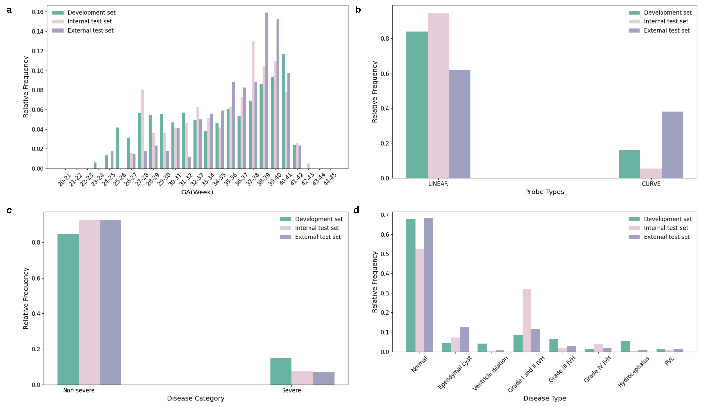
Supplementary Figure 1 | Distribution of Specific Conditions in the Dataset. a, Proportion of each condition within the development, internal, and external test sets. "Clinical diagnosis" indicates the proportion of non-severe and severe cases, with grade III and IV IVH, hydrocephalus, and PVL classified as severe cases. b, Distribution of specific conditions within subgroups. The pie charts display the number and proportion of each condition within the full-term, preterm, and very preterm groups. The bar chart illustrates the count of severe and non-severe cases in both the linear probe group and the convex probe group (severe cases are shown in green and non-severe cases are shown in red; Linear probe group has a higher probe frequency); The violin plot shows the proportion of intervention and non-intervention cases across different gestational ages (non-severe cases in green and severe cases in red).

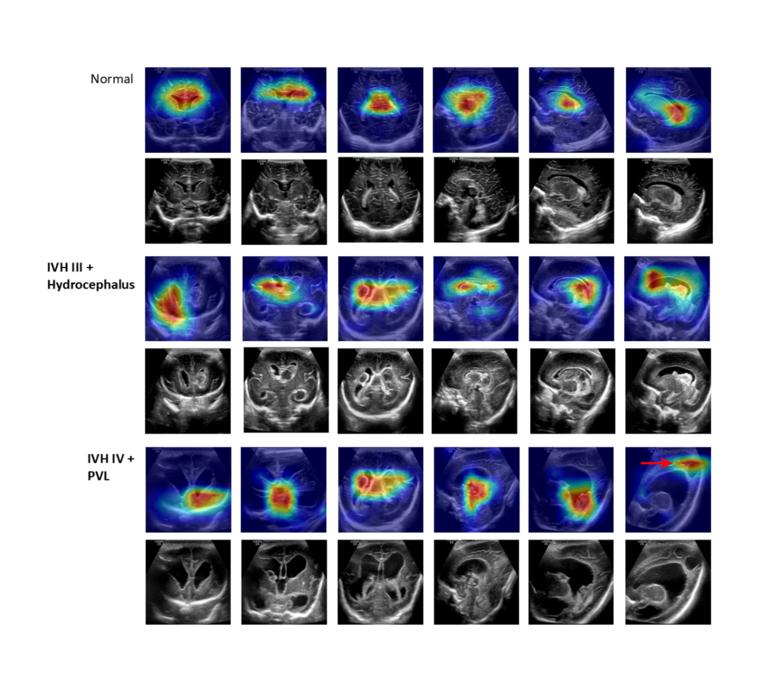
Supplementary Figure 2 | Heatmap for certain cases. We used grad-cam to obtain gradient heatmap. In all standard views, the model correctly focused on key clinical areas of interest, such as the anterior horns, the third ventricle, the body of the lateral ventricles and the choroid plexus. In a case with grade III IVH and hydrocephalus, the model accurately identified blood clots in the body of the lateral ventricles, as well as thickening of the choroid plexus, which corresponds with clinical diagnostic criteria. In a case with grade IV IVH, the model accurately captured the liquefaction of the hemorrhagic in the top-posterior region (indicated by the red arrow). These heatmaps of attention points are consistent with the information needed during clinical cranial ultrasound screening.

