Supplementary Information
Supplementary Figure 1: Overview of ovarian TMA dataset, including MxIF and H&E-stained sections.
Supplementary Figure 2: Example of manually annotated landmarks in TMA cores for establishing ground truth transformations.
Supplementary Figure 3: Examples of segmentation discrepancies between H&E and MxIF.
Supplementary Figure 4: Results of CPD-based alignment extended with "super-cell" clustering for whole-slide images.

Supplementary Figures:
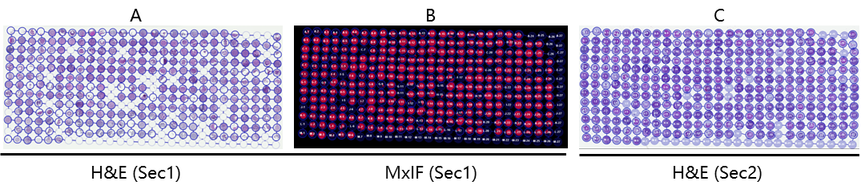
Supplementary Figure 1. Ovarian TMA dataset used in this study. A) and B) were a tissue section (Section 1) stained with MxIF protocol and then restained with H&E. C) was H&E stain of a serial section (Section 2) 5 µm apart from section 1.

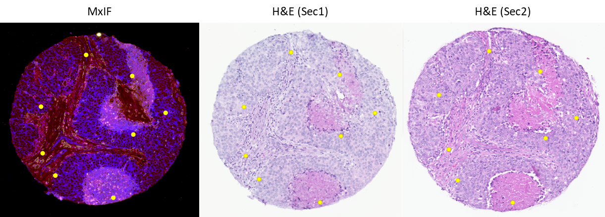
Supplementary Figure 2. TMA core with manually labeled landmarks (eight points annotations). Each yellow dot was a landmark manually label for establishing ground truth transformation. The size of the landmarks was enlarged for better visualization. The actual resolution of landmarks equals to the pixel size of the image.

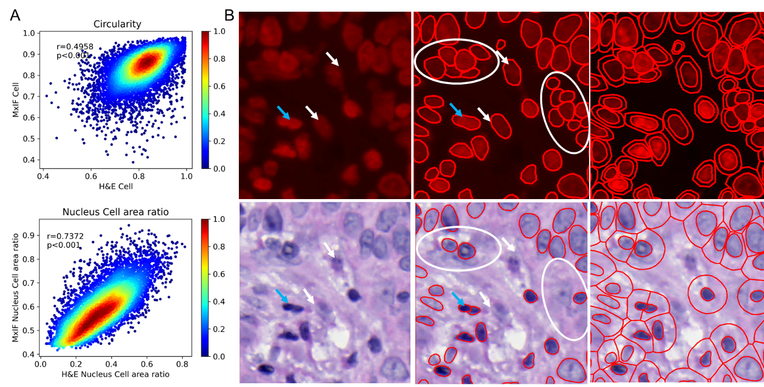
Supplementary Figure 3. Cell morphology differences caused by segmentation discrepancies. A) concordance of cell morphology features; B) segmentation differences within MxIF and H&E.

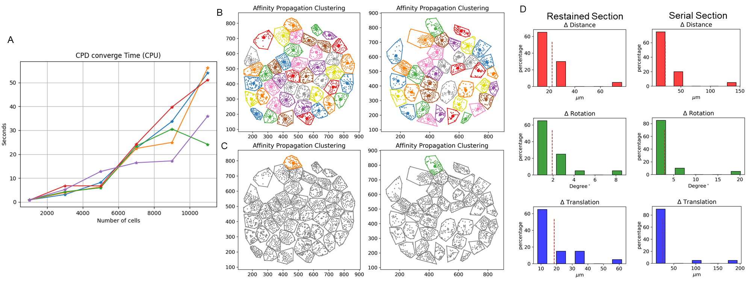
Supplementary Figure 4. A) Time efficiency of CPD. Each curve is an instance of simulation. B) Cell clustering results for a MxIF (left) and H&E (right) core. C) Clustering results with a pair of matched cell clusters. D) Quantitative evaluation results for restained and serial sections using “super-cell” as initialization.

