Supplementary Materials

Distribution of Ecological Momentary Assessment (EMA) Responses
Participants in the OPTIMA study were significantly different from the population sampled using MTurk in terms of sex at birth (chi-squared 57.24; Bonferonni adjusted p-value = 1.5e-13), age (mean difference = 3.49 years, Bonferonni adjusted p-value = 1.12e-06), PHQ-8 total score (mean difference 5.68, Bonferonni adjusted p-value = 6.11e-30), and PVSS total score (mean difference = 0.89, Bonferonni adjusted p-value = 2.12e-16). This finding demonstrated that, compared with the population in the MTurk dataset, the OPTIMA study population included participants who were significantly younger, more depressed, more anhedonic, and with more females (Fig. S1 A).
Additionally, we see significant differences in the distributions for responses to 7 of 9 affect EMA items and 4 of 6 reward EMA items. These differences are shown in Figures S1 B-C and Table S1.

Table S1 EMA response means in the OPTIMA study versus the population sample from Amazon MTurk. P-values from Wilcoxon rank-sum test between OPTIMA and MTurk means adjusted with Bonferroni method FWER < 0.05. * added if adjusted p-value < 0.05
EMA item | OPTIMA mean | MTurk mean | Mean difference | Adjusted p-value
Reward (1-5)
sad | 1.784 | 1.837 | -0.054 | 1.00E+00
stressed*** | 2.427 | 2.078 | 0.348 | 2.01E-08
anxious*** | 2.335 | 1.951 | 0.384 | 6.09E-10
annoyed** | 1.827 | 1.731 | 0.095 | 4.42E-03
energetic*** | 2.114 | 2.839 | -0.725 | 3.57E-18
happy*** | 2.127 | 3.010 | -0.883 | 1.00E-23
motivated*** | 2.198 | 3.310 | -1.112 | 7.28E-40
engaged*** | 2.382 | 3.575 | -1.193 | 2.39E-44
Lonely | 1.776 | 2.010 | -0.234 | 1.00E+00
Affect (0-1)
anticipatory*** | 0.480 | 0.735 | -0.255 | 4.11E-11
consummatory*** | 0.427 | 0.715 | -0.289 | 2.07E-14
effort*** | 0.302 | 0.639 | -0.336 | 8.55E-17
inactive enjoy | 0.169 | 0.265 | -0.096 | 6.89E-02
inactive effort | 0.253 | 0.346 | -0.093 | 1.55E-01
meaning*** | 0.359 | 0.715 | -0.356 | 2.25E-19
Figure S1 Distribution of demographics, depression severity, anhedonia, and EMA responses between OPTIMA and a population sample collected on Amazon MTurk. A) Sex at birth, age, PHQ-8 score (depression severity, directly comparable to PHQ-14 total score), PVSS (anhedonia; lower means more anhedonia). All measures significantly difference at p < 0.001 between groups. B) Bar plot comparing affect EMA item response and C) reward EMA responses. Significant differences between items in B and C annotated if p < 0.05 after Bonferroni adjustment with FWER < 0.05. Annotation legend: * < 0.05, ** < 0.01, *** < 0.001.

Sensitivity to Missing Data
To assess the impact of missing data, model performance was evaluated on both the full sample (including EMA responses missing more than 10 of the 29 passive sensing features) and a subset containing only responses missing fewer than 10 features (n=2716, 56.6% of EMA sessions in the holdout test set). Results indicate significant differences in performance based on data availability. For the ‘anxious’ and ‘energetic’ EMA items, which perform above random chance, models performed significantly better on the full sample than on the subset with fewer missing features, suggesting that the highly missing features are not essential for these predictions. In contrast, model performance for the ‘consummatory,’ ‘sad,’ ‘inactive enjoy,’ ‘anticipatory,’ and ‘meaning’ EMA items was higher in the subset with less missing data, indicating that data completeness may enhance prediction accuracy for these outcomes. The full results of the sensitivity analysis are summarized in Table S2. The findings may be explained in part by the fact that models whose performance degrades, such as the model detecting sad EMA, rely on features that are sampled less frequently, such as HRV (see Figure S2).
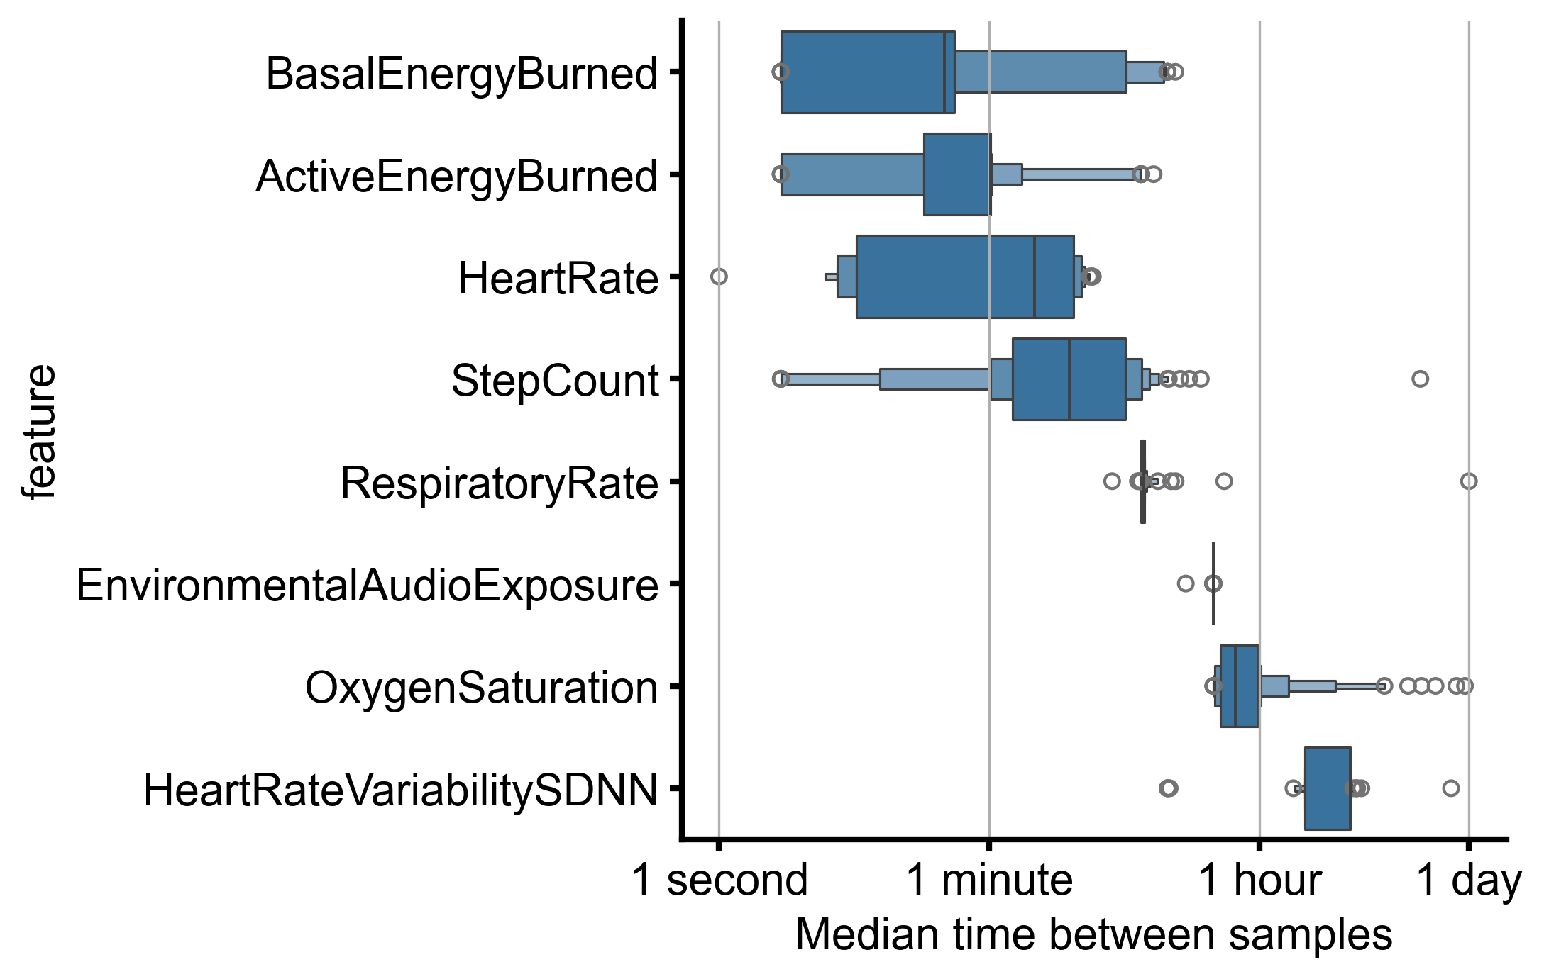
Figure S2 Median time between samples of a feature per user. Boxen plot shows distribution across participants. X-axis is logarithmically scaled.

Table S2 Difference in performance of models detecting EMA item response in the test set on either the full test set, or a subset of responses with fewer than 10 of 29 features missing. Bold values indicate FWER adjusted p-value < 0.05 for difference and the full sample model performed greater than random chance (AUROC > 0.5 and adjusted p-value < 0.05).
EMA Item | Features | Window | Mean AUROC |  | AUROC Difference | Adjusted P-value
 |  |  | Full Test Set | Missing < 10 features
anxious | momentary | 2h | 0.545 | 0.510 | 0.035 | 1.59E-26
consummatory | with sleep | 2h | 0.543 | 0.559 | -0.016 | 9.04E-17
sad | momentary | 3h | 0.572 | 0.584 | -0.012 | 1.18E-11
inactive enjoy | with sleep | 2h | 0.551 | 0.563 | -0.012 | 5.13E-10
anticipatory | momentary | 2h | 0.549 | 0.557 | -0.008 | 1.68E-04
meaning | with sleep | 2h | 0.532 | 0.539 | -0.007 | 2.88E-04
energetic | with sleep | 3h | 0.586 | 0.580 | 0.006 | 1.54E-02
annoyed | momentary | 2h | 0.540 | 0.536 | 0.005 | 5.13E-02
motivated | with sleep | 3h | 0.567 | 0.562 | 0.005 | 1.53E-01
stressed | with sleep | 1h | 0.554 | 0.556 | -0.002 | 1.00E+00
inactive effort | with sleep | 2h | 0.550 | 0.551 | -0.001 | 1.00E+00

Feature Importance
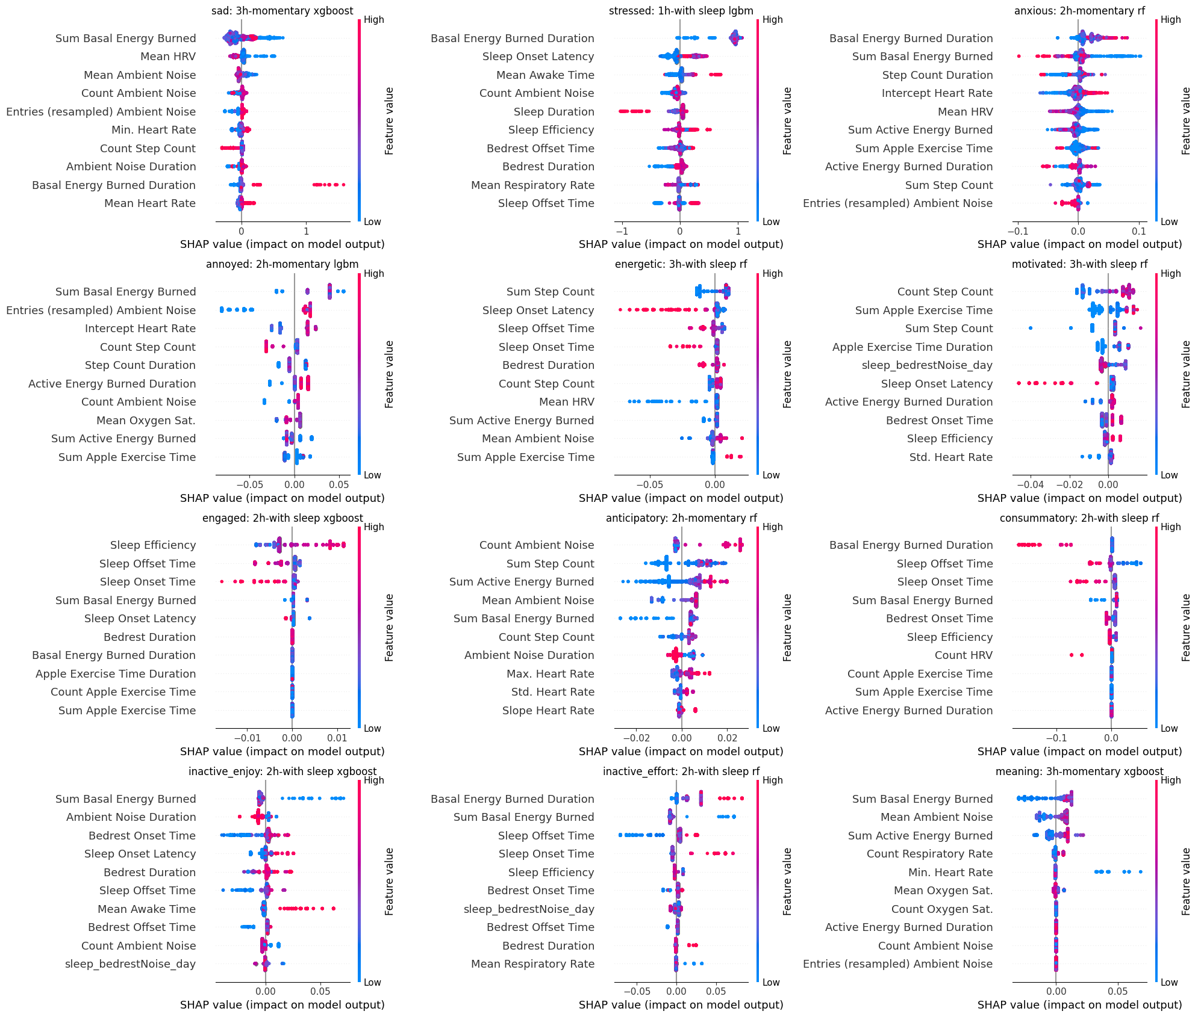
Figure S3 Feature importance via SHAP value for models EMA item endorsement. Each dot represents a prediction within the held out test set. Color indicates relative feature value (e.g, higher mean heart rate is red, lower mean heart rates is blue). SHAP value indicates how influential a feature was to a single prediction. The sign (positive or negative) of the SHAP value denote whether importance was for classifying as negative or positive class (low vs high class). Magnitude of the SHAP value indicates its importance to the model for a prediction.

