Supplementary Figure 1. Proportions on ART and viral suppression rates over time by phenotype.

Supplementary Figure 2. Longitudinal trajectories for participants with viral suppression (left) and all participants (right).

Supplementary Tables and Figures

Supplementary Table 1

Supplementary Table 1. Baseline neurocognitive performance, self-reported cognitive symptoms (PAOFI), and dependence in instrumental activities of daily living (IADLs).
 |  | Phenotype 1 | Phenotype 2 | Phenotype 3 | Phenotype 4 | p | Pairwisec
Characteristics |  | (n=231) | (n=108) | (n=97) | (n=70)
Cognition
Global scaled score |  | 9.6 (1.69) | 8.01 (1.66) | 9 (1.76) | 7.27 (1.61) | <.001 | 1>2, 3, 4
Neurocognitive global deficit scorea |  | 0.25 (0.26) | 0.59 (0.44) | 0.32 (0.33) | 0.96 (0.59) | <.001 | 2, 4>1
Global T-score |  | 49.7 (4.96) | 44.6 (5.26) | 48.4 (5.17) | 40.4 (5) | <.001 | 1>2, 3, 4
Cognitive impairment |  | 41 (17.8%) | 51 (47.2%) | 23 (23.7%) | 55 (78.6%) | <.001 | 1>2, 4
Psychiatric
BDI-II Total scorea |  | 7.29 (5.84) | 21.9 (10.4) | 21.3 (10.9) | 11.6 (10.6) | <.001 | 2, 3, 4 >1
Lifetime MDD |  | 83 (35.9%) | 76 (70.4%) | 67 (69.1%) | 37 (52.9%) | <.001 | 2, 3, 4>1
Daily Functioning
Total PAOFI scorea |  | 1.49 (2.12) | 11.5 (7.7) | 8.75 (7.76) | 5.66 (8.24) | <.001 | 2, 3, 4>1
PAOFI symptoms (total score | ≥ 𝟑) | 49 (21.2%) | 100 (92.6%) | 75 (77.3%) | 32 (45.7%) | <.001 | 2, 3, 4>1
IADL Dependence (total score | ≥ 𝟐) | 51 (2.08%) | 75 (69.4%) | 58 (59.8%) | 27 (38.6%) | <.001 | 2, 3, 4>1
Total IADL scorea |  | 0.91 (1.26) | 3.21 (2.69) | 2.68 (2.53) | 1.87 (2.3) | <.001 | 2, 3, 4>1

Note: ªsquare root and ^{b}log10 transformations before comparative analysis, raw values reported in the table; IADL = instrumental activities of daily living; PAOFI=assessment of own functioning inventory; Values are mean (standard deviation) or number of cases (%); cThree pairs comparisons (2, 3, and 4 vs. 1, where 1= Phenotype 1; 2= Phenotype 2; 3= Phenotype 3; 4= Phenotype 4) were performed and adjusted using the Benjamini Hochberg (BH) procedure for multiple comparisons (k=3); dAdding comparisons between Phenotypes 2, 3, 4 (k=6).

Supplementary Table 2
Multivariable odds for baseline medical and psychiatric characteristics comparing phenotypes, excluding education as a covariate (see Table 3)
Characteristics | Phenotype 2 | p | Phenotype 3 | p | Phenotype 4 | p
Duration of HIV infection
(years) | 1.02 (0.97, 1.06) | 0.47 | 1.02 (0.97, 1.07) | 0.41 | 1.07 (1.02, 1.13) | 0.005
CPD | 1.86 (0.74, 4.65) | 0.18 | 2.44 (0.99, 6.00) | 0.052 | 4.42 (1.80, 10.9) | 0.001
LT any SUD | 1.64 (0.95, 2.82) | 0.074 | 2.95 (1.54, 5.64) | 0.001 | 1.04 (0.56, 1.94) | 0.9
DNP | 1.34 (1.07, 1.69) | 0.011 | 1.31 (1.04, 1.65) | 0.024 | 1.18 (0.90, 1.54) | 0.24
CCI | 0.76 (0.36, 1.57) | 0.45 | 2.51 (1.09, 5.79) | 0.031 | 1.33 (0.51, 3.43) | 0.56
Creatininea (mg/dL) | 0.31 (0.032, 2.98) | 0.31 | 0.048 (0.004, 0.55) | 0.015 | 0.042 (0.003, 0.65) | 0.023
Polypharmacyb | 1.89 (1.37, 2.61) | <0.001 | 1.62 (1.16, 2.26) | 0.005 | 2.48 (1.68, 3.65) | <0.001

Supplementary Figure 1

Supplementary Figure 1. Antiretroviral therapy use and viral suppression rates by phenotype. Rates of both increased across the study period and were similar for all phenotypes.

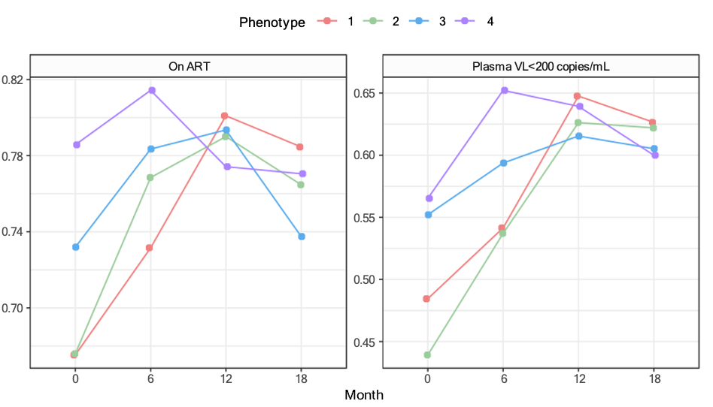
Proportion of participants

Supplementary Figure 2. Longitudinal trajectories of neurocognitive performance, depression symptom severity, cognitive complaints, and instrumental activities of daily living were similar for participants with viral suppression (left) and all participants (right).

