Supplementary Information for
“A high-resolution compound vulnerability function for European winter storm losses”
D. van Ederen^{1,2} , M.D.S. Fonseca Cerda¹, W.J.W. Botzen¹, J.C.J.H. Aerts^{1,3}, V. Lupi¹, P. Scussolini¹, K.B. Gubbels^{2,4,5}

1 Institute for Environmental Studies (IVM), Vrije Universiteit Amsterdam, Amsterdam, the Netherlands
2. Achmea, Zeist, the Netherlands
3. Deltares, Delft, the Netherlands
4. Tilburg University, Tilburg, the Netherlands
5. Actuarial Institute, Utrecht, the Netherlands

S1 Filtering the damage data
The insurance dataset provides weather-related residential building claims and policy holder information in the Netherlands from 2008 up to and including 2021. A temporal filtering makes sure that only weather-related residential building claims in the winter storm season (October up to and including March) are retained. As the Dutch financial conglomerate insures a wide range of environmental- and weather-related damage to residential buildings, additional filters need to be applied in order to isolate claims resulting from winter storms. Accordingly, residential building claims caused by earthquakes, floods, lightning, meteorite impacts and frost are excluded from the sample.

S2 Calculating reconstruction values
The reconstruction values of the residential buildings are calculated according to best practices in the Dutch insurance industry. This methodology is specifically designed for residential buildings and provided by the Dutch Association of Insurers. It receives a yearly update, incorporating changes in building costs, regulation (e.g. building codes) and methodology if necessary. The reconstruction value represents the costs of rebuilding a residential building according to the latest building codes, in case the building is damaged completely. It, therefore, excludes any value derived from a building’s location or the land it is placed on. The reconstruction value is approximated by multiplying a building’s volume ($m^{3})$ with a predetermined price which is tailored to the building’s type, the construction year and characteristics of the building’s structures. The baseline prices range from €740.- per $m^{3}$ building volume for terraced houses built after 2015, to €1040.- per $m^{3}$ building volume for detached houses built before and after 2015. The methodology distinguishes six building types: terraced houses, corner houses, semi-detached houses, detached-houses, apartments situated up to and including the fourth floor, and apartments situated between the fifth and up to and including the eighth floor. There are two construction year categories: before and after 2015. Premiums and discounts can be applied to the baseline building volume prices to reflect characteristics of the building’s structures which are of further influence to the reconstruction value. Amongst others, these structures include the foundation, the roof, the exterior walls, solar panels and heat generation installations. The reader is referred to the latest version of the reconstruction value calculation manual of the Dutch Association of Insurers (called Herbouwwaardemeter Woningen 2024) for an overview of all building volume prices and optional price corrections (Verbond van Verzekeraars, 2024).

S3 Indexing the ground up damage and reconstruction values
The ground up damage and the reconstruction values used in the beta regressions are denoted in 2024 price levels. To adjust the price levels in which the damage data was originally denoted, a price index was derived from the development of the reconstruction value prices in the aforementioned methodology of the Dutch Association of Insurers. Table S1 contains this price index for the years 2008-2024, here 2015 was set as the reference year. The price index was constructed by taking the weighted average of the baseline volume prices of all building types, where the share of a particular building type in the total building stock served as its weight. The development of this weighted average building volume price in turn determined the evolution of the price index. The share of a particular building type in the total building stock was based on building stock information provided by the Central Agency for Statistics of the Netherlands (Centraal Bureau voor de Statistiek [CBS], 2023). Table S2 provides the allocated weights (i.e. shares in the total building stock) per building type, which were assumed to stay fixed over the period of interest.

Table S1. Price index Table S2. Building type weights
This table provides the weights which were used in the price index calculation.
Year | Price Index
2008 | 86
2009 | 89
2010 | 90
2011 | 92
2012 | 94
2013 | 97
2014 | 98
2015 | 100
2016 | 107
2017 | 108
2018 | 110
2019 | 113
2020 | 127
2021 | 130
2022 | 141
2023 | 157
2024 | 162
Building type | Share in building stock
Terraced & Corner houses | 42%
Semi-detached houses | 9%
Detached-houses | 13%
Apartments, floor 0 to 4 | 18%
Apartments, floor 5 to 8 | 18%

This table provides the price
index which was used to adjust
the price levels of the ground
up damage and reconstruction
values.

S4 Measurement methodologies meteorological data
Meteorological data was retrieved from the Royal Netherlands Meteorological Institute (KNMI), which is the Dutch national weather service. The meteorological variables of interest are: the daily maximum 3-second wind gust in a 10-minute period at 10 m height and the daily maximum one-hour cumulative precipitation and the daily 24-hour cumulative precipitation.

Wind gusts
The aforementioned wind gust metric was derived from the Dutch Offshore Wind Atlas (DOWA) and Winds of the North Sea in 2050 (WINS50) datasets (Koninklijk Nederlands Meteorologisch Instituut [KNMI], 2018; KNMI, 2019; KNMI, 2022). These are regional reanalysis based wind climatology datasets containing time series of hourly information on the wind speed, wind direction, temperature, pressure and relative humidity at 10 m to 600 m and for a horizontal resolution of 2.5 km. The reanalysis is based on the numerical weather prediction model HARMONIE-AROME which is nested in the European Centre for Medium-Range Weather Forecasts (ECMWF) reanalysis ERA5. The daily maximum 3-second wind gust in a 10-minute period at 10 m height is approximated by the hourly average wind speed at 140 m as per derivation from van den Brink (2019) who validated this relationship with empirical observations. For more information on the numerical weather prediction model HARMONIE-AROME, the reader is referred to the websites of both wind climatology datasets:
https://www.dutchoffshorewindatlas.nl/
https://www.wins50.nl/

Precipitation
The aforementioned precipitation metrics were derived from a climatological radar rainfall dataset containing time series of one hour precipitation depths at a horizontal resolution of 1 km, which have been adjusted employing validated and complete rain gauge data from KNMI rain gauge networks (KNMI, 2017). The rainfall dataset covers the entire land surface of the Netherlands and is updated on a monthly basis. The daily maximum one-hour cumulative precipitation equals the maximum one hour precipitation depth, measured between each full hour, over 24 hours between 00:00 AM and 23:59 PM UTC. The daily 24-hour cumulative precipitation equals the sum of these one hour precipitation depths. For more information on the weather radars, the rain gauge network and the derivation of the one hour precipitation depths from these data sources, the reader is referred to section 2.3 in Overeem et al. (2011).

Figure S1
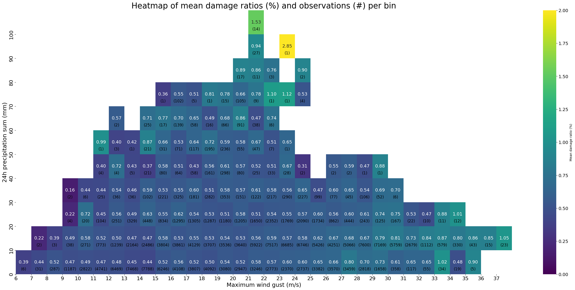
This figure shows a heatmap of the observed mean damage ratios in percentages, per binned range of meteorological conditions. The top number in each bin represents the mean damage ratio whereas the bottom number within parentheses refers to the number of claims captured in each binned range of meteorological conditions. The bins are color coded based on the value of its mean damage ratio and according to the legend on the right. The figure indicates that both high wind gust speeds and high 24-hour cumulative precipitation levels are associated with higher mean damage ratios.
Figure S2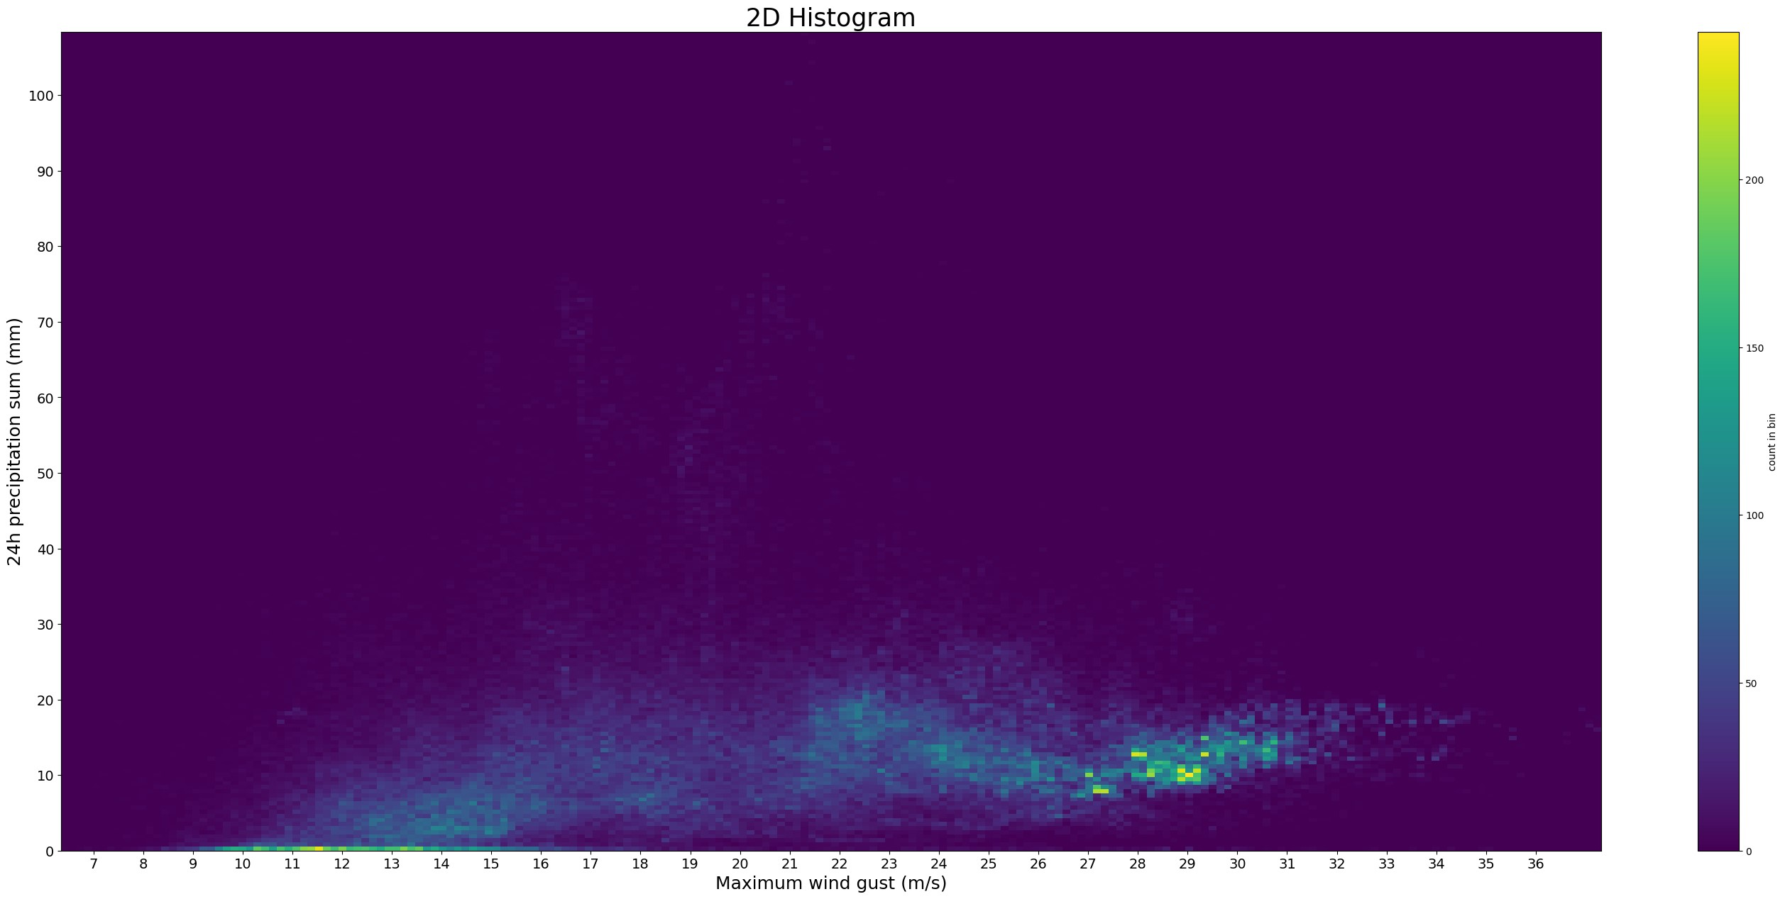
This figure shows a two dimensional histogram of the observed combination of meteorological conditions. The bins are color coded based on the frequency of the observed combination of meteorological conditions. The figure indicates that highest wind gust speeds do not cooccur with the highest 24-hour cumulative precipitation levels.

Figure S3
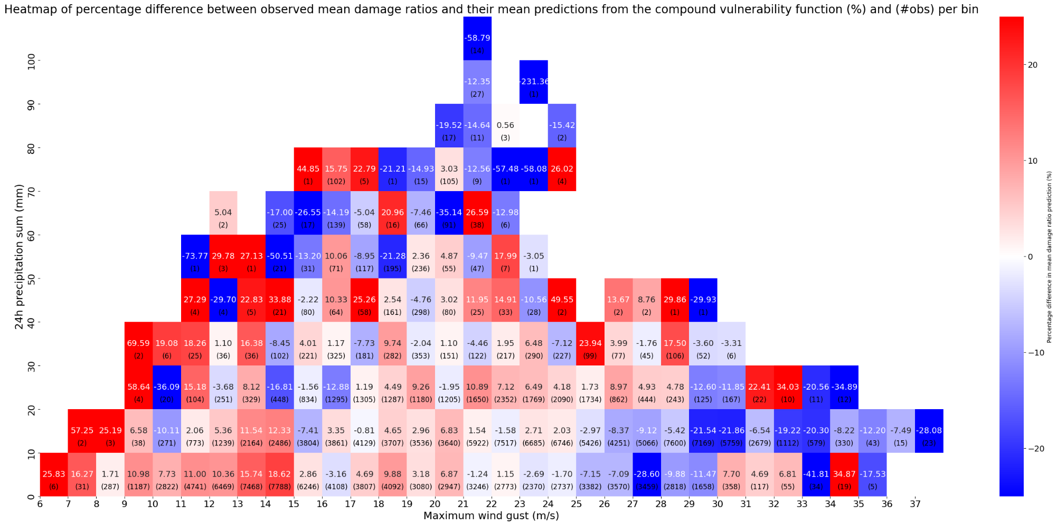
This figure shows a heatmap of the difference between the observed mean damage ratios and the mean damage ratio predictions from the compound vulnerability function in percentages, per binned range of meteorological conditions: -(observed mean damage ratios per bin - mean damage ratio predictions per bin)/mean damage ratio predictions per bin * 100. The top number in each bin represents this difference whereas the bottom number within parentheses refers to the number of claims captured in each binned range of meteorological conditions. The bins are color coded based on this difference and according to the legend on the right. The figure indicates that most underestimations occur at the highest wind gust speeds and 24-hour cumulative precipitation levels while most overestimations occur at their lowest values. Compared to the univariate vulnerability function, the compound vulnerability function underestimates the damage ratios for winter storms with high precipitation levels less severely and less often.
Figure S4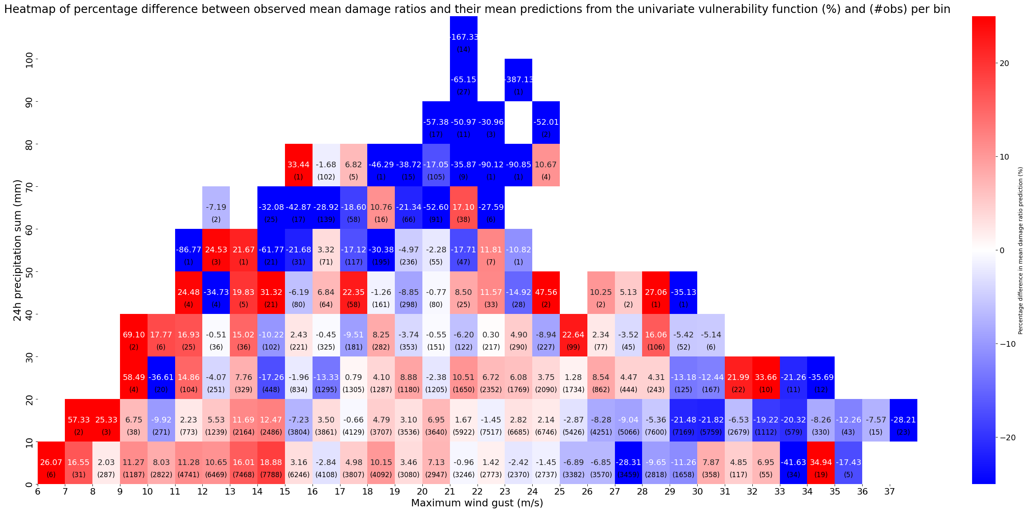
This figure shows a heatmap of the difference between the observed mean damage ratios and the mean damage ratio predictions from the univariate vulnerability function in percentages, per binned range of meteorological conditions: -(observed mean damage ratios per bin - mean damage ratio predictions per bin)/mean damage ratio predictions per bin * 100. The top number in each bin represents this difference whereas the bottom number within parentheses refers to the number of claims captured in each binned range of meteorological conditions. The bins are color coded based on this difference and according to the legend on the right. The figure indicates that most underestimations occur at the highest wind gust speeds and 24-hour cumulative precipitation levels while most overestimations occur at their lowest values. Compared to the compound vulnerability function, the univariate vulnerability function underestimates the damage ratios for winter storms with high precipitation levels more severely and more often.
Figure S5
Pearson residuals vs fitted values
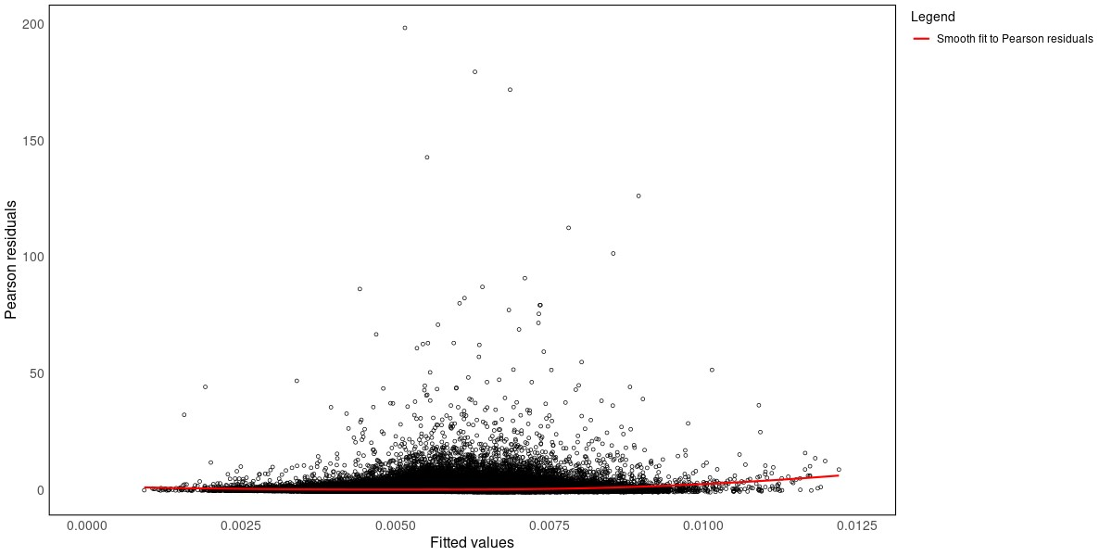
This figure shows the Pearson residuals against the fitted values (i.e. the expected damage ratio estimates) of the compound vulnerability function. The red line represents a smooth fit to these residuals, and is designed to help identify any trend more easily. Apart from a slight increase in the smooth fit for higher fitted values, the figure shows no significant patterns in the relationship between the Pearson residuals and the fitted values. Thus, although the model has a slight tendency to underestimate damage ratios more at higher fitted values than at lower fitted values, it adequately captures the relationship between the dependent variable and regressors.
Figure S6
Pearson residuals vs indices of observations 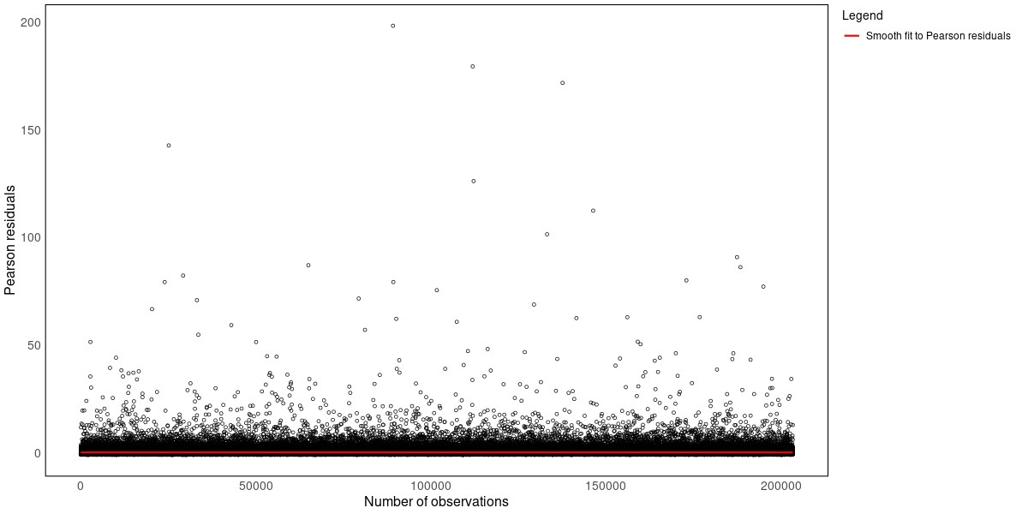

This figure shows the Pearson residuals against the indices of the observations of the compound vulnerability function. The red line represents a smooth fit to these residuals, and is designed to help identify any trend more easily. The figure shows no signs of a pattern in the relationship between the Pearson residuals and indices of the observations, which implies that the model adequately captures the relationship between the dependent variable and regressors.
Figure S7
QQ-normal plot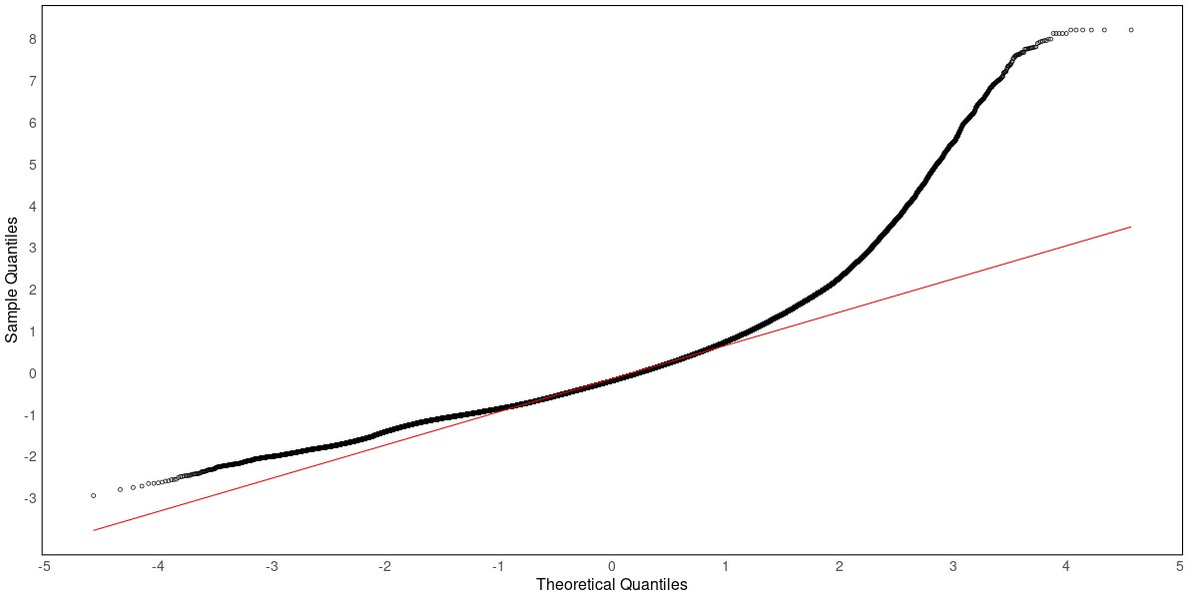
This figure shows the normal quantile-quantile plot of the compound vulnerability function where the residuals are quantile residuals as proposed by Dunn and Smyth (1996). The red line represents a reference line to aid in assessing the adherence to the theoretical quantiles. The figure highlights that the empirical damage ratio distribution has a heavier right tail than the fitted beta distribution (i.e. the theoretical damage ratio distribution), whereas its left tail is lighter than that of the fitted beta distribution
Figure S8
Densities of quantile residuals and standard normal distribution
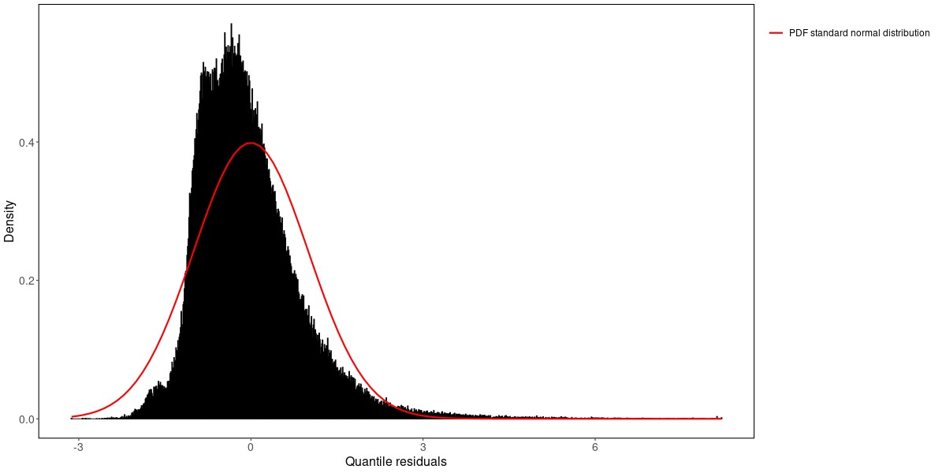
This figure shows the density of the quantile residuals of the compound vulnerability function and of the standard normal distribution. Similar to the quantile-quantile plot, this figure indicates that the empirical damage ratio distribution has a heavier right tail than the fitted beta distribution (i.e. the theoretical damage ratio distribution), whereas its left tail is lighter than that of the fitted beta distribution. In addition, the figure also highlights discrepancies between the central regions of the empirical damage ratio distribution and the fitted beta distribution. In particular, it shows that the empirical damage ratio distribution has relatively less support for damage ratios slightly above its expectation, whereas it has relatively more support for damage ratios slightly below its expectation.
Figure S9
Leverage values vs indices of observations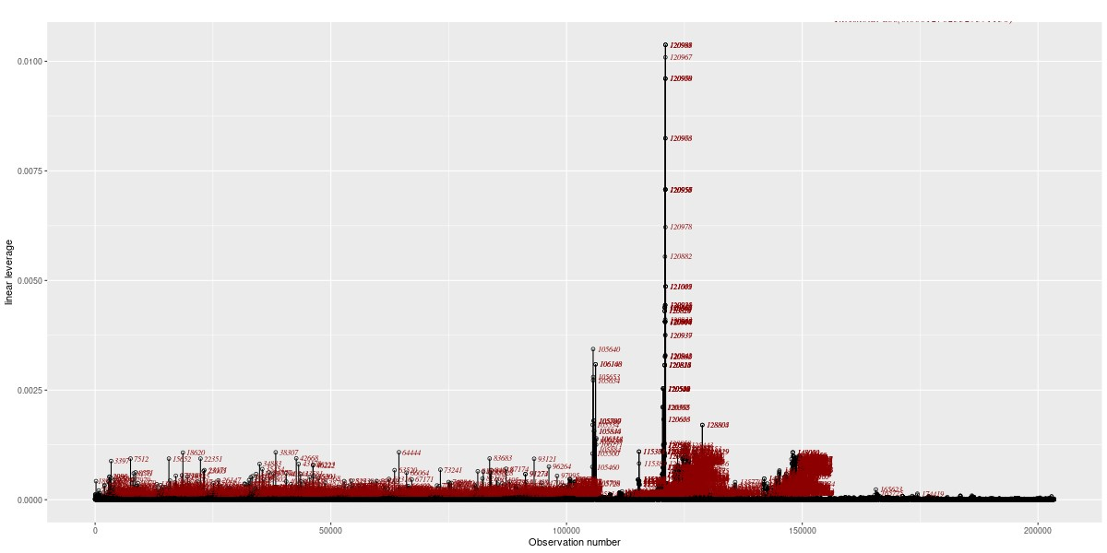
This figure shows the leverage values of all observations against their indices of the compound vulnerability function. The numbers in this figure correspond to the index values of the observations. This figure indicates that there are many high leverage observations. Nonetheless, a sensitivity analysis points out that they are not of influence as the regression parameters are at least robust to removing the top 0.5% (~1000 observations) of observations, ranked according to their leverage. This finding suggests that the prediction errors which accompanied the high leverage observations were not large enough to make them influential.
S5 Damage ratio tables
To facilitate the usage of the vulnerability functions, the following tables provide the end-user with the damage ratio output from the compound vulnerability function for an average residential building, which has a reconstruction value of €370,000.- denoted in 2024 price levels. The expected damage ratios (E[DR]) in percentages are reported for differing wind gust speeds in m/s and 24-hour cumulative precipitation levels in mm. In addition, the 1st, 25th, 75th and 99th quantiles (Q) of the conditional beta distribution are also provided to describe the variance of the damage ratio estimates. Lastly, the 75% and 99% confidence interval (CI) for the expected damage ratio are also provided (and their quantiles) to describe the uncertainty in the expected damage ratio estimate.

With these damage ratios, the end-user can easily acquire the ground up damage, denoted in 2024 price levels, by multiplying the damage ratio with the related reconstruction value of €370,000.-. Note that the output of the compound vulnerability function at a 24-hour cumulative precipitation levels of 0 mm is approximately equal to the output of the univariate vulnerability function.

24-hour cumulative precipitation levels of 0 mm

Table S3
Wind gust speed | 1st Q | 25th Q | E[DR] | 75th Q | 99th Q
6 m/s | 0.007 | 0.163 | 0.524 | 0.726 | 2.303
10 m/s | 0.007 | 0.166 | 0.527 | 0.731 | 2.311
15 m/s | 0.008 | 0.172 | 0.538 | 0.746 | 2.335
20 m/s | 0.010 | 0.186 | 0.560 | 0.775 | 2.382
25 m/s | 0.013 | 0.209 | 0.597 | 0.826 | 2.462
30 m/s | 0.019 | 0.249 | 0.658 | 0.907 | 2.588
35 m/s | 0.032 | 0.314 | 0.754 | 1.031 | 2.779
38 m/s | 0.045 | 0.371 | 0.835 | 1.136 | 2.936
Expected damage ratios (%) and their 1st, 25th, 75th and 99th quantiles.

Table S4
Wind gust speed | 1st Q | 25th Q | 75% lower CI | 75th Q | 99th Q |  | 1st Q | 25th Q | 75% upper CI | 75th Q | 99th Q
6 m/s | 0.007 | 0.162 | 0.522 | 0.724 | 2.299 |  | 0.007 | 0.165 | 0.526 | 0.729 | 2.308
10 m/s | 0.007 | 0.164 | 0.525 | 0.729 | 2.307 |  | 0.008 | 0.167 | 0.529 | 0.734 | 2.315
15 m/s | 0.008 | 0.171 | 0.536 | 0.744 | 2.331 |  | 0.008 | 0.173 | 0.540 | 0.748 | 2.338
20 m/s | 0.010 | 0.185 | 0.558 | 0.773 | 2.379 |  | 0.010 | 0.186 | 0.561 | 0.777 | 2.385
25 m/s | 0.013 | 0.208 | 0.596 | 0.824 | 2.459 |  | 0.013 | 0.210 | 0.599 | 0.828 | 2.465
30 m/s | 0.019 | 0.247 | 0.656 | 0.903 | 2.583 |  | 0.020 | 0.251 | 0.661 | 0.910 | 2.594
35 m/s | 0.031 | 0.310 | 0.748 | 1.024 | 2.768 |  | 0.033 | 0.318 | 0.759 | 1.038 | 2.790
38 m/s | 0.044 | 0.365 | 0.827 | 1.125 | 2.920 |  | 0.047 | 0.377 | 0.843 | 1.146 | 2.952
The 75% confidence intervals of the expected damage ratios (%) and their 1st, 25th, 75th and 99th quantiles.

Table S5
Wind gust speed | 1st Q | 25th Q | 99% lower CI | 75th Q | 99th Q |  | 1st Q | 25th Q | 99% upper CI | 75th Q | 99th Q
6 m/s | 0.007 | 0.161 | 0.520 | 0.721 | 2.294 |  | 0.007 | 0.166 | 0.528 | 0.732 | 2.313
10 m/s | 0.007 | 0.163 | 0.523 | 0.726 | 2.302 |  | 0.008 | 0.168 | 0.531 | 0.737 | 2.320
15 m/s | 0.008 | 0.170 | 0.534 | 0.741 | 2.327 |  | 0.008 | 0.174 | 0.542 | 0.751 | 2.343
20 m/s | 0.010 | 0.184 | 0.557 | 0.771 | 2.375 |  | 0.010 | 0.188 | 0.563 | 0.780 | 2.389
25 m/s | 0.013 | 0.207 | 0.594 | 0.821 | 2.455 |  | 0.013 | 0.212 | 0.601 | 0.830 | 2.469
30 m/s | 0.019 | 0.245 | 0.652 | 0.899 | 2.576 |  | 0.020 | 0.253 | 0.664 | 0.914 | 2.600
35 m/s | 0.030 | 0.305 | 0.742 | 1.016 | 2.755 |  | 0.034 | 0.322 | 0.766 | 1.047 | 2.803
38 m/s | 0.042 | 0.358 | 0.817 | 1.112 | 2.901 |  | 0.049 | 0.384 | 0.853 | 1.159 | 2.971
The 99% confidence intervals of the expected damage ratios (%) and their 1st, 25th, 75th and 99th quantiles.

24-hour cumulative precipitation levels of 25 mm

Table S6
Wind gust speed | 1st Q | 25th Q | E[DR] | 75th Q | 99th Q
6 m/s | 0.007 | 0.166 | 0.527 | 0.731 | 2.312
10 m/s | 0.008 | 0.168 | 0.531 | 0.736 | 2.319
15 m/s | 0.008 | 0.175 | 0.542 | 0.751 | 2.343
20 m/s | 0.010 | 0.188 | 0.564 | 0.781 | 2.390
25 m/s | 0.013 | 0.212 | 0.602 | 0.831 | 2.471
30 m/s | 0.020 | 0.252 | 0.663 | 0.913 | 2.598
35 m/s | 0.033 | 0.318 | 0.759 | 1.038 | 2.790
38 m/s | 0.046 | 0.375 | 0.841 | 1.143 | 2.947
Expected damage ratios (%) and their 1st, 25th, 75th and 99th quantiles.

Table S7
Wind gust speed | 1st Q | 25th Q | 75% lower CI | 75th Q | 99th Q |  | 1st Q | 25th Q | 75% upper CI | 75th Q | 99th Q
6 m/s | 0.007 | 0.165 | 0.526 | 0.729 | 2.307 |  | 0.008 | 0.167 | 0.529 | 0.734 | 2.316
10 m/s | 0.008 | 0.167 | 0.529 | 0.734 | 2.315 |  | 0.008 | 0.169 | 0.533 | 0.739 | 2.323
15 m/s | 0.008 | 0.173 | 0.540 | 0.749 | 2.339 |  | 0.009 | 0.176 | 0.544 | 0.753 | 2.347
20 m/s | 0.010 | 0.187 | 0.562 | 0.779 | 2.387 |  | 0.010 | 0.189 | 0.565 | 0.783 | 2.393
25 m/s | 0.013 | 0.211 | 0.600 | 0.829 | 2.468 |  | 0.013 | 0.213 | 0.603 | 0.833 | 2.474
30 m/s | 0.019 | 0.250 | 0.660 | 0.909 | 2.592 |  | 0.020 | 0.254 | 0.666 | 0.916 | 2.603
35 m/s | 0.032 | 0.314 | 0.754 | 1.031 | 2.779 |  | 0.034 | 0.321 | 0.765 | 1.045 | 2.800
38 m/s | 0.045 | 0.369 | 0.832 | 1.133 | 2.932 |  | 0.048 | 0.381 | 0.849 | 1.154 | 2.963
The 75% confidence intervals of the expected damage ratios (%) and their 1st, 25th, 75th and 99th quantiles.

Table S8
Wind gust speed | 1st Q | 25th Q | 99% lower CI | 75th Q | 99th Q |  | 1st Q | 25th Q | 99% upper CI | 75th Q | 99th Q
6 m/s | 0.007 | 0.163 | 0.523 | 0.726 | 2.302 |  | 0.008 | 0.168 | 0.532 | 0.737 | 2.321
10 m/s | 0.007 | 0.165 | 0.527 | 0.731 | 2.310 |  | 0.008 | 0.170 | 0.535 | 0.742 | 2.328
15 m/s | 0.008 | 0.172 | 0.538 | 0.746 | 2.335 |  | 0.009 | 0.177 | 0.546 | 0.756 | 2.351
20 m/s | 0.010 | 0.186 | 0.560 | 0.776 | 2.383 |  | 0.010 | 0.190 | 0.567 | 0.785 | 2.397
25 m/s | 0.013 | 0.210 | 0.598 | 0.827 | 2.464 |  | 0.014 | 0.214 | 0.605 | 0.836 | 2.478
30 m/s | 0.019 | 0.248 | 0.657 | 0.905 | 2.585 |  | 0.021 | 0.256 | 0.669 | 0.921 | 2.610
35 m/s | 0.031 | 0.309 | 0.747 | 1.022 | 2.766 |  | 0.035 | 0.326 | 0.771 | 1.054 | 2.814
38 m/s | 0.043 | 0.362 | 0.822 | 1.120 | 2.912 |  | 0.050 | 0.388 | 0.859 | 1.167 | 2.983
The 99% confidence intervals of the expected damage ratios (%) and their 1st, 25th, 75th and 99th quantiles.
24-hour cumulative precipitation levels of 50 mm

Table S9
Wind gust speed | 1st Q | 25th Q | E[DR] | 75th Q | 99th Q
6 m/s | 0.009 | 0.182 | 0.554 | 0.768 | 2.370
10 m/s | 0.010 | 0.184 | 0.558 | 0.773 | 2.378
15 m/s | 0.011 | 0.192 | 0.569 | 0.788 | 2.403
20 m/s | 0.012 | 0.206 | 0.592 | 0.819 | 2.451
25 m/s | 0.016 | 0.232 | 0.632 | 0.872 | 2.535
30 m/s | 0.024 | 0.275 | 0.697 | 0.957 | 2.666
35 m/s | 0.039 | 0.344 | 0.798 | 1.088 | 2.864
38 m/s | 0.055 | 0.406 | 0.883 | 1.197 | 3.028
Expected damage ratios (%) and their 1st, 25th, 75th and 99th quantiles.

Table S10
Wind gust speed | 1st Q | 25th Q | 75% lower CI | 75th Q | 99th Q |  | 1st Q | 25th Q | 75% upper CI | 75th Q | 99th Q
6 m/s | 0.009 | 0.179 | 0.550 | 0.762 | 2.360 |  | 0.010 | 0.185 | 0.559 | 0.774 | 2.380
10 m/s | 0.009 | 0.182 | 0.553 | 0.767 | 2.368 |  | 0.010 | 0.187 | 0.563 | 0.779 | 2.388
15 m/s | 0.010 | 0.189 | 0.565 | 0.782 | 2.393 |  | 0.011 | 0.195 | 0.574 | 0.795 | 2.412
20 m/s | 0.012 | 0.203 | 0.588 | 0.813 | 2.441 |  | 0.013 | 0.209 | 0.597 | 0.825 | 2.461
25 m/s | 0.016 | 0.229 | 0.627 | 0.865 | 2.524 |  | 0.017 | 0.235 | 0.637 | 0.879 | 2.545
30 m/s | 0.023 | 0.271 | 0.691 | 0.949 | 2.654 |  | 0.025 | 0.279 | 0.703 | 0.965 | 2.678
35 m/s | 0.038 | 0.338 | 0.789 | 1.077 | 2.848 |  | 0.040 | 0.350 | 0.806 | 1.099 | 2.881
38 m/s | 0.052 | 0.398 | 0.872 | 1.183 | 3.007 |  | 0.057 | 0.414 | 0.895 | 1.212 | 3.049
The 75% confidence intervals of the expected damage ratios (%) and their 1st, 25th, 75th and 99th quantiles.

Table S11
Wind gust speed | 1st Q | 25th Q | 99% lower CI | 75th Q | 99th Q |  | 1st Q | 25th Q | 99% upper CI | 75th Q | 99th Q
6 m/s | 0.009 | 0.176 | 0.544 | 0.754 | 2.348 |  | 0.010 | 0.189 | 0.565 | 0.782 | 2.392
10 m/s | 0.009 | 0.178 | 0.548 | 0.759 | 2.356 |  | 0.010 | 0.191 | 0.568 | 0.787 | 2.400
15 m/s | 0.010 | 0.185 | 0.559 | 0.775 | 2.381 |  | 0.011 | 0.198 | 0.580 | 0.802 | 2.425
20 m/s | 0.012 | 0.200 | 0.582 | 0.805 | 2.429 |  | 0.013 | 0.213 | 0.603 | 0.833 | 2.474
25 m/s | 0.015 | 0.225 | 0.621 | 0.857 | 2.511 |  | 0.018 | 0.239 | 0.644 | 0.887 | 2.558
30 m/s | 0.022 | 0.266 | 0.683 | 0.939 | 2.639 |  | 0.026 | 0.284 | 0.710 | 0.975 | 2.693
35 m/s | 0.036 | 0.331 | 0.779 | 1.064 | 2.828 |  | 0.042 | 0.358 | 0.817 | 1.113 | 2.902
38 m/s | 0.050 | 0.388 | 0.859 | 1.166 | 2.981 |  | 0.060 | 0.424 | 0.909 | 1.229 | 3.075
The 99% confidence intervals of the expected damage ratios (%) and their 1st, 25th, 75th and 99th quantiles.

24-hour cumulative precipitation levels of 75 mm

Table S12
Wind gust speed | 1st Q | 25th Q | E[DR] | 75th Q | 99th Q
6 m/s | 0.017 | 0.233 | 0.634 | 0.875 | 2.538
10 m/s | 0.017 | 0.236 | 0.638 | 0.880 | 2.547
15 m/s | 0.018 | 0.245 | 0.651 | 0.898 | 2.574
20 m/s | 0.022 | 0.262 | 0.678 | 0.932 | 2.627
25 m/s | 0.028 | 0.293 | 0.723 | 0.992 | 2.719
30 m/s | 0.039 | 0.344 | 0.797 | 1.087 | 2.863
35 m/s | 0.060 | 0.426 | 0.912 | 1.234 | 3.081
38 m/s | 0.082 | 0.499 | 1.010 | 1.357 | 3.261
Expected damage ratios (%) and their 1st, 25th, 75th and 99th quantiles.

Table S13
Wind gust speed | 1st Q | 25th Q | 75% lower CI | 75th Q | 99th Q |  | 1st Q | 25th Q | 75% upper CI | 75th Q | 99th Q
6 m/s | 0.015 | 0.222 | 0.617 | 0.853 | 2.504 |  | 0.018 | 0.244 | 0.651 | 0.897 | 2.574
10 m/s | 0.015 | 0.225 | 0.622 | 0.858 | 2.513 |  | 0.019 | 0.247 | 0.656 | 0.903 | 2.583
15 m/s | 0.017 | 0.233 | 0.634 | 0.875 | 2.539 |  | 0.021 | 0.256 | 0.669 | 0.921 | 2.610
20 m/s | 0.019 | 0.250 | 0.660 | 0.909 | 2.591 |  | 0.024 | 0.274 | 0.696 | 0.956 | 2.664
25 m/s | 0.025 | 0.280 | 0.704 | 0.967 | 2.681 |  | 0.030 | 0.306 | 0.743 | 1.017 | 2.757
30 m/s | 0.035 | 0.329 | 0.776 | 1.060 | 2.822 |  | 0.043 | 0.359 | 0.818 | 1.115 | 2.905
35 m/s | 0.055 | 0.408 | 0.887 | 1.202 | 3.035 |  | 0.066 | 0.445 | 0.938 | 1.266 | 3.129
38 m/s | 0.075 | 0.478 | 0.982 | 1.321 | 3.210 |  | 0.089 | 0.521 | 1.039 | 1.393 | 3.314
The 75% confidence intervals of the expected damage ratios (%) and their 1st, 25th, 75th and 99th quantiles.

Table S14
Wind gust speed | 1st Q | 25th Q | 99% lower CI | 75th Q | 99th Q |  | 1st Q | 25th Q | 99% upper CI | 75th Q | 99th Q
6 m/s | 0.013 | 0.209 | 0.597 | 0.826 | 2.462 |  | 0.021 | 0.259 | 0.673 | 0.926 | 2.618
10 m/s | 0.013 | 0.212 | 0.601 | 0.831 | 2.470 |  | 0.022 | 0.262 | 0.677 | 0.932 | 2.627
15 m/s | 0.015 | 0.220 | 0.614 | 0.848 | 2.496 |  | 0.023 | 0.271 | 0.691 | 0.950 | 2.655
20 m/s | 0.017 | 0.236 | 0.638 | 0.880 | 2.548 |  | 0.027 | 0.290 | 0.719 | 0.986 | 2.711
25 m/s | 0.022 | 0.264 | 0.681 | 0.937 | 2.635 |  | 0.034 | 0.323 | 0.767 | 1.049 | 2.806
30 m/s | 0.031 | 0.311 | 0.750 | 1.027 | 2.772 |  | 0.047 | 0.379 | 0.846 | 1.150 | 2.958
35 m/s | 0.050 | 0.387 | 0.857 | 1.164 | 2.979 |  | 0.073 | 0.469 | 0.970 | 1.307 | 3.189
38 m/s | 0.068 | 0.452 | 0.947 | 1.278 | 3.147 |  | 0.099 | 0.549 | 1.077 | 1.440 | 3.381
The 99% confidence intervals of the expected damage ratios (%) and their 1st, 25th, 75th and 99th quantiles.
24-hour cumulative precipitation levels of 100 mm

Table S15
Wind gust speed | 1st Q | 25th Q | E[DR] | 75th Q | 99th Q
6 m/s | 0.043 | 0.363 | 0.824 | 1.121 | 2.915
10 m/s | 0.044 | 0.367 | 0.829 | 1.128 | 2.925
15 m/s | 0.047 | 0.379 | 0.846 | 1.150 | 2.958
20 m/s | 0.054 | 0.403 | 0.880 | 1.193 | 3.022
25 m/s | 0.066 | 0.446 | 0.939 | 1.268 | 3.132
30 m/s | 0.088 | 0.517 | 1.034 | 1.387 | 3.305
35 m/s | 0.128 | 0.630 | 1.184 | 1.572 | 3.570
38 m/s | 0.166 | 0.729 | 1.310 | 1.727 | 3.788
Expected damage ratios (%) and their 1st, 25th, 75th and 99th quantiles.

Table S16
Wind gust speed | 1st Q | 25th Q | 75% lower CI | 75th Q | 99th Q |  | 1st Q | 25th Q | 75% upper CI | 75th Q | 99th Q
6 m/s | 0.035 | 0.327 | 0.773 | 1.056 | 2.817 |  | 0.053 | 0.401 | 0.877 | 1.190 | 3.017
10 m/s | 0.036 | 0.331 | 0.778 | 1.063 | 2.827 |  | 0.055 | 0.406 | 0.883 | 1.197 | 3.028
15 m/s | 0.038 | 0.342 | 0.794 | 1.084 | 2.858 |  | 0.058 | 0.419 | 0.901 | 1.220 | 3.061
20 m/s | 0.044 | 0.365 | 0.826 | 1.125 | 2.920 |  | 0.066 | 0.445 | 0.937 | 1.266 | 3.129
25 m/s | 0.054 | 0.404 | 0.882 | 1.195 | 3.025 |  | 0.080 | 0.491 | 1.000 | 1.345 | 3.244
30 m/s | 0.073 | 0.470 | 0.971 | 1.308 | 3.190 |  | 0.105 | 0.568 | 1.102 | 1.471 | 3.426
35 m/s | 0.107 | 0.575 | 1.111 | 1.482 | 3.442 |  | 0.151 | 0.691 | 1.262 | 1.667 | 3.704
38 m/s | 0.141 | 0.665 | 1.229 | 1.628 | 3.648 |  | 0.194 | 0.797 | 1.397 | 1.832 | 3.934
The 75% confidence intervals of the expected damage ratios (%) and their 1st, 25th, 75th and 99th quantiles.

Table S17
Wind gust speed | 1st Q | 25th Q | 99% lower CI | 75th Q | 99th Q |  | 1st Q | 25th Q | 99% upper CI | 75th Q | 99th Q
6 m/s | 0.026 | 0.287 | 0.715 | 0.981 | 2.703 |  | 0.068 | 0.453 | 0.949 | 1.280 | 3.149
10 m/s | 0.027 | 0.291 | 0.720 | 0.987 | 2.712 |  | 0.070 | 0.458 | 0.955 | 1.288 | 3.161
15 m/s | 0.029 | 0.301 | 0.734 | 1.006 | 2.741 |  | 0.074 | 0.472 | 0.975 | 1.312 | 3.197
20 m/s | 0.034 | 0.321 | 0.764 | 1.045 | 2.799 |  | 0.083 | 0.501 | 1.014 | 1.361 | 3.268
25 m/s | 0.042 | 0.357 | 0.815 | 1.110 | 2.898 |  | 0.100 | 0.553 | 1.082 | 1.446 | 3.390
30 m/s | 0.057 | 0.416 | 0.898 | 1.215 | 3.055 |  | 0.130 | 0.637 | 1.192 | 1.582 | 3.584
35 m/s | 0.086 | 0.511 | 1.026 | 1.377 | 3.291 |  | 0.183 | 0.772 | 1.365 | 1.793 | 3.880
38 m/s | 0.114 | 0.593 | 1.135 | 1.512 | 3.485 |  | 0.234 | 0.889 | 1.512 | 1.970 | 4.125
The 99% confidence intervals of the expected damage ratios (%) and their 1st, 25th, 75th and 99th quantiles.

 | Pearson residuals
mean | -0.021
std | 1.954
min | -1.272
Q25 | -0.715
Q50 | -0.425
Q75 | 0.102
max | 198.159
skewness | 27.608
kurtosis | 1756.955
 | Quantile residuals
mean | -0.037
std | 0.932
min | -3.127
Q25 | -0.668
Q50 | -0.185
Q75 | 0.398
max | 8.210
skewness | 1.607
kurtosis | 8.993
Table S18 Table S19

This table provides the descriptive
statistics for the quantile residuals.
This table provides the descriptive
statistics for the Pearson
residuals.

References

Centraal Bureau voor de Statistiek. (2023). Woningvoorraad; woningtype op 1 januari, regio (updated on 22-09-2023) [Data set]. https://opendata.cbs.nl/#/CBS/nl/dataset/85035NED/table

Dunn, P. K., & Smyth, G. K. (1996). Randomized quantile residuals. Journal of Computational and Graphical Statistics, 5(3), 236-244

Koninklijk Nederlands Meteorologisch Instituut. (2017). Precipitation - 1 hour precipitation accumulations from climatological gauge-adjusted radar dataset for The Netherlands (1 km) in NetCDF4 format (Version 2) [Data set]. https://dataplatform.knmi.nl/dataset/rad-nl25-rac-mfbs-01h-netcdf4-2-0

Koninklijk Nederlands Meteorologisch Instituut. (2018). Dutch Offshore Wind Atlas - time series files from 2008-2017 at 10-600 meter height at individual 2.5 km grid location (Version 1) [Data set]. https://dataplatform.knmi.nl/dataset/dowa-netcdf-ts-singlepoint-1

Koninklijk Nederlands Meteorologisch Instituut. (2019). Dutch Offshore Wind Atlas - time series files for 2018 at 10-600 meter height at individual 2.5 km grid location (Version 1) [Data set].
https://dataplatform.knmi.nl/dataset/dowa-netcdf-ts-singlepoint-upd-1

Koninklijk Nederlands Meteorologisch Instituut. (2022). WINS50 - wind at 10-600 meter height for the Netherlands from HARMONIE-AROME as time series per grid point (Version 3) [Data set]. https://dataplatform.knmi.nl/dataset/wins50-ctl-nl-ts-singlepoint-3

Overeem, A., Leijnse, H., & Uijlenhoet, R. (2011). Measuring urban rainfall using microwave links from commercial cellular communication networks. Water Resour. Res., 47. doi:10.1029/2010WR010350

van den Brink, H.W. (2019). An effective parametrization of gust profiles during severe wind conditions. Environmental Research Communications, 2(1). doi: 10.1088/2515-7620/ab5777

Verbond van Verzekeraars. (2024). Herbouwwaardemeter Woningen 2024. Verbond van Verzekeraars. https://www.verzekeraars.nl/media/a0ehmis4/vvv-herbouwwaardemeter_2024_lr_def.pdf

