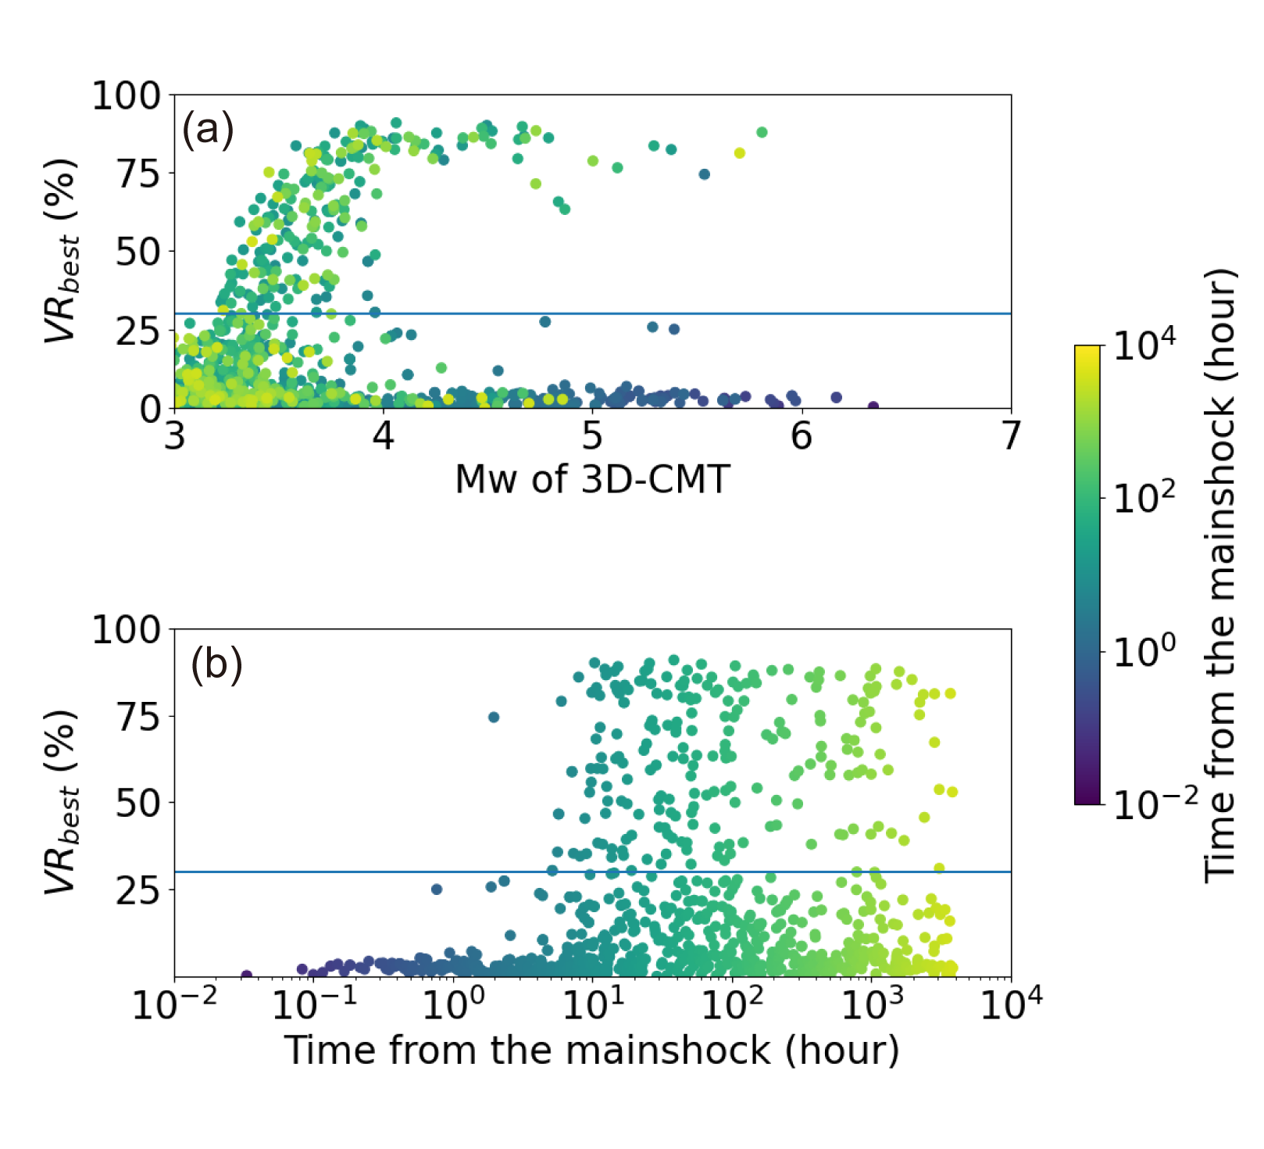
Figure S1: (a) Moment magnitudes of the optimal 3-D CMT solutions against the VR_{best}, and (b) time elapsed from the mainshock against the VR_{best}. The colors represent the time passed from the mainshock. A horizontal line denotes the threshold at the VR_{best} of 30%.
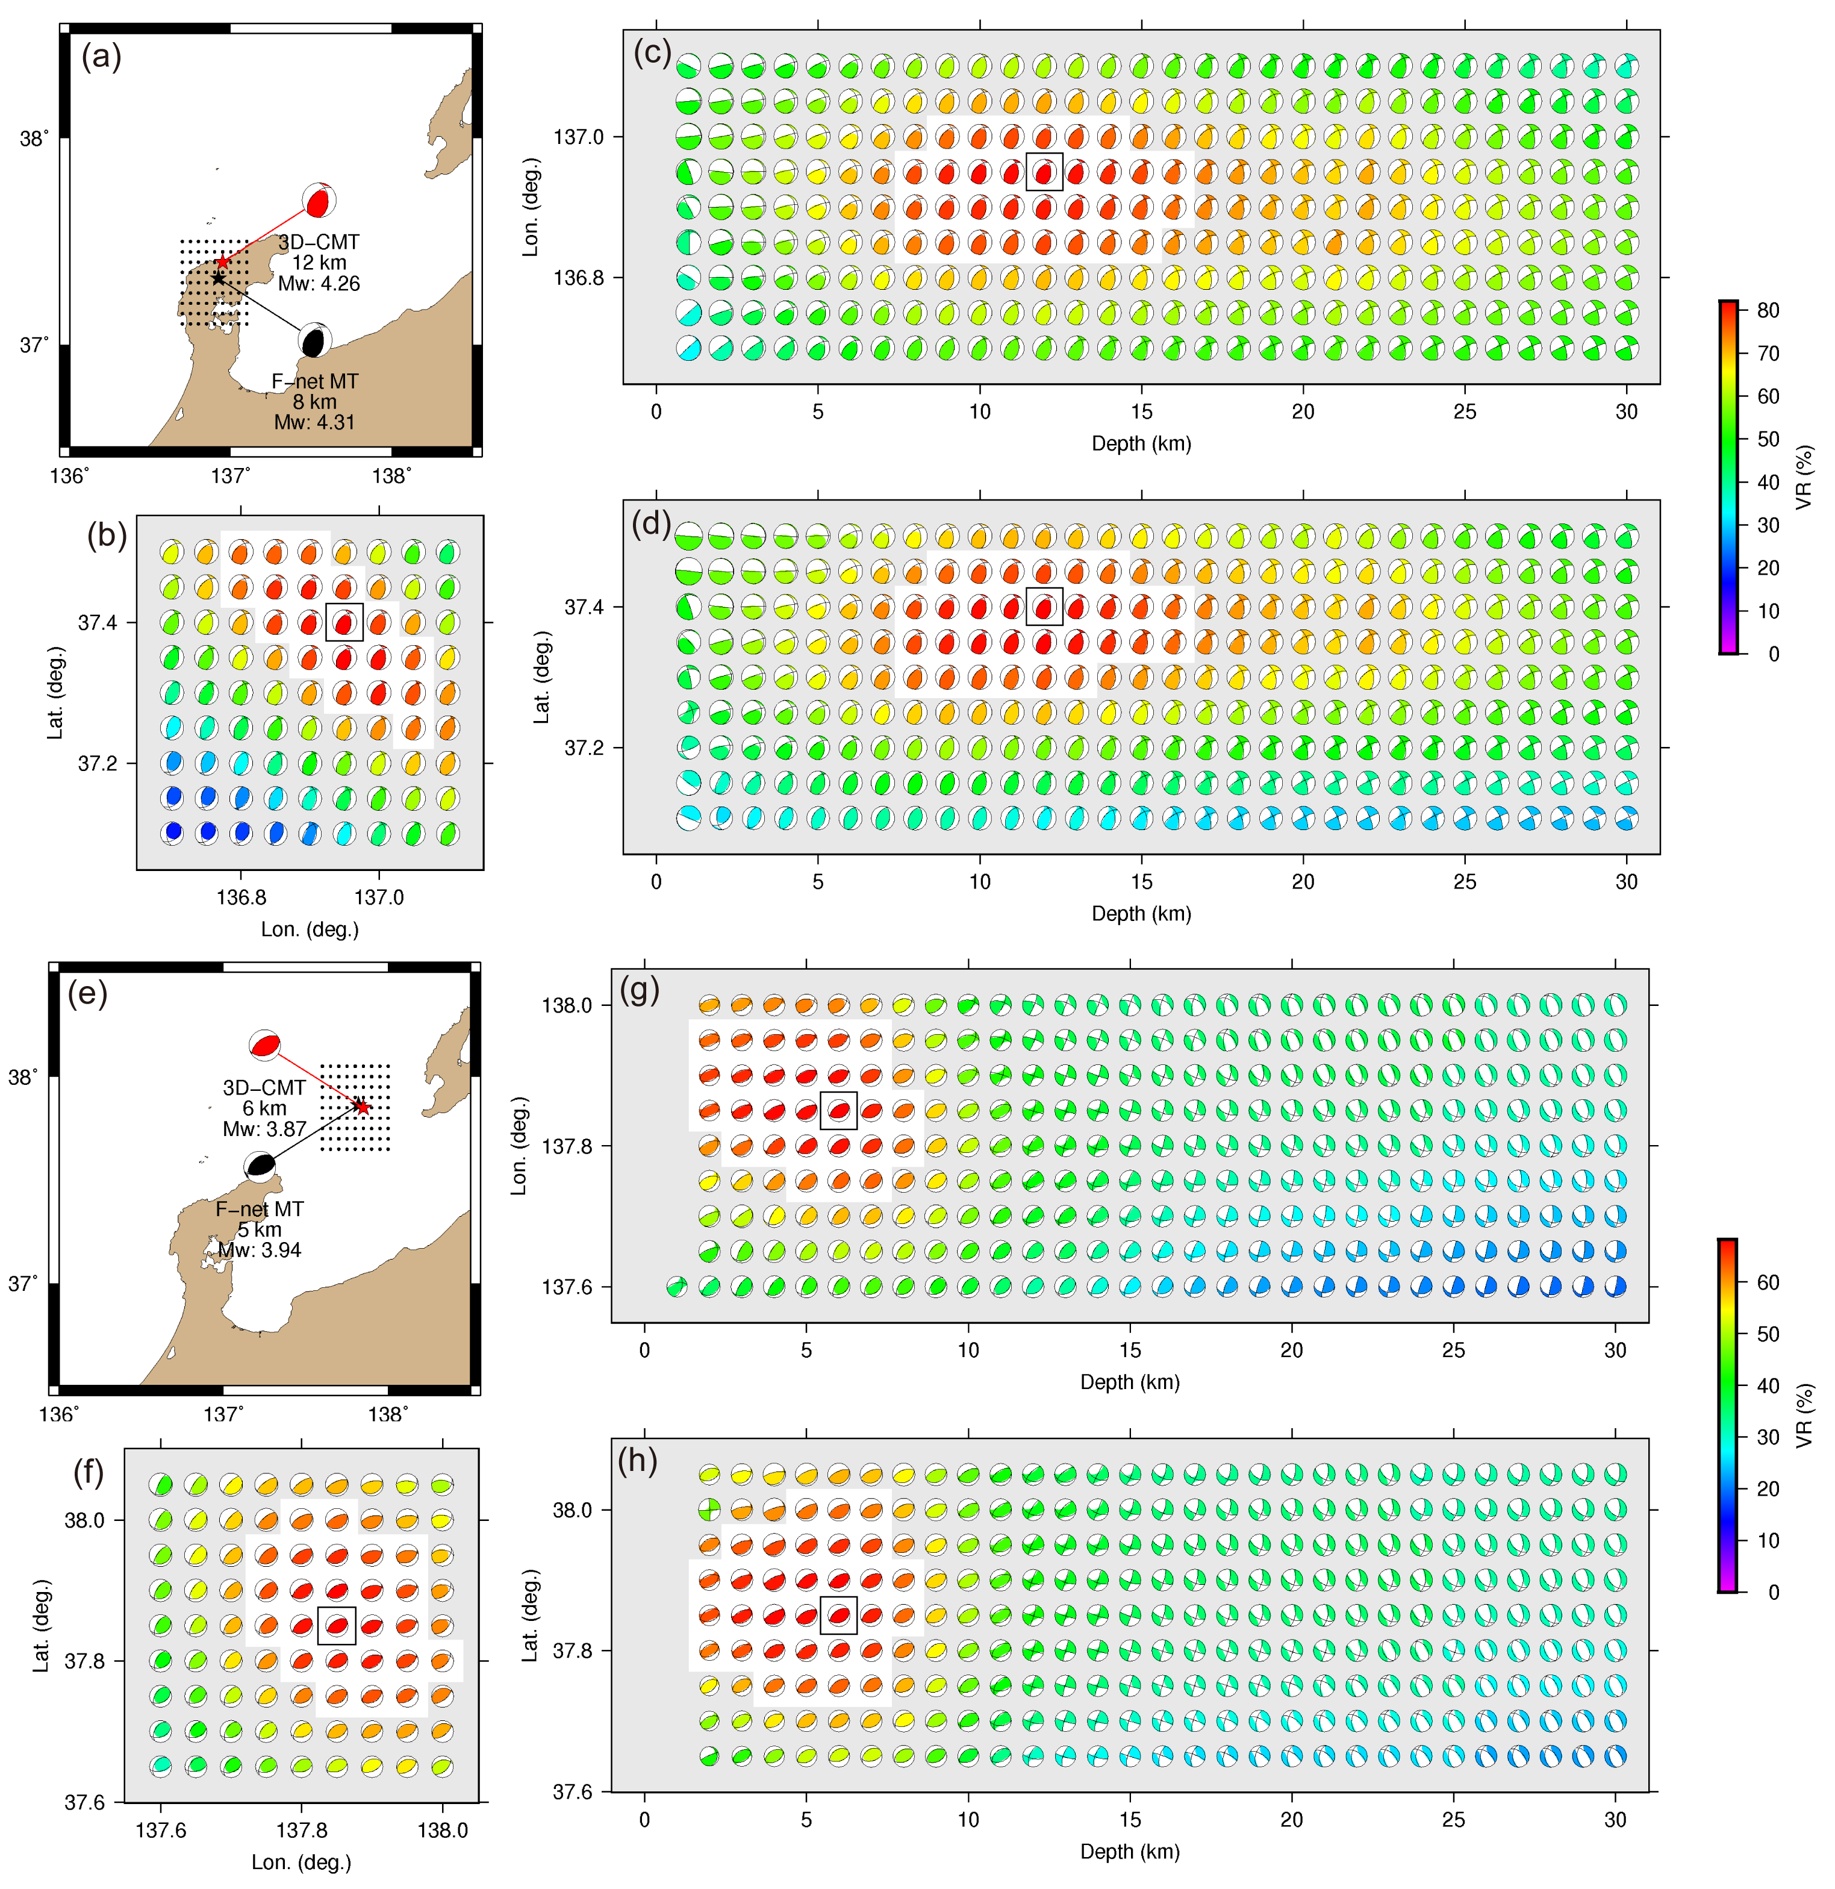
Figure S2: (a–d) The 3D-CMT solutions for the onshore earthquake that occurred at 22:13, January 1 (UTC). (a) Centroid location of the earthquake and stations. The red star shows the horizontal location of the optimal 3D-CMT solution with a depth of 12 km. The red focal mechanism shows the moment tensor of the optimal 3D-CMT solution. The black star indicates the horizontal location of the F-net MT solution with a depth of 8 km. The black focal mechanism shows the moment tensor of the F-net MT. (b) Horizontal resolution of the 3D-CMT solution in the depth plane of the optimal 3D-CMT solution. The color of the focal mechanisms denotes the VR. The white colored region shows VR higher than 90% from the $VR_{best}$ of the 3D-CMT solution. The optimal 3D-CMT solution is surrounded by the square. (c) Depth resolution in the longitudinal direction in the latitude plane of the optimal 3D-CMT, and (d) the latitudinal direction in the longitude plane of the optimal 3D-CMT solution. The color scale is used for (b–d). (e–h) The 3D-CMT solutions for the offshore earthquake that occurred at 17:48 on January 1 (UTC). The notations for (e–h) are the same as those for (a–d). The same color scale is used for (f–h).
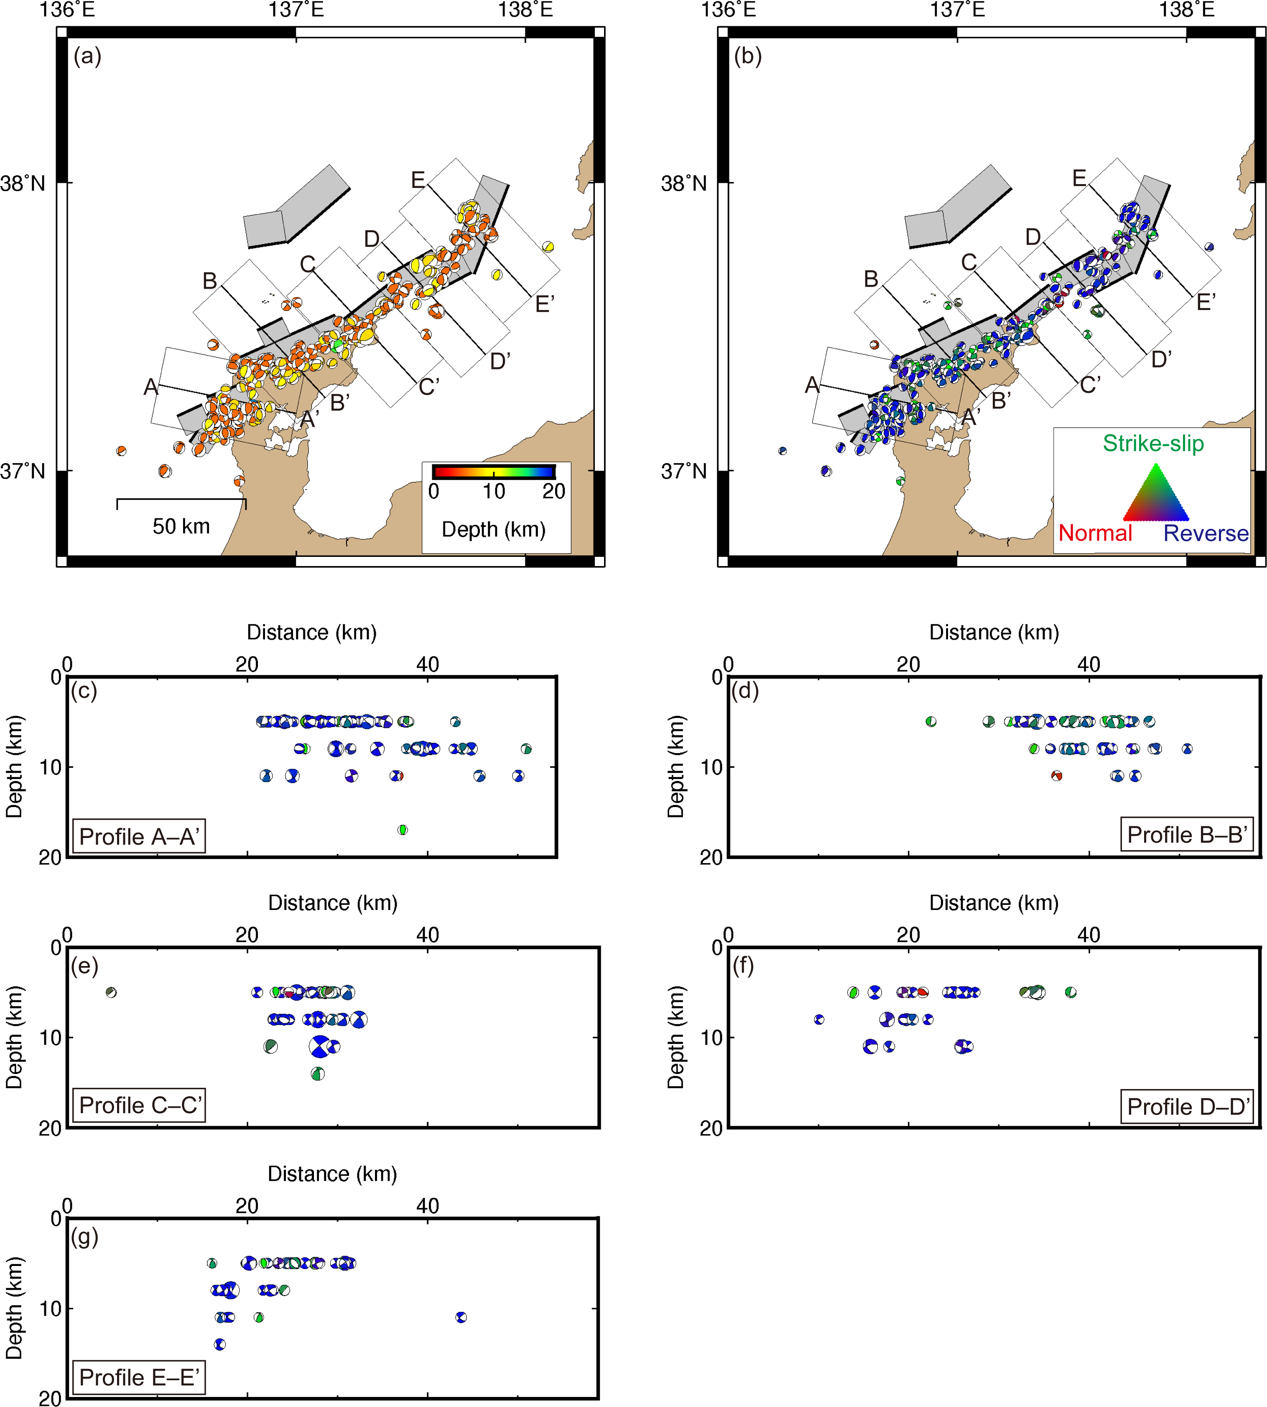
Figure S3: Spatial distribution of the F-net MT solutions. The notations are the same as in Figure 2.

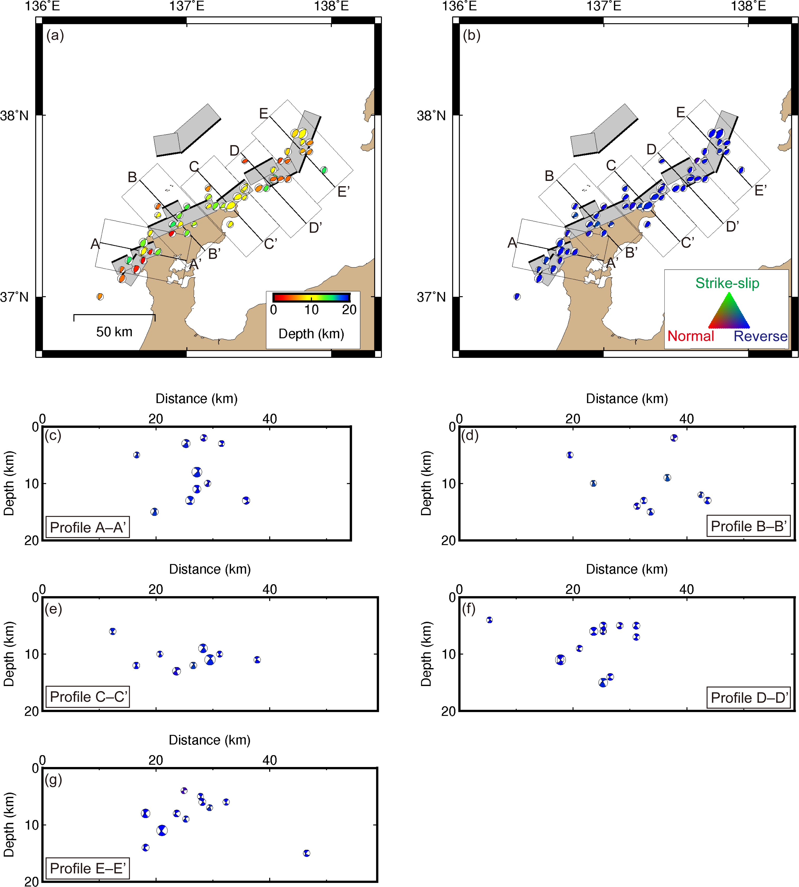
Figure S4: Spatial distribution of the obtained CMT solutions for the aftershocks of the 2024 Noto Peninsula earthquake. The earthquakes were selected whose Kagan angles with the F-net MT solution of the mainshock were less than 30º. The notations are the same as in Figure 2.
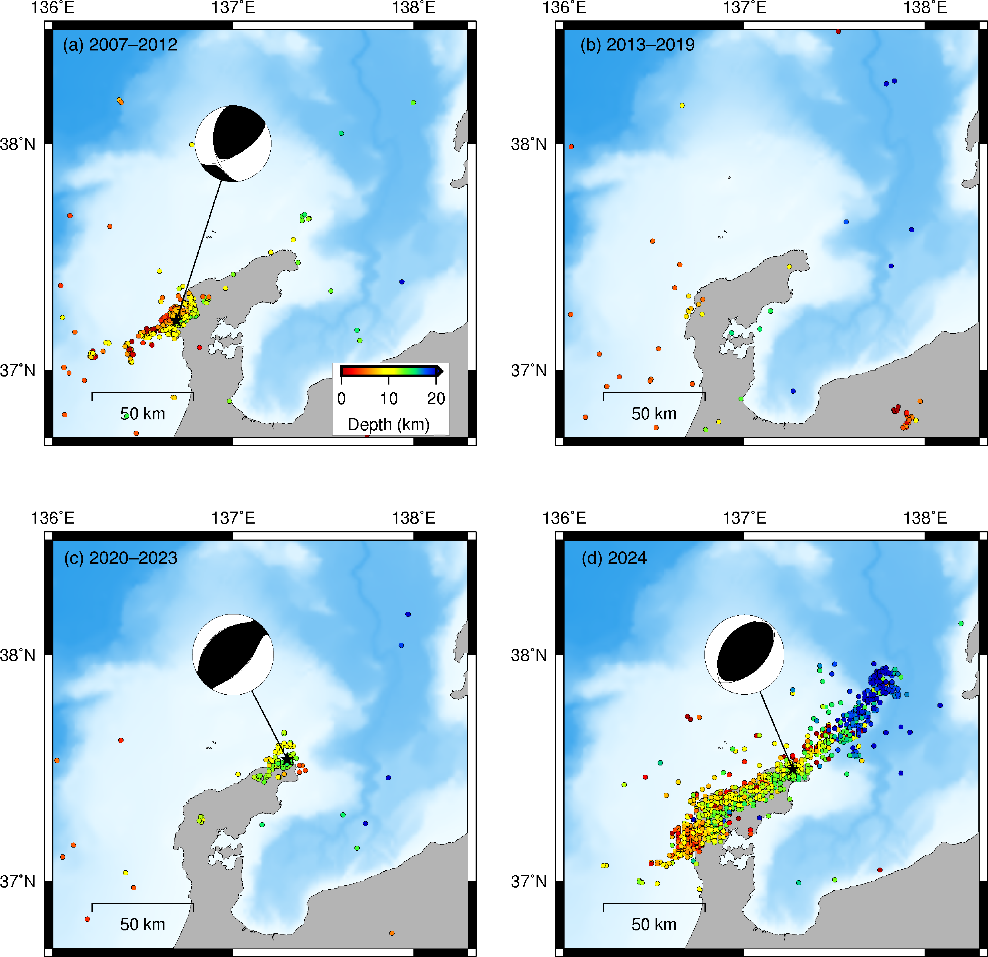
Figure S5: Seismicity distribution (a) from 2007 to 2012, (b) from 2013 to 2019, (c) from 2020 to 2023, and (d) for 2024. Black stars show the JMA hypocenters of the significant earthquakes: (a) the M_{w} 6.7 earthquake on March 25, 2007; (c) the M_{w} 6.2 earthquake on May 5, 2023; and (d) the M_{w} 7.4 2024 Noto Peninsula earthquake. Black focal mechanisms represent the F-net MT solutions. The notations are the same as in Figure 1a.
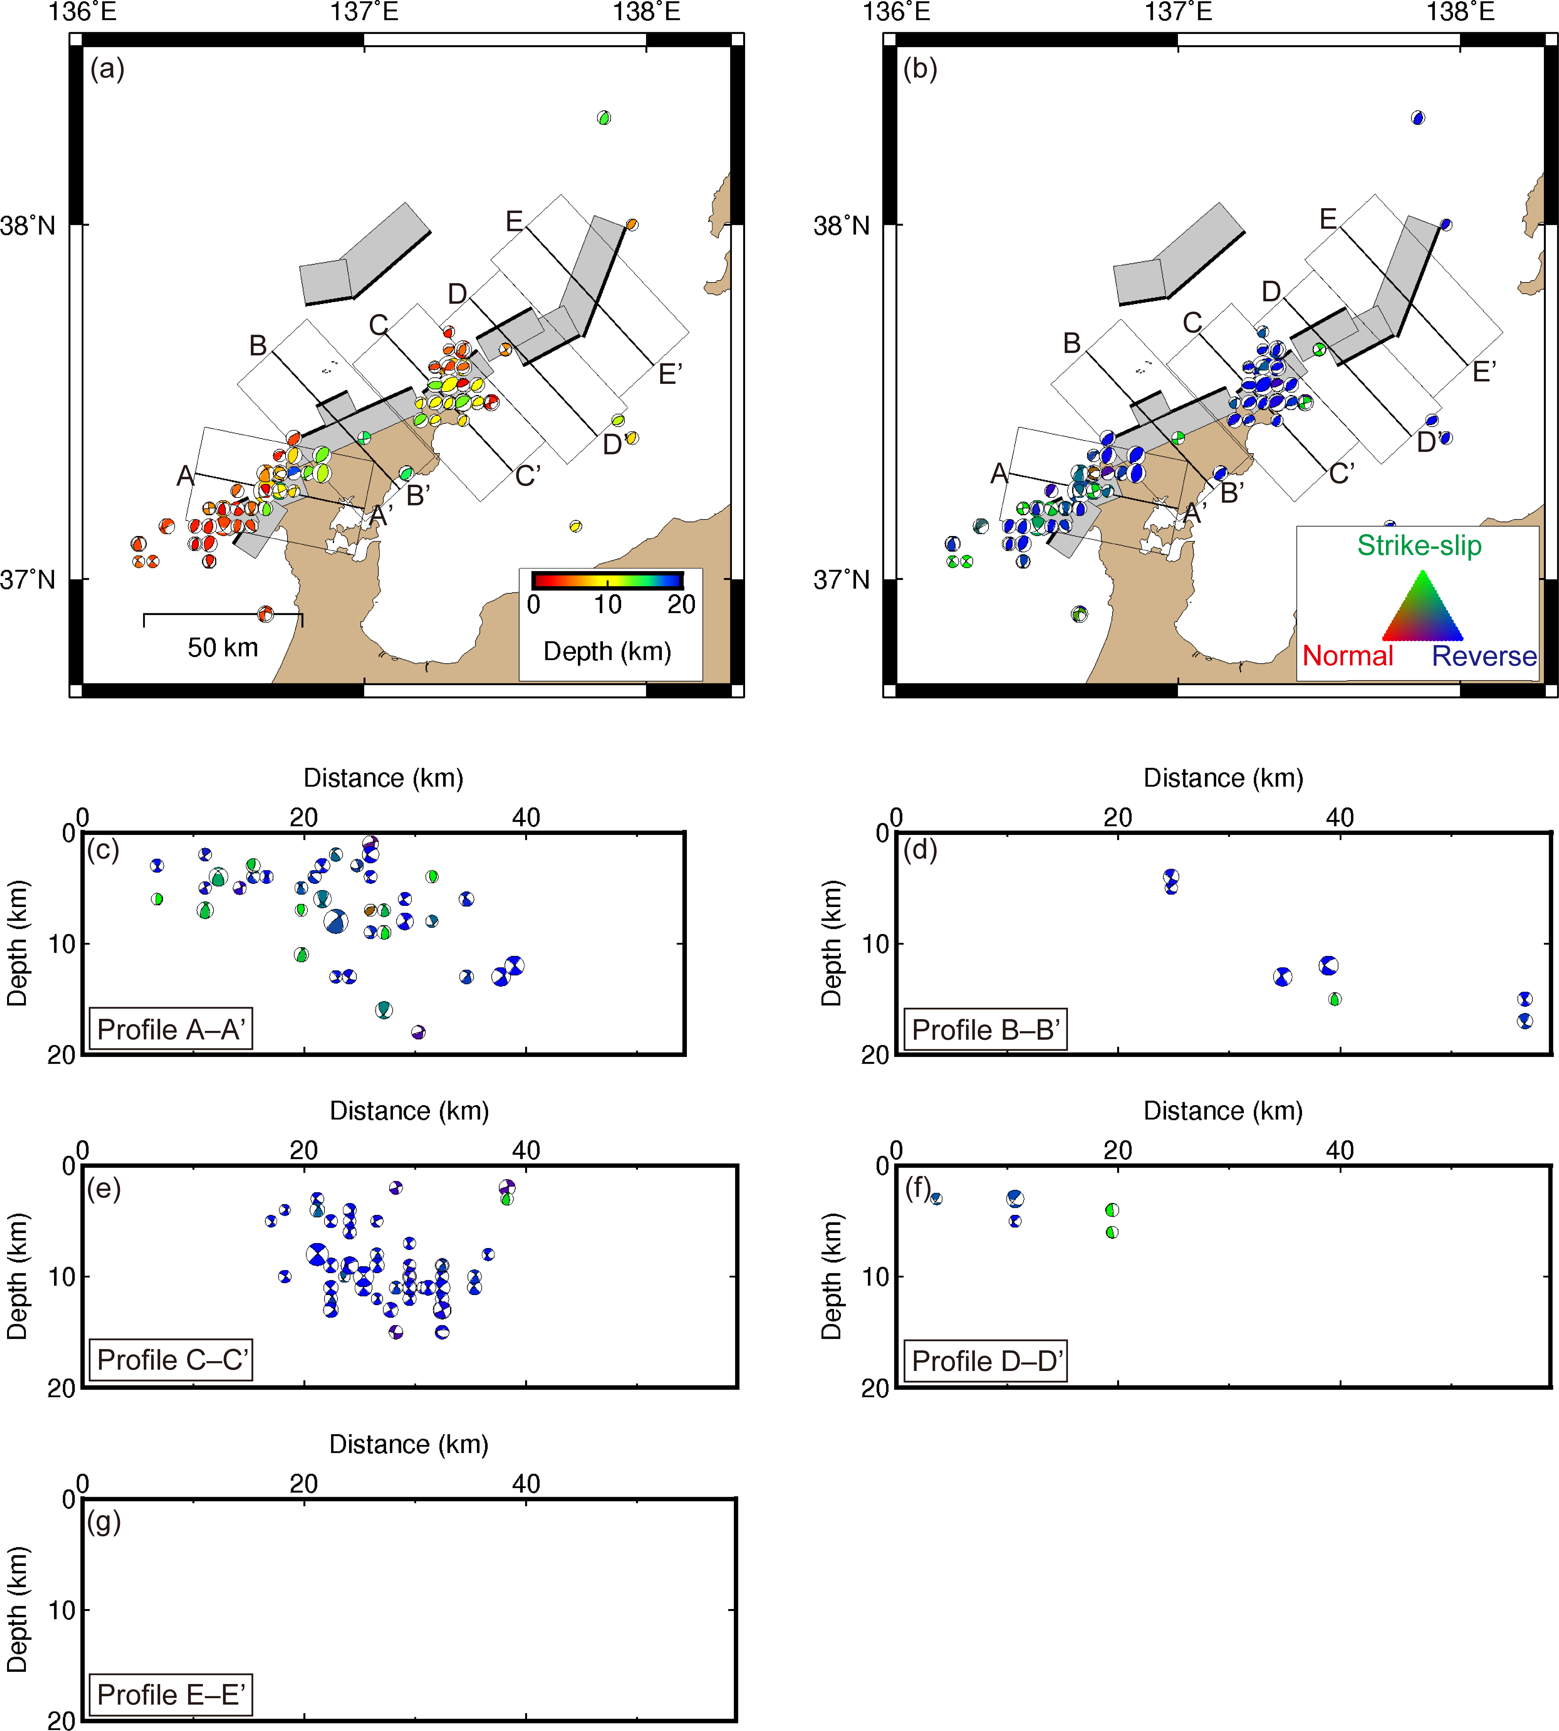
Figure S6: Spatial distribution of the 3D-CMT solutions for the earthquakes that occurred between 2007 and 2023. The notations are the same as in Figure 2.
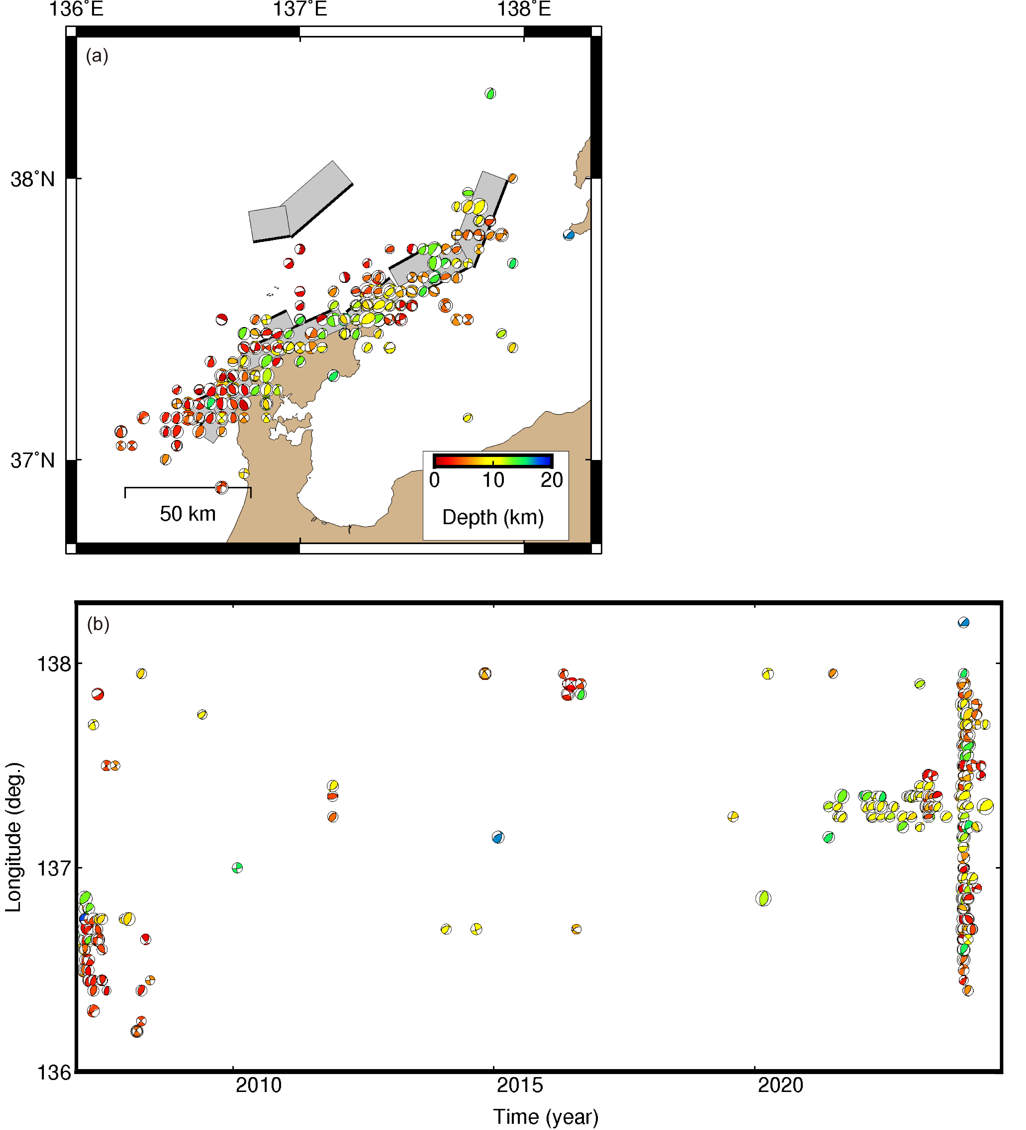
Figure S7: (a) Spatial distribution of the 3D-CMT solutions for the earthquakes that occurred from 2007 to July 10, 2024. (b) Spatial and temporal distribution of the 3D-CMT solutions.
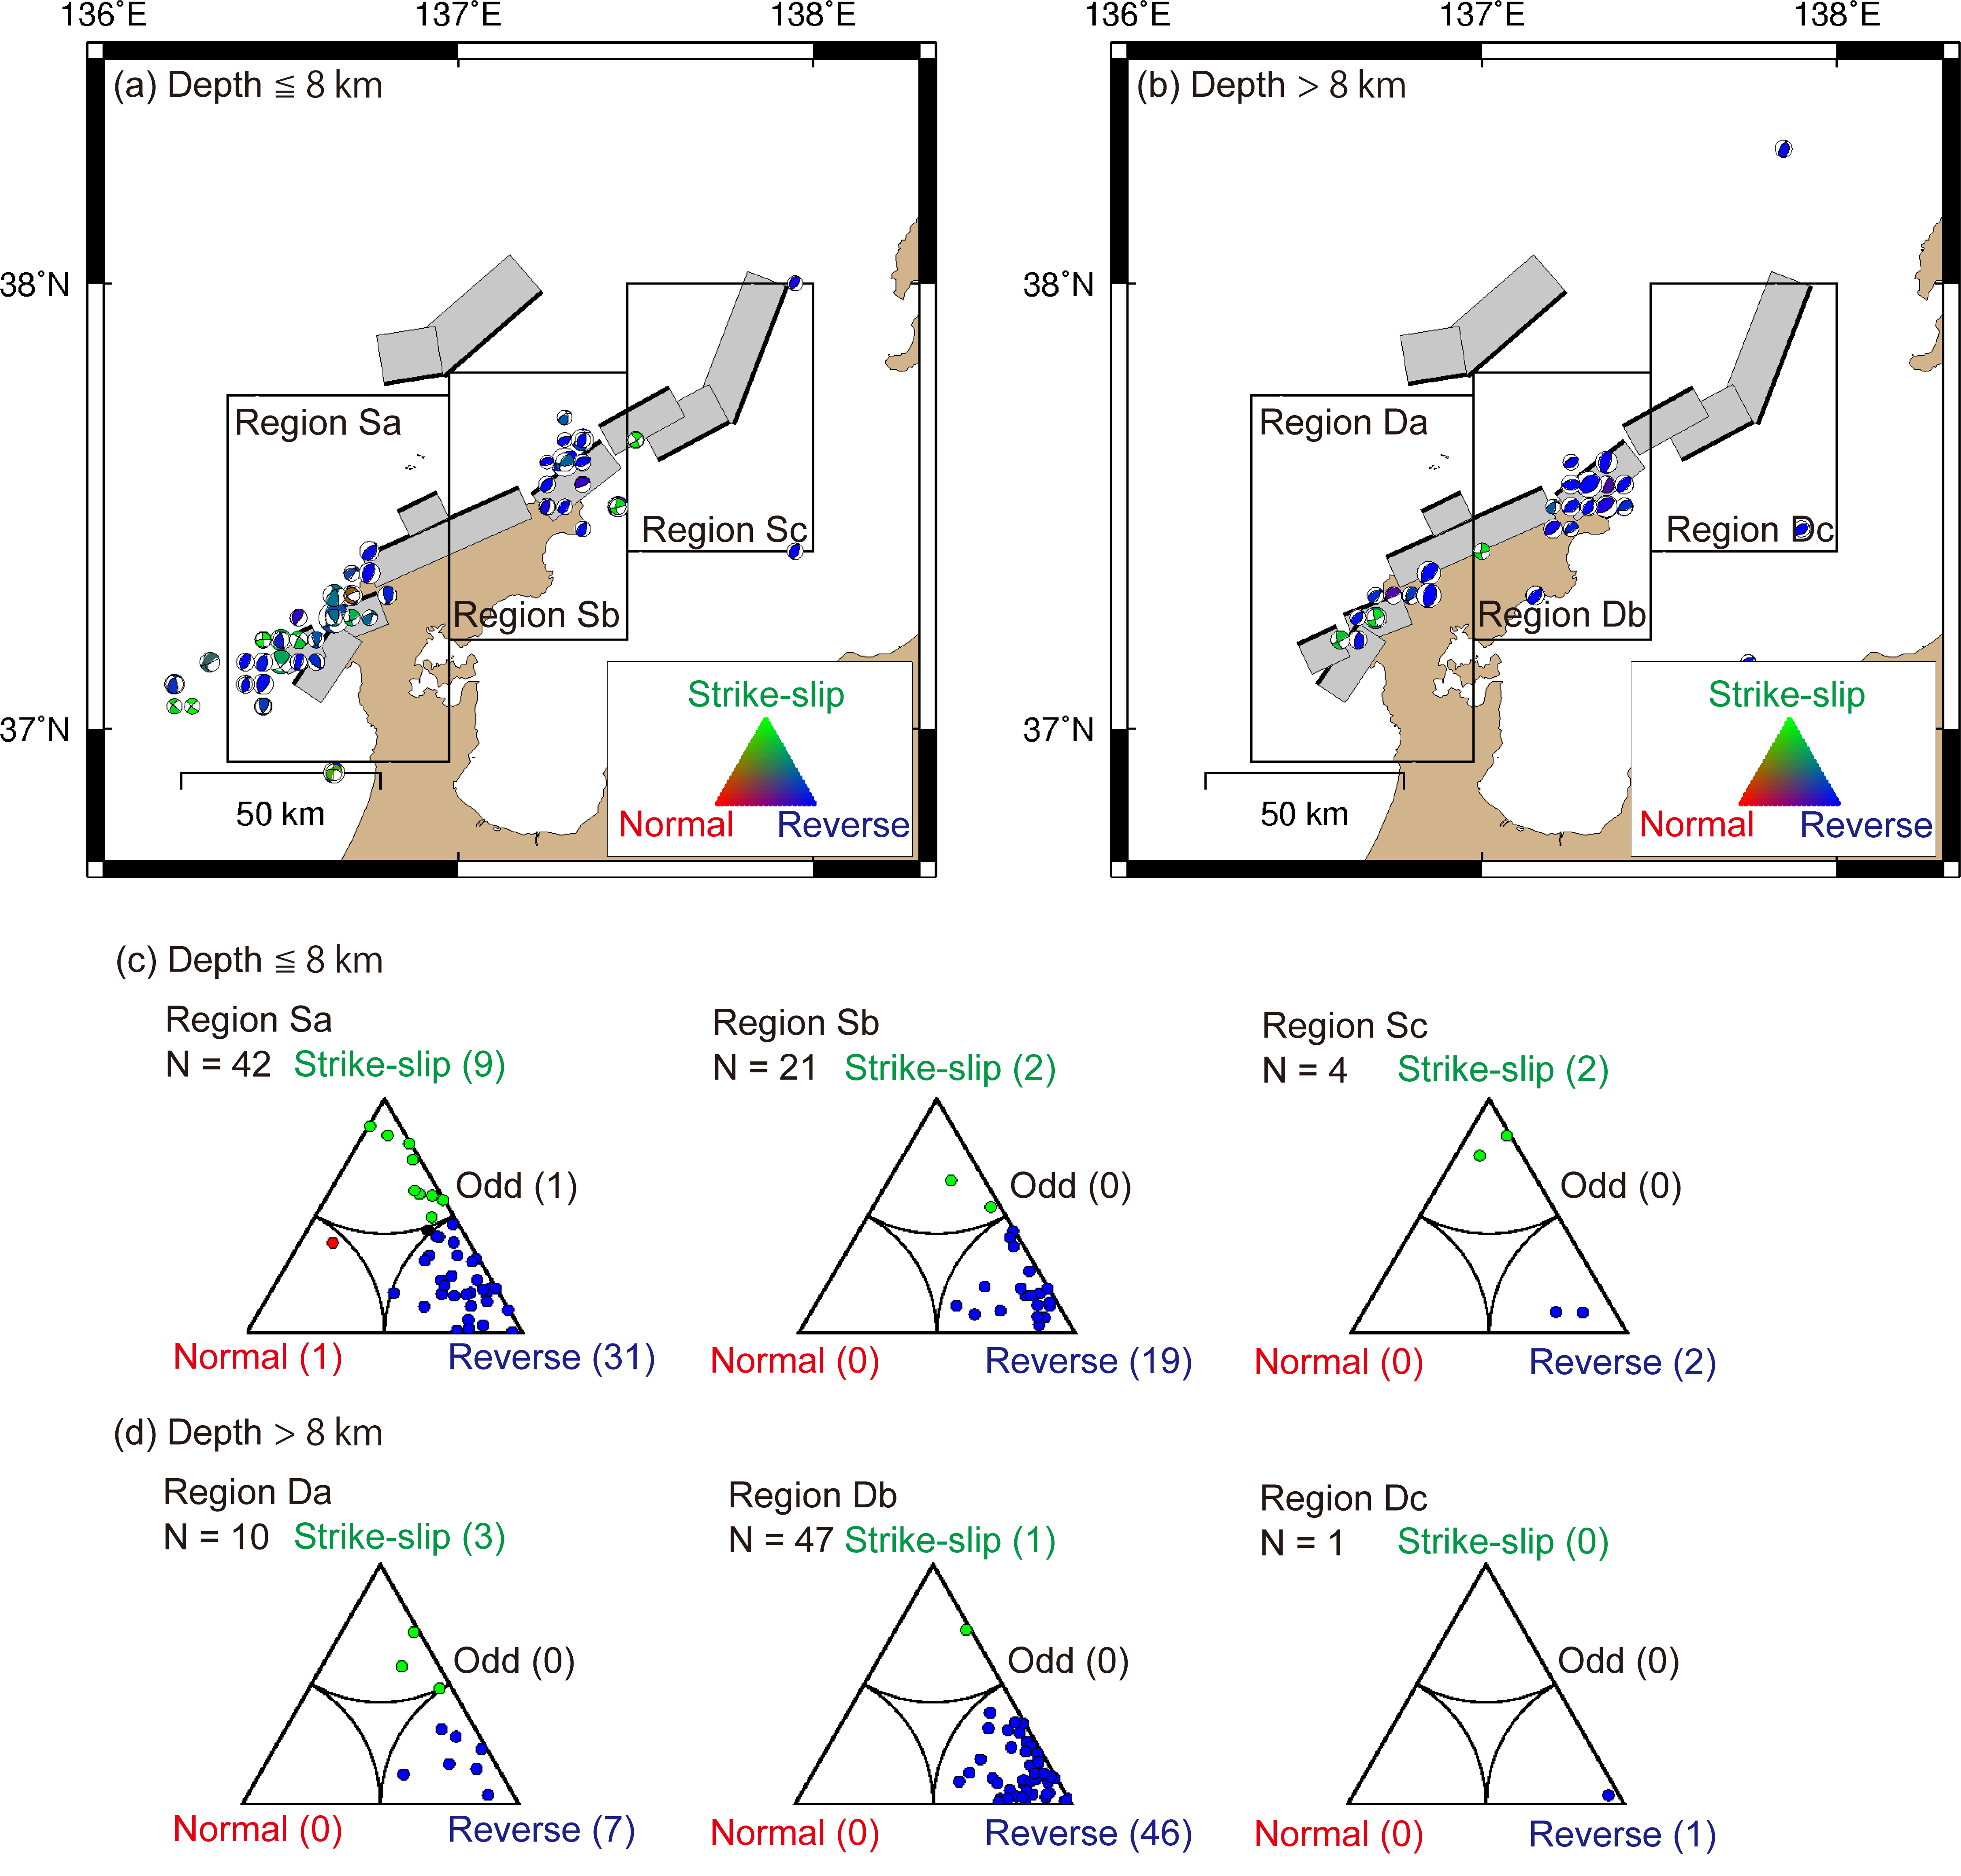
Figure S8: (a–b) Spatial distribution of the fault mechanisms for the obtained CMT solutions for the earthquakes that occurred from 2007 to 2023 at (a) 8 km or shallower and (b) deeper than 8 km. (c–d) Frohlich diagrams illustrating the types of the fault mechanisms from the 3D-CMT solutions for the earthquakes that occurred from 2007 to 2023 at (c) shallower than 8 km and (d) deeper than 8 km. The notations are the same as in Figure 4.
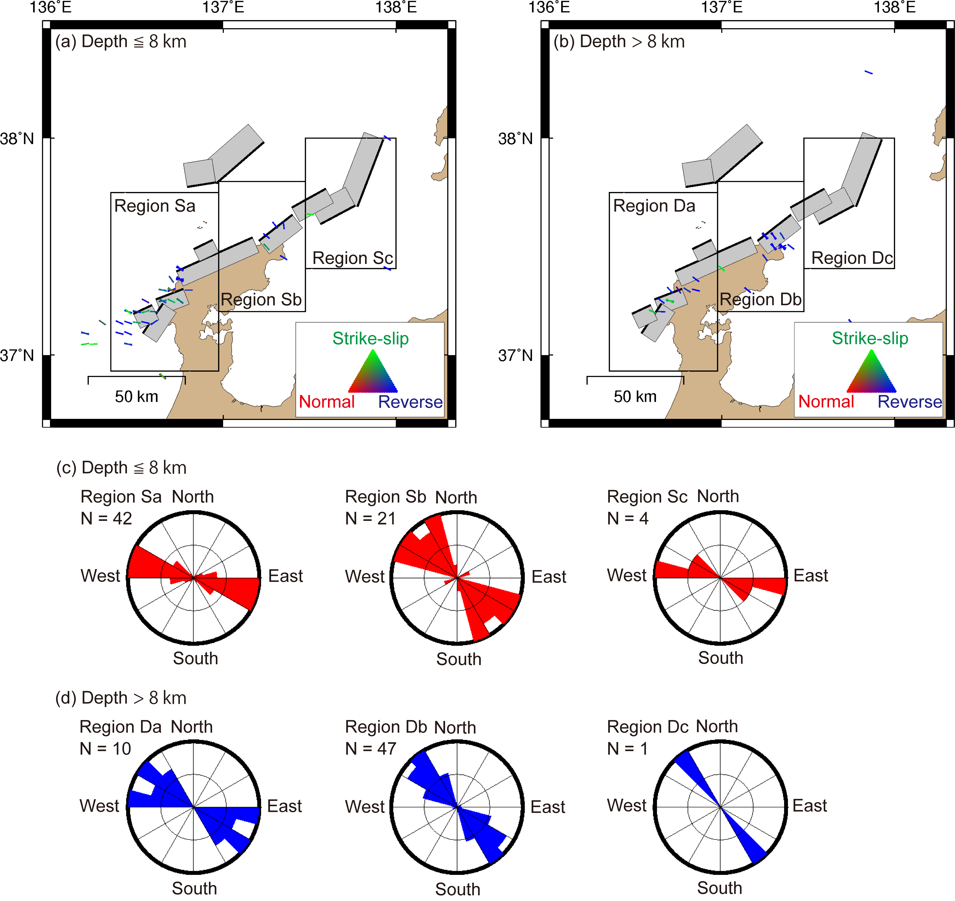
Figure S9: (a–b) Spatial distribution of the compressive axes from the 3D-CMT solutions for the earthquakes that occurred from 2007 to 2023 at (a) 8 km or shallower and (b) deeper than 8 km. (c–d) Rose diagrams illustrating the orientations of the P-axes from the 3D-CMT solutions for the earthquakes that occurred from 2007 to 2023. The notations are the same as in Figure 5.

