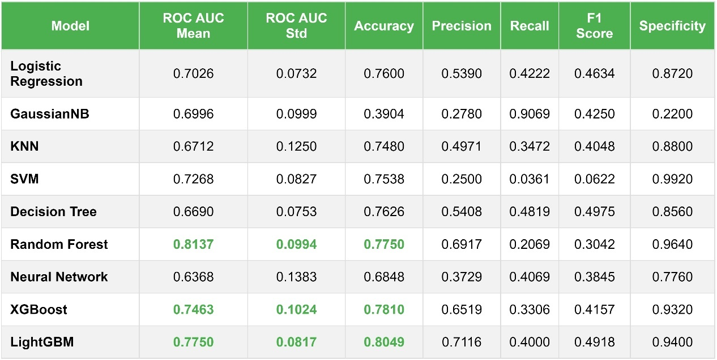
Table 2. Detailed performance metrics of nine machine learning models during 10-fold cross-validation
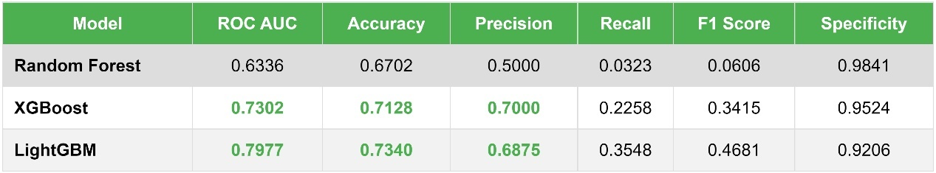
Table 3. Performance Metrics Comparison of Machine Learning Models on External Validation Dataset.
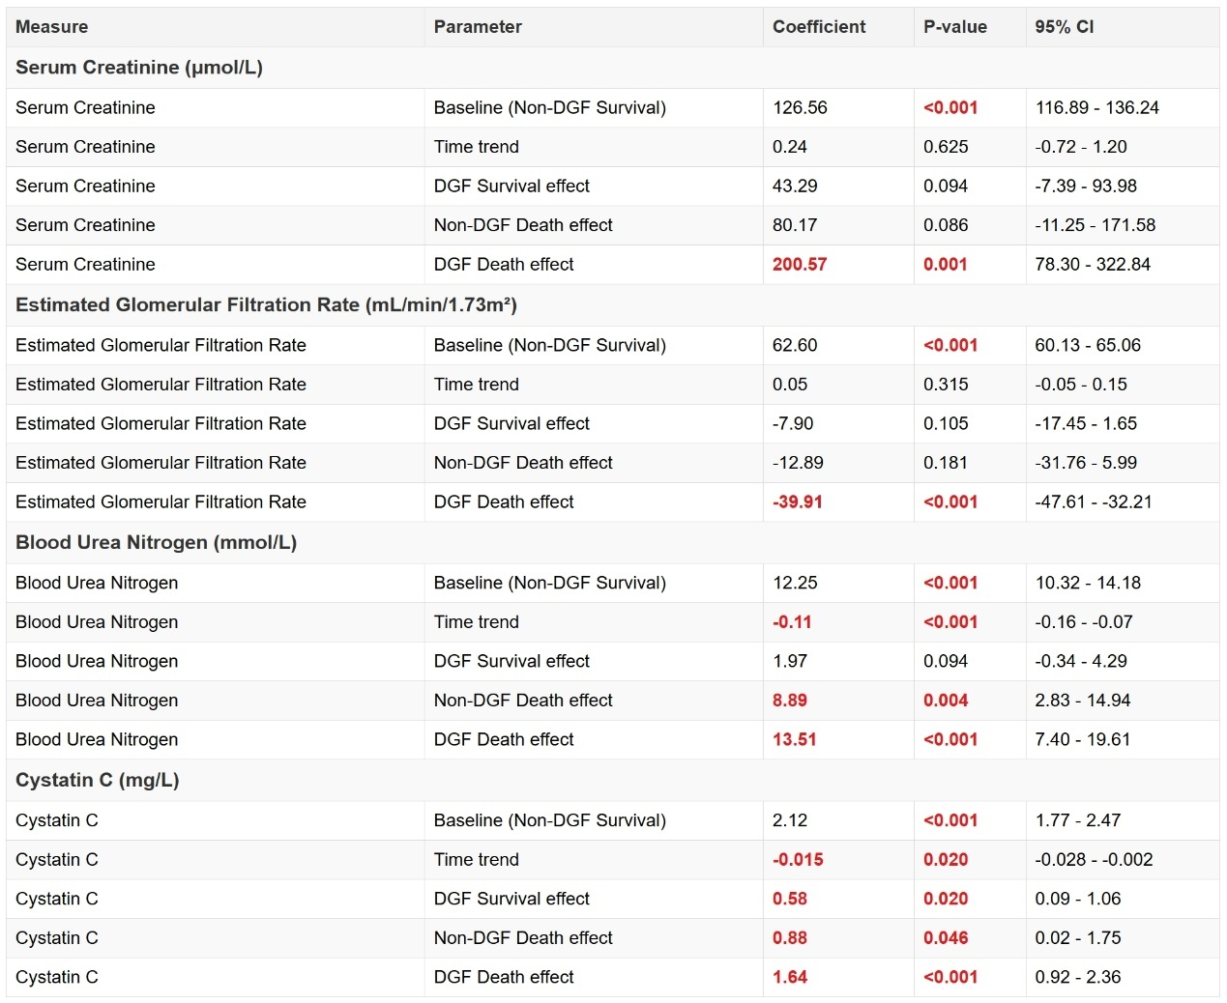
Table 3. GEE Model Analysis of Renal Function Parameters Between Groups with Non-DGF Survival as Reference.

