Supporting Figures
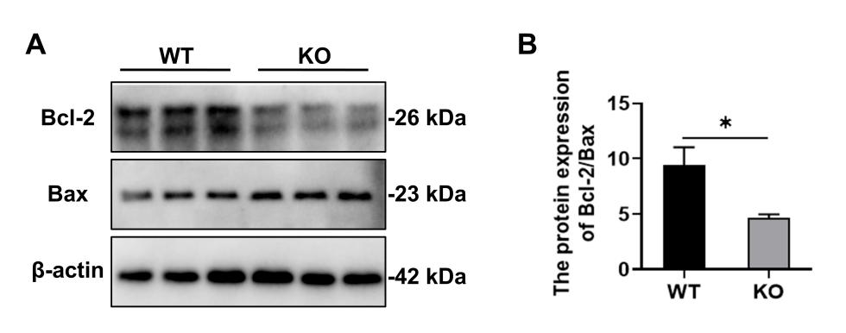
Supporting Fig.1 GPR35 ablation aggravates APAP-induced liver injury
- Western blot analysis of Bcl-2 and Bax in liver tissue from WT or Gpr35^{−/−} mice 24 hours after APAP administration.

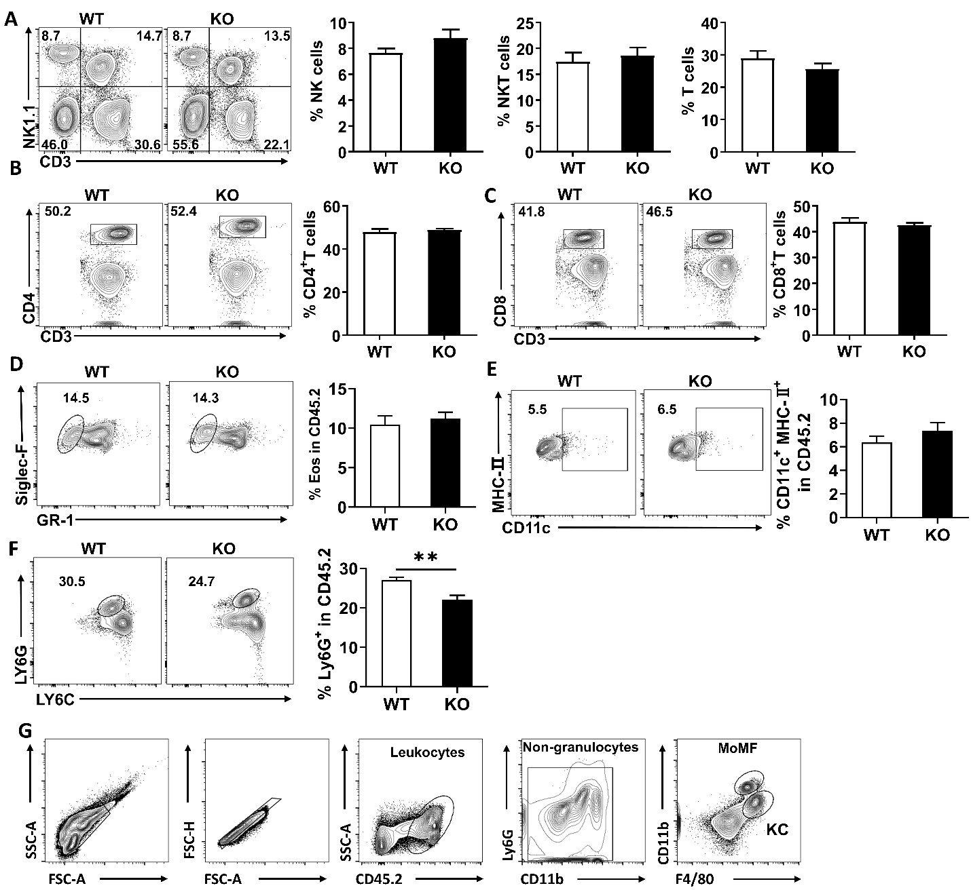
Supporting Fig.2 GPR35 deficiency does not influence hepatic lymphocyte populations after APAP challenge
- Percentages of hepatic NK cells, NKT cells and T cells in WT mice and Gpr35^{−/−} mice at 12h after APAP challenge. (B) Percentages of hepatic CD4⁺ T cells in WT mice and Gpr35^{−/−} mice at 12h after APAP challenge. (C) Percentages of hepatic CD8⁺ T cells in WT mice and Gpr35^{−/−} mice at 12h after APAP challenge. (D-F) Percentages of hepatic Neutrophil (CD11b⁺Ly6G⁺), Eosinophils (Siglec-F⁺) and DCs (MHC-Ⅱ⁺CD11c⁺) in CD45⁺ cells in WT mice and Gpr35^{−/−} mice at 12h after APAP challenge (G) Gating strategy of hepatic F4/80⁺ cells in WT mice and Gpr35^{−/−} mice at 12h after APAP challenge. The data are representative of three independent experiments and shown as the mean ± SEM. *, P < 0.05; **, P < 0.01; ***, P < 0.001.
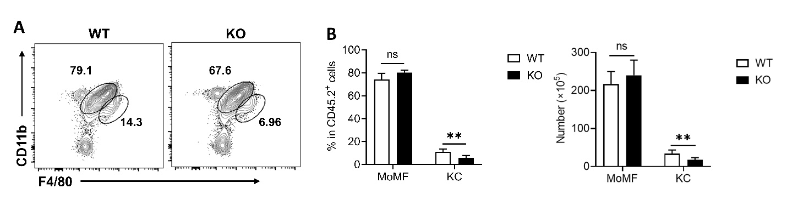
Supporting Fig.3 GPR35 ablation aggravates APAP-induced liver injury via hepatic macrophages
Frequencies of MoMFs and KCs in CD45⁺ cells from livers of WT mice and Gpr35^{−/−} mice treated with APAP. The data are shown as the mean ± SEM. *, P < 0.05; **, P < 0.01; ***, P < 0.001.

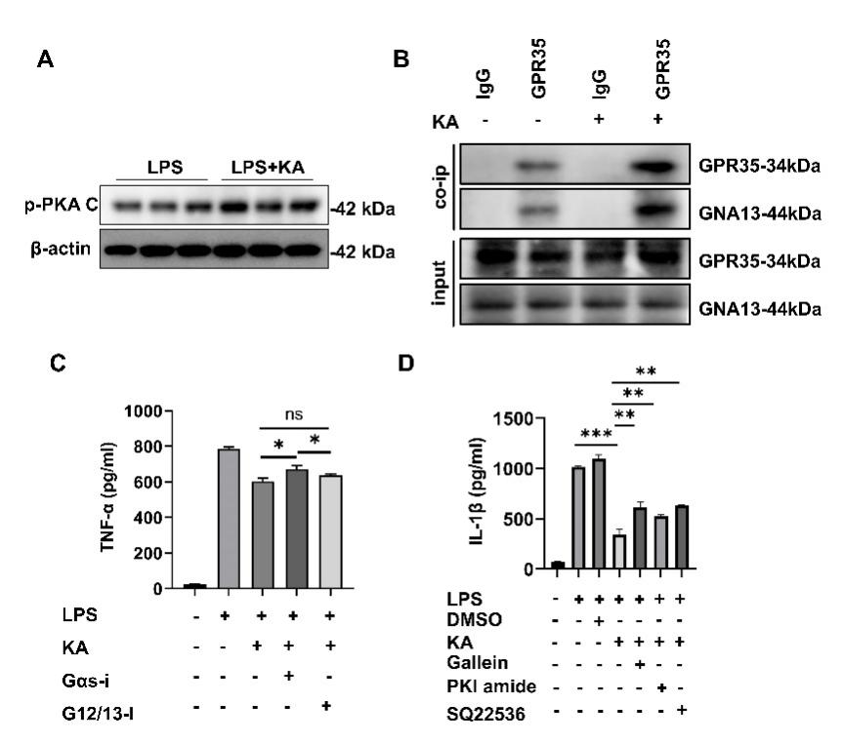
Supporting Fig.4 GPR35 dampens inflammatory signaling via the Gαs-cAMP-PKA pathway
(A) Western blot analysis of Phospho-PKA C in peritoneal macrophages from WT mice at 12 h after LPS stimulation with or without KA. (B) Co-IP detection of GPR35 and Gαs in peritoneal macrophages from WT mice stimulated with or without KA. (C) Levels of TNF-α in supernatants from peritoneal macrophages with indicated pretreatment after LPS stimulation. Gαs inhibitor or G12/G13 inhibitor was added to the culture 30 min before treatment with GPR35 agonist KA. (D) The levels of IL-1β in supernatants from peritoneal macrophages, following the indicated pretreatments and LPS stimulation, were measured. Gαs inhibitor NF449, AC inhibitor SQ22536, or PKA inhibitor PKI amide was added to the culture 30 minutes prior to treatment with the GPR35 agonist KA. The data are shown as the mean ± SEM. *, P < 0.05; **, P < 0.01; ***, P < 0.001.

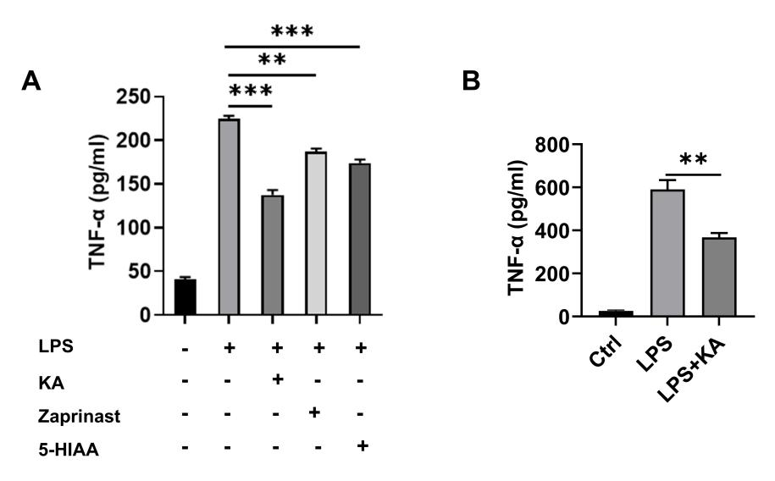
Supporting Fig.5 GPR35 agonists protect against APAP-induced liver injury
- The levels of TNF-α in supernatants from peritoneal macrophages, following the indicated pretreatments and LPS stimulation, with or without GPR35 activators KA, Zaprinast, or 5-HIAA. (B) The levels of TNF-α in the supernatants from THP-1 cells with the indicated pretreatments after LPS or LPS+KA stimulation. The data are shown as the mean ± SEM. *, P < 0.05; **, P < 0.01; ***, P < 0.001.

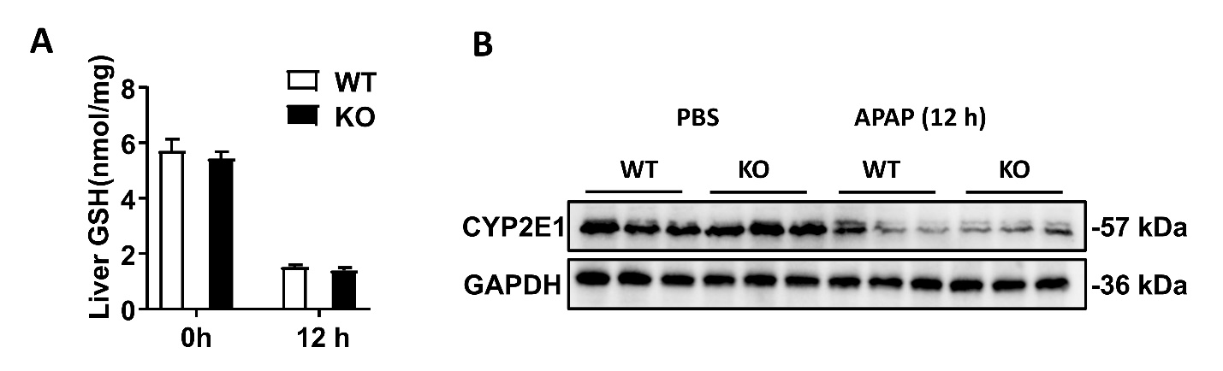
Supporting Fig.6 GPR35 deficiency does not influence the levels of hepatic GSH and CYP2E1
(A) Levels of hepatic GSH in WT mice and Gpr35^{−/−} mice at indicated time points after APAP challenge. (B) Levels of hepatic CYP2E1 in WT mice and Gpr35^{−/−} mice at 12h after APAP challenge or PBS treatment. The data are representative of three independent experiments and shown as the mean ± SEM.

Supporting table 1. Primers of genes of interest
Gene | Primer sequence
GAPDH-F | 5’-TCAACAGCAACTCCCACTCTTCCA-3’
GAPDH-R | 5’-ACCTGTTGCTGTAGCCGTATTCA-3’
TNFα-F | 5′-AATGGCCTCCCTCTCATCAGT-3′
TNFα-R | 5′-CTACAGGCTTGTCACTCGAA-3′
IL6-F | 5′-TATGAAGTTCCTCTCTGCAAGAGA-3′
IL6-R | 5′-TAGGGAAGGCCGTGGTT-3′
IL10-F | 5′-GTGAAAATAAGAGCAAGGCAGTG-3′
IL10-R | 5′-ATTCATGGCCTTGTAGACACC-3′
IL1β-F | 5′-GATCCACACTCTCCAGCTGCA-3′
IL1β-R | 5′-CAACCAACAAGTGATATTCTCCATG-3′
IL4-F | 5’-GGTCTCAACCCCCAGCTAGT-3’
IL4-R | 5’-GCCGATGATCTCTCTCAAGTGAT-3’
IL1α-F | 5’-TCTATGATGCAAGCTATGGCTCA-3’
IL1α-R | 5’-CGGCTCTCCTTGAAGGTGA-3’
MCP1-F | 5’-TAAAAACCTGGATCGGAACCAAA-3’
MCP1-R | 5’-GCATTAGCTTCAGATTTACGGGT-3’
GPR35-F | 5’-CTATGTGGCAGTGCGGCATCC-3’
GPR35-R | 5’-CAGCAGTGAGAAGGCAGTGGTG-3’

