Supplementary Table 1. Morphometry of clam P.erosa in different spawning phases
Spawning phases | Weight  (g) | Length  (cm) | Height  (cm) | Width  (cm)
Pre-spawning | 133. 88+44.69  (n=13) | 7.17+0.76  (n=13) | 6.49+0.98  (n=13) | 3.97+0.51  (n=13)
Spawning | 98.59+6.98  (n=7) | 6.63+0.11  (n=7) | 6.32+0.17  (n=7) | 3.65+0.29  (n=7)
Post-spawning | 98.19+6.38  (n=3) | 6.71+0.14  (n=3) | 6.33+0.18  (n=3) | 3.85+0.42  (n=3)

Supplementary Table 2. Geochemical parameters of ambient surface sediment (0-2 cm bss) of P. erosa
Parameters | Pre-spawning | Spawning | Post-spawning
Eh (mV) | 4.12+30.72 | -84.88+40.27 | 5.22+15.65
O₂ (μM)ª | 44.65+22.00 | 63.79+25.44 | 20.83+18.8
NO₂⁻ (μM)^{b} | 0.71+1.08 | 0.39+0.64 | 0.04+0.05
NO₃⁻ (μM) ^{b} | 1.79+1.79 | 11.82+3.98 | 0.71+0.78
NH₄⁺ (μM) ^{b} | 3.32+6.00 | 142.92+217.09 | 44.47+57.14
H₂S (μM) | 313.47+283.61 | 385+394.42 | 35.38+3.56
Iodometric sulphur  (μM) ^{b} | 42.07+72.88 | 161.23+244.13 | 35.89+84.32
TOC ( mg C g⁻¹) | 6.93+2.16 | 10.27+2.83 | 40.48+0.25
bss: below sediment surface; ªoverlying water; ^{b}pore-water ; TOC-Total organic carbon

Supplementary Table 3. Depth wise geotechnical properties of ambient mangrove sediment of
P. erosa
Depth  (cm bss) | Water content  (%) | Porosity  (%) | Specific gravity
0-2 | 7.98+0.2 | 37.07+1 | 2.32+0.02
2-4 | 8.4+0.3 | 38.82+2 | 2.31+0.2
4-6 | 8.69+0.4 | 28.40+21 | 1.67+0.9
6-8 | 8.49+0.02 | 41.52+8 | 2.44+0.3
8-10 | 7.68+0.1 | 36.3+1.5 | 2.36+0.2
bss: below sediment surface

Supplementary Table 4. PERMANOVA showing extent of variation in bacterial parameters across phases and tissues of P. erosa.
Parameters | Source of variation | P-value | Source of variation | P-value
TBC | Phases  (pre-spawning: 22, spawning: 14, post-spawning: 5) | 0.001 | Tissues  (n= gill: 16, foot: 13,  mantle: 12) | 0.993
TVCa | Phases  (pre-spawning: 23, spawning: 15, post-spawning: 3) | 0.001 | Tissues  (n=gill: 15, foot: 13,  mantle: 13) | 0.894
TVCan | Phases  (pre-spawning: 23, spawning: 15, post-spawning: 5) | 0.001 | Tissues  (n=gill: 16, foot: 14,  mantle: 13) | 0.89
CFU | Phases  (pre-spawning: 94, spawning: 40, post-spawning: 15) | 0.016 | Tissues  (n=gill: 52, foot: 51,  mantle: 46) | 0.007
TBC-Total bacterial count; TVCa-Total viable count (aerobic); TVCan-Total viable count (anaerobic); CFU-colony forming unit

Supplementary Table 5. PERMANOVA showing extent of variation in S₂O₃²⁻ and HCO₃⁻ uptake rate in tissues across phases.
Parameters | Source of variation | P-value
S₂O₃²⁻ uptake rate | Gill (pre-spawning (n=27), spawning (n=20), post-spawning (n=12)) | 0.001
 | Foot (pre-spawning (n=28), spawning (n=21), post-spawning (n=12)) | 0.001
 | Mantle (pre-spawning (n=26), spawning (n=20), post-spawning (n=12)) | 0.001
HCO₃⁻uptake rate | Gill (pre-spawning (n=3), spawning (n=3), post-spawning (n=2)) | 0.113
 | Foot (pre-spawning (n=3), spawning (n=3), post-spawning (n=2)) | 0.425
 | Mantle (pre-spawning (n=3), spawning (n=3), post-spawning (n=2)) | 0.495

Supplementary Table 6. PERMANOVA showing extent of variation in S₂O₃²⁻ and HCO₃⁻ uptake rate in phases across tissues.
Parameters | Phases | P-value
S₂O₃²⁻ uptake rate | Pre-spawning (gill (n=27), foot (n=28), mantle (n=26)) | 0.448
 | Spawning (gill (n=20), foot (n=21), mantle (n=20) | 0.113
 | Post-spawning (gill (n=12), foot (n=12), mantle (n=12) | 0.003
HCO₃⁻uptake rate | Pre-spawning (gill (n=3), foot (n=3), mantle (n=3)) | 0.742
 | Spawning (gill (n=3), foot (n=3), mantle (n=3)) | 0.08
 | Post-spawning (gill (n=2), foot (n=2), mantle (n=2)) | 0.649

Supplementary Table 7. Sampling frequency of clam P. erosa in different spawning phases
Pre-spawning  (No. of sampling : 5) |  |  |  |  |  | Spawning  (No. of sampling: 3) |  |  | Post-spawning  (No. of sampling: 2)
Jan  (2014) | Feb  (2013) | Mar | Apr | May  (2014) | Jun  (2013,  2015) | Jul  (2014) | Aug  (2014) | Sep  (2014) | Oct  (2013) | Nov | Dec  (2014)

Supplementary Information

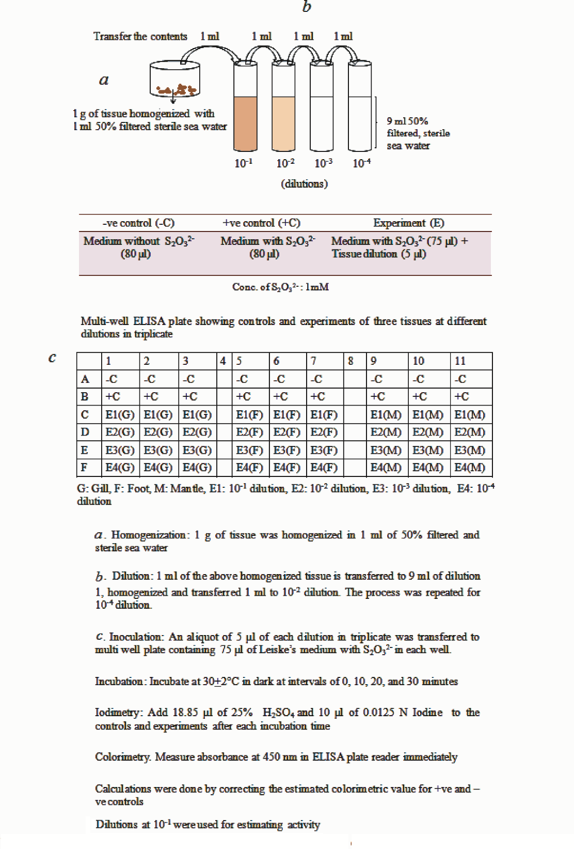
Supplementary Fig. 1. Flow diagram for measuring S₂O₃²⁻ uptake rates using multi-well Elisa plate

Supplementary Document 1
Estimation of S₂O₃²⁻ uptake rate in clam tissues
Most probable numbers (MPN) method used for measuring S₂O₃²⁻ was suitably adopted for colorimetric estimation in multiwell plates for assessing the activity of S₂O₃²⁻ utilizing bacteria. In detail, tissue samples were homogenized as described before in section 2.3 and serially diluted up to 10⁻⁴. Leiske’s medium 75 µl containing 1 mmole of Na₂S₂O₃. 5H₂O was added to each well in the microplate in triplicate and inoculated with 5 μl of sample from each dilution of homogenized tissue. Positive controls of 80 µl of S₂O₃²⁻ containing medium without inoculum and negative controls of medium (80 µl) without S₂O₃²⁻ and inoculum were maintained. The plates with the contents were incubated at 30±2 °C for 0, 10, 20 and 30 min. prior to the measurement,at each time interval, appropriate volume of 25% H₂SO₄ was added to give a final concentration of 6% to eliminate interference from phenolic compounds. It was then followed by the addition of 10 µl of 0.0125N iodine (ASTM 1978). The absorbance was measured at 450 nm in ELISA plate reader (Model 680 microplate Reader S/N 19667 Bio-Rad laboratories). Calculations were done using a constant derived from standards run as above. S₂O₃²⁻ uptake and release rates were measured based on increase and decrease in level of added S₂O₃²⁻respectively in the inoculated medium. These changes in the concentrations of added S₂O₃²⁻were corrected with reference to the measured concentration of S₂O₃²⁻ in the positive control (medium+S₂O₃²⁻) to confirm its utilization and release. The rates were calculated from the triplicate values of the inoculated set of the first dilution (Supplementary Fig. 1).
Estimation of HCO₃⁻ Uptake (¹⁴C uptake) in clam tissues
Experiments were carried out for HCO₃⁻ uptake after initial standardization for substrate concentration and incubation time. Tissue samples were incubated for 0, 10, 20 and 30 min. Briefly, 0.1 g of each tissue (gill, foot and mantle) was incubated separately in 0.9 ml of Leiske’s medium. The medium contained 1mmole of NaS₂O₃.5H₂Oand 0.01 µ Ci ml⁻¹ of NaH¹⁴CO_{3.} The contents were incubated at 30+2°C in the dark. Suitable controls for tissue (gluteraldehyde (2.5%) fixed tissue kills associated bacteria) (Pimenov et al. 2002) and ethanolamine (absorbant for inorganic carbon) for added labeled carbon were included (Knap et al. 1996). The samples and controls were filtered through 0.22 μm GSWP (Millipore) filter paper. The filter papers were further acidified by adding 2 to 3 drops of 1N HCl to eliminate the physically adsorbed labeled carbon. About 4 ml of scintillation cocktail (Aqualight for HIDEX liquid scintillation counter) was added to the samples, controls and blanks, 24 hours prior to the measurement of radioactivity. The incorporation of labeled carbon in tissues was read as disintegration per minute using HIDEX Triathler scintillation counter. The rates were estimated by applying the modified calculation for HCO₃⁻ uptake of tissues derived from the basic JGOFS (Joint Global Ocean Flux Study) protocol of inorganic carbon assimilation (Pimenov et al. 2002). Apart from DPM (disintegration per minute), time of incubation, volume of sample filtered, dissolved inorganic carbon (DIC) of Mandovi estuarine water, amount of tissue used, were taken into consideration for the calculation of rates as follows:
mg C m⁻³ d⁻¹ | - =DPM/V * W * 0.25/1000 * 1/TDPM * 1.05/T
Where, DPM | - : DPM (sample)-DPM (control)
V | :Volume filtered
W | - : DIC concentration in Mandovi estuarine water (361 μM) (Sarma et al. 2012)
0.25/1000 | - : Conversion of pipetted volume (ml) of control (gluteraldehyde fixed tissue) for TDPM to liters
TDPM | : Total Disintegration Per Minute of ethanolamine containing added ¹⁴C
1.05 | :Correction for the lower uptake of ¹⁴C compared to ¹²C (as per standard protocol)
T | : Time in days (expressed incubation time in day by dividing with 24 hours as per JGOFS protocol)
Uptake rates are expressed in nmole C g dry wt⁻¹ h⁻¹. Separately, dry weight of tissues were calculated from a conversion constant obtained by measuring the wet and dry weight of a series of different tissues of gill, foot and mantle (n=5 each) as mentioned earlier. This procedure was adopted to minimize radioactive contamination.

