Supplementary information of
Water Droplets Driven by the Giant Surface Potential of Organic Films
Tsuyoshi Tsujioka¹*, Hiroyuki Kawashima², Kenji Koike², Naoki Matsumoto², Junwei Shen³, and Shinichiro Nakamura³
¹Division of Math, Sciences, and Information Technology in Education, Osaka Kyoiku University, 4-698-2, Asahigaoka, Kashiwara, Osaka 582-8582, Japan
E-mail: tsujioka@cc.osaka-kyoiku.ac.jp
²Tosoh Corp., 2743-1, Hayakawa, Ayase, Kanagawa 252-1123, Japan
³Priority Organization for Innovation and Excellence, Kumamoto University, 2-39-1, Kurokami, Chuo, Kumamoto 860-8555, Japan

Keyword: organic film; vacuum deposition; droplet moving, giant surface potential; glass transition temperature

Driving Force Illustration of Water-Droplet Movement in Fig. 1d
Figure S1a illustrates the driving force behind water droplet movement shown in the left panel of Fig. 1d. As a droplet approaches the edge of the PTAA film, it is pulled back by the attractive force from the opposing surface potential, similar to being reflected.
Figure S1b provides the driving force illustration for the right panel of Fig. 1d. When water droplet A approaches another droplet B, the lower surface potential of droplet B reduces the driving force that would otherwise attract droplet A. As a result, droplet A comes to a stop. Conversely, droplet B initially remains stationary due to a balance in surface potentials on its left and right sides. However, when droplet A approaches, this balance is disrupted, generating a driving force that pushes droplet B away from droplet A, causing droplet B to move in response.

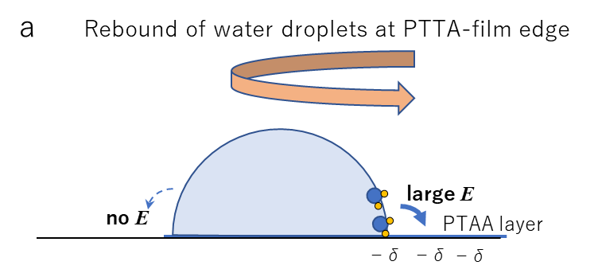

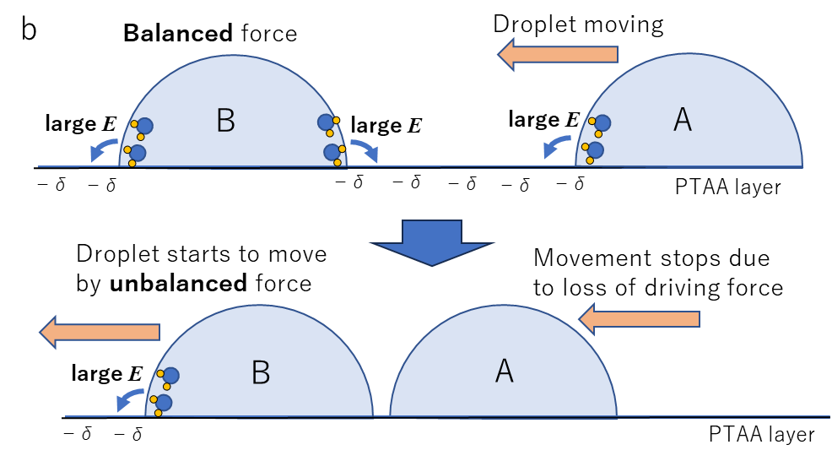

Fig. S1 (a) Driving force illustration on water droplet “reflection” at PTAA film edge. (b) Driving force illustration on water droplet “repulsion” between multiple water droplets like “slow billiards”.
Calculated Permanent Molecular Dipole Moment (PDM), Molecular Volumes, and Their Relationship to the Glass Transition Temperature (Tg)
The structures of various organic molecules used in this study are shown in Fig. S2. The results of the PDM calculations for the main diarylethenes and PTAA are shown in Fig. S3 and detailed in Table S1. Diarylethenes (DAEs) undergo ring-closing and ring-opening reactions upon photoirradiation. Some molecules exhibit significant changes in PDM during isomerization, while others show minimal changes. All films formed by vacuum deposition were in the ring-open form, a detail that will be discussed further later. The molecular volume was calculated using Gaussian Molar Volume and COSMO-RS Molar Volume. The results of these molecular volume calculations are summarized in Table S2.

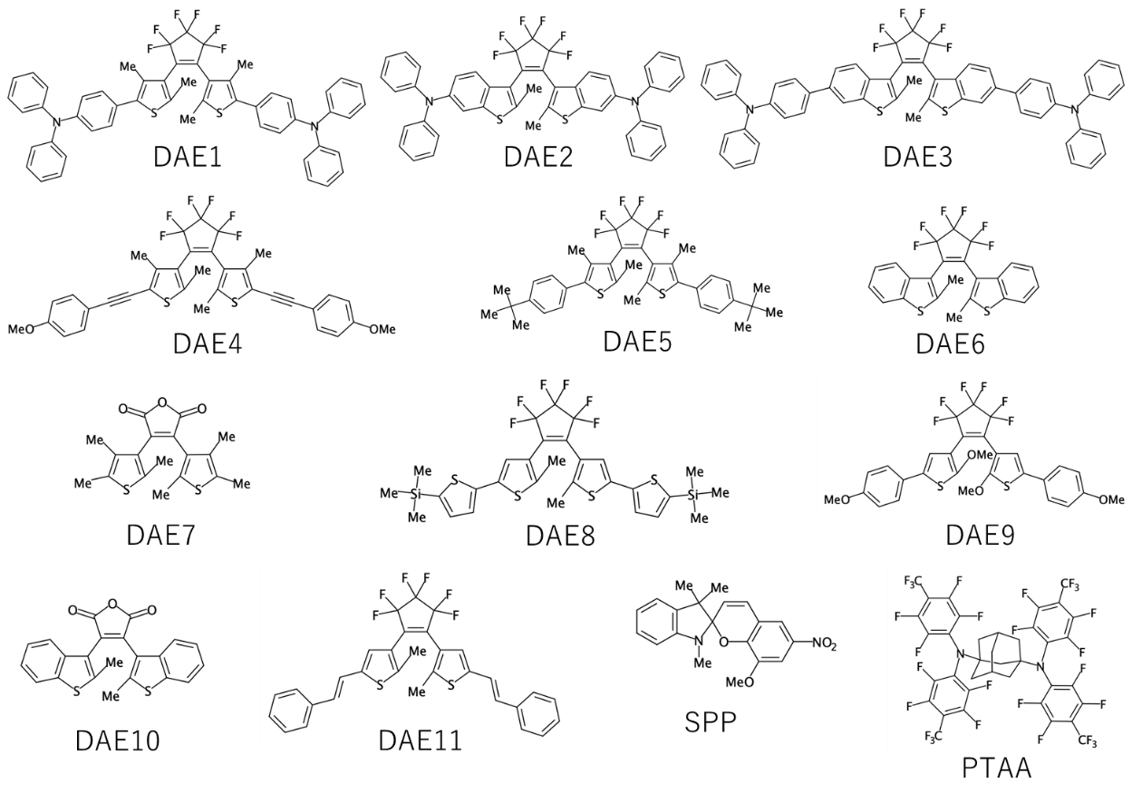
Fig. S2 Molecular structures of materials

Surface potential measuring device using electrostatic induction
Figure S3a illustrates the experimental setup used to measure the surface potential in this study. A portable surface potential measurement device (KSD-3000, Kasuga Electric Co., Ltd.) was placed inside an electrostatic shielding container and positioned such that the distance between the measurement sample surface and the probe was 10 mm.
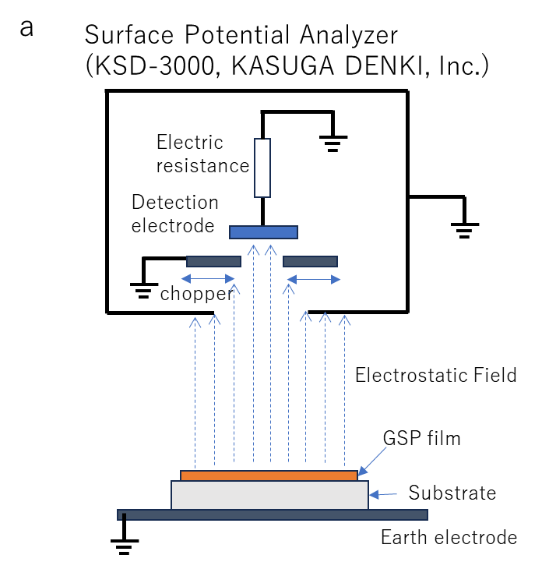
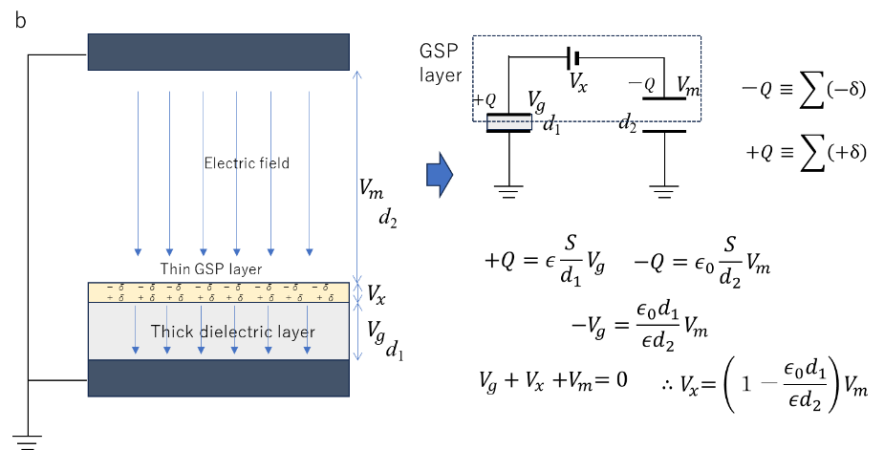
Figure S3b present a model of the measurement system, specifically focusing on the effects of applying a GSP film to a dielectric substrate, such as glass, on surface potential measurements. The system is modeled as two parallel capacitors: the GSP layer acts as a constant voltage source (V_{x}), while the electrodes form two capacitors with top and bottom earth electrodes. V_{x} can be derived from the measurable V_{m}. For a glass substrate with a thickness of 1.0 mm and a relative permittivity of approximately 5, the error is around 2%, which is smaller than the measurement error and can be considered negligible. Calibration of this measurement device was conducted using the known GSP measurements of the Alq3 film.

Fig. S3 (a) Surface potential measuring device using electrostatic induction. (b) Concept of surface potential measurement when the substrate is an insulator such as a glass substrate and two capacitor model of measurement system.

GSP slopes, PDMs, relative permittivity, and molecular orientations
Figure S4 presents data on Tgs, the GSP slopes, PDM calculation results, relative permittivity, and the mean molecular orientation <cosθ> for vacuum-deposited films of various materials. <cosθ> was determined using equation (1).
$Measured surface potential=\frac{1}{ε_{0}ε_{r}}\frac{p〈\cos{θ}〉}{v_{m}}d$ (1),
where p represents PDM, v_{m} denotes molar volume, ε₀ and εᵣ correspond to the permittivity of vacuum and relative permittivity, respectively, and d indicates the thickness of the GSP layer.

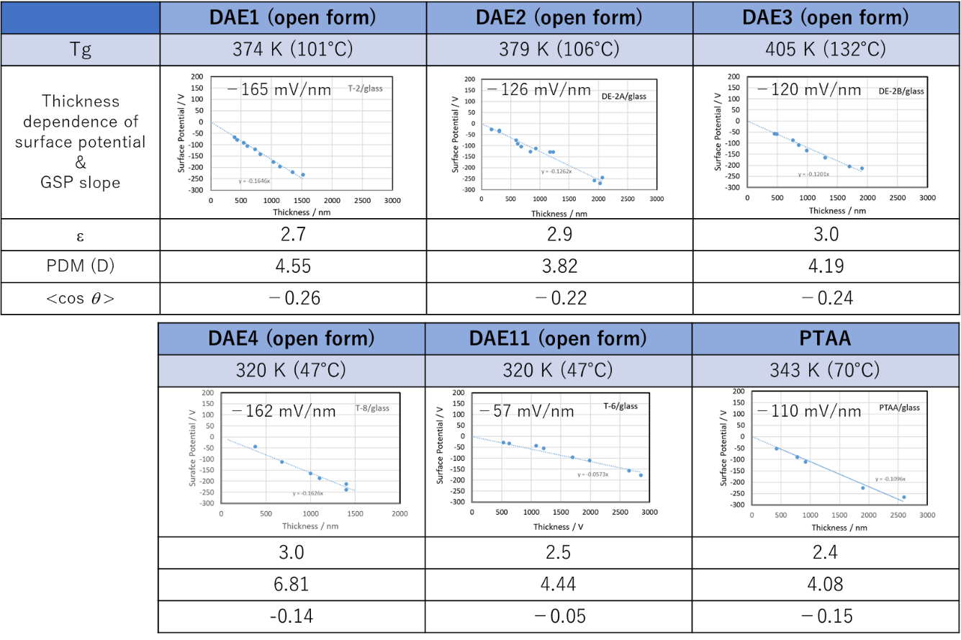
Fig. S4 (a) Materials exhibiting negative GSP slope.

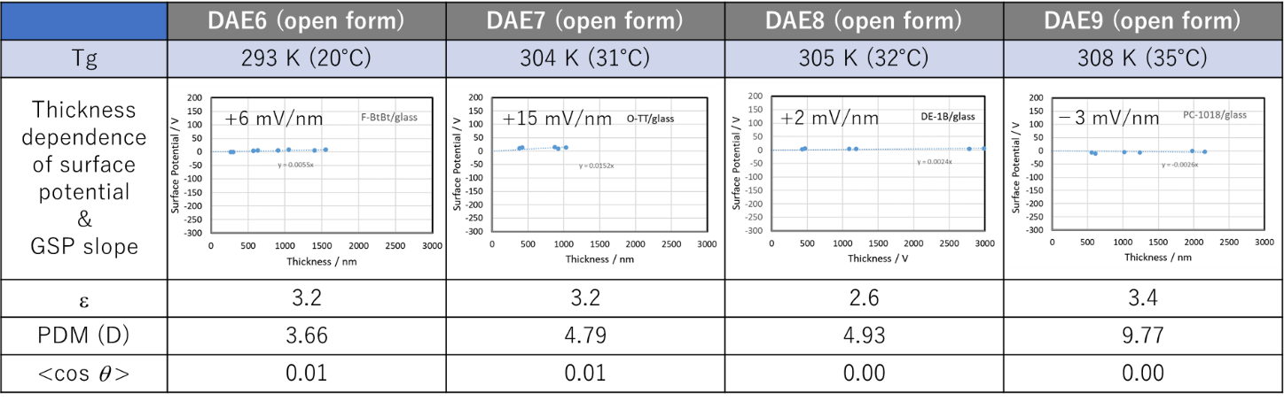
Fig. S4 (b) Materials exhibiting nearly-zero GSP slope.

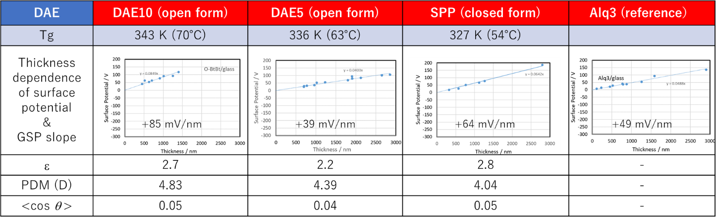
Fig. S4 (c) Materials exhibiting positive GSP slope.

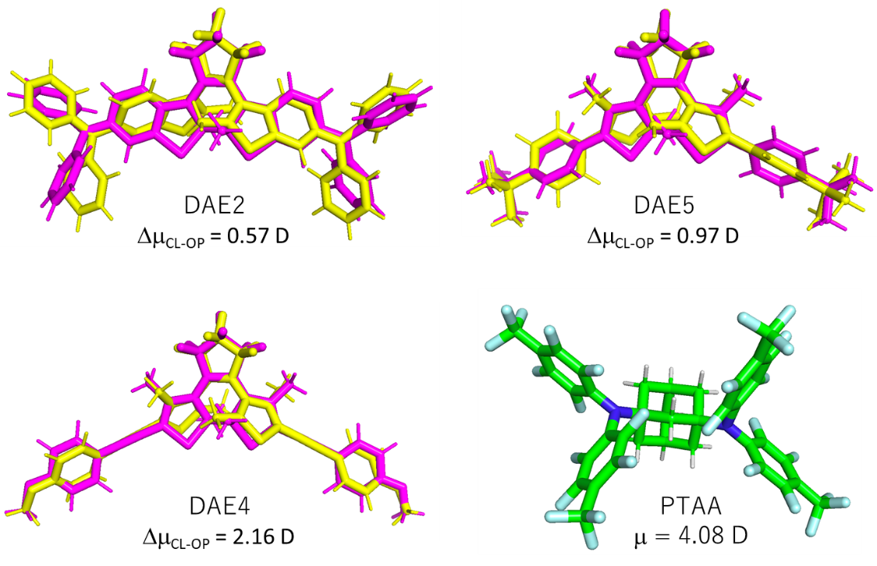
Fig. S5 Examples of PDM calculation for open-ring (yellow) and closed-ring (magenta) forms and PTAA molecule

Table S1 Comparison of PDM calculation results for each molecule with GSP slope. The dipole moments were calculated by Gaussian program at B3LYP/6-311G(d,p) level.
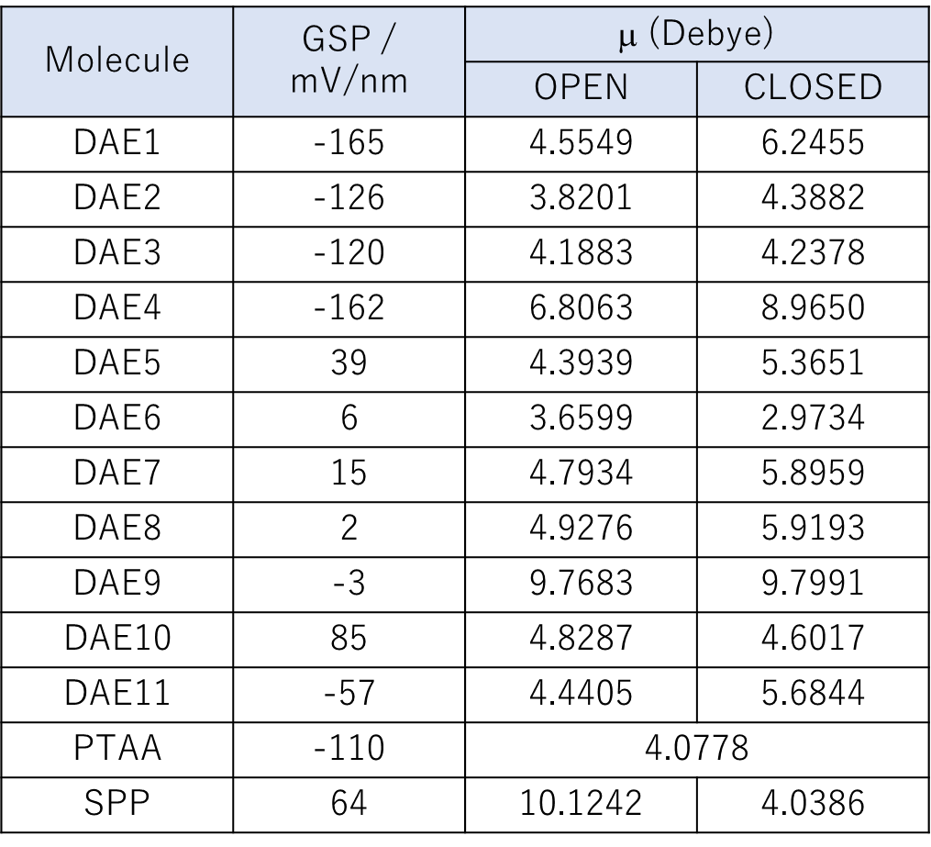

Table S2 Calculation results of molecular volume and estimated cosq values. The molecular volume was predicted by using COSMO-RS model, and the amorphous density at 298.15K was obtained from an average of 10 ns molecular dynamics simulation.

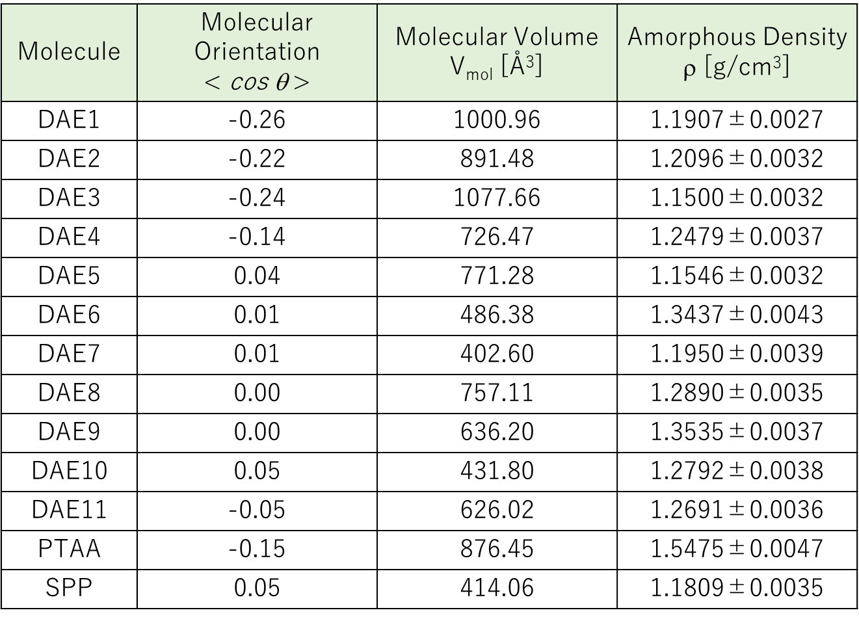

Deposition rate dependence of GSP slope
It is of interest to investigate whether the molecular orientation depends on the deposition rate. Figure S5d shows the deposition rate dependence of the GSP slope of DAE2. We measured the GSP slope at deposition rates ranging from 1.0 nm/s to 10 nm/s and observed no significant variation within this range. However, at extremely high rates (~100 nm/s), a slight decrease in the GSP slope was noted (Fig. S6a).
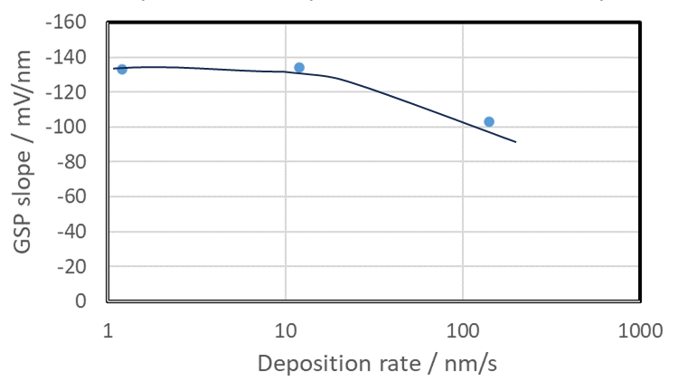
Fig. S6 (a) Deposition rate dependence of GSP slope for DAE2.

GSP slope of colored DAE molecule
Few DAEs exhibit significant changes in their PDMs upon photoisomerization (see Table S1). However, it is well-documented that their Tgs undergoes substantial changes [ref. 27, ref. S1; T. Tsujioka, Y. Nakanishi et al., Dyes and Pigments, 186, 109069 (2021)]. Typically, the Tg of the closed-ring isomer is higher than that of the open-ring isomer. Therefore, if a vapor-deposited film can be formed from the closed-ring isomer, it might be possible to achieve a large GSP slope even for a material with a low Tg when in its open-ring form.
Therefore, we aimed to achieve a large GSP slope by using a vapor-deposited film of the colored closed-ring isomer of DAE9 (PDM = 9.78 D). The open-ring form of DAE9 has a low Tg near room temperature and does not exhibit a large GSP slope in its vapor-deposited film form. To prepare the deposition source in its colored state, we followed the procedure outlined in ref. S1. Specifically, a toluene solution of DAE9 was irradiated with UV light to reach a photostationary state (PSS), after which the toluene solvent was evaporated to obtain colored crystals. These crystals were then vacuum-deposited onto a glass substrate to form the film.
Tg was determined using differential scanning calorimetry (DSC) characterization (see Fig. S6b). The first heating scan revealed Tg at 84 °C. Two significant endothermic peaks were observed around 200 °C, which correspond to the melting point and the thermal ring-opening reaction. In subsequent heating cycles (second, third, and fourth), Tg gradually decreased, approaching the colorless state with Tg = 35 °C. This decrease is attributed to the reduction in the proportion of colored ring-closed molecules in the sample.
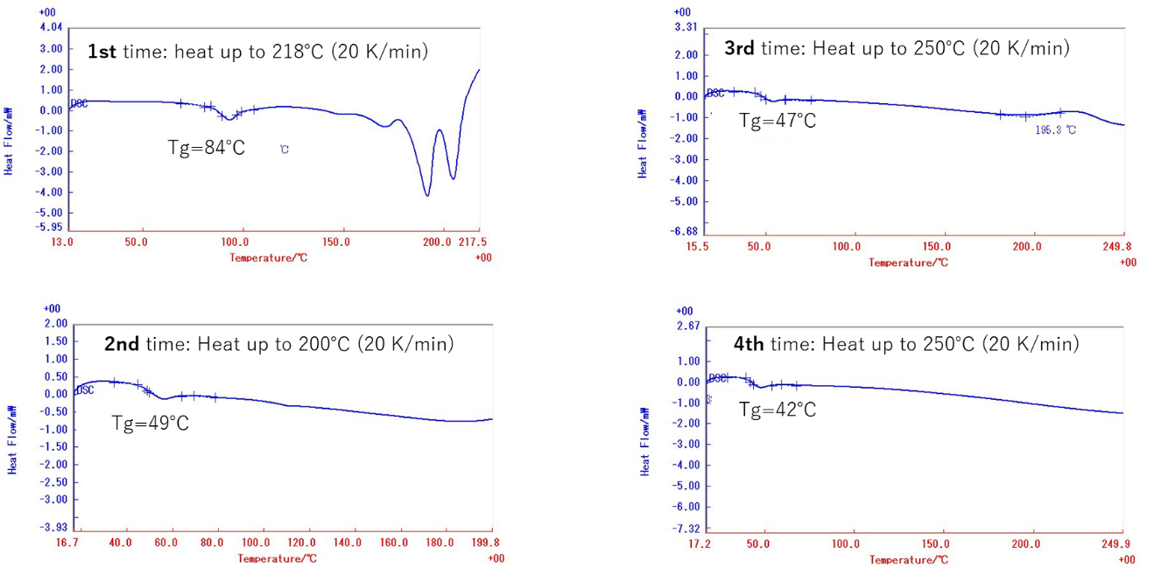
Fig. S6 (b) DSC characterization of colored DAE9.

The top left panel in Fig. S6c displays the spectra of the source before evaporation and after UV irradiation (toluene solution). The absence of spectral changes upon UV irradiation indicates that the source is in PSS. The spectra of the residual source after deposition and subsequent UV irradiation are also shown. The top right panel in Fig. S6c presents the spectra of the residual source material after evaporation. The significant increase in absorbance in the visible range upon UV irradiation suggests that a ring-opening reaction occurred due to heating during deposition. Consequently, the deposited film likely contains a substantial proportion of open-ring molecules.
The bottom panel in Fig. S6c shows the absorption spectrum of the vacuum-deposited film. During the evaporation of the colored closed-ring DAE molecules, a thermal ring-opening reaction occurs, which complicates the accurate measurement of the GSP slope for the closed-ring deposited film. The film, with a thickness of 450 nm and a surface potential of -87 V, exhibited a GSP slope of -193 mV/nm.
A challenge in measuring the GSP on films obtained in this manner is the unknown isomerization structure of the film, as the proportion of colorless molecules is expected to increase towards the surface. Based on the isomerization state of the source, it is speculated that if all the molecules in the film were in the colored state, the GSP slope could potentially reach approximately -250 mV/nm, which would be the highest known value to date.

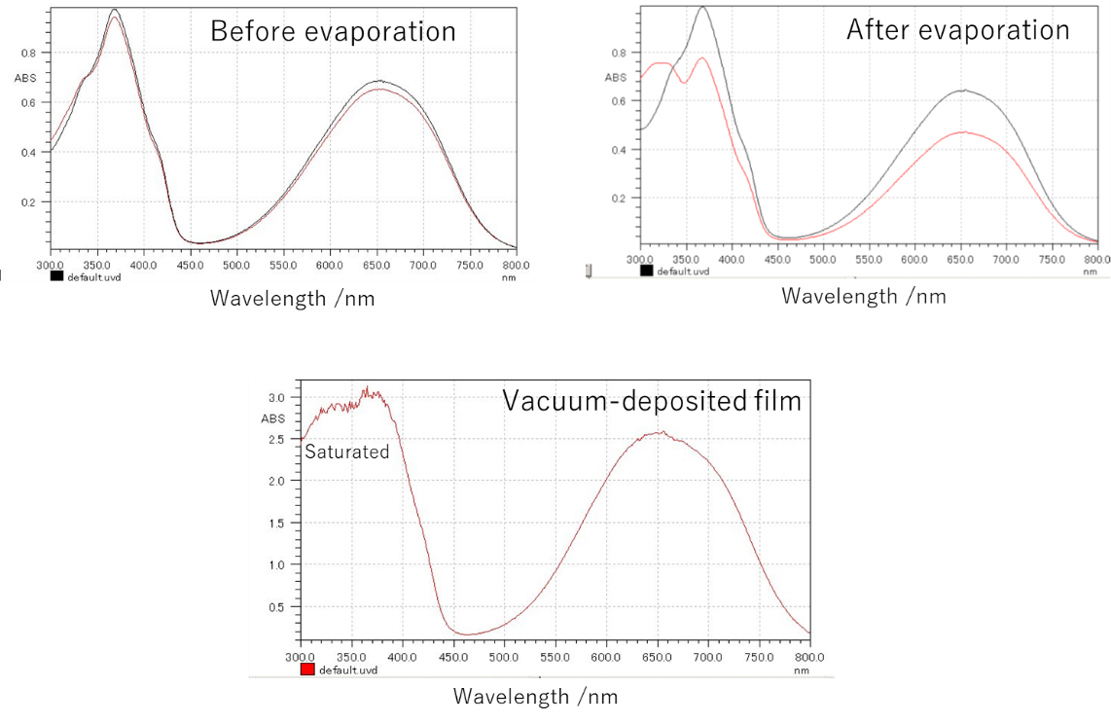
Fig. S6 (c) Absorption spectra of DAE9 when the colored molecules were evaporated. The top two spectra are of the source material before and after deposition, while the bottom spectrum is of the deposited film.

Correlation between GSP slope, PDM, and Tg
Figure S7a shows the relationship between PDM and the GSP slope. No clear correlation was observed in this analysis. In contrast, a distinct trend was observed between Tg and the GSP slope (Fig. S7b). Specifically, as Tg increased from around room temperature to approximately 130°C, the GSP slope also increased.
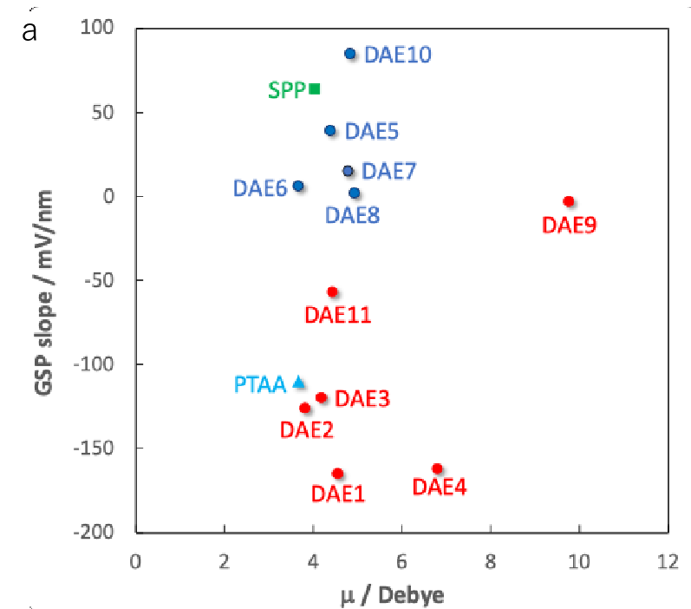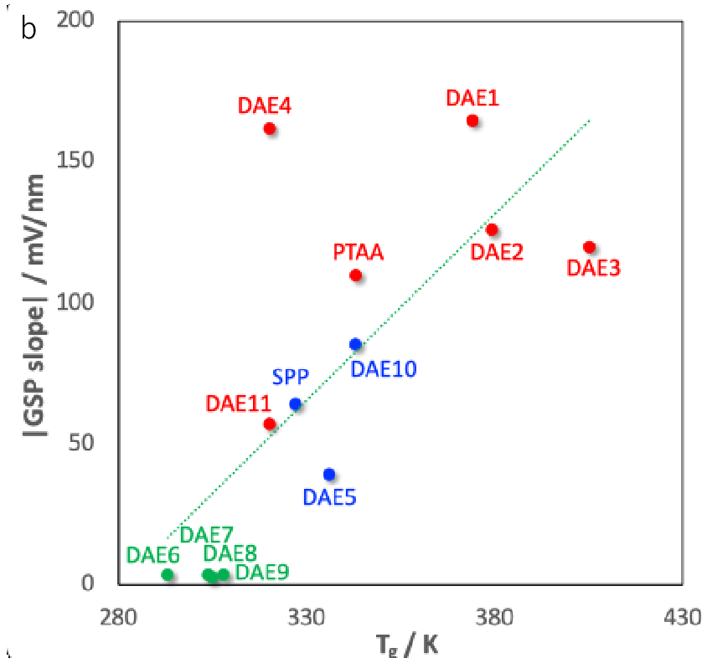

Fig. S7 (a) Correlation between PDM and GSP slope. The compounds were showed as positive GSP slope (blue cycles), negative GSP slope (red cycles), and two non-DAE compounds SPP (green square) and PTAA (cyan triangle), respectively. (b) Correlation between Tg and GSP slope. The materials were showed as positive GSP slope (blue cycles), nearly-zero GSP slope (green cycles) and negative GSP slope (red cycles), respectively. The dashed line is as a guide to the eye.

Tsub dependence of GSP slope and enthalpy relaxation (ΔH)
Figure S8a shows the dependence of the GSP slope and ΔH on substrate temperature (T_{sub}) for materials with different Tg values: SPP (Tg = 327 K), PTAA (Tg = 343 K), and DE-2A (Tg = 379 K). The ΔH measurements are shown in Fig. S7b. The results indicate that the substrate temperature corresponding to the maximum GSP slope is the same as that for the maximum ΔH, and this temperature is 0.83 times Tg.

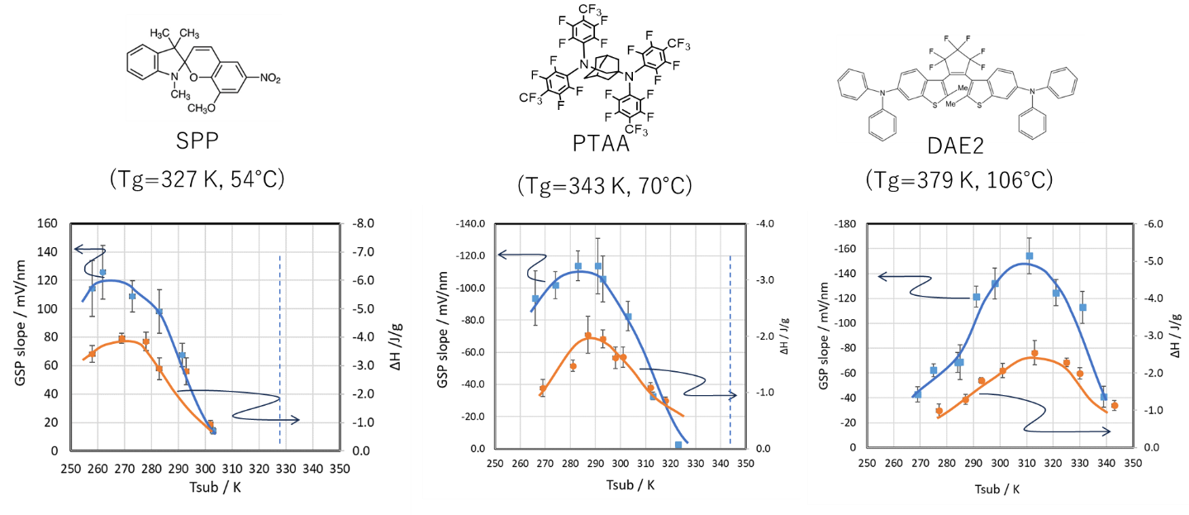
Fig. S8 (a) Substrate temperature dependence of GSP slope and enthalpy relaxation (ΔH).

Sample preparation for enthalpy relaxation (ΔH) measurement with DSC
Figure S8b illustrates the sample preparation method for measuring the ΔH of evaporated films using DSC and provides an example measurement for DAE2. A very thick film was prepared by directly evaporating the material onto an aluminum pan, with temperature control provided by a heat sink. The quantity of heat absorbed at the small peak around Tg observed in the DSC analysis was measured. A large amount of heat absorption at this peak indicates that the sample is in an enthalpy-relaxed state.
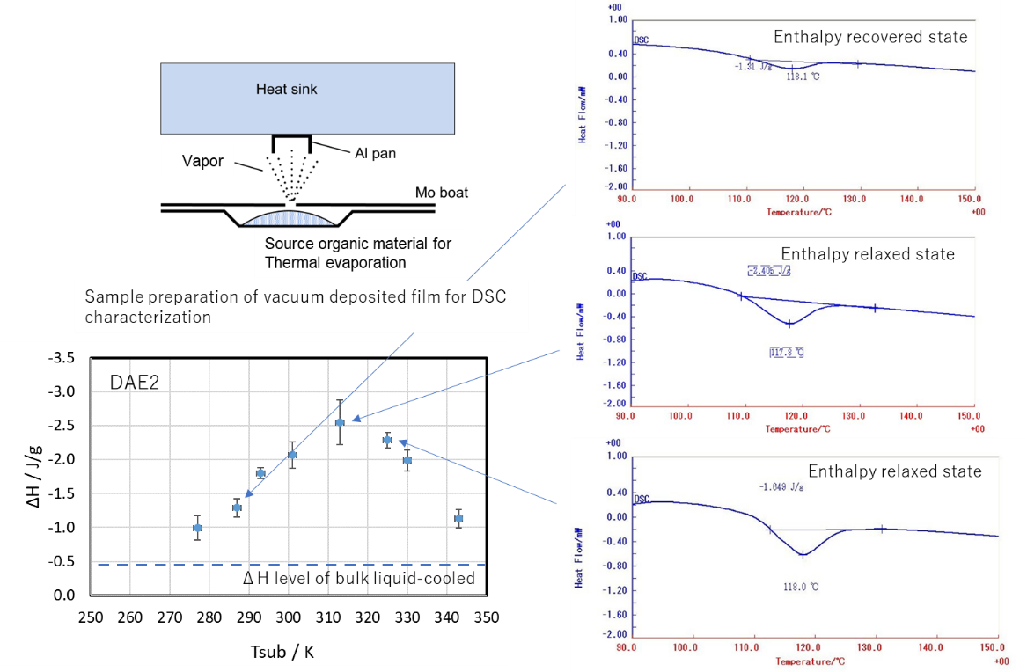

Fig. S8 (b) ΔH measurement method for vacuum-deposited film using DSC.

Changes in water contact angle and surface potential due to annealing
One proposed mechanism for the spontaneous orientation of polar molecules during vapor deposition is the minimization of surface free energy. According to this hypothesis, surfaces with large surface potential should exhibit a large contact angle with water, while surfaces with diminished GSPs due to heating above Tg should show a smaller contact angle. Figure S9 illustrates the changes in GSP and the contact angle of water droplets before and after annealing above Tg for PTAA, DAE2, and SPP films that exhibit GSPs. All films lost their GSPs upon annealing. Notably, the contact angle increased for PTAA and decreased for DAE2, with no significant change observed for SPP. This result does not necessarily invalidate the minimization of surface free energy as a mechanism for GSP generation but suggests that other factors may also be influencing the behavior.

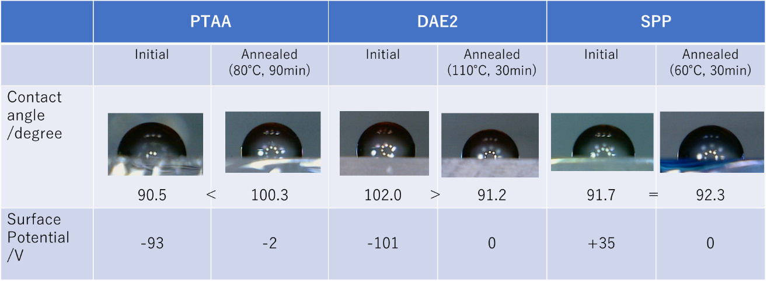
Fig. S9 Changes in water contact angle and surface potential due to annealing.

Relationship between film thickness and surface roughness
A small surface roughness (Ra) is essential for the movement of water droplets, while a large surface potential is also desirable. Increasing the film thickness generally enhances the surface potential but also tends to increase Ra, as shown in Fig. S10. Achieving the required surface smoothness for spontaneous water droplet movement (Ra < 1.0 nm) is challenging with materials like Alq3 or DAE2, even when deposited on a Si substrate. In contrast, with PTAA, this smoothness can be achieved with a film thickness of about 1 μm or less on a Si substrate. However, on a glass substrate, which typically has a rougher surface compared to Si, the range for achieving the desired surface smoothness is more limited.

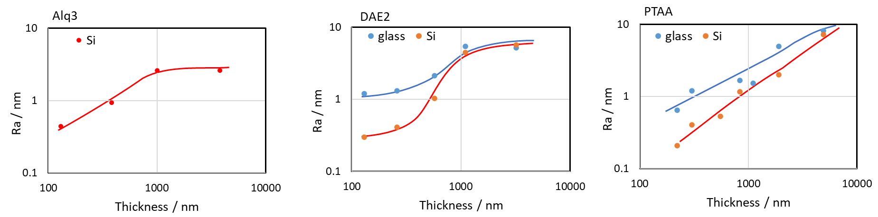
Fig. S10. Relationship between Alq3, DAE2 and PTAA film-thicknesses and surface roughness Ra

Surface roughness and contact angle hysteresis of PTAA and DAE4 surfaces
The left side of Fig. S11 shows AFM images and the roughness average (Ra) of the surfaces of PTAA and DAE4 deposited on a Si substrate. Both materials have suitable Tg values of 70°C and 47°C, respectively, which facilitate the active migration of molecules on the surface during deposition, resulting in a small Ra of 0.3 nm. However, PTAA exhibits superior performance in terms of the ease with which water droplets move across its surface. When the contact angle hysteresis of water was measured (right side of Fig. S11), it was found to be 20° for DAE4 and just 7° for PTAA, indicating significantly lower hysteresis for PTAA.
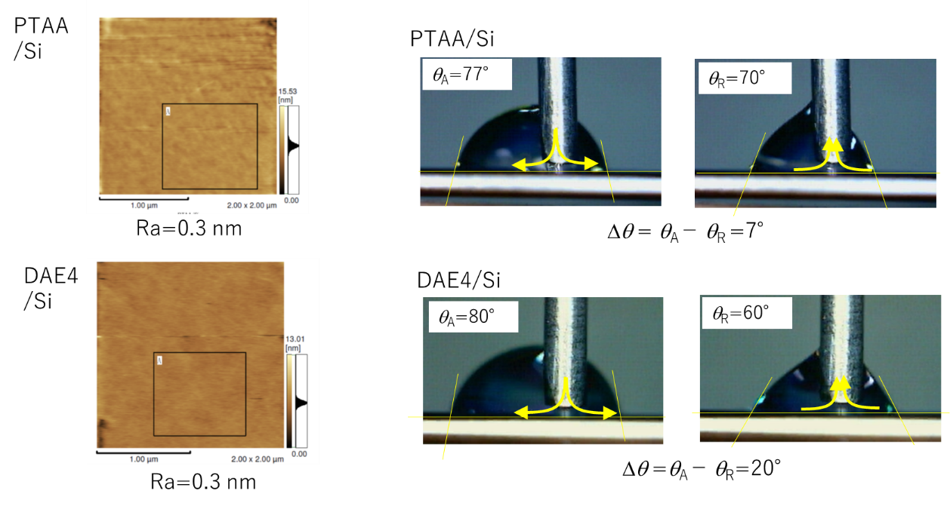
Fig. S11 Surface roughness Ra and contact angle hysteresis Δθ of PTAA and DAE4 surfaces.

COSMO-RS solvation model and σ-profile
The Conductor-like screening model for real solvents (COSMO-RS) model originally developed by Andreas Klamt et al. [ref.46,47], as an effective predictive model of thermophysical properties has attracted large interest in the recent years. The model is based upon density functional theory (DFT) calculations incorporating an implicit solvation model, the so-called conductor-like screening model (COSMO) [ref.46], which is similar to other polarizable continuum models (PCMs) but includes an additional outlying charge correction that goes beyond the cavity surface. The screening charge distribution (SCD) of a molecule embedded in a perfect conductor (with an infinitely large dielectric constant), then, can be obtained from the electrostatic potential of the molecular electron density for the molecule-shaped cavity. In COSMO-RS approach, the molecular surface is divided into a number of equal-area segments, and each segment of a surface has a surface charge density (i.e. the actual charge distribution averaged over segment area). Instead of calculating all the different mutual contacts of the three-dimensional (3D) representation of the molecule, a further simplification of the SCD is introduced by means of the SCD profile (so-called “σ-profile”): The charge distribution on the 3D molecular surface is reduced to a two-dimensional histogram, that represents the probability to find a certain SCD on the cavity surface of molecule. Based on the SCD information, the electrostatic and hydrogen bonding interactions based on SCD, as well as van der Waals interactions can be calculated assuming that each segment interacts independently. The approximation of independent surface segments makes the computation of thermodynamic ensemble properties quite tractable.
A representative example of the σ-profiles is shown in Figure S12 for nonpolar hexane, benzene and polar water molecules. The entire σ-profile areas can be roughly divided into three regions; the electronic basicity region, the nonpolar region, and the electronic acidity region from negative to positive-σ range. As illustrated in Figure S1, the σ-profile of water molecule has a relatively broad distribution, with two almost symmetrical peaks in the negative and positive regions, attributed to two polar hydrogen and one oxygen atom, respectively. On the other hand, the nonpolar benzene molecule shows two symmetrical picks in the region slightly off center, where the pick in positive σ-region can be assigned to delocalized σ-electron in benzene. For hexane, there is a narrow distribution of a nearly neutral charge density around zero, with a shoulder appearing in slightly positive region arises from the carbon atoms of hexane.
The σ-profile quantifies the density distribution of charges of a given polarity on the molecular surface, which is used in conjunction with statistical thermodynamics to calculate the electrostatic interaction energy between pairs of surface segments. In fact, comparing the σ-profiles of two molecules can provide straightforward insights for estimating intermolecular compatibility based on their polarity.

Fig. S12 Three representative σ-profiles of nonpolar (hexane, benzene), and polar (water) molecules.
Absorption spectra of materials exhibiting GSP
Figure S13 shows the absorption spectra of the materials used in this study. Most of the materials used in this study exhibit absorption at λ = 365 nm, but PTAA does not. Therefore, we need to employ a shorter wavelength UV (λ = 254 nm) to investigate the photostability of the GSP of PTAA film.
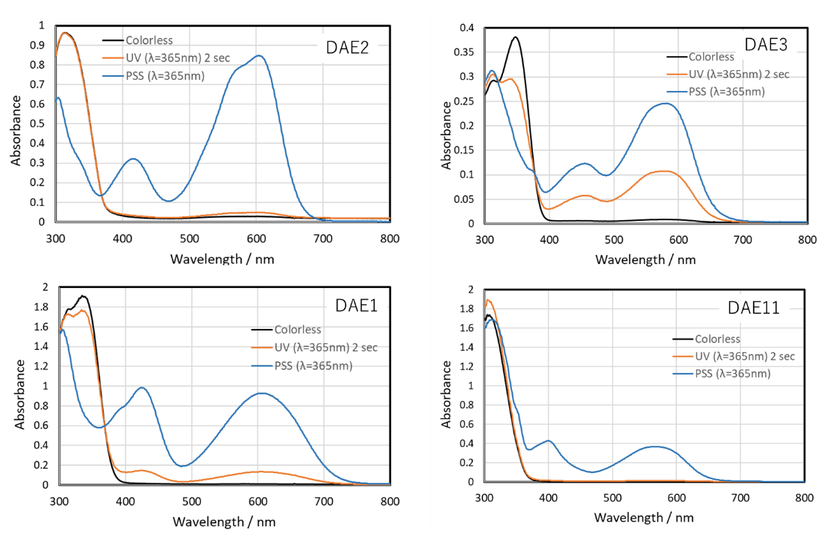
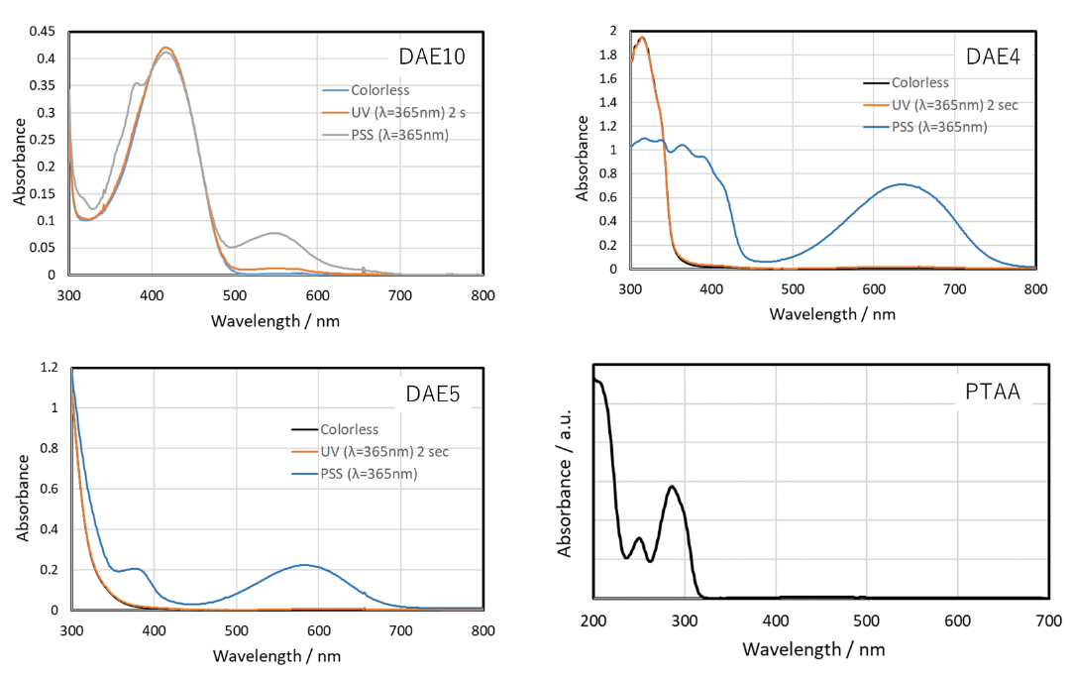
Fig. S13 Absorption spectra of materials (in toluene) exhibiting GSP.

Surface potential decrease upon UV irradiation (λ=365 nm)
Figure S14 shows the decrease in surface potential during UV irradiation with a wavelength of 365 nm, used to assess the stability of PTAA, DAE2, DAE5, and Alq3 (used as a reference sample). PTAA does not absorb at 365 nm. DAE2 exhibited a rapid decline in surface potential to zero within a few seconds, while Alq3 showed a decrease over tens of seconds. In contrast, PTAA and DAE5 demonstrated no significant decrease in surface potential even after 300 seconds of irradiation.
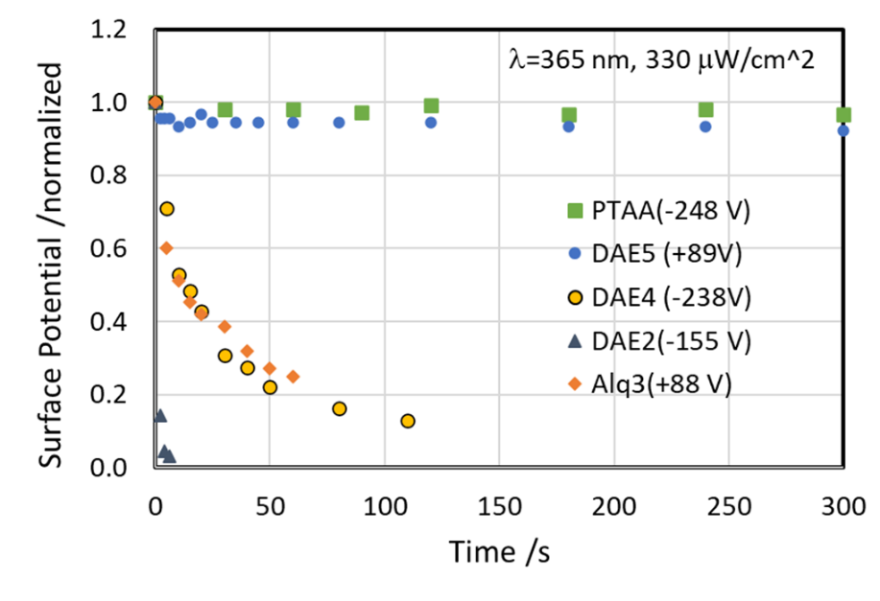
Fig. S14 Residual ratio of surface potential against UV irradiation (λ=365 nm). The initial potential is in brackets.

Surface potential change of DAE2 monolayer upon UV irradiation (λ=365 nm)
In the case of the DAE2 monolayer, a rapid decrease in the surface potential was observed upon UV irradiation and then recovered in the dark (Fig. S15). This was also due to the inflow and outflow of carriers at the surface as explained in Fig. 4b.
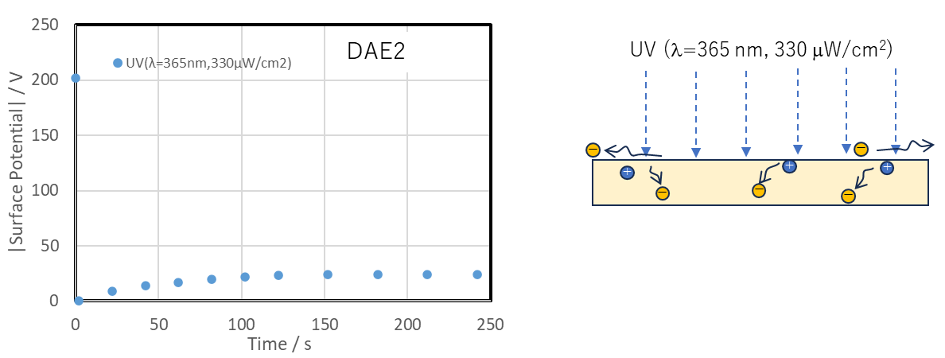
Fig. S15 Surface potential change due to UV irradiation on DAE2 mono layer.

Dependence of GSP expression on substrate conductivity
When GSP materials were evaporated onto substrates, some did exhibit very low GSP slope on conductive substrates (Fig. S16). Notably, this includes DAE2, which showed a rapid decrease in surface potential upon UV exposure (Table S3). This drop is thought to be due to the inflow of carriers from the conductive substrate.
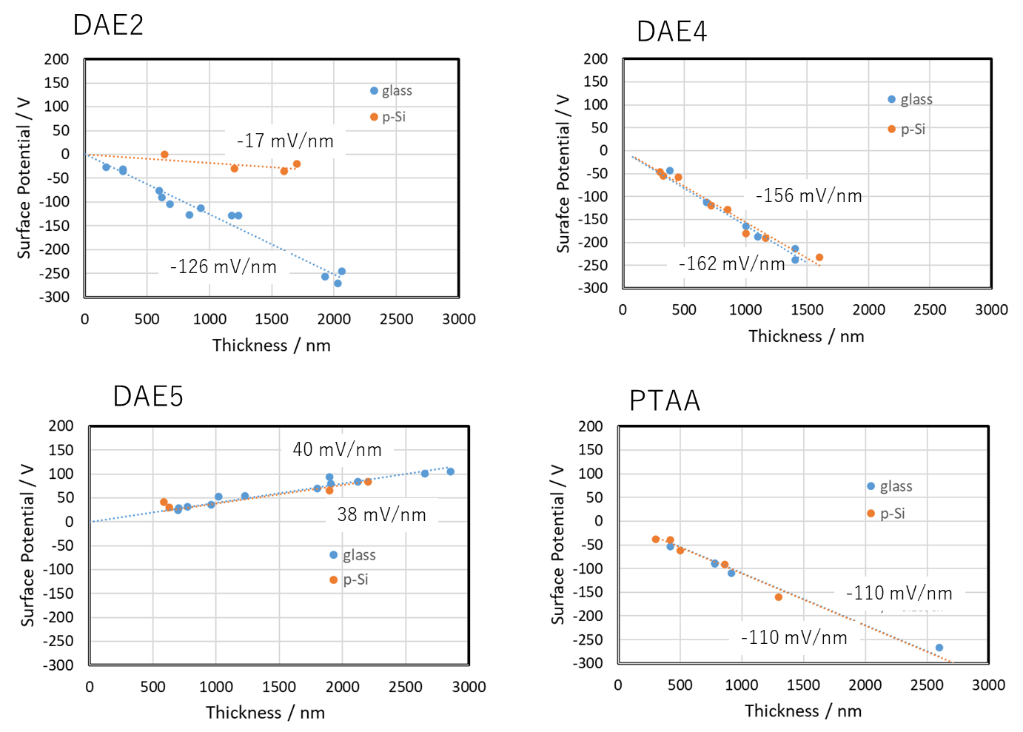
Fig. S16 Relationship between substrate conductivity and GSP slope.

Table S3 GSP tendency depending on substrate conductance and stability upon UV irradiation.
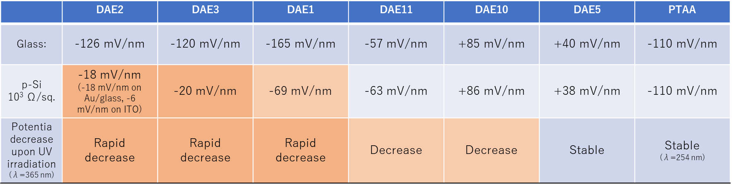

Movement of droplets of other liquid species
Figure S17 shows the spontaneous movement of various droplets on the PTAA surface. Saturated saline droplets exhibited movement similar to that of water droplets. However, only slight movement was observed for methylene iodide and ethylene glycol. This difference suggests that droplets with very large relative permittivity (~80), such as water and saturated saline, move more easily, while droplets with lower permittivity and/or higher viscosity, such as methylene iodide and ethylene glycol, show reduced mobility.
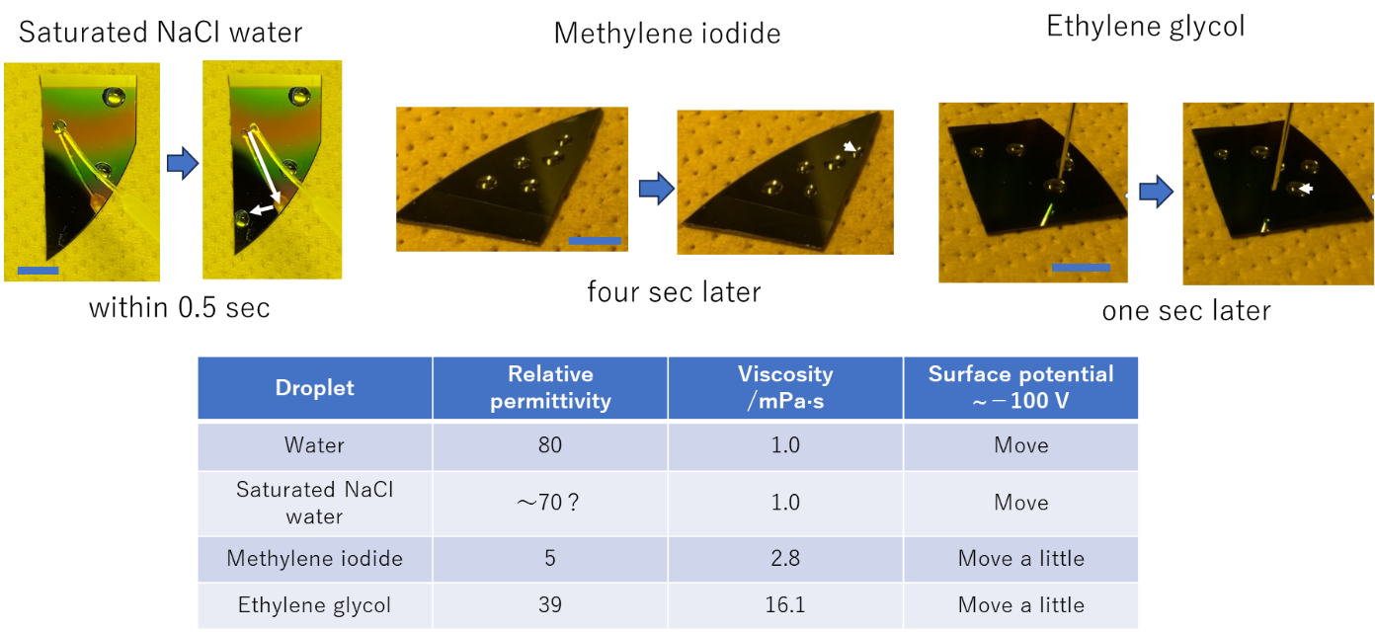
Fig. S16 Spontaneous movement of other droplets on PTAA surface.

