Supplementary Information

Interpreting SAXS data recorded on cellulose rich pulps
Per Tomas Larsson^{a,b,*}, Jasna Stevanic-Srndovicª, Stephan V. Roth^{c,d}, Daniel Söderberg^{d}
(a) RISE Bioeconomy, Drottning Kristinas Väg 61, SE-114 86 Stockholm, Sweden
(b) Wallenberg Wood Science Center, KTH Royal Institute of Technology, Stockholm, SE-100 44, Sweden
(c) DESY, Notkestrasse 85, Hamburg, D-22607, Germany
(d) KTH Royal Institute of Technology, Stockholm, SE-100 44, Sweden
(*) Corresponding author, tomas.larsson@ri.se

Supplementary Information
The modelling of SAXS data was based on a conceptual representation of the distribution of cellulose fibrils and fibril aggregates in the fibre wall, which is illustrated in Figure S1. The model is conceptual in the sense that it was only used as a route to design the algorithm used for generating electron density paths.
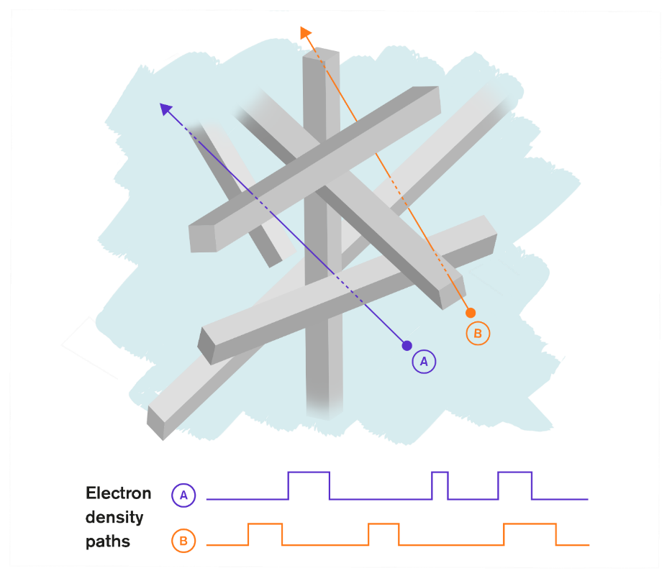
Figure S1. A conceptual image describing how an electron density path (EDP) can be visualized in a two-component sample, here the solid material is cellulose. The EDPs shown at the bottom illustrates two examples of electron density paths encountered when following path A or path B through the sample. The grey cuboids can represent the solids assigned a higher electron density value, and the interstitial spaces between the grey cuboids (vacuum or water) are assigned a lower electron density value. Depending on the size-range (q-range) of modelled data the grey cuboid can represent cellulose fibrils (widths about 3 nanometres to 5 nanometres) or cellulose fibril aggregates (widths in the range of ten to several tenths of nanometres).

The modelling of experimental SAXS data, $I_{EXP}$, was performed by superposition of simulated SAXS intensity profiles $I_{k}$ weighted by $w_{k}$, with the addition of a modelling parameter describing the background intensity $b$:
$$I_{EXP}\left(q\right)≈\sum_{k}{w_{k}I_{k}\left(q\right)+b}$$ | [S1]
For the case of statistically isotropic samples without long-range order, the elastic scattering intensity can be expressed in one-dimensional form (Porod 1982):
$$I\left(q\right)=\int_{0}^{∞}{x^{2}g(x)\frac{sin⁡(qx)}{qx}dx}$$ | [S2]
For calculation of the scattering intensity, the spatial correlation function (SCF) g(x) was defined to decay to zero at long distances:
$$g\left(x\right)=h\left(x\right)-h(∞){=〈ρ\left(x_{1}\right)ρ\left(x_{1}-x\right)〉}_{x_{1}}-〈ρ〉〈ρ〉$$ | [S3]
Where $ρ(x)$ is the electron density at point $x$, $〈ρ〉$ is the sample’s average electron density and ${〈⋯〉}_{x_{1}}$ indicates averaging over the real space coordinate $x_{1}$.
For the numerical calculations performed in this work, the discrete versions of Equation [S2] and Equation [S3] were expressed as:

$$I_{k}\left(q\right)≡\sum_{n=0}^{L_{SCF}-1}{{\left(n∆x_{k}\right)}^{2}g_{n}\frac{sin\left(nq∆x_{k}\right)}{nq∆x_{k}}∆x_{k}}={\left(∆x_{k}\right)}^{3}\sum_{n=0}^{L_{SCF}-1}{n^{2}g_{n}\frac{sin\left(nq∆x_{k}\right)}{nq∆x_{k}}}$$ | [S4]
and
$$g_{n}=h_{n}-h_{L_{SCF}-1}$$ | [S5]
where n is a vector element index and L_{SCF} is the length of the vectors holding the numerical estimate of the autocorrelation function (ACF), h_{n}, and the spatial correlation function (SCF), g_{n}.

In the following text a few key-points of the numerical simulation will be described, relating to Equations [S4] and Equation [S5], followed by a more thorough discussion of the simulation algorithm.
The simulation software developed gives as output a sum of autocorrelation functions (ACF), calculated from several simulated electron density paths (EDP). Each simulated electron density path was stored into a real valued vector of length, L_{EDP}. Because of their real valued-ness, the Fourier transform of an EDP are Hermitian and the corresponding autocorrelation function became real-valued and symmetric (Press et al. 1992). Consequently, in subsequent calculation it was enough to use only half of the simulated autocorrelation function. In this work only values from the positive half of the autocorrelation functions were added to generate the ACF, once the L_{EDP} was given the L_{ACF} was implied (L_{ACF} = L_{EDP}/2).
The calculation of the autocorrelation function utilized numerical routines based on the discrete Fourier transform (DFT) (Press et al. 1992) because of its numerical efficiency. A requirement of the DFT is that all input vectors have lengths that are integer powers of 2, this was implemented in the software developed.
At large distances, the autocorrelation function decays to the average electron density squared, Equation [S3]. To obtain an estimate of the spatial correlation function (SCF) needed for the calculation of scattered intensity, a numerical estimate of h(∞) = <ρ><ρ> (Equation [S3]) was obtained from the last element (the least correlated) in the vector containing the numerical estimate of the ACF, the vector element with index L_{SCF}-1. Subtraction of this value from all elements in the ACF vector was used as an estimate of the sought SCF, with both vectors, ACF and SCF, having the same length, L_{ACF} = L_{SCF}.
Once a numerical estimate was obtained for the SCF, g_{n} in Equation [S4], numerical calculation of the scattered intensities became possible by use of Equation [S4].
The algorithm used in this work for simulating SAXS intensity profiles for a two-component system is described below. Once the numerical values of the input parameters were defined, the generation of SAXS intensity profiles, I_{k}(q), was performed using the following steps:
- Generation of a pseudo-random electron density path (EDP) of length L_{EDP}.
- Calculation of the autocorrelation function of the EDP, length L_{SCF}.
- Accumulate a large number, N_{EDP,} of autocorrelation functions by repeating steps 1 and 2, resulting in a numerical estimate of the autocorrelation function h_{n}.
- Subtract an estimate of the average electron density squared from h_{n}, giving a numerical estimate of the spatial correlation function (SCF) g_{n}
- Calculation of the scattering intensity by numerical integration (trapezoid) using Equation [S4] with different q-values.
Typical input parameters, used for the SAXS intensity profile simulation algorithm, is listed in Table S1, each step in the simulation algorithm outlined above will be discussed in some more detail in the following text.

Table S1. The input parameters for the program used to simulate SAXS intensity profiles.
Parameter | Explanation | Typical values used in this work
L_{EDP} | Length of the electron density path vector (vector elements) | 8192
S_{MAX} | Maximum segment size (vector elements) | 600 - 800
N_{EDP} | Number generated electron density paths | 10⁸
e_{LO} | Electron density, low value (a.u.) | 0.0 or 1.0
e_{HI} | Electron density, high value (a.u.) | 1.4
F_{F} | Volumetric fill factor (m³/m³) | 0.4 – 0.9
F_{J} | Jitter factor | 0.333333
N_{T} | Number of parallel computation threads | 16 - 24

The simulation program was written in C++ and utilized parallelization, performing simulations in parallel on multi-core CPUs decreased the simulations times. For numerical efficiency, the simulation program can be adapted to hardware capacity by the input parameter N_{T}, number of parallel threads.
The input for the calculation of SAXS profiles consists of parameters describing the sample as well as parameters for the numerical calculations. For a two-component sample, three parameters were used to describe the sample, values representing the high and low electron densities and the volumetric fill factor, e_{HI}, e_{LO} and F_{F} respectively. For convenience, the average electron density of water was normalized to a value of 1.0. Consequently, the average electron density for cellulose (assuming a density of 1500 kg/m³) was assigned a value of 1.4.
The electron density was calculated as:
$$ρ_{e}=N_{A}n_{e}\frac{ρ}{M_{m}}$$
Where ρ_{e} is the electron density (m⁻³), N_{A} is Avogadros number (6.022 x 10²³ mole⁻¹), n_{e} is the number of electrons per molecule (unitless), ρ is the substance’s density (kg/m³), M_{m} the molecular mass (kg/mole). In the case of water (10 electrons per molecule, a molecular mass of 0.018 kg/mole and a density of 1000 kg/m³) the electron density was approximately 3.35 x 10²⁹ m⁻³, and in the case of cellulose (86 electrons per anhydroglucose unit, a molecular mass of 0.162 kg/mole and a density of 1500 kg/m³) the electron density was approximately 4.80 x 10²⁹ m⁻³. Normalizing both electron densities with the electron density of water gave the approximate numbers of 1.0 for water and 1.4 for cellulose, used as input to the simulations. In the case of dry samples, exposed to the beam path vacuum, the low electron density value describing the cavities (pores) was set to 0. Here the concept of cavities was applied to interstitial spaces between solid particles whether filled with liquid or evacuated.
The generation of the EDPs was performed by using a uniform pseudo-random number generator. An EDP was generated by initially setting all elements of the EDP vector (length L_{EDP}) to the high electron density value (e_{HI}). A segment of consecutive vector elements, of random length in the range from 1 to (1 ± F_{J})S_{MAX} (see below) having low electron density values (e_{LO}) was inserted into the EDP vector at a random position.
The numerical randomization of the EDP vectors used a jitter factor, F_{J}. Each EDP vector was generated using a uniform pseudo-random number distribution with a maximum value in a symmetric range centred around the input maximum size (S_{MAX}) by use of a jitter factor (F_{J}). For example, if the input maximum was 100 vector elements and the input jitter factor was 0.3, all EDP vectors were generated with maximum insertion segment lengths in the range from 70 to 130 vector elements. However, the average maximum segment insertion length based on all EDP vectors was still 100. This additional randomization was introduced to consider the material’s variability, where the local environment traversed by different EDPs need not be the same.
The insertion process was repeated until the average electron density of the EDP vector matched (to the resolution imposed by L_{EDP}) a target average electron density $〈ρ_{e}〉$, calculated based on the input parameters e_{HI}, e_{LO}, and the volumetric fill factor, F_{F}:
$$〈ρ_{e}〉=F_{F}e_{HI}+\left(1-F_{F}\right)e_{LO}$$The iteration process for generating EDPs used periodic boundary conditions and closure for termination. Segments of low electron density with a length that would extend beyond the length of the EDP vector, L_{EDP}, were folded onto the beginning of the EDP vector. Closure for termination was implemented by ensuring that the length of an inserted random segment resulted in an average electron density of the EDP vector that was larger than or equal to the target average electron density value. Generated insertion segments that failed this criterion were discarded.
When the average electron density of the EDP vector matched the target electron density (to the resolution imposed by L_{EDP}), the iteration was terminated. A consequence of the termination by closure was that all electron density paths generated for a certain set of e_{HI}, e_{LO}, F_{F} input parameters had the same number of vector elements with high electron density values, though distributed differently within the EDP vector. The variability between electron density paths generated with the same set of input parameters was in the number of segments with consecutive high or low electron density values. The periodic boundary conditions made the number of segments with high electron density values equal to the number of segments with low electron density values. Hence, only one number was needed to specify the number of segments within an electron density path.
For each EDP the number of segments and the number vector elements with high and low electron density values were accumulated, making it possible to establish an apparent average particle size (AAPS) and an apparent average cavity size (AACS) for a certain set of input parameters. Due to the strong and abundant interaction between particles in cellulose rich fibre walls, the average size estimates obtained for this kind of samples were interpreted as apparent average sizes.
Once an EDP vector simulation was terminated, its autocorrelation function, h_{n} in Equation[S5], was calculated numerically using a double precision implementation of the autocorrelation routine correl (Press et al. 1992) and accumulated. The process was repeated and typically about 10⁸ autocorrelation functions were accumulated and averaged to obtain a sufficiently low noise in the ACF at large distance. Once the h_{n} was established the corresponding spatial correlation function, g_{n} could be generated, Equation [S5].
From Equation [S4] the discrete counterpart of the so-called pair distance distribution function (PDDF) was identified as:
$${PDDF}_{n}=∆x^{2}n^{2}g_{n}$$ | [S6]
At large distances (large values of n) the n² scaling of g_{n} in Equation [S6] effectively means that the noise in the g_{n} at large distances must be kept small. Also, the length of the g_{n} vector must be long enough to accommodate the decay of g_{n} to values sufficiently close to zero. For these reasons, the discrete PDDF can be used to evaluate the quality of the simulated correlation functions, g_{n} or h_{n}.
Two examples of simulated PDDFs are shown in Figure S2, both graphs show an increase to a maximum followed by a decay approaching zero frequency at larger distances. The effect of noise can also be seen in both graphs in Figure S2. At intermediate distances (distances around 2000 units in the PDDF for the water swollen case, and distances around of 1250 units in the PDDF for the dry case) the frequency are close to zero, deviating successively more from zero at larger distances. The deviation from zero frequency at large distances was due to the noise in the SCFs at large distances and not a structural feature of the sample. This was established by performing simulations with increasing numbers of accumulated EDPs. Based on the simulated PDDF judgements were made about the values necessary for the numerical input parameters. The PDDFs shown in Figure S2 was judged acceptable for numerical calculations of scattered intensities.
As guide-lines for choosing values of the numerical input parameters, the position of maximum frequency in the PDDF was used as a starting point. Once the input parameters describing a sample was chosen, and values has been set for the numerical input parameters (Table S1), in particular the S_{MAX} and the F_{J} parameters, a trial simulation with a smaller number of accumulated EDPs was performed. From the results of such trial simulation the position of maximum frequency in the PDDF was established, and the necessary length of the EDP vectors could be estimated. For reaching a sufficient decay in the PDDF the length of the SCF was set to about ten times the distance to the position of the maximum in the PDDF, implying an EDP length twice that of the SCF. With those parameters set, the number of accumulated autocorrelation functions was increased until a sufficiently low noised in the PDDF was obtained at long distances.
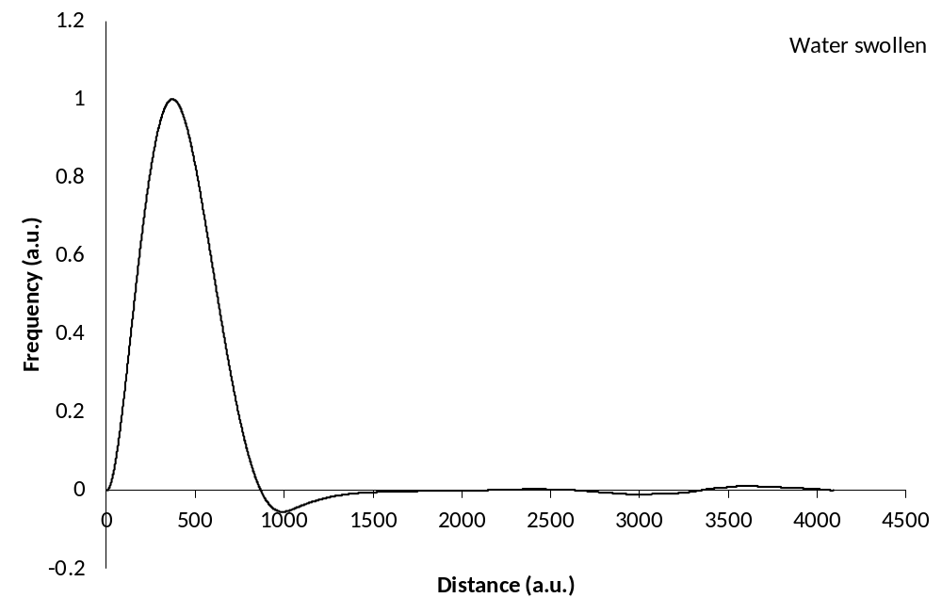
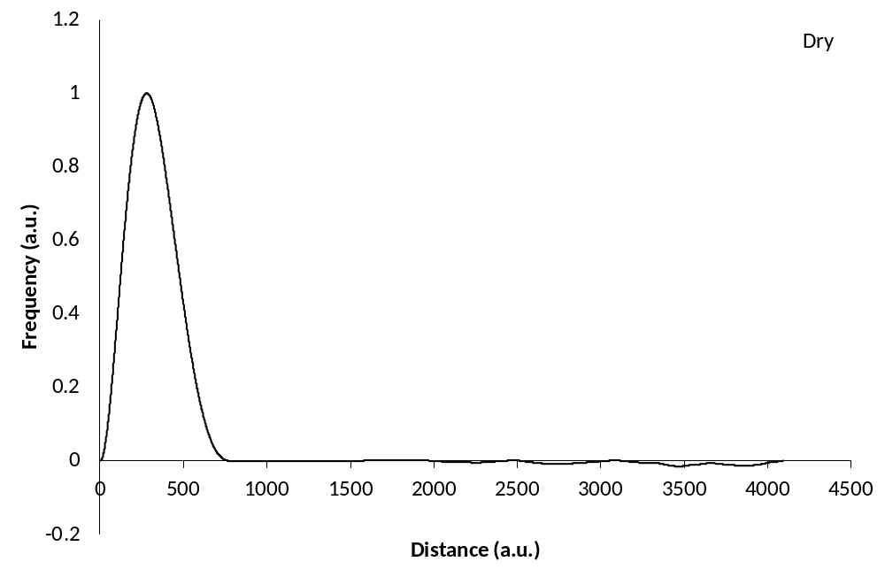Figure S2. Two examples of simulated pair distance distribution functions (PDDF). The label in the top right corner relates to the input parameters used. For charting, the point of maximum frequency in both curves were arbitrarily normalized to a value of 1.

Table S2. The input parameters used to simulate the pair distance distribution functions shown in Figure S2. The input values L_{EDP} = 8192, N_{EDP} = 1x10⁸, F_{J} = 0.333 were used for both cases. The sampling statics parameters refer to the apparent average cavity size (AACS) and the apparent average particle size (AAPS). The values in parenthesis are standard deviations describing the population width generated during the simulation. The units of electron densities are arbitrarily scaled so that the average electron density of water becomes 1, S_{MAX}, AACS and AAPS are in units of vector elements, i.e. corresponding to a Δx value of 1.
Label | S_{MAX} | e_{LO} | e_{HI} | F_{F} | AACS | AAPS
Dry | 600 | 0 | 1.4 | 0.9 | 239 (81) | 2148 (733)
Water swollen | 800 | 1 | 1.4 | 0.5 | 479 (127) | 479 (127)

For the purpose of modelling experimental data, one useful feature of the discrete Equation [S4] was exploited; the SCF in Equation [S4], g_{n}, has no explicit dependence on the step size in real space i.e. the value chosen for the Δx. Once a SCF of sufficiently low noise was simulated, for a set of values assigned to the low and high electron density values and the volumetric fill factor, that SCF could be used to calculate SAXS intensity profiles for any choice of Δx and q-range as long as the Nyquist criteria (Press et al. 1992) in Equation [S7] was fulfilled.
$$q_{MAX}∆x<π$$ | [S7]
This reduced the number of simulated SCFs that was needed for modelling purposes and allowed for a convenient separation between the simulation of the SCF, and the less numerically demanding calculation of the SAXS intensity profile.
Modelling of experimental data was performed by adding intensity components and if needed a background term, Equation [S1], subsequently adjusting the weight (w) and real space step size (Δx) of each intensity component, Equation [S4], while trying to minimize the sum of squared relative residuals (SSRR), Equation [S8].
$$SSRR=\sum_{i}{{\left[\frac{\left(I_{EXP,i}-I_{CALC,i}\right)}{I_{EXP,i}}\right]}^{2}}$$ | [S8]
References
Press WH, Teukolsky S A, Vetterling W T, and Flannery B P. (1992) Chapter 12 and 13 in Numerical Recipes in C. The Art of Scientific Computing, 2nd Ed. Cambridge University Press, Cambridge U.K.
Porod G (1982) Chapter 2, General Theory. In: in Small angle x-ray scattering, Glatter O and Kratky O (ed.) Academic Press, London, pp 17-52. doi.org/10.1002/actp.1985.010360520.

