The Composition and Design Principle of Myelopathy-hand Functional Evaluation System (MFES)
MFES mainly consists of a pair of wise-gloves, a computer with software, a light, and two mutually perpendicular cameras (Fig.1).
- Wise-gloves: The wise-gloves are used to capture and measure the changes of the angles of the hand joints in real time. Ten resistance bend sensors are installed in the interlayer of the wise-gloves. The sensor is composed of a flexible circuit board, a force-sensitive component and an elastic packaging material, which is connected to a signal processing circuit through a wire. Sensors on the dorsal side of each finger can measure and simulate the angle of the metacarpophalangeal joint, converting analog signals to digital signals using a 12-bit high-precision analog-digital converter. Then, the digital signals are transmitted to the computer. Elastic material ensures its comfortability when wears (Fig. 2).
- Software Design: This software compilation system chooses Microsoft object-oriented Visual integration programming system Visual C++. It can convert the digital signals into waveforms. The software interface contains four regions: waveform, real-time video, 3D animation simulation and basic information of subjects (Fig. 3). During the test, the waveform and real-time animation recorded by the bending angle of each finger are displayed in real time. The operator can visually observe the accuracy of the test through the waveform and animation. In addition, it can automatically count the number of grip and release cycles, calculate the average time per cycle, and save all data and support playback at different speeds. There are many types of test to choose from, including 10-s grip and release test, 15-s grip and release test and RHF test. The software’s functionality and logic diagram were shown in Fig. 4.
- Two Mutually Perpendicular Cameras: The whole motor process of each hand can be recorded by two cameras in real-time from front and side directions and synchronously shown in computer. Further analysis can be conducted through video playback.

Fig.1: Picture showing MFES and its components.
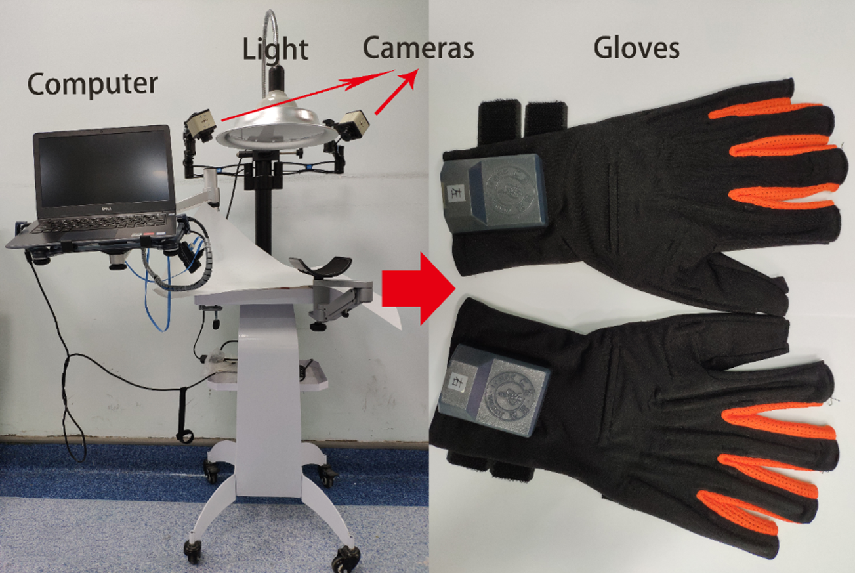

Fig. 2: Picture showing a pair of gloves and its components.
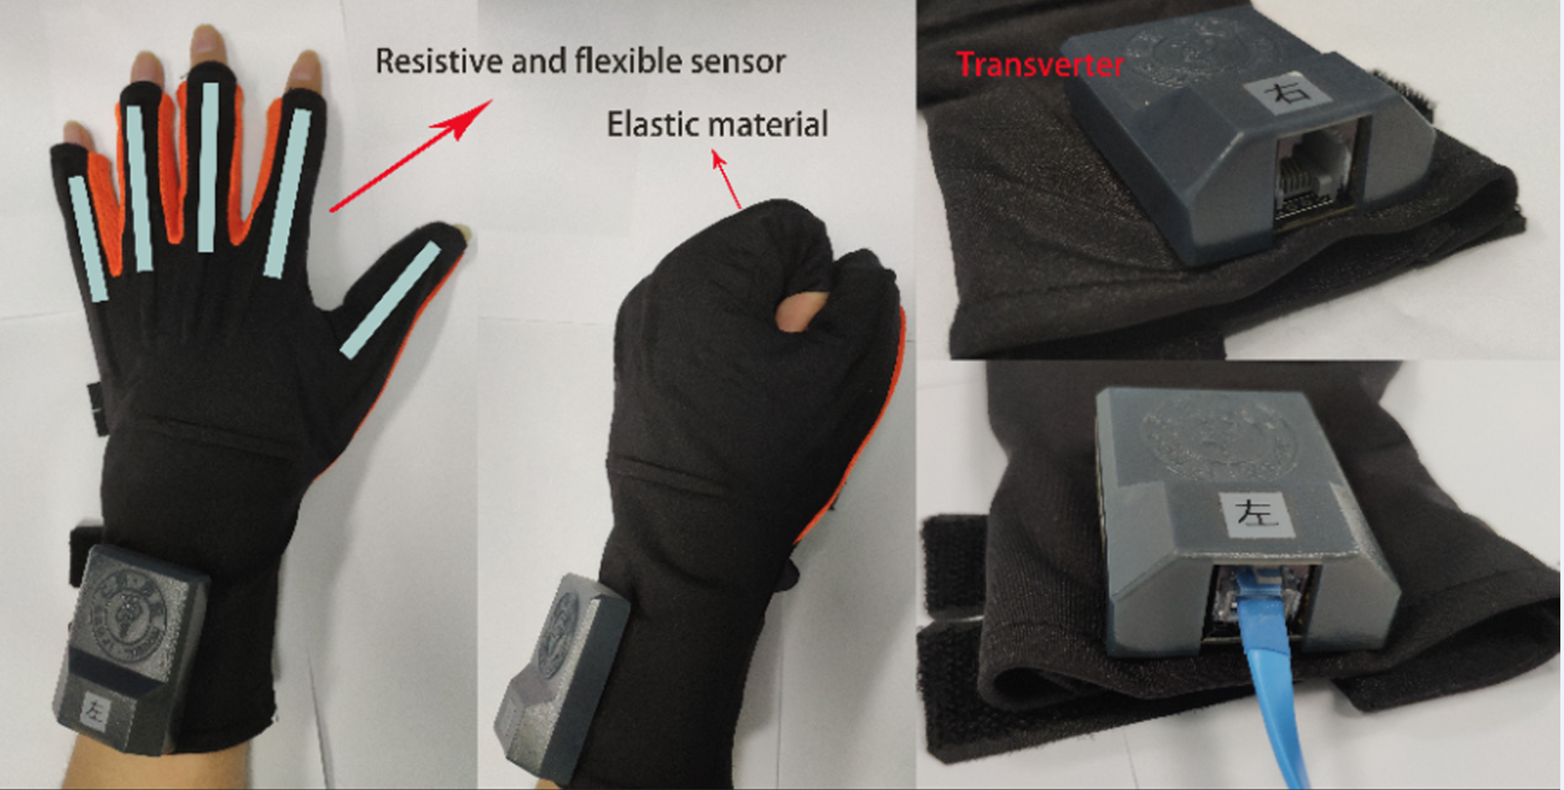

Fig. 3: Picture showing the interface of software.
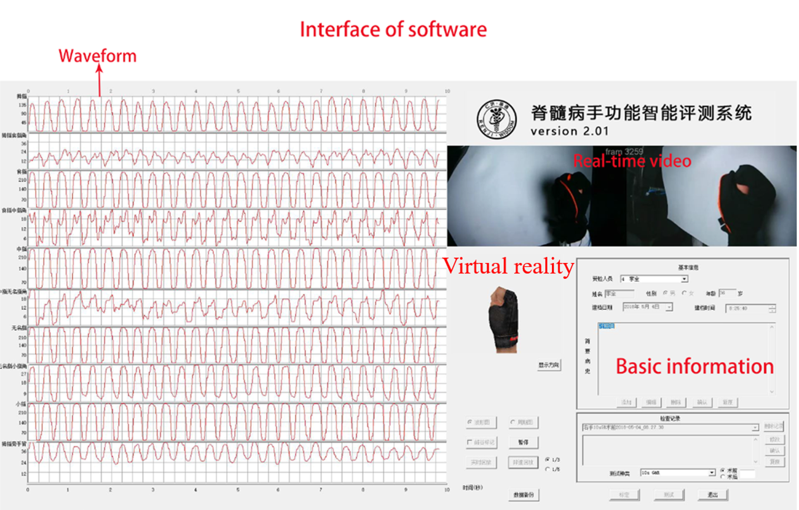

Fig. 4: The software’s functionality and logic diagram.
