Development of a sustainable strategy for cultured fat production based on serum-free 3D culture of bovine adipose stem cells
Supplementary information
Assessment of Ki-67 expression
For the evaluation of proliferation potential, cells previously cultured in each medium until passage 9 were seeded in triplicate into 6-well plates. After 24 hours of culture, cells were fixed with 4% paraformaldehyde for 15 minutes at room temperature followed by permeabilization with 0.1% Triton X-100 in PBS for 5 minutes. Nonspecific binding was blocked with 1% bovine serum albumin (BSA) in PBS for 30 minutes. The cells were then incubated with a polyclonal rabbit anti-Ki-67 primary antibody (PA5-19462, Invitrogen, dilution 1:100). After washing, the cells were incubated with a goat anti-rabbit IgG (H+L) antibody conjugated with Alexa Fluor 555 (Invitrogen, dilution 1:250). The primary and secondary antibodies were incubated for 1 hour at room temperature with gentle shaking. The cell nuclei were counterstained with Hoechst 33342 (Sigma-Aldrich, dilution 1:1000). Samples were observed using a fluorescence microscope (Axio Observer Z1, Carl Zeiss) and images were captured using a digital camera (C11440 ORCA Hamamatsu) and ZEN 2012 software. For each condition, six randomly selected fields were imaged at low magnification (5× objective) and the ZEN software's built-in routines for automatic cell counting were used. The percentage of Ki-67–positive cells was calculated by dividing the number of Ki-67–positive nuclei by the total number of nuclei per field.
Evaluation of the colony forming units (CFU-F)
The bASCs were seeded in triplicate in 6-well plates at four different densities (20, 60, 120, and 150 cells/well) and cultured in serum-containing GM for 14 days. The medium was changed on day 7 and every 3 days thereafter. On day 14, the cells were fixed with 4% formaldehyde and stained with 0.05% crystal violet (Sigma-Aldrich). The plates were placed on an LED light pad (Shenzhen Huion Trend Technology) and images were captured with a single-lens reflex camera (EOS750D, Canon). CFU-F efficiency was determined in the 60 cells/well group by dividing the initial cell density by the average number of cell colonies formed.
Osteogenesis assay
The bASCs were seeded in triplicate in a 24-well plate in serum-containing GM at a density of 8,000 cells/cm². After reaching 80-90% confluence, the medium was replaced with StemPro Osteogenic Differentiation Media (StemPro, ThermoFisher Scientific). One group of wells was kept in GM as a negative control. After 8 days, cells were fixed with 4% formaldehyde for 1 hour and the mineralized matrix was stained with Alizarin Red S (14 mg/ml) for 3 minutes. Cell images were taken under a standard inverted microscope (CKX41, Olympus).

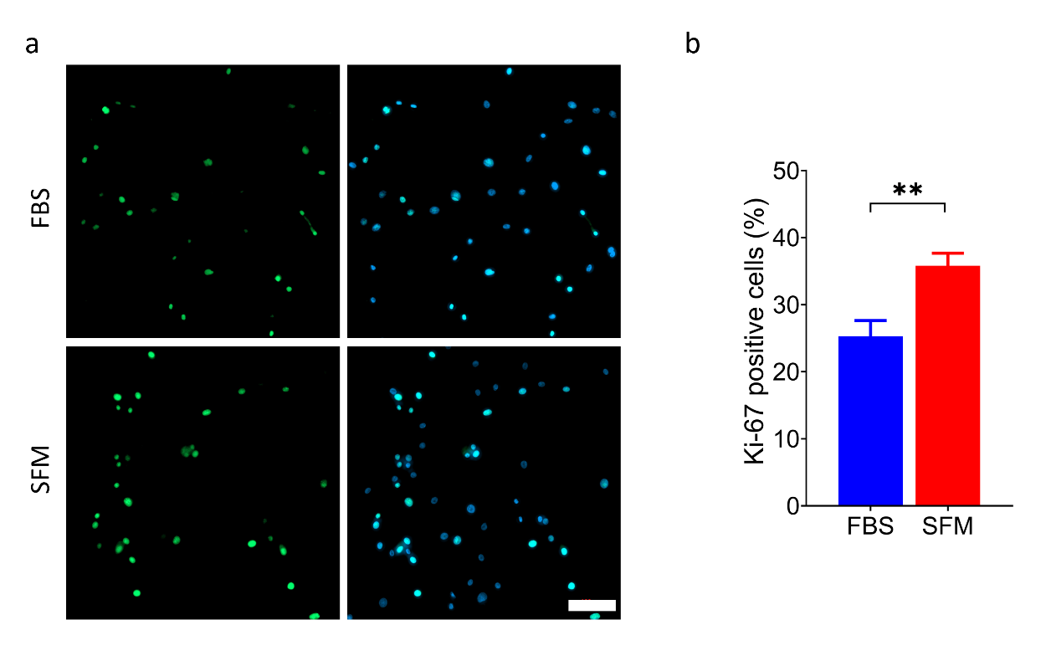
Fig. S1. Analysis of proliferation based on Ki-67 expression. (a) Representative images of Ki-67 staining (green) in bASCs grown in growth medium supplemented with fetal bovine serum (FBS) or serum-free supplement (SFM). The images on the right include Hoechst 33342 staining for the cell nuclei (blue). Scale bar = 100 µm. (b) Quantitative evaluation of the number of Ki-67-positive cells under the different culture conditions. (**p<0.01, n=6).
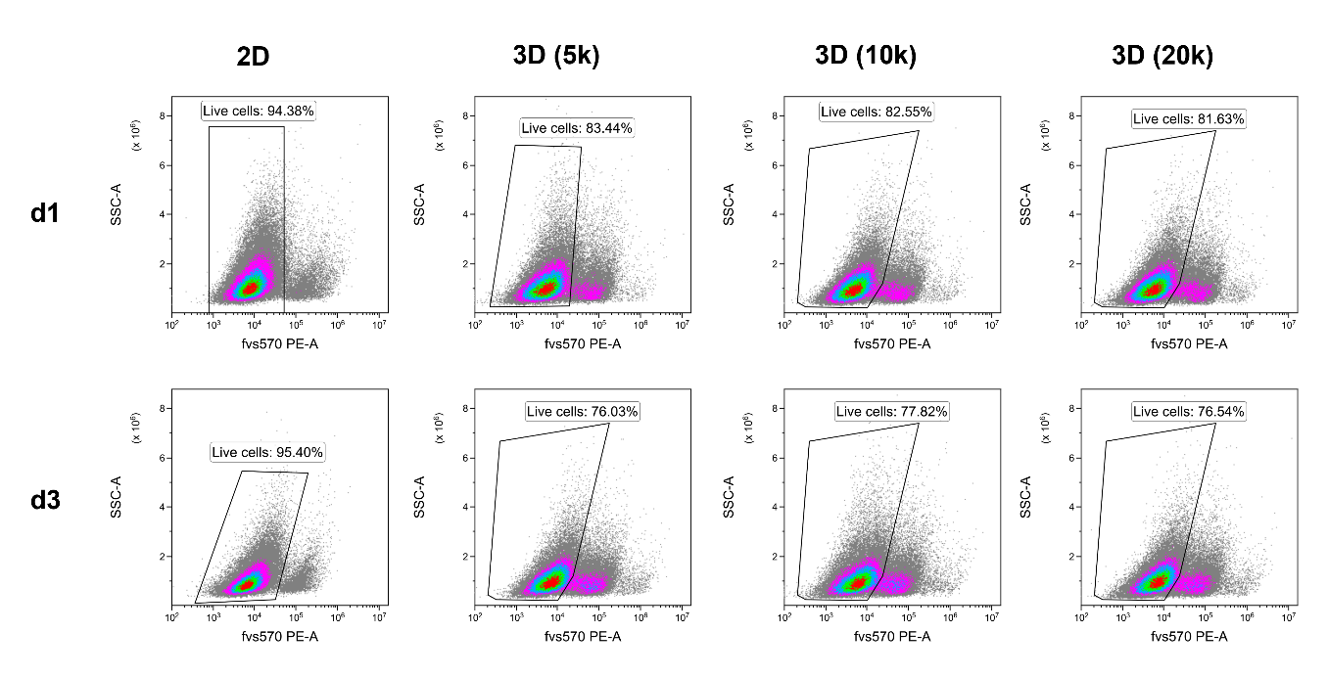
Fig. S2. Representative flow cytometry plots of live/dead cell staining in 2D and 3D cultures at day 1 (d1) and day 3 (d3). Cells were stained with the fixable viability dye 570 (FVS 570) and analyzed by flow cytometry. The x-axis represents fluorescence intensity, and the y-axis represents side scatter (SSC-A). Each plot shows the percentage of live cells within the gated population. Conditions include 2D culture and 3D spheroids seeded with 5,000, 10,000, or 20,000 cells.
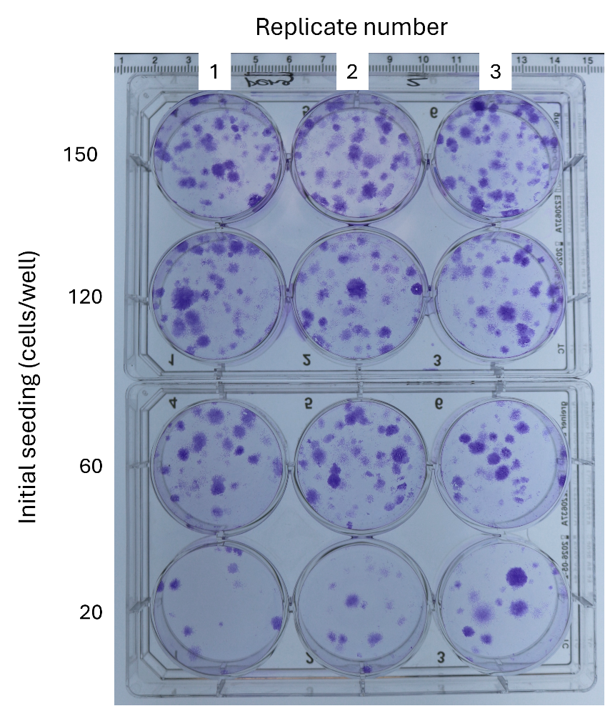
Fig. S3. Image of the plates displaying colonies formed after 14 days of culture. In the 60 cells/well group, the average number of colonies was 16.3 ± 2.4, resulting in an overall CFU-F efficiency of 27.3 ± 3.9%. The plates were flipped to better visualize the cell colonies in the wells (1, 2, and 3 indicate replicate number).

Fig. S4. Alizarin red staining of bASCs after osteogenic induction. (a) Image of the whole wells to visualize matrix production in cells cultured in osteogenic differentiation medium (DM) compared to cells cultured in growth medium (GM). (b) Phase contrast micrographs showing the mineral matrix secreted by the cells induced in DM as opposed to cells in GM. Scale bar = 100 µm.

