Methods
Trace gas measurements
CO₂, CH₄, and δ¹³C-CO₂ measurements in trapped air were made at Oregon State University. CO₂ concentrations for small, 9-12 g samples were measured using the dry extraction method as developed¹, using a needle crusher housed in a -40°C vacuum chamber. The extracted air was subsequently trapped into stainless steel tubes in an exchange gas cryostat at 10 K and measured for CO₂ using gas chromatography after being warmed to room temperature. The pooled standard deviation of replicate measurements (n = 51 run in duplicate, n = 3 run in triplicate) was 3.0 ppm. A blank correction was made by measuring standard gas over artificial air-free ice. The standard used was a high pressure compressed air cylinder (CB11301) with a concentration of 268.8 ppm, calibrated by the NOAA Global Monitoring Division (GMD) on the WMO X2019 CO₂ scale. Because there were five distinct sampling campaigns, a different blank correction was applied to each collection of samples within the same period. These corrections range from 0.72 to 3.0 ppm. Gravitational enrichment was corrected for using δ¹⁵N-N₂ (Equation 1).

Equation 1. ${{CO}_{2}}_{corr}={CO}_{2_{meas}}(1+∆M*\frac{δ^{15}N}{1000})$ ,

where ΔM is the difference in molar mass between air (28.96 g/mol) and CO₂ (44.01 g/mol). Gravitational corrections ranged from 0.22 to 0.42 ppm.

Methane concentrations were measured following the method as described^{2,3}. Samples underwent wet extraction, melting and then refreezing ~50 g of ice while under vacuum in glass flasks with stainless steel flanges. Concentrations were measured using a 6890N Agilant gas chromatograph and the pooled standard deviation of replicate measurements (n = 57 run in duplicate, n = 6 in triplicate, n = 4 in quadruplicate) was 12.3 ppb (n=56). An empirically derived solubility correction of 1.0165 was applied to all samples³. A blank correction was applied to samples from the same measurement period, ranging from 8.1 to 14.8 ppb. Gravitational correction using Equation 1 (adjusted for CH₄) was small, ranging from 0.43 to 0.74 ppb. The standard used was CB11302 standard air with a concentration of 481.25 ppb calibrated by the NOAA GMD on the WMO X2004A CH₄ scale. This measurement technique provides a measurement of total air content (TAC) as well. TAC was corrected for solubility (1.3%) and the cut-bubble effect (1.9%)⁴.

δ¹³C of CO₂ was measured following the method as described⁵. Air was extracted from ice using a dry technique of ice grating inside a stainless-steel chamber under vacuum within a -60°C freezer. CO₂ and N₂O were then trapped using liquid nitrogen and transferred to a dual inlet isotope ratio mass spectrometer equipped with a microvolume inlet. To correct for the interference of N₂O on the δ¹³C result, the N₂O-to-CO₂ ratio was estimated by measuring the ¹⁴N¹⁶O fragment of the sample produced in the source during ionization⁶. To extract similar quantities of CO₂ from each sample, sample mass required was determined using the small-sample CO₂ concentrations measured at the same depth and ranged from 80-350 g. The purpose of measuring δ¹³C-CO₂ was to detect samples containing excess CO₂ due to oxidation of reduced carbon or decarbonation of CaCO₃. CO₂ concentrations from the δ¹³C-CO₂ measurement agreed with previous concentrations at the same depth (the absolute difference for samples with CO₂ < 500 ppm averaged 3.6 ppm). Results outside the range seen in Antarctic cores from the last 160 ka (-6 to -7.1‰)^{7–9} were assumed to contain a component of non-atmospheric CO₂. This range is supported by a reconstruction of δ¹³C_{atm} from benthic and planktonic δ¹³C records of the Cenozoic¹⁰.

Measurements of O₂/N₂, δ¹⁸O_{atm}, and δ¹⁵N
Samples were analyzed for δ¹⁵N-N₂, δ¹⁸O-O₂, δAr/N₂ and δO₂/N₂ at Scripps Institution of Oceanography following laboratory methods described in¹¹. Briefly, air was extracted from a 10-15 g sample using a melt-refreeze method. The sample was then trapped using liquid He and analyzed on a Thermo Finnigan Delta V dual-inlet mass spectrometer. In order to reconstruct δ¹⁸O_{atm,} measured δ¹⁸O-O₂ must be corrected for gravitational fractionation and gas loss. Here, we use the method and gas loss parameterizations from¹², which require inputs of δ¹⁵N (for gravitational corrections), and δAr/N₂ and δO₂/N₂ (for gas loss). The empirical gas loss parameterization was established based on individual and replicate measurements of Taylor Glacier samples covering the last ~150,000 years¹². Over this relatively recent/narrow interval, these authors assumed that atmospheric O₂/N₂ was constant and therefore determined measured δO₂/N₂ to reflect only fractionations related to firn processes and post-depositional alteration. However, evidence from older ice core records suggest a secular decrease in atmospheric O₂/N₂¹³ starting at ~1Ma¹⁴. We therefore account/correct for this change in atmospheric O₂/N₂ change¹⁴ before applying the empirical gas loss corrections¹².

⁴⁰Ar_{atm} measurement and dating technique
Samples were dated using the δ⁴⁰Ar_{atm} technique as described¹⁵. Briefly, measurements were made on 500-800 g samples at Princeton University. The laboratory procedure uses cryogenic trapping of gases as they are released from the ice by melting. After the ice sample is entirely melted, a magnetic stir bar within the sample vessel is used to promote complete exsolution of gases from the meltwater. Non-noble gas species are then removed via gettering. The pure noble gas sample is then analyzed on a MAT 253plus mass spectrometer. Further detail on this method can be found in¹⁶.

Reexamination of the ALHIC1503 record
The ALHIC1503 borehole (-76.73243, 159.3562) is approximately 8 m from the ALHIC1901 core (-76.73236, 159.35622). We used a multi-proxy approach to compare the two records. All gas properties from ALHIC1901, including ⁴⁰Ar_{atm} age, δ¹⁸O_{atm}, δO₂/N₂, δ¹⁵N-N₂, CO₂, and CH₄, can be matched to ALHIC1503 measurements (Supplementary Fig. 1). This comparison shows a depth offset between the cores of 9-12 m, implying isochrons in this region are dipping at ~48°. A comparison of the water isotope data reveals the same depth offset. We assigned new ages to the ALHIC1503 depth-adjusted gas measurements by linearly interpolating to the ⁴⁰Ar_{atm} chronology from ALHIC1901.

Preservation of atmospheric signals in ALHIC1901
The percentage of the EDC range^{17–19} represented by ALHIC1901 measurements with ⁴⁰Ar_{atm} ages between 400-800 ka for CO₂, CH₄, and δ¹⁸O_{atm} are 42 ± 1%, 38 ± 1% and 23 ± 0.7%, respectively. These fractions were derived by first interpolating each EDC record to be evenly spaced with respect to time, at 50-year resolution. We then created 10,000 Monte Carlo simulations of each EDC record to incorporate published analytical uncertainty^{17–19}. We report the fraction that the range in values for each parameter in ALHIC1901 represents relative to the average range of the Monte Carlo simulations. The smaller range in δ¹⁸O_{atm} is likely because variations in this parameter are dominated by precession^{20,21}, with a ~20 ka periodicity. The attenuation of the δ¹⁸O_{atm} signal is evident in Supplementary Fig. 2, where the same Gaussian smoothing applied to all three gas parameters produces a smaller range in δ¹⁸O_{atm} compared to CO₂ or CH₄.

No glacial-level values for the three gas parameters are found in ALHIC1901. Data from cores penetrating the penultimate glacial period and last interglacial at Allan Hills show very low glacial period accumulation rates and an order-of-magnitude increase across the termination^{22,23}, suggesting that preservation bias could explain the lack of glacial values. To quantify this possibility, we applied the difference in annual layer thickness from MIS6 to MIS5e calculated for S27 (roughly an order of magnitude change)²³ to the EDC data from 400-800 ka, creating a synthetic ice core record of the three gas parameters. We then created 10,000 Monte Carlo simulations of each EDC record to incorporate published uncertainty. To compare the synthetic EDC records to the distributions of each gas parameter seen in ALHIC1901, we smoothed these EDC records with two differing Gaussian filters and then took the average of all Monte Carlo simulations. We then randomly selected an equivalent number of values to the number of observations in ALHIC1901. Supplementary Fig. 2 shows the results of this simulation. Glacial-level values are not observed in the simulated distributions for any gas parameter. Likewise, each gas parameter exhibits a slight interglacial bias, particularly when a more extreme Gaussian filter is applied. Though we recognize this an oversimplified demonstration of signal preservation at this site, it illustrates that a large glacial-interglacial accumulation rate gradient could produce distributions similar to those we have measured.

Though all three gas parameters display a slight interglacial bias, many CO₂ concentrations are higher than expected given the value of CH₄ for the same subsample (Supplemental Fig. 4). One explanation for this observation could be a difference in the preservation of interglacial-level CO₂ and CH₄ in ice that has undergone smoothing. In the synthetic EDC records, maximum CO₂ levels are preserved even in the range produced from more extreme Gaussian smoothing, whereas maximum CH₄ levels are not observed (Supplementary Fig. 2). Alternatively, the larger variance in CO₂ relative to CH₄ and δ¹⁸O_{atm} could partially be explained by small deviations from atmospheric CO₂. A number of processes have been observed to alter the CO₂ concentration in ice cores, such as the presence of melt layers, carbonate or silicate weathering, oxidation of organic carbon, and post-coring effects^{24–28}. Apart from silicate weathering and carbonate precipitation, most known processes increase the CO₂ concentration in bubbles leading to an overestimate of atmospheric CO₂. While in some cases CO₂ can be highly enriched (for example, due to oxidation of organic matter near the bedrock interface), in other cases alteration is subtle, with differences between ice cores reported in the 5-20 ppm range^{8,18,29}.

Changes in preservation downcore
Assuming that the older ALHIC1901 samples represent a similar fraction of the variance of the original atmospheric history as the 400-800 ka samples, our record would imply reduced interglacial maxima in samples older than 1 Ma. Alternatively, we can consider that characteristics such as diffusion and thinning may not be constant with depth at this site. From 120 – 141 m depth, ⁴⁰Ar_{atm} ages are somewhat homogenous (within 300 ka). Below 141 m, there are several age reversals between ice younger than 800 ka and older than 1 Ma old. We speculate that these abrupt age transitions may be associated with margins of shear stress, where ice flow may be behaving differently above and below. Within this deepest unit the CO₂ and CH₄ concentrations measured in samples with overlapping ages with EDC plot much closer to the depth-averaged glacial cycle values from 500-800 ka in EDC (Supplementary Fig. 3). The EDC depth-averaged value still contains a slight interglacial bias due to the variable layer thickness across glacial cycles in EDC (Supplementary Fig. 4).

It is not obvious that the implied range of signal preserved in the younger ice can be extended to the older samples because the accumulation rate contrast between glacial and interglacial cycles before the MPT is unknown. However, the observation that glacial-interglacial cycles prior to the MPT were more muted suggests a lower contrast in accumulation and temperature between ice ages and warm periods^{30,31}. If accumulation rate across glacial cycles in the pre-MPT were more constant, the pre-MPT CO₂ measured in ALHIC1901 would reflect a time-averaged value as opposed to a depth-averaged value. The time-averaged EDC value of CO₂ from 500-800 ka, is ~5 ppm lower than the average ALHIC1901 value from 500-800 ka for samples >141 m depth (Supplementary Fig. 4).

Constraints on late-Pliocene CO₂ levels
CO₂ in polar ice cores are sensitive to post-depositional processes that can both raise and lower measured CO₂ levels. The most likely post-depositional processes involve oxidation of co-existing organic carbon and interactions with CaCO₃ dust in the ice²⁸. Oxidation of organic matter is the most likely process causing elevated CO₂ concentrations near the ice-bedrock interface based on the isotopically depleted δ¹³C values, and the dramatic reduction in the δO₂/N₂ ratio (Supplementary Fig. 5). Reduction in CO₂ levels due to interactions with alkaline ice have been observed in ice from Greenland, however, it is also associated with a strong depletion in δ¹³C values³², suggesting that δ¹³C_{CO2} is useful for distinguishing both CO₂ addition by respiration and CO₂ removal by carbonation. A change in total air content is not observed in samples containing non-atmospheric CO₂, which we might expect if production of CO₂ is occurring in situ^{27,33}. An alternative explanation to in situ production could be CO₂ production at the ice-sediment interface and subsequent vertical diffusion through the ice matrix.

Dissolution can also impact the preservation of atmospheric CO₂ in ice. The high solubility of CO₂ and the known kinetic and equilibrium fractionation of δ¹³C from the exchange between aqueous and gaseous CO₂ would likely lead to altered signals in bubbles surrounding refrozen melt³⁴. Unlike a melt layer produced in the firn²⁵, the closed system of a basal melt event would possibly preclude fractionation assuming 100% extraction efficiency. However, the dry extraction technique used to measure CO₂ and δ¹³C likely does not extract CO₂ incorporated into the ice matrix with the same efficiency as CO₂ incorporated in bubbles, and would therefore capture an altered signal. Using noble gas ratios as a proxy for melt processes, we can rule out dissolution as an explanation for elevated CO₂ concentrations. Evidence of argon loss in the deepest sample (⁴⁰Ar_{atm} age of 4 Ma), indicated by negative Ar/N₂ ratios, opens up the possibility of secondary processes altering the CO₂ concentration, and we therefore exclude this deepest sample from our model (Shackleton et al. 2024a).

We can constrain the original atmospheric CO₂ in the samples with elevated concentrations using the isotopic data and a two-endmember mixing model. The range of atmospheric δ¹³C measured in ice cores is -6.0‰ to -7.1‰ across glacial-interglacial cycles over the last 160 ka^{8,9,35} (older data are not available). A reconstruction of δ¹³C_{atm} from benthic and planktonic δ¹³C records provides supporting evidence for a range of -6 to -7‰ extending back to the early Pliocene ¹⁰. Assuming this is the full range of possible variability of this parameter, any signature out of this range was deemed to include non-atmospheric CO₂. Without empirical data for isotopic signatures of organic matter at the Allan Hills, we constrain our model (Equation 2) using the following assumptions:

- The isotopic signature of the organic source (δ¹³C_{OM}) must be lighter than the most depleted δ¹³C measurement (-25‰).

- The lower limit of δ¹³C_{OM} must keep CO_{2atm} higher than 150 ppm. This threshold assumes that glacial minima were very likely less extreme in the pre-MPT than in the “100 ka world” so CO₂ concentrations were very unlikely to have been lower than observed in the continuous ice core record. A minimum corrected CO_{2atm} of 150 ppm requires the δ¹³C_{OM} must be less than -28‰.

- δ¹³C_{OM} must be within the range of δ¹³C_{OM} measured in basal material near the Dry Valleys, East Antarctica. The most depleted δ¹³C_{OM} found in published literature is -30‰ ^{36,37}.

These assumptions result in a range of likely δ¹³C_{OM} signatures to be between -30‰ to -28‰ PDB. A secondary method for determining the most likely δ¹³C_{OM} signature uses the strong correlation between measured δ¹³C and [CO₂]⁻¹ (Fig. 2). Taking the y-intercept of the linear regression to signify δ¹³C_{OM} results in a signature of -29‰ PDB. Considering the very strong correlation (R² = 0.97), and that this signature falls directly between our assumed δ¹³C_{OM} range, we assign -29‰ as our most likely δ¹³C_{OM}, with vertical bars representing the full range from -30‰ to -28‰ PDB (Fig. 3).

Atmospheric CO₂ was determined using Equation 2,

Equation 2. ${{CO}_{2}}_{atm}={CO}_{2_{m}}-\frac{{CO}_{2_{m}}(δ^{13}C_{m}-δ^{13}C_{atm})}{δ^{13}C_{OM}-δ^{13}C_{atm}}$ ,

where CO_{2m} and δ¹³C_{m} are the measured concentration and isotopic signature, respectively, δ¹³C_{atm} is the atmospheric isotopic signature (set to -6.5 ± 0.5‰), and δ¹³C_{OM} ranged from -30‰ to -28‰ PDB. Supplementary Fig. 6 shows the corrected CO₂ concentrations compared to the pristine record.

CO₂ Proxies
Proxies vetted by the Cenozoic CO₂ Proxy Integration Project (CenCO₂PIP) Consortium were included in this paper. For 3 Ma to 400 ka, this includes boron isotopes, phytoplankton
δ¹³C (Alkenones), and soil carbonate δ¹³C (Paleosols). Of published alkenone records, only those identified as “Category 1”, denoting the highest-quality record by CenCO₂PIP were included. Records relevant to the ALHIC1901 ages come from Core site ODP999 and ODP925 and are published, either originally or recalculated, in^{38–40}. Records from the two core sites are distinguished from one another in all figures. All alkenone measurements come from T. sacculifer.

Criteria for the inclusion of boron isotope proxies as written⁴⁰. Measurements from Core site ODP999 run on MC-ICP-MS were prioritized over measurements from Core site ODP668 and/or run on NTIMS. Measurements from the latter were included when no overlapping measurements from site ODP999 existed. Boron isotope proxy records were plotted according to core site. This separation also distinguished organism type (Core site ODP999 and ODP926 used T. trilobus and Core site ODP668B used G. ruber).

The reconstruction based on the isotopic composition of leaf wax record was also included in our paper⁴¹, though not listed as a vetted proxy from CenCO₂PIP.

Considering that glacial cycles have likely been smoothed out of our deep ALHIC1901 measurements via mixing and diffusion, we applied a Gaussian smoothing to each CO₂ proxy record to compare long-term trends (Supplementary Fig. 7). Each record was interpolated to be evenly spaced at 1000-year timesteps. The records were subsequently smoothed using a gaussian smoothing method. The gaussian filter equated to 400,000 years to remove orbital-scale signals. Apart from CO₂-leafwax and the CO₂-boron records from site ODP999, the irregular spacing of the proxy records may cause the smoothed curves to be skewed due to outliers or periods of sparse data. The curves are therefore used in a more qualitative sense to compare to the ALHIC1901 record. Conversely, the smoothing of the high-resolution, regularly spaced leaf wax record was considered more robust and used to assess changes across the MPT in more detail.

Model reconstructions

The observed secular decline in CO₂ is comparable to some model reconstructions (Supplementary Fig. 8)^{42–45}. Studies using an inverse modeling approach based on the benthic δ¹⁸O stack show a secular decline in CO₂ from 2.9 Ma to 1.2 Ma of 35-50 ppm, and long-term average concentrations in the late Pliocene and early Pleistocene of <300 ppm^{42,43}. A recent reconstruction using a carbon cycle box model incorporating solid earth processes (BICYCLE-SE) produced 18 CO₂ curves with varying scenarios for the last 5 Ma^{45,46}. Notably, all scenarios that include a long-term decline in volcanic CO₂ outgassing from 4.5 to 1 Ma exhibit the poorest fit with our data (Supplementary Fig. 8b-c). These model runs all show higher CO₂ concentrations in the early Pleistocene followed by a significant decline during the MPT. Conversely, scenarios more closely resembling the initial model setup, characterized by weak CO₂-dependency of weathering fluxes and no change in outgassing, have the best match with our data, showing a much more gradual decline in CO₂ across the whole Pleistocene. Furthermore, CO₂ concentrations under these scenarios did not exceed 350 ppm in the Pliocene.

METHODS REFERENCES
1. Ahn, J., Brook, E. J. & Howell, K. A high-precision method for measurement of paleoatmospheric CO ₂ in small polar ice samples. J. Glaciol. 55, 499–506 (2009).
2. Grachev, A. M., Brook, E. J., Severinghaus, J. P. & Pisias, N. G. Relative timing and variability of atmospheric methane and GISP2 oxygen isotopes between 68 and 86 ka. Global Biogeochemical Cycles 23, (2009).
3. Lee, J. E. et al. An 83,000-year-old ice core from Roosevelt Island, Ross Sea, Antarctica. Climate of the Past 16, 1691–1713 (2020).
4. Epifanio, J. A. et al. Millennial and orbital-scale variability in a 54&thinsp;000-year record of total air content from the South Pole ice core. The Cryosphere 17, 4837–4851 (2023).
5. Bauska, T. K., Brook, E. J., Mix, A. C. & Ross, A. High-precision dual-inlet IRMS measurements of the stable isotopes of CO₂ and the N₂O / CO₂ ratio from polar ice core samples. Atmospheric Measurement Techniques 7, 3825–3837 (2014).
6. Assonov, S. S. & Brenninkmeijer, C. a. M. On the N2O correction used for mass spectrometric analysis of atmospheric CO2. Rapid Communications in Mass Spectrometry 20, 1809–1819 (2006).
7. Schneider, R., Schmitt, J., Köhler, P., Joos, F. & Fischer, H. A reconstruction of atmospheric carbon dioxide and its stable carbon isotopic composition from the penultimate glacial maximum to the last glacial inception. Climate of the Past 9, 2507–2523 (2013).
8. Eggleston, S., Schmitt, J., Bereiter, B., Schneider, R. & Fischer, H. Evolution of the stable carbon isotope composition of atmospheric CO2 over the last glacial cycle. Paleoceanography 31, 434–452 (2016).
9. Bauska, T. K. et al. Carbon isotopes characterize rapid changes in atmospheric carbon dioxide during the last deglaciation. Proceedings of the National Academy of Sciences 113, 3465–3470 (2016).
10. Tipple, B. J., Meyers, S. R. & Pagani, M. Carbon isotope ratio of Cenozoic CO2: A comparative evaluation of available geochemical proxies. Paleoceanography 25, (2010).
11. Sowers, T., Bender, M. & Raynaud, D. Elemental and isotopic composition of occluded O2 and N2 in polar ice. Journal of Geophysical Research: Atmospheres 94, 5137–5150 (1989).
12. Baggenstos, D. et al. Atmospheric gas records from Taylor Glacier, Antarctica, reveal ancient ice with ages spanning the entire last glacial cycle. Climate of the Past 13, 943–958 (2017).
13. Stolper, D. A., Bender, M. L., Dreyfus, G. B., Yan, Y. & Higgins, J. A. A Pleistocene ice core record of atmospheric O₂ concentrations. Science 353, 1427–1430 (2016).
14. Yan, Y., Brook, E., Kurbatov, A., Severinghaus, J. & Higgins, J. Ice core evidence for atmospheric oxygen decline since the Mid-Pleistocene transition. https://www.science.org/doi/10.1126/sciadv.abj9341 (2021) doi:10.1126/sciadv.abj9341.
15. Bender, M. L., Barnett, B., Dreyfus, G., Jouzel, J. & Porcelli, D. The contemporary degassing rate of 40Ar from the solid Earth. Proceedings of the National Academy of Sciences 105, 8232–8237 (2008).
16. Shackleton, S., Hishamunda, V., Davidge, L., Bender, M. & Higgins, J. 6 million-year-old ice and air from the Allan Hills blue ice area, East Antarctica. Submitted (2024).
17. Loulergue, L. et al. Orbital and millennial-scale features of atmospheric CH4 over the past 800,000 years. Nature 453, 383–386 (2008).
18. Bereiter, B. et al. Revision of the EPICA Dome C CO2 record from 800 to 600 kyr before present. Geophysical Research Letters 42, 542–549 (2015).
19. Extier, T. et al. On the use of δ18Oatm for ice core dating. Quaternary Science Reviews 185, 244–257 (2018).
20. Bender, M., Sowers, T. & Labeyrie, L. The Dole Effect and its variations during the last 130,000 years as measured in the Vostok Ice Core. Global Biogeochemical Cycles 8, 363–376 (1994).
21. Landais, A. et al. What drives the millennial and orbital variations of δ18Oatm? Quaternary Science Reviews 29, 235–246 (2010).
22. Carter, A. et al. Evidence for diminished Ross Ice Shelf and West Antarctic Ice Sheet during the Last Interglacial from ice cores at the Allan Hills, Antarctica. Submitted (2024).
23. Yan, Y. et al. Enhanced moisture delivery into Victoria Land, East Antarctica, during the early Last Interglacial: implications for West Antarctic Ice Sheet stability. Climate of the Past 17, 1841–1855 (2021).
24. Berner, W., Stauffer, B. & Oeschger, H. Past atmospheric composition and climate, gas parameters measured on ice cores. Nature 276, 53–55 (1978).
25. Neftel, A., Oeschger, H., Schwander, J. & Stauffer, B. Carbon dioxide concentration in bubbles of natural cold ice. J. Phys. Chem. 87, 4116–4120 (1983).
26. Anklin, M., Barnola, J.-M., Schwander, J., Stauffer, B. & Raynaud, D. Processes affecting the CO2 concentrations measured in Greenland ice. Tellus B 47, 461–470 (1995).
27. Souchez, R., Janssens, L., Lemmens, M. & Stauffer, B. Very low oxygen concentration in basal ice from Summit, central Greenland. Geophysical Research Letters 22, 2001–2004 (1995).
28. Smith, H. J., Wahlen, M., Mastroianni, D., Taylor, K. & Mayewski, P. The CO2 concentration of air trapped in Greenland Ice Sheet Project 2 ice formed during periods of rapid climate change. Journal of Geophysical Research: Oceans 102, 26577–26582 (1997).
29. Bauska, T. K., Marcott, S. A. & Brook, E. J. Abrupt changes in the global carbon cycle during the last glacial period. Nat. Geosci. 14, 91–96 (2021).
30. Lisiecki, L. E. & Raymo, M. E. A Pliocene-Pleistocene stack of 57 globally distributed benthic δ18O records. Paleoceanography 20, (2005).
31. Clark, P. U., Shakun, J. D., Rosenthal, Y., Köhler, P. & Bartlein, P. J. Global and regional temperature change over the past 4.5 million years. Science 383, 884–890 (2024).
32. Krauss, F. Optimisation of a continuous sublimation extraction technique to reconstruct past CO2, CH4, and N2O concentrations and δ13C-CO2 from ice cores. (University of Bern, Germany, 2024).
33. Montross, S. et al. Debris-Rich Basal Ice as a Microbial Habitat, Taylor Glacier, Antarctica. Geomicrobiology Journal 31, 76–81 (2014).
34. Zhang, J., Quay, P. D. & Wilbur, D. O. Carbon isotope fractionation during gas-water exchange and dissolution of CO2. Geochimica et Cosmochimica Acta 59, 107–114 (1995).
35. Menking, J. A. et al. Multiple carbon cycle mechanisms associated with the glaciation of Marine Isotope Stage 4. Nat Commun 13, 5443 (2022).
36. Faure, G., Hoefs, J., Jones, L. M., Curtis, J. B. & Pride, D. E. Extreme 18O depletion in calcite and chert clasts from the Elephant Moraine on the East Antarctic ice sheet. Nature 332, 352–354 (1988).
37. Barker, J. D., Grottoli, A. G. & Lyons, W. B. Stable isotope evidence for the biogeochemical transformation of ancient organic matter beneath Suess Glacier, Antarctica. Arctic, Antarctic, and Alpine Research 50, e1448643 (2018).
38. Badger, M. P. S. et al. Insensitivity of alkenone carbon isotopes to atmospheric CO₂ at low to moderate CO₂ levels. Climate of the Past 15, 539–554 (2019).
39. Zhang, Y. G. et al. Refining the alkenone-pCO2 method I: Lessons from the Quaternary glacial cycles. Geochimica et Cosmochimica Acta 260, 177–191 (2019).
40. Rae, J. W. B. et al. Atmospheric CO2 over the Past 66 Million Years from Marine Archives. Annual Review of Earth and Planetary Sciences 49, 609–641 (2021).
41. Yamamoto, M. et al. Increased interglacial atmospheric CO2 levels followed the mid-Pleistocene Transition. Nat. Geosci. 15, 307–313 (2022).
42. van de Wal, R. S. W., de Boer, B., Lourens, L. J., Köhler, P. & Bintanja, R. Reconstruction of a continuous high-resolution CO₂ record over the past 20 million years. Climate of the Past 7, 1459–1469 (2011).
43. Stap, L. B. et al. CO2 over the past 5 million years: Continuous simulation and new δ11B-based proxy data. Earth and Planetary Science Letters 439, 1–10 (2016).
44. Berends, C. J., de Boer, B., Dolan, A. M., Hill, D. J. & van de Wal, R. S. W. Modelling ice sheet evolution and atmospheric CO₂ during the Late Pliocene. Climate of the Past 15, 1603–1619 (2019).
45. Köhler, P. Atmospheric CO2 Concentration Based on Boron Isotopes Versus Simulations of the Global Carbon Cycle During the Plio-Pleistocene. Paleoceanography and Paleoclimatology 38, e2022PA004439 (2023).
46. Köhler, P. & Munhoven, G. Late Pleistocene Carbon Cycle Revisited by Considering Solid Earth Processes. Paleoceanography and Paleoclimatology 35, e2020PA004020 (2020).
47. Chalk, T. B. et al. Causes of ice age intensification across the Mid-Pleistocene Transition. Proceedings of the National Academy of Sciences 114, 13114–13119 (2017).
48. Martínez-Botí, M. A. et al. Plio-Pleistocene climate sensitivity evaluated using high-resolution CO2 records. Nature 518, 49–54 (2015).
49. de la Vega, E., Chalk, T. B., Wilson, P. A., Bysani, R. P. & Foster, G. L. Atmospheric CO2 during the Mid-Piacenzian Warm Period and the M2 glaciation. Sci Rep 10, 11002 (2020).
50. Hönisch, B., Hemming, N. G., Archer, D., Siddall, M. & McManus, J. F. Atmospheric Carbon Dioxide Concentration Across the Mid-Pleistocene Transition. Science 324, 1551–1554 (2009).
51. Dyez, K. A., Hönisch, B. & Schmidt, G. A. Early Pleistocene Obliquity-Scale pCO2 Variability at 1.5 Million Years Ago. Paleoceanography and Paleoclimatology 33, 1270–1291 (2018).
52. Zhang, Y. G. et al. Refining the alkenone-pCO2 method I: Lessons from the Quaternary glacial cycles. Geochimica et Cosmochimica Acta 260, 177–191 (2019).
53. Seki, O. et al. Alkenone and boron-based Pliocene pCO2 records. Earth and Planetary Science Letters 292, 201–211 (2010).
54. Willeit et al. Mid-Pleistocene transition in glacial cycles explained by declining CO2 and regolith removal. Science Advances 5, (2019).

Supplementary Figures
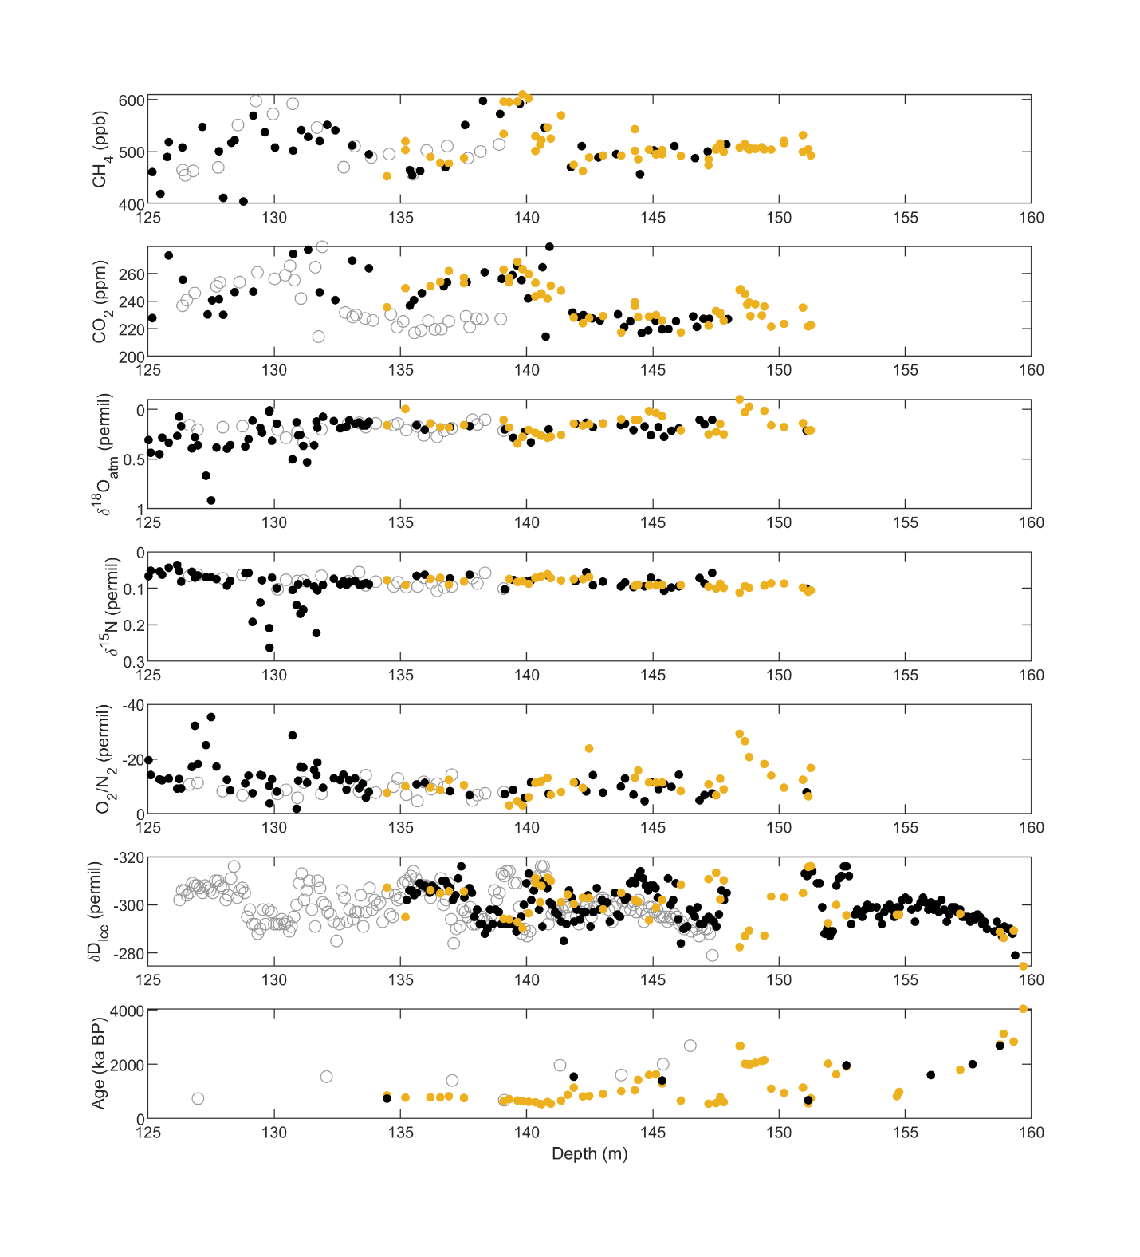
Supplemental Figure 1. From top to bottom: CH₄ concentrations, CO₂ concentrations, δ¹⁸O_{atm}, δO₂/N₂, δ¹⁵N-N₂, δD_{ice}, and ⁴⁰Ar_{atm} age, all plotted on depth. A comparison of measurements from two Allan Hills cores (ALHIC1901 and ALHIC1503). Open circles are ALHIC1503 data plotted on true depth, yellow circles are ALHIC1901 measurements on true depth, and black circles are ALHIC1503 data on adjusted depths to align with ALHIC1901.

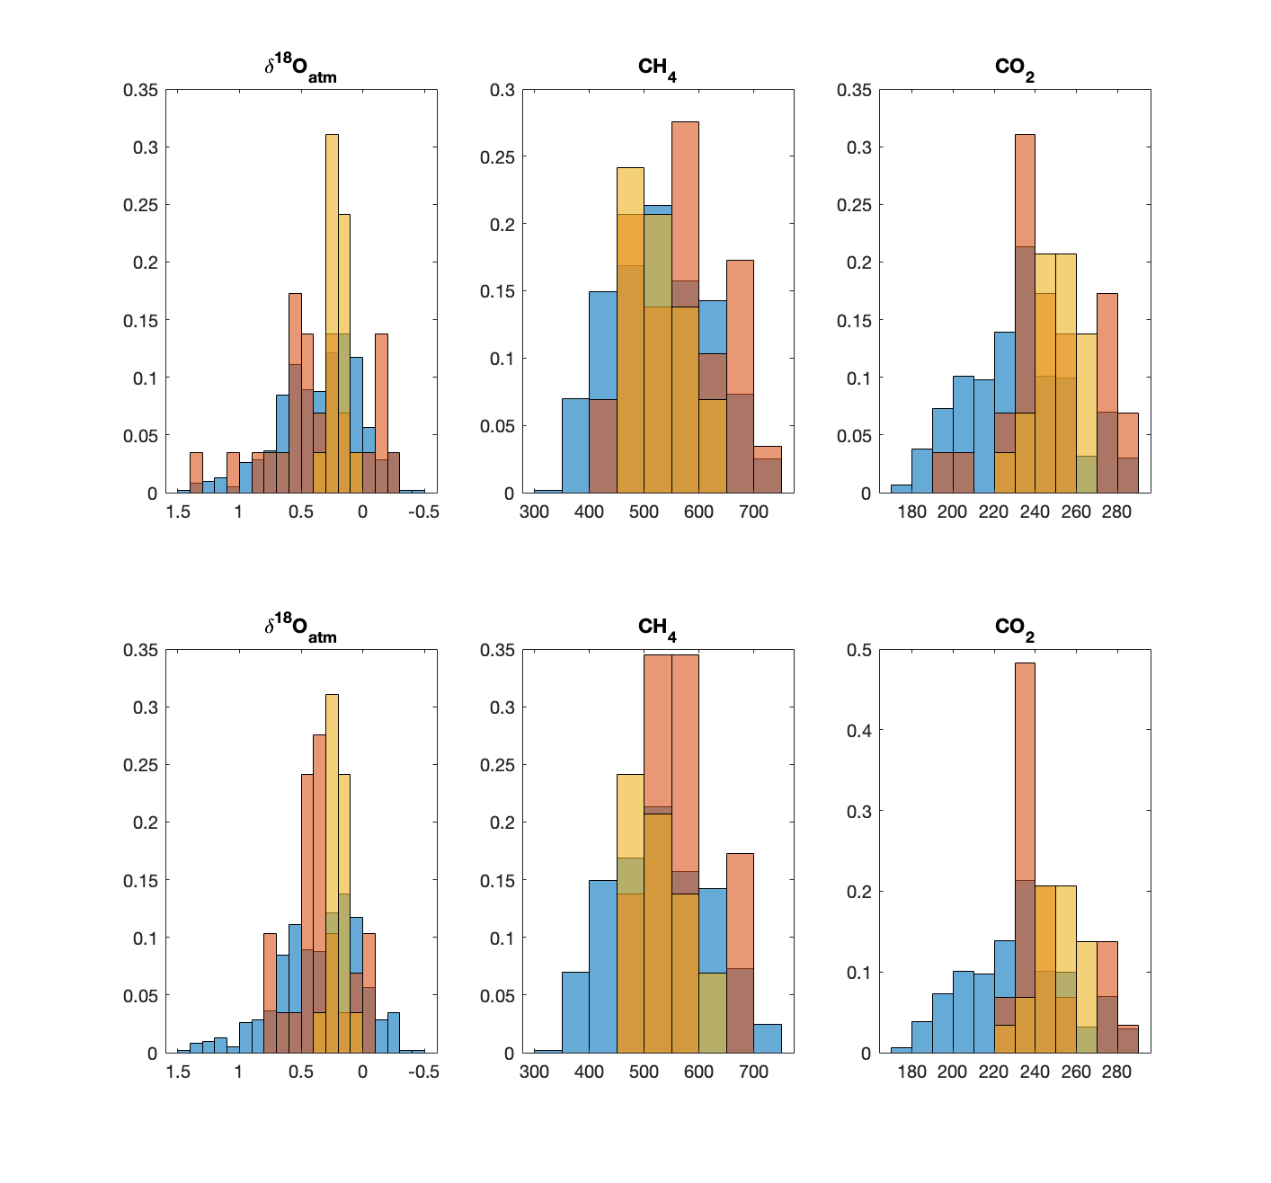
Supplemental Figure 2. Normalized histograms of the distribution of three gas parameters from 400-800 ka: δ18Oatm, CH₄ and CO₂. In each subplot, the distribution of EDC values is in blue, the distribution of 1901 samples in yellow, and the synthetic EDC record in red (see Methods). The top three subplots show a smoothed, weighted EDC record (Gaussian kernel = 50 points), the bottom three subplots show more extreme smoothing (Gaussian kernel = 1000 points). For each gas parameter, we see glacial-level values are lost in the smoothed distributions, appearing more similar to the distribution observed in ALHIC1901.

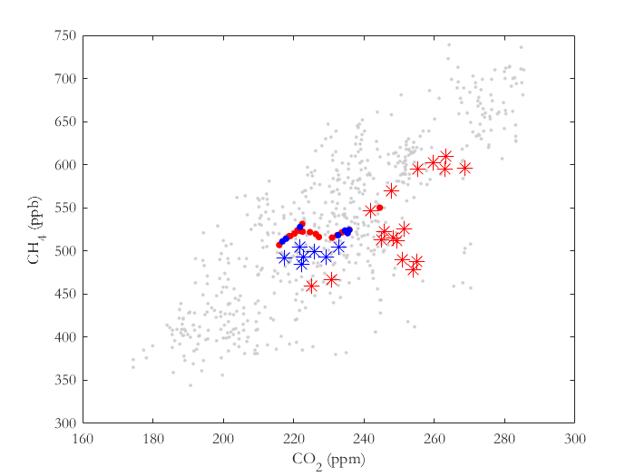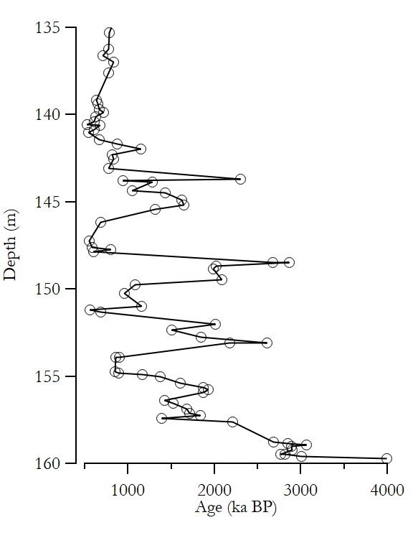

Supplemental Figure 3. Left: A plot of CO₂ vs CH₄ from samples with ages ranging from 400-800 ka. Gray circles are EDC values from Loulergue et al., 2008 and Bereiter et al., 2015. Red and blue stars are ALHIC1901 measurements corresponding to different depths in the core (red are all samples <141 m, blue are all deep samples). Closed circles are the mean EDC CO₂ and CH₄ value averaged across the corresponding ALHIC1901 ⁴⁰Ar_{atm} age uncertainty (±10%). The color of the closed circle corresponds to the ⁴⁰Ar_{atm} ages of the ALHIC1901 measurements of the same color. The deeper ALHIC1901 samples reflect the average EDC value whereas the shallow samples (<141 m, red), display a larger range including interglacial-level values.

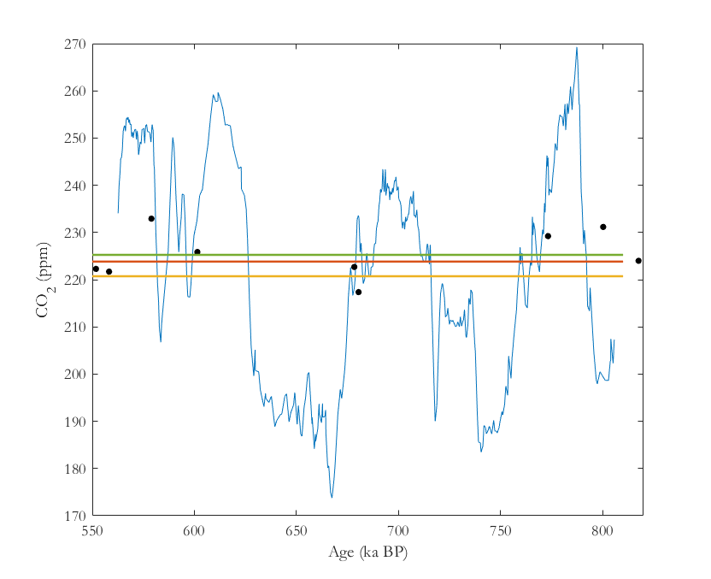
Supplemental Figure 4. A plot showing the effect of time-averaging versus depth-averaging of the EDC core. CO₂ record from EDC from 560-806 ka¹⁸ plotted in blue. ALHIC1901 CO₂ measurements from >141 m depth plotted in black circles on their assigned ⁴⁰Ar_{atm} age. The yellow line represents the average CO₂ value of the EDC record after interpolating the record to be evenly spaced with respect to time. This value is approximately 3 ppm lower than the average CO₂ value of EDC when averaging over depth (red line), due to the variable layer thickness across glacial cycles. The green line represents the average CO₂ value of the ALHIC1901 measurements from this time interval from samples >141 m depth. The similarity between the ALHIC1901 average and the depth-averaged EDC value suggests a slight interglacial bias in the Allan Hills record.

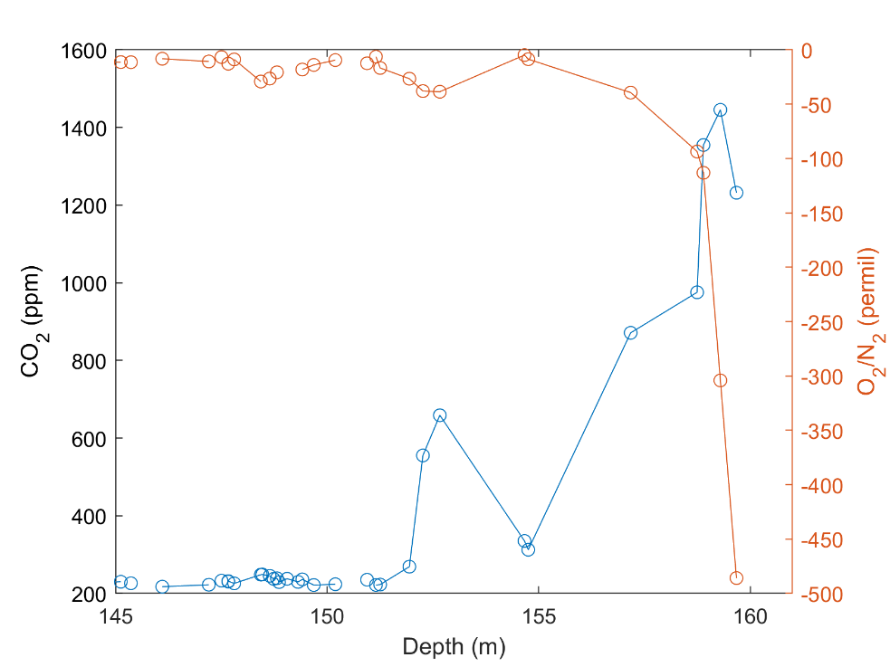
Supplemental Figure 5. CO₂ concentrations (blue) and δO₂/N₂ measurements (orange) plotted against depth for ALHIC1901. Significant δO₂/N₂ deviations from 0‰ represent O₂ depletion in the sample, correlating with high CO₂ concentrations.

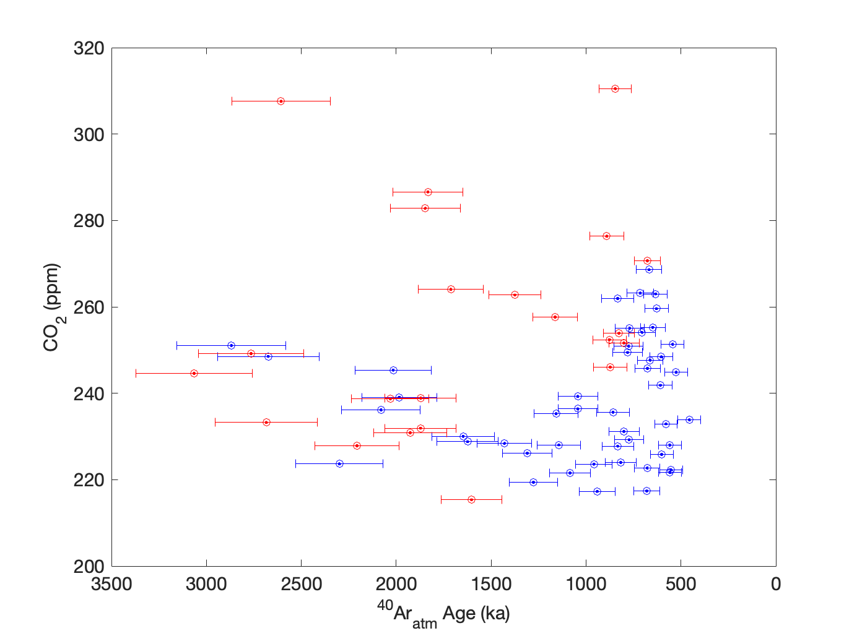
Supplementary Figure 6. A comparison of CO₂ concentrations from the ALHIC1901 core plotted on their ⁴⁰Ar_{atm} age. Blue points show atmospheric CO₂ from samples without respired organic matter (“pristine”), representing purely atmospheric CO₂. Red points represent samples with added non-atmospheric CO₂, corrected using the two-endmember mixing model and an organic endmember of -29‰. Using this endmember, 64% (14/22) of corrected CO₂ samples agree with pristine samples. See Fig. 3 for the full range of organic endmembers used in the model.

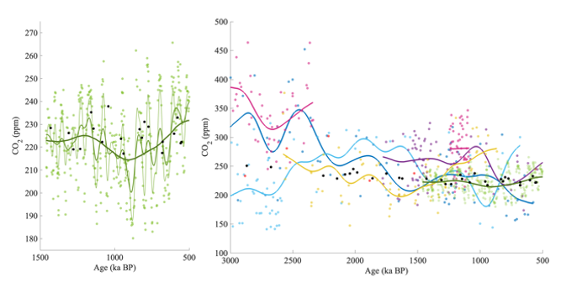
Supplementary Figure 7. Long-term changes in proxy CO₂ records compared to ALHIC1901 CO₂ (black) from 3 Ma to 500 ka BP. Panel (a) shows only CO₂-leafwax⁴¹ compared to ALHIC1901 CO₂ across the MPT. Three gaussian smoothing filters were applied to CO₂-leafwax (40 ka, thinnest line; 100 ka, medium thickness; 400 ka, thickest line). Panel (b) shows all proxies (CO₂-boron in pink (ODP999A)^{47–49} and purple (ODP668B)^{50,51}, CO₂-alk in light (ODP925)^{39,40,52} and dark (ODP999)^{38,53} blue, CO₂-paleosol in yellow, and CO₂-leafwax in green) with a gaussian smoothing equivalent to 400 ka. Uncertainties have been removed to view long-term trends more clearly.

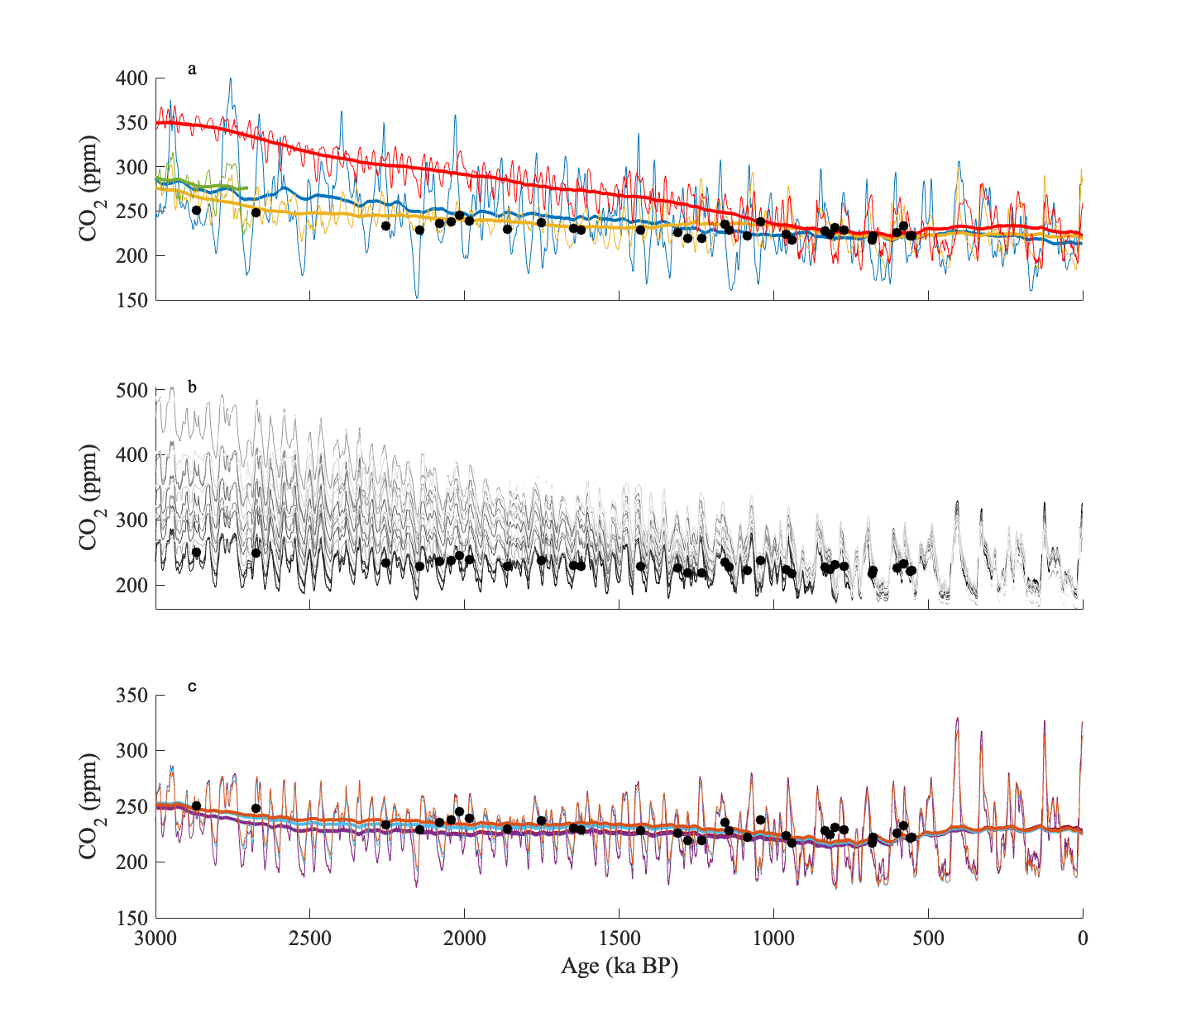

Supplemental Figure 8. Comparison of ALHIC1901 CO₂ measurements (this study, black circles) with output from model reconstructions from 3 Ma to 500 ka. Panel (a) shows benthic δ¹⁸O-based inverse models (thinner line) and a 400 ka smoothing (thicker line) (Blue⁴³; yellow⁴²; green⁴⁴; red⁵⁴). Panel (b) shows model output from all scenarios from the BICYCLE model ⁴⁵. Panel (c) shows only BICYCLE model scenarios in agreement with ALHIC1901 data (thinner line) and an applied 400 ka smoothing (thicker line). Scenarios that agree do not include a decline in volcanic outgassing from 4.5 – 1.0 Ma.

