Appendix
Table A1 FarmCoSwiss baseline questionnaire: definitions and categorizations of selected variables included in the present analyses
Variable name | Variable definition | Response options | Categorization | Re-coding*
Production system | production system employed on participant’s farm | arable farming, forestry, horticulture, grazing livestock (dairy), grazing livestock (meat), pig husbandry, poultry, special crops (e.g. wine, fruit, vegetables, berries), other (multiple choice) | Animal husbandry (with or without crops), crop production | -
Farming system | farming system employed on participant’s farm | conventional, integrated production, organic, transformation to organic, other (multiple choice) | organic or non-organic | -
SF-12 physical and mental component scores (PCS, MCS) | physical health score, mental health score | 12-item instrument with different Likert scales | scale scores aggregated into PCS and MCS | -
Physical activity | physical activity for 30+ minutes, leading to breathlessness and sweating | days per week (0-7 days),  separately for cold and warm season | days per week, averaged across cold and warm season | -
Sitting time | hours/day spent sitting, separately for work and rest day | h/d (text field) | h/d spent sitting | less than 4 hours, 4 to 5 hours, 6 to 7 hours, 8 to 9 hours, 10 hours or more
Diet | days per week with consumption of (i) red meat/sausage, (ii) cooked vegetables, (iii) raw vegetables/salad, and (iv) fruit | Likert scale: 1 (never), 2 (less than once a week) and 3 (once a week) to 9 (7 days a week) | Likert scale value (1-9) | meat consumption:  1 to 3 days/week or less,  4 to 6 days a week, daily
Smoking status | consumption of cigarettes, e-cigarettes and other tobacco products | never, not anymore, some days, daily | non-smokers, former smokers, smokers | -
Alcohol consumption | consumption of beer/wine/cider and hard liquor | Likert scale:1 (never), 2 (1-4 times a month or less), 3 (several times a week), to 4 (daily). | never, less than once a week, several times a week, daily | SHS data: 1 to 2 times a week and 3 to 6 times a week were re-coded as several times a week
BMI | calculated based on self-reported height and weight | height in cm (text field), weight in kg (text field) | underweight (<18.5), healthy weight (18.5-24.9),  overweight (25-29.9),  obesity (≥30) | -
Stress level | stress level at work or at home during past 12 months, for cold and warm season | Likert scale : 1 (no stress) to 6 (extreme stress), separately for cold and warm season | Likert scale value (1-6) | -
Sleep quality | sleep quality during past 12 months, for cold and warm season | Likert scale : 1 (very good) to 5 (very bad), separately for cold and warm season | Likert scale value (1-5) | -
Lifetime prevalence  of 11 diseases and accidents | medically diagnosed disease (ever, up until time of study participation) | yes/no | yes/no | -
* Re-coding necessary for comparative analyses with SHS data.

Table A2 Characteristics of individuals not participating in the FarmCoSwiss cohort at baseline but answering the non-responder questionnaire (n = 238; three of those completed the non-responder survey, i.e. withdrew from the study, after having signed the ICF).
 |  | Non-responder  individuals (n) | Percentage (%) | FarmCoSwiss participants (%)
Sex
 | Male | 179 | 75.2 | 63.3
 | Female | 44 | 18.5 | 36.7
 | NA | 15 | 6.3 | 0.0
Age
 | 18-34 | 23 | 9.7 | 12.2
 | 35-44 | 44 | 18.5 | 24.8
 | 45-54 | 54 | 22.7 | 30.5
 | 55-64 | 63 | 26.5 | 25.9
 | 65+ | 30 | 12.6 | 6.7
 | NA | 24 | 10.1 | 0.0
Educational level¹
 | Low | 17 | 7.1 | 3.8
 | Middle | 106 | 44.5 | 49.0
 | High | 101 | 42.4 | 46.8
 | NA | 14 | 5.9 | 0.5
Farm owner
 | Themselves | 164 | 68.9 | 67.4
 | Family member/partner | 41 | 17.2 | 27.9
 | Owner outside of family | 9 | 3.8 | 4.2
 | NA | 24 | 10.1 | 0.5
Farm orientation
 | Crop production | 30 | 12.6 | 9.4
 | Animal husbandry | 181 | 76.1 | 89.7
 | NA | 27 | 11.3
Farming system
 | Organic | 42 | 17.6 | 22.4
 | Non-organic | 164 | 68.9 | 77.4
 | NA | 32 | 13.4 | 0.9
General health
 | Excellent | 14 | 5.9 | 6.4
 | Very good | 58 | 24.4 | 30.5
 | Good | 103 | 43.3 | 48.2
 | Less good | 42 | 17.6 | 12.5
 | Poor | 9 | 3.8 | 2.2
 | NA | 12 | 5.0 | 0.2
¹Education: Low = Mandatory primary and secondary education (≤ 9 years), Middle = Vocational training or high school (≤ 12 years), High = Higher technical or vocational school or university (>12 years).

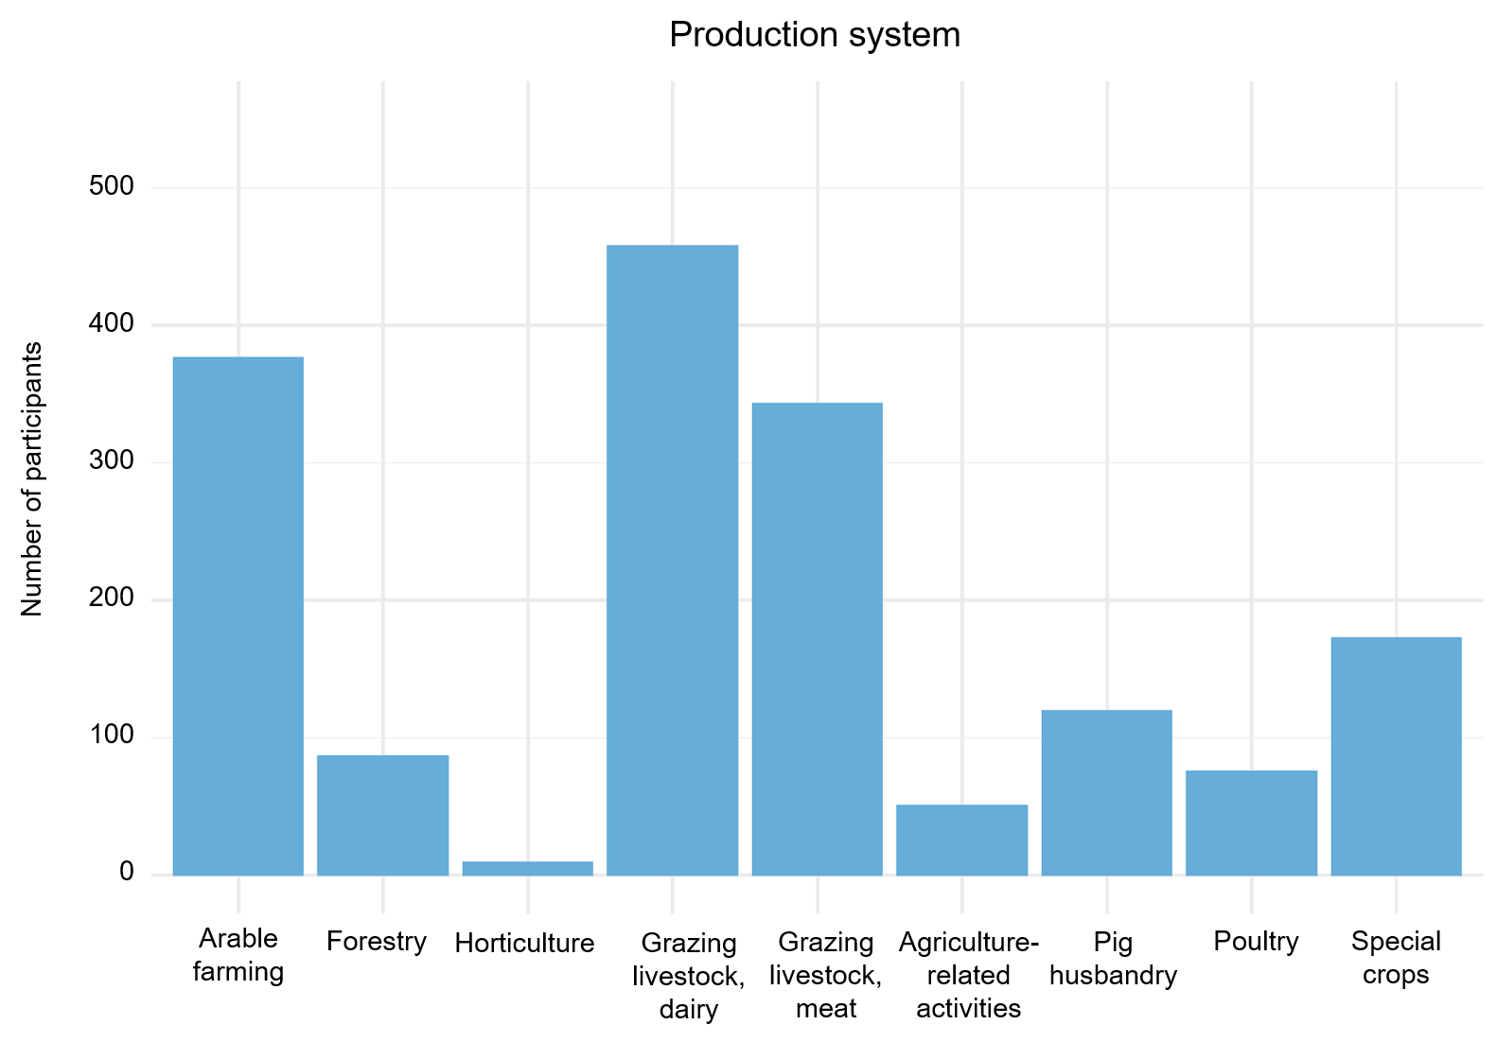
Figure A1 Distribution of different production systems in the FarmCoSwiss (n = 872, NA = 8) cohort before categorization. Numbers may add up to more than the total sample size due to multiple choice answer options.
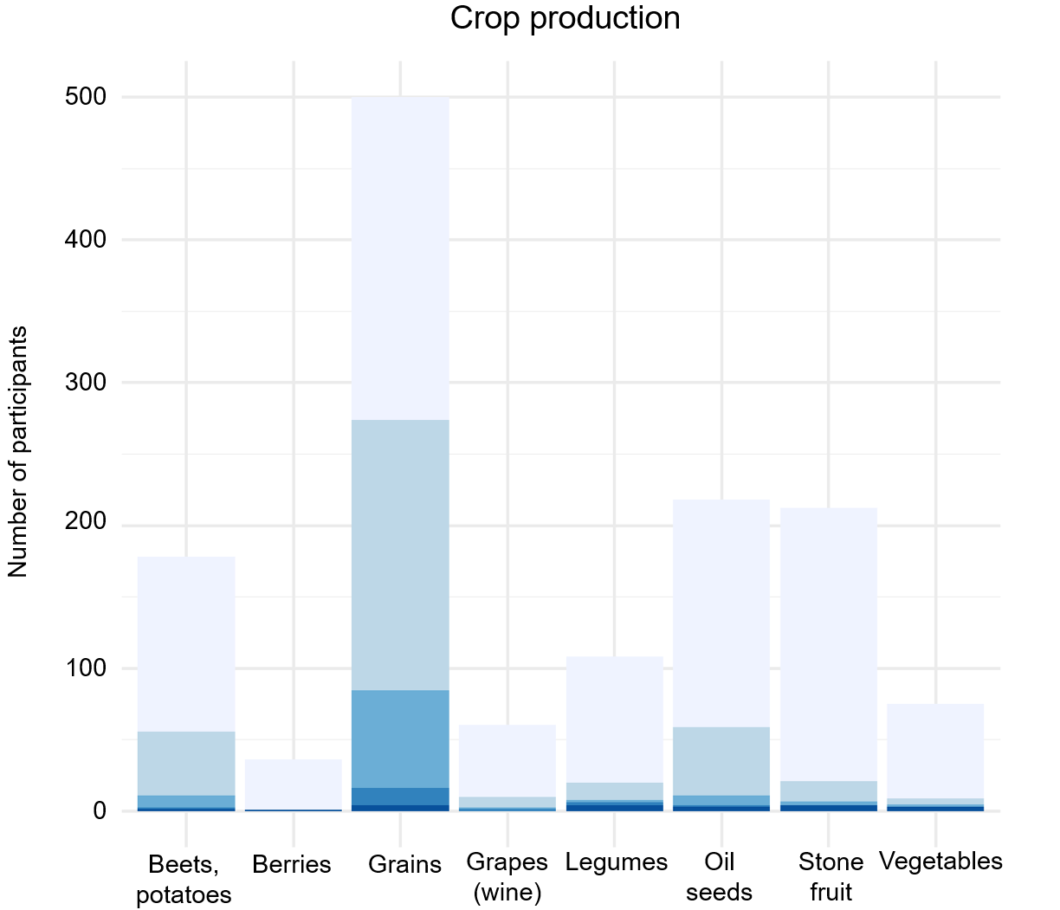
Figure A2 Distribution of different crops in the FarmCoSwiss cohort of participants with crop production with or without animal husbandry (n = 492). Numbers may add up to more than the total sample size due to multiple choice answer options.

