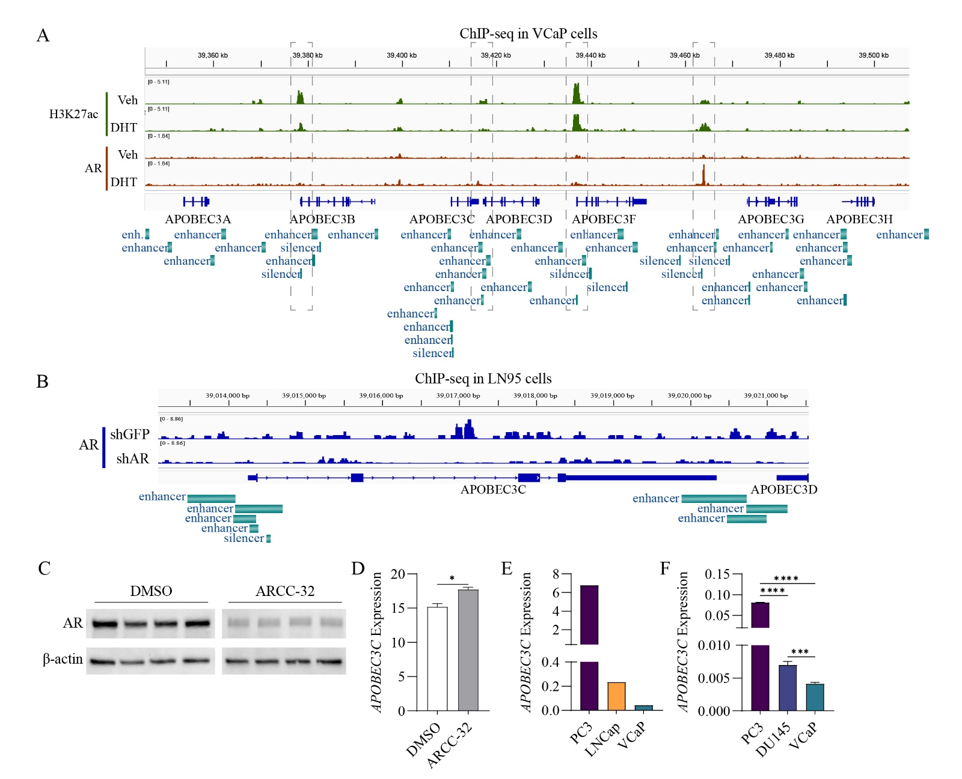
Figure S1. AR-mediated regulation of the APOBEC3 family genes in PCa. A, Track visualization of H3K27ac, AR and CTCF ChIP-seq peaks in the whole APOBEC3 family member gene loci in VCaP cells, upon treatment with vehicle control (Veh) versus DHT. B, Track visualization of AR ChIP-seq peaks in the APOBEC3C gene locus in LN95 PCa cell line, upon knockdown with shAR in comparison to shGFP control. The ChIP-seq analyses were based on GSE106559. C, Western blotting assay on AR proteins in LN95 cells, upon treatment with the AR degrader (ARD, ARCC-32) versus DMSO control. The individual lanes in each group represent biological replicates. D, APOBEC3C RNA expression in the LN95 cells exposed to the same treatments as described in C. (E) Computational analysis of APOBEC3C transcript levels in AR-heterogeneous cell lines (PC3: AR-null, LNCaP: AR-sensitive, VCaP: CRPC-derived AR-active) through the DepMap portal. (F) Experimental validation of APOBEC3C mRNA expression by RT-PCR in metastatic PCa models with distinct AR signaling contexts (PC3: AR-null, DU145: AR-low, and VCaP: CRPC-derived AR-active). * denotes p < 0.05, *** denotes p < 0.001, **** denotes p < 0.0001.

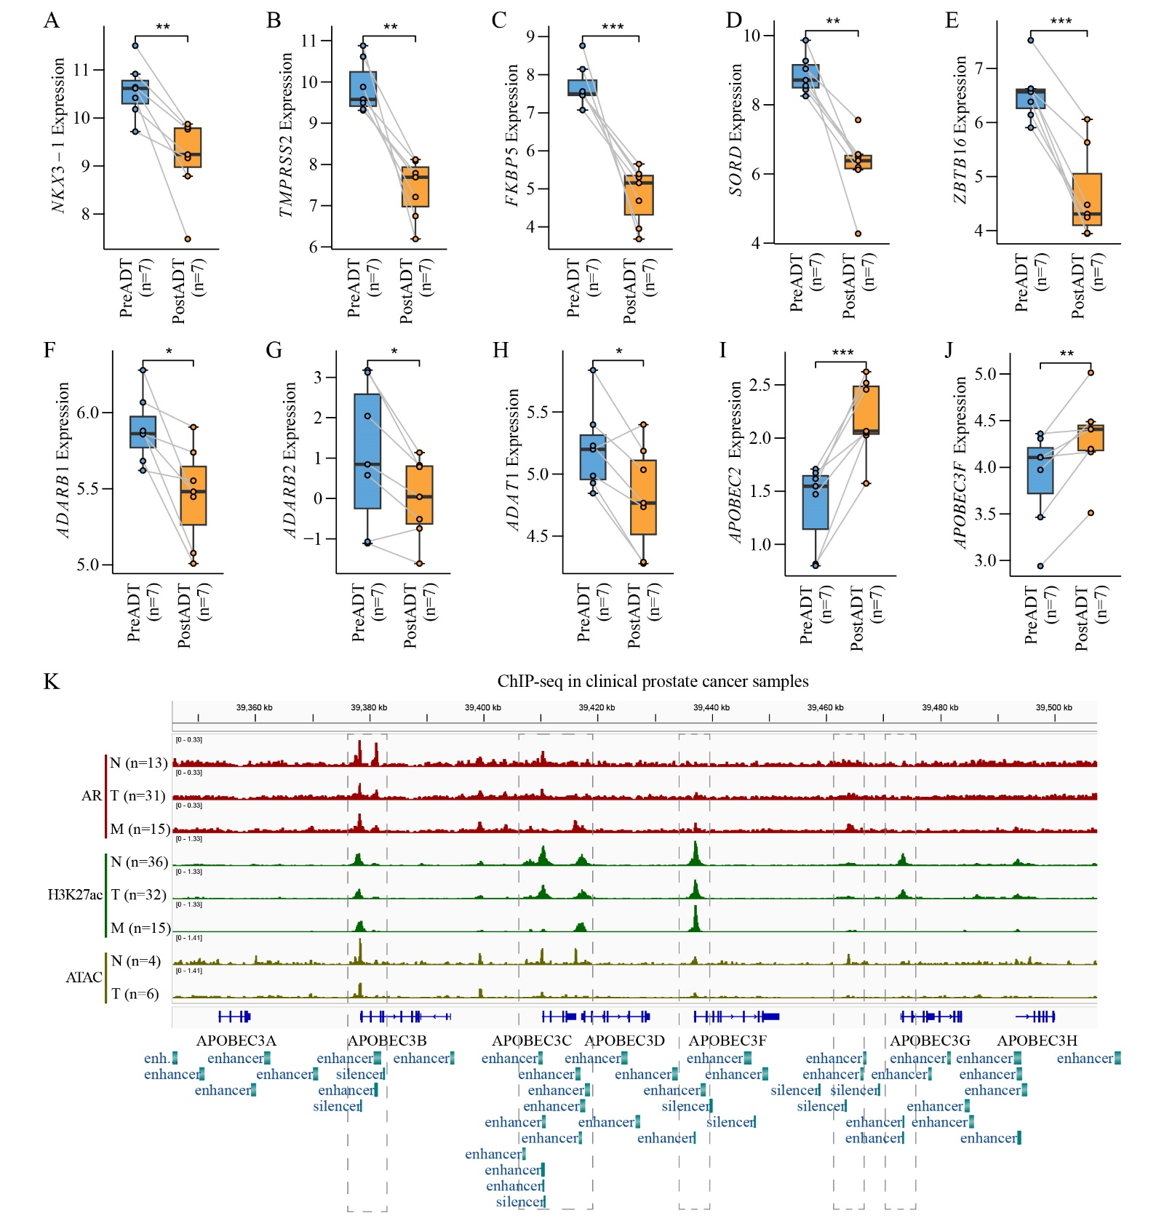
Figure S2. AR-mediated regulation of RNA-editing genes in clinical PCa datasets. A-E, The expression profiles of AR-signature genes (NKX3-1, TMPRSS2, FKBP5, SORD and ZBTB16) in each individual PCa patients, before and after the androgen deprivation therapy (ADT). F-J, The expression profiles of RNA-editing genes (ADARB1, ADARB2, ADAT1, APOBEC2, and APOBEC3F) in the same PCa cohorts as described. * denotes p < 0.05, ** denotes p < 0.01, *** denotes p < 0.001, and - denotes no significant difference. K, Track visualization of AR and H3K27ac ChIP-Seq and ATAC-seq peaks in the whole APOBEC3 family gene loci in clinical prostate cancer samples. N: normal control, T: primary PCa tumor, M: metastatic CRPC (M).

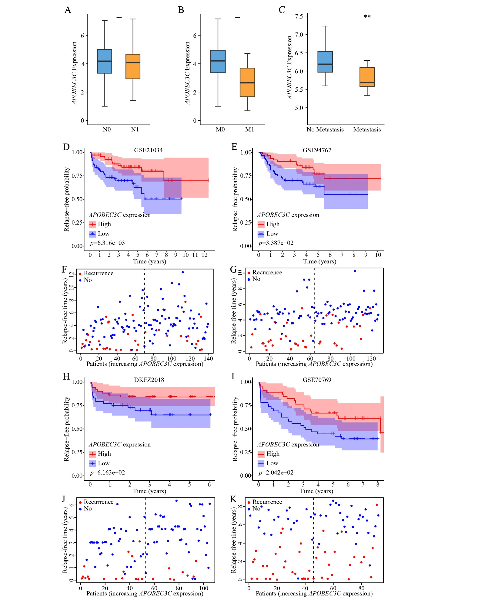
Figure S3. Validation of clinicopathological and prognostic significance of APOBEC3C in PCa datasets. A-B, The expression profiles of APOBEC3C in primary PCa (TCGA datasets), classified by pathological N stage (A) and M stage (B). C, The expression of APOBEC3C in PCa patients stratified based on their metastasis status, as derived from GSE41408 (No metastasis, n=39; Metastasis, n=9). D-K, Kaplan-Meier analysis of relapse-free survival probability in PCa cohorts that were categorized into APOBEC3C high versus low expression groups. The algorithms were based on GSE21034 (D, n = 140), GSE94767 (E, n = 127), DKFZ2018 (H, n = 105) and GSE70769 (I, n = 92) datasets, respectively. The plots on PCa risk distribution and recurrence status based on the GSE21034 (F), GSE94767 (G), DKFZ2018 (J) and GSE70769 (K) datasets, respectively.

