Appendix A: Screenshots of AI-Generated IELTS Writing Task 2 Essays
Band 6 Essay 1:
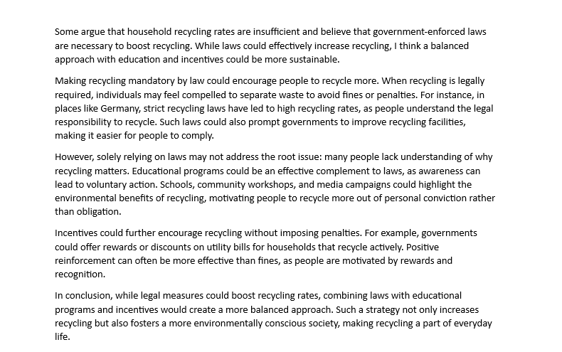

Band 7 Essay 1:
