Supplementary material

Table SM1. Outputs of the general linear model (GLM) testing the effects of year of study on average ambient temperature and sum of precipitation during the breeding season (May-June). ***Significant values P< 0.05 are in bold.

Sources of variation | Estimate | SE | t | P
Temperature
Intercept | -94.61 | 26.13 | -3.62 | <0.001
Year of study | 0.05 | 0.013 | 4.07 | <0.001
Sum of precipitation
Intercept | 13.00 | 11.33 | 1.15 | 0.258
Year of study | -0.005 | 0.006 | -1.04 | 0.305

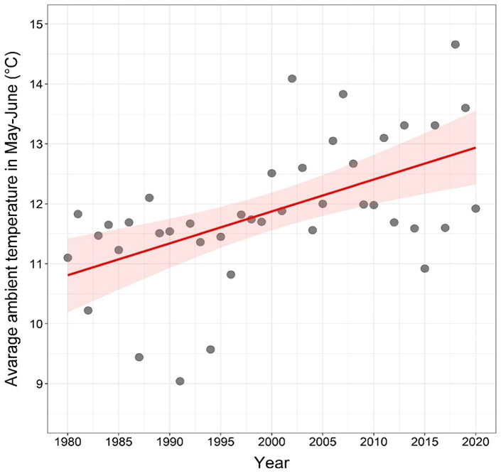
Figure SM1. Average ambient temperature during breeding season (May-June) on Gotland Island between 1980 and 2020.

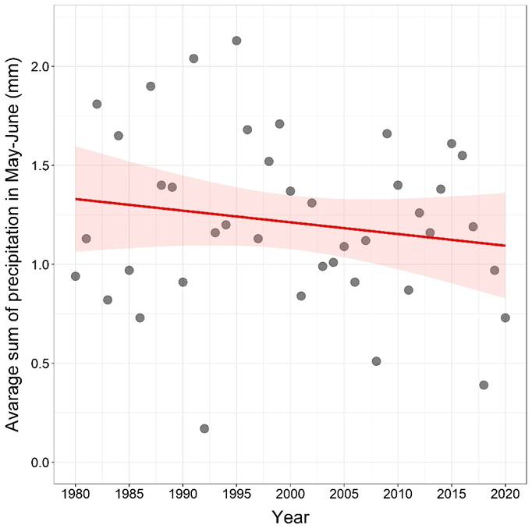
Figure SM2. Average sum of precipitation during breeding season (May -June) on Gotland Island between 1980 and 2020.

Table SM2. Variance inflation factor (VIF) and tolerance calculated for each term in all examined generalized mixed models (GLMMs).

 | GLMM for hatching success |  | GLMM for offspring production:  conditional component |  | GLMM for offspring production:  zero-inflated component |  | GLMM for recruitment rate
 | VIF | Tolerance | VIF | Tolerance | VIF | Tolerance | VIF | Tolerance
Temp.  incubation | 1.39 | 0.72 | 1.42 | 0.70 | 1.62 | 0.62 | 1.65 | 0.61
Temp.  nestling | - | - | 1.78 | 0.56 | 1.97 | 0.51 | 2.15 | 0.46
Precip.  incubation | 1.12 | 0.89 | 1.24 | 0.81 | 1.27 | 0.79 | 1.26 | 0.79
Precip.  nestling | - | - | 1.27 | 0.79 | 1.32 | 0.76 | 1.27 | 0.79
Laying  date | 1.57 | 0.64 | 2.47 | 0.41 | 3.19 | 0.31 | 3.25 | 0.31
Clutch  size | 1.14 | 0.88 | 1.13 | 0.88 | 1.27 | 0.79 | 1.16 | 0.86

Table SM3. The correlation matrix for explanatory variables in a subset of data analyzing hatching success (A), offspring production (B), and local recruitment rate (C). Pearson's correlation coefficients are shown.

A
 | Temp.  incubation | Precip. incubation | Laying date | Clutch size
Temp.  incubation | 1.00 | - | - | -
Precip.  nestling | -0.17 | 1.00 | - | -
Laying  date | 0.19 | 0.26 | 1.00 | -
Clutch  size | -0.05 | -0.08 | -0.41 | 1.00

B
 | Temp.  incubation | Temp. nestling | Precip. incubation | Precip. nestling | Laying date | Clutch size
Temp.  incubation | 1.00 | - | - | - | - | -
Temp.  nestling | 0.47 | 1.00 | - | - | - | -
Precip.  incubation | -0.20 | -0.02 | 1.00 | - | - | -
Precip.  nestling | 0.08 | -0.27 | -0.17 | 1.00 | - | -
Laying  date | 0.21 | 0.22 | 0.26 | 0.12 | 1.00 | -
Clutch  size | -0.04 | -0.05 | -0.09 | -0.01 | -0.41 | 1.00

C
 | Temp.  incubation | Temp. nestling | Precip. incubation | Precip. nestling | Laying date | Clutch size
Temp.  incubation | 1.00 | - | - | - | - | -
Temp.  nestling | 0.49 | 1.00 | - | - | - | -
Precip.  incubation | -0.18 | 0.00 | 1.00 | - | - | -
Precip.  nestling | 0.13 | -0.19 | -0.18 | 1.00 | - | -
Laying  date | 0.25 | 0.27 | 0.25 | 0.12 | 1.00 | -
Clutch  size | -0.05 | -0.07 | -0.09 | -0.01 | -0.42 | 1.00

