Supplementary Materials of

Sentinel-2 enabled E. coli and Enterococcus faecal bacteria surveillance in coastal-recreational waters
Masuma Chowdhury*^{1,2}, Irene Laiz², Ignacio de la Calle¹
¹Quasar Science Resources, S.L., Camino de las Ceudas 2, 28232 Las Rozas de Madrid,
(Madrid), Spain
masuma.chowdhury@quasarsr.com, ignaciodelacalle@quasarsr.com
²Departamento de Física Aplicada, Instituto Universitario de Investigación Marina (INMAR), Universidad de Cádiz, Campus de Excelencia Internacional/Global del Mar (CEI·MAR), E-11510, Puerto Real (Cádiz), Spain.
masuma.chowdhury@uca.es, irene.laiz@uca.es
*Corresponding author’s email: masuma.chowdhury@quasarsr.com

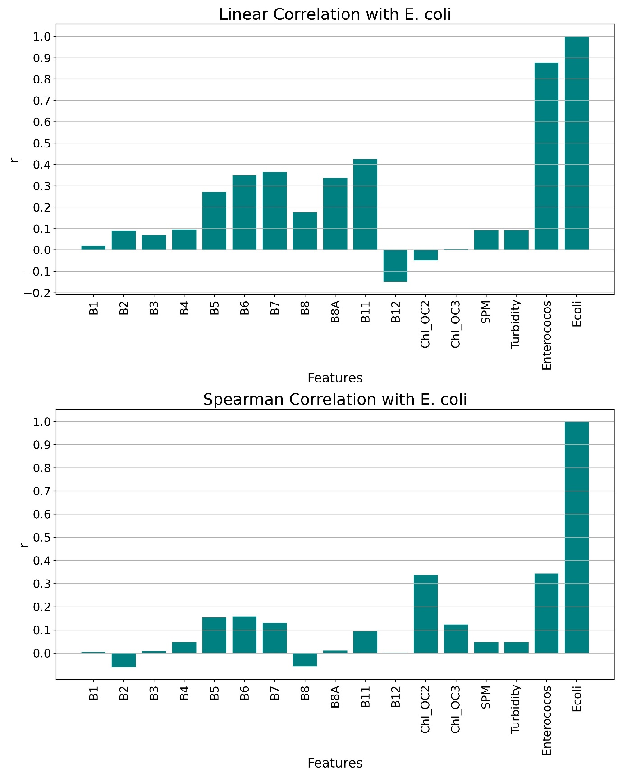
Supplementary Figure 1: Linear (upper panel) and non-linear (bottom panel) correlation analysis of in-situ E.coli with Sentinel-2 bands (B1-B12) and satellite-derived water quality indicators. Python 3.7 (https://www.python.org/downloads/release/python-370/)

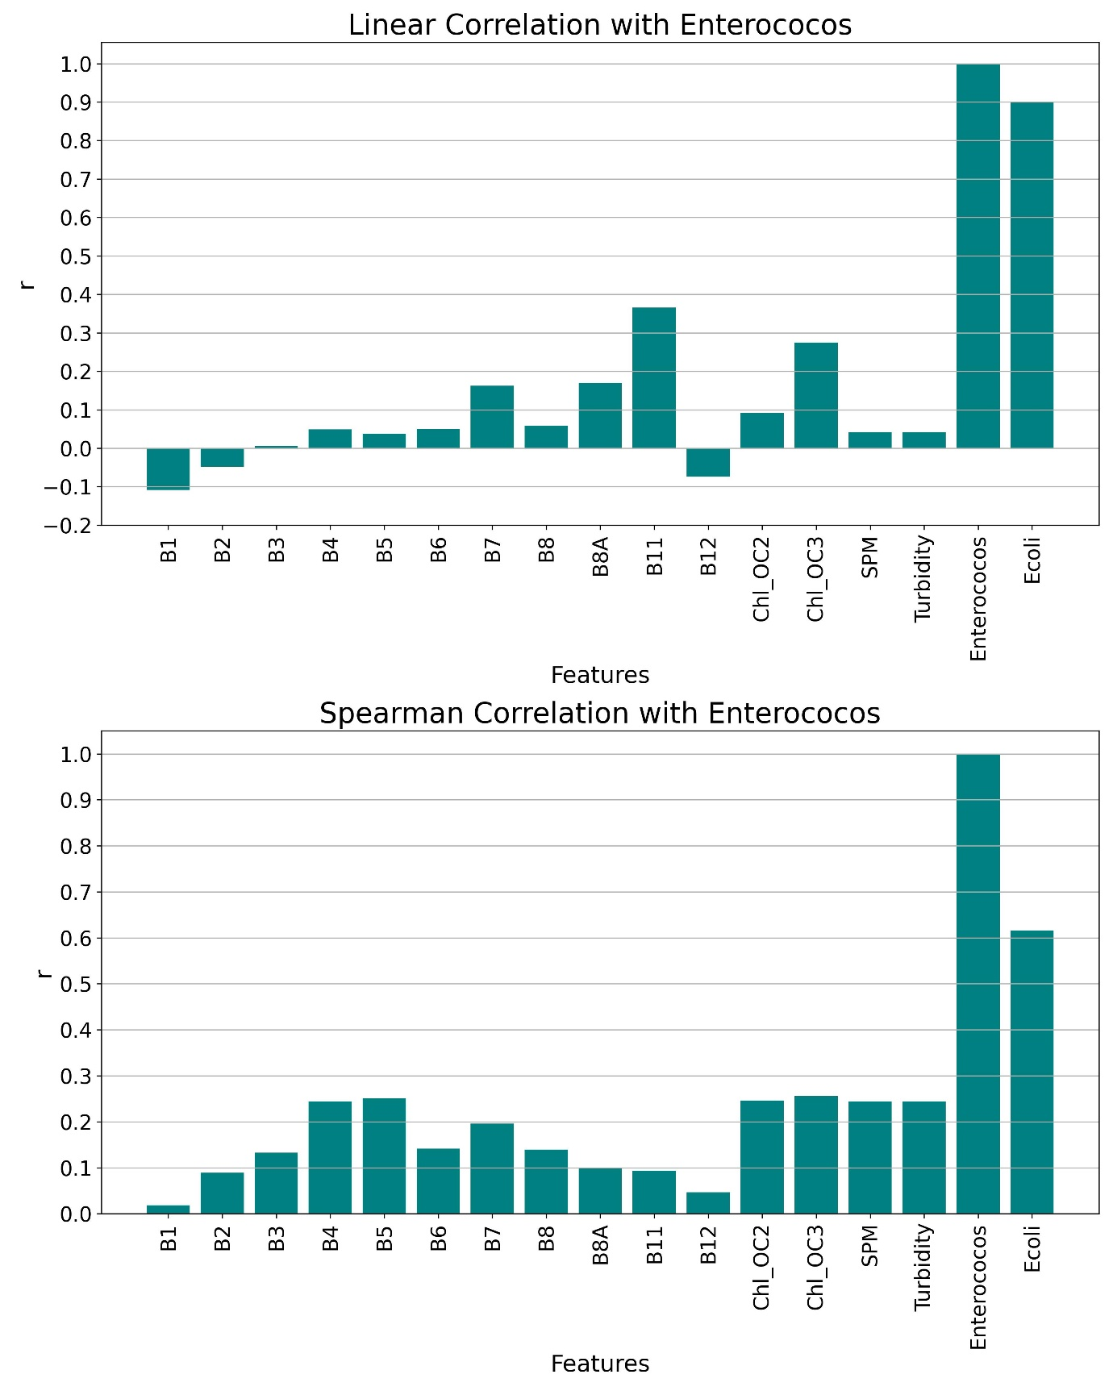
Supplementary Figure 2: Linear (upper panel) and non-linear (bottom panel) correlation analysis of in-situ Enterococcus with Sentinel-2 bands (B1-B12) and satellite-derived water quality indicators. Python 3.7 (https://www.python.org/downloads/release/python-370/)
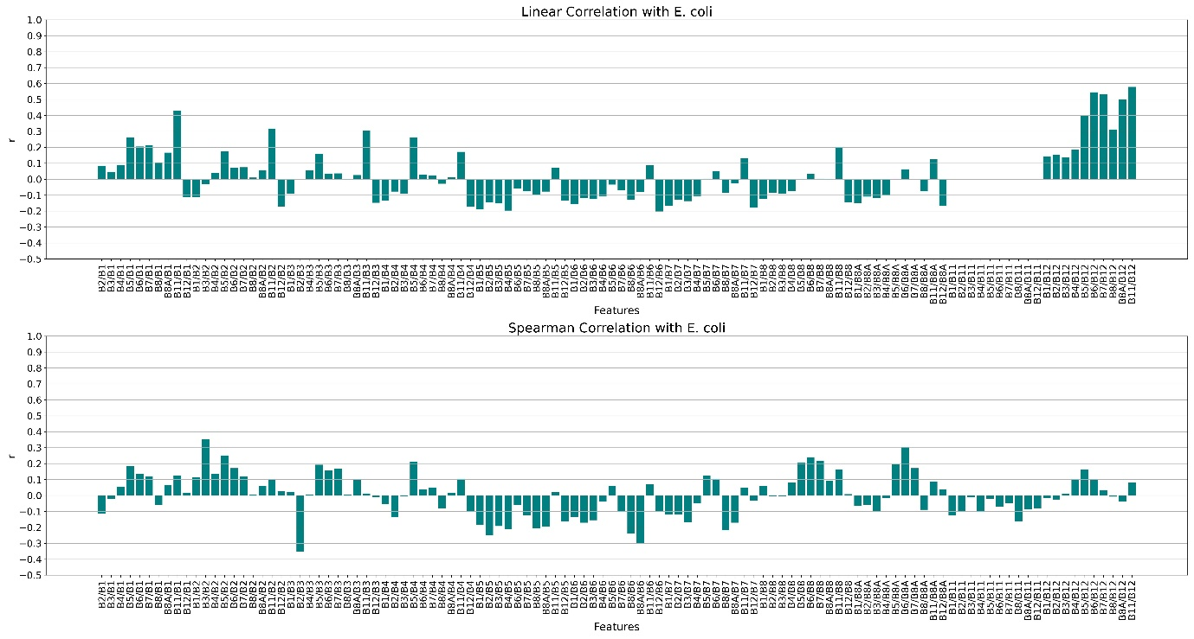
Supplementary Figure 3: Linear (upper panel) and non-linear (bottom panel) correlation analysis of in-situ E.coli with Sentinel-2 band ratios. Python 3.7 (https://www.python.org/downloads/release/python-370/)

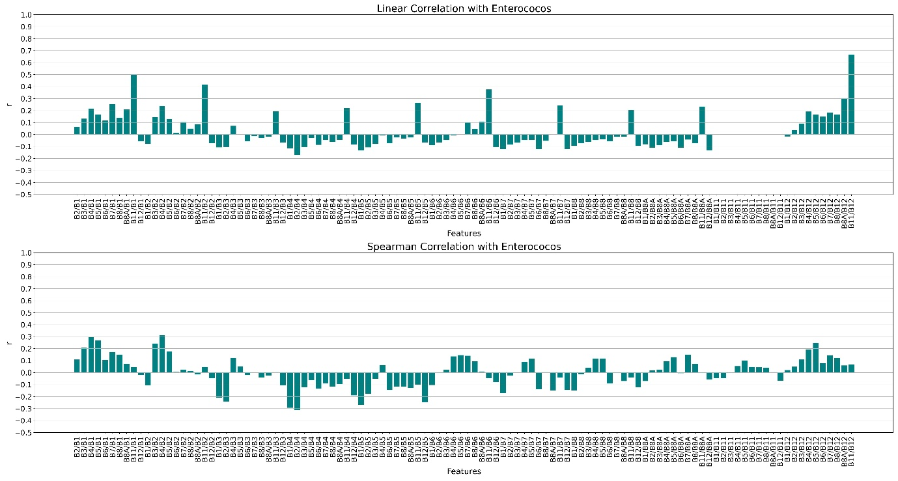
Supplementary Figure 4: Linear (upper panel) and non-linear (bottom panel) correlation analysis of in-situ Enterococcus with Sentinel-2 band ratios. Python 3.7 (https://www.python.org/downloads/release/python-370/)

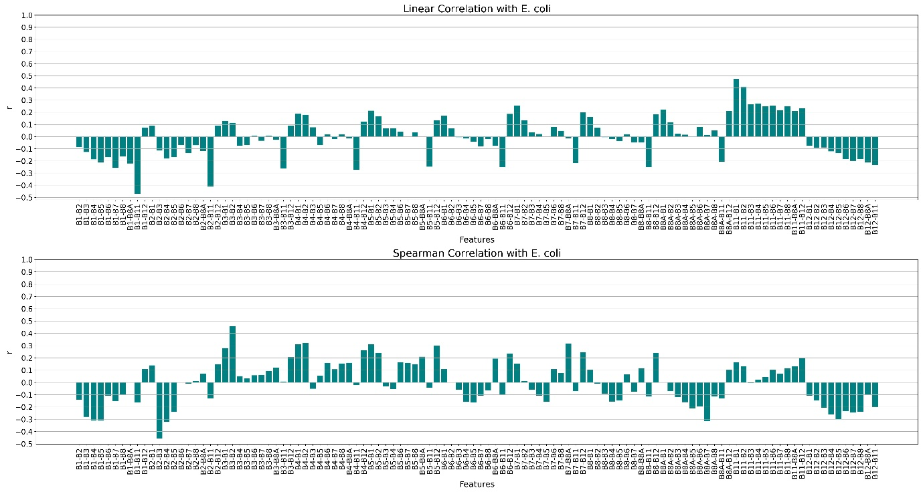
Supplementary Figure 5: Linear (upper panel) and non-linear (bottom panel) correlation analysis of in-situ E.coli with Sentinel-2 band difference indices. The features are indicated by the numerator of the indices. Python 3.7 (https://www.python.org/downloads/release/python-370/)

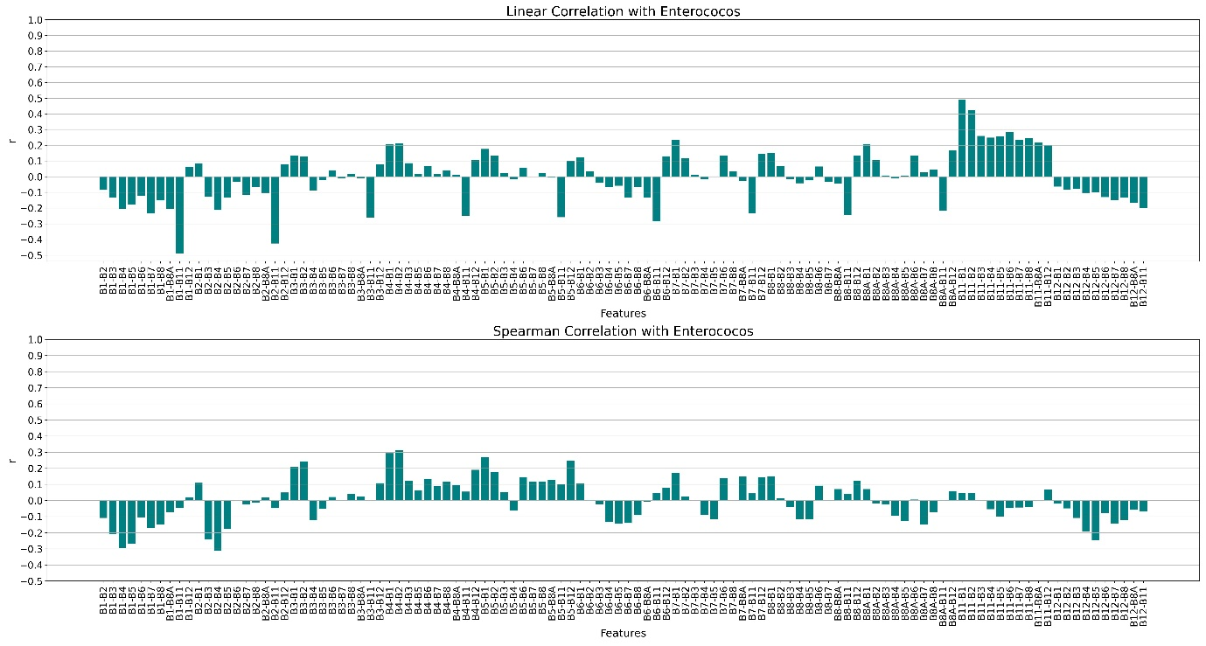
Supplementary Figure 6: Linear (upper panel) and non-linear (bottom panel) correlation analysis of in-situ Enterococcus with Sentinel-2 band difference indices. The features are indicated by the numerator of the indices. Python 3.7 (https://www.python.org/downloads/release/python-370/)

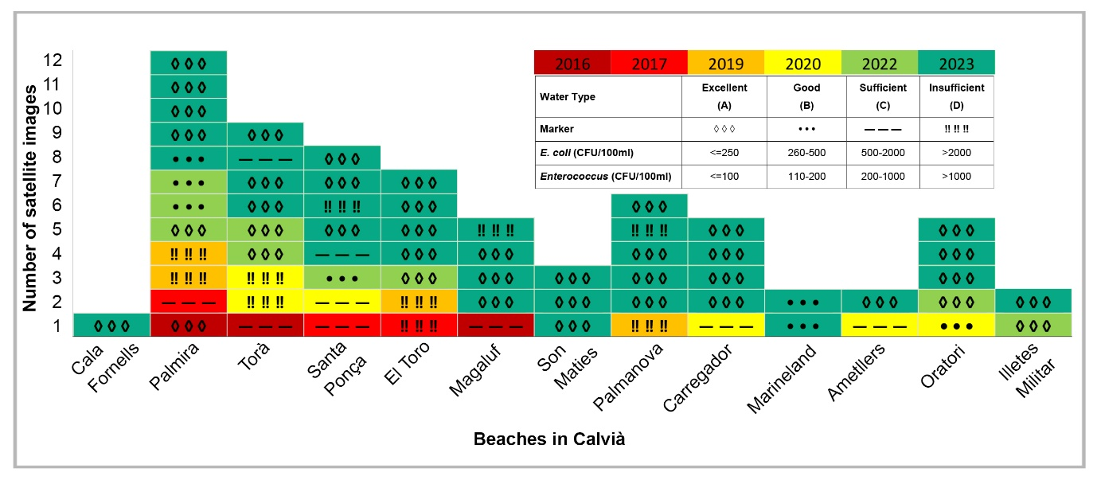
Supplementary Figure 7: Temporal coverage of the Sentinel-2 satellite images used in this study from 2016 to 2023 for excellent, good, sufficient, and insufficient water quality types. Microsoft Excel 2016 (https://www.microsoft.com/en-us/microsoft-365/excel) and Photoshop 2023 (https://www.adobe.com/products/photoshop.html).

