Supplementary Information

Quantum Spin-Engineering in On-Surface Molecular Ferrimagnets

Wantong Huang¹, Máté Stark¹, Paul Greule¹, Kwan Ho Au-Yeung¹, Daria Sostina^{1,2}, José Reina Gálvez^{3,4}, Christoph Sürgers¹, Wolfgang Wernsdorfer^{1,2}, Christoph Wolf^{3,4}, Philip Willke^{1,*}
- Physikalisches Institut, Karlsruhe Institute of Technology (KIT), Karlsruhe, Germany
- Institute for Quantum Materials and Technologies, Karlsruhe, Germany
- Center for Quantum Nanoscience, Institute for Basic Science (IBS), Seoul, Republic of Korea.
- Ewha Womans University, Seoul, Republic of Korea.

* corresponding author: philip.willke@kit.edu,
Table of Contents

1. Building FePc-Fe(C₆H₆) complexes 2
2. Lattice site analysis 3
3. Spin Hamiltonian and IETS dI/dV spectra simulations 4
4. Magnetic sensing 9
5. DFT calculations 11
6. ESR and fitting 17
7. Rabi rate as a function of V_{RF} 18
8. Conductance-dependent spin lifetime 21
9. Spin transport simulations and enhanced spin lifetime 22
10. ESR transitions in a Heisenberg two-spin system with the tip field detuning effect 25

Building FePc-Fe(C₆H₆) complexes
The FePc-Fe(C₆H₆) complexes were created using the atom manipulation scheme sketched in Fig. S1a. First, the tip is positioned above one ligand of FePc. The tip is then moved $\sim 600 pm$ closer to the molecule and a bias voltage of $850 mV$ is applied. Next, the tip is retracted from the surface with the FePc sticking to its apex. To drop off the molecule, we used two methods: 1) Perform Z-Spectroscopy starting with setpoints of $10$pA and $-10$mV, gradually moving the tip $250-330 pm$ towards the Fe atom. 2) Scan fast across the Fe atom at closer distance ($V_{set}=-40 mV$, $I_{set}=1 \text{nA}$ and scan speed of $300 nm/s$). Figure S1b and S1c show the topographic images before and after building an FePc-Fe(C₆H₆) complex, respectively. Fig. S1d,e show additional cross sections across the complex, in which the protrusion at the position of the Fe atom becomes greatly visible. In Fig. 1a in the main text, we also showed multiple dimers of complexes. These were built using similar atom manipulation schemes. For two coupled FePc-Fe(C₆H₆) complexes, we build two complexes separately first and then move one towards the other. To move the complex, the tip is positioned between two ligands ($V_{set}=-100 mV$, $I_{set}=20 \text{pA}$), next moved $200-400 pm$ closer to the surface and finally a bias voltage of $500-750 mV$was applied.
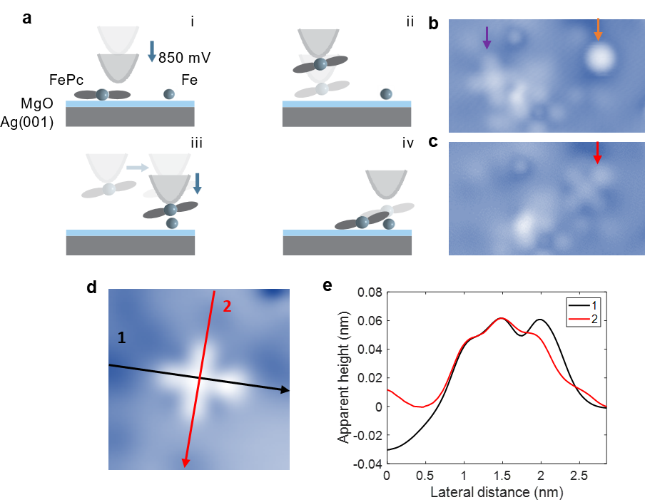
Supplementary Fig. S1. a, Schematic illustrating the manipulation procedures involved in building FePc-Fe(C₆H₆) complexes. b, Topographic image consisting of one Fe atom (orange arrow) and one FePc molecule (purple arrow) on 2ML MgO ($V=100 mV$, $I=20 pA$). c, Topographic image afterwards with a newly formed FePc-Fe(C₆H₆) complex (red arrow). d, STM topography image ($V=100 mV$, $I=20 pA$) and e, the corresponding line profiles comparing the ligands of the FePc-Fe(C₆H₆) complex with (black) and without (red) the Fe adatom underneath the benzene ring.

Lattice site analysis
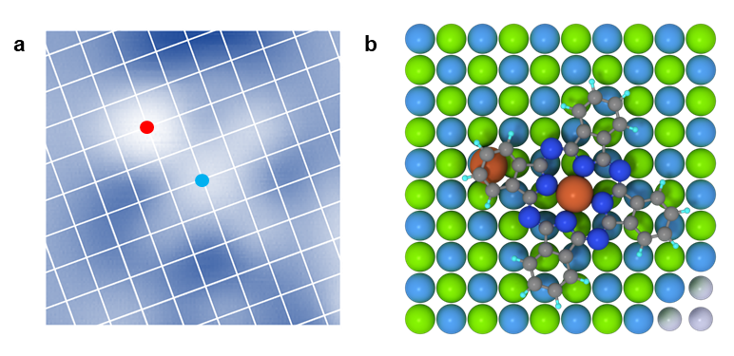
The FePc-Fe(C₆H₆) complexes adsorbed on 2ML MgO/Ag(001) tend to adopt specific site configurations. The precise positioning of the Fe atoms and FePc molecules with respect to the underlying MgO lattice is determined by atomic resolution images of the bare MgO area. In addition, the position of nearby individual Fe atoms, which are adsorbed atop a MgO oxygen lattice site¹, is taken as a reference of the lattice. In Fig. S2a, the oxygen lattice is indicated by a white grid overlaid on the FePc-Fe(C₆H₆) complex structure. The Fe atom (marked in red) is situated at a distance of 0.64 nm (2×1 oxygen lattice sites) from the center of FePc. Consequently, both Fe and FePc are still adsorbed atop oxygen sites (Fig. S2b), as it is the case for the isolated atom and molecule^{1,2}. These specific positions are used as the basis for our DFT calculations.
Supplementary Fig. S2. FePc-Fe(C₆H₆) complexes binding site. a, Topographic image of an FePc-Fe(C₆H₆) complex with MgO lattice overlaid (2nm × 2 nm, setpoint: V = 100 mV, I = 20 pA). b, Top view image shows the stable configuration of the FePc-Fe(C₆H₆) complex calculated by DFT. The positions of Fe atom and molecule center are labeled by red and blue dots, respectively. The position of oxygen atoms in the MgO lattice is indicated by a white grid.

Spin Hamiltonian and IETS dI/dV spectra simulations
In this section, we introduce the IETS dI/dV spectra simulations and investigate in detail the spin Hamiltonian described for the FePc-Fe(C₆H₆) complexes in the main text. When applying the external magnetic field $B$ in z-direction, we consider the following Hamiltonian for the complex:
 | $$H=J∙{\vec{S}}_{FePc}∙{\vec{S}}_{Fe(C6H6)}+D∙{\hat{S}}_{z,Fe(C6H6)}^{2}-g_{1}μ_{B}B{\hat{S}}_{z,Fe(C6H6)}-g_{2}μ_{B}B{\hat{S}}_{z,FePc}$$ | (3)
Where $J$ is the Heisenberg exchange coupling, $D$ is the out-of-plane zero-field splitting term of the Fe(C₆H₆) spin, $μ_{B}$ is the Bohr magneton, $B$ is the external perpendicular magnetic field and $g_{1}$ and $g_{2}$ are g-factors of the Fe(C₆H₆) and FePc spins, respectively. In our case, $S_{FePc}=1/2$ and $S_{Fe(C6H6)}=1$. The energies and eigenstates of this mixed spin-(1/2,1) system can be expressed analytically³. The eigen-energies are:
 | $$E_{1,2}=\frac{1}{2}\left[J+2D∓\left(g_{1}μ_{B}B+2g_{2}μ_{B}B\right)\right],$$ | (4)
 | $$E_{3,4}=-\frac{1}{4}(J-2D+2g_{2}μ_{B}B)∓\frac{1}{4}\sqrt{{\left[J-2D-2(g_{1}μ_{B}B-g_{2}μ_{B}B)\right]}^{2}+8J^{2}},$$ | (5)
 | $$E_{5,6}=-\frac{1}{4}(J-2D-2g_{2}μ_{B}B)∓\frac{1}{4}\sqrt{{\left[J-2D+2(g_{1}μ_{B}B-g_{2}μ_{B}B)\right]}^{2}+8J^{2}},$$ | (6)
whereas the corresponding eigenvectors are
 | $$ψ_{1,2}=|±\frac{1}{2},±1>,$$ | (7)
 | $$ψ_{3,4}=c_{1}^{∓}\left|+\frac{1}{2},0>∓c_{1}^{±}\right|-\frac{1}{2},1>,$$ | (8)
 | $$ψ_{5,6}=c_{2}^{±}\left|+\frac{1}{2},-1>∓c_{2}^{∓}\right|-\frac{1}{2},0>.$$ | (9)
The probability amplitudes in the last four eigenvectors (8) and (9) are:
 | $$c_{1}^{±}=\frac{1}{\sqrt{2}}\sqrt{1±\frac{J-2D-2(g_{1}μ_{B}B-g_{2}μ_{B}B)}{\sqrt{{\left[J-2D-2(g_{1}μ_{B}B-g_{2}μ_{B}B)\right]}^{2}+8J^{2}}}},$$ | (10)
 | $$c_{2}^{±}=\frac{1}{\sqrt{2}}\sqrt{1±\frac{J-2D+2(g_{1}μ_{B}B-g_{2}μ_{B}B)}{\sqrt{{\left[J-2D+2(g_{1}μ_{B}B-g_{2}μ_{B}B)\right]}^{2}+8J^{2}}}}.$$ | (10)
For $J≫D$,$g_{1}μ_{B}B,g_{2}μ_{B}B,$ the factors $c_{1,2}^{+}≅\sqrt{\frac{2}{3}}$, $c_{1,2}^{-}≅\sqrt{\frac{1}{3}}$.
At zero field $B=0 T$ (and $J≫D$), this simplifies the energies to:
 | $$E_{1,2}=\frac{1}{2}(J+2D),$$ | (11)
 | $$E_{3,5}=-\frac{1}{4}\left(J-2D\right)-\frac{1}{4}\sqrt{{\left(J-2D\right)}^{2}+8J^{2}}≅-J+\frac{2}{3}D,$$ | (12)
 | $$E_{4,6}=-\frac{1}{4}\left(J-2D\right)+\frac{1}{4}\sqrt{{(J-2D)}^{2}+8J^{2}}≅\frac{J}{2}+\frac{1}{3}D,$$ | (13)
This approximation nicely illustrates that the ground state energy is given by $E_{3,5}$ (assuming antiferromagnetic exchange, i.e. $J>0$). The wave functions of the ground state doublet are given as $ψ_{3,5}$:
 | $$\left.\left|0\right.\right\rangle {=ψ}_{3}=\frac{1}{\sqrt{3}}\left.\left|+\frac{1}{2}\right.;0\right\rangle -\frac{\sqrt{2}}{\sqrt{3}}\left.\left|-\frac{1}{2}\right.;+1\right\rangle$$ | (14)
 | $$\left.\left|1\right.\right\rangle {=ψ}_{5}=\frac{\sqrt{2}}{\sqrt{3}}\left.\left|+\frac{1}{2}\right.;-1\right\rangle -\frac{1}{\sqrt{3}}\left.\left|-\frac{1}{2}\right.;0\right\rangle$$ | (14)
The corresponding energy level diagram is shown in Fig. S3a (see also Fig. 2b). Two state manifolds form with $S_{tot}≈1/2$ and $S_{tot}≈3/2$ which are separated by an energy ~ $\frac{3}{2}⋅J$. The excited state quartet is further split by $2/3⋅D$.
Supplementary Fig. S3. a, Energy level diagram of a mixed-spin (1/2,1) Heisenberg quantum ferrimagnet. b, Simulated IETS dI/dV spectra with S = ½ for FePc, S = 1 for Fe(C₆H₆). Fitting parameters: For Fe(C₆H₆): J = 14.65 meV, D = 1.9 meV, U = 0.945. For FePc: J = 13.8 meV. U = 0.494. T=0.8 K.

In the IETS simulations, we take the solution of the Hamiltonian described above to calculate the resulting tunneling current by using the spin simulation code developed in Ref.^{4,5} . The latter considers contributions to the tunneling current stemming from 1) potential scattering U and 2) inelastic scattering of the tunneling electrons. The values of parameters $D$, $J$ and $U$ are adjusted for Fe(C₆H₆) and FePc in the complex to match the step heights and positions in the experiment: The simulated IETS dI/dV spectra shown in Fig. S3b (see also Fig. 1c) reproduce the double step feature found in the experimental data well.
The IETS calculations and the resulting dI/dV spectra are crucially influenced by the assumptions made in the initial spin Hamiltonian. As such, the IETS spectrum plays an important role to determine the spin state of the Fe(C₆H₆) in the complex. We screened a wide variety of cases and found that in particular the double step feature (along with constraints imposed by the results of the ESR measurements, remote sensing experiments as well as DFT calculations), can only be explained assuming $S_{FePc}= ½$ and $S_{Fe(C6H6)}= 1$ as shown in Fig. S3. In the following, we will exemplarily illustrate, how other reasonable spin models are not in agreement with the data.
- FePc: S = 1/2, Fe(C₆H₆): S = 2
A first guess for the FePc spin state and the Fe spin would be adapting those of the individual spin systems, i.e. $S_{FePc}= ½$ and $S_{Fe(C6H6)}= 2$. In this case, FePc and Fe(C₆H₆) retain their spin states as individual FePc (charged by one electron) and Fe on MgO. For the simulation, we initially assume that Fe has the same magnetic anisotropy ($D=-4.7 meV$⁶) as for isolated Fe atoms and that there is Heisenberg exchange coupling between the two spins. For ferromagnetic coupling ($J<0$), there are two IETS steps and the separation between these steps increases with increasing $J$, while for antiferromagnetic coupling ($J>0$), there are three IETS steps (Fig. S4). None of these simulations are consistent with the experimental results. Here, we exclude the E-term, which would otherwise potentially split the states and lead to additional steps. A similar double-step feature, consistent with experimental dI/dV, can be qualitatively reproduced by using D ~ 20 meV and |J| ~ 1. However, this is not consistent with our other experimental results, such as remote sensing experiments (Supplementary Section 4).
Supplementary Fig. S4. Simulated dI/dV spectra of a coupled spin system consisting of a S=1/2 and a S=2. For the $S = 2$ system, we assume anisotropy parameters $D = -4.7 meV$, $E = 0 meV$. Left: Colormap of simulated spectra atop the $S=2$ system using different coupling strengths from $J=-10 meV$ to $10 meV$. Right: Selected spectra for $J=-4 meV$, $0 meV$ and $4 meV$. The spectra are shifted with an offset for clarity. Simulation uses 0.2 K and 0 T.

- FePc S = 1, Fe(C₆H₆) S = 2
In this case, we assume a spin of 1 for FePc, as it does in the gas phase, and that Fe retains S = 2. Moreover, we assume Heisenberg exchange coupling between them. An exemplary choice of different anisotropy and coupling parameters is displayed in Fig. S5 for coupling strength J ranging from -10 meV to 10 meV. We find that one can adjust J, D, and E-term to reproduce the double steps at around $±20 meV$ (Fig. S5), but there are more IETS steps at larger energies and always one step at around zero bias, which is absent in our experimental data.
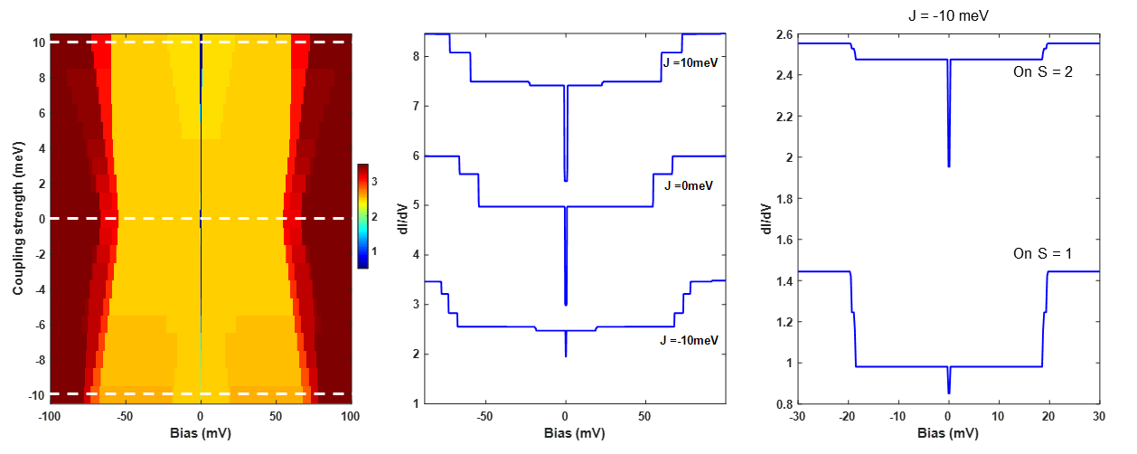
Supplementary Fig. S5. Simulated dI/dV spectra of a coupled spin system consisting of a S=1 and a S=2. Anisotropy parameters: $D = -20 meV$, $E = 2 meV$ (for $S=2$) and $D = -3 meV$, $E = 2 meV$ (for $S=1$) were exemplarily chosen, but a wide set of parameters was tested. Left: Colormap of simulated spectra for the $S=2$ system using different coupling strengths from $J = -10 meV$ to $10 meV$. Middle: Selected spectra for $J = -10 meV$, 0$meV$ and $+10 meV$ . Right: Zoom in plot for both FePc and Fe with $J = -10 meV$, showing two IETS steps at around $±20 meV$. The spectra are shifted with an offset for clarity. Simulation uses 0.2 K and 0 T.

Besides the cases illustrated here, we also tested for instance a spin S = 1/2 coupled to a spin S= 3/2 or 5/2, which always results in more than two IETS steps or of two steps with incorrect position or intensity. Further constraints on the spin system will be discussed in section S4 and S5, which is only fulfilled by the spin model proposed and discussed at the beginning of this chapter.

Magnetic sensing
To gain further insight into the spin state and magnetic moment of the Fe(C₆H₆) in the complex, we used a close-by single Fe atom as a magnetic sensor to sense the complexes magnetic field⁷. The magnetic dipole–dipole interaction between the sensor Fe atom and the target spin causes a change of the resonance frequency of the sensor Fe, that is shifted to higher or lower frequencies depending on the spin direction and whether it is in its ground or excited state. Due to its large magnetic anisotropy, the magnetic moment $μ_{Fe}$ of the sensor Fe is oriented out-of-plane along the applied magnetic field. Therefore, only the z-component of the target magnetic moment $μ_{\text{t}}^{z}$ is measured and the frequency difference $Δf$ between its ground and excited state is given by⁷
$$Δf=\frac{4E_{\text{dd}}}{h}=\frac{1}{h}∙\frac{μ_{0}}{π}\frac{1}{r^{3}}μ_{\text{Fe }}μ_{\text{t}}^{z}$$ | (15)
where $h$ is Planck’s constant, $μ_{0}$ is the vacuum permeability and $r$ is the distance between the two magnetic moments $μ_{Fe}$ and $μ_{t}$. In the experiment, the ESR signals are measured using tip-field sweeps^{8,9}.
As a reference, we first measured the ESR signal of a single Fe atom that shows a single resonance peak (Fig. S6, top). Second, we investigated an Fe-Fe dimer with a distance of $0.91 \text{nm}$. The splitting of the resonance peak is $Δf=(2.1±0.3) \text{GHz}$ (Fig. S6, middle). From this, the magnetic moment of Fe is determined to be $μ_{\text{Fe}}=(5.6±0.4) μ_{\text{B}}$, which agrees well with previous measurements of $μ_{\text{Fe}}=5.4 μ_{\text{B}}$⁷. This good agreement indicates that magnetic dipole-dipole interaction is dominant at this distance, despite the close distance between the two spins - below 1 nm. Here, exchange interaction can often contribute significantly to the coupling⁷.
Next, we position a sensor Fe atom 0.91 nm from the Fe site of the complex, the same distance as in the previous experiment. The influence of the FePc spin is negligible as its distance to the sensor Fe is roughly twice that of the Fe(C₆H₆) in the complex. We find a frequency splitting of $Δf=\text{(0.9}\text{±}\text{0.2) GHz}$, which is roughly half of the frequency splitting observed for a single Fe atom at the same distance. This corresponds to a magnetic moment of $μ_{\text{Fe}\text{(C6H6)}}=(2.8±0.8) μ_{\text{B}}$. This significantly smaller magnetic moment is incompatible with a $S=2$ of the Fe atom. While the value of 2 $μ_{\text{B}}$, indicative of a spin 1 system without orbital contributions, is still within the error bar, we believe that likely exchange interaction is increasing the splitting due to the small distance between sensor and target^{2,7}. This subsequently leads to a higher apparent magnetic moment in the sensing experiments.
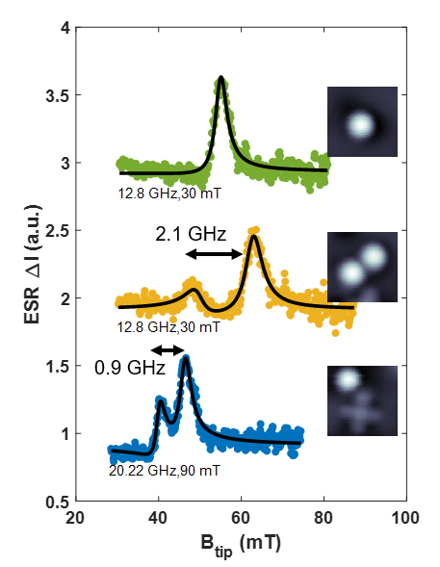
Consequently, this reduction strongly suggests that the spin state of Fe(C₆H₆) in the complexes is lower than S = 2.
Supplementary Fig. S6. Magnetic sensing experiment. Tip-field sweep ESR measurements on a single Fe (green), a sensor Fe atom close to another Fe (yellow) and a sensor Fe atom close to the Fe(C₆H₆) of an FePc-Fe(C₆H₆) complex (blue). All data was taken with the same magnetic microtip. Insets: topographic images (size: 2 nm $×$ 2 nm). The inserted numbers display the used external field and RF frequency for the tip-field sweep. The resonance peaks are split by 2.1 GHz (yellow) and 0.9 GHz (blue), respectively. A linear background was subtracted from the data stemming from a general increase in signal with increase of the setpoint current. The black line indicates fits to one or two Lorentz functions.

DFT calculations
- Details of DFT parameters
All periodic-cell density functional theory (DFT) calculations were performed using plane-wave basis and pseudopotentials in Quantum Espresso version 7.1^{10,11}. All pseudopotentials use the Perdew–Burke–Ernzerhof (PBE) parametrization for the exchange and correlation potential¹². We mimic the experiment by placing the Fe on top of MgO (100) which is supported by a silver (100) substrate. The bulk lattice constants for silver and MgO with PBE are a_{Ag} = 4.16 Å and a_{MgO} = 4.25 Å, which results in a lattice mismatch of about 2% (experimental value: 2.9%¹²). To construct the surface slab, we used 4 layers of Ag with the lateral lattice constant fixed to that of the PBE bulk silver and added up to 2 layers of MgO. We created lateral supercells of about 20x20 Å and 15 Å of vacuum were used to pad the cell in z-direction. All calculations used a k-grid equivalent to 15x15x1 k-points of the 1x1x1 unit cell. All 3d plots in the main text were created using OVITO ref. ¹³.
- A Fe(C₆H₆) toy model
To qualitatively understand the effect of Fe with an FePc ligand ring atop, we employ a toy model by placing a benzene ring on top of the Fe atom (as in Fig. 1d/1e but without MgO). Our DFT calculations show that without the presence of a benzene ring, the Fe d-states of individual Fe atoms are mostly found close to the Fermi level. For Fe with benzene ring atop, Fe(C₆H₆), the crystal field generated by the benzene ring leads to a change of the orbital order and spin state that leads to bonding between Fe and (C₆H₆) and new molecular orbitals. Combining simple molecular orbital theory with our DFT (Fig. S7), we find a strong overlap between the benzene E1 orbitals and $d_{xz}$, $d_{yz}$ of the Fe, forming a strong set of $π$-bonds. This is also commonly the case for other metallocenes¹⁴ and also rationalizes the stability of the Fe(C₆H₆) complex. Similarly, the frontier orbitals are formed by an overlap between $d_{xz}$, $d_{yz}$ and the (C₆H₆) E1 antibonding states. Still, the frontier orbitals maintain a strong d-character (Fig. S8a). For instance, the $d_{xz}$-, $d_{yz}$-like orbitals account for 76% of 2e₁ near $E_{F}$.

Supplementary Fig. S7. Molecular orbital energy diagram of Fe and Benzene (in vacuum). On the left side, Fe 3d and 4s states are shown with their respective symmetry group, on the right side the $π$ molecular orbitals of benzene. In the center the combined molecular orbitals of Fe(C₆H₆) are shown. The lowest lying states are dominated by the benzene states (1a₁ 90%; 1e₁ 84%) with some overlap of the 3d and 4s states. For the higher ones, the main contribution stems from the d states (1e₂ 72%; 2a₁ 93%; 2e₁ 76%). Energies and orbital character are obtained from DFT calculations. The addition of the MgO/Ag(001) surfaces leads to further hybridization of all states (See supplementary Fig. S8).

- DFT calculations of the full system
We first confirmed that DFT accurately reproduced S = 2 of individual Fe atoms on the MgO/Ag(100) surface as discussed elsewhere¹⁵. From the local density of states (LDOS) in Fig. 1d, the Fe $d$-states are mostly found close to the Fermi level with the $d_{z^{2}}$ orbital strongly hybridizing with the $4s$ orbital. This hybridization results in the $d_{z^{2}}$ orbital being half-filled due to on-site repulsion. As a consequence, Fe has a final electron occupation of $3d^{6.5}4s^{0.8}$ obtained from a Lowdin charge analysis and four orbitals (${d_{z^{2}}/d}_{xy}/d_{xz}$/$d_{yz}$) are close to being half-filled (Supplementary Table 1). This consequently indicates a spin $S=2$, consistent with previous works^{1,15}. To understand how the Fe(C₆H₆) spin state in the complex becomes $S=1$, we employ again the simple model by placing a benzene ring on top of the Fe atom (Fig. 1e). We find that the benzene ring does not change the charge state of the Fe atom: Here, Fe exhibits a $3d^{6.8}4s^{0.3}$ configuration, indicating no significant charge transfer (Supplementary Table 1). However, the crystal field generated by the benzene ring changes the $d$ orbital order: the $d_{z2}$, $d_{xy}$ and $d_{x2-y2}$ like orbitals are now shifted and lowered in energy, and the $4s-3d_{z^{2}}$ hybridization is eliminated due to the depletion of the 4s in the presence of benzene ring. Consequently, only the $d_{xz}$/$d_{yz}$ like orbitals are close to the Fermi energy and half-filled, suggesting an Fe spin state of $S=1$.

Configuration | $$d_{z2}$$ | $$d_{xy}$$ | $$d_{xz}$$ | $$d_{yz}$$ | $$d_{x2-y2}$$ | total
Fe ($↑$) | 0.9263 | 0.9965 | 0.9962 | 0.9962 | 0.9836 | 4.9
Fe ($↓$) | 0.5274 | 0.0034 | 0.0472 | 0.0472 | 0.9628 | 1.6
Fe+benzene ($↑$) | 0.8525 | 0.8542 | 0.959 | 0.9592 | 0.8386 | 4.5
Fe+benzene ($↓$) | 0.6793 | 0.6932 | 0.1314 | 0.1323 | 0.6826 | 2.3
Supplementary Table 1. Filling of the 3d shell obtained from a Lowdin charge analysis for Fe on 2ML MgO/Ag(001) without and with a benzene ring on top.

To shed light on the role of the substrate, we compare Fe-benzene formation in vacuum and on the MgO/Ag(001) surface (Figure S9). While there is more overlap with other states, the simple molecular orbital picture derived from the toy model still remains valid: Figure S9 shows that both deliver similar results. However, the surface decreases the energy splitting between d states and further mixes the states by hybridization with the substrate.
DFT calculations including the full FePc molecule do not change our observations (see Fig. S9). The 3d states near the Fermi level show a similar trend to Fe(C₆H₆), however the tilted final geometry makes the analysis of the orbital character of the Fe 3d states less straightforward.
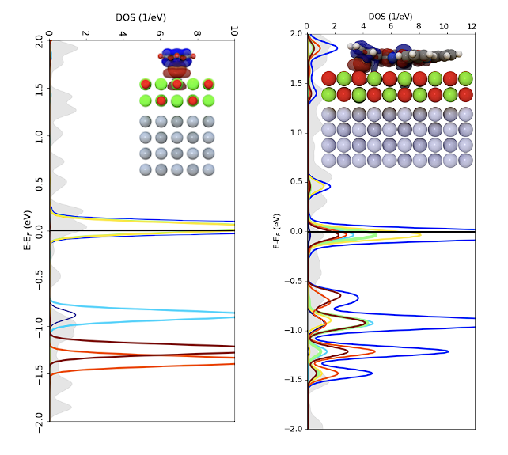
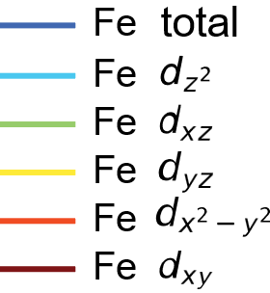
Supplementary Fig. S8. Molecular orbital energy diagrams of Fe(C₆H₆) in different environments. a, in vacuum and b, on a MgO/Ag(001) substrate. The orbital weights are given in percent (%) listing the orbital of the dominating weight. The remaining contributions to 100% are hybridizations with other orbitals. Energies and character are obtained from DFT calculations.
a
b
Supplementary Fig. S9. Atomic orbital projected DOS of Fe(C₆H₆) and FePc-Fe(C₆H₆). a, Fe 3d orbitals in the Fe-benzene complex used in the main text. b, the same plot but now with an FePc-Fe(C₆H₆) complex. The resulting states show more mixing but the behavior of the states close to E_{F} follows a similar trend as in a.
- Exchange interaction within the complex
We use DFT calculations of an FePc-Fe(C₆H₆) complex to estimate the exchange coupling between the two spin centers using the broken-symmetry approach^{2,16}. The magnetic exchange coupling strength is obtained by comparing the energy of the high spin (HS) and low-spin or broken symmetry (BS) states as:
$$J=\frac{-[E\left(HS\right)-E(BS)]}{s_{max}^{2}}$$
The high-spin solution corresponds to FM coupling whilst the BS solution is obtained from an antiferromagnetically coupled configuration and $s_{max}$ is the total spin of the high-spin state. We obtain an exchange coupling $J$ for the Fe-FePc complexes of around 7 meV, which is of the same order as the experimental results (14 meV). We emphasize that this is the largest $J$ observed for spins on MgO and is mediated via the FePc ligand and by far exceeds the exchange coupling of two Fe atoms at the same distance but without the ligand. This indicates that the exchange coupling is mediated through the ligand as also observed in FePc-FePc dimers² and FePc-Ti dimes¹⁷. We confirm that the exchange coupling in this system is strongly mediated by the ligand by slowly lifting the ligand up from the Fe atom in the calculation (Fig. S10). In such a model, the exchange coupling constant is approximately exponentially dependent on the Fe atom – ligand distance. As the distance increases by tilting the ligand from 0° to 20°, the exchange coupling J decreases exponentially from 7 meV to 0.29 meV.
Supplementary Fig. S10. Exchange energy as a function of Fe atom – ligand distance. Inset: sketch showing 0° (left) and 20°(right) tilt angle configurations. The red dash line is a linear fit to data in log scale.

ESR and fitting
Figure 2(e-f) in the main text show the external magnetic field dependent ESR measurement at the FePc site and Fe(C₆H₆) site of the same FePc-Fe(C₆H₆) complex with the same tip. Fitting $f_{0}$ linearly as a function of $B_{z}$ gives the magnetic moment of (1.008±0.007) µ_{B} at the Fe(C₆H₆) site (Fig. S11a) and (1.004±0.012) µ_{B} at the FePc center (Fig. S11b), which is consistent to the effective spin ½ ground state doublet. Figure S12c shows the magnetic moments at both sites obtained for different FePc-Fe(C₆H₆) complexes, giving an averaged magnetic moment of $\left(1.003±0.025\right)µ_{B}$. While this is close to an effective magnetic moment of 1 $µ_{B}$, the variations are larger than the individual errorbars. We suggest that this results from the influence of the magnetic tip field¹⁸ as well as changes in the local environment of the spin center, i.e. given by defects and strain in the substrate.
Supplementary Fig. S11. Magnetic moment of FePc-Fe(C₆H₆) complexes. Resonance frequency $f_{0}$ as a function of an out-of-plane external magnetic field $B.$ a, Fe(C₆H₆) site ($I_{\text{set}}=5 pA$ / $V_{\text{set}}=25 mV$); b, FePc site ($I_{\text{set}}=50 pA$ / $V_{\text{set}}=70 mV$) extracted from Fig. 2e,f in the main text. c, Statistics of magnetic moments in different FePc-Fe(C₆H₆) complexes.

Rabi rate as a function of V_{RF}
We extract the Rabi rate at different $V_{RF}$ from Fig. 3b in the main text, and a linear fit yields a slope of $9.6±0.3 rad/(µs·mV)$ (Fig. S12). This slope is 5 times higher than that of pristine FePc [$1.86±0.13 rad/(µs·mV)$ in Ref.¹⁹] and 3-7 times larger than values reported for Ti atoms [$\sim 1.3 rad/(µs·mV)$ in Ref.²⁰ and $\sim 2.8 rad/(µs·mV)$ in Ref.²¹]. In the following we discuss possible reasons for these results.
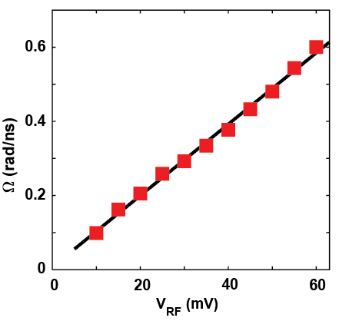
Supplementary Fig. S12. Extracted Rabi rate Ω as a function of V_{RF} from Fig. 3b in main text. The black line is a linear fit to the data with a slope of $9.6±0.3 rad/(µs·mV)$ .
The driving mechanism of individual atoms and molecules in ESR-STM is still subject to current research, both theoretically and experimentally²¹⁻²⁵ . We first discuss the ESR driving mechanism in the framework of the frequently employed piezoelectric displacement model²², which relies on the displacement of the surface spin and a subsequent modulation of one of the parts of the Hamiltonian. Employing the same formalism as presented in Ref. ²², we write
$$Ω\left(t\right)=\frac{F}{h}z(t)$$
where the Rabi rate $Ω$ depends on the oscillating displacement $z(t)$ and the Rabi force $F$. The latter can have different origins²². The dominating term was found theoretically²² and experimentally²⁰ to originate from exchange interaction of the tip magnetic moment and the surface spin leading to an effectively oscillating local magnetic field. Thus, a higher Rabi rate can originate either from an increase in $z(t)$ or $F$.
A straightforward description of the displacement is given by
$$z\left(t\right)=\frac{q}{k}\frac{V_{RF}\left(t\right)}{d}$$
Here, it is assumed that the time-dependent electric field $E(t)=\frac{V_{RF}\left(t\right)}{d}$ couples via Hooke’s law to the surface spin with an effective charge $q$ and effective spring constant $k$, i.e. the stiffness of the vibrational mode of the spin center on the surface.
Thus, a larger displacement can either be caused by a different $q$ of the surface spin, a less stiff interaction to the surface $k$, or simply a different initial distance $d$ between the surface spin and the tip.
In addition, the Rabi force itself is potentially stronger for the Fe(C₆H₆) site in the complex:
$$F=\frac{∂J\left(z\right)}{∂z}\left\langle {\vec{S}}_{T}\right\rangle ⋅⟨0\left|\vec{S}\right|1⟩$$
Here, $\frac{∂J\left(z\right)}{∂z}$ is the gradient of the exchange interaction between the surface spin and the tip magnetic moment $\left\langle {\vec{S}}_{T}\right\rangle$. $⟨0\left|\vec{S}\right|1⟩$ is the transition matrix element, emphasizing that a finite overlap between two states is necessary for their connection. Thus, both $\frac{∂J\left(z\right)}{∂z}$ and $⟨0\left|\vec{S}\right|1⟩$ can cause an increase in $Ω$. While the former is difficult to estimate, the latter can be calculated from the Hamiltonian of the FePc-Fe(C₆H₆) complex given in the main text for the Fe(C₆H₆) site. When comparing this to a normal spin ½, we find a 33% increase (see Supplementary Table 2). This increase is very likely to play a role in the faster Rabi rate observed for the FePc-Fe(C₆H₆) complex, but cannot explain the full effect.
Beyond the piezoelectric displacement model, it was proposed by some of the authors²⁴, that the electric field of the tip can directly modulate the charges of the atoms without displacement. This leads for spin dimers to a modulation of the J-coupling and thus explains experimental work on Fe-Ti spin pairs quite well²¹. Thus, for the FePc-Fe(C₆H₆) complex, J-modulation between the Fe and FePc spin adds another possibility for a higher Rabi rate.
Lastly, in another recent work, some of the authors proposed an electron transport model²⁶, which predicts that the magnitude of the Rabi term mainly depends on tip polarization and the DC bias magnitude compared to the ionization energy of the adsorbate. In particular, the latter changes for the new molecular orbitals emerging in the complex (Fig. 1e).
In general, we believe that a combination of the different origins discussed here play a role for the enhanced Rabi rate: This includes the summarized effects to the displacement $z(t)$, differences in the Rabi force, the strong exchange coupling as well as a change in ionization energy in the dimer.

Matrix Element | Spin ½ (FePc) | Spin (1, ½) Ferrimagnet (Complex)
$$|\left\langle 0 | S_{x} | 1\right\rangle |$$ | 0.5 | 0.667
$$|\left\langle 0 | S_{y} | 1\right\rangle |$$ | 0.5 | 0.667
$$|\left\langle 0 | S_{z} | 1\right\rangle |$$ | 0 | 0
Supplementary Table 2. Table of transition matrix elements of the respective ESR transition for different spin systems. For the FePc-Fe(C₆H₆) complex, the transition matrix element is determined for the Fe site which corresponds to the case in the Rabi measurements.

Conductance-dependent spin lifetime
To further investigate the processes that limit the spin lifetime $T_{1}$, we performed pump-probe measurements as a function of tip-sample conductance, $G_{ts}=I/V$, for both pristine FePc (Fig. S13a) and FePc in the complex (Fig. S13b). In both cases, the lifetime drops dramatically as the tip approaches the spin centers. At large tip-sample distances (i.e. low $G_{ts}$), $T_{1}$ reaches a plateau where it becomes independent of tip-sample distance. This plateau, defined as $T_{1}^{0}$, is also independent of the specific tip and molecules in use. We therefore conclude that $T_{1}^{0}$ represents the intrinsic relaxation lifetime on a 2ML MgO surface. The effect of the tip height on $T_{1}$ can be understood by a model based on electron-hole generation in the nearby electrodes, i.e. the metallic substrate and tip, as described in Ref.²⁷ for single Fe atoms on MgO/Ag(001). According to this model, $T_{1}$ is a function of sample–sample ($G_{ss}$), tip–sample ($G_{ts}$) and tip–tip ($G_{tt}=\frac{G_{ts}^{2}}{G_{ss}}$) conductance: $T_{1}=\frac{T_{1}^{0}}{{(1+\frac{G_{ts}}{G_{ss}})}^{2}}$ (Fig. S13c). Fitting T₁ as a function of $G_{ts}$ yields $T_{1}^{0}$ of $(0.41±0.05) μs$ for pristine FePc (solid blue curve in Fig. S13a) and $(1.6±0.6) μs$ for the complex (solid red curve in Fig. S13b). In Figure S14d, we show the longest $T_{1}$ achieved at a large tip-sample distance ($G_{ts}=\frac{20}{200} pA/mV$ ). The data reveals a $T_{1}$ of $(1428±323)$ ns for FePc in the complex and $(363±26)$ ns for pristine FePc, which are consistent with the values from our model. At large tip-sample distance, the lifetime is limited by the sample-sample conductance $G_{ss}$. We believe that $T_{1}$ can be further enhanced by increasing the MgO layer thickness as it is the case for individual Fe atoms²⁷.
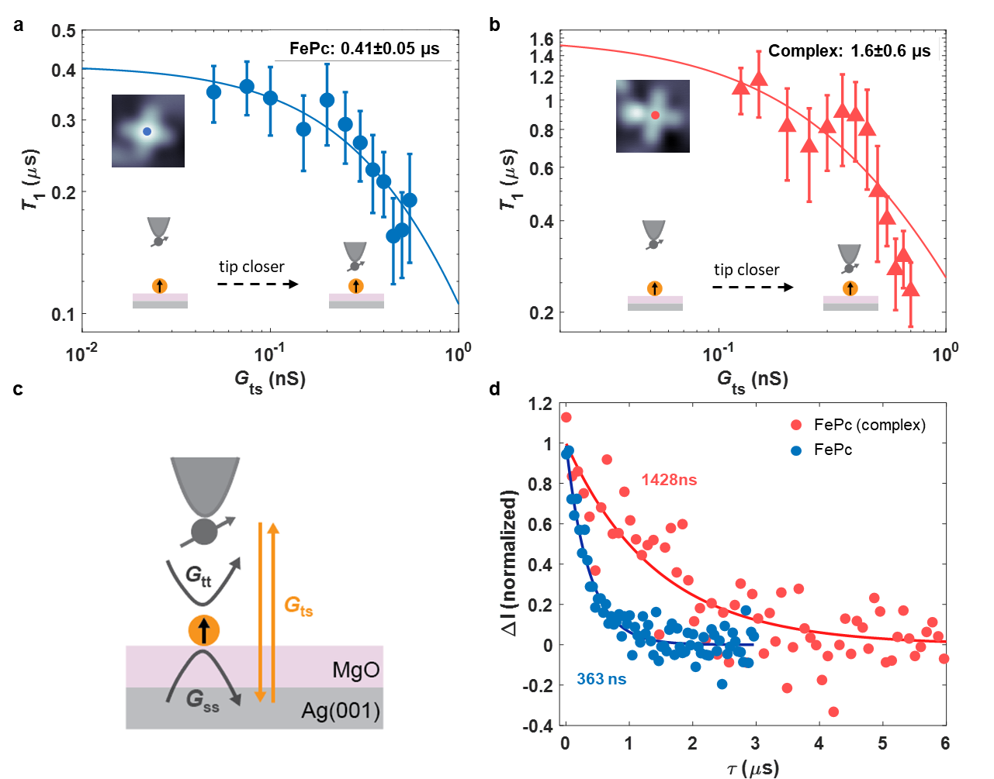
Supplementary Fig. S13. Conductance-dependent spin lifetime T₁ as a function of tip-surface conductance. a,b T₁ as a function of tip-surface conductance for pristine FePc and FePc site in the complex. (setpoint: $V_{set}= 200 mV$, $I_{set}= = 10-100 pA$ for FePc, $I_{set}=$ $25-140 pA$ for the complex). All data are measured with the same tip. Error bars are determined by exponential fits to pump–probe data. The solid lines are fits. Fitted parameters: $T_{1}^{0}=(1.6±0.6) μs$, $G_{ss}=0.4 nS$ (complex), and $T_{1}^{0}=(0.41±0.05) μs, G_{ss}=0.21 nS$ (FePc). c, Illustration of tip–tip ($G_{tt}$), tip–sample ($G_{ts}$) and sample–sample ($G_{ss}$) conductance paths. Their relative strength can be tuned by adjusting the distance of the metallic tip to the spin. $G_{tt}=G_{ts}^{2}/G_{ss}$. d, T₁ for a pristine FePc (blue) and FePc in the complex (red) on 2 ML MgO/Ag(001) at low $G_{ts}$. [parameters: $I_{set}= 20 \text{pA}$, $V_{set}=200 \text{mV}$, $B = 600 mT$, $V_{pump} = 80 mV$, $V_{probe}=40 mV,τ_{cycle}=6 µs$ (FePc site in the complex), $τ_{cycle}=3 µs$ (FePc)].

Spin transport simulations and enhanced spin lifetime
- Spin transport simulations
In the following, we discuss the spin transport simulation in greater detail. These are employed to explain the improvement in spin lifetime, which in the main text, we ascribe to the correlation of the two spins in the complex. For a electron tunneling process through an STM tunnel barrier featuring a single spin, the intensity of the transition from a given initial state $\left|\left.φ_{i},ψ_{i}\right\rangle \right.$ to a final state $\left|\left.φ_{f},ψ_{f}\right\rangle \right.$, i.e. the transition matrix element, is given as (Eq. 13 and 14 in Ref.⁵)
$${\left|M_{if}\right|}^{2}={\left|\left\langle φ_{f},ψ_{f} | \frac{1}{2}S∙σ+U | φ_{i},ψ_{i}\right\rangle \right|}^{2}={\left|m_{if}\right|}^{2}+{\left|U\right|}^{2}δ_{if}+2∙Re\left[u×m_{if}\right]δ_{if}$$ | (15)
Here, $\left|\left.φ\right\rangle \right.$ ($\left|\left.ψ_{i}\right\rangle \right.$) describes states of the electron baths (spin system). The interaction between the tunneling electron and the localized spin is described as an exchange interaction of the form $\frac{1}{2}S∙σ$. Here, $S$ and $σ$ are the spin vector operators of the local spin and the tunneling electron, respectively. The (dimensionless) parameter $U$ accounts for spin-independent components of the interaction, i.e. Coulomb potential scattering. $m_{if}=\left|\left\langle φ_{f},ψ_{f} | \frac{1}{2}S∙σ | φ_{i},ψ_{i}\right\rangle \right|$ also contains the inelastic scattering between the two spins. Fig. S14 illustrates the composition of the different contributions to a dI/dV measurement including elastic and inelastic channels as derived in Ref.⁵. From the dI/dV measurement, the ratio of inelastic scattering (blue area in Fig. S14) and spin conserving transport processes can be determined in an external magnetic field. In order to obtain the probability for inelastic scattering we thus simulated both FePc and complex spectra and extracted the ratio between inelastic and elastic tunneling channels. We take the spin configuration from the dI/dV and ESR analysis performed in the main text (Complex: $S_{Fe(C6H6)}=1$, $S_{FePc}=½$, $J=14 meV$, $D=1.8 meV$, $U_{Fe}=1$, $U_{FePc}=0.5$; isolated FePc: $S_{FePc}=½$, $U_{FePc}=0.5$ taken form Ref.²). In the simulation, we additionally apply a magnetic field of 5 T in order to separate inelastic and elastic contributions at around zero bias (As shown in Fig. S15a). The exemplary ratio from these simulations are shown in Fig. S15a for both the complex and the pristine FePc. As it can be seen, the probability of inelastic scattering, i.e. the height of the IETS step is significantly reduced for the complex, in particular for the FePc site. In Fig. 3f in the main text we show the continuous evolution of this ratio as a function of exchange coupling between the two spins, which tunes the system continuously from the pristine FePc into the ferrimagnet configuration. Compared to pristine FePc, the reduction in inelastic spin-flip fraction for FePc in the complex is mostly attributed to the large J which leads to strong correlation between two spins, as the U parameter remains similar for them. This emphasizes that the correlation in the spin system is crucial to protect the spin from inelastic scattering contributions in the environment. While these simulations are based solely on the parameters extracted from the zero-field dI/dV spectra measured with non-spin polarized tips, we can additionally obtain these fractions from experimental dI/dV spectra which are discussed in the following section.
$${\left|\left\langle ↓ | S_{+} | ↑\right\rangle \right|}^{2}$$
$${\left|\left\langle ↑ | S_{z} | ↑\right\rangle \right|}^{2}$$
$${\left|\left\langle ↑ | U | ↑\right\rangle \right|}^{2}$$
Supplementary Fig. S14. Simulated tunneling spectra for a S=1/2 system at different magnetic fields. The different contributions to the conductance are labeled. Blue: Conductance due to inelastic spin-spin scattering with changing the localized spin, Dark gray: elastic spin-spin scattering without changing the spin, light gray. Elastic Coulomb potential scattering with $\left|U\right|=0.25$. The spectra are normalized and g = 2 here. T was set to 0.5 K.
Supplementary Fig. S15. Inelastic Scattering in dI/dV. a, Simulated dI/dV of FePc and of the complex: $S_{Fe(C6H6) }=1$, $S_{FePc}=½$, $J=14 meV$, $D=1.8 meV$, $U_{Fe}=1$, $U_{FePc}=0.5$; isolated FePc: $S_{FePc}=½$, $U_{FePc}=0.5$ taken form Ref. ² . T = 0.8 K, B = 5 T. b, Normalized dI/dV measurements with a spin-polarized tip to determine the fraction of inelastic scattering for the pristine FePc, as well as Fe(C₆H₆) and FePc in the complex. Data taken with a magnetic tip, in order to induce a large Zeeman splitting (Tunneling Parameter: FePc: $I_{\text{set}}=1 nA$ / $V_{\text{set}}=-30 mV$; FePc (complex): $I_{\text{set}}=0.5 nA$ / $V_{\text{set}}=-30 mV$).
- Experimental determination of inelastic scattering probability
Besides the spin transport simulations, which offer a detailed picture of the influence of the exchange coupling and correlation on inelastic scattering processes, we can also experimentally determine the probability of inelastic scattering by performing dI/dV measurements on the FePc and the complex.
Fig. S15b shows dI/dV spectra, which were recorded using a magnetic tip with a field strong enough to split the doublet ground state. Usually, an external magnetic field is used for this kind of measurements, which however in our experimental setup is not strong enough to sufficiently split the two states. The spectra in Fig. S15b include both the isolated FePc and measurements on the FePc site in the complex. For all spectra, the signal above the inelastic transition is asymmetric for different bias polarity due to the additional spin-polarization of the magnetic tip⁵. Thus, we normalize the spectra to the average of the two step heights, which corresponds to the level in the non-spin-polarized case. As can be seen, the fraction of inelastic scattering (blue) is largest for FePc, and decreases for the FePc site in the complex. The ratio of inelastic scattering can be read off and is shown for different measurements (different FePcs/complexes and different tips) in the main text in Fig. 3f.

ESR transitions in a Heisenberg two-spin system with the tip field detuning effect
In the main text, we argue that the two coupled complex spins (four spins) can be treated effectively as two coupled spin ½, such as found in Ref. ^{2,28}. In the following, we will derive the essential equations necessary to describe the two coupled complexes as effectively two coupled spin ½. Moreover, we will discuss the antiferromagnetically (AFM) coupled case, in contrast to the ferromagnetically (FM) case discussed in the main text.
Using the secular approximation, the Hamiltonian in the main text can be rewritten as
$$H=-g_{1}μ_{\text{B}}\left(B_{\text{tip}}+B\right)⋅S_{1}^{z}-g_{2}μ_{\text{B}}B⋅S_{2}^{z}+\left(J_{2}^{eff}+2D\right){⋅ S}_{1}^{z}S_{2}^{z}+(J_{2}^{eff}-D)\left(S_{1}^{x}S_{2}^{x}+S_{1}^{y}S_{2}^{y}\right)$$
Here z is aligned with $B$, $μ_{\text{B}}$ is the Bohr magneton, and $J$ and $D$ represent the exchange and dipole coupling strengths, respectively. Labels 1 and 2 indicate the first and second complex. Thus, the first two terms are the Zeeman splittings of the respective complexes. The detuning, i.e. the difference between the Zeeman splittings of the two complex spins, is given by the imbalance of these two terms, i.e.
$δ=g_{1}μ_{\text{B}}\left(B+B_{\text{tip}}\right)-g_{2}μ_{\text{B}}B$. The coupling constant for the dipolar coupling is given by $D=\frac{D_{0}}{2}\left(1-3cos^{2}θ\right)$ with $D_{0}=\frac{μ_{0}γ_{1}γ_{2}ℏ^{2}}{4 π r^{3}}$, where $γ_{1,2}=g_{1,2}μ_{B}/ℏ$ are the gyromagnetic ratios of the two complex spins. Here, $θ=$90° represents the angle between the external field and the connection vector $r$ of the two complex spins, resulting in $D=\frac{D_{0}}{2}$. The magnetic dipolar coupling treats the effective coupling between the two complex spins. Using Zeeman product states $\left|00\right\rangle ,\left|10\right\rangle , \left|01\right\rangle , and \left|11\right\rangle$ as a computational basis, the eigenstates and corresponding eigenenergies of the coupled complex Hamiltonian are:
n | Eigenstate $\left|n\right\rangle$ | Eigenenergy $E_{n}$
0 | $$\left|00\right\rangle$$ | $$-\frac{1}{2}\left(g_{1}μ_{\text{B}}\left(B+B_{\text{tip}}\right)+g_{2}μ_{\text{B}}B\right)+\frac{1}{4}\left(J_{2}^{eff}+2D\right)$$
1 | $$\left|-\right\rangle :-\frac{α}{\sqrt{1+α²}} \left|01\right\rangle + \frac{1}{\sqrt{1+α²}} \left|10\right\rangle$$ | $$-\frac{1}{2}\sqrt{δ^{2}+{\left(J_{2}^{eff}-D\right)}^{2}}-\frac{1}{4}\left(J_{2}^{eff}+2D\right)$$
2 | $$\left|+\right\rangle : \frac{1}{\sqrt{1+α²}} \left|01\right\rangle + \frac{α}{\sqrt{1+α²}} \left|10\right\rangle$$ | $$\frac{1}{2}\sqrt{δ^{2}+{\left(J_{2}^{eff}-D\right)}^{2}}-\frac{1}{4}\left(J_{2}^{eff}+2D\right)$$
3 | $$\left|11\right\rangle$$ | $$\frac{1}{2}\left(g_{1}μ_{\text{B}}\left(B+B_{\text{tip}}\right)+g_{2}μ_{\text{B}}B\right)+\frac{1}{4}\left(J_{2}^{eff}+2D\right)$$

The coupling terms cause the formation of two mixed states $\left|+\right\rangle$ and $\left|-\right\rangle$, which are a superposition of the two Zeeman states $\left|01\right\rangle$ and $\left|10\right\rangle$ and can be characterized by the parameter $α$, which depends on the detuning $δ$ and the exchange coupling $J_{2}$.
$$α=\frac{δ+\sqrt{δ^{2}+{\left(J_{2}^{eff}-D\right)}^{2}}}{J_{2}^{eff}-D}$$
$$δ=g_{1}μ_{\text{B}}\left(B+B_{\text{tip}}\right)-g_{2}μ_{\text{B}}B$$
Four possible transitions could occur, labeled by the corresponding ESR frequencies: $f_{1}$ for $\left|00\right\rangle →\left|-\right\rangle$, $f_{2}$ for $\left|+\right\rangle →\left|11\right\rangle$, $f_{3}$ for $\left|00\right\rangle →\left|+\right\rangle$ and $f_{4}$for $\left|-\right\rangle →\left|11\right\rangle$.
These four transitions are those shown in Fig. 4c-f in the main text and in Figs. S17-19. The frequency difference between $f_{1}{(f}_{3})$ and $f_{2}(f_{4})$ depends on $J_{2}^{eff}$ and $D$ given by:
$Δf_{1}=f_{2}-f_{1}=f_{4}-f_{3}=J_{2}+2D=J_{2}^{eff}+D_{0}$.
When the exchange coupling is dominant$(\left|J_{2}^{eff}\right|≫D_{0})$, $Δf_{1}$ can be either positive ($J_{2}^{eff}>0$, AFM coupling) or negative ($J_{2}^{eff}<0$, FM coupling). In the main text, we demonstrate that the two complex spins are coupled ferromagnetically. However, they can also be coupled antiferromagnetically when the two Fe(C₆H₆) in each complex are positioned close together. The coupling sign can be determined by comparing the relative ESR peak heights of $f_{3}$ $(f_{1})$ and $f_{4}(f_{2})$. Since for the AFM case (Fig. 4 and Fig. S16) the ESR peak at $f_{3}(f_{1})$ coresponds to the ground state of the neighboring complex spin (the spin under the tip), the ESR peak at $f_{3}$ $(f_{1})$ is taller than at $f_{4}(f_{2})$. In the FM case, the mixed states $\left|-\right\rangle$ and$\left|+\right\rangle$ move to higher energies, causing $f_{3}(f_{1})$ to appear at a higher frequency than $f_{4}(f_{2})$. Generally speaking, the peak at lower frequencies is taller for AFM (Fig. S17), while it is at higher frequencies in the FM case (Fig.4).
Supplementary Fig. 16. Energy levels of a pair of AFM or FM coupled spin 1/2. The arrows indicate the possible ESR transitions. The frequency and intensity are represented by the length and thickness of the arrows. The peak at lower frequencies ($f_{1}$ or $f_{3}$) is taller for AFM, while it is higher in the FM case.
Supplementary Fig. S17. AFM Coupling in a Dimer of Complexes. a. Energy level diagram of two AFM coupled spin ½ in the presence of $B$ and $B_{tip}$. b. Topographic image of two coupled complexes built by atom manipulation ($I=10 pA$, $V_{\text{DC}}=-100 mV$, image size: $3 nm$). The two Fe atoms in the complexes are closest together. c. The ESR spectrum measured on Fe site in the right complex marked by red dot in b. ($V_{\text{DC}}=60 mV$, $V_{\text{rf}}=12 mV$, $B=484 mT$, $B_{tip}=34 mT$)

The qualitative behavior of the ESR peaks at the point of no detuning $δ=0$ can be understood by considering the frequency difference between the second and third ESR resonance, specifically $f_{2}$ ($f_{1})$ and $f_{3} {(f}_{4})$ in AFM (FM) case:
$f_{3}-f_{2}=\sqrt{δ^{2}+{\left(J_{2}^{eff}-D\right)}^{2}}-\left(J_{2}^{eff}+2D\right),$
$$f_{4}-f_{1}=\sqrt{δ^{2}+{\left(J_{2}^{eff}-D\right)}^{2}}+\left(J_{2}^{eff}+2D\right)$$
Since $\left|J_{2}^{eff}\right|>D$, we have for $δ=0$:
$Δf_{2}=f_{3}-f_{2}=-3D=-3/2D_{0}$($J_{2}^{eff}>0$, AFM)
$Δf_{2}=f_{4}-f_{1}=3/2D_{0}$ ( $J_{2}^{eff}<0$, FM)
Since $D_{0}>0,$ $f_{3}>f_{2}$ for the AFM case for $δ=0$, which causes the resonances to cross twice as the tip approaches (Fig. S18). In contrast, in the FM case, $f_{4}>f_{1},$ and the two resonances remain separated, as shown in Fig. 4. Thus, crossed or separated transitions at $δ=0$are another indication of AFM and FM coupling, respectively.
Supplementary Fig. S18. AFM Coupling in a Dimer of Complexes. a, ESR measurements at various tip heights, showing an avoided level crossing at $δ=0$ ($V_{\text{DC}}=-60 mV$, $V_{\text{rf}}=12 mV$, $B=473 mT$). Inset: topographic image ($I=10 pA$, $V_{\text{DC}}=-100 mV$, image size: $3 nm×3 nm$). B, Simulation of the coupled spin system using a two-spin model (inset) of spins (1/2, 1/2), with $J_{2}^{eff}=390 MHz$, $D_{0}=60 MHz$ (corresponding to 1.54 nm, roughly (2,5) MgO lattice) and$B=495 mT$. c. Simulation of the coupled spin system using a four-spin model (inset) of spins (1/2, 1, 1, 1/2) with alternating antiferromagnetic coupling strengths $J_{1}$ and $J_{2}$. The fitting parameters are: $J_{1} = 14.65 meV$, $J_{2}=225 MHz$, $g_{FePc}=2$, $g_{Fe}=2, B=495 mT$, $T = 1.5 K$.

We can use the equations of the two spin-model to analyze the data in Fig. 4e and Fig. S18a directly: the magnetic dipolar coupling can be determined by $D_{0}= \frac{2}{3}\left|Δf_{2}\right|$ (extracted directly at $δ=0$) while the inter-complex coupling $J_{2}^{eff}$ can be determined by the ESR splitting $Δf_{1}=J_{2}^{eff}+D_{0}$. For the FM case in Fig. 4, we obtain $D_{0}= 131 MHz$, $J_{2}^{eff}=-531 MHz.$ For the AFM case in Fig. S18, we find $D_{0}= 60 MHz$, $J_{2}^{eff}=390 MHz$. The two-spin model is verified through our ESR simulation based on the spin Hamiltonian of two coupled spin ½ (dotted line in Fig. 4e and Fig. S18b). In the simulation, the amplitude of the ESR signal is determined by calculating the matrix element of the transitions, with each state thermally populated according to the Boltzmann distribution of its eigenenergy.
To capture minute details in the position and intensity of the peaks, we employ a simulation of the full four-spin system (Fig. 4f and Fig. S18c), where the coupling between adjacent spins still remains antiferromagnetic and the magnetic dipolar couplings are calculated based on the distances (Fig. S19) between all spin centers. The full four spin model does not show any significant deviations from the two-spin model for both the FM case discussed in the main text and the AFM case discussed in this section. Merely the exchange coupling changes by a factor of around two (Fig. S18), which mostly results from the incorporation of the spin number of the Fe(C₆H₆) (S=1) into the coupling constant in case of the two-spin model. Thus, we conclude that the complexes can be effectively treated as spin ½ systems and that they can serve as building blocks for larger spin structures.
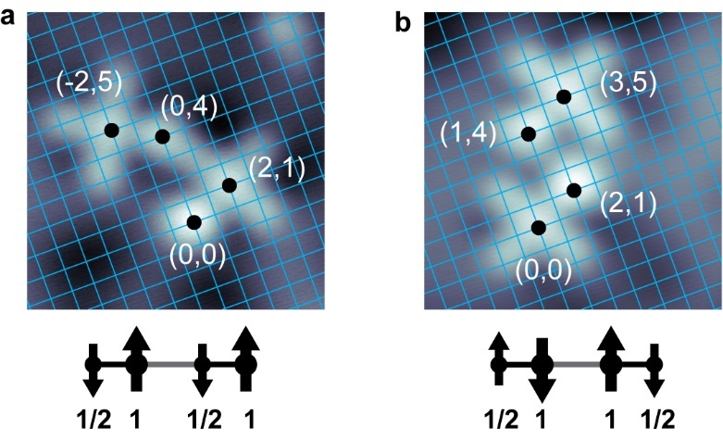
Supplementary Fig. S19. Lattice fit of two coupled complexes. a. Topographic image of two ferromagnetically coupled complexes with MgO lattice overlaid as shown in Fig. 4 in the main text. The distances between spins are used for the four-spin model in Fig. 4f. b. Topographic image of two antiferromagnetically coupled complexes with MgO lattice overlaid (Fig. S14). The distances between spins are used for the four-spin model in Fig. S14c. Both images: The positions of the Fe and molecule spins are labeled by black dots and are defined relative to the oxygen lattice, which is indicated by a blue grid. Size: 3 nm × 3 nm, setpoint: V = -100 mV, I = 20 pA.

References
1 Baumann, S. et al. Origin of Perpendicular Magnetic Anisotropy and Large Orbital Moment in Fe Atoms on MgO. Physical Review Letters 115, 237202 (2015). https://doi.org/10.1103/PhysRevLett.115.237202
2 Zhang, X. et al. Electron spin resonance of single iron phthalocyanine molecules and role of their non-localized spins in magnetic interactions. Nature Chemistry 14, 59-65 (2022). https://doi.org/10.1038/s41557-021-00827-7
3 Čenčariková, H. & Strečka, J. Unconventional strengthening of the bipartite entanglement of a mixed spin-(1/2,1) Heisenberg dimer achieved through Zeeman splitting. Physical Review B 102, 184419 (2020). https://doi.org/10.1103/PhysRevB.102.184419
4 Loth, S., Lutz, C. P. & Heinrich, A. J. Spin-polarized spin excitation spectroscopy. New Journal of Physics 12, 125021 (2010). https://doi.org/10.1088/1367-2630/12/12/125021
5 Ternes, M. Spin excitations and correlations in scanning tunneling spectroscopy. New Journal of Physics 17, 063016 (2015).
6 Baumann, S. et al. Electron paramagnetic resonance of individual atoms on a surface. Science 350, 417-420 (2015). https://doi.org/doi:10.1126/science.aac8703
7 Choi, T. et al. Atomic-scale sensing of the magnetic dipolar field from single atoms. Nature Nanotechnology 12, 420-424 (2017). https://doi.org/10.1038/nnano.2017.18
8 Willke, P. et al. Tuning Single-Atom Electron Spin Resonance in a Vector Magnetic Field. Nano Letters 19, 8201-8206 (2019). https://doi.org/10.1021/acs.nanolett.9b03559
9 Singha, A. et al. Engineering atomic-scale magnetic fields by dysprosium single atom magnets. Nature Communications 12, 4179 (2021). https://doi.org/10.1038/s41467-021-24465-2
10 Giannozzi, P. et al. QUANTUM ESPRESSO: a modular and open-source software project for quantum simulations of materials. Journal of Physics: Condensed Matter 21, 395502 (2009). https://doi.org/10.1088/0953-8984/21/39/395502
11 Giannozzi, P. et al. Advanced capabilities for materials modelling with Quantum ESPRESSO. Journal of Physics: Condensed Matter 29, 465901 (2017). https://doi.org/10.1088/1361-648X/aa8f79
12 Dal Corso, A. Pseudopotentials periodic table: From H to Pu. Computational Materials Science 95, 337-350 (2014). https://doi.org/https://doi.org/10.1016/j.commatsci.2014.07.043
13 Stukowski, A. Visualization and analysis of atomistic simulation data with OVITO–the Open Visualization Tool. Modelling and Simulation in Materials Science and Engineering 18, 015012 (2010). https://doi.org/10.1088/0965-0393/18/1/015012
14 Crabtree, R. H. The Organometallic Chemistry of the Transition Metals. (John Wiley & Sons, 2009).
15 Wolf, C., Delgado, F., Reina, J. & Lorente, N. Efficient Ab Initio Multiplet Calculations for Magnetic Adatoms on MgO. The Journal of Physical Chemistry A 124, 2318-2327 (2020). https://doi.org/10.1021/acs.jpca.9b10749
16 Noodleman, L. Valence bond description of antiferromagnetic coupling in transition metal dimers. The Journal of Chemical Physics 74, 5737-5743 (1981). https://doi.org/10.1063/1.440939
17 Zhang, X. et al. Influence of the Magnetic Tip on Heterodimers in Electron Spin Resonance Combined with Scanning Tunneling Microscopy. ACS Nano 17, 16935-16942 (2023). https://doi.org/10.1021/acsnano.3c04024
18 Seifert, T. S., Kovarik, S., Gambardella, P. & Stepanow, S. Accurate measurement of atomic magnetic moments by minimizing the tip magnetic field in STM-based electron paramagnetic resonance. Physical Review Research 3, 043185 (2021). https://doi.org/10.1103/PhysRevResearch.3.043185
19 Willke, P. et al. Coherent Spin Control of Single Molecules on a Surface. ACS Nano 15, 17959-17965 (2021). https://doi.org/10.1021/acsnano.1c06394
20 Yang, K. et al. Coherent spin manipulation of individual atoms on a surface. Science 366, 509-512 (2019). https://doi.org/doi:10.1126/science.aay6779
21 Phark, S.-h. et al. Electric-Field-Driven Spin Resonance by On-Surface Exchange Coupling to a Single-Atom Magnet. Advanced Science 10, 2302033 (2023). https://doi.org/https://doi.org/10.1002/advs.202302033
22 Lado, J. L., Ferrón, A. & Fernández-Rossier, J. Exchange mechanism for electron paramagnetic resonance of individual adatoms. Physical Review B 96, 205420 (2017). https://doi.org/10.1103/PhysRevB.96.205420
23 Delgado, F. & Lorente, N. A theoretical review on the single-impurity electron spin resonance on surfaces. Progress in Surface Science 96, 100625 (2021). https://doi.org/https://doi.org/10.1016/j.progsurf.2021.100625
24 Reina-Gálvez, J. et al. Efficient driving of a spin-qubit using single-atom magnets. arXiv preprint arXiv:2408.07289 (2024).
25 Chen, Y., Bae, Y. & Heinrich, A. J. Harnessing the Quantum Behavior of Spins on Surfaces. Advanced Materials 35, 2107534 (2023). https://doi.org/https://doi.org/10.1002/adma.202107534
26 Reina-Gálvez, J., Wolf, C. & Lorente, N. Many-body nonequilibrium effects in all-electric electron spin resonance. Physical Review B 107, 235404 (2023). https://doi.org/10.1103/PhysRevB.107.235404
27 Paul, W. et al. Control of the millisecond spin lifetime of an electrically probed atom. Nature Physics 13, 403-407 (2017). https://doi.org/10.1038/nphys3965
28 Veldman, L. M. et al. Free coherent evolution of a coupled atomic spin system initialized by electron scattering. Science 372, 964-968 (2021). https://doi.org/doi:10.1126/science.abg8223

