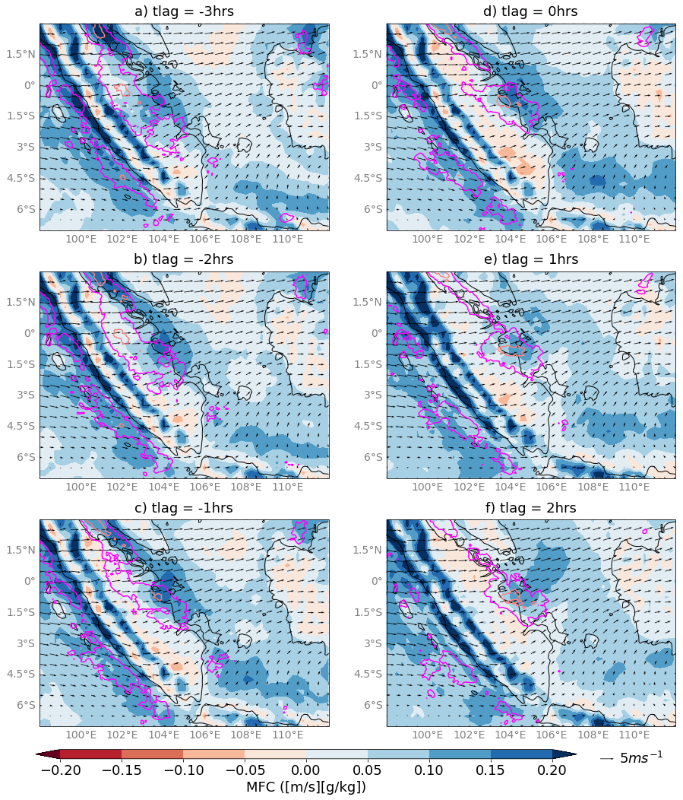
Figure A1: Same as Fig. 3 but for the occurrence of Sumatra squalls that did not make landfall over Singapore.

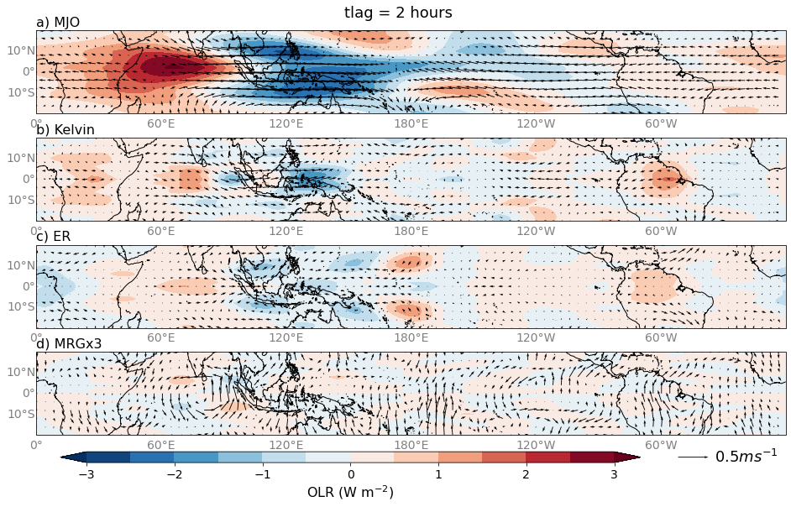Figure A2: Same as Fig. 4 but averaged over the occurrence of Sumatra squalls that did not make landfall over Singapore.

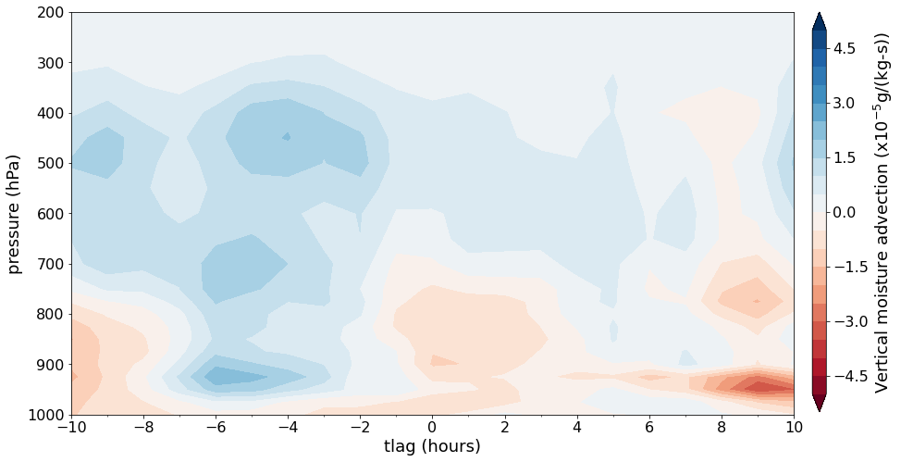
Figure A3: Same as Fig. 7 but for the occurrence of Sumatra squalls that did not make landfall over Singapore.

