Supplemental material
Title: Building Machine Learning Predictive Models for Adolescent Internet Addiction: Key Findings on Self-Esteem and Resilience Interaction

Supplemental captions:
Supplemental Figure 1. ROC curves for all models in train sets.
Supplemental Figure 2 SHAP feature dependence diagram.
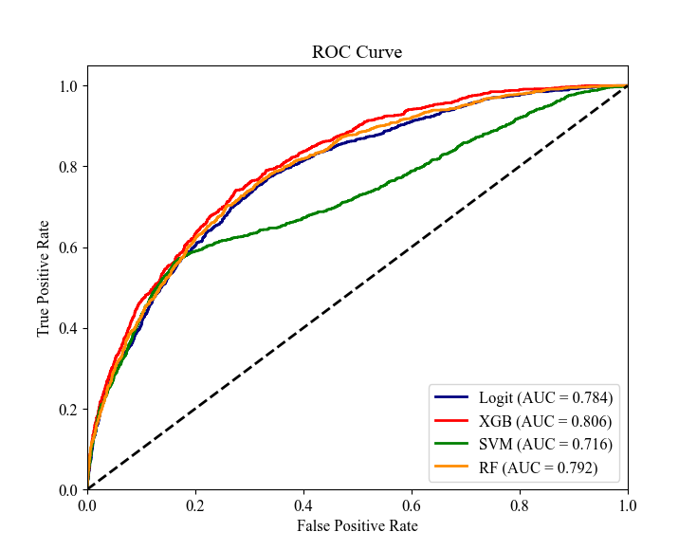
Supplemental Figure 1. ROC curves for all models in train set.
Notes: ROC: Receiver operating characteristic.
Supplementary Figure2. SHAP feature dependence diagram.
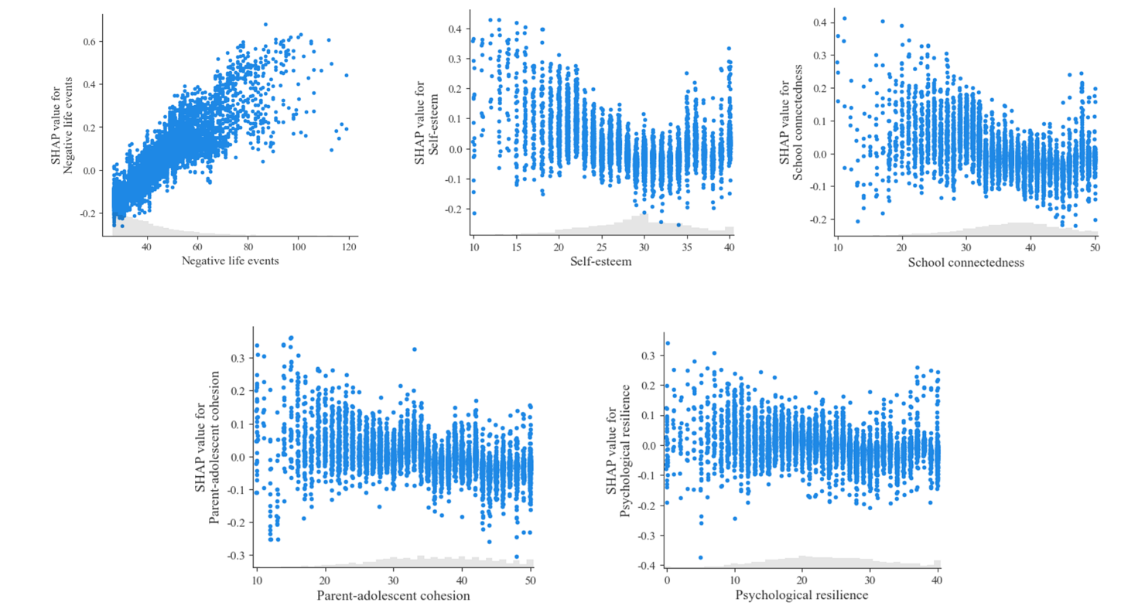
The order of the charts (top-down, left-right) follows the order of the most important variables according to SHAP.

