Appendix
Additional Table 1. Subgroup analysis for prospective datasets
 | Diverticulitis |  |  | Sleep Apnea |  |  | Headaches in Pregnancy
 |  | found/total (%) | P-value |  | found/total (%) | P |  | found/total (%) | P-value
Study design | RCT | 18/28 (64) | 0.5390 | RCT | 8/35 (23) | 0.3682 | RCT | 0/2 (0) | 0.1775
Study design | NRCS | 13/22 (59) |  | NRCS | 2/21 (10) |  | NRCS | 1/13 (8)
Study design | cohort/  single arm | 16/34 (47) |  | cohort/  single arm | 1/13 (8) |  | cohort/  single arm | 2/5 (40)
 |  |  |  |  |  |  | Case report | 2/18 (11)
 |  |  |  |  |  |  | Systematic Review | 1/27 (4)
Key Question | KQ 1 | 3/7 (43) | < 0.001 | KQ 1 | 9/65 (14) | 0.5426 | KQ 1 | 1/14 (7) | 1.0000
Key Question | KQ 2 | 19/25 (76) |  | KQ 2 | 6/29 (21) |  | KQ 2 | 5/51 (10)
Key Question | KQ 3 | 16/19 (84)
Key Question | KQ 4 | 12/50 (24)
Study size | <100 | 4/6 (67) | 0.3674 | <100 | 3/22 (14) | 0.9468 | 1 | 2/18 (11) | 0.8165
Study size | 101-500 | 26/42 (62) |  | 101-500 | 6/31 (19) |  | 2-200 | 2/8 (25)
Study size | 501-1000 | 10/16 (63) |  | 501-1000 | 0/3 (0) |  | 201-1,000 | 0/4 (0)
Study size | 1001-10000 | 7/20 (35) |  | >1001 | 2/13 (8) |  | 1,000-5,547 | 1/7 (14)
* Note: this does not include data that was not reported, and some studies fit into more than one category. P-value based on Fisher exact test.
Additional Table 2. Subgroup analysis for retrospective datasets: Tympanostomy Tubes
 |  | Positive and negative key phrases |  | No key phrases |  | Positive key phrases only
 |  | found/total (%) | P-value | found/total (%) | P-value | found/total (%) | P-value
Study design | RCT | 39/59 (66) | 0.0034 | 39/59 (66) | 0.0034 | 38/59 (66) | 0.0034
Study design | NRCS | 10/33 (30) |  | 10/33 (30) |  | 10/33 (30)
Study design | cohort/single arm | 33/68 (49) |  | 33/68 (49) |  | 33/68 (49)
Key Question | KQ 1 | 17/54 (31) | 0.0009 | 17/54 (31) | 0.0009 | 17/54 (31) | 0.0009
Key Question | KQ 2 | 6/13 (46) |  | 6/13 (46) |  | 6/13 (46)
Key Question | KQ 3 | 41/90 (46) |  | 40/90 (44) |  | 39/90 (43)
Key Question | KQ 4 | 6/11 (55) |  | 6/11 (55) |  | 6/11 (55)
Key Question | KQ 5 | 13/14 (93) |  | 13/14 (93) |  | 13/14 (93)
Study size | 14-78 | 14/34 (41) | 0.3210 | 13/34 (38) | 0.0606 | 14/34 (41) | 0.0995
Study size | 79-185 | 18/33 (55) |  | 16/33 (48) |  | 15/33 (46)
Study size | 186-358 | 21/35 (60) |  | 22/35 (63) |  | 21/35 (60)
Study size | 359-217,206 | 21/34 (62) |  | 23/34 (68) |  | 23/34 (68)
* Note: this does not include data that was not reported, and some studies fit into more than one category. P-value based on Fisher exact test.
Additional Table 3. Subgroup analysis for retrospective datasets: Urinary Incontinence
 |  | Positive and negative key phrases |  | No key phrases |  | Positive key phrases only
 |  | found/total (%) | P-value | found/total (%) | P-value | found/total (%) | P-value
Study design | RCT | 17/80 (21) | 0.4813 | 10/80 (13) | 1.000 | 23/80 (29) | 1.000
Study design | NRCS | 0/1 (0) |  | 0/1 (0) |  | 0/1 (0)
Study design | cohort/single arm | 5/15 (33) |  | 1/15 (7) |  | 4/15 (27)
Key Question | KQ 1 | 17/68 (25) | 0.7244 | 8/68 (12) | 0.6323 | 24/68 (35) | 0.0663
Key Question | KQ 2 | 3/23 (13) |  | 2/23 (9) |  | 2/23 (9)
Key Question | KQ 3 | 1/4 (25) |  | 1/4 (25) |  | 1/4 (25)
Key Question | KQ 4 | 1/5 (20) |  | 0/5 (0) |  | 1/5 (20)
Study size | 12-42 | 3/25 (12) | 0.1567 | 2/25 (8) | 0.8154 | 3/25 (16) | 0.8154
Study size | 43-90 | 8/22 (36) |  | 2/22 (9) |  | 11/22 (50)
Study size | 91-184 | 3/24 (13) |  | 4/24 (17) |  | 7/24 (29)
Study size | 184-12,733 | 6/25 (24) |  | 3/25 (12) |  | 5/25 (20)
* Note: this does not include data that was not reported, and some studies fit into more than one category. P-value based on Fisher exact test.
Additional Table 4. Subgroup analysis for retrospective datasets: Nonmelanoma Skin Cancer
 |  | Positive and negative key phrases |  | No key phrases |  | Positive key phrases only
 |  | found/total (%) | P-value | found/total (%) | P-value | found/total (%) | P-value
Study design | RCT | 21/62 (34) | 0.3642 | 16/62 (26) | 0.7477 | 27/62 (44) | 0.2537
Study design | NRCS | 3/16 (19) |  | 3/16 (19) |  | 4/16 (25)
Key Question | KQ 1 | 24/78 (31) | 0.0589 | 19/78 (24) | 0.1431 | 31/78 (40) | 0.2919
Key Question | KQ 2 | 10/18 (56) |  | 8/18 (44) |  | 10/18 (56)
Study size | 12-39 | 4/19 (21) | 0.7344 | 5/19 (26) | 0.7344 | 7/19 (37) | 0.6300
Study size | 40-101 | 7/19 (37) |  | 6/19 (32) |  | 8/19 (42)
Study size | 102-367 | 6/20 (30) |  | 3/20 (15) |  | 10/20 (50)
Study size | 367-1483 | 7/20 (35) |  | 5/20 (25) |  | 6/20 (30)
* Note: this does not include data that was not reported, and some studies fit into more than one category. P-value based on Fisher exact test.
Additional Table 5. Subgroup analysis for retrospective datasets: Venous Thromboembolism.
 |  | Positive and negative key phrases |  | No key phrases |  | Positive key phrases only
 |  | found/total (%) | P-value | found/total (%) | P-value | found/total (%) | P-value
Study design | RCT | 19/41 (46) | 0.095 | 18/41 (44) | 0.105 | 23/41 (56) | 0.220
 | NRCS | 2/12 (17) |  | 2/12 (17) |  | 2/12 (17)
Key Question | KQ 1 | 14/34 (41) | 0.086 | 15/34 (44) | 0.007 | 20/34 (59) | 0.008
 | KQ 2 | 1/5 (20) |  | 1/5 (20) |  | 2/5 (40)
 | KQ 3 | 8/13 (62) |  | 2/13 (15) |  | 4/13 (31)
 | KQ 4 | 2/11 (18) |  | 1/11 (9) |  | 2/11 (18)
 | KQ 5 | 7/11 (64) |  | 8/11 (73) |  | 9/11 (82)
 | KQ 6 | 0/3 (0) |  | 0/3 (0) |  | 0/3 (0)
Study size | 24-120 | 2/13 (15) | 0.223 | 1/13 (8) | 0.077 | 3/13 (23) | 0.300
 | 121-716 | 6/14 (43) |  | 7/14 (50) |  | 8/14 (57)
 | 717-1,532 | 7/13 (54) |  | 6/13 (46) |  | 7/13 (54)
 | 1,533-316,495 | 6/14 (43) |  | 6/14 (43) |  | 7/14 (50)
* Note: this does not include data that was not reported, and some studies fit into more than one category. P-value based on Fisher exact test.

Additional Figure 1. Concept Map: Nonmelanoma Skin Cancer
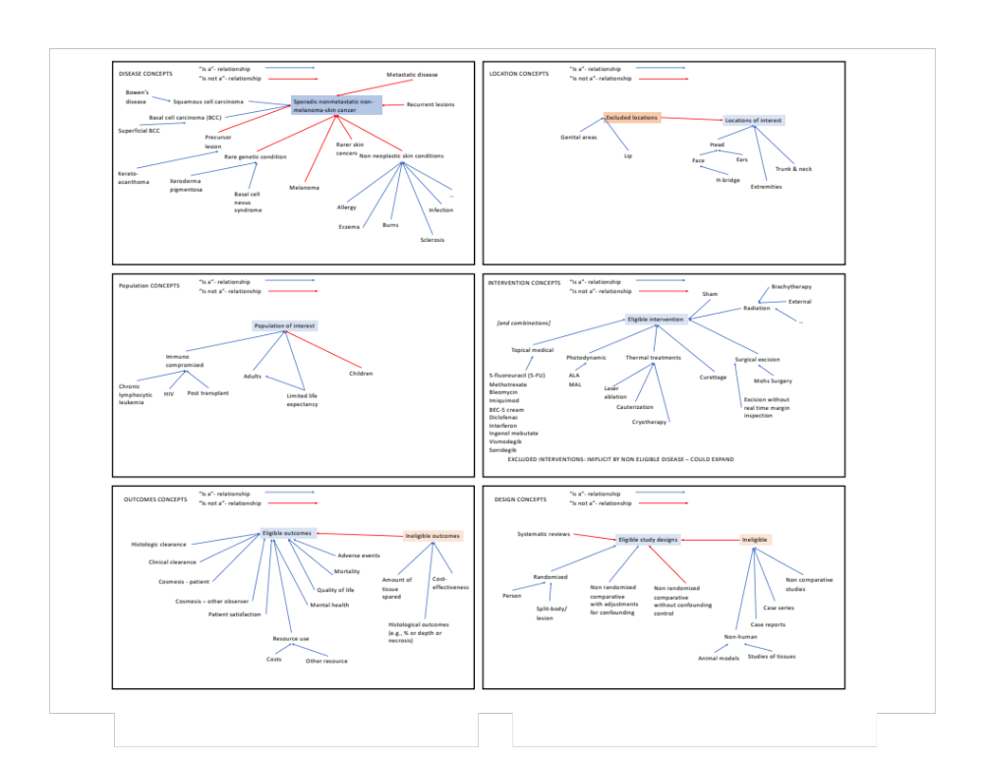
Additional Figure 2. Concept Map: Tympanostomy
