Supporting Information

An actuatable ionogel thermoelectric fiber with aligned mesogens-induced unprecedented thermopower for four-dimensional dynamically adaptive heat harvesting

Liuqi Cao^{1†}, Tingting Sun^{2†*}, Huiru Zhao¹, MengHan Shang¹, Lianjun Wang^{1,3*} & Wan Jiang^{1,4*}

¹State Key Laboratory for Modification of Chemical Fibers and Polymer Materials, College of Materials Science and Engineering, Donghua University, 201620 Shanghai, China.
²College of Biological Science and Medical Engineering, Donghua University, 201620 Shanghai, China.
³Engineering Research Center of Advanced Glasses Manufacturing Technology, Ministry of Education, Donghua University, 201620 Shanghai, China.
⁴Institute of Functional Materials, Donghua University, 201620 Shanghai, China.
e-mail: Tingtingsun@dhu.edu.cn; wanglj@dhu.edu.cn; wanjiang@dhu.edu.cn

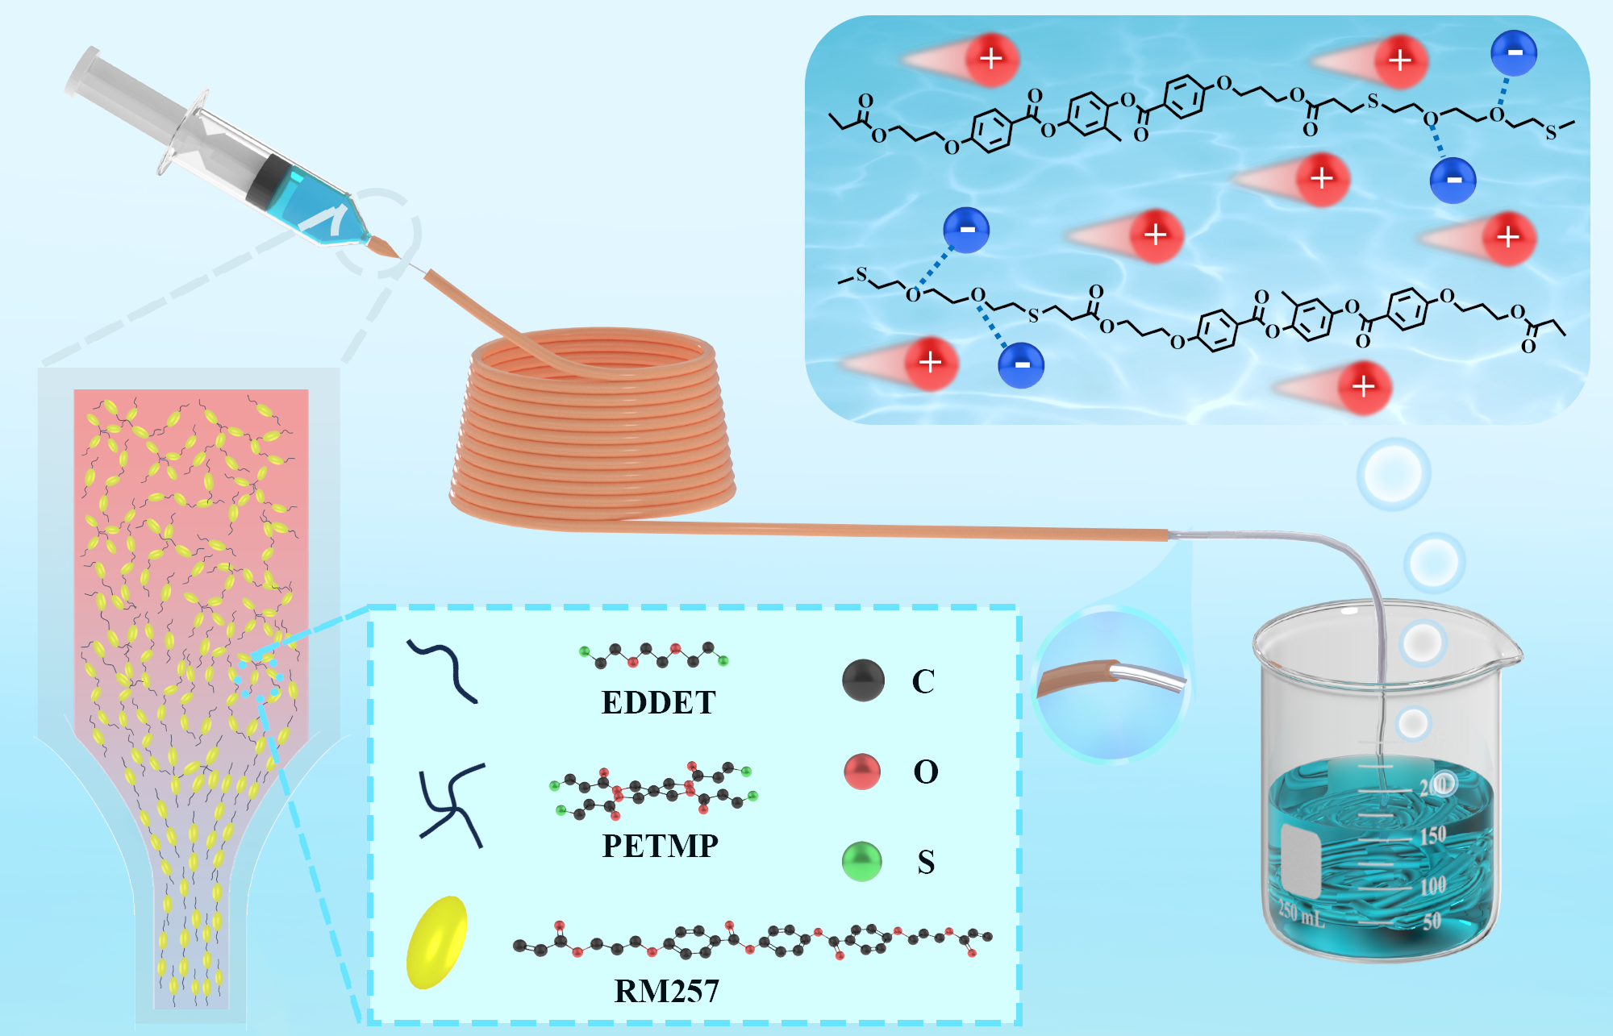
Fig. S1 Preparation diagram of LCE-based ionic thermoelectric fibers

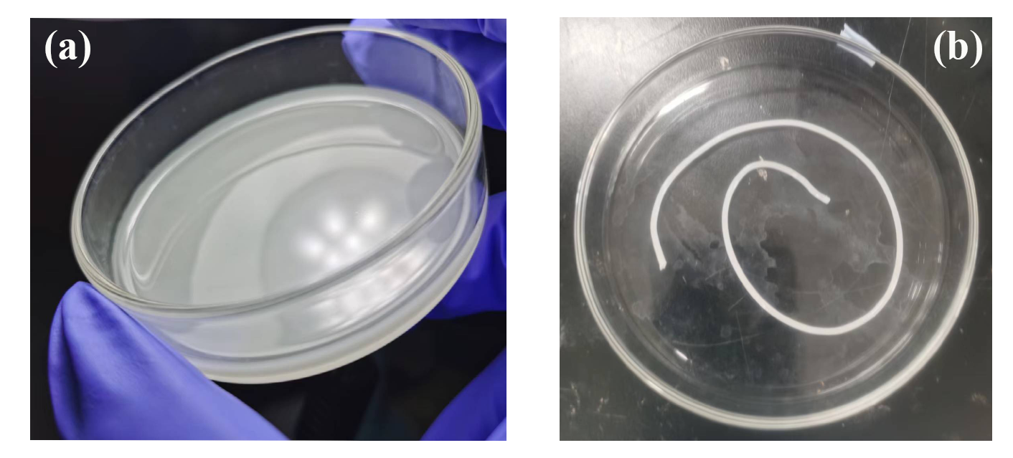
Fig. S2 LCE-based ionic thermoelectric films (a) and fibers (b) prepared by a one-step synthesis method

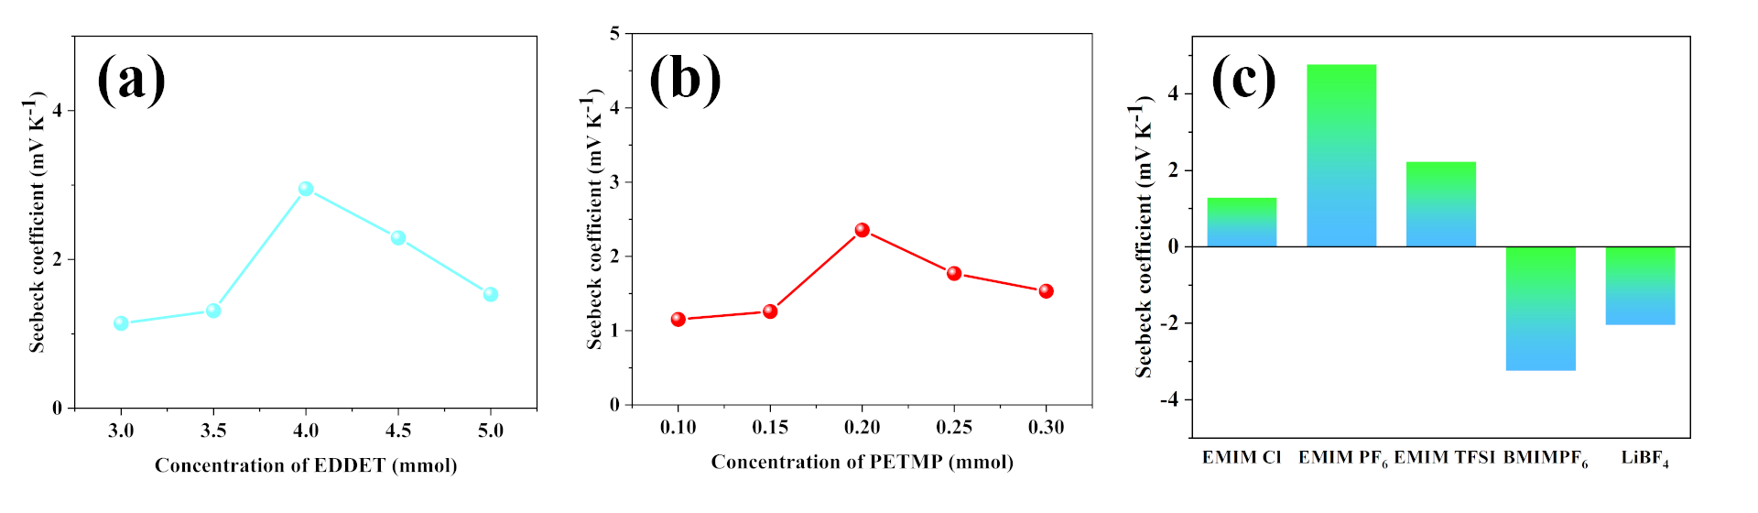
Fig. S3 Thermoelectric properties of LCE i-TE fibers obtained by one-step synthesis with different compositional elements. (a-b) Seebeck coefficient of LCE i-TE fibers synthesized with different concentration of EDDET and PETMP. (c) Seebeck coefficient of LCE fibers synthesized with different types of ionic liquids.
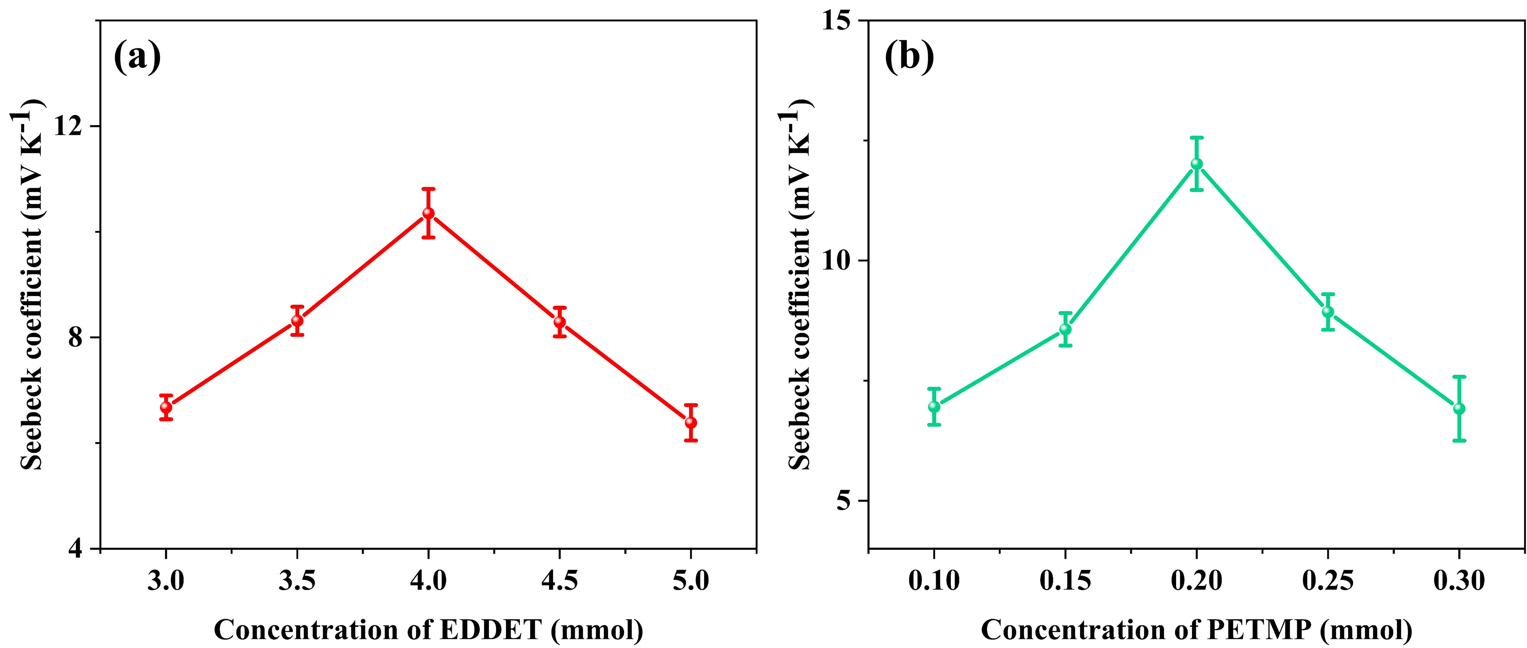
Fig. S4 Thermoelectric properties of LCE i-TE fibers obtained by solution impregnation method with different compositional elements. (a-b) Seebeck coefficient of LCE i-TE fibers synthesized with different concentration of EDDET and PETMP.

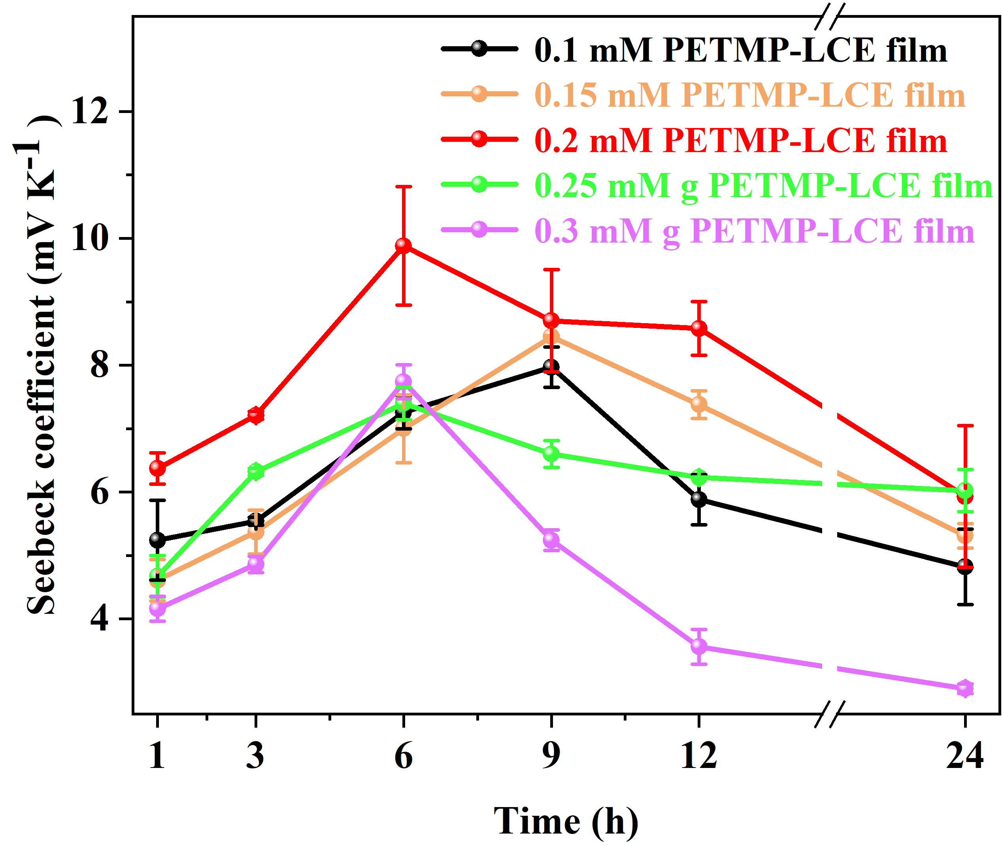
Fig. S5 Seebeck coefficient of LCE i-TE films with different concentration of PETMP at different impregnation time.

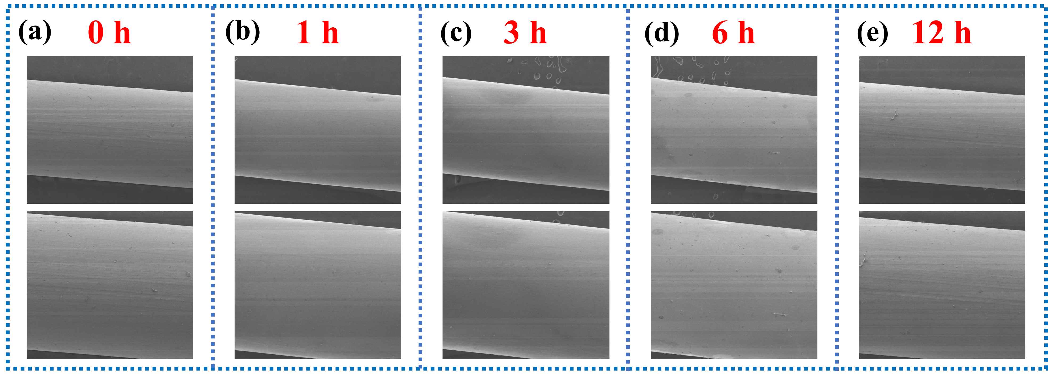
Fig. S6 SEM images of LCE i-TE fibers at different immersion time (a) 0h, (b) 1h, (c) 3h, (d) 6h, (e) 12h.

Fig. S7 Tensile stress-strain curves at stretching rate of 50 mm·min⁻¹ of LCE i-TE films with different impregnation time.

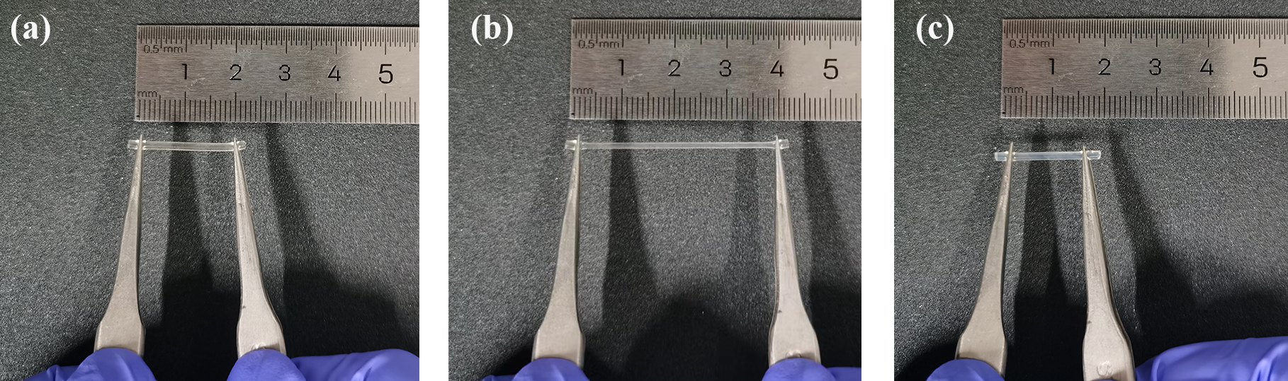
Fig. S8 LCE-based ionic thermoelectric fibers tensile rebound test (a) Stretch 0%, (b) Stretch 100%, (c) rebound 100%.

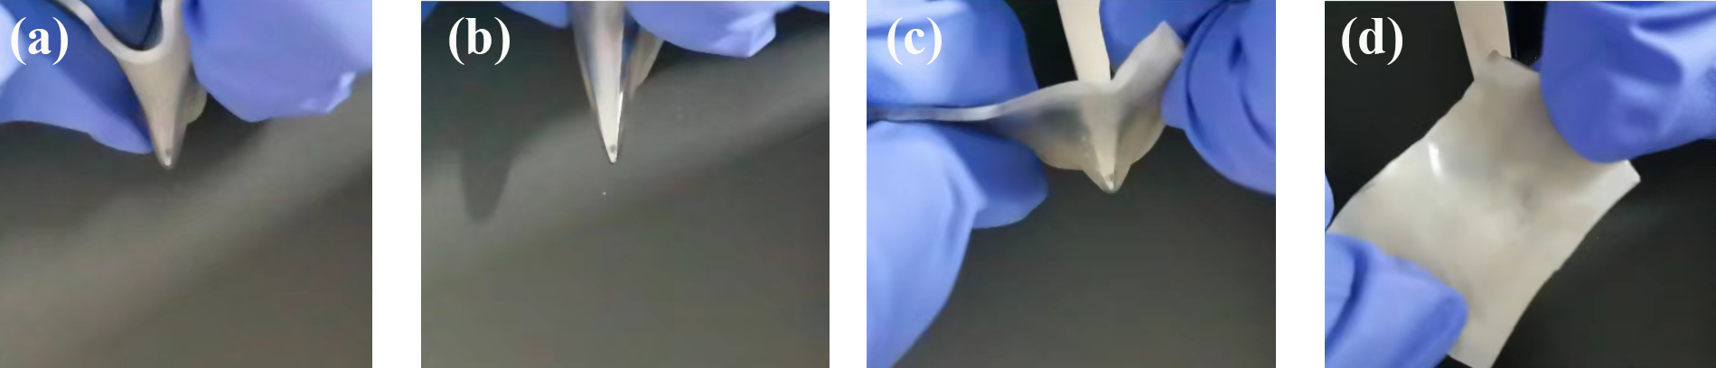
Fig. S9 Tear resistance testing of LCE-based ionic thermoelectric films (a-d).

Fig. S10 DSC curves of i-TE fibers.

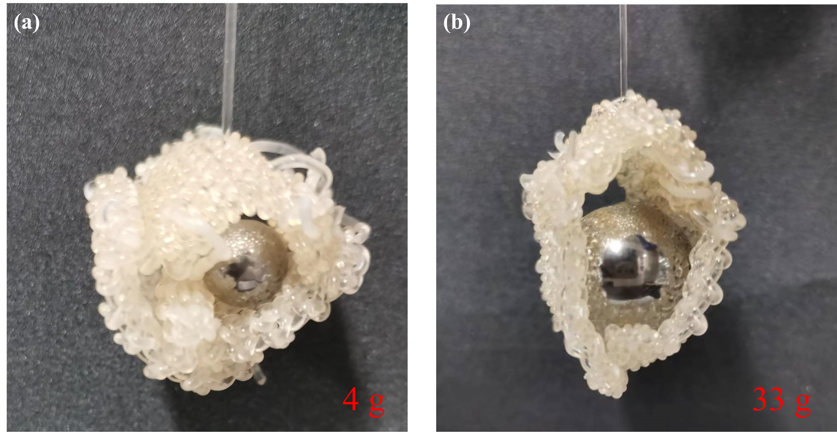
Fig. S11 Gripping of 4 g (a) and 33 g (b) steel balls by double-armed 4DCRT i-TE device

