Figures
Figure S1 Hierarchical realm (a) and biome (b) classifications underlying the ecoregions used as a basis for our analyses (Olson et al., 2001). Note that code and figure dimensions are drawn from supplementary material originally published as part of Ellis et al. (2024, doi:10.1111/ecog.07127).

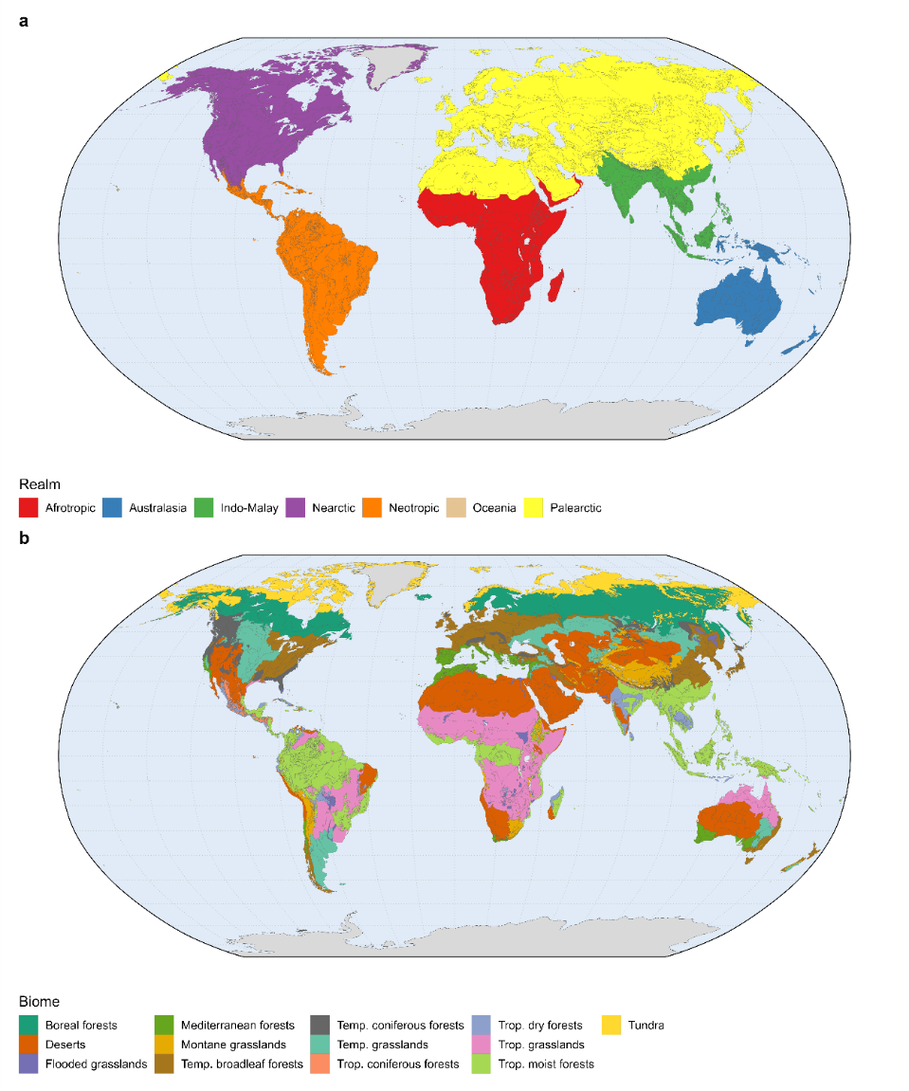

Tables
Table 1 Data summary of all datasets used throughout our analyses.
Dataset | Units | Timespan | Reference(s) | Output | Associated data
Terrestrial ecoregions of the world | Realm, biome, and ecoregion regional classifications |  | Olson et al., 2001
Ecoregional flammability thresholds | Canadian Fire Weather Index (FWI) System dead fine fuel moisture content (DFFMC: %) | 1979 - 2019 | Ellis et al., 2024 |  | ERA5 reanalysis (Hersbach et al., 2020)
Global Fire Weather Index dataset | Canadian FWI System’s DFFMC | 1991 - 2020 | McElhinny et al., 2020; Jain et al., 2022 | Fire seasons | ERA5 reanalysis (Hersbach et al., 2020)
WWLLN Global Lightning Climatology | Lightning density | 2010 - 2023 | Kaplan and Lau, 2021 | Lightning strikes; mixed ignition period; anthropogenic ignition period | World Wide Lightning Location Network (Rodger et al., 2004)
MODIS MCD64A1 Burned Area Product | Burned area | 2001 - 2023 | Giglio et al., 2018 | Burnt area occurring within ignitions periods
MODIS MOD17A3 | Net primary productivity | 2001 - 2023 | Running et al., 2015 | Mean net primary productivity
Gridded Population of the World | Population density | 2020 | Center for International Earth Science Information Network, 2018 | Population density

Table S2 Summary statistics for biome- and realm-level fire season and ignition period definitions. Bare earth environments are excluded. Both mean and standard deviation are weighted by the total represented area.
 |  | Totals |  |  |  | Mean (±std. dev.) |  |  |  |  |  | %
 |  |  |  |  |  | Season length |  |  | Ignitions period length |  |  | Burnt area represented by ignitions period
Biome | Realm | Ecoregions | Grid cells | Area (G ha) |  | Fire | Lightning | Peak daily lightning strikes | Mixed | Anthropogenic |  | Mixed | Anthropogenic
All biomes | All realms | 751 | 197,256 | 10.90 |  | 164.4 (±80) | 185.7 (±90.1) | 8.3 (±11.3) | 108.9 (±75.1) | 55.5 (±53.8) |  | 23.7% | 46.3%
 | Afrotropic | 98 | 25,454 | 1.90 |  | 162.9 (±80.4) | 218.5 (±76.5) | 7.4 (±4.2) | 71.6 (±83.4) | 91.4 (±65.9) |  | 11.8% | 54.9%
 | Australasia | 78 | 12,493 | 0.90 |  | 217.9 (±63.3) | 194.7 (±57.1) | 11.6 (±11.7) | 151.4 (±64.4) | 66.4 (±65) |  | 32.1% | 41.8%
 | Indo-Malay | 95 | 11,330 | 0.80 |  | 181.1 (±100.5) | 281.2 (±65.7) | 11.7 (±8.9) | 129.6 (±93.5) | 51.5 (±53) |  | 46.8% | 36.8%
 | Nearctic | 117 | 44,519 | 2.00 |  | 149.8 (±79.3) | 143.8 (±88.3) | 7.9 (±12.9) | 114.4 (±72.4) | 35.4 (±32.7) |  | 66.2% | 15.7%
 | Neotropic | 157 | 25,114 | 1.80 |  | 184.4 (±89.6) | 247.8 (±70.9) | 17.4 (±17.2) | 119.6 (±89.5) | 64.8 (±53.1) |  | 37.7% | 36.6%
 | Oceania | 12 | 56 | 0.00 |  | 259.5 (±75.4) | 245 (±61.1) | 9.5 (±7.5) | 148.3 (±81) | 111.3 (±64.6) |  | 19.3% | 65.7%
 | Palearctic | 194 | 78,290 | 3.50 |  | 145.6 (±62.1) | 134.5 (±70.1) | 2.7 (±3) | 105.2 (±46.7) | 40.5 (±40.3) |  | 50.6% | 18.5%
Boreal forests | All realms | 28 | 39,086 | 1.50 |  | 111.7 (±24.6) | 92.6 (±25.1) | 1.4 (±1.3) | 84.1 (±21.1) | 27.6 (±18.9) |  | 64.9% | 13.8%
 | Nearctic | 17 | 12,306 | 0.50 |  | 114.6 (±25.3) | 96.8 (±32.6) | 1.2 (±1.2) | 84.9 (±25.3) | 29.7 (±20.9) |  | 81.3% | 7.7%
 | Palearctic | 11 | 26,780 | 1.00 |  | 110.3 (±24.1) | 90.5 (±19.8) | 1.6 (±1.4) | 83.7 (±18.6) | 26.6 (±17.7) |  | 59.6% | 15.7%
Deserts | All realms | 88 | 17,196 | 1.10 |  | 188.2 (±66.9) | 203.9 (±66.9) | 6.7 (±8.9) | 135 (±60) | 53.2 (±56.2) |  | 43.4% | 30.3%
 | Afrotropic | 18 | 2,383 | 0.20 |  | 226.8 (±53) | 202.7 (±43.9) | 4.7 (±4.6) | 151.3 (±53.8) | 75.5 (±50.2) |  | 17.4% | 62.0%
 | Australasia | 10 | 4,580 | 0.30 |  | 206.2 (±37.9) | 181.5 (±38.8) | 8 (±6.1) | 161.7 (±23.5) | 44.5 (±45.5) |  | 57.7% | 21.5%
 | Indo-Malay | 4 | 1,487 | 0.10 |  | 205.4 (±87) | 301.8 (±57.8) | 3.4 (±2.4) | 159.6 (±89.1) | 45.9 (±49.2) |  | 47.8% | 11.0%
 | Nearctic | 13 | 3,622 | 0.20 |  | 152.5 (±76) | 212.9 (±54.9) | 11.8 (±14.5) | 126.2 (±49.6) | 26.2 (±45.1) |  | 57.9% | 5.8%
 | Neotropic | 12 | 1,157 | 0.10 |  | 188.4 (±71.9) | 185.1 (±56.2) | 9.1 (±11.4) | 89.4 (±63.4) | 99 (±63.5) |  | 35.7% | 52.2%
 | Palearctic | 31 | 3,967 | 0.20 |  | 163.5 (±58.4) | 190.2 (±85.9) | 1.9 (±2.4) | 101.9 (±62.3) | 61.6 (±64.4) |  | 44.3% | 13.4%
Flooded grasslands | All realms | 24 | 1,439 | 0.10 |  | 163.9 (±68.6) | 202.3 (±68.1) | 8.6 (±8) | 74.9 (±71.8) | 89 (±57.6) |  | 15.1% | 51.6%
 | Afrotropic | 8 | 549 | 0.00 |  | 145.2 (±67.1) | 190.3 (±59.6) | 6 (±2.5) | 29.2 (±40.8) | 116 (±57.1) |  | 9.3% | 57.3%
 | Indo-Malay | 1 | 41 | 0.00 |  | 216.5 (±28.4) | 215.7 (±56.9) | 3.9 (±1.5) | 84.3 (±55) | 132.1 (±55.9) |  | 38.6% | 42.1%
 | Neotropic | 7 | 367 | 0.00 |  | 177.2 (±73.6) | 267.6 (±40.7) | 18.6 (±9) | 120.1 (±84.4) | 57.1 (±38) |  | 42.5% | 34.5%
 | Palearctic | 8 | 482 | 0.00 |  | 174 (±60.2) | 155.6 (±52.6) | 3.4 (±2.5) | 100.3 (±54.6) | 73.7 (±52.1) |  | 11.1% | 33.6%
Mediterranean forests | All realms | 39 | 4,651 | 0.30 |  | 169.8 (±65) | 250.5 (±66.3) | 4.3 (±4.5) | 145.2 (±52.3) | 24.6 (±44.4) |  | 59.5% | 11.0%
 | Afrotropic | 3 | 137 | 0.00 |  | 288.3 (±56.3) | 271.8 (±46.7) | 1.2 (±0.9) | 226.5 (±41.9) | 61.8 (±44.9) |  | 83.7% | 8.0%
 | Australasia | 10 | 1,226 | 0.10 |  | 202.5 (±33.6) | 210.9 (±43.8) | 2.9 (±1.8) | 178.5 (±22.8) | 23.9 (±28.6) |  | 50.6% | 10.3%
 | Nearctic | 3 | 183 | 0.00 |  | 239.7 (±77.3) | 283.6 (±53.6) | 1.6 (±1.4) | 190.3 (±60.8) | 49.4 (±49.8) |  | 76.4% | 17.1%
 | Neotropic | 1 | 183 | 0.00 |  | 208 (±118) | 150.1 (±78.5) | 1.4 (±1) | 85.5 (±55.4) | 122.5 (±97.2) |  | 17.3% | 11.0%
 | Palearctic | 22 | 2,922 | 0.20 |  | 142.2 (±50.6) | 271.8 (±60.5) | 5.4 (±5.3) | 127.4 (±46.6) | 14.8 (±33.3) |  | 62.8% | 11.7%
Montane grasslands | All realms | 48 | 6,042 | 0.40 |  | 174.1 (±90.3) | 158.1 (±63.8) | 4.8 (±7) | 94 (±59.7) | 80.1 (±67.2) |  | 13.8% | 74.9%
 | Afrotropic | 15 | 1,172 | 0.10 |  | 219.2 (±85.1) | 215.3 (±46.5) | 6.4 (±3.1) | 98.6 (±59.7) | 120.6 (±50.8) |  | 13.2% | 76.4%
 | Australasia | 3 | 97 | 0.00 |  | 213.4 (±71) | 243.9 (±63.2) | 5.8 (±8.8) | 155.3 (±57.8) | 58.1 (±44.7) |  | 71.8% | 14.1%
 | Indo-Malay | 1 | 3 | 0.00 |  | 346 (±4.3) | 340.3 (±6.1) | 13.1 (±0.9) | 320.3 (±4.6) | 25.7 (±6.1) |  | 100.0% | 0.0%
 | Neotropic | 7 | 737 | 0.10 |  | 187 (±73.3) | 159.7 (±51.7) | 17 (±11.4) | 49.7 (±48.7) | 137.4 (±67.6) |  | 11.9% | 60.6%
 | Palearctic | 22 | 4,033 | 0.30 |  | 155.2 (±89.3) | 136.3 (±56.9) | 1.7 (±1.5) | 100.1 (±56.9) | 55.1 (±57.7) |  | 39.1% | 25.9%
Temp. broadleaf forests | All realms | 82 | 23,038 | 1.30 |  | 197.4 (±66.4) | 183 (±65.4) | 6.2 (±7.8) | 152 (±49.7) | 45.4 (±43.7) |  | 49.8% | 20.7%
 | Australasia | 13 | 1,162 | 0.10 |  | 203.1 (±62.7) | 221.2 (±57.8) | 4.3 (±4) | 165.3 (±48.1) | 37.8 (±52.5) |  | 55.0% | 19.0%
 | Indo-Malay | 3 | 213 | 0.00 |  | 235.5 (±77.3) | 292 (±48.9) | 5.1 (±3.5) | 169.3 (±96.3) | 66.1 (±46.9) |  | 74.1% | 13.9%
 | Nearctic | 17 | 4,826 | 0.30 |  | 218.4 (±73.3) | 226.7 (±57.1) | 12.6 (±13.2) | 187.9 (±52.7) | 30.5 (±32.5) |  | 64.9% | 23.0%
 | Neotropic | 3 | 720 | 0.00 |  | 152.5 (±52.1) | 128 (±106.5) | 0.5 (±0.8) | 82.6 (±65.6) | 69.9 (±58.1) |  | 59.9% | 16.2%
 | Palearctic | 46 | 16,117 | 0.80 |  | 191.5 (±62.4) | 166 (±54.9) | 4.6 (±3.4) | 142 (±37.7) | 49.4 (±43.7) |  | 46.6% | 20.8%
Temp. coniferous forests | All realms | 53 | 7,261 | 0.40 |  | 168 (±83.2) | 167.9 (±72.8) | 7.7 (±12.4) | 124.9 (±64.4) | 43.1 (±45.1) |  | 57.9% | 19.1%
 | Indo-Malay | 2 | 100 | 0.00 |  | 193.6 (±87) | 283.2 (±60.9) | 3.4 (±2.2) | 138.6 (±94.4) | 55 (±46.4) |  | 53.0% | 16.6%
 | Nearctic | 30 | 4,232 | 0.20 |  | 165.3 (±93) | 181.3 (±76.1) | 10.4 (±15.4) | 133.1 (±73) | 32.2 (±37.9) |  | 65.7% | 17.0%
 | Palearctic | 21 | 2,929 | 0.20 |  | 170.9 (±65.6) | 143.2 (±56.4) | 3.9 (±3.4) | 112.3 (±44.2) | 58.5 (±49.9) |  | 31.0% | 26.7%
Temp. grasslands | All realms | 40 | 17,699 | 1.00 |  | 181.2 (±54) | 163.9 (±64.3) | 7.5 (±9.4) | 143.4 (±52.7) | 37.8 (±27.9) |  | 55.9% | 15.5%
 | Afrotropic | 1 | 11 | 0.00 |  | 345.9 (±3.1) | 319.1 (±33.1) | 1.7 (±0.4) | 302.3 (±29.9) | 43.6 (±27.8) |  | - | -
 | Australasia | 3 | 963 | 0.10 |  | 205.8 (±29.3) | 200.9 (±28.5) | 4.2 (±2.1) | 180.6 (±21.6) | 25.1 (±25.6) |  | 48.8% | 8.3%
 | Nearctic | 15 | 5,592 | 0.30 |  | 212.7 (±58.9) | 185.5 (±62.9) | 16 (±12.2) | 172.4 (±54.6) | 40.2 (±26.9) |  | 66.4% | 12.8%
 | Neotropic | 4 | 2,591 | 0.20 |  | 199.7 (±56.4) | 197 (±80.6) | 5.9 (±5.3) | 159.1 (±59.4) | 40.6 (±37.3) |  | 58.6% | 14.9%
 | Palearctic | 17 | 8,542 | 0.40 |  | 148.3 (±26.4) | 131.1 (±43.3) | 2.6 (±1.5) | 111.5 (±27.4) | 36.9 (±24.1) |  | 54.7% | 16.4%
Trop. coniferous forests | All realms | 16 | 993 | 0.10 |  | 129.6 (±67.4) | 239.3 (±62.1) | 30.6 (±20.8) | 81.6 (±61.2) | 48 (±45.5) |  | 51.4% | 34.5%
 | Indo-Malay | 4 | 142 | 0.00 |  | 159.3 (±89) | 304.3 (±53.6) | 7.9 (±6.7) | 136.3 (±77.5) | 23 (±42) |  | 81.1% | 11.8%
 | Nearctic | 2 | 403 | 0.00 |  | 98.5 (±59.8) | 209 (±60.3) | 28.1 (±15.9) | 64.6 (±51.1) | 34 (±31.3) |  | 40.4% | 32.0%
 | Neotropic | 10 | 448 | 0.00 |  | 147.2 (±54.7) | 245.9 (±47.8) | 39.3 (±21.5) | 80 (±54.2) | 67.2 (±48.7) |  | 49.0% | 39.5%
Trop. dry forests | All realms | 49 | 3,964 | 0.30 |  | 137.3 (±75) | 252.5 (±70.8) | 18.4 (±19.2) | 73.2 (±60.1) | 64.1 (±58.3) |  | 28.7% | 49.5%
 | Afrotropic | 2 | 252 | 0.00 |  | 133.9 (±39.8) | 155.1 (±9.6) | 12.4 (±4.4) | 16.2 (±15.2) | 117.7 (±35.4) |  | 4.2% | 62.5%
 | Australasia | 4 | 94 | 0.00 |  | 120.6 (±52.4) | 186.5 (±19.9) | 16.4 (±5.5) | 28.3 (±25.1) | 92.3 (±44.2) |  | 5.3% | 70.5%
 | Indo-Malay | 12 | 2,049 | 0.10 |  | 117.1 (±58.6) | 283.9 (±58.7) | 10 (±5.9) | 76.4 (±55.8) | 40.7 (±40.1) |  | 36.4% | 50.0%
 | Nearctic | 1 | 73 | 0.00 |  | 339.2 (±44.2) | 134.9 (±21.3) | 31.4 (±8) | 129 (±24.5) | 210.1 (±39.5) |  | 60.5% | 32.9%
 | Neotropic | 28 | 1,480 | 0.10 |  | 156.2 (±82.1) | 236.1 (±66) | 30.3 (±25.9) | 78.5 (±65.5) | 77.7 (±62.5) |  | 37.2% | 39.8%
 | Oceania | 2 | 16 | 0.00 |  | 240.7 (±76.4) | 230.7 (±63.1) | 14 (±10.2) | 122.1 (±77.6) | 118.6 (±67.2) |  | 14.9% | 73.1%
Trop. grasslands | All realms | 45 | 24,956 | 1.90 |  | 156.2 (±79.4) | 206.3 (±71) | 10.6 (±8.9) | 59.1 (±72.6) | 97.1 (±65.1) |  | 13.7% | 51.4%
 | Afrotropic | 24 | 16,471 | 1.20 |  | 142.4 (±67.7) | 202.8 (±71.9) | 7.2 (±3.7) | 40.2 (±60) | 102.2 (±66) |  | 9.2% | 54.5%
 | Australasia | 9 | 2,875 | 0.20 |  | 221.7 (±77.2) | 148.8 (±15.5) | 22.2 (±15.3) | 85.7 (±51.8) | 136 (±64.2) |  | 21.4% | 51.0%
 | Indo-Malay | 1 | 46 | 0.00 |  | 157.3 (±51.9) | 260.4 (±65.1) | 6.9 (±3.5) | 84.3 (±46.1) | 72.9 (±59.8) |  | 64.2% | 9.2%
 | Nearctic | 1 | 118 | 0.00 |  | 312.2 (±50.4) | 309.7 (±23.7) | 54.4 (±11.3) | 264.2 (±46.2) | 48 (±19.7) |  | 62.9% | 17.9%
 | Neotropic | 8 | 5,443 | 0.40 |  | 161.8 (±92.6) | 245 (±61.5) | 14.4 (±6.7) | 100.3 (±89.1) | 61.5 (±42.1) |  | 33.1% | 36.5%
 | Oceania | 2 | 3 | 0.00 |  | 242.7 (±61.7) | 287.3 (±54.2) | 6.6 (±3.6) | 188.4 (±45) | 54.4 (±52.2) |  | 31.9% | 0.0%
Trop. moist forests | All realms | 206 | 25,990 | 1.90 |  | 200.6 (±99.8) | 277.2 (±62.4) | 16.1 (±14.7) | 142.6 (±97.3) | 58 (±53.7) |  | 42.9% | 40.7%
 | Afrotropic | 27 | 4,479 | 0.30 |  | 192.6 (±98.6) | 289.5 (±73.4) | 9.7 (±4.8) | 143.7 (±99.7) | 48.9 (±57.5) |  | 37.3% | 48.5%
 | Australasia | 25 | 1,495 | 0.10 |  | 276.2 (±81.3) | 281.8 (±57.9) | 17.2 (±9.8) | 206.7 (±97.1) | 69.4 (±53.8) |  | 44.3% | 51.0%
 | Indo-Malay | 67 | 7,249 | 0.50 |  | 193 (±106.1) | 276.1 (±68.5) | 14.3 (±9.4) | 137.9 (±97.4) | 55.1 (±56.2) |  | 49.8% | 35.9%
 | Neotropic | 77 | 11,988 | 0.90 |  | 197 (±94.9) | 276.1 (±52.8) | 20 (±18.8) | 136.6 (±94.8) | 60.4 (±50) |  | 43.6% | 36.1%
 | Oceania | 8 | 37 | 0.00 |  | 269 (±74.2) | 247.9 (±58.8) | 7.8 (±5.1) | 156.3 (±81.7) | 112.7 (±62.2) |  | 32.3% | 63.2%
 | Palearctic | 2 | 742 | 0.10 |  | 221.7 (±90.7) | 215 (±39.6) | 7 (±3) | 144.1 (±69.5) | 77.7 (±46.7) |  | 36.2% | 42.6%
Tundra | All realms | 33 | 24,941 | 0.70 |  | 82.1 (±26.1) | 44.7 (±35.7) | 0.3 (±0.3) | 40.9 (±31.5) | 41.1 (±26.2) |  | 65.7% | 23.2%
 | Australasia | 1 | 1 | 0.00 |  | 2 (±0) | 145 (±0) | 0 (±0) | 2 (±0) | 0 (±0) |  | - | -
 | Nearctic | 18 | 13,164 | 0.40 |  | 78 (±29.3) | 33 (±33.9) | 0.1 (±0.2) | 30.5 (±31.3) | 47.5 (±25.5) |  | 67.3% | 21.8%
 | Palearctic | 14 | 11,776 | 0.30 |  | 86.5 (±21.1) | 57.6 (±33) | 0.4 (±0.4) | 52.4 (±27.5) | 34.1 (±25.1) |  | 64.7% | 24.0%

