Incident angle-dependent dynamic tuning of high-purity structural colors with an array of nanovoids on a dielectric surface

Hrudya Radhakrishnan¹, Tummaluru Khadar Basha², Junaid Masud Laskar^{2§}, Sandip Dhara¹, Ramanathaswamy Pandian^{1*}

¹Surface and Sensors Studies Division, Materials Science Group, Indira Gandhi Centre for Atomic Research, A CI of Homi Bhabha National Institute, Kalpakkam 603102, Tamil Nadu, India

²Nanophotonics and Quantum Meta-Optics Group, Center for Nanophotonics, Department of Physics and Nanotechnology, SRM Institute of Science and Technology, Kattankulathur - 603203, Tamil Nadu, India
* Corresponding author email: *rpandian@igcar.gov.in, §junaidmb@srmist.edu.in

Figure S1

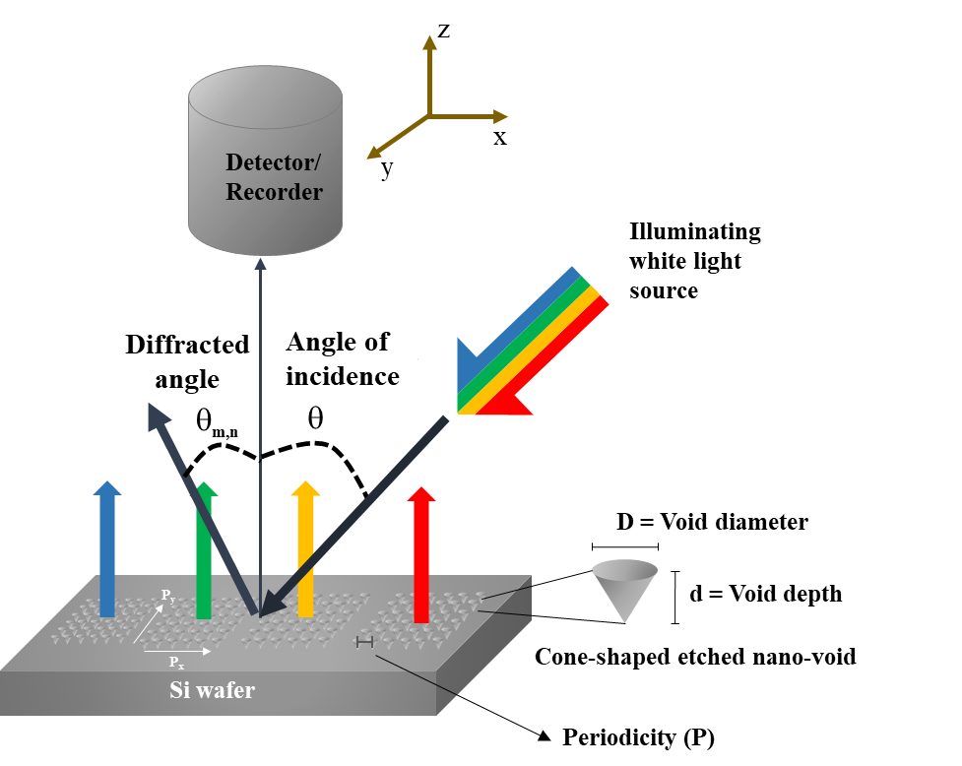
Figure S1: The experimental setup for measuring reflectance and capturing bright-field optical images of 2D square array patterns is illustrated schematically. These patterns, located on a high-index crystalline Si surface, comprise cone-shaped nanovoid elements with a diameter D and depth d, arranged in various periodicities P. When exposed to white light, these patterns reflect vibrant colors. The apparatus for recording reflectance and optical images was positioned directly above the patterned surface, while a white light source illuminated the patterns at different angles of incidence (θ).

Figure S2
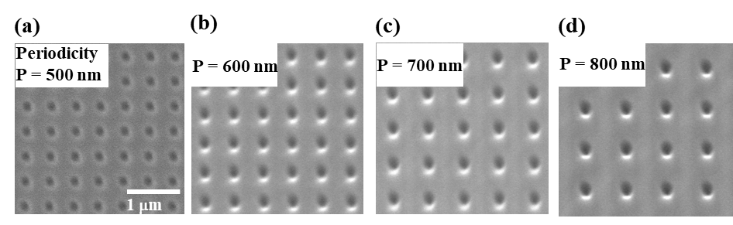
Figure S2: Top-view scanning electron micrographs showing 2D array patterns of cone-shaped nanovoids on the surface of Si. Images (a), (b), (c) and (d) show the magnified view of the patterns with periodicities of 500, 600, 700 and 800 nm, respectively.

Chromaticity coordinates and the chromaticity diagram

The chromaticity factors (or tristimulus values), X, Y and Z were calculated using the equations given below.
X=$\int_{400}^{700}{x\left(λ\right)P\left(λ\right)dλ}$
Y=$\int_{400}^{700}{y\left(λ\right)P\left(λ\right)dλ}$
Z=$\int_{400}^{700}{z\left(λ\right)P\left(λ\right)dλ}$
Where, P(λ) is the spectral power density, in this case the measured reflectance spectrum, and x(λ), y(λ) and z(λ) are color matching functions obtained from the color matching function graph as shown in S3.
Figure S3: Color matching function used for calculations of CIE 1931chromaticity coordinates corresponding to red, green and blue colors respectively

The coordinates on CIE 1931 color space, x and y were calculated using the equations given below.
$x= \frac{X}{X+Y+Z}$
$y= \frac{Y}{X+Y+Z }$

