The Effect of Social Media Consumption on Emotion
and Executive Functioning in College Students: an fNIRS Study in Natural Environment
Supplementary Materials
Figure S1. Group by session interaction effect in Go/No-Go reaction time
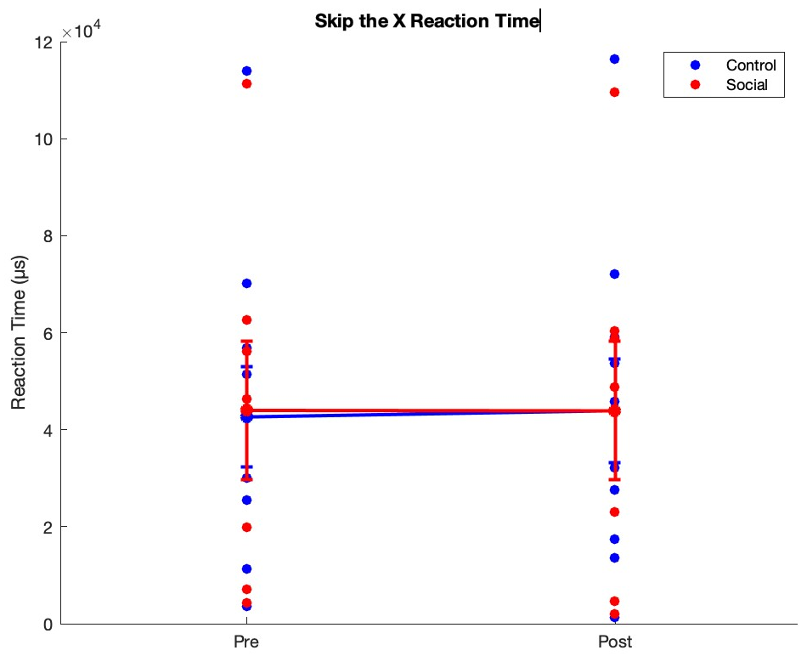
Figure S2. Group by session interaction effect in 3-back behavioral accuracy
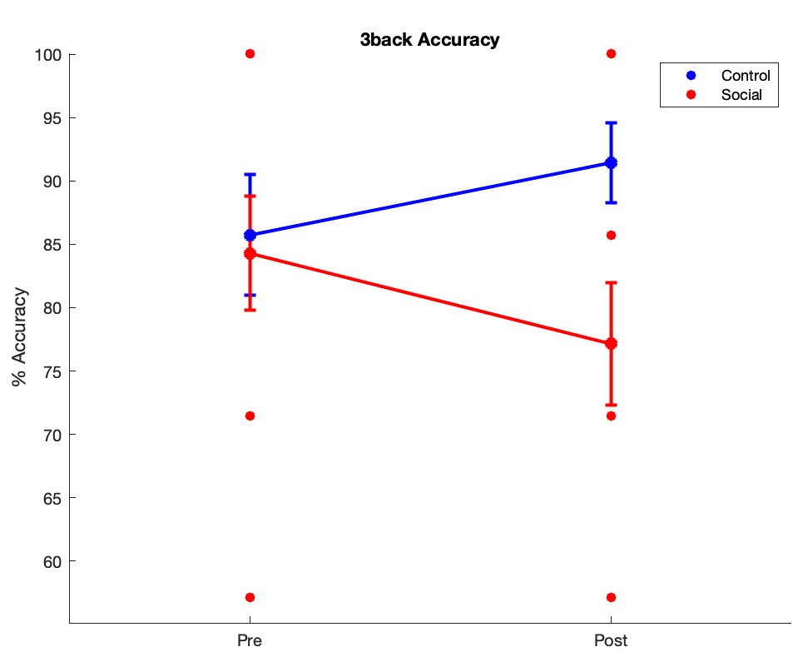
Figure S3. Group by session significant interaction effect in average DEQ Happiness item score

