Table:1: Depicting impairment of conscience functioning for each domain of conscience in the two groups sorted according to the earliest age at onset of ACEs (before six years of age and after six years of age)

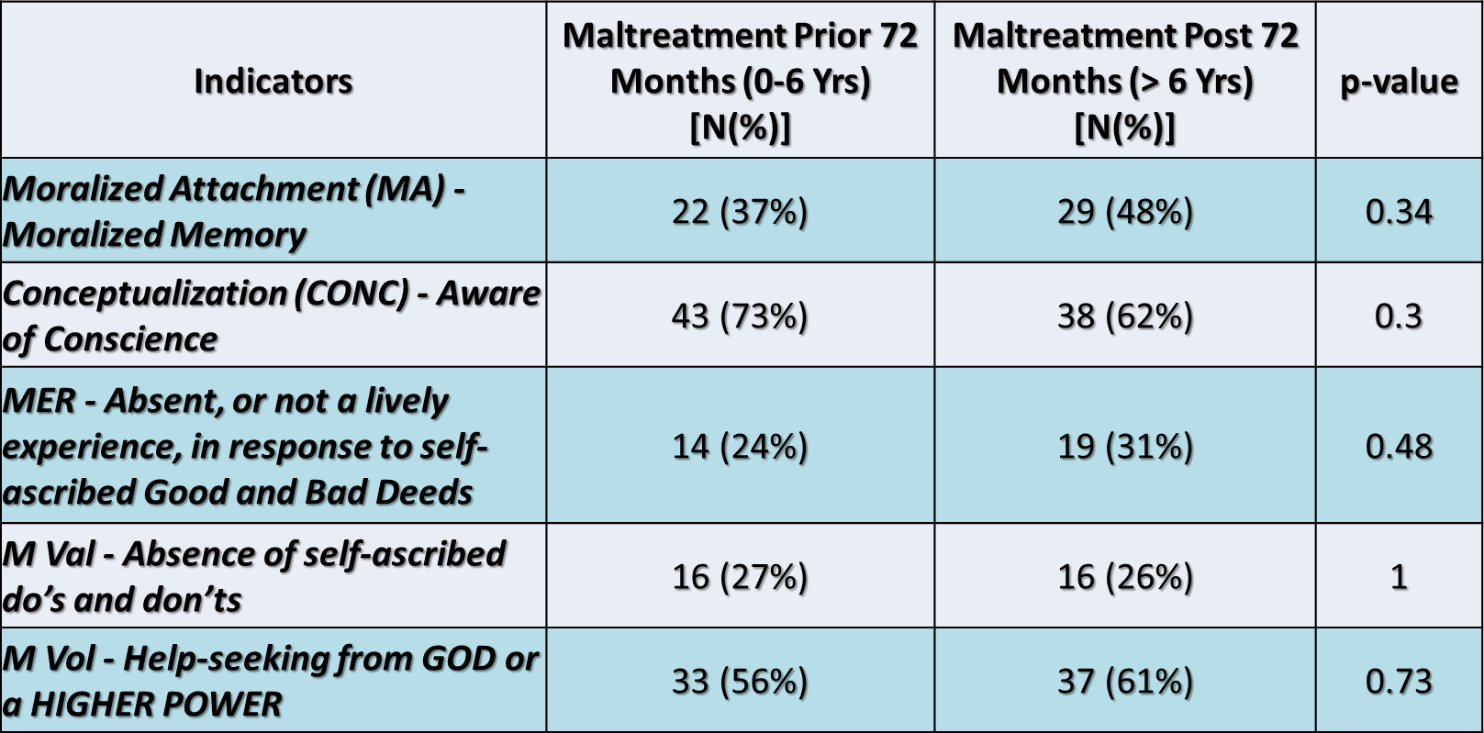

Notes:

- The total number of cases having ACEs before 72 months is 59.

- The total number of cases having ACEs after 72 months is 61.

Table 2: The covariates used in the model to assess the association between CDQ and PI severity.

Covariates | p-values
Severity of PI | 0.036
Count of kind of ACEs | 0.853
ACE Onset Age | 0.001

Legal History | 0.174
CGAF | 0.017
Types of disorders (internal, external, or both) | 0.024
Axis-2 Disorders | 0.070

