Additional File 5

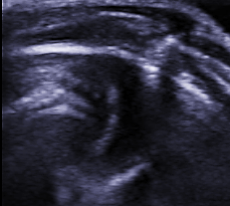
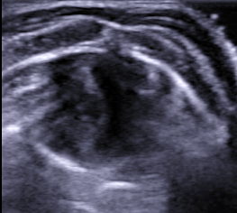
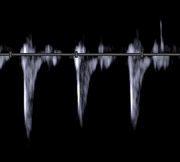
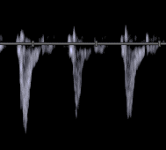
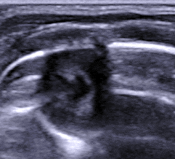
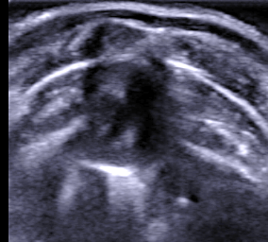
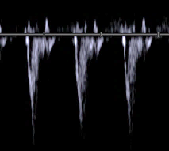
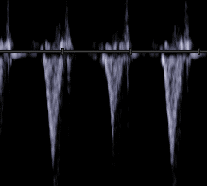
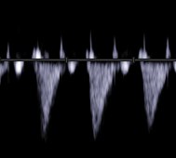
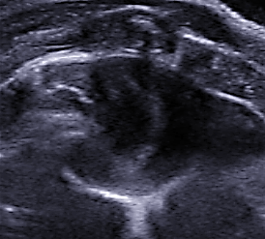
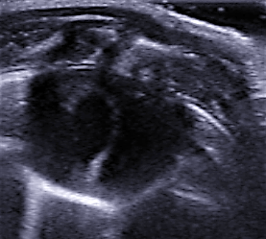
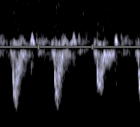
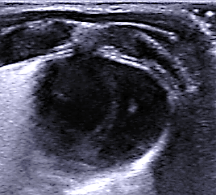
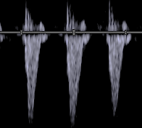
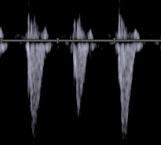
LV
RV
LV
RV
INITIAL FINAL
NORMO FAST
A
B
C
D
LV
RV
LV
RV
I
J
K
L
INITIAL FINAL
NORMO SLOW
LV
RV
LV
RV
E
F
HIGH FAST
G
H
LV
RV
LV
RV
HIGH SLOW
M
N
O
P
Fig. S2. A, B, E, F, I, J, M and N. Short-axis view of the left and right ventricles (LV, RV). C, D, G, H, K, L, O and P. Pulmonary Doppler. The NORMO-FAST and HIGH-FAST groups exhibit a significant increase of the RV at FINAL. Pulmonary Doppler shows a short acceleration time that is remained at FINAL. The NORMO-SLOW group shows slight increases in the LV and RV as well as in acceleration time at FINAL. Unlike the NORMO-SLOW group, the HIGH-SLOW group exhibited an increase in LV at FINAL, which was accompanied by an increase in pulmonary flow.

