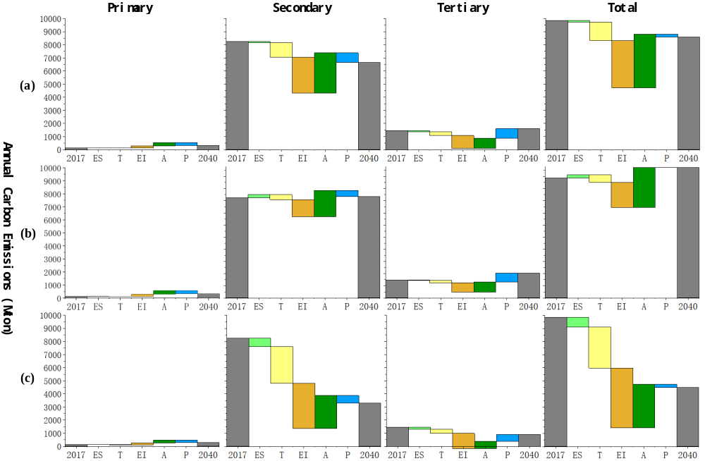
Fig. 5 Decomposition result of China’s CEs during 1997-2040 in different sector. (a) New Policies Scenario; (b) Current Policies Scenario; (c) Sustainable Development Scenario.

