Supplementary-1
Highlighting the Phenomenon of Relative Difficulty in Isolating Bacteriophage against Staphylococcus aureus compared to Escherichia coli
Akanksha Rai^{1,2}, and Krishna Khairnar^{1,2,}*
¹Environmental Virology Cell, Council of Scientific and Industrial Research-National Environmental Engineering Research Institute (CSIR NEERI), Nehru Marg, Nagpur, Maharashtra, India, ²Academy of Scientific and Innovative Research (AcSIR), CSIR-NEERI Campus, Nagpur
*Corresponding author: Krishna Khairnar (k_khairnar@neeri.res.in)
Corresponding author’s contact: Dr. Krishna Khairnar,
Senior Scientist & Head,
Environmental Virology Cell, CSIR-National Environmental Engineering Research Institute,
Nehru Marg, Nagpur-440020,
India
&
Faculty of AcSIR
Email 1: k_khairnar@neeri.res.in Email 2: kskhairnar@gmail.com
Mob: 07588887569 Telephone no.: 0712-2249885; Ext: 663 & 355 Fax: +91-712-2249900.

Isolation of a bacteriophage against an environmental multi-drug resistant (MDR) Staphylococcus aureus in comparison with bacteriophages of Escherichia coli. Environmental water samples were taken for isolation of S. aureus and its bacteriophages, across different locations at Nagpur, India. Four MDR S. aureus were obtained from wastewater samples. Screening of bacteriophage from the water samples against the four isolates was done, this was compared with the screening of bacteriophage of E. coli (as control). The initial screening yielded no bacteriophage against MDR S. aureus, but bacteriophages against E. coli were obtained from multiple water samples. Subsequently, a river-water sample was taken and through enrichment method with little modification, a bacteriophage against an MDR S. aureus was found.
Bacteriophages have been isolated from various sources like water, sediment, and soil. Bacteriophage isolation especially against S. aureus is a little daunting task because previously reported studies have highlighted difficulty in isolating phage against this host [1,2], especially from the sources rich in the phage of the enteric group [3,4]. Even if we get Staphylococcal phage, their plaque size is extremely small or turbid, making the process of isolation and purification of phage very difficult [4].
In this study, we isolated few MDR S. aureus from water samples, and screening of phage against the isolates was done. Upon difficulty in obtaining phage against our Staphylococcal isolates, we chose a river water. We got phage from the river sample

Isolation of S. aureus and its phage from water samples
Wastewater and lake water samples were taken from seven different locations across Nagpur city to isolate S. aureus and for the screening of phage. All the samples were serially diluted, 100 µL of two-fold diluted sample was taken and was spread plated on Mannitol Salt Agar (MSA) and also on Vogel Johnson Agar (VJA). Yellow color colonies on MSA plates and black-coloured colonies on VJA plates indicated putative S. aureus. Identification through Gram staining, biochemical tests through ‘HiStaph’ identification kit and Hi-PCR® Methicillin Resistant Staphylococcus aureus (MRSA) Semi-Q PCR Kit (Multiplex) (Himedia labs Pvt. Ltd., Mumbai, India). Resistance profiling or the Antibiotic Susceptibility Test of the confirmed S. aureus (that is isolates W1-W4) (AST) in comparison to S. aureus ATCC 25923 was done by Kirby Bauer disk diffusion method as per the guidelines of Clinical Laboratory Standard Institute (CLSI) with the following antibiotics having concentrations in μg/disk: Vancomycin (VA30), Cefepime (CPM30), Cefuroxime (CXM30), Cefprozil (CPR30), Gentamicin (GEN10), Tobramycin(TOB30), Erythromycin (E15), Clindamycin (CD2), Ciprofloxacin (CIP5), ceftriaxone/Tazobactam (CIT30/10), Tetracycline (TE30), Chloramphenicol (C30), Oxacillin (OX5), Ampicillin (AMP10) (Himedia Labs Pvt. Ltd., Mumbai, India). Details of sampling site, bacterial host identification, and AST are given in supplementary file 2.
There are several methods for phage isolation such as- Enrichment method [5], bituminous coal adsorption method [6] and membrane immobilization method [7]. Here ‘Enrichment method’ with slight modification by Jensen et al. (2015) was followed [8]. Enumeration of phage (plaque assay) was done by Double agar overlay method [9].
Simultaneously, E. coli was also isolated and the screening of the phage against it was done for method validation and for comparison.
16S rRNA sequencing was done for the isolate W1 against which a confirmed phage (PhiW1) was got. 16S rRNA gene was amplified by 27F and 1492R primers. A single discrete PCR amplicon band of 1500 b.p was observed. Forward and reverse DNA sequencing reaction of PCR amplicon was carried out with forward primer and reverse primers using BDT v3.1 Cycle sequencing kit on ABI 3730xl Genetic Analyzer (Eurofins genomics India Pvt. Ltd), the sequence was deposited in public database GenBank, submission ID- MN078268.All four isolates were found to be MDR. Especially isolates W1 and W4 were resistant to vancomycin and oxacillin. Results of the phage screening from the water samples are summarized in the tables 1 and table 2. Isolation of phage against E. coli ATCC 23848 was more abundant than S. aureus, figure 1 is a representative of plaques got against S. aureus (W1 isolate) and E. coli, one can clearly see the difference the density of phage against E. coli ATCC 23848 was too numerous to count (TNTC) whereas density of phage against S. aureus (W1 isolate) was 38pfu/ml.
Although the presence of S. aureus was scanty, all of them are highly MDR. Through AST, four MDR S. aureus isolates were obtained from wastewater. All four isolates were resistant to oxacillin and two isolates were resistant to vancomycin, which includes isolate W1.
The screening of phage against S. aureus isolates was done in comparison with E. coli. In the screening process, no lytic phage against S. aureus were found but a few lytic phages were obtained against E coli. Our findings corroborate with the earlier research that it is relatively difficult to find phage against S. aureus. We may also hypothesize that isolating phage against the already low concentrated host is a daunting task, as we know that the phage exists where its host exists [10]. In this case, although MDR S. aureus has been isolated from environmental wastewater but, it was in a very low concentration and difficult to grow.
The River Ganga holds a special position in the history of phage [11]. Our lab has isolated phage against Escherichia spp. from the ‘Gomukh’- the origin point of the River Ganga (the melting Himalayan Permafrost) hence it is considered the most important reservoir of phage [11]. Therefore, river Ganga water sample was selected for phage isolation. As seen in figure 1, there are several types of plaques present in both the plates; this may indicate that different phage may be present against the same host. This difference in finding phage can also be related to the organismal composition of man-made sewage systems and a natural river system. Man-made sewage systems are richer in enteric groups [12], whereas a natural river system is richer in species compositions.
It is important to mention that the phage we obtained (against our environmental S. aureus) from the river Ganga is a distinctive phage, that is, its features are not related to the well characterized S. aureus phage available in the literature (characterization of this phage has been discussed elsewhere). This difference may be attributed to the vast geographical difference in the isolation of the host and the phage and the fact that the river Ganga is an important phage reservoir. In most studies, phage has been isolated from the place where the host is isolated thus the phage has feature related to the host, for example, Staphylococcal phage have G+C content similar to the S. aureus. In this study, G+C content is higher unlike other Staphylococcal phage. Therefor we not only bring attention towards the difficulty in screening of phage against a certain host but also highlight an interesting aspect of phage biology which is about geographical separation of phage that may result in getting a unique phage. Or, maybe it’s a phage which shows cross-infectivity. It can be an interesting topic to delve deeper.
Acknowledgements
We are thankful to Environmental Virology Cell, CSIR-NEERI, Nagpur and Director CSIR-NEERI for providing the research facility and infrastructure. We are thankful for the funding from National Mission for Clean Ganga (NMCG, GAP-2103). Financial assistance to Akanksha Rai in form of fellowship from the University Grant Commission (UGC), India is gratefully acknowledged.
Declarations
Funding: The research was supported by the National Mission for Clean Ganga (NMCG, GAP-2103). Financial assistance as fellowship from the University Grant Commission (UGC), India.
Conflict of Interest: The authors have no conflict of interest.
Availability of Data and material: 16S rRNA sequencing data of the MDR S. aureus (W1 isolate) deposited at the GenBank, submission ID: MN078268.
Author’s contributions: Conceptualization: Krishna khairnar and Akanksha Rai; Methodology: Akanksha Rai; Investigation: Akanksha Rai; Writing- original draft preparation: Akanksha Rai; Writing- review and editing: Krishna Khairnar and Akanksha Rai; Supervision: Krishna Khairnar.
Ethical Approval: Not applicable

References

- Mattila, S., Pilvi, R., and Matti, J. (2015) On-demand isolation of bacteriophages against drug-resistant bacteria for personalized phage therapy. Front Microbiol 6: 1271. https://doi.org/10.3389/fmicb.2015.01271
- Latz, S., Wahida, A., Arif, A., Häfner, H., Hoß, M., Ritter, K.and Horz, H.P. (2016) Preliminary survey of local bacteriophages with lytic activity against multi‐drug resistant bacteria. J Basic Microbiol 56(10): 1117-1123. https://doi.org/10.1002/jobm.201600108
- Rakieten, M.L., Rakieten, T.L. and Doff, S. (1936) Absorption of Staphylococcus Bacteriophages. J bacterial 32 (5): 505. https://doi.org/10.1128/jb.32.5.505-518.1936
- Kaur, S., Harjai, K., and Chhibber, S. (2012) Methicillin-resistant Staphylococcus aureus phage plaque size enhancement using sublethal concentrations of antibiotics. Appl Environ Microbiol 78(23): 8227–8233. https://dx.doi.org/10.1128%2FAEM.02371-12
- Adams, M.H. (1959) Bacteriophages. Interscience Publishers Inc. New York, N.Y.
- Dahling, D.R., Phirke, P.M., Wright, B.A., Safferman, R.S. (1985) Use of bituminous coal as an alternative technique for field concentration of waterborne viruses. Appl Environ Microbiol 49: 1222-1225. https://doi.org/10.1128/aem.49.5.1222-1225.1985
- Ghugare, G.S., Nair, A., Nimkande, V., Sarode, P., Rangari, P. and Khairnar, K. (2y017) Membrane filtration immobilization technique—a simple and novel method for primary isolation and enrichment of bacteriophages. J Appl Microbiol 122: 531-539. https://doi.org/10.1111/jam.13344
- Jensen, K.C., Hair, B.B., Wienclaw, T.M., Murdock, M.H., Hatch, J.B., Trent, A.T., White, T.D., Haskell, K.J. and Berges, B.K. (2015) Isolation and host range of bacteriophage with lytic activity against methicillin-resistant Staphylococcus aureus and potential use as a fomite decontaminant. PloS one, 10(7). https://doi.org/10.1371/journal.pone.0131714
- Kropinski, A.M., Mazzocco, A., Waddell, T.E., Lingohr, E. and Johnson, R.P. (2009) Enumeration of bacteriophages by double agar overlay plaque assay. Bacteriophages Methods and Protocols, Isolation, Characterization, and Interactions, 1st ed., Clokie, M.R. and Kropinski, A.M Humana press: New York city, United States, Volume 1, 69-76. https://doi.org/10.1007/978-1-60327-164-6
- Howard-Varona, C., Hargreaves, K. R., Abedon, S. T., and Sullivan, M. B. (2017) Lysogeny in nature: mechanisms, impact and ecology of temperate phages. The ISME J 11(7), 1511-1520. https://doi.org/10.1038/ismej.2017.16
- Khairnar, K., 2016. Ganges: special at its origin. J Biol Res-Thessalon 23(1):1-2. https://dx.doi.org/10.1186%2Fs40709-016-0055-6
- Jofre, J., Lucena, F., Blanch, A.R. and Muniesa, M. (2016) Coliphages as model organisms in the characterization and management of water resources. Water 8(5): 99. https://doi.org/10.3390/w8050199

Tables and Figures
Table 1: Bacteriophage isolation from all the water samples against confirmed S. aureus isolates.
Host→  Water sample↓ | W1 | W2 | W3 | W4
1 | Nil | Nil | Nil | Nil
2 | Nil | Nil | Nil | Nil
3 | Nil | Nil | Nil | Nil
4 | Nil | Nil | Nil | Nil
5 | Nil | Nil | Nil | Nil
6 | Nil | Nil | Nil | Nil
7 | Nil | Nil | Nil | Nil
River Ganga | Phage (38PFU/ml) | Nil | Nil | Nil

Table 2: Screening of bacteriophages from water samples against E. coli isolated from water samples. E. coli ATCC 23848 was used in comparing bacteriophage isolation from River Ganga.
Host→  Water sample↓ | 1 | 2 | 3 | 4 | 5 | 6 | 7 | 8 | 9 | 10 | 11
1 | + | - | + | - | + | + | - | - | - | + | -
4 | - | - | + | - | - | - | - | - | - | - | -
5 | - | - | - | - | + | - | - | - | + | - | -
6 | - | - | - | - | - | - | - | - | - | - | -
7 | - | + | - | - | + | - | + | + | - | + | +

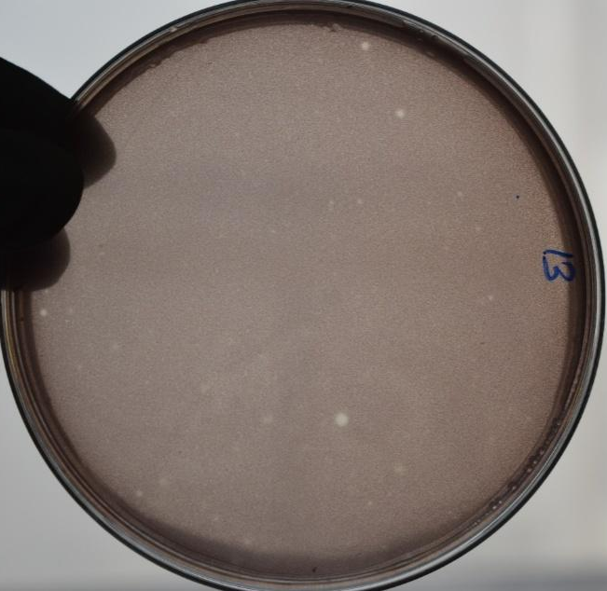
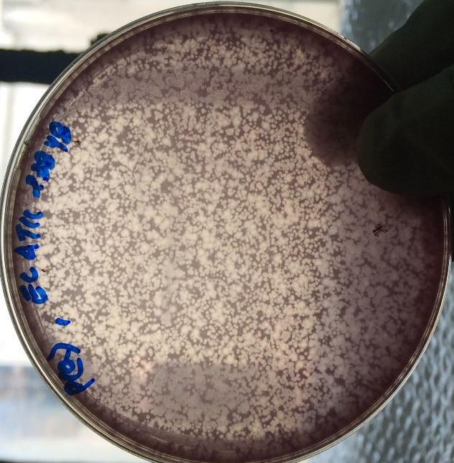
Figure 1. Presence of clear spots (plaque) over the lawn of bacteria confirms phage. The image on the left is a representative plate of phage got from the river Ganga against the MDR S. aureus (arrow showed at the zone of clearing is a plaque). The image on right is a representative plate of phage got from the river Ganga against E coli ATCC 23848.

