Supplementary Information

Supplementary Figures.
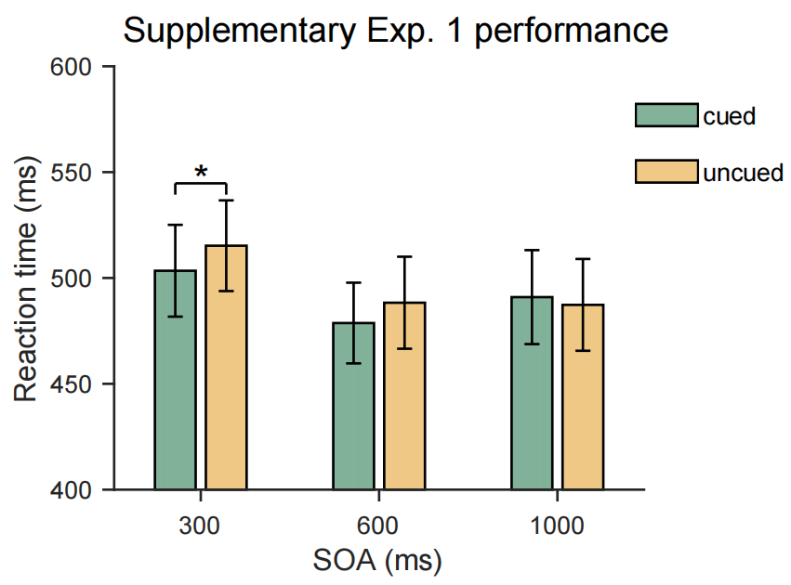
Figure S1. Early Facilitation Induced by Invisible Cues in Supplementary Experiment 1. The bar graph illustrates the effect of invisible cues on reaction times in a pilot experiment involving 15 participants (11 female, mean age 21.9 ± 8.1). Participants completed a Posner-cueing task similar to Experiment 1, with identical equipment and similar stimulus parameters, but with only three SOA conditions (0.3/0.6/1 s). As in Experiment 1, participants reported not perceiving the invisible cues. We observed a facilitation effect at the condition of 300 ms (503 ms vs. 515 ms; BF₁₀ = 4.11; t(14) = 2.79, p_{Bonf} = .045*, Cohen’s d = 0.72), with no evidence of ROI at 600 ms or 1000 ms (ps_{Bonf} > .100).
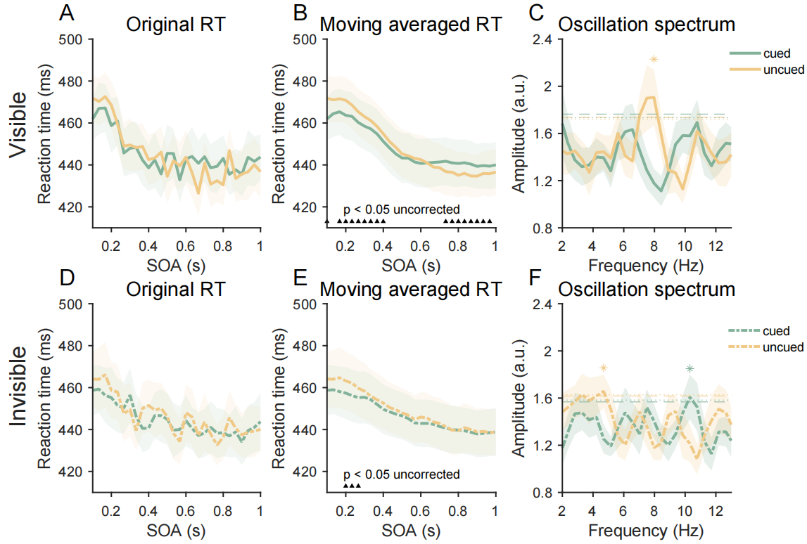
Figure S2. Temporal Dynamics of RTs in Experiment 1. Panels A–C represent the visible condition results. (A) shows raw response time (RT) data, with the yellow line representing the cued condition and the green line representing the uncued condition; the shaded area denotes the standard error. (B) illustrates attention trends, with black triangles marking significant differences between the cued and uncued conditions, though not corrected for multiple comparisons. Early in the SOA time window, facilitation was observed, while inhibition of return (IOR) occurred in the later SOA time window. (C) presents the spectral analysis results, where both conditions exhibited power peaks in the 6–8 Hz range, with the uncued condition showing particularly significant results.
Panels D–F depict the invisible condition results. (E) shows no significant IOR in the late time window, contrasting with the visible condition. In (F), both the cued and uncued conditions peaked in the 3–4 Hz range for the invisible cues, with the uncued condition surpassing the significance threshold. Interestingly, the spectrum of cue condition also peaked at around 10 Hz, similar to both the visible and invisible cues. These findings are consistent with previous research, suggesting that the theta-band behavioral oscillations observed in the uncued conditions may indicate the rhythm of attentional reorienting. In contrast, the alpha oscillations found in the cued condition may reflect perceptual fluctuations, as supported by some EEG studies.

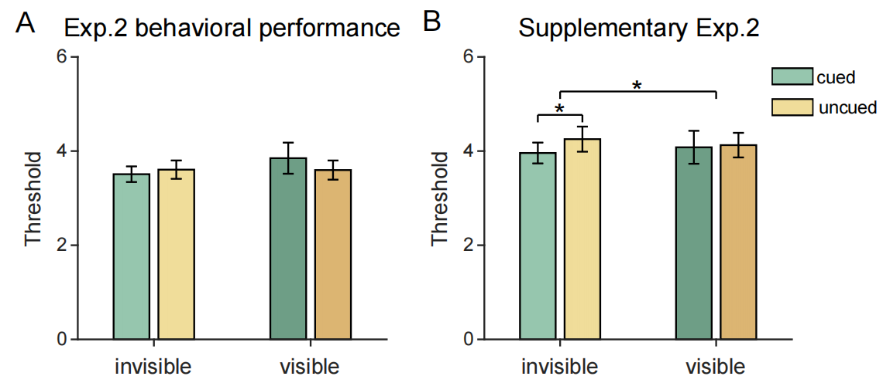
Figure S3. Behavioral Performance in Experiment 2 and Supplementary Experiment 2. The Bar graphs (A) and (B) depict the behavioral performance in Experiment 2 and Supplementary Experiment 2, respectively. The green and yellow bars represent contrast luminance thresholds at which participants discriminated targets with approximately 80% accuracy in the cued and uncued discs, respectively. The error bars denote the standard errors.
In the EEG experiments, a repeated-measures ANOVA was performed with cue awareness (visible vs. invisible) and cue congruency (cued vs. uncued) as independent variables. The analysis revealed no significant main effects or interactions (ps > .100). Notably, in the invisible condition, the threshold was slightly lower in the cued condition compared to the uncued condition (3.51 vs. 3.61), whereas this trend reversed in the visible condition (3.85 vs. 3.60). Given the limited number of trials involving target presence in the EEG experiments, factors such as individual judgment criteria may have influenced the observed attentional effects.
To further validate the trend observed in the EEG experiment, we conducted Supplementary Behavioral Experiment 2, recruiting 39 participants (one excluded for failing to fit the threshold, leaving 20 female and 18 male, mean age = 23.6 ± 3.13 years). The equipment and stimuli were identical to the main experiment, except that the target was present in every trial, with 56 trials conducted per condition. The results revealed a significant interaction between cue awareness and cue congruency [F(1,37) = 5.00, p = .031*, η²_{p} = .12]. In the invisible cue condition, the threshold was lower in the cued condition than in the uncued condition (4.02 vs. 4.32; BF₁₀ = 1.37; t(37) = 2.15, p_{Bonf} = .076, Cohen’s d = 0.35), indicating a facilitation effect due to cue-induced attentional shifts. Conversely, no significant threshold changes were observed in the visible condition (4.20 vs. 4.04; p_{Bonf} > .100), suggesting that participants might have suppressed the influence of the cues. These findings are consistent with Experiment 1, indicating that invisible cues induce attentional facilitation, while visible cues may also engage inhibitory processes.
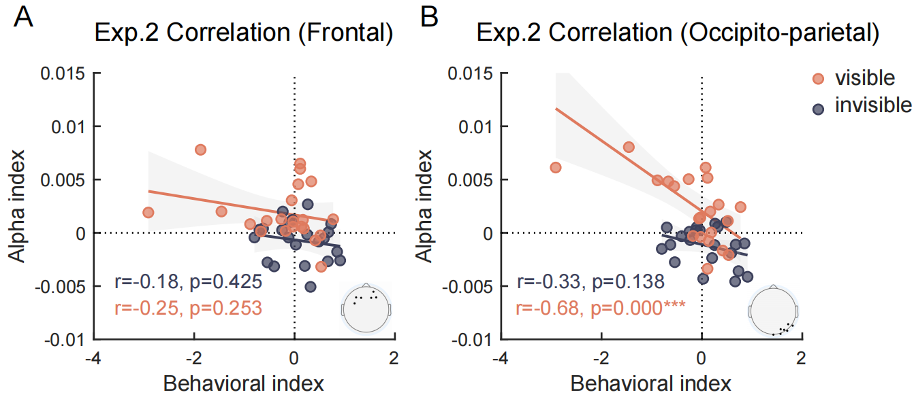
Figure S4. Correlation between Behavioral Performance Across Different Levels of Awareness and Attentional Alpha Power Modulation. Scatter plots illustrate the correlation between behavioral performance (uncued-cued) and alpha power modulation (cued-uncued) in the frontal (A) and occipito-parietal regions (B). Orange dots represent the visible condition, while gray dots denote the invisible condition. The shaded gray area represents the 95% confidence interval. Correlation analysis showed that alpha power modulation in the frontal region was not significantly correlated with behavioral performance. However, in the right-lateralized occipito-parietal region, alpha power changes were negatively correlated with behavioral performance, particularly in the visible condition (p < 0.000***). Specifically, the greater the alpha power in the cued condition compared to the uncued condition, the weaker the cues’ facilitation of the perceptual threshold. These findings suggest that the right occipito-parietal attention system plays a crucial role in bottom-up attentional orienting. Furthermore, the enhancement of alpha power likely serves as an index of attentional inhibition, consistent with previous studies.

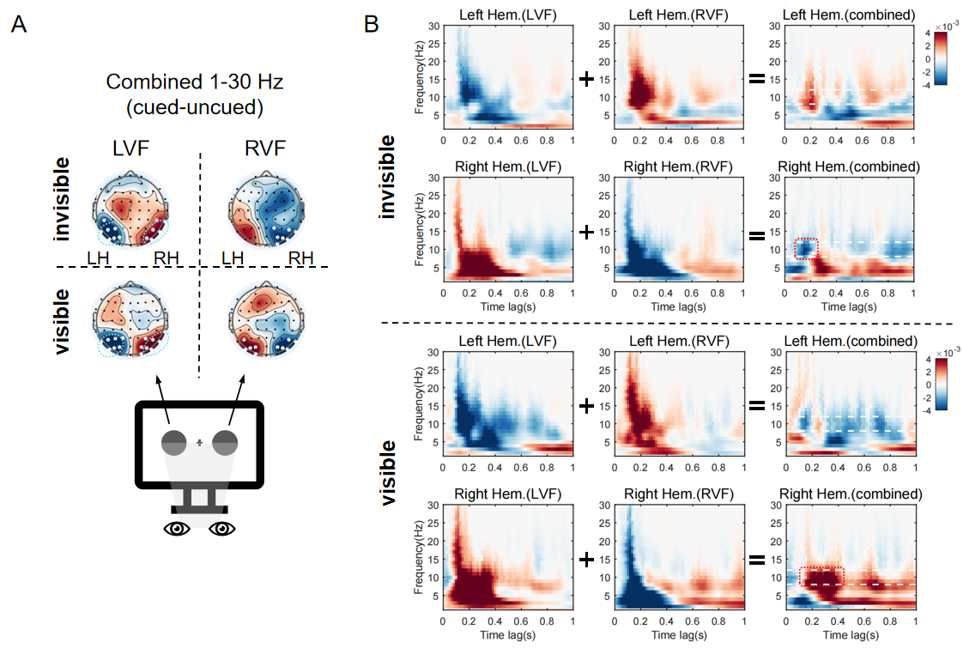
Figure S5. Analysis of TRF in Response to Stimuli Presented at Different Visual Fields. (A) illustrate the topographic maps of statistical values comparing cued and uncued conditions within the time window of interest (117-380 ms) across different visual fields (left visual field, LVF, vs. right visual field, RVF) and levels of cue awareness. White dots indicate electrodes showing significant differences. The results showed that cues, whether visible or not, enhanced TRF in brain regions contralateral to the visual field of the stimuli while suppressing TRF in ipsilateral regions. This led to power changes across all frequency bands (1-30 Hz).
Two possible mechanisms could explain these results. First, the visual pathway corresponding to the stimulated visual field may be enhanced when both the cue and disc are encoded in the perceptual network, even without attention orienting. Alternatively, the cue might draw attention to the cued side, heightening the perceptual representation. To disentangle these possibilities, we combined the effects of stimuli from both visual fields. If the observed effects were solely due to the lateralized perceptual encoding of both the cue and discs, cueing effects from opposite visual fields would cancel each other out, as they would involve solely opposing perceptual encoding. Instead, if attention is responsible, we would expect to see consistent modulation of neural coding, regardless of the visual field.
(B) presents the time-frequency spectrum of cueing effects (cued vs. uncued) before and after combining the visual field data for the two clusters located in the right and left hemispheres (circled by green dashed lines in A). Before combining the visual field data, power lateralization was evident across most frequency bands. However, after merging the data from both visual fields, the effects in most frequency bands largely canceled out, except in the alpha and theta bands of the right hemisphere. This preserved pattern closely mirrors the findings highlighted in the manuscript (circled by the red dashed line). These results suggest that the effects reported in our study reflect a unified, attention-driven modulation pattern across both visual fields.
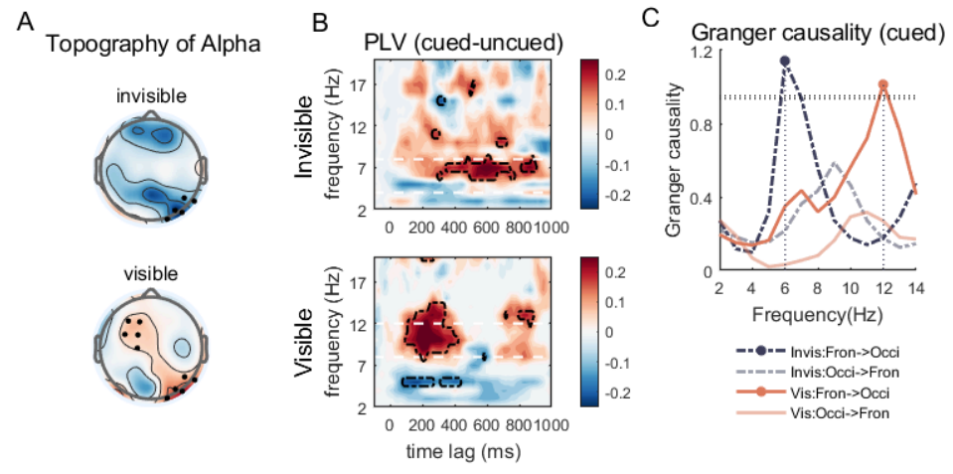
Figure S6. Results of Experiment 2 After Excluding Subjects Who Did Not Complete the Objective Awareness Check. (A) Topography of the alpha power difference (cued vs. uncued) within the time window of interest (117–383 ms) for both the invisible and visible conditions, with black dots marking electrodes showing significant effects. (B) Connectivity analysis between the frontal and occipito-parietal regions, showing that phase coherence (PLV) between these regions was stronger in the cued condition compared to the uncued condition. (C) Granger causality analysis of signals between the two brain regions in the cued condition. These results align with the findings in the main manuscript, indicating that the exclusion of the two subjects did not significantly affect the key outcomes of the study.

Supplementary Tables.
Table S1. Accuracy rates and statistical values for the awareness check tasks across the two experiments.
 |  |  |  |  |  | 95% CI
Awareness Check | Mean ACC | BF₁₀ | t | df | p | Lower | Upper | Cohen's d
Exp.1 | 49.80% | 0.31 | -0.105 | 19 | 0.918 | -0.0459 | 0.0415 | -0.0234
Exp.2 1st | 51.20% | 0.348 | 0.54 | 19 | 0.596 | -0.0351 | 0.0595 | 0.121
Exp.2 2nd | 50.70% | 0.362 | 0.491 | 16 | 0.63 | -0.0244 | 0.0391 | 0.119
*In Experiment 1, all participants completed the forced-choice awareness check, with accuracy rates that did not significantly differ from chance level (50%). In Experiment 2, 20 of the 22 participants completed the first awareness check prior to the main experiment, and 17 completed the second check after the main experiment. The accuracy rates from both tests were also not significantly different from chance.
Two participants who did not complete the objective awareness check subjectively reported being unable to perceive the invisible cues. Notably, excluding these participants from the analysis did not result in significant alterations to the behavioral and EEG outcomes reported in the main article (see Fig. S6).

