Supplementary Information
Concurrently Enhanced Piezoelectric Performance and Curie Temperature in Stressed Lead-free BCTZ Ceramics
Yuanhui Su¹, Qingying Wang¹, Yu Huan^{1*}, Jianli Wang², Wei Sun³, Yongjun Li⁴, Tao Wei^{1*}, Zhenxiang Cheng^{2*}
¹School of Material Science and Engineering, University of Jinan, Jinan 250022, China
²Institute for Superconducting and Electronic Materials, Faculty of Engineering and Information Sciences, University of Wollongong, Innovation Campus, North Wollongong, NSW 2500, Australia
³Shandong Provincial Key Laboratory of Preparation and Measurement of Building Materials, University of Jinan, Jinan 250022, China
⁴Bruker (Beijing) Scientific Technology Co., Ltd, Beijing 100192, China
*Corresponding Authors. E-mail: mse_huany@ujn.edu.cn (Y. Huan), mse_weit@ujn.edu.cn (T. Wei), cheng@uow.edu.au (Z. Cheng).

1. Supplementary Notes
Note 1: The P‒E analysis of BCTZ−xAlN ceramics.
Supplementary Fig. 7 illustrates the P‒E hysteresis loops of the BCTZ‒xAlN‒300 ceramics, where all ceramics exhibit well-saturated ferroelectric loops. The corresponding P_{max} and P_{r}, values are summarized in the Supplementary Fig. 8. The P_{max} and P_{r} dramatically increase with increasing x contents, reaching their respective peak values of 18.9 μC cm⁻² and 9.54 μC cm⁻² at x = 1.75, and then decrease sharply.

Note 2: The TG-DSC analysis of BCTZ and BCTZ−1.75AlN−300 powder.
As shown in the Supplementary Fig. 16a, the TG profile of BCTZ powder exhibits three distinct regions of weight loss. The initial weight loss of 0.16% beyond 300 ºC is primarily due to the evaporation of residual moisture. The weight loss observed between 300 and 1000 ºC is predominantly associated with the decomposition of carbonates. When temperature exceeds 1000 ºC, a decrease in weight accompanied by an endothermic peak is observed, which is attributed to ceramics densification and oxygen release.
Similarly, the BCTZ−1.75AlN−300 powder (Supplementary Fig. 16b) exhibits comparable weight loss characteristics. However, unlike BCTZ, a sharp weight increases and an exothermic peak occurs within in the temperature range of 1000–1150 ºC, corresponding to the reaction between AlN and oxygen as well as Ba²⁺, leading to the formation of BaAl₂O₄. The subsequent decrease in weight corresponds to the ceramics densification and oxygen release.

Note 3: The EDS element mapping analysis of BCTZ−xAlN ceramics.
The element distribution in BCTZ−xAlN ceramics is investigated using EDS element mapping analysis (Supplementary Figs. 23–25). In all ceramics, Ba, Zr, Ti, and O exhibit uniform distribution. Regarding the Al element, in BCTZ−xAlN−50 ceramics, it is dispersed within the matrix grains and distributed along the grain boundaries. However, in BCTZ−xAlN−300 and BCTZ−xAlN−3000 ceramics, the Al element is also concentrated within strip-like BaAl₂O₄ particles. Additionally, a minor dissolution of CaO particles is observed in BCTZ−xAlN−300 and BCTZ−xAlN−3000 ceramics. This can be attributed to the generation of BaAl₂O₄ in the ceramics, resulting in the production of CaO to maintain chemical balance.

Note 4: The domain configuration of ceramics.
The evolution of domain configuration was further examined using bright-field transmission electron microscopy (TEM), as illustrated in Supplementary Fig. 26. A large number of typical stripe and herringbone domains are found in all the BCTZ and BCTZ−1.75AlN−300 ceramics, respectively. Post-AlN doping, a modest decrease in domain structure size of BCTZ−1.75AlN−300 ceramic (180 nm) is observed in comparison to undoped BCTZ ceramic (210 nm).

Note 5: The average grain size of BaAl₂O₄ in the BCTZ–xAlN ceramics.
The average grain size distribution of BaAl₂O₄ in the BCTZ−xAlN−300 and BCTZ−xAlN−3000 ceramics was measured, with the results shown in Supplementary Fig. 27. In BCTZ−xAlN−50 ceramics, the BaAl₂O₄ secondary phase particles are nano-sized and plate-like, aggregating at the grain boundaries. This characteristic can also be clearly seen in EDS mapping of BCTZ−1.75AlN−50 ceramics (Supplementary Fig. 23). Due to the extremely small thickness of the BaAl₂O₄ particles in the BCTZ−xAlN−50 ceramics，their average grain size distribution is not included in the Supplementary Fig. 27.
For BCTZ−xAlN−300 and BCTZ−xAlN−3000 ceramics, the BaAl₂O₄ grains exhibit a micro-sized, strip-like shape (Supplementary Figs.23–25). As the doping concentration increases, the size of these BaAl₂O₄ grains also increases. Additionally, the grain size of BaAl₂O₄ in BCTZ−xAlN−3000 ceramics is larger than that in BCTZ−xAlN−300 ceramics at the same doping level.

Note 6: The thermal expansion coefficient of BCTZ and BaAl₂O₄ ceramics.
To determine the thermal expansion coefficient of the secondary phase BaAl₂O₄ of BCTZ−1.75AlN−300 ceramic, pure BaAl₂O₄ ceramics were prepared using conventional solid-state reaction method. Raw material powders (BaCO₃ and Al₂O₃) were mixed and ball-milled for 12 hours, dried at 75 ºC, and calcined at 1300 ºC for 5 hours. The obtained BaAl₂O₄ powders were ball-milled again for 12 hours, dried at 75 ºC, pressed into blocks (5×5×25 mm³), and then sintered at 1700 ºC for 6 hours. As shown in Supplementary Fig. 29a, all diffraction peaks of BaAl₂O₄ powders matched JCPDS No.17-0306, confirming the successful preparation of BaAl₂O₄ ceramic.
The temperature dependence of the thermal expansion coefficient of BCTZ and BaAl₂O₄ ceramics is shown in Supplementary Fig. 29b. The BCTZ ceramic has an average linear coefficient of thermal expansion of about 11.3 × 10⁻⁶ K⁻¹ in the testing temperature range of 30 – 1100 ºC, which is significantly higher than that of BaAl₂O₄ ceramic (5.8 × 10⁻⁶ K⁻¹).

Note 7: The KPFM analysis of BCTZ ceramic.
Topographies and surface potential mapping of untreated BCTZ ceramic were captured using KPFM, as depicted in the Supplementary Fig. 34a–b. Supplementary Fig. 34a depicts a color map of the surface topographies in micrometers, with different colors indicating varying topographic features. The BCTZ ceramic exhibits irregularly shaped grains. Supplementary Fig. 34b presents the corresponding surface potential map, revealing a relatively uniform potential distribution with no significant increases in potential across the grains.

Note 8: The coercive electric field of BCTZ−xAlN ceramics.
Supplementary Fig. 35a compares the P−E loops curves of BCTZ, BCTZ−1.75AlN−50, BCTZ−1.75AlN−300, and BCTZ−1.75AlN−3000 ceramics measured at 30 kV cm⁻¹. The differences (ΔE_{C}) between the negative E_{C} (E_{C−}) and positive E_{C} (E_{C+}) for BCTZ−xAlN are summarized in Supplementary Fig. 35b. As shown, ΔE_{C} of AlN-doped ceramics is significantly higher than in the undoped ceramics. Among the doping concentrations x from 1.00 to 1.75, the BCTZ−xAlN−3000 ceramics exhibit the highest ΔE_{C}, followed by BCTZ−xAlN−300 ceramics, and then BCTZ−xAlN−50 ceramics. This indicates that the secondary phase significantly affects the E_{C} of the ceramics.
It is worth noting that adding AlN to BCTZ ceramics results in two effects: the formation of BaAl₂O₄ secondary phases of varying sizes and the incorporation of different amounts Al³⁺ into the lattice. The BaAl₂O₄ secondary phase introduces an internal electric field at the interface between BaAl₂O₄ and BCZT. At the same doping level, as the AlN particle size increases, the resulting larger BaAl₂O₄ secondary phase enhances the local electric field, while the amount of Al³⁺ incorporated into the lattice decreases. The observed variation in ΔE_{C} arises from the combined influence of this internal electric field and Al³⁺ doping. As shown in Supplementary Fig. 34, the increase in ΔE_{C} with larger AlN particle sizes is attributed to the stronger internal electric field created by the larger secondary phase. For BCTZ−xAlN−50 ceramics, with nanoscale secondary phases, the substantial incorporation of Al³⁺ into the lattice leads to an increase in ΔE_{C} as the doping concentration increases.
Note 9: The impedance spectra analysis of BCTZ−xAlN−300 ceramics.
All the impedance spectra exhibit two distinct semicircles, which can be attributed to the differences in thermally activated electrical properties between grains (semicircle at high frequencies) and grain boundaries (semicircle at lower frequencies).^{[1]} The impedance spectra were analyzed by fitting them to an equivalent circuit model (Supplementary Fig. 37). This model includes a resistance for grains (R_{g}) in parallel with a constant phase element for grains (CPE_{g}), as well as a resistance for grain boundaries (R_{gb}) in parallel with a constant phase element for grain boundaries (CPE_{gb}). The activation energy (E_{a}) of grains and grain boundaries is determined by the Arrhenius equation:
$\text{σ} \text{=}{ \text{σ}}_{\text{0}}\text{exp}\frac{{-\text{E}}_{\text{a}}}{\text{kT}}$ (S1)
where σ, σ₀, k, and T represent conductivity, high-temperature limit of the conductivity, Boltzmann constant, and absolute temperature, respectively.

2. Supplementary Figures
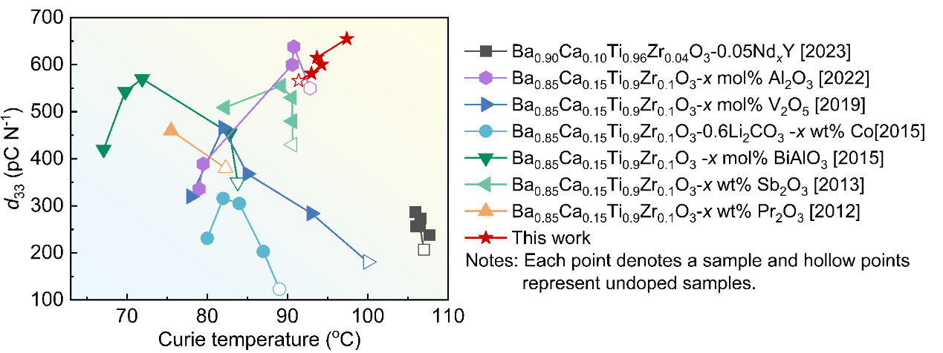
Supplementary Fig. 1 Comparison of d₃₃ and T_{c} in BCTZ-based piezoceramics. (Notes: Each point denotes a sample and hollow points represent undoped samples.)^{[2-8]}

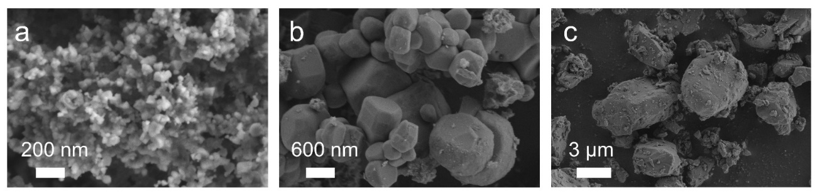
Supplementary Fig. 2. The SEM images of AlN material used in this work with average size of (a) 50 nm, (b) 300 nm, and (c) 3000 nm.

Supplementary Fig. 3. The ε_{r}−T and tanδ−T curve of BCTZ−xAlN−50 ceramics.

Supplementary Fig. 4. The ε_{r}−T and tanδ−T curve of BCTZ−xAlN−300 ceramics.

Supplementary Fig. 5. The ε_{r}−T and tanδ−T curve of BCTZ−xAlN−3000 ceramics.

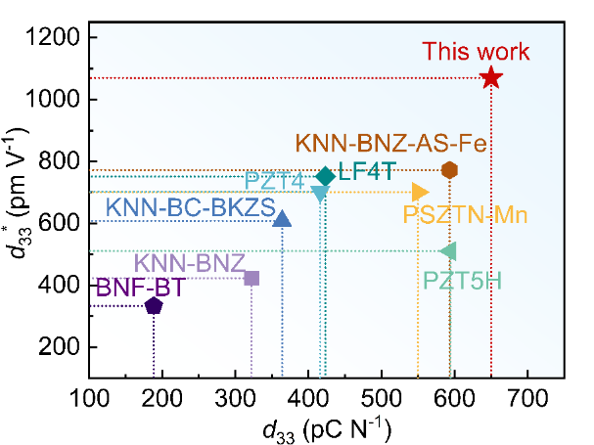
Supplementary Fig. 6. Summary of d₃₃*vs. d₃₃ for other piezoceramics.^{[3, 9]}

Supplementary Fig. 7. The P−E loops curves of BCTZ−xAlN−300 ceramics measured at a frequency of 1 Hz.

Supplementary Fig. 8. The P_{max} and P_{r} of BCTZ−xAlN−300 ceramics measured at 30 kV cm⁻¹.

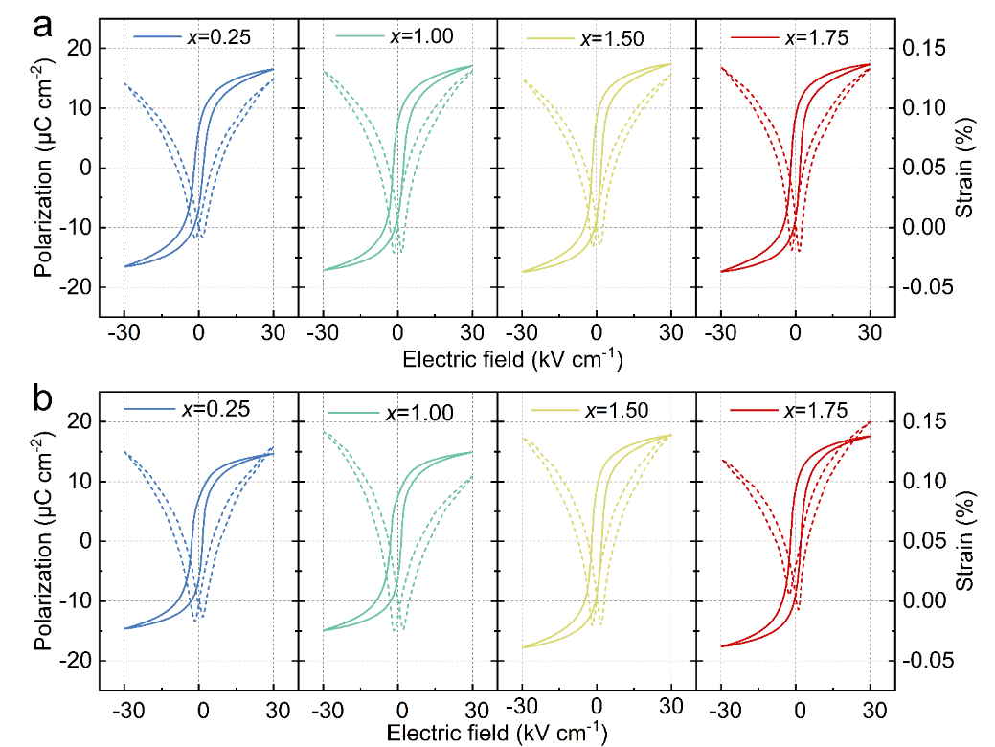
Supplementary Fig. 9. The P−E loops curves of (a) BCTZ−xAlN−50 and
(b) BCTZ−xAlN−3000 ceramics measured at a frequency of 1 Hz.

.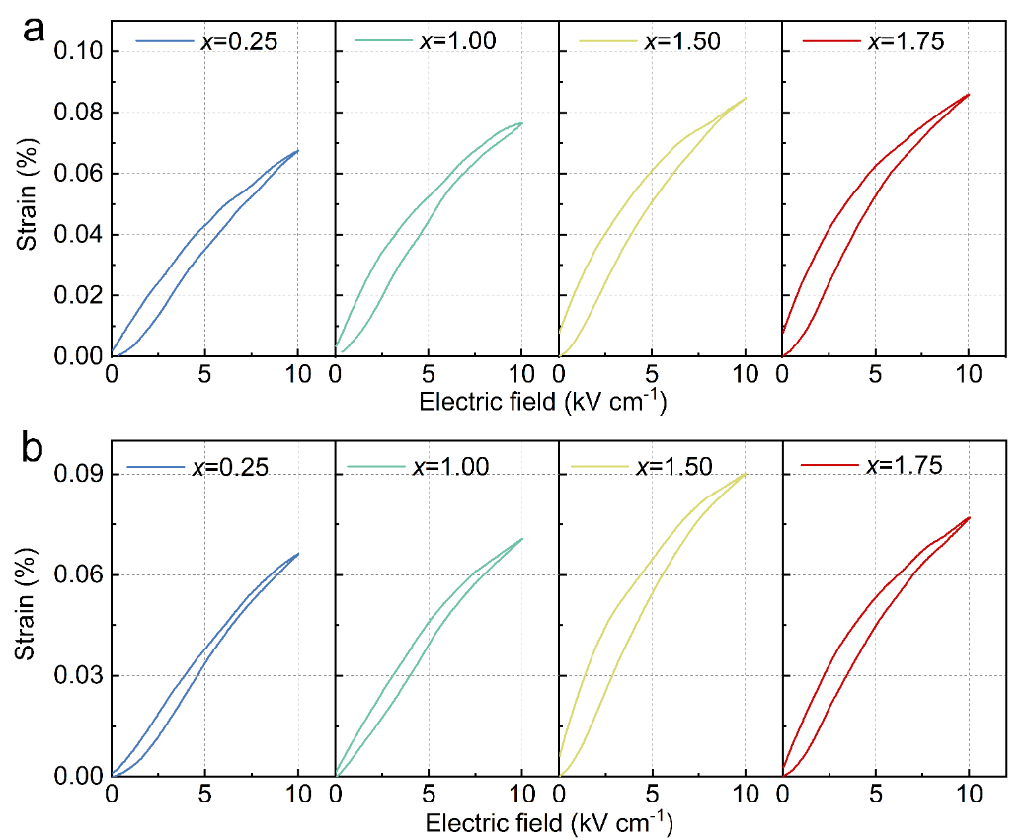
Supplementary Fig. 10. The S−E loops curves of (a) BCTZ−xAlN−50 and
(b)BCTZ−xAlN−3000 ceramics measured at a frequency of 1 Hz.

Supplementary Fig. 11. Temperature-dependent unipolar strain curves of multiple BCTZ–1.75AlN–300 ceramics measured at 20 ºC and 60 ºC.

Supplementary Fig. 12. The in-situ d₃₃ of ceramic as a function of temperature for BCTZ–1.50AlN–50, BCTZ–1.75AlN–50, BCTZ–1.50AlN–300, BCTZ–1.50AlN–3000, and BCTZ–1.75AlN–3000 ceramics.

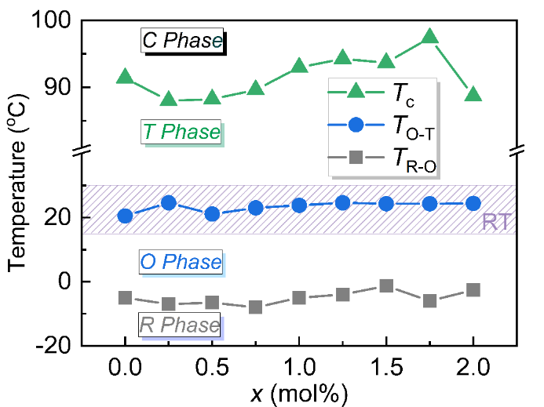
Supplementary Fig. 13. The phase transition temperatures of BCTZ−xAlN−300 ceramics.

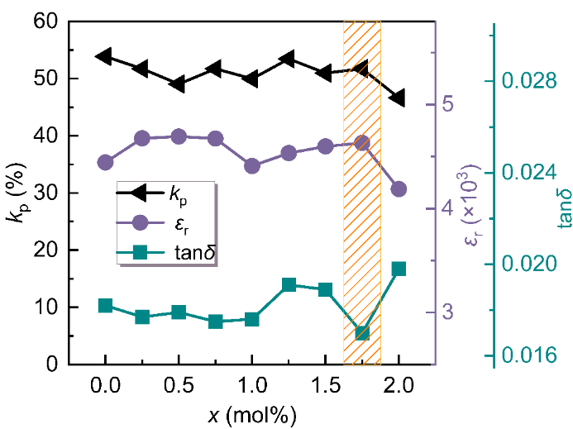
Supplementary Fig. 14. The electromechanical coupling coefficient (k_{p}), dielectric constant (ε_{r}), and dielectric loss (tanδ) of BCTZ−xAlN−300ceramics.

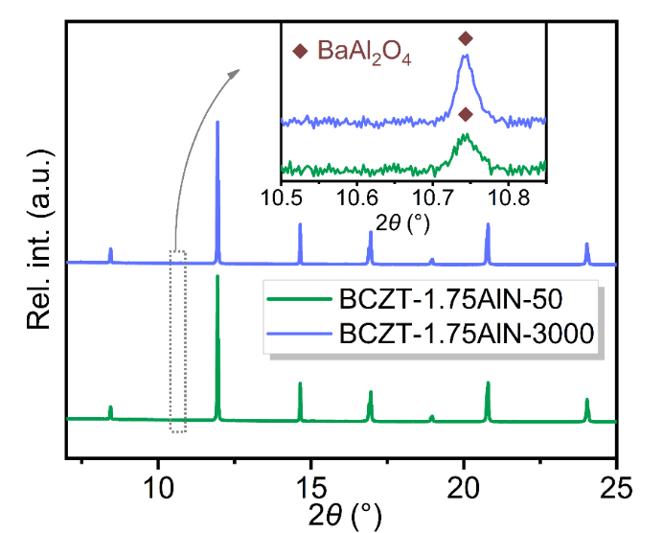
Supplementary Fig. 15. The high-resolution SXRD patterns of BCTZ−1.75AlN−50 and BCTZ−1.75AlN−3000 ceramics at room temperature. Inset is the enlarged region between 10.5º and 10.82º.

Supplementary Fig. 16. The TG–DSC curves of (a) BCTZ and (b) BCTZ −1.75AlN−300 powders.

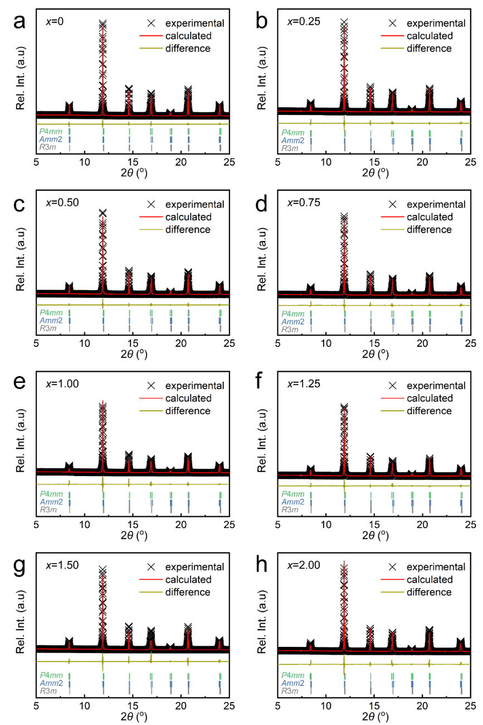
Supplementary Fig. 17 Rietveld SXRD refinement results of BCTZ−xAlN−300 ceramics: (a) x = 0, (b) x = 0.25, (c) x = 0.50, (d) x = 0.75, (e) x = 1.00, (f) x = 1.25, (g) x = 1.50, and (h) x = 2.00.

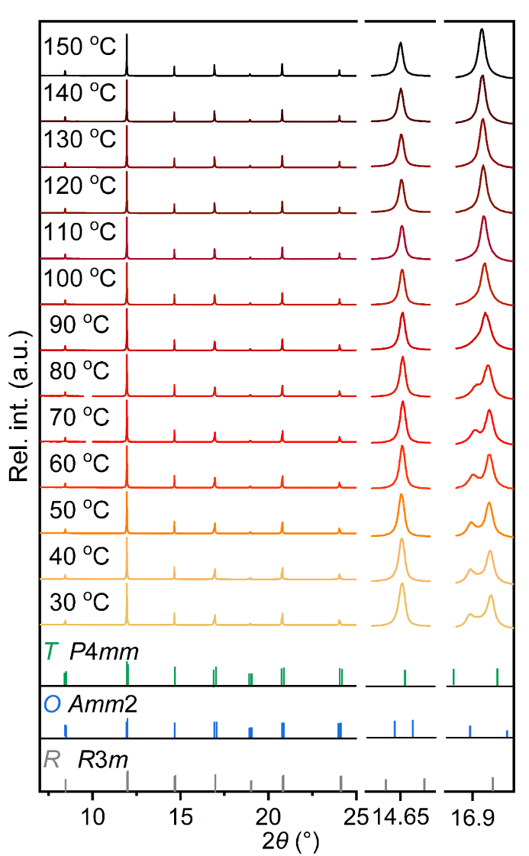
Supplementary Fig. 18. The in-situ variable-temperature high-resolution SXRD of BCTZ−1.75AlN−300 ceramics.

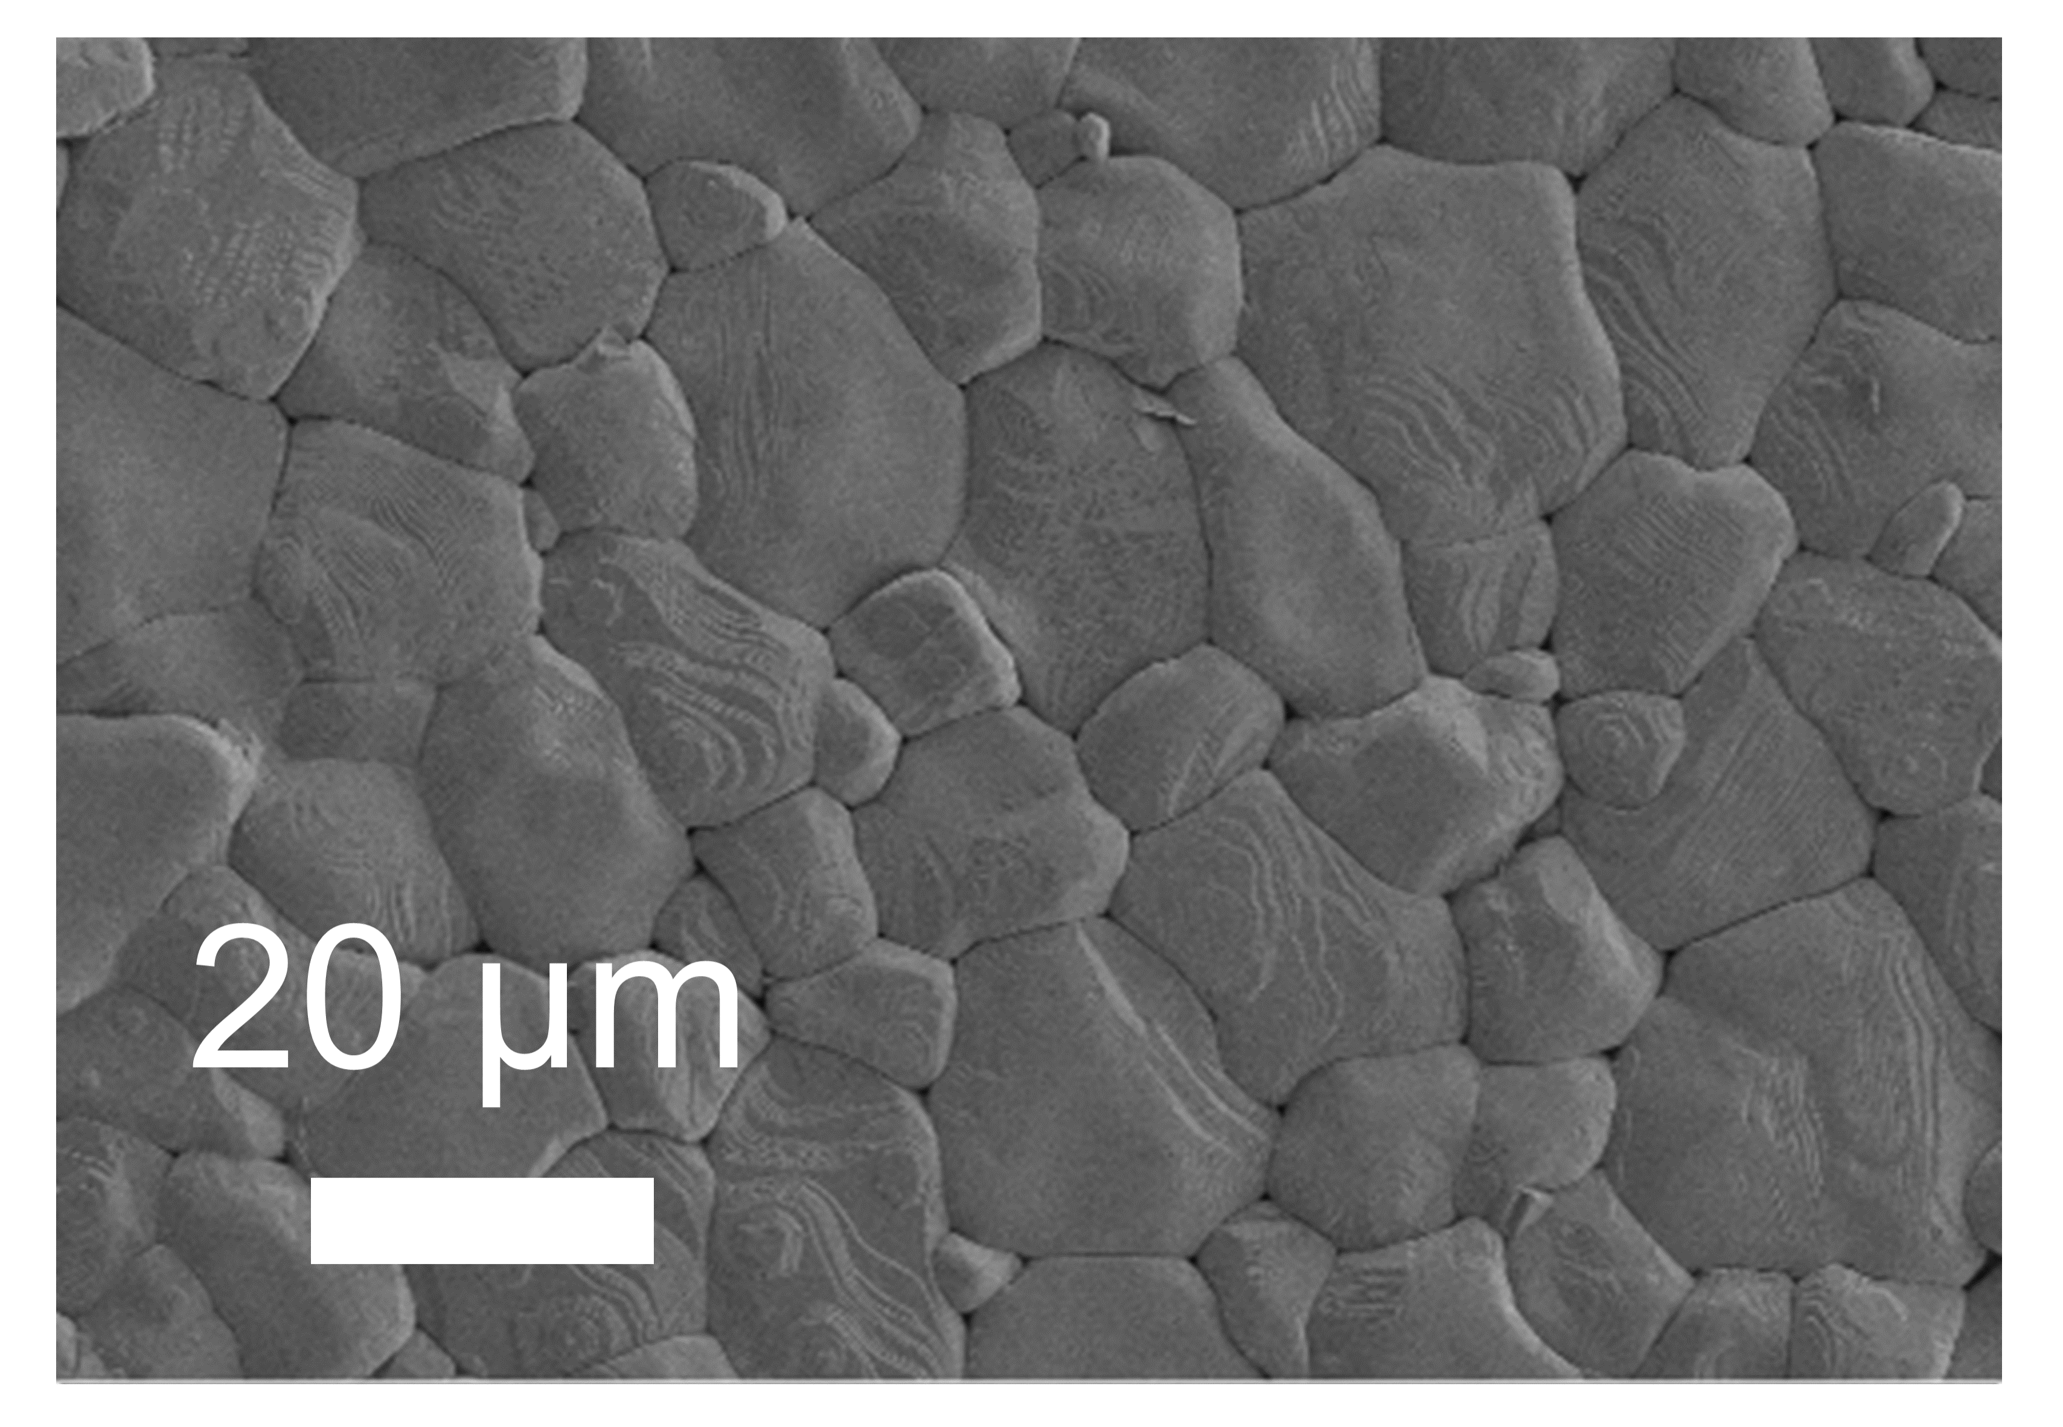
Supplementary Fig. 19. The SEM images of BCTZ ceramics.

Supplementary Fig. 20. The SEM images of BCTZ−xAlN−50 ceramics:
(a) x = 0.25, (b) x = 1.00, (c) x = 1.50.

Supplementary Fig. 21. The SEM images of BCTZ−xAlN−300 ceramics: (a) x = 0.25, (b) x = 0.50, (c) x = 0.75, (d) x = 1.00, (e) x = 1.25, (f) x = 1.50, (g) x = 2.00.

Supplementary Fig. 22. The SEM images of BCTZ−xAlN−3000 ceramics:
(a) x = 0.25, (b) x = 1.00, (c) x = 1.50.

Supplementary Fig. 23. The SEM images and corresponding EDS mapping of BCTZ−1.75AlN−50 ceramics (the yellow-circled area represents BaAl₂O₄).

Supplementary Fig. 24. The SEM images and corresponding EDS mapping of BCTZ−1.75AlN−300 ceramics (the yellow-circled area represents BaAl₂O₄).

Supplementary Fig. 25. The SEM images and corresponding EDS mapping of BCTZ−1.75AlN−3000 ceramics (the yellow-circled area represents BaAl₂O₄).

Supplementary Fig. 26. TEM images of (a) BCTZ and (b) BCTZ−1.75AlN−300 ceramic.

Supplementary Fig. 27. The average grain size of BaAl₂O₄ in the BCTZ–xAlN–300 and BCTZ–xAlN–3000 ceramics.

Supplementary Fig. 28. EDS mapping images of Ba, Ca, Ti, Zr, Al, and O elemental distribution in BCTZ−1.75AlN−300 ceramic.

Supplementary Fig. 29. a The XRD pattern of BaAl₂O₄ ceramic. b Average relative expansion and thermal expansion coefficients of sintered BCTZ and BaAl₂O₄ ceramics. Insets are the photographs of BCTZ (right) and BaAl₂O₄ (left) ceramics.

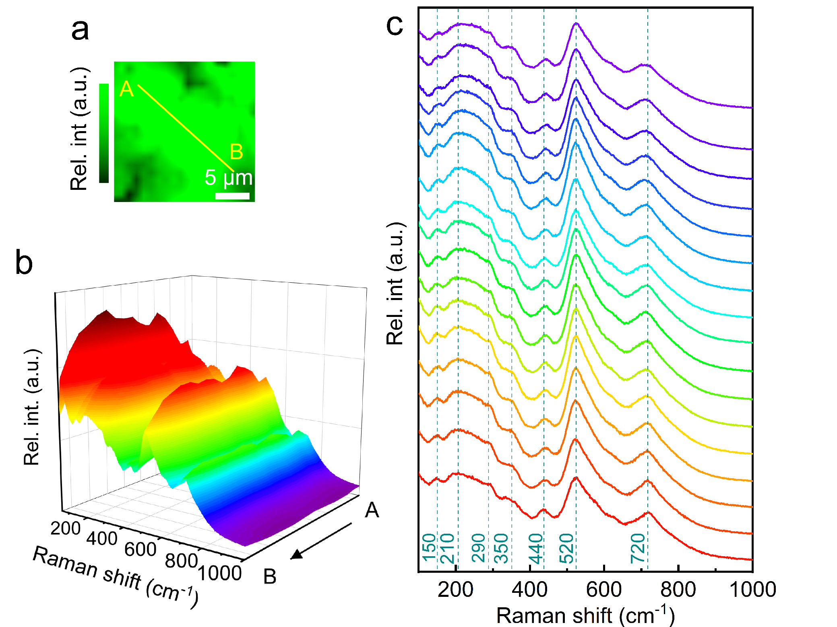
Supplementary Fig. 30. a Raman mapping images of BCTZ ceramic integrating with the bands of 523 cm⁻¹. b 3D stereo plot of specific Raman spectra from points A to B of BCTZ ceramic and (c) corresponding line plot.

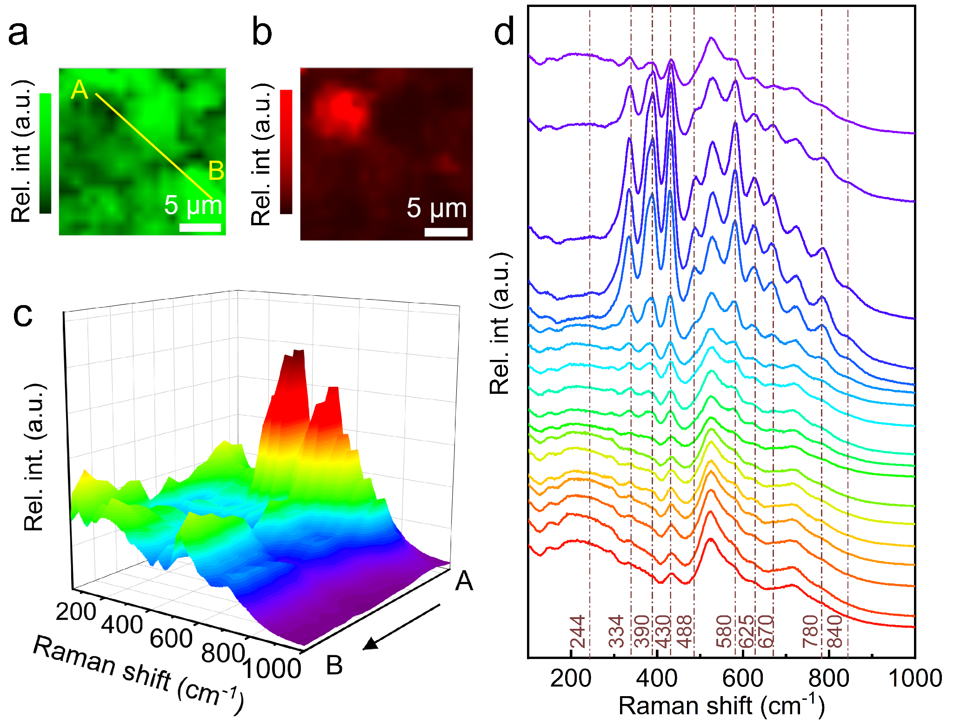
Supplementary Fig. 31. Raman mapping images of BCTZ−1.75AlN−300 ceramic integrating with the bands of (a) 523 cm⁻¹ and (b) 390 cm⁻¹. c 3D stereo plot of specific Raman spectra from points A to B of BCTZ−1.75AlN−300 ceramic and (d) corresponding line plot.

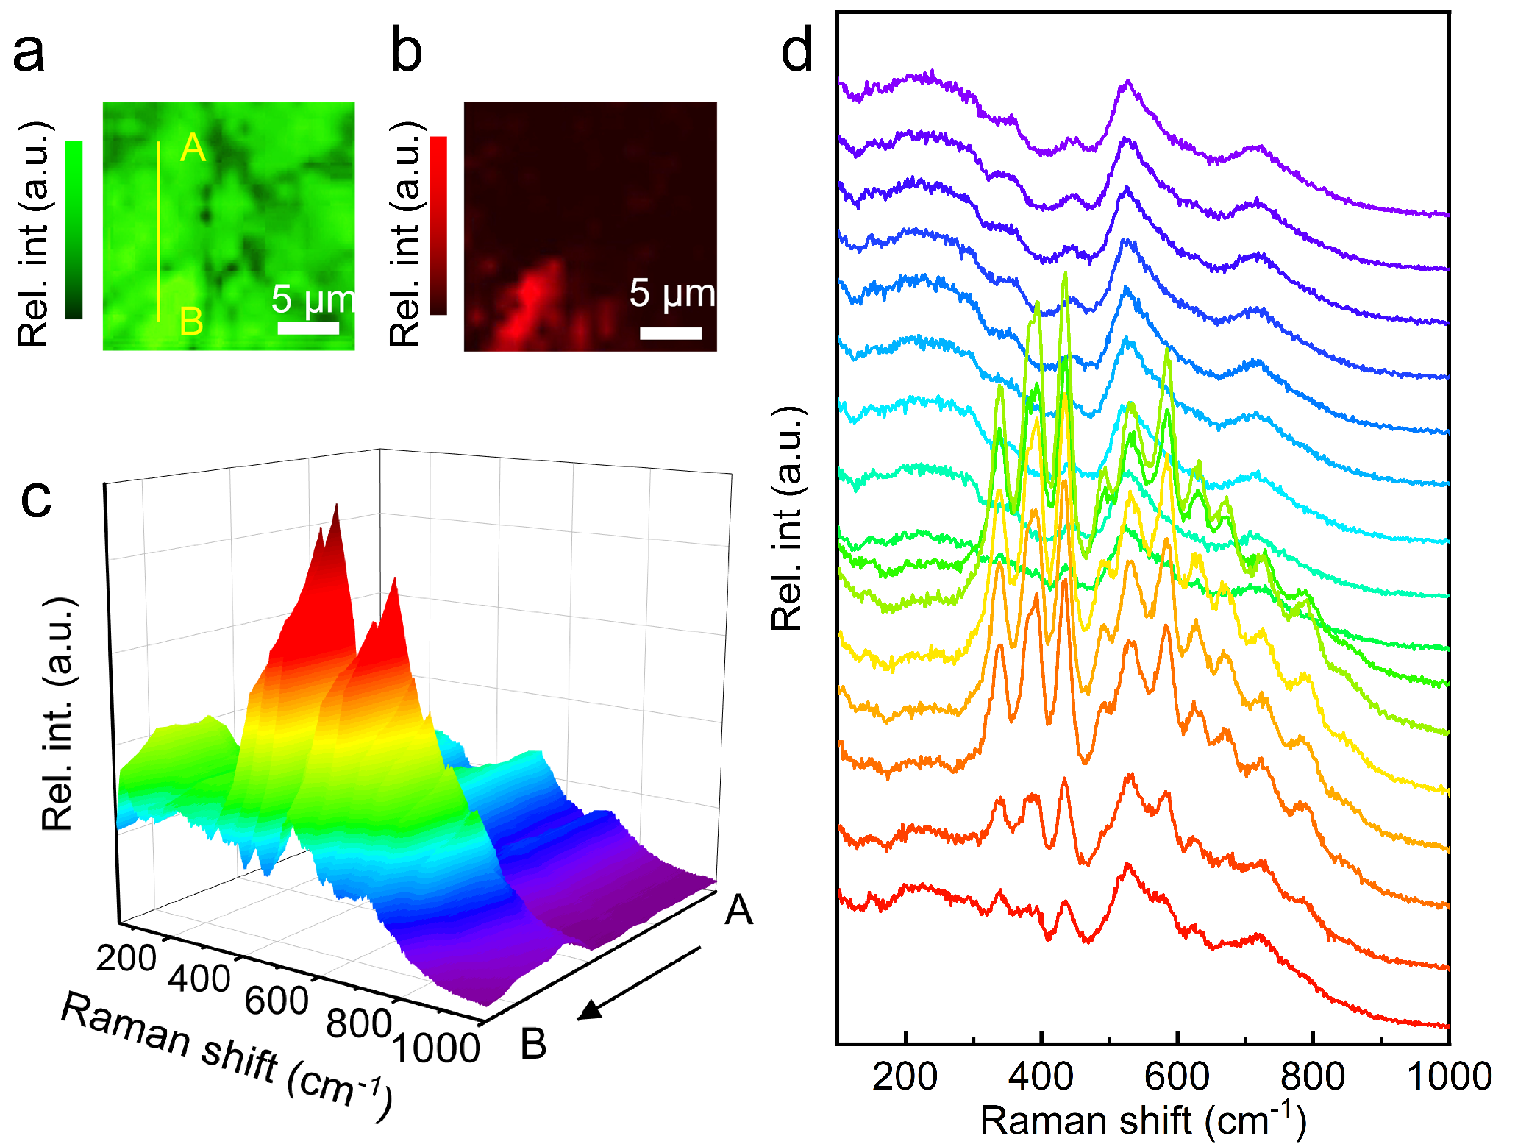
Supplementary Fig. 32. Raman mapping images of BCTZ−1.75AlN−3000 ceramic integrating with the bands of (a) 523 cm⁻¹ and (b) 390 cm⁻¹. c 3D stereo plot of specific Raman spectra from points A to B of BCTZ−1.75AlN−3000 ceramic and (d) corresponding line plot.

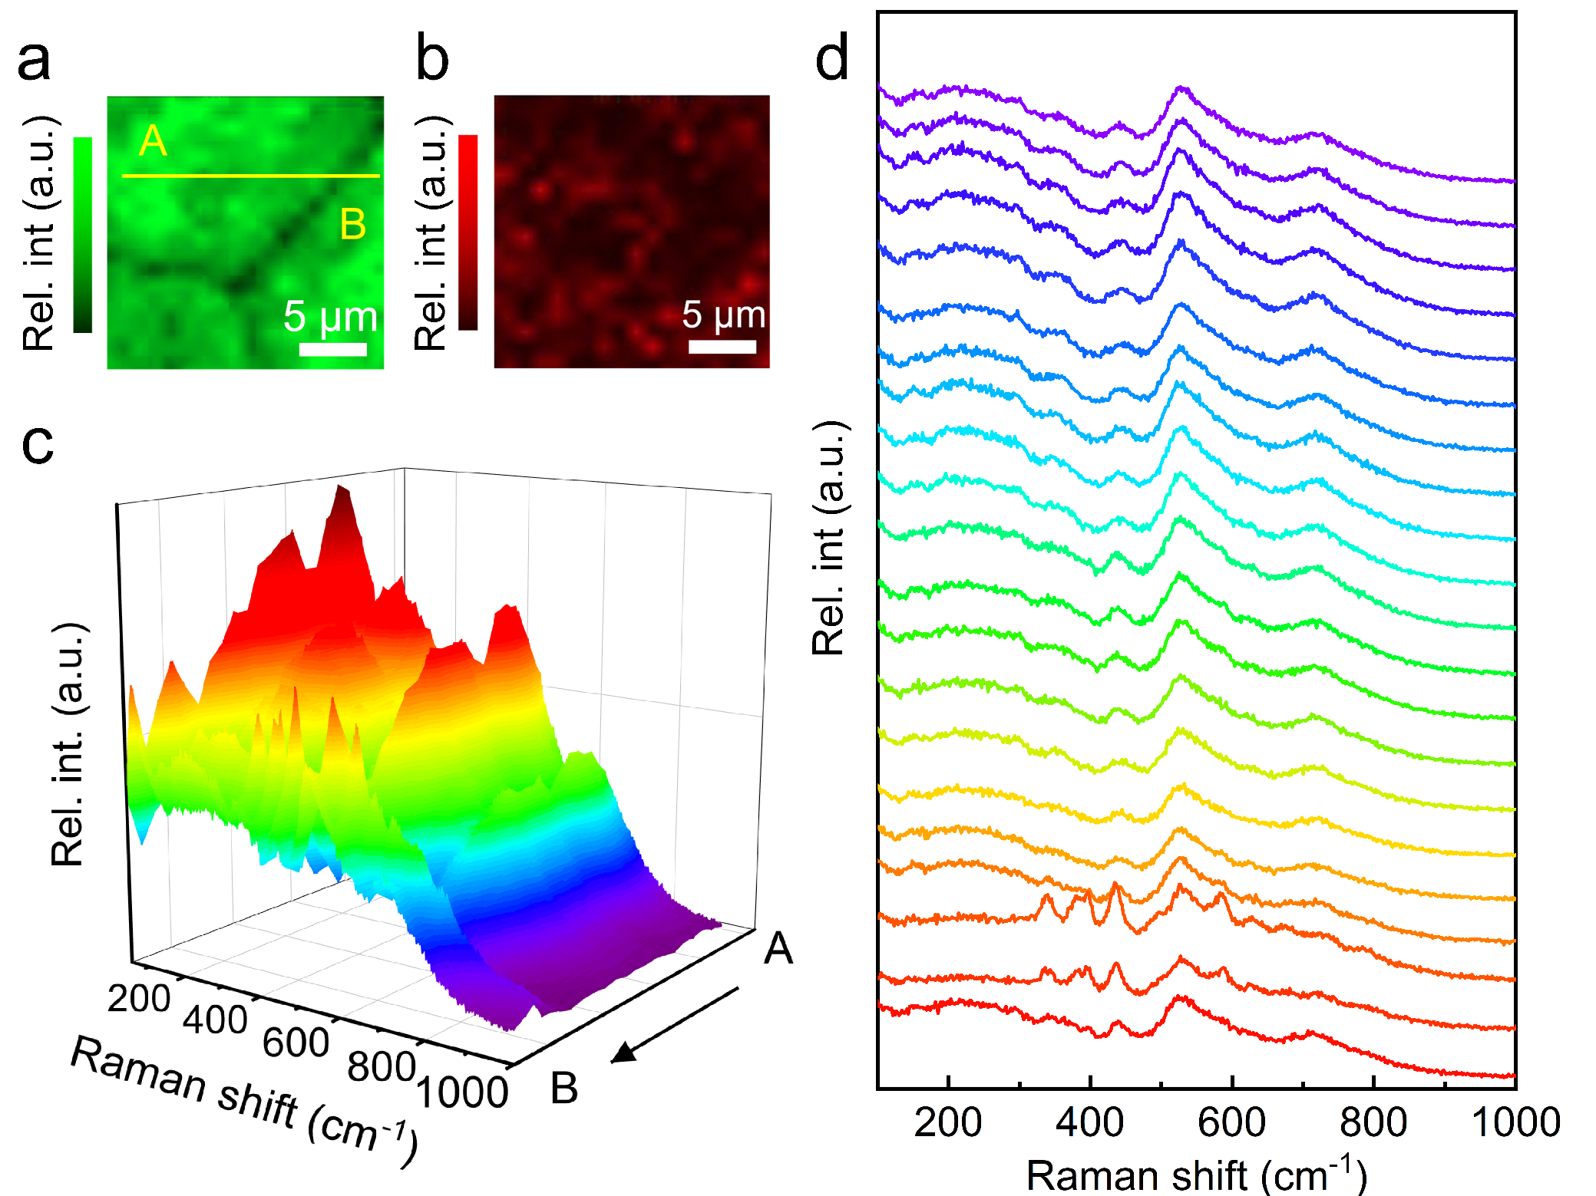
Supplementary Fig. 33. Raman mapping images of BCTZ−1.75AlN−50 ceramic integrating with the bands of (a) 523 cm⁻¹ and (b) 390 cm⁻¹. c 3D stereo plot of specific Raman spectra from points A to B of BCTZ−1.75AlN−50 ceramic and (d) corresponding line plot.

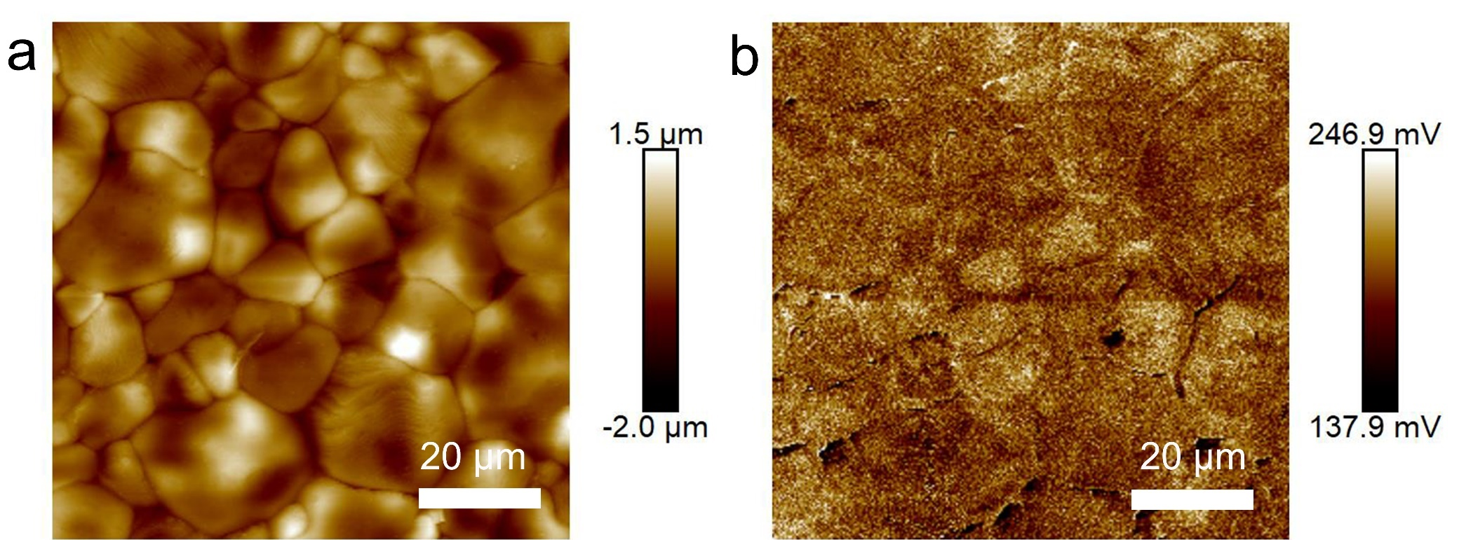
Supplementary Fig. 34. a Topographies and (b) surface potential mapping of BCTZ ceramics measured using KPFM.

Supplementary Fig. 35. a The P−E loops curves of BCTZ, BCTZ−1.75AlN−50, BCTZ−1.75AlN−300, and BCTZ−1.75AlN−3000 ceramics measured at a frequency of 1 Hz. b The ΔE_{C} of BCTZ−xAlN ceramics measured at 30 kV cm⁻¹.

Supplementary Fig. 36. XPS spectra of O1s in the BCTZ−xAlN−300 ceramic.

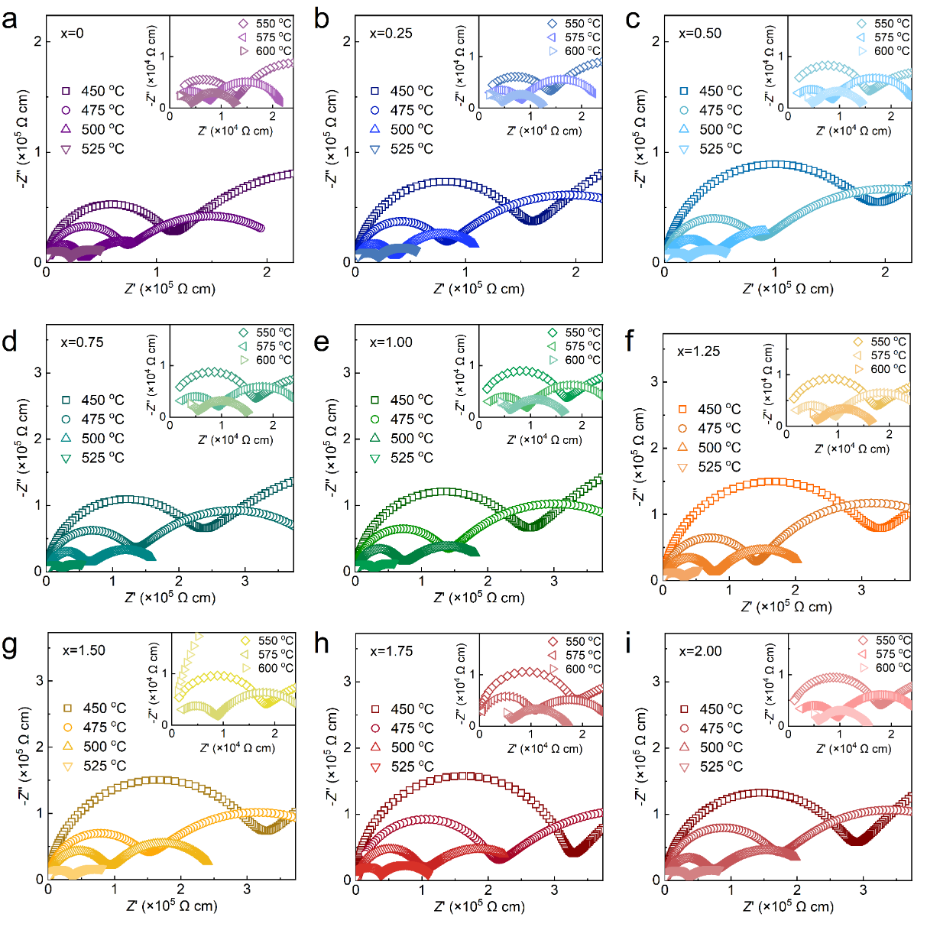
Supplementary Fig. 37. Impedance spectra of of BCTZ−xAlN−300 ceramics measured at 450-600 ºC.

Supplementary Fig. 38. The equivalent circuit of impedance spectra of BCTZ−xAlN ceramics.

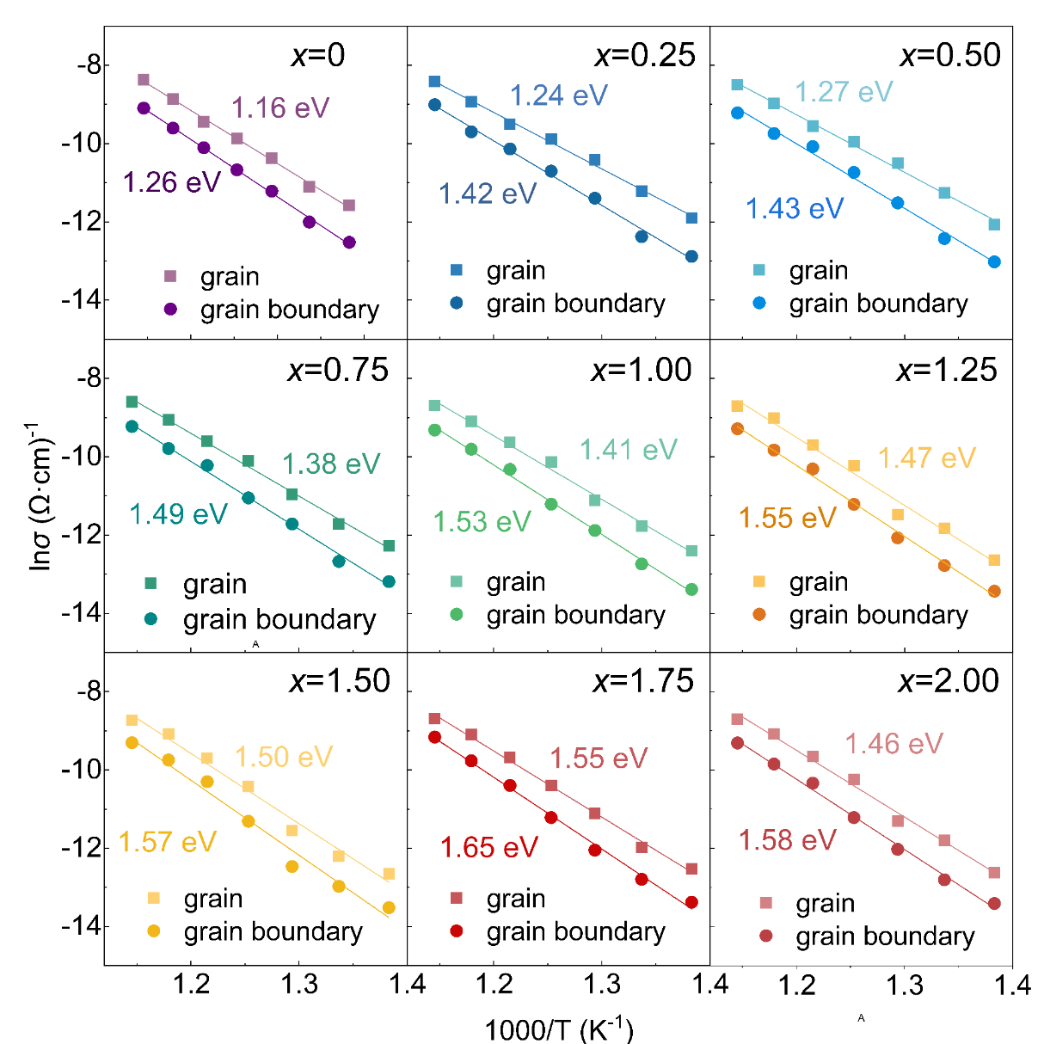
Supplementary Fig. 39. Arrhenius plots and the fitted E_{a} values of BCTZ−xAlN−300 ceramics.

3. Supplementary Table

Supplementary Table 1. Comparison of d₃₃ and T_{C} of BT-based piezoceramics (detailed composition and data in Fig. 2b).
No. | Compositions | d₃₃  (pC N⁻¹) | T_{C}  (ºC) | Ref.
 | (Ba_{0.85}Ca_{0.15})(Zr_{0.1}Ti_{0.9})O₃−x mol% AlN (300 nm), x=1.75 | 650 | 95 | This work
1 | (1-x)Ba(Ti_{0.8}Hf_{0.2})O₃-x(Ba_{0.7}Ca_{0.3})TiO₃, x=0.50 | 550 | 90 | [10]
2 | (Ba_{1−y}Ca_{y})(Ti_{1−x}Hf_{x})O₃, x=0.10 and y=0.15 | 540 | 95 | [11]
3 | (1-x-y)BaTiO_{3-y}CaTiO_{3-x}(BaZr_{1-z}Hf_{z})O₃ at 0.065≤x≤0.085, 0.08≤y≤0.12 and 0≤z≤1.0 | 500 | 100 | [12]
4 | (1-x)Ba(Hf_{y}Ti_{1-y})O₃-x(Ba_{1-z}Ca_{z})TiO₃, x=0.53, y=0.20, z=0.30 | 448 | 110 | [13]
5 | (Ba_{0.95}Ca_{0.05})(Ti_{0.9}Sn_{0.1})O_{3-x}CuO, at x=2 | 683 | 46 | [14]
6 | BaTiO_{3-x}(0.4CaTiO₃-0.6BaSnO₃), x=0-0.20 mol | 570 | 62 | [15]
7 | (Ba_{0.91}Ca_{0.09})(Ti_{0.916}Sn_{0.084})O₃ | 530 | 73 | [16]
8 | (Ba_{0.925}Ca_{0.075})(Ti_{0.90}Sn_{0.10})O₃ | 515 | 52 | [17]
9 | (Ba_{0.84}Ca_{0.15}Sr_{0.01})(Ti_{0.90}Zr_{0.09}Sn_{0.01})O₃ | 514 | 85 | [18]
10 | (Ba_{0.95}Ca_{0.05})(Ti_{0.90}Sn_{0.10})O₃+3 mol% of Li₂CO₃ | 485 | 52 | [19]
11 | (Ba_{0.97}Ca_{0.03})(Ti_{0.94}Sn_{0.06})O₃ | 440 | 63 | [20]
12 | (Ba_{0.90}Ca_{0.10})(Ti_{0.94}Sn_{0.06})O₃ | 405 | 90 | [21]
13 | Ba_{0.85}Ca_{0.15}Zr_{0.1}Ti_{0.9}O₃− x mol% Al₂O₃ | 638 | 91 | [3]
14 | Ba_{0.85}Ca_{0.15}(Ti_{0.9}Zr_{0.1})O₃+4 wt.%CeO₂ | 600 | 87 | [22]
15 | (Ba_{0.85}Ca_{0.15})(Ti_{0.9}Zr_{0.1})O₃+0.8 mol.%BiAlO₃ | 568 | 72 | [6]
16 | (Ba_{0.85}Ca_{0.15})(Ti_{0.9}Zr_{0.1})O₃+0.02 mol.Y₂O₃ | 564 | 105 | [23]
17 | (Ba_{0.85}Ca_{0.15})(Zr_{0.10}Ti_{0.90})O₃+0.1 wt.%Ba(Cu_{0.5}W_{0.5})O₃ | 555 | 95 | [24]
18 | [(Ba_{0.85}Ca_{0.15})(Zr_{0.1}Ti_{0.9})]O₃-0.1 wt.%Sb₂O₃ | 556 | 87 | [7]
19 | (Ba_{0.85-x}Sr_{x}Ca_{0.15})(Zr_{0.1}Ti_{0.9})O₃ at x=0.03 | 534 | 73 | [25]
20 | Li-doped Ba_{0.85}Ca_{0.15}Ti_{0.9}Zr_{0.1}O₃ | 512 | 79 | [26]
21 | (Ba_{0.7}Ca_{0.3})(Zr_{0.2}Ti_{0.8})O₃+0.5 wt.% SiO₂ | 500 | 90 | [27]
22 | Li-doped Ba_{0.85}Ca_{0.15}Ti_{0.9}Zr_{0.1}O₃ | 493 | 75 | [28]
23 | (Ba_{0.85}Ca_{0.15})(Ti_{0.9}Zr_{0.1})O₃+0.2 mol.% V₂O₅ | 466 | 90 | [4]
24 | (Ba_{0.85}Ca_{0.15})(Ti_{0.915}Zr_{0.085})O₃+0.004 wt% CuO+1.5 wt%B₂O₃ | 462 | 95 | [29]
25 | (Ba_{0.85}Ca_{0.15})(Ti_{0.90}Zr_{0.10})O₃+0.04 wt.% Pr₆O₁₁ | 435 | 103 | [30]
26 | (Ba_{0.85}Ca_{0.15})(Ti_{0.9}Zr_{0.1})O₃+0.5 mol.% CuO | 403 | 92 | [31]
27 | (Ba_{0.85}Ca_{0.15})(Ti_{0.9}Zr_{0.1})O₃+0.15 wt.% MnO₂ | 382 | 97 | [32]
28 | (Ba_{0.85}Ca_{0.15})(Zr_{0.1}Ti_{0.9-x}Ce_{x})O₃+ySb | 372 | 110 | [33]
29 | Ba_{0.85}Ca_{0.15}Ti_{0.9}Zr_{0.1}O₃+0.6 Li₂CO₃+x wt% Co | 316 | 82 | [5]
30 | (Ba_{0.90}Ca_{0.10})(Ti_{0.96}Zr_{0.04})O₃+0.05Nd_{x}Y | 286 | 105 | [2]

4. Supplementary References
[1] S. Yotthuan, C. Kornphom, S. Prasertpalichat, T. Suriwong, S. Pinitsoontorn, T. Bongkarn, Phys. Status Solidi A 2019, 216, 1800803.
[2] Y. Tian, M. Ma, S. Li, J. Dong, X. Ji, H. Wu, J. Wang, Q. Jing, Materials 2023, 16, 2369.
[3] X. Wang, Y. Huan, S. Ji, Y. Zhu, T. Wei, Z. Cheng, Nano Energy 2022, 101, 107580.
[4] Y. Yang, J. Guo, W. Ma, H. Zhao, M. Ma, J. Wu, M. Chi, J. Mater. Sci. Mater. Electron. 2019, 30, 2854.
[5] X. Huang, C. Gao, M. Huang, Z. Yue, Ferroelectrics 2015, 481, 146.
[6] X. Chao, J. Wang, L. Wei, R. Gou, Z. Yang, J. Mater. Sci. Mater. Electron. 2015, 26, 7331.
[7] J. Ma, X. Liu, M. Jiang, H. Yang, G. Chen, X. Liu, L. Qin, C. Luo, J. Mater. Sci. Mater. Electron. 2014, 25, 992.
[8] C. Han, J. Wu, C. Pu, S. Qiao, B. Wu, J. Zhu, D. Xiao, Ceram. Int. 2012, 38, 6359.
[9] N. Zhang, T. Zheng, N. Li, C. Zhao, J. Yin, Y. Zhang, H. Wu, S. J. Pennycook, J. Wu, ACS Appl. Mater. Inter. 2021, 13, 7461.
[10] C. Zhou, W. Liu, D. Xue, X. Ren, H. Bao, J. Gao, L. Zhang, Appl. Phys. Lett. 2012, 100, 222910.
[11] C. Zhao, W. Wu, H. Wang, J. Wu, J. Appl. Phys. 2016, 119, 024108.
[12] C. Zhao, B. Wu, H.-C. Thong, J. Wu, J. Eur. Ceram. Soc. 2018, 38, 5411.
[13] D. Wang, Z. Jiang, B. Yang, S. Zhang, M. Zhang, F. Guo, W. Cao, J. Am. Ceram. Soc. 2014, 97, 3244.
[14] P.-F. Zhou, B.-P. Zhang, L. Zhao, X.-K. Zhao, L.-F. Zhu, L.-Q. Cheng, J.-F. Li, Appl. Phys. Lett. 2013, 103, 172904.
[15] L.-F. Zhu, B.-P. Zhang, L. Zhao, J.-F. Li, J. Mater. Chem. C 2014, 2, 4764.
[16] D. Xue, Y. Zhou, H. Bao, J. Gao, C. Zhou, X. Ren, Appl. Phys. Lett. 2011, 99, 122901.
[17] W. Janbua, T. Bongkarn, T. Kolodiazhnyi, N. Vittayakorn, RSC Adv. 2017, 7, 30166.
[18] X. Liu, Z. Chen, B. Fang, J. Ding, X. Zhao, H. Xu, H. Luo, J. Alloys Compd. 2015, 640, 128.
[19] L. Zhao, B.-P. Zhang, P.-F. Zhou, X.-K. Zhao, L.-F. Zhu, J. Am. Ceram. Soc. 2014, 97, 2164.
[20] W. Li, Z. Xu, R. Chu, P. Fu, G. Zang, J. Eur. Ceram. Soc. 2012, 32, 517.
[21] M. Chen, Z. Xu, R. Chu, Y. Liu, L. Shao, W. Li, S. Gong, G. Li, Mater. Lett. 2013, 97, 86.
[22] Y. Cui, X. Liu, M. Jiang, X. Zhao, X. Shan, W. Li, C. Yuan, C. Zhou, Ceram. Int. 2012, 38, 4761.
[23] X. Wang, P. Liang, L. Wei, X. Chao, Z. Yang, J. Mater. Sci. Mater. Electron. 2015, 26, 5217.
[24] W. Li, X. Liu, J. Ma, Y. Wu, Y. Cui, J. Mater. Sci. Mater. Electron. 2013, 24, 1551.
[25] W. F. Bai, W. Li, B. Shen, J. W. Zhai, Key Eng. Mater. 2012, 512-515, 1385.
[26] X. Chen, X. Ruan, K. Zhao, X. He, J. Zeng, Y. Li, L. Zheng, C. H. Park, G. Li, J. Alloys Compd. 2015, 632, 103.
[27] W. Liu, S. Li, IEEE T. Dielect. El. In. 2015, 22, 734.
[28] X. Chen, Y. Li, J. Zeng, L. Zheng, C. H. Park, G. Li, J. Am. Ceram. Soc. 2016, 99, 2170.
[29] S.-H. Shin, J.-D. Han, J. Yoo, Mater. Lett. 2015, 154, 120.
[30] I. Coondoo, N. Panwar, H. Amorín, V. E. Ramana, M. Algueró, A. Kholkin, J. Am. Ceram. Soc. 2015, 98, 3127.
[31] T. Chen, T. Zhang, G. Wang, J. Zhou, J. Zhang, Y. Liu, J. Mater. Sci. 2012, 47, 4612.
[32] J. Wu, Z. Wang, B. Zhang, J. Zhu, D. Xiao, Integr. Ferroelectr. 2013, 141, 89.
[33] W. Zheng, J. Lin, X. Liu, W. Yang, Y. Li, RSC Adv. 2021, 11, 2616.

