Fig. S1 Heat maps representing the abundance profile of the distinct metabolic features between dust-exposed workers (DEW) without silicosis and healthy controls (CON). Identity of the metabolic features was shown on the right side, individual samples in rows, respectively. Cells colored in red represent up-regulated, colored in blue down-regulated abundances. The analysis was done with the MetaboAnalyst online platform.

Fig. S2 Heat maps representing the abundance profile of the distinct metabolic features between the patients with silicosis (SIL) and healthy controls (CON). Identity of the metabolic features was shown on the right side, individual samples in rows, respectively. Cells colored in red represent up-regulated, colored in blue down-regulated abundances. The analysis was done with the MetaboAnalyst online platform.

Table S1 List of assigned statistically significantly distinct metabolic features after comparison of dust exposure workers without silicosis to healthy controls
No | Compund | Formula | m/z | Fold change | VIP | P value
1 | Creatinine | C₄H₇N₃O | 114.0664 | 1.33 | 1.35578 | 9.87E-09
2 | Creatine | C₄H₉N₃O₂ | 132.0768 | 0.58 | 1.00349 | 0.000162
3 | L-Lysine | C₆H₁₄N₂O₂ | 147.1127 | 1.31 | 1.07589 | 0.000108
4 | Citrulline | C₆H₁₃N₃O₃ | 176.1029 | 1.29 | 1.47938 | 0.001383
5 | Vaccenic acid | C₁₈H₃₄O₂ | 281.2479 | 1.82 | 1.60362 | 0.000591
6 | 9-Decenoylcarnitine | C₁₇H₃₁NO₄ | 314.2322 | 1.68 | 1.03997 | 0.000549
7 | Decanoylcarnitine | C₁₇H₃₃NO₄ | 316.2479 | 1.59 | 1.00507 | 3.76E-06
8 | Docosahexaenoic acid | C₂₂H₃₂O₂ | 327.2325 | 2.28 | 1.5569 | 0.000138
9 | Dodecanoylcarnitine | C₁₉H₃₇NO₄ | 344.2792 | 2.57 | 1.1982 | 2.56E-06
10 | 3, 5-Tetradecadiencarnitine | C₂₁H₃₇NO₄ | 368.2791 | 2.32 | 1.14665 | 2.56E-06
11 | trans-2-Tetradecenoylcarnitine | C₂₁H₃₉NO₄ | 370.2948 | 2.98 | 1.16016 | 3.79E-07
12 | Tetradecanoylcarnitine | C₂₁H₄₁NO₄ | 372.3106 | 2.28 | 1.35387 | 4.88E-08
13 | 9,12-Hexadecadienoylcarnitine | C₂₃H₄₁NO₄ | 396.3104 | 2.37 | 1.20337 | 8.61E-07
14 | trans-Hexadec-2-enoyl carnitine | C₂₃H₄₃NO₄ | 398.3262 | 2.51 | 1.20725 | 1.11E-08
15 | L-Palmitoylcarnitine | C₂₃H₄₅NO₄ | 400.3417 | 1.70 | 1.22433 | 8.48E-08
16 | Linoelaidylcarnitine | C₂₅H₄₅NO₄ | 424.3415 | 2.22 | 1.11106 | 9.46E-08
17 | Oleoylcarnitine | C₂₅H₄₇NO₄ | 426.3574 | 2.66 | 1.71806 | 4.32E-09
18 | Stearoylcarnitine | C₂₅H₄₉NO₄ | 428.3738 | 1.60 | 1.07869 | 5.00E-06
19 | LysoPE(16:0) | C₂₁H₄₄NO₇P | 454.2924 | 1.32 | 1.20662 | 0.036689
20 | LysoPE(18:1) | C₂₃H₄₆NO₇P | 480.3085 | 1.90 | 1.37356 | 2.36E-05
21 | LysoPC(16:1) | C₂₄H₄₈NO₇P | 494.3241 | 1.49 | 1.03094 | 0.001697
22 | LysoPC(16:0) | C₂₄H₅₀NO₇P | 496.3391 | 1.34 | 1.73954 | 7.02E-05
23 | LysoPE(22:6) | C₂₅H₄₄NO₇P | 502.2925 | 2.03 | 1.06968 | 1.05E-05
24 | LysoPC(18:1) | C₂₆H₅₂NO₇P | 522.3552 | 1.81 | 1.12145 | 2.11E-06
25 | LysoPE(20:4) | C₂₇H₄₄NO₇P | 526.292 | 1.77 | 1.02334 | 0.001048
26 | LysoPC(20:2) | C₂₈H₅₄NO₇P | 548.3716 | 1.81 | 1.17706 | 8.61E-07
27 | LysoPC(22:6) | C₃₀H₅₀NO₇P | 568.3393 | 2.03 | 1.12556 | 4.33E-05
28 | Cer(d18:1/24:1) | C₄₂H₈₁NO₃ | 648.6283 | 1.97 | 1.27691 | 4.55E-06
29 | PC(o-16:0/16:1) | C₄₀H₈₀NO₇P | 718.5736 | 0.84 | 1.06874 | 0.042377
Abbreviations: LysoPE lysophosphatidyl ethanolamine, LysoPC lysophosphatidylcholine, PC phosphatidylcholine, Cer ceramide. The variable importance for projection (VIP) statistics and t-test were used applied to select significant variables leading to group separation. VIP values of > 1.0 and P values of < 0.05 were considered statistically significant.

Table S2 List of assigned statistically significantly distinct metabolic features after comparison of the patients with silicosis to healthy controls
No | Compund | Formula | m/z | Fold change | VIP | P value
1 | Threonine | C₄H₉NO₃ | 120.0655 | 0.70 | 1.79124 | 4.79E-05
2 | Creatine | C₄H₉N₃O₂ | 132.0768 | 0.48 | 1.65789 | 3.07E-05
3 | L-Arginine | C₆H₁₄N₄O₂ | 175.1189 | 1.52 | 1.52316 | 0.000231
4 | Kynurenine | C₁₀H₁₂N₂O₃ | 209.0921 | 1.66 | 1.64859 | 1.05E-05
5 | Palmitic acid | C₁₆H₃₂O₂ | 255.2322 | 1.33 | 2.42667 | 2.52E-05
6 | Stearic acid | C₁₈H₃₆O₂ | 283.2635 | 1.51 | 1.794 | 2.15E-12
7 | LysoPE(18:2) | C₂₃H₄₄NO₇P | 478.2924 | 2.33 | 2.47867 | 0.000474
8 | PC(o-16:0/16:1) | C₄₀H₈₀NO₇P | 718.5736 | 0.72 | 1.44861 | 0.001719
9 | PC(20:4/14:0) | C₄₂H₇₆NO₈P | 754.5375 | 0.667 | 1.44874 | 0.011574

Abbreviations: LysoPE lysophosphatidyl ethanolamine, PC phosphatidylcholine. The variable importance for projection (VIP) statistics and t-test were used applied to select significant variables leading to group separation. VIP values of > 1.0 and P values of < 0.05 were considered statistically significant.
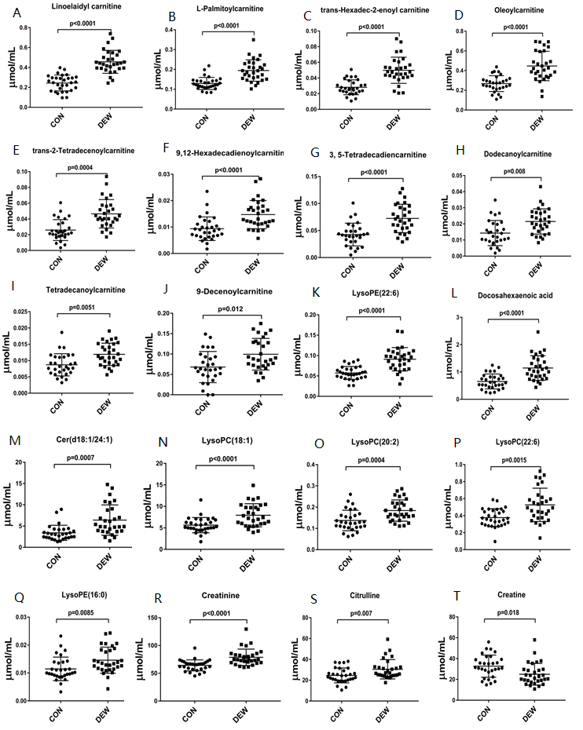
Fig. S3 Comparison of the abundance of the distinct metabolic features in dust exposure workers (DEWs) without silicosis and healthy control (CON) groups after targeted metabolomics validation and ROC analyses. P< 0.05 indicated statistical significance.

